ECEY4001 Human Development Portfolio
I have not used AI within this portfolio.
Contents
- Maslow Infographic
- Part 2- The concept of Holistic Child Development
- Part 3- Maslow’s significance in understanding child development
- Reference’s Infographic
- Reference’s Part 2
- Reference’s Part 3

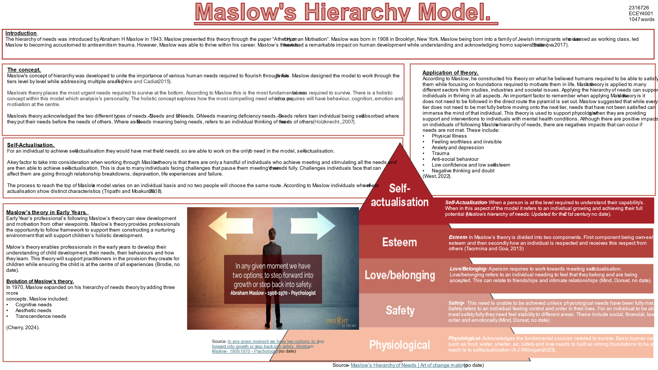

The concept of Holistic Child Development

Development in Early Years is a complex area which has numerous approaches to support children. This essay will discuss the concept of holistic development, while acknowledging theories that provide influential framework to child development and analysing the limitations of these theories.
Early years children are in a fundamental stage of development. Between 0-3 years old they are learning, growing, and beginning to progress in every aspect. There is strain that this process needs to be conducted right for them to build the foundations required to become component as they grow (Hadfield et al., 2012).
The concept of Holistic development in early years is when a child is looked at as a full person and not only focusing on a child’s academic achievements. Holistic development is constructed of five components. These components are physical, social, emotional, intellectual, and spiritual which are all required for a child to grow and develop their happiness, independence, and functioning skills.
A principal factor to consider with holistic development is ensuring the whole picture is being taken into consideration, and that all components that make up holistic development are being given the same about of attention and being developed using a holistic approach (Mcllroy, 2024).
Early years children will not all develop in the same way as relatives and peers. There are theories which analyse the development a child should follow and the timeline to hit milestones, but this is not always the case. According to NHS Cambridge they suggest that by the time a child is twelve months old they will be able to walk around while holding on to furniture (NHS Cambridge, no date). However, each child develops and learns at their own pace and in a unique way.
Holistic development can be supported by adults in the child’s life by considering a child’s development from different approaches. To support holistic development in Early Years it is crucial that adults around the child are practicing reflection. This leads to focusing on all five components rather than only one two components of their development (Brodie. 2018).
The importance of adults in the child’s life following a holistic approach is vital for a child’s wellbeing. Fostering a holistic approach will support children building the skills required for later life which will be essential to their learning as they grow, strengthens their capabilities to learn and be able to adapt to environments. Holistic development in early years plays a vital role in a child’s neurological development and promotes neurological connections (Queen Margaret University, 2023).
Holistic development can be seen in practice through the opportunities children are being provided with. For example, building a shelter supports development in these areas physical, emotional, social, intellectual, and spiritual. This is due to the teamwork that is required to build a shelter, and this activity also tests a child perseverance and resilience skills (Learningintheleaves, no date).
Holistic development and fostering this approach have copious positives in developing children to become capable throughout their lives, but there are also problems within holistic development and situations which may occur than can interfere with holistic development.
Social influences and influences from the wider society such as racism can affect a child’s holistic development in a negative way. The main limitation that can affect this technique is a child’s attachment. A child having secure attachment or avoidant attachment influence’s how they interact with adults and explore their environments to make the most of their learning opportunities.
Other challenges children may face in their environments that can affect holistic development include poverty, genetics passed through the mother, opportunities they are given and technology (Brodie, 2018).
Maslow’s hierarchy of needs theory connects with children developing holistically, as he constructed his theory by acknowledging the importance of physical and emotional needs, being met before being able to develop cognitively. Maslow suggests that for children to develop fully their physiological needs to be met before cognitive needs are met. Maslow states in his theory that children need to feel that they are emotionally and physically safe and accepted this will then support them moving up his theory to meet cognitive needs, so they are able to reach their full potential (foreverwildforestschool, 2023).
Urie Bronfenbrenner’s theory developed first in 1979 was constructed on the foundations of the ecological system. Bronfenbrenner acknowledged the impact the environment has on a child’s development. According to Bronfenbrenner he suggests that a child needs to be in a secure supportive environment, so they can build positive relationships with their care givers and other adults this will then result in them feeling a sense of belonging.
Bronfenbrenner’s ecological theory has been constructed by five components which include microsystem, mesosystem, exosystem, macrosystem and chronosystem. These components connect with each other. When this theory was first developed Bronfenbrenner’s main emphasis was on the ecological factors of development. This theory has now been expanded further to include biological factors (Brodie, 2016).
While theorist Frederick Herzberg shares more similarities with Maslow. There are links between Maslow and Bronfenbrenner with a key feature being the impact both theories have had on development. It can be argued that there are similarities in both theories as there is acknowledgment to the needs that are required to be met for a child to reach their full potential. Maslow and Bronfenbrenner analyse in depth how a child needs to feel a sense of belonging to support them flourishing. Both theories understand how cognitive needs cannot be met first while acknowledging that a child’s environment support holistic development.
Maslow and Bronfenbrenner’s theories have played an influential role in development. Nevertheless, both theories face limitations.
The main weakness with Maslow’s theory is that it does not consider or acknowledge the real world, and challenges that occur such as poverty, recission and war. Critics of Maslow’s theory have acknowledged that there is minimum data available to support the theory (Esmainia and Thoma, 2021).
One of the main difficulties with Bronfenbrenner’s theory is that child development is a complex area, and this theory does not represent this. Many writers have challenged Bronfenbrenner’s theory as it undervalues differences that individuals will face, and genetic factors are not considered. While Bronfenbrenner undervalues aspects, he also exaggerates the importance of focus, leading to critics fearing that active involvement by the child is overlooked (Brodie, no date).
Bronfenbrenner’s theory is unable to adequately explain and consider historical changes in development which impacts on development for instance the evolution of technology and the influence of social norms (Elder and Shanahan, 2006).

Maslow’s significance in understanding child development.
This essay will discuss three issues from Early Years and the adults role in supporting the child, so they are able to flourish. Within this essay Maslow will be analysed at depth and how his theory links into each issue while acknowledging relatable policies.
Transition
Transition is a challenge that all children will face throughout their lives and can result in children becoming vulnerable. Transition refers to a child moving between settings. A key factor to take into consideration when referring to transition is that it can happen in many ways. Transition can happen when moving classroom’s, schools or moving to a different part of the day. Transition can also occur with parent separations (birthto5matters, 2021).
When children are going through a phase of transition it is an opportunity for children to develop individuality which will support them progressing in social and emotional skills and building their confidence. Maslow’s theory supports transition as it recognises children having a sense of belonging as a fundamental basic need. Having this need met will support the child being able to process and manage transitions (City of Bradford Council, no date).
Adults working in early years can support children in transition through various strategies. It is the role of the adult to support children gaining the knowledge and confidence to understand their own personal and social skills, and ensuring the child’s voice is being heard (Symonds, 2015).
Under the UNCRC article 12 it states that every child has a right to be heard. This needs to be a focus when children are transitioning (UNICEF, no date). Adults have a duty to support a child’s wellbeing and help them feel safe when transitioning, but also inform them that there are key adults to support them throughout the process (Bomber, 2007).
Adults can be seen in practice supporting children through transition by strong effective communication which is clear and consistent while allowing parents to be fully involved. Practitioners will reflect on their practice. In Early Years strategies when transitioning into a new setting are to share an information book with parents, this will build their trust and start to build a relationship. Professionals will provide children with opportunities to make friends with their peers. They do this to support children feeling a sense of belonging, and to build relationships with a key adult. This adult can then ensure the child is having their basic needs met in all settings (Welsh Government, 2019).
Children living in poverty.
In the United Kingdom between 2022/2023 it was recorded that 4.3 million children are living in poverty. This is 30% of children in the United Kingdom (Houses of Lords Library, 2024).
Poverty is a critical issue within the United Kingdom and an issue that professionals will face daily. There have been prominent levels of research on the impact poverty has on a child’s development. The data from research has shown that children who live in poverty are developing slower and this affects them emotionally and causes distress (Ridge, 2011).
A mothers mental, physical health and socio-economic status play’s a part of a child developing poverty from when the child is conceived. Poverty is detrimental to children in the Early Years as this is when the foundations are forming in physical, social, and emotional development (Oppenheim, 2023).
Maslow’s theory illustrates the significant importance of meeting the physiologic needs first before any other needs can be met. It recognizes in the base level physiological needs such as food, water, and shelter and the second level how important it is to have access to basic human rights. For example, a child who is not having accesses to food and water will not be able to concentrate in school and the human body will not be able to function to full capacity (Kuo, 2011).
Professionals have a duty to provide engaging effective opportunities and environments while being an enabling adult. Adults building a relationship with the children and having robust communication is key, while providing safe and secure environments where the child can express themselves (ndna, no date).
In Wales they introduced an initiative in schools to relieve the pressure off families throughout the summer holidays. This initiative was introduced with the focus on supporting schools who are in high deprivation areas and predominantly free school meals. This programme not only relieves stress from parents and help them meet the costs of the summer holidays but also supports improving collaboration with external agencies while improving parents and caregivers’ health and wellbeing. (Welsh Government, no date)
Children going through relationship breakdown.
In early years professionals will see children going through relationship break downs and can find it difficult to build relationships with these children. This is due to the child having avoidant attachment or insecure attachment.
Children can face relationship breakdowns through more than just their parent’s relationships, this can be from trauma, abuse, and poverty (NSPCC, 2023).
Bowlby suggests children between the ages 0-2 years old are in a crucial stage of developing skills to support them in shaping and building their relationships. During this time, it will determine how a child trust’s, operates and is confident around adults leading to their style of attachment (Bowlby, 1997).
Maslow states that a child needs to have a sense of belonging and be able to build secure attachments. Maslow put a focus on relationships and this need is a deficiency need. According to Maslow, relationships and feeling a sense of belonging and acceptance is the last layer of the lower needs which need to be met before being able to move onto the B-Needs (Wahome, 2022).
The Department of Education have set out statutory framework for the Early Years. Within this it sets out the expectations of adults becoming a key adult for children while supporting them construct skills required to build and maintain relationships. It puts a focus on the importance of relationships and how professionals are required to support children achieving at school and later life (Department of Education).
Children who face the trauma of a relationship break down will often receive intervention from the pastoral team, where they will work to support filling unmet needs and developing their emotional literacy. During these interventions a child will be supported to understand they are not to blame and have a safe space for them to express themselves (Welsh Government, no date).
Conclusion
Maslow played a fundamental role in early years practice and is significant to philosophers and professionals across the world. According to Maslow he provided a methodical approach centred around a mentally health human. Maslow’s significance to early years development have supported the continuous research of human behaviour. Maslow have acknowledged the importance of children having basic needs met while placing an understanding on the consequences of needs being unfulfilled (Stoyanov, 2017). In summary of Maslow’s theory, practitioners in consider more than a child’s academic and cognitive needs, they focus on emotional, social, and physical wellbeing of a child so they flourish and reach self-actualisation (Brodie, no date).

