Student Name
Dayvid Petrov
Student Number
2010795
Module Title,
Marketing Fundamentals (LCBB4004)
Lecturer’s Name
Md Sadeque Imam Shaikh

Land Rover Car Company

Blog Post 1
The Brand
Land Rover is an old and iconic British brand that is renowned for its four-wheel drive and off-road capable rugged vehicles. The brand was established back in 1958 before earning the Royal Warrant in 1951. It majorly focused on producing utilitarian off-road cars, solely under the box shape that has remained with the firm for multiple decades (Robson, 1981, p.5). However, this changed later on with the progressive acquisitions of the firm, first by BMW, and later by Ford. The two are especially attributed to a fundamental shift in the heritage of the brand through the introduction of monocoque and integrated body frames respectively. Subsequently, Land Rover also upscaled its model in both production and manufacturing through the introduction of range Rover and Freelander models. The firm moved beyond its rugged and off-road focus into an entity that manufactures cars for the upscale market and fits the luxury segment. Later in 2008, Tata Motors Group acquired Land Rover and Jaguar, along with Daimler and two dormant brands, Lanchester and Rover in the UK. While the Jaguar and Land Rover brands have continued to operate separately, there was a fundamental restructuring and subsequent integration between them. Today, these changes are a key element in their operations within the UK and global markets. Land Rover has evolved from a utilitarian vehicle with its rugged and off-road features into a brand whose products fit the swanky luxury market, while still retaining the iconic look and original heritage all along. The changes in the brand have focused on providing more luxury while keeping the original strength of the names and giving affordable products to consumers globally. Subsequently, the firm under its new management continues to make inroads and manage overall growth into the overseas and global emerging markets, even in the developing world. The brand has also been associated with use in the military along with an independent civilian line. Land Rover also has an extension into bicycles and pushchairs at an ample scale.
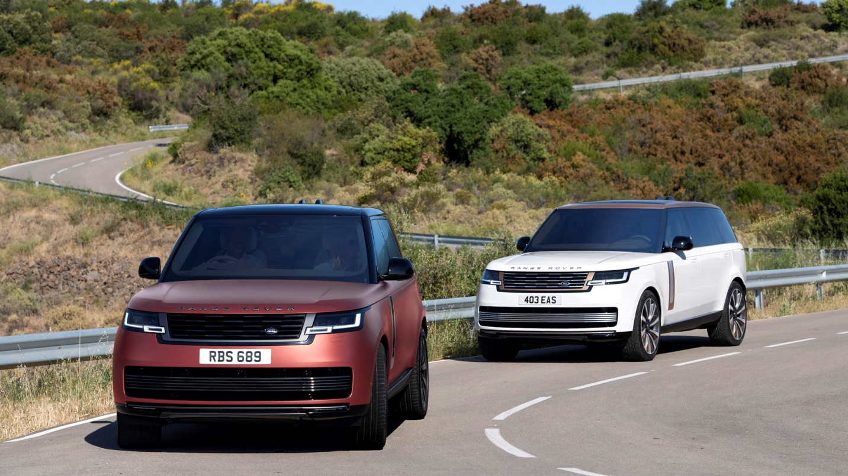
Blog post 2
Marketing concept
The marketing concept brings together various variables that look into various systems in ways that would create value for the consumer. The marketing process focuses on identifying the consumer needs and working to align what the product or service from the brand has in tandem with these wants. Additionally, marketing as a function helps to set apart the organisation’s product from what other brands are offering in the market. Land Rover has demonstrated the marketing process and function through its transition of the brand from the rugged and off-road feel into one that reflects and fits the touch of the luxury market. Since its inception, Land Rover emphasized creating a functional car that meets the varied needs of its early consumers, especially before luxury became mainstream (Car and Driver, 2022, p.1). However, the company readjusted its operating model along the progressive acquisitions to reflect the present state of the market. its change from the box to the monocoque and integrated design reflected this transition. The change also came with an introduction of more variants, including the Freelander and Range Rover models under the products that the firm has and gives across its markets. Land Rover has also honed on marketing beyond production alone. The firm has a dedicated media segment that portrays the design and uses features in its new brands in ways that are clear and relatable to the consumer. The cutting-edge approach feeds the prospective consumers with cutting-edge feeds about features and the overall design in its graphic representation and portrayal of the brand. The firm also holds a structured campaign that has helped to extend popularity around its products in the global market and inspired the growth in its brand even further (Land Rover, 2022). Marketing in Land Rover is about growing with the needs of its market, which is reflected in its progressive change on a design, product specification, and the number of line affiliations to fit the needs of consumers dynamically and globally.
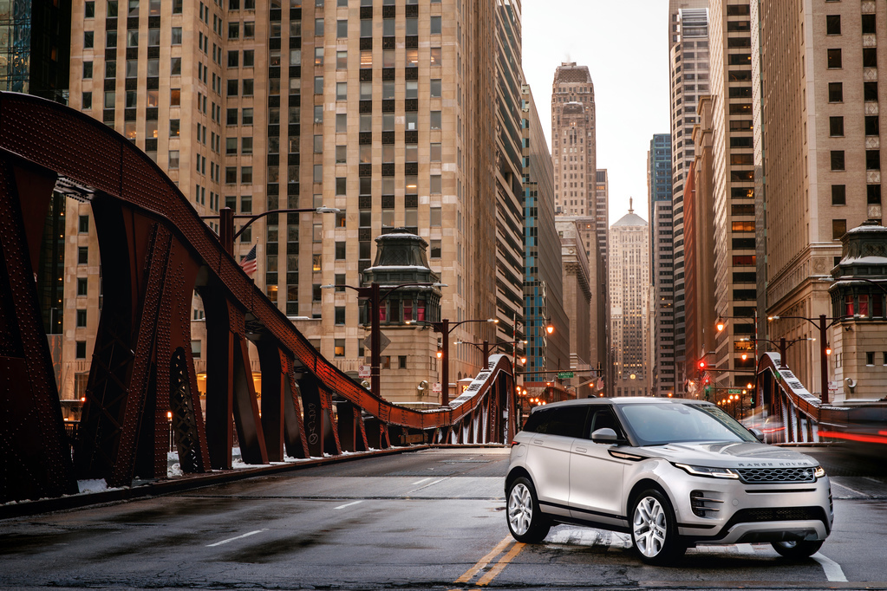
Blog post 3
Segmentation of the brand
Land Rover as a brand is now segmented based on customer niche and the different products that it has for the market. majorly, Land Rover has aligned its product model along with the geographic, demographic, and psychographic segments. The structure is developed to reflect the different dynamics and pillars among its consumers. There are target consumers for the firm from upper social class, executives, and professionals, in addition to the family level. Each group has its dynamics and the needs that it desires to be met from the product. Subsequently, the internal structure of the firm has also established its development and manufacturing regime to reflect the different segments and needs. currently, Land Rover cars are manufactured under the Jaguar Land Rover umbrella. Here, the firm has also established three strong pillars in its product segments which are; Defender, Discovery, and Range Rover (Banks, 2019, p.1). Defender retains the initial look and feel of the Land Rover heritage that its customers that focus on classic looks and the foundation of the brand are attracted to buy. The Discovery is a development on this product to reflect comfort and modern use. ultimately, the Range Rover is the epitome of luxury and class for the up-market segment. Each group also resonated to a specific demographic, its tastes, choices, and specific preferences as it associates with every single product in the brand. Similarly, the firm has extended its marketing and accrual physical reach to the global market. today, Land Rover is present across all major regions globally with hubs that touch even on the emerging markets. The orographically distribution model that the firm has assumed involves working with specific vendors that help to stock and distribute its products. Additionally, the vendors also take care of growth in these markets by working hand in hand with the appointed entities under the Land Rover brand across each of these locations.
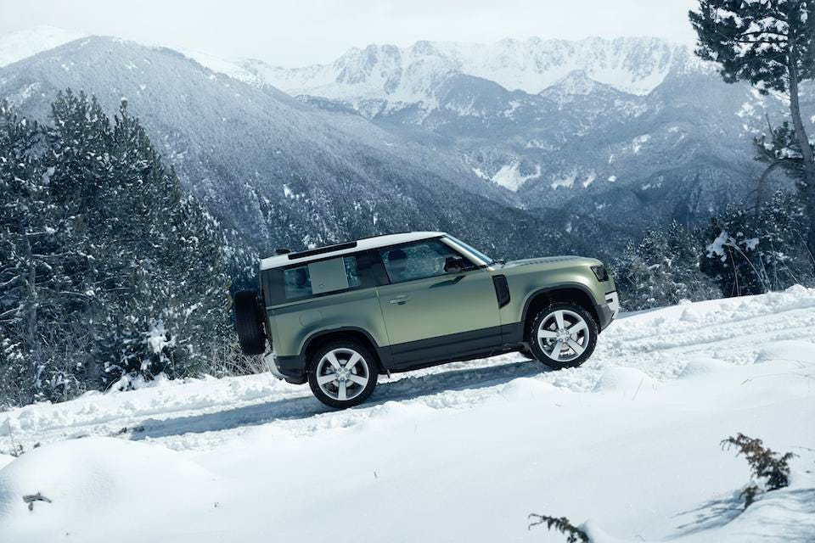
Blog post 4
Targeting of the brand
Land Rover works on targeting as a brand by emphasizing the focus of its products on the most appealing consumers that would elicit returns in the market. originally, the function-focused model of the firm created an equally utility-based vehicle. However, in the successive takeovers of the brand, this changed to reflect the new needs of the firm to generate value and create even more return from the process. In particular, the emphasis of the brand on structure and function was the initial motivation that especially attracted the ordinary male to its products. Today, Land Rover has the Defender series that retains the classic heritage, especially among the males of this age who are still keen on function and the physical association with performance in the car they buy. Still, the main target for land Rover remains the ale with high net worth within the ages of 34 to 54 years. The affluent demographic within this segment has driven growth and consumption for years before the firm opted to extend its marketing reach and diversify through its products. The development of the Freelander and discovery in addition to Range Rover all reflect the aspiration of the firm to extend its scope and achieve more growth in its said market. The Discovery is a development on the original Land Rover to the demographic needs of a current group of younger males that desire a touch of affluence, comfort, and class in the product. The Range Rover extended the target range for the firm even further and brought along and brought along an interest in the female demographic. The Evoque is specially designed with the female customers in mind and brings a touch of class and aesthetics that would appeal well to the same demographic group of women between 35 and 50 years (Koltun, 2019, p.3).
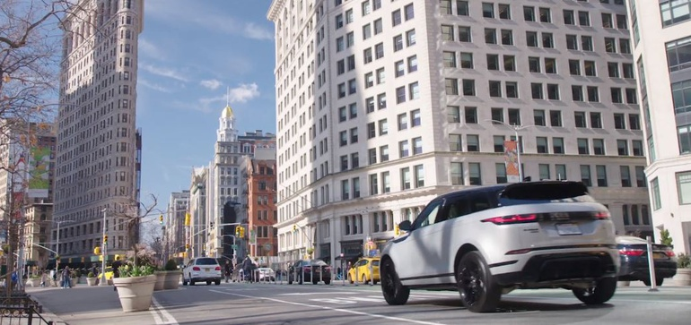

Blog post 5
Positioning of the brand
The brand positioning in Land Rover, right from its background has remained articulate and clear with a focus on design and capability. The initial Land Rover developed and became iconic in the market through the way that its product-focused on efficiency and use. Its cars were leaders in off-road experienced and four-wheel use, fit for all-weather and different conditions. When the firm changed hands through acquisition, especially to its current ownership under Jaguar Land Rover, the firm has honed on its customer-centric experience even further. Land Rover builds on innovation and emphasizes both technology and quality in the form of its current products. Subsequently, the firm has moved from an entity whose emphasis is solely on function and efficiency to a premium brand. Land Rover has done this without necessarily undercutting its initial emphasis on value and quality in its products. Its focus remains the same, with an extra reach that appeals to a modern and more affluent niche of consumers in the present. Additionally, the fluid positioning of the firm in the market has helped to extend its scope and deliver more value through its variety of products and sale processes. Today, Land Rover operates the Defender, Discovery, and Range Rover that all deliver different features and specifications, each with an orientation that helps to meet the needs of specific consumer groups. The firm has also managed to move across multiple markets globally by independently marketing the features in different products to the target consumer segments (Sundaram, 2021, p .2). Each group generates its organic return and growth that registers the overall position of the firm and trends of consumption within the market.
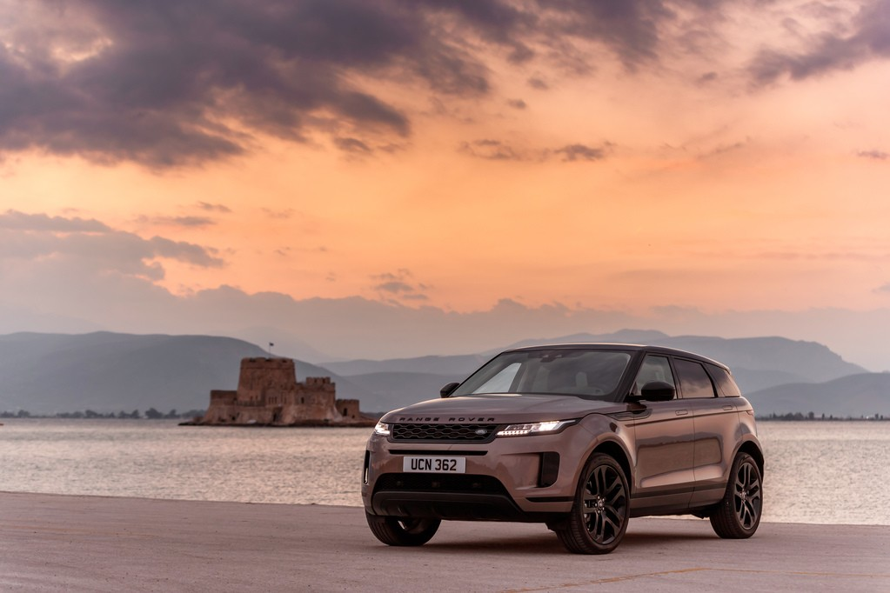
Blog Post 6
Marketing mix strategies of Land Rover (5 P's)
The products in Land Rover fall into the outlined segments that are Defender, Discovery, and Range Rover. Each also has individual segments and products that it produces and avails to consumers based on the preferences and needs across various locations in the global markets. The pricing of Land Rover products is mostly premium. The firm has established its modern niche in the market as an affluent product that focuses on similarly high-end consumers. The distinctive products and features provide not only an air of elegance but also an aura of exclusivity. Its place aspect is globally distributed to reflect the overall reach of the firm and its presence in the market. Land Rover is virtually present across all major locations, including others in the emerging markets. Its distribution network and work model where it develops affiliation with local vendors has allowed the firm to continue growing and achieve its current organic presence in the market. in promotion, Land Rover has worked out an elaborate media strategy that articulates the focus of the firm and its overall reach in the global market. The model allows users to experience the firm’s products first hand and have their selection based on features. It also updates them on the latest trends, especially on the coming products. Essentially, its strategy on promotion focuses on and emphasizes the product.
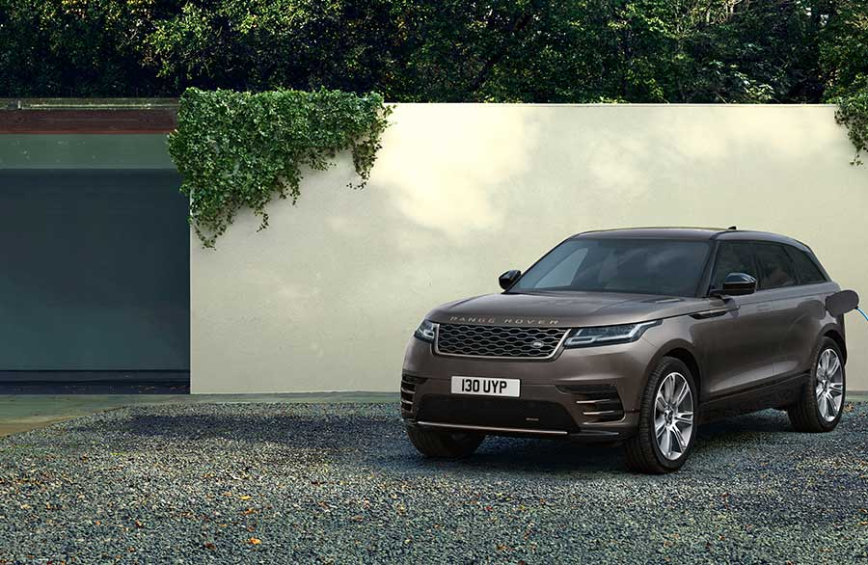

Reference list
Banks, N. (2019). Introducing The All-New Land Rover Defender, The Ultimate Adventure SUV. [online] Forbes. Available at: https://www.forbes.com/sites/nargessbanks/2019/09/10/all-new-land-rover-defender/?sh=5a50f5703ec6 [Accessed 9 Jan. 2022].
Car and Driver (2022). Land Rover SUVs: Reviews, Pricing, and Specs. [online] Car and Driver. Available at: https://www.caranddriver.com/land-rover [Accessed 9 Jan. 2022].
Koltun, N. (2019). Land Rover steers toward women with urban-focused campaign. [online] Marketing Dive. Available at: https://www.marketingdive.com/news/land-rover-steers-toward-women-with-urban-focused-campaign/552918/ [Accessed 9 Jan. 2022].
Land Rover (2022). Land Rover Launches Cutting Edge Marketing for 2020 Range Rover Evoque | Land Rover International Homepage. [online] media.landrover.com. Available at: https://media.landrover.com/node/21074.
Robson, G. (1981). The Rover story. Cambridge Cambridgeshire: Stephens.
Sundaram, G. (2021). How Jaguar Land Rover Can Build its Corporate Brand. [online] www.linkedin.com. Available at: https://www.linkedin.com/pulse/how-jaguar-land-rover-can-build-its-corporate-brand-geeta-sundaram [Accessed 9 Jan. 2022].

