Moodle: Professional Career Development BMSW4005 – Term 3 Assignment
Student name: Ioannis Nikiforos (1915954)
Lecturer’s name: Mr Afzal Munna

TABLE OF CONTENTS
- Introduction.
- Role play reflection.
- Personal career plans.
- Description and analysis of my skills and knowledge.
- SWOT Analysis.
- Personal Development Plan
- Kolb’s learning cycle
- Gibb’s reflective cycle
- Conclusion
- References
INTRODUCTION
In this academic report, I analyse my personal career development plans and goals. My personal reflection on the role play task was given as part of the assignment. The skills and knowledge I gathered through out studying that Moodle. All of that done, by using ‘’tools’’ or techniques I was taught during lessons. Such as, a ‘’SWOT Analysis’’ and my ‘’Personal Development Plan’’. Following that, I summarise the ‘’ Theory of Reflection’’, based on public literature and more specifically the 2 cycles we were taught in class, ‘’ Kolb’s Reflective Learning Cycle’’ and ‘’ Gibb’s Reflective Cycle’’. In the end of the report contain the ‘’SMART Objectives’’ and the ‘’Johari Window’’.

ROLE PLAY REFLECTION
I can admit the specific assignment task was my favourite, for different reasons. The task objectives were two, once interviewing a job candidate for a courier driver position and the second part was me to be interviewed, as a candidate for a barista position, in a coffee shop.
My partner on both occasions was my classmate Mr Gabriel Mititelu, I am very thankful because I believe we had a good co-operation.
Practically preparing for the assignment was personally a familiar process, as I have interviewed people in the past, in different occasions. Of course, doing an interview as a university assignment, feels different from real time. The main reason is that the interview would be marked by our lecturer and it was witnessed by all my classmates. Something that could certainly raise the stress level and make us more nervous. Despite the extra pressure, I feel we both kept our calm and professionalism on high standards.
As an interviewer, I prepared my questions based on the job’s criteria such as:
- Type of agreement. As a courier driver position, the candidate could choose if he wants to operate as an employee or as a self-employer. Gabriel chose to be interviewed as a self-employer.
- Time schedule. Regarding the flexibility of working hours and days.
- Salary. Regarding the financial part of the agreement.
- Van hiring services. It is common in that type of job, the companies to provide vans to their partners, in order to operate after holding a holding a commission.
- Position tasks. As an interviewer, I had to make clear the job tasks and goals that are set from the company in a daily basis.
- Skills and Education. Depending on the nature of each job, the interviewer must identify the needed skills or require proof certifications if needed. In the role play, necessary qualification was to hold a driving license for more than a year, in order to drive the vehicle. Some general knowledge about using google applications and GPS services, and be in good physical condition, in order to lift and hand heavy parcels.
For the second part of the role play, I had to prepare to be interviewed as a possible candidate for a barista position in a coffee shop in central London. The questions were made to me by my classmate, were related to the position:
- Working hours. The schedule would be Monday to Friday, with good salary and paid holidays.
- Job tasks. The job tasks for a barista position are quite the same everywhere. Such as, taking orders, preparing orders, taking stocktakes and keep the workplace clean and tidy.
- Position requirements. During the interview, my classmate made me some questions to find out my communication skills, which combines with my English language level, I also had to make sure as an employee that I have high sense of responsibility and I would provide excellent customer service to our customers.
As I previously mentioned, personally I had interviewed people in the past for real time jobs. It is a fact that some crucial parameters must be taught, in order to be understood. Of course, some elements like professionalism, are gained by experience and every day practise, but be able to direct and control an interview is a result of practising skills and gaining the necessary knowledge.

PERSONAL CAREER PLANS
Everyone in the market seeks for opportunities and try to visualise future according to the circumstances in everyday life. Personally, I have gained a lot of working experience, in different areas of the market, since have been working from a very young age. In my path I realised that working experience can bring expectations up to a limit. So, to me, studying how to operate a business or a department could be the key to a successful career. In my short-term plans, I would like to seal my knowledge with a strong and useful diploma. So, I would be able to transit in the market with confidence and certain steps. For the past three years I am lucky to be working in an exceptional law firm company based in Waterloo. The environment in the company is ideal for personal career growth and motivation is not difficult to be found. Been surrounded by experienced and successful colleagues can only get the best out of everyone. For me it would mean to become a good ‘’Account Manager’’, which is considered as a difficult and very responsible position, because as an account manager must keep transparency and continuation of services with customers.
On the other hand, as a long-term plan, I would like to get involved in the real estate market. An endless market with unlimited potential growth and probably one of the richest in the world. I feel it is almost everyone’s goal, in this city, to buy a property and turn it in profit.

DESCRIPTION AND ANALYSIS OF MY SKILLS AND KNOWLEDGE

During that course, we were taught, how to categorise and identify the variety of skills we meet in our routine and obviously in everyone’s workplace. I will start analysing my soft skills or otherwise my interpersonal skills and how or if I developed during that course.
- Time management. For many people has been proved the key to success. Speaking for myself, before starting my studies, I had a struggle to organise my time. But soon enough I realised that good planning and be responsible in deadlines are the elements to create momentum, again in professional and personal terms.
- Communication skills. Been able to communicate effectively is a crucial skill that, is needed in every kind of job. As a migrant, despite having certificated proof of English language knowledge, I found some difficulties to adopt, the variety of accents and even more the ‘’argo’’ people used around me. Therefore, I found my way through everyday communication and studying. In professional terms, my studies helped me to improve, on directing a conversation in my way, and become much more effective with my colleagues and customers.
- Teamwork. Be a good team player is required in almost all kind of jobs. A skill heavily linked to everyone’s communication skills. By improving communication skills, you become a better teammate, too. Personally, in my life I have been part of teams in many and different occasions. Speaking about our course, we were asked to form teams in order to do, different kind of assignments. Through teamwork, I improved my communication skills and I believe, I became a better listener, too.
- Leadership. Personally, I believe it is a skill that can be developed with a limit. Be a leader is element you are born with. Inspiring people to follow and trust you, is more of a talent than a skill. I am glad enough, that my classmates chose me on both occasions, throughout the course, to be their team leader. Something that certainly helped me to develop as a leader. The struggles were many, because in a team of five people there are always challenges, in order to synchronise everyone’s part and divide responsibilities equally. Thankfully in my teams I always found goodwill and appreciation, from at least most of my team members. I will always remember that experience, and be thankful I had the chance to lead, for academic purposes.
The second category of skills we were taught, throughout the course are the hard skills or otherwise teachable skills. These are abilities gained by studying and are easy to quantify.
- Language knowledge. Since I started the course, I believe my vocabulary range has significantly grew, and in general my use of the language has reached higher standards. Something that certainly reflects in my workplace, too.
- Typing or writing skills. Studying in English certainly helps becoming more typical and firmer, in writing communication. In personal terms, I do not feel very strong in that area. I prefer direct communication because I can express myself or ideas easier than in writing. During the course I refreshed in my mind the differences of writing types (essay, report, letter etc) and hopefully I have improved on it.
- IT skills. Starting studying gave me the opportunity to understand better the technological trends nowadays. The differences between the types of data, and the extend use of Microsoft programmes played a crucial role in improving all the IT skills I had until today. On top because of the global pandemic we witness, me and my classmates lived the unique experience of ‘’e-learning’’. As a fact it helps everyone understand virtual interaction in class and of class, too.

SWOT ANALYSIS
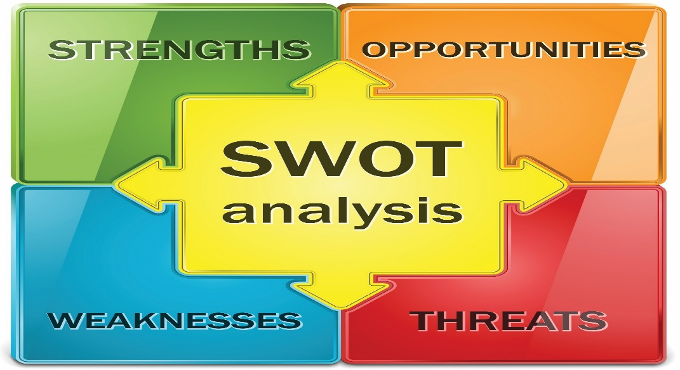
According to ‘’MindTools.com ’’ ‘’You can use SWOT analysis to make the most of what you’ve got, to your organisation’s best advantage. And you can reduce the chances of failure, by understanding what you are lacking, and eliminating hazards that would otherwise catch you unawares’’.

It is a fact that since I was taught that type of analysis, I have improved in finding errors in different types of occasions. Below I have broken down my personal SWOT Analysis.
- STRENGTHS:
- Hard working
- Creative
- Dedicate
- Integrate
- Flexible
- Communicative
- WEAKNESESS:
- Time management
- Stress
- Academic qualifications
- Collective
- OPPORTUNITIES:
- Networking
- Academic certification
- Career development
- Financial growth
- THREATS
- Economic environment
- Political environment
- Personal health
- Other graduates

PERSONAL DEVELOPMENT PLAN
DEVELOPMENT  AREA | STEPS TO TAKE | WHAT INDICATES SUCCESSFUL COMPLETION | START DATE | COMPLETION TARGET DATE | COMPLETED
Time management | Using time organising application, set timetable board. | Successfully reaching deadlines, attend meetings on time, be flexible with time. | 01/01/2021 | 07/01/2021 | YES
Stress | Ask for assistance or advise, change routine, find motivation. | Involve happily and drastically, enjoying more routine tasks. | 01/01/2021 | 01/02/2021
Academic qualifications | Start studying, follow seminars or webinars, claim online certificates. | Academic graduation, collection of certificates. | 13/02/2020 | 17/02/2021
Collective | Become a better listener, share responsibilities, trust more my colleagues | See colleagues around me happy and inspired to work with me. Read books about the subject | 01/01/2021 | 01/02/2021

KOLB’S LEARNING CYCLE
A very important part of our course is when we were taught the ‘’Kolb’s learning cycle’’. A theory that explains the learning process. As ‘’Mr Undrahbuyan Baasanjav’’ mentions on ‘’MERLOT journal’’. ‘’One of the most cited experientalists, David Kolb (1984) describes the experiential learning process as ‘a process whereby concepts are derived from and continually modified by experience’’. The Kolb’s learning cycle is following 4 steps.
- The concrete experience. A new experience or situation is encountered or a reinterpretation of existing experience.
- Reflective observation of the new experience. Of particular importance are any inconsistencies between experience and understanding.
- Abstract Conceptualisation. Reflection gives rise to a new idea, or a modification of an existing abstract concept (the person has learnt from their experience).
- Active experimentation. The learner applies their idea(s) to the world around them to see what happens.

GIBB’S REFLECTIVE CYCLE
According to the ‘’University of Edinburgh’’, ‘’Gibb’s reflective cycle was developed by Graham Gibbs in 1988 to give us structure to learning from experiences. It offers a framework for examining experiences, and given its cyclic nature lands itself particularly well to repeated experiences, allowing you to learn and plan from things that either went well or didn’t go well.’’ In order to follow the model correctly there are six stages someone needs to go through:
- Description of the experience.
- Feelings and thoughts about the experience.
- Evaluation of the experience, both good and bad.
- Analysis to make sense of the situation.
- Conclusion about what we learned and what you could have done differently.
- Action plan for what you would deal with similar situations in the future, or general changes you might find appropriate.

CONCLUSION
As a conclusion, I found the specific Moodle very helpful, in order to understand and adapt all the knowledge I have gained through out the course. Mainly Gibb’s reflective cycle, is what unlocked my mind, on asking myself the correct questions about the information I got in every lesson.

REFERENCES
- SWOT Analysis – MindTools.com,
https://www.mindtools.com/pages/article/newTMC_05.htm
- Kolb’s learning cycle – Undrahbuyan Baasanjav, MERLOT journal of Online learning and teaching, Vol 9, No4, December 2013 https://jolt.merlot.org/
- Gibb’s reflective cycle – University of Edinburgh, Gibb’s reflective cycle, https://www.ed.ac.uk/reflection/reflectors-toolkit/reflecting-on-experience/gibbs-reflective-cycle

