Assessment Form

Module: Preparing for Professional Policing
Student Name: Ellie Bowen
Module Tutor (s): Kelly Andrews
Question | 1  Situation | 2  Task | 3.  Action | 4.  Result |  | Total Mark
1 | 3/5 | 1/5 | 11/15 | 3/5 |  | 18/30
2 | 3/5 | 2/5 | 10/15 | 2/5 |  | 17/30
3 | 2/5 | 1/5 | 11/15 | 3/5 |  | 17/30
 |  |  |  |  |  | Total Mark 52 /90
Key
No Reference | Minimum | Satisfactory | Exceptional
0 | 0-4 | 5-10 | 11-15

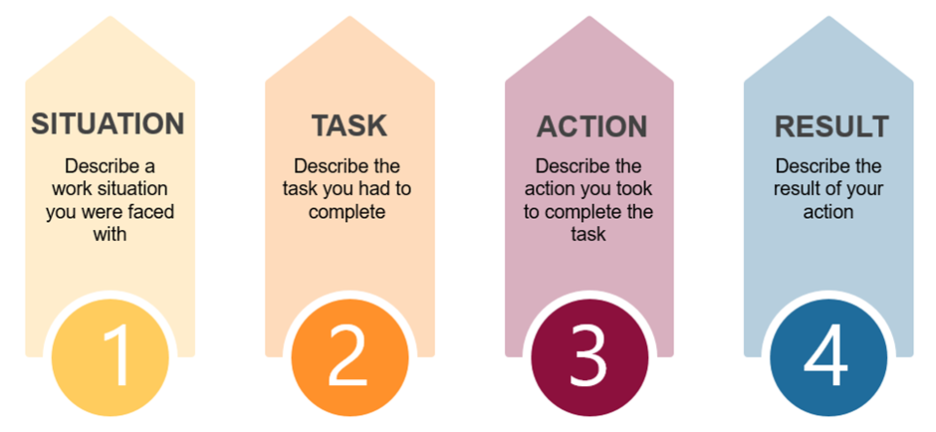

Question | Comments
1 | Q5  Work example : Casualty near us – needed more detail around this.  I was first aid trained- I closed shop to help to casualty, the woman had fallen and grazed her face.  It was me and two other supervisors there. Her children were present and panicking. I dealt with the children, got her up and cleaned her up, explained to them that it would be ok.  Be careful you don’t repeat yourself.  The fast responders came and dealt with the casualty.  Upon reflection we could have done other things such as moving people on from watching.  Needed to spend more time at the beginning outlining what had happened.  Needed to explain in more detail why you made certain decisions.  Use I not we when discussing what you did.
2 | Q8:  Work example – colleague who was involved in a domestic violence incident.  She was coming to work, and her boyfriend was following her.  She came in with her mother and she disclosed all the information to a group of us.  We needed to go into detail – offer her support – remember to focus on what you did not what everyone did you use we not I to answer.  She had injuries, she we allowed her to wear long sleeve tops.  Needed to highlight how active listening skills were used in more detail.  Showing her support – building that trust back up in the workplace, giving her breaks etc.  Communicating with her over the phone making sure she was ok, and safeguarding her.  Needed a prompt for result.
3 | Q4:  Family example:  Family member has terminal illness – mother is care giver, this is a very stressful situation,  Being aware of what I am saying around my mother and gran.  Situation is stressful for various reasons. It is affecting everyone emotionally.  Trying to not show that it is affecting us, so that it doesn’t impact mother.  Result – needed a prompt  Needed to use STAR in more detail. Needed to link back to the question answer could have been more specific and more detail discussed around the need to remain calm in this situation as this was only touched upon.  .

.

.

