UWTSD
Control System Design
Instrumentation & Control ACDA 5011
Jenny Mungham
7-20-2020

Contents
Figures 2
Tables 2
Equations 2
Abstract 3
Introduction 4
Equipment 7
Method 8
Task 1 8
Initial Set-Up 8
Tuning 13
Task 2 16
Results 19
Task 1 19
Task 2 21
Discussion 24
Conclusion 25
References 26

Figures
Figure 1 Block Diagram of an open loop system consisting of an input, a system and an output [2] 4
Figure 2 Example of a general single input single output closed loop control system [3] 4
Figure 3 Example of a system response curve [10] 5
Figure 4 MATLAB Command window showing how to start Simulink 8
Figure 5 Simulink Library showing the step function location 9
Figure 6 Block parameters of the Add function which contains the list of signs 9
Figure 7 Connection configuration of the step and add function blocks 10
Figure 8 Location of the Continuous PID Controller in the Simulink library 10
Figure 9 Parameter Menu for the Transfer Function 11
Figure 10 Wiring Plan for the system 11
Figure 11 Menu Location for the Scope Function 12
Figure 12 Finished wiring diagram for the system 12
Figure 13 Settings menu for altering the display of the output from the scope function 13
Figure 14 Scope Results output for initial set up of the system 13
Figure 15 Pop Up Parameters Menu for the PID Controller function 14
Figure 16 Initial output of the system before being manually tuned 15
Figure 17 Parameters from the initial output of the system before manually tuning 15
Figure 18 Results of tuning the system to meet the specifications 16
Figure 19 Optimal tuning settings of the PID system 19
Figure 20 Final Parameter values for the tuned PID control system 20
Figure 21 Final Scope outputs from the tuned PID Control System 20
Figure 22 Nyquist diagram for tuned system with unit circle 21
Figure 23 Results from scope output for the transfer function using single equation 21
Figure 24 Comparison of Transfer Function2(using single equation) and Transfer Function (using tuned system) 22
Figure 25 Nyquist Diagram for system using one equation 22
Figure 26 Nyquist diagram for system using one equation with unit circle 23
Figure 27 Comparison of the scope outputs for the PID system before and after tuning 24

Tables
Table 1 Results for the PID Function Parameters following Manual Tuning 17
Table 2 Comparison of the results from initial and manual tuning compared to requirements 19

Equations
Equation 1 General equation for transfer function G(s) for a closed loop system [8] 5
Equation 2 Equation for transfer function G(s) with assigned values substituted for a, b and c 16
Equation 3 General Compensator Equation for the PID controller function from Simulink 16
Equation 4 Specific Compensator Equation for the PID controller function from Simulink 17
Equation 5 Combination of the PID controller and transfer function equations 17
Equation 6 Simplified Equation for the combination of the PID control and transfer function equations 17
Equation 7 Final equation for the PID controller and Transfer Function 17
Equation 8 General Equation for the whole System 18
Equation 9 Specific Equation for the Transfer Function System as a whole 18
Equation 10 Final Solution for the entire system 18

Abstract
A Proportional-Integral-Derivative (PID) Control system, which is a system used to manage processes in industrial and commercial settings, was built in the modelling software Simulink in MATLAB. An over-shoot of less than 5% and a settling time of less than 2 seconds was required from the system which the initial set-up did not achieve. This system was then tuned to find the optimal proportional, integral and derivative values for the system response to meet the specifications.
It was hypothesised that the equations describing the PID controller could be combined with the transfer function of the plant system to create one equation describing the entire closed loop system. This equation was derived and then used to build and model a second system which was compared to the original system. Both systems showed similar response curves with the same over-shoot and settling time values. Initially the small differences were assumed to be from rounding errors, but further comparisons using Nyquist plots suggested that the differences were more substantial and possibly due to an error in the derivation of the equation.

Introduction
Many industrial and domestic processes are regulated by control systems; which are a type of system that manages other devices to achieve the desired result [1]. There are two main types of control systems; closed loop systems and open loop systems. Open loop systems are generally simpler, cheaper to install and cheaper to maintain, but can be unreliable or inaccurate [1].
Open loop systems, when simplified down consists of an input, a control process defined by a mathematical relationship, and an output [1] as displayed in Figure 1.
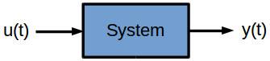
Figure 1 Block Diagram of an open loop system consisting of an input, a system and an output [2]
Figure 1 is an example of a single input single output open loop system, such as a volume control process. More complicated multi input multi output systems are also common but beyond the scope of this work.
Closed loop systems include a feedback or error loop from the output back to the input of the system via an error detector. The addition of the feedback loop, to create a closed loop system, improves the system’s accuracy, reduces the effects of noise and can make a system more stable [3] as the system can self-regulate itself to the input parameter. It compares the current status value (PV) to the desired set point value (SP) and applies the necessary measures to correct for any errors [4]. Such as a thermostat which receives a set temperature and then increases and decreases the heating power to meet that temperature based on current measurement readings.
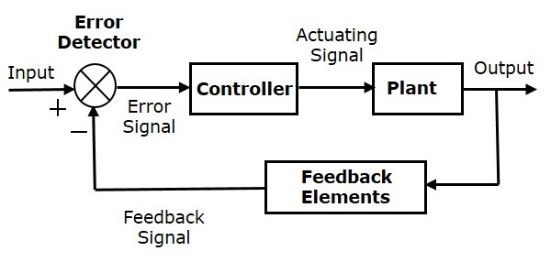
Figure 2 Example of a general single input single output closed loop control system [3]
One of the most common types of a closed loop system in the Proportional-Integral-Derivative (PID) system, which are robust and have a functional simplicity [5]. They consist of three different responses to generate a controlling action; the proportional, integral and derivative responses. The proportional response is governed by the proportional gain which when increased, increases the response speed of the system [6]. If it increased too far it can cause unstable oscillations in the system [6]. The integral response moves the system to having the correct set-point with an error of zero by summing the error over time until it reaches zero [6]. Lastly the derivative response, which is sensitive to noise, controls how the system reacts to the error to increase or decrease the response speed. To get the optimal values for the P, I and D responses the system needs to be tuned to find the optimal relationship between the values.
For both loop types, the relationship between a process’s input to its output is described by a transfer function, which is typically a non-linear expression denoted by G(s) [7]. A simple, general transfer function for a closed loop system can be seen in Equation 1.
Equation 1 General equation for transfer function G(s) for a closed loop system [8]
$$G\left(s\right)=\frac{1}{as^{2}+bs+c}$$
Some processes may consist of multiple systems each with their own transfer function, these can be simplified into a single block by finding the product of all of the different transfer functions for the different systems [9].
Knowing the transfer function of a control system means it can be modelled in simulation programs such as MATLAB and Simulink, and therefore tuned. Modelling allows the user to tune the system to determine the optimum settings and check for stability, rise time and overshoot. Where the overshoot is the amount that the system initially exceeds the set point usually due to the hysteresis in the larger system. For example, if setting a temperature, once the environment has reached the desired temperature and the control system stops heating the room, there will be a short period where the temperature continues to rise due to residual heat before it then begins to cool again towards the set point. Often a faster rise time leads to a larger over-shoot and so these considerations need to be modelled and then balanced to optimise the system to the users’ requirements.
When modelling the systems response curve is usually plotted to visualise the rise time, overshoot and settling time.
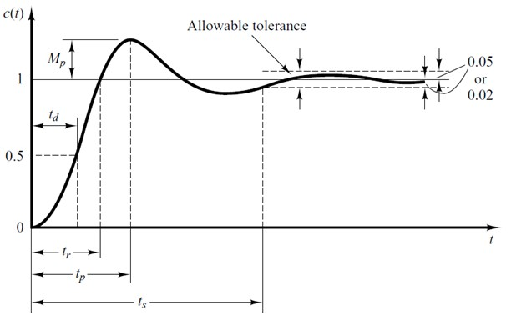
Figure 3 Example of a system response curve [10]
To measure the performance of a system a step function is applied as the set point and the responses of the system are measured. The rise time is the time taken for the curve to reach 90% of its steady state value from 10%. [6] The over shoot is denoted in Figure 3 as Mp where the set point is at 1, and the settling time, the time for the system to maintain a value around the setpoint withing the allowed tolerances, is denoted by t_{s}.

Equipment
- ACDA 5011 Assignment Brief
- HP Laptop
  - 7th Gen Core i3 Processor
- MATLAB r2019a update 8
- Simulink
  - Blocks:
    - Step
    - Add
    - Continuous PID Controller
    - Transfer Function
    - Scope

Method

Task 1

Initial Set-Up
Task 1 was undertaken following the method outlined in the provided Panopto video [11] and using the values given for the transfer function in the assignment brief [8] (2, 4, 4).
MATLAB and Simulink were used to model the transfer function and tune the system. Once MATLAB was opened, Simulink could be run by entering the word “simulink” in the command window or by using the Simulink button in the top menu ribbon.
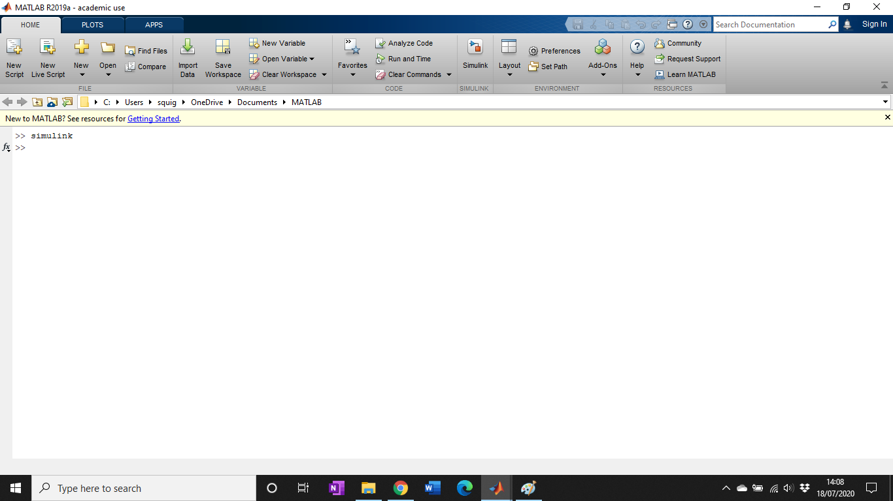
Figure 4 MATLAB Command window showing how to start Simulink
Once Simulink was running a blank model was chosen to begin and the control system built. The first step was selecting the step function from the library and opening the sources section. The function was then dragged into the blank workspace.
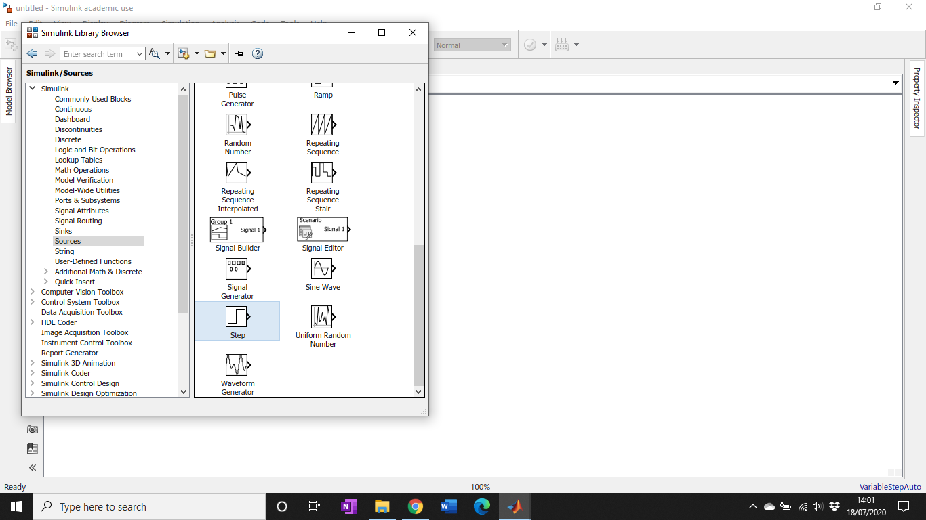
Figure 5 Simulink Library showing the step function location
Using the library function again but within the maths section the add function was chosen to act as the error feedback for the system. The standard configuration for the signs of the add function is ++ so this was changed within the block parameters to +-.
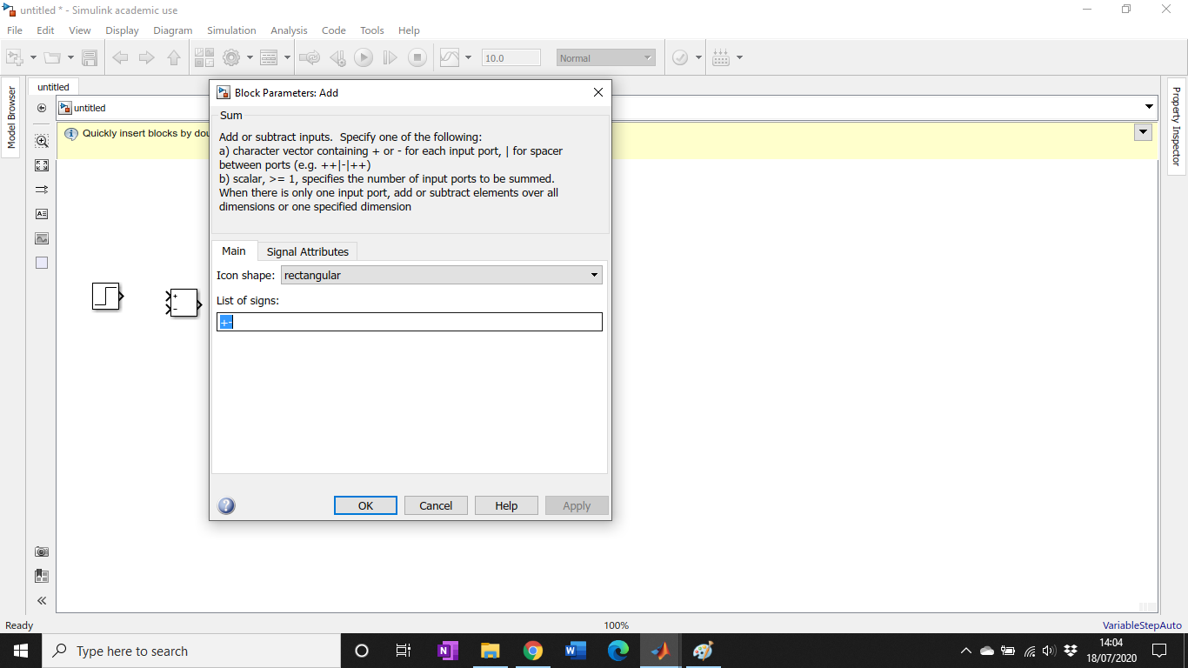
Figure 6 Block parameters of the Add function which contains the list of signs
With the first two blocks in the workspace, they could be joined by connecting the output of the step to the + input of the addition function, as in Figure 7.
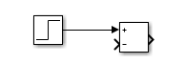
Figure 7 Connection configuration of the step and add function blocks
From the continuous menu in the library the PID controller and transfer functions were selected and placed in the workspace.
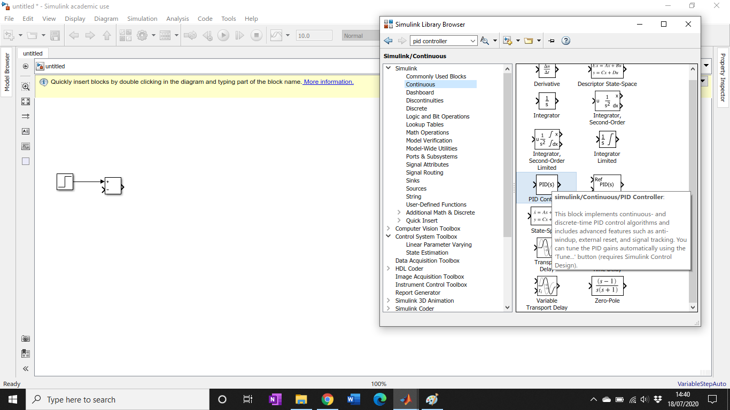
Figure 8 Location of the Continuous PID Controller in the Simulink library
The transfer function had some parameters that needed altering; the denominator coefficients were changed to those stated in the assignment brief, [2, 4, 4] and the numerator coefficient left at 1.
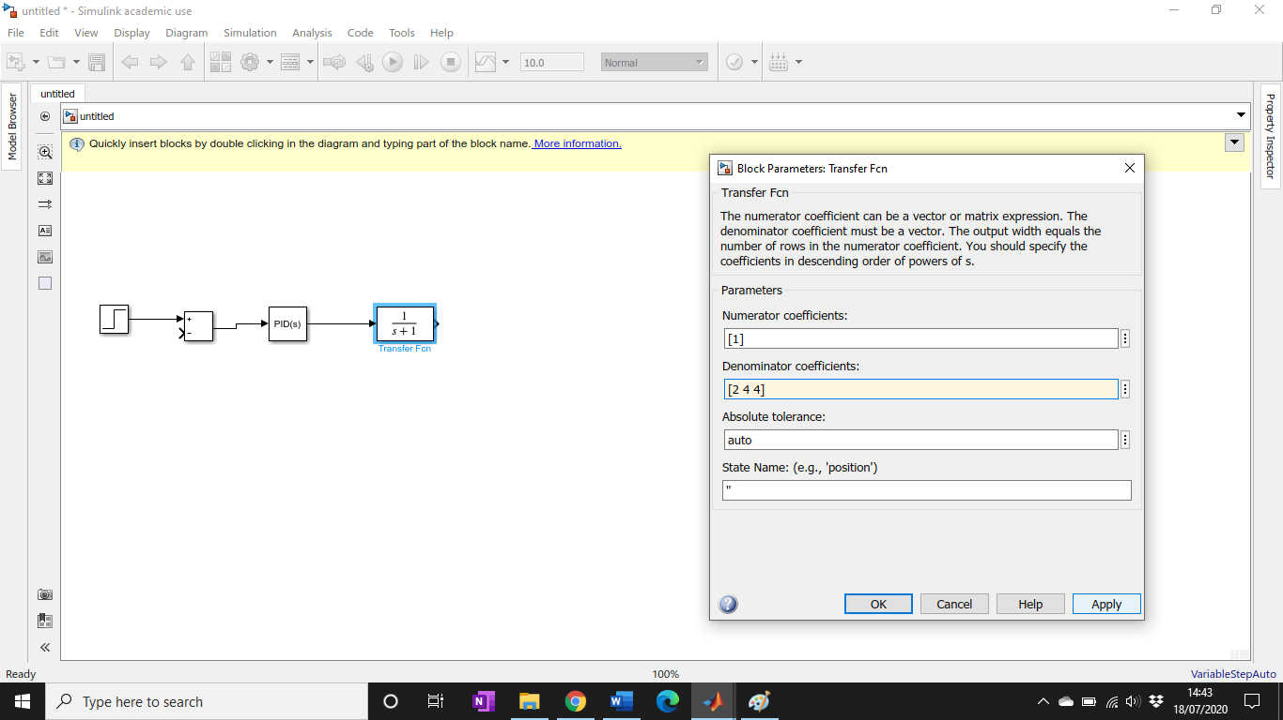
Figure 9 Parameter Menu for the Transfer Function
With all the blocks in place they were wired together as shown in Figure 10 below.
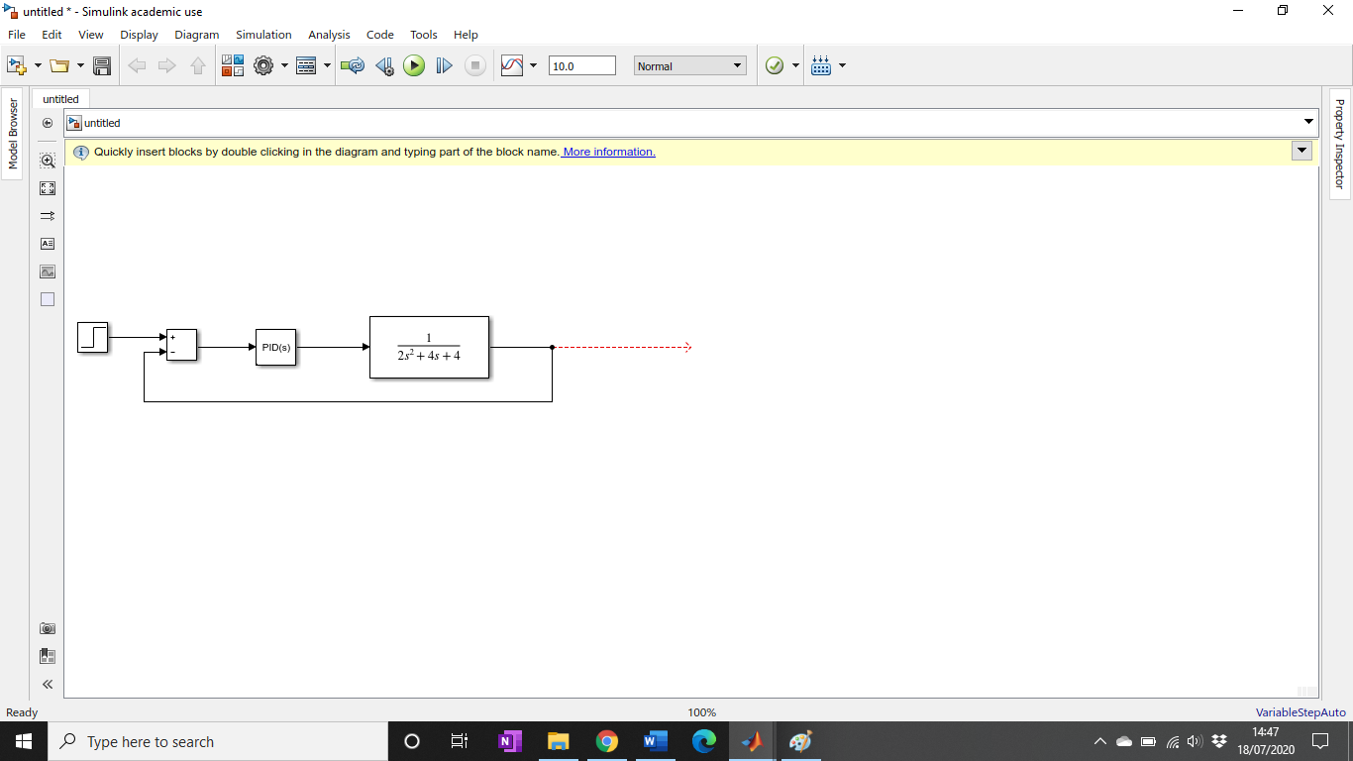
Figure 10 Wiring Plan for the system
To visualise and record the results, a scope function was selected from the sinks menu in the Simulink library, see Figure 11 below and wired into the system.
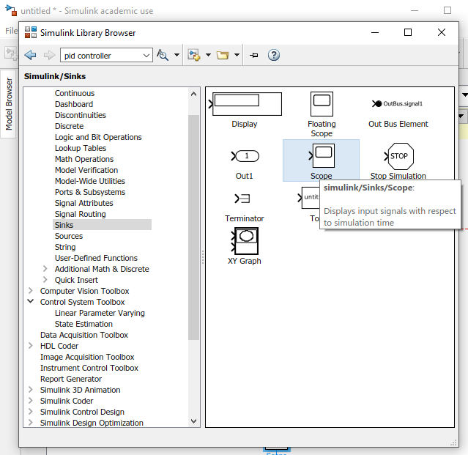
Figure 11 Menu Location for the Scope Function
The scope function was wired up as can be seen in Figure 12; with the input leading to channel 1, the error signal to channel 2, the controller output to channel 3 and the plant output to channel 4.
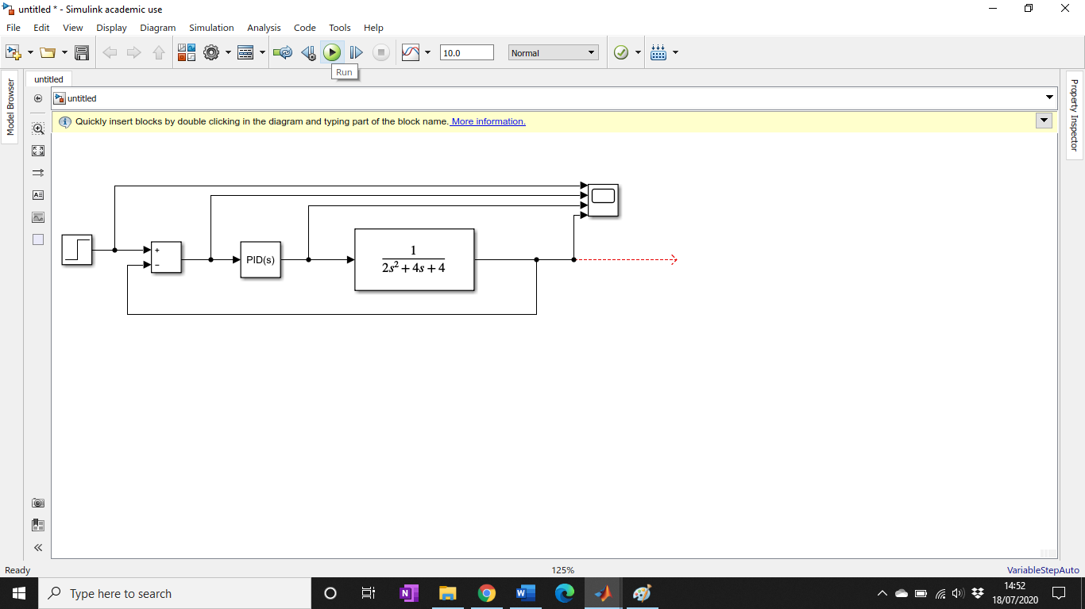
Figure 12 Finished wiring diagram for the system
With all the function wired in and the correct parameters inputted, the program was run. The results were displayed by double clicking on the scope function icon. They were initially displayed on one graph but the display was changed using the settings in the pop-up as in Figure 13.
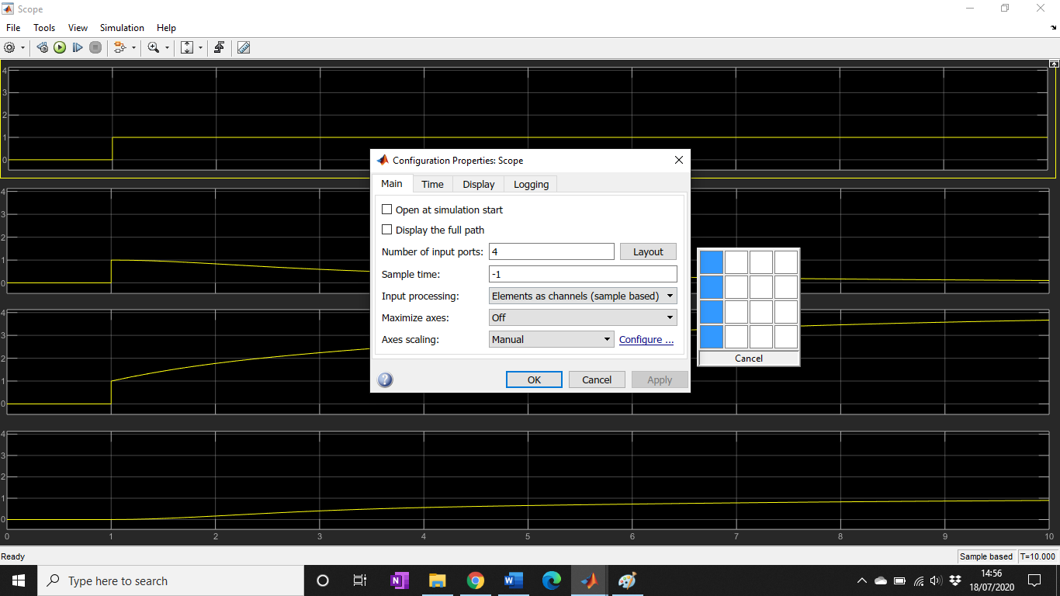
Figure 13 Settings menu for altering the display of the output from the scope function
Lastly, the results were auto-scaled to improve their legibility and the final output results on this initial set up can be seen in Figure 14.
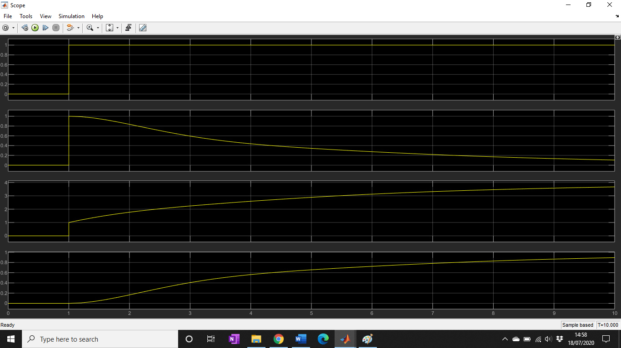
Figure 14 Scope Results output for initial set up of the system

Tuning
Once the system had been built, it needed to be tuned for the best possible results and to meet the required specifications; to have an overshoot of less than 5% and to be settled within 2 seconds.
Double clicking on the PID controller open up the parameters menu for that function; the filter was changed to 1. In this menu is the option to Tune which opens a graph showing the block output and the tuned output. This tuned output can then be altered manually to improve the tuning.
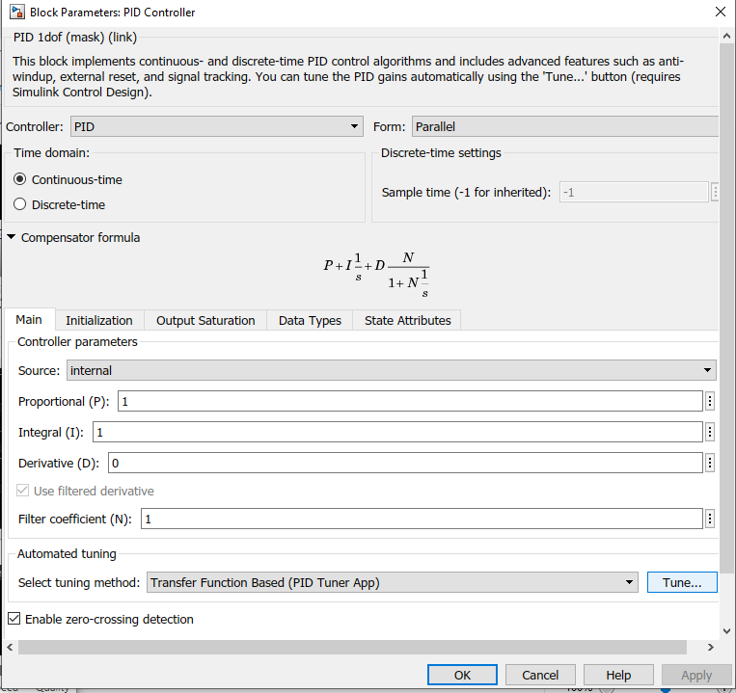
Figure 15 Pop Up Parameters Menu for the PID Controller function

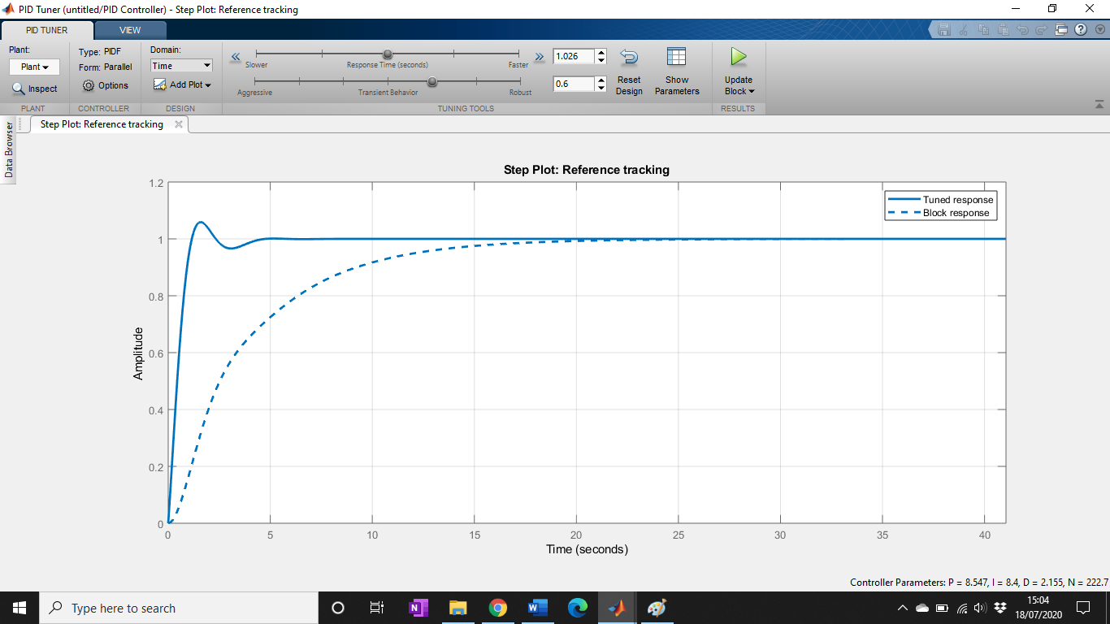
Figure 16 Initial output of the system before being manually tuned
To confirm that the specifications were being met, the parameters window was opened which states the current setting time and overshoot of the system. As can be seen in Figure 17, the initial tuning was not within the specifications given in the assignment brief.
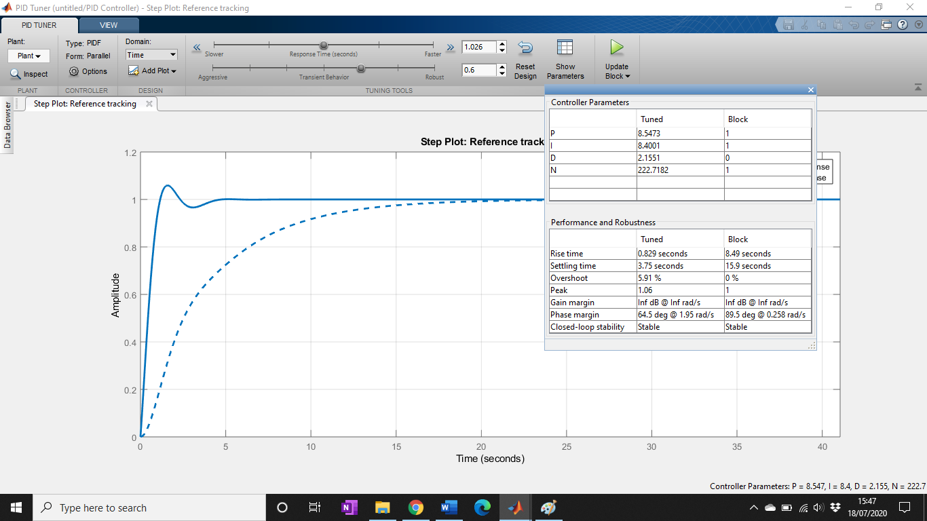
Figure 17 Parameters from the initial output of the system before manually tuning

The two slider functions in the top menu; response time and transient behaviour were incrementally changed until the required specifications were met as can be seen in Figure 18.

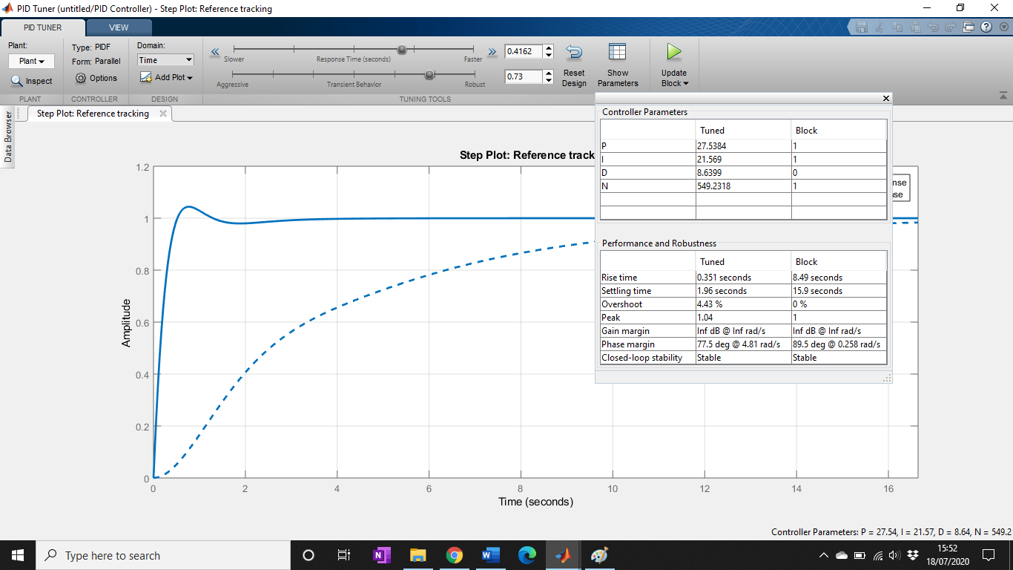
Figure 18 Results of tuning the system to meet the specifications
With the new parameters decided upon, the block was updated using the update block icon. This transferred the new values back into the bloc diagram system so when the scope function was re-run it used the new values and showed the results of the tuned system (Figure 21).

Task 2
Using the given parameters from the assignment brief we can substitute them into the general equation for a transfer function (Equation 1) to obtain Equation 2.
Equation 2 Equation for transfer function G(s) with assigned values substituted for a, b and c
$$G\left(s\right)=\frac{1}{2s^{2}+4s+4}$$
For the closed loop transfer function of the whole system, the equation describing the PID controller is also required. From the parameters pop up for the PID function (Figure 20) we can find the general equation and the values calculated following the tuning of the system.
Equation 3 General Compensator Equation for the PID controller function from Simulink
$$P+I\frac{1}{s}+D\frac{N}{1+N\frac{1}{s}}$$

Parameter | Tuned Value
P | 34.1828632033763
I | 23.3400143420945
D | 12.1561662538248
N | 730.727913409661
Table 1 Results for the PID Function Parameters following Manual Tuning
These results were put into the general compensator formula to create the formula specific to the tuned system:
Equation 4 Specific Compensator Equation for the PID controller function from Simulink
$$34.1828632033763+23.3400143420945\frac{1}{s}+12.1561662538248\frac{730.727913409661}{1+730.727913409661\frac{1}{s}}$$
The compensator equation for the PID controller is multiplied by the equation for the transfer function to account for the combining of the two processes.
Equation 5 Combination of the PID controller and transfer function equations
$$34.1828632033763+23.3400143420945\frac{1}{s}+12.1561662538248\frac{730.727913409661}{1+730.727913409661\frac{1}{s}} x \frac{1}{2s^{2}+4s+4}$$
This can be simplified to:
Equation 6 Simplified Equation for the combination of the PID control and transfer function equations
$$\left(\frac{12.1396s^{2}+34.183s+23.340}{s}\right) \left(\frac{1}{2s^{2}+4s+4}\right)$$

Equation 7 Final equation for the PID controller and Transfer Function
$$\left(\frac{12.1396s^{2}+34.183s+23.340}{\left(2s^{3}+4s^{2}+4s\right)}\right)$$

The feedback loop also needs to be incorporated and so the following equation is used (Equation 8) where TF is the transfer function of the whole system and H =1.
Equation 8 General Equation for the whole System
$$TF=\frac{G}{1+GH}$$

Equation 9 Specific Equation for the Transfer Function System as a whole
$$TF=\frac{\left(\frac{12.1396s^{2}+34.183s+23.340}{\left(2s^{3}+4s^{2}+4s\right)}\right)}{1+\left(\frac{12.1396s^{2}+34.183s+23.340}{\left(2s^{3}+4s^{2}+4s\right)}\right)}$$

$$TF=\frac{\left(\frac{12.1396s^{2}+34.183s+23.340}{\left(2s^{3}+4s^{2}+4s\right)}\right)}{\left(\frac{2s^{3}+4s^{2}+4s}{\left(2s^{3}+4s^{2}+4s\right)}\right)+\left(\frac{12.1396s^{2}+34.183s+23.340}{\left(2s^{3}+4s^{2}+4s\right)}\right)}$$

$$TF=\frac{\left(\frac{12.1396s^{2}+34.183s+23.340}{\left(2s^{3}+4s^{2}+4s\right)}\right)}{\left(\frac{2s^{3}+16.1396s^{2}+38.183s+23.340}{\left(2s^{3}+4s^{2}+4s\right)}\right)}$$

$$TF=\left(\frac{12.1396s^{2}+34.183s+23.340}{\left(2s^{3}+4s^{2}+4s\right)}\right)*\left(\frac{2s^{3}+4s^{2}+4s}{2s^{3}+16.1396s^{2}+38.183s+23.340}\right)$$

$$TF=\left(\frac{12.1396s^{2}(2s^{3}+4s^{2}+4s)+34.183s(2s^{3}+4s^{2}+4s)+23.340(2s^{3}+4s^{2}+4s)}{2s^{3}(2s^{3}+4s^{2}+4s)+16.1396s^{2}(2s^{3}+4s^{2}+4s)+38.183s(2s^{3}+4s^{2}+4s)+23.340(2s^{3}+4s^{2}+4s)}\right)$$

$$TF=\left(\frac{24.2792s^{5}+48.5584s^{4}+48.5584s^{3}+68.366s^{4}+136.732s^{3}+136.732s^{2}+46.68s^{3}+93.36s^{2}+93.36s)}{4s^{6}+8s^{5}+8s^{4}+16.1396s^{2}+32.2792s^{5}+64.5584s^{4}+64.5584s^{3}+76.3662s^{4}+152.732s^{3}+152.732s^{2}+46.68s^{3}+93.36s^{2}+93.36s}\right)$$

$$TF=\left(\frac{24.2792s^{5}+48.5584s^{4}+68.366s^{4}+48.5584s^{3}+136.732s^{3}+46.68s^{3}+136.732s^{2}+93.36s^{2}+93.36s)}{4s^{6}+8s^{5}+32.2792s^{5}+8s^{4}+64.5584s^{4}+76.3662s^{4}+64.5584s^{3}+152.732s^{3}+46.68s^{3}+152.732s^{2}+16.1396s^{2}+93.36s^{2}+93.36s}\right)$$

Equation 10 Final Solution for the entire system
$$TF=\left(\frac{24.2792s^{5}+116.92446s^{4}+231.9704s^{3}+230.092s^{2}+93.36s)}{4s^{6}+40.2792s^{5}+148.9264s^{4}+263.9701s^{3}+262.2316s^{2}+93.36s}\right)$$
This equation was used in place of the given equation for the Transfer Equation in Simulink and the PID controller and feed back loop were removed. The simulation was then re-run with the new inputs.

Results

Task 1
From task 1 the system was tuned further, after the specifications had already been met to further improve the results. A settling time of 1.82 seconds and an overshoot on 1.82% was obtained as displayed in.
Specification | Initial | Final | Required
Overshoot | 5.91% | 1.82% | <5%
Settle Time | 3.75s | 1.82s | <2s
Table 2 Comparison of the results from initial and manual tuning compared to requirements

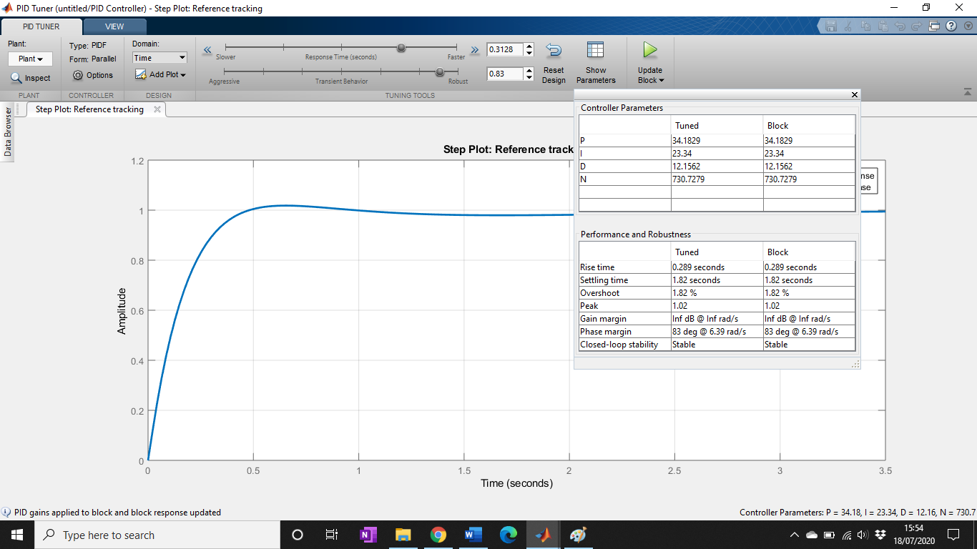
Figure 19 Optimal tuning settings of the PID system

The P, I and D values were transferred back into the PID controller parameter menu by Simulink.
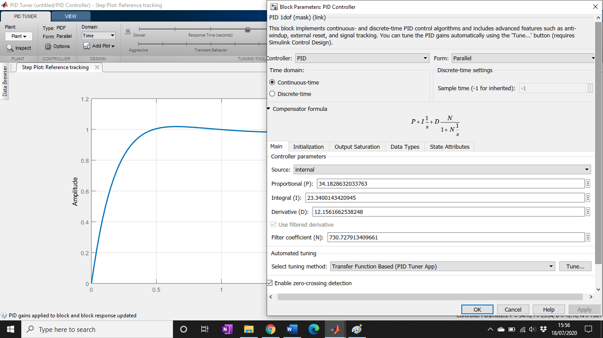
Figure 20 Final Parameter values for the tuned PID control system
The scope function was run with the new values showing a quicker rise time for the whole system output that was within the required specifications.
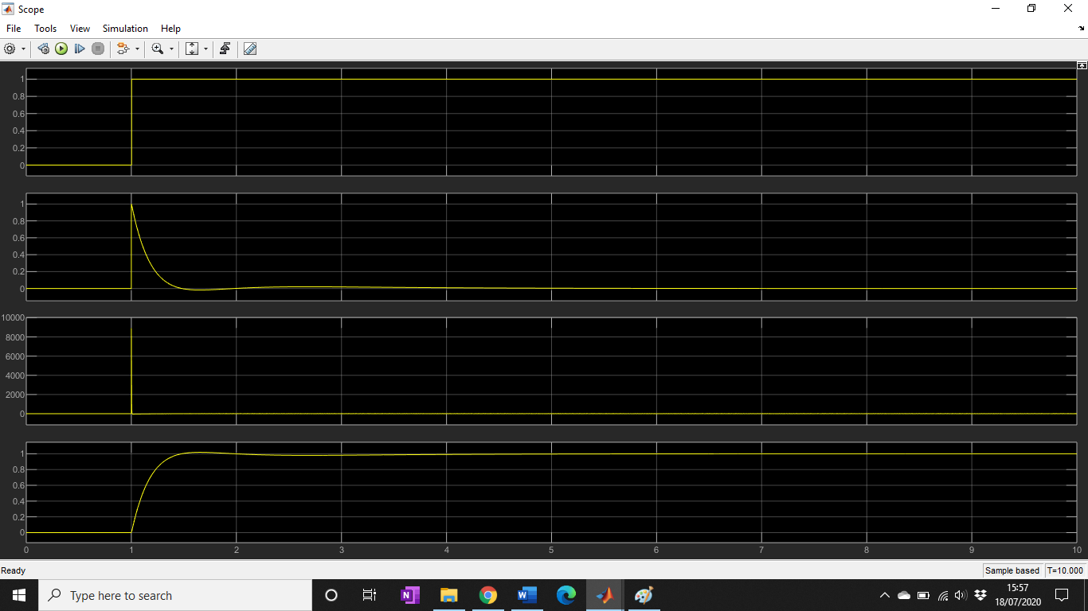
Figure 21 Final Scope outputs from the tuned PID Control System

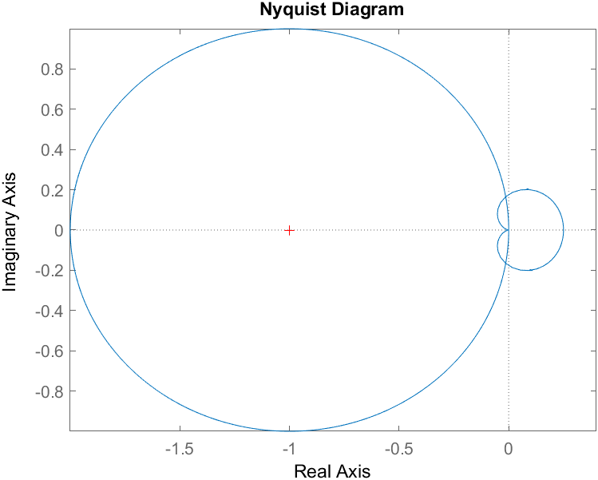
Figure 22 Nyquist diagram for tuned system with unit circle

Task 2
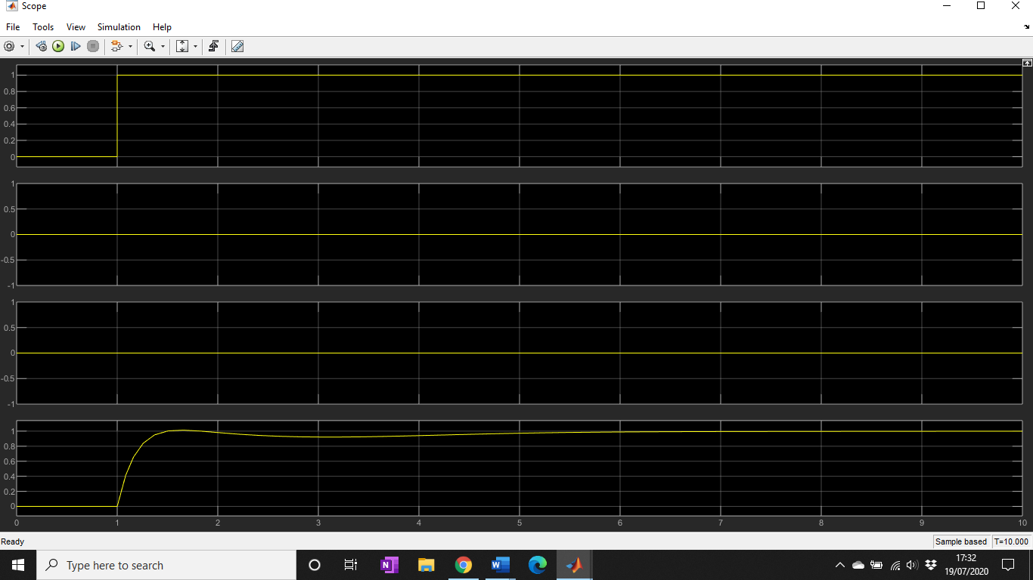
Figure 23 Results from scope output for the transfer function using single equation

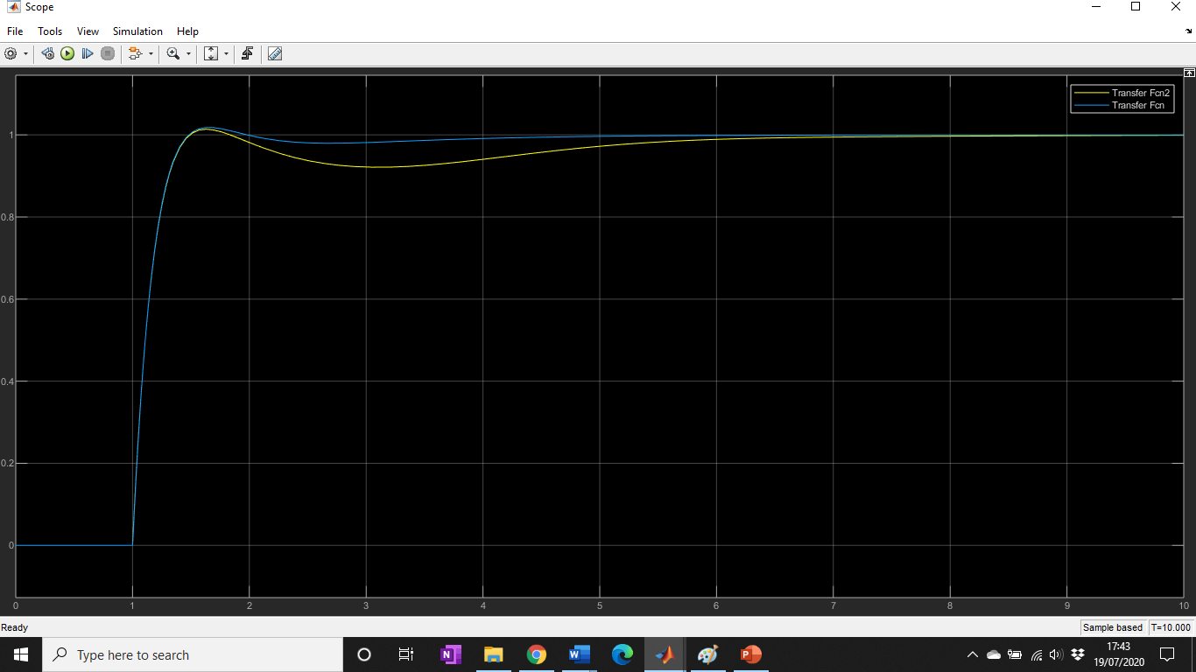
Figure 24 Comparison of Transfer Function2(using single equation) and Transfer Function (using tuned system)

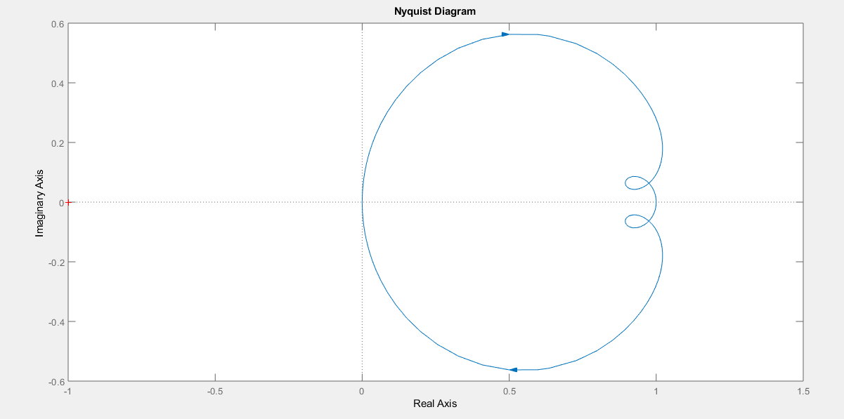
Figure 25 Nyquist Diagram for system using one equation

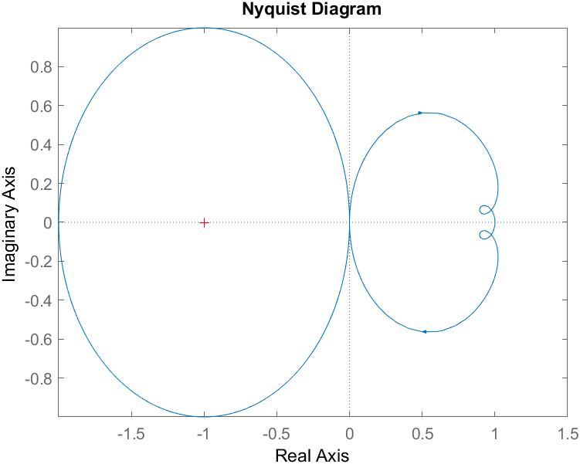
Figure 26 Nyquist diagram for system using one equation with unit circle

Discussion
In task one a PID controller system was built and then tuned, the output of the system before and after tuning can be seen next to each other below in Figure 27 for a 10 second run time.
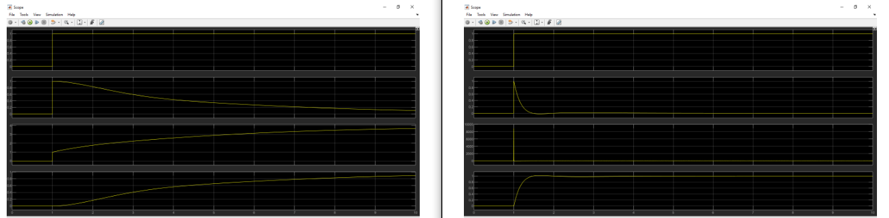
Figure 27 Comparison of the scope outputs for the PID system before and after tuning
The rise time of the system has been reduced, making a sharper initial curve, a small over-shoot is now visible, which wasn’t in the original, but it is withing the specifications for <5%. Through tuning it was possible to increase the response time of the plant output (bottom graphs) and keep within the given specifications of less than 5% overshoot and a less than 2 second response time. This was done by manually adjusting the response time and transient behaviour sliders to reduce both as much as possible. Adjusting the response time would have a large effect on the rise time but would also lead to a larger over-shoot and longer lasting transient behaviour. Likewise reducing the transient behaviour would reduce the over-shoot but also have an effect on the rise time. A balance needed to be found between the two controls to meet both specifications.
Whilst using the sliders was an inefficient method of tuning, relying on human input, results better than the specifications could be achieved within a few minutes. Without more information about the specifications it wasn’t possible to optimally tune the system as there wasn’t any information relating to the relative importance of response time and overshoot. For example, would further improvements in the overshoot be of better benefit or improvements in the response time or was it best to keep them both similarly below the specifications. With relative importance information it would be possible to programmatically find the optimal tuning settings.
In task 2, a single equation (Equation 10) was developed for the transfer function, using the values from the tuned PID controller, to replace the PID controller and error loop in the simulation. In theory, both systems should behave identically. Figure 24 shows the results of Task 1 and Task 2 for comparison. The traces showed some similarities; with the same overshoot and final stability times. The second transfer function, which represented the task 2 system, deviated from the task 1 model after the initial over-shoot, which was possibly due to rounding errors in the maths undertaken to create the single equation.
The Nyquist plot for the task 1 tuned system shows that the system is stable, the Nyquist plot for the system designed using the single equation flows in the same directions but has a different shape and position on the axis suggesting differences between the two systems that aren’t just from rounding errors. This is most likely due to an error in the determination of the single equation that the author was unable to spot.

Conclusion
A closed loop system was simulated in Simulink and then tuned to meet defined specifications. This was achieved through the manual manipulation of sliders controlling the rise time and transient behaviour.
The specifications were met and improved upon but without more information about which of the specifications was of more value to the demander it wasn’t possible to fully optimise the system.
Using the transfer function equation and PID equation a single equation representing the feedback loop, PID controller and transfer function was created. The outputs of the two systems were then compared to confirm that the equations were correct. There was some difference in the response after the over-shoot but both graphs had the same over-shoots and similar times for their transient behaviour. The differences could be due to rounding or mathematical errors.
Nyquist plots of both systems were created and mapped over the unit circle, this showed differences between the two systems more clearly.

References

[1] | Electrical4U, “Control System: Closed Loop Open Loop Control System,” Electrical4U, 16 June 2019. [Online]. Available: https://www.electrical4u.com/control-system-closed-loop-open-loop-control-system/. [Accessed 20 June 2020].
[2] | x-engineer, “How to find the transfer function of a system,” x-engineer.org, 2020. [Online]. Available: https://x-engineer.org/graduate-engineering/signals-systems/control-systems/find-transfer-function-system/. [Accessed 20 June 2020].
[3] | TutorialsPoint, “Control Systems - Introduction,” TutorialsPoint, 2020. [Online]. Available: https://www.tutorialspoint.com/control_systems/control_systems_introduction.htm. [Accessed 20 June 2020].
[4] | Wikipedia, “Control System,” Wikipedia, 21 May 2020. [Online]. Available: https://en.wikipedia.org/wiki/Control_system. [Accessed 20 June 2020].
[5] | Control Systems Minnesota, “PID for Dummies,” Control Systems Minnesota, 2019. [Online]. Available: https://www.csimn.com/CSI_pages/PIDforDummies.html. [Accessed 20 June 2020].
[6] | NI, “PID Theory Explained,” NI, 17 March 2020. [Online]. Available: https://www.ni.com/en-gb/innovations/white-papers/06/pid-theory-explained.html. [Accessed 20 June 2020].
[7] | A. Whitworth, “The Wikibook of Control Systems and Control Engineering,” Wikimedia, 31 May 2020. [Online]. Available: https://en.wikibooks.org/wiki/Control_Systems. [Accessed 20 June 2020].
[8] | S. Mosey, “Instrumentation and Control,” 19 March 2020. [Online]. Available: https://moodle.uwtsd.ac.uk/course/view.php?id=2258. [Accessed 26 March 2020].
[9] | W. Bolton, Transfer Function, Oxford: Elsevier Ltd, 2004.
[10] | I. Hussain, “Feedback Control Systems,” MUET, 2016. [Online]. Available: https://slideplayer.com/slide/6029365/. [Accessed 20 June 2020].
[11] | S. Mosey, UWTSD, 19 March 2020. [Online]. Available: https://uwtsd.hosted.panopto.com/Panopto/Pages/Viewer.aspx?id=13dcd9ea-9500-4f25-8afd-ab8300e7336d. [Accessed 18 June 2020].

