University of Wales Trinity Saint David
School of Engineering

Six Sigma Principles for Process Improvement
Quality & Business Improvement – ACMA4004

Samuel Barry
2312272
20/05/2024

Table of Contents
1 Introduction 1
1.1 Aims 1
1.2 Objectives 1
2 Main Body 2
3 Conclusions 9
4 References 10

Figure 1 - Fishbone Diagram Example 4
Figure 2 - Pareto Chart Example 5
Figure 3 - SPC chart example 7

Introduction
Life within manufacturing can be incredibly difficult to navigate without the proper processes in place to guide an organisation to success. There is a plethora of ways companies can implement processes and methodologies to their manufacturing to which it will better their efficiency, improve their quality output but also provide a path for sustainable growth. PESC is a company that falls into this category where they are experiencing difficulties in efficiency and quality levels. The DMAIC framework is a well established and structured process improvement tool, where it can enhance processes already in place, it provides methods of intervention as well as ways to monitor the ongoing progress.

In this paper, the DMAIC framework will be explored and provided to show methods and process that can be implemented to PESC to help improve their current situation as a manufacturing company. Showing which performance metrics need analysing, tools to identify causes of problems and ways to prevent or control these issues going forward.

Aims
- To provide an overview of the DMAIC framework to show process improvement
- To show ways of implementing DMAIC to analyse underlying problems
- To provide methods of sustaining quality with control measures

Objectives
- To examine each phase of the DMAIC process, showing its methodologies
- To show ways of identifying root causes
- To show potential improvement strategies and how to measure the success in the process performance

Main Body
The DMAIC framework is an abbreviation which imbodies a method of tackling processes, to get the best out of them whilst going that step further and looking to improve them. DMAIC stands for Define, Measure, Analyse, Improve and Control. Each phase is as important to the framework as the next. The define phase or the problem statement phase can be neglected however, it is imperative to the success of a DMAIC project (N & S, 14). The problem statement is key to showing everyone involved in the process the problem at hand, it aligns everyone’s thinking to ways of improving the issues whilst focusing all resources on the most pressing problem. A clear problem statement provides a way of showing the impact on the business that the problems are having, by quantifying the degree of the problem and analysing the implications to help guide decision making on the project.
To formulate a clear and precise problem statement requires clarity and relevance. Firstly, the issues at hand must be addressed but to focus only on the key issues is hard, try to not get distracted by side issues. Once the key issues have been identified, a precise location of the where the problems lay along with the processes involved gives a direction and boundaries to the investigation. Quantifying any data will help illustrate the impact of the problems on key performance metrics, such as costs, quality of product, and customer satisfaction. Highlighting these areas within the problem statement allows the investigation to have a sole purpose however, no suggestions of blame should be made at this point. An open mind must be kept as further information could be unveiled during the investigation which points the blame elsewhere ( Institute, 2024).

When it comes to the measurement phase of the framework, it is essential that the performance metrics that have been chosen can be quantifiable. It helps to understand the issue at hand as it is supported with data. If the performance metric cannot be quantified then collecting data, analysing, and coming up with solutions can become incredibly tricky to do. There are many performance metrics that can be identified to measure the current state of the manufacturing process for PESC. Some of the performance metrics that could be investigated for improvement could be measuring the on-time delivery of components to customers, total cycle time of components, number of scrapped components, and change over time. These are just a selection of metrics that could be used to investigate, as these are areas that seem to be lacking or needing updating. The collection of data is crucial to understanding the process issues, as it provides a baseline of data. There are many tools that can help quantify the data, whilst providing visuals to view the findings. One tool that can be used is a process map. A process map is essentially a visual aid to show relationships between an input and output of a process. A process map should be created with all the activities that go into the process from raw material until end component, whilst identifying the critical to quality factors (CTQ). A process map will identify inefficiencies or waste in the process, which in turn can provide an insight on what to change to that process (Hessing , 2019). A second tool that could be useful within the measure phase is using data collection check sheets. These are simple check sheets that use tally charts or any method of keeping count. However simple, it is a tool that can help identify where or how problems appear within a process. This method is designed for a process that is being investigated (Hessing, 2019).

Once all the necessary data has been collected, the analysing phase will begin. This phase of the process is arguably the most critical component to the framework. As the main objective is to identify all potential root causes of the problem and finding suitable solutions to the main root cause identified (Hessing, 2019). There are several techniques or tools available, that analyse data and identify root causes of a problem, the Ishikawa diagram (Fishbone diagram) is a commonly used technique that gives a visual representation of the potential root causes of the process. The Ishikawa diagram was created with the goal of identifying and grouping root causes that make up a quality problem (Gheorghe & Clocolu, 2010). As the name suggests, it is created in the shape of a fishbone, with the main problem at the head of the diagram and on the outer sections, there are subheadings which categorise areas of potential root causes to the main problem. There is a standard of subheadings that are used within a fishbone diagram, these are classed as the 6Ms. The 6Ms are as stated, Manpower, Materials, Methods, Machines, Measurement and Mother nature (environment). The 6Ms are a great way to categorise potential causes with key pointers to areas of the process that could an issue. A fishbone diagram example is shown below in figure 1, within the diagram it shows potential causes to the main problem whilst under the 6M subheadings.

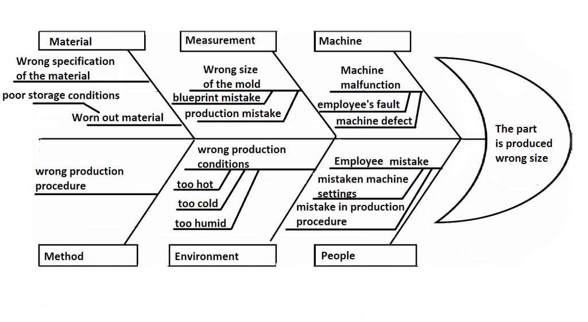

Figure 1 - Fishbone Diagram Example

(Anon., n.d.)

A secondary tool to use for analytical purposes can be using pareto charts. Pareto charts show data collected in a graph format whilst using the 80-20 rule. The 80-20 rule states that 80% of consequences come from 20% of causes, this rule with the pareto chart really helps to organise which problems to prioritize. The pareto chart consists of various bar graphs in order of frequency from highest to lowest, as well as the bar graphs there is a line that sits at 80% which indicates the 80-20 rule. Anything to the left of the line, should be prioritized more than anything to right of the line (Commision, 2024) states that “the vital few factors that warrant the most attention sit under the 80% cut off line.” The pareto chart can ensure that the causes that are proving to be the greatest impact to the process, can be focused on with data that is driven by facts. As shown below in figure 2, a pareto chart example showing the 80-20 line whilst showing which areas should be prioritized, known as the Vital few.

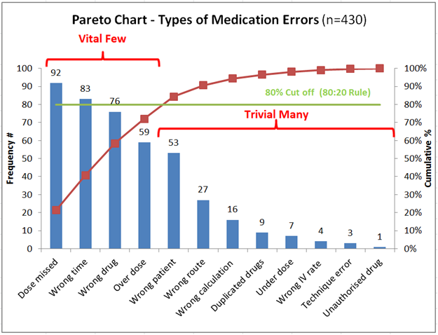
Figure 2 - Pareto Chart Example

(Commision, 2024)

Once all the data has been analysed and understood, the next step within the investigation is the improvement phase. The improvement phase is a section in which the root causes found within the analysing phase are eliminated or at best mitigated to the point they have no adverse effect on the process. Finding improvement strategies are imperative to the whole process as without finding suitable methods it would allow the process to continue bleeding. One improvement strategy that could be implemented is Jidoka. Jidoka is a Japanese word for automation but with a human’s touch. The principle is well established within lean manufacturing, it consists of designing a process or machine to be partially automatic with the intent of the machine or process stopping once a problem as been detected, and immediately calling attention to it. This way it prevents defects in components being manufactured in batch, sorting the problem there and then to ensure high quality standards are met and sustained. PESC could absolutely implement Jidoka to their processes, as alert systems could be implemented to signal any abnormalities such as raw material errors when delivered, or any machine failure or product defect. The signal would ensure attention has been raised and a solution could be sought out before the process continues down the line, where the error is irreversible. Jidoka principle would also allow the workers to stop production flow whenever a problem or defect has arisen, further enhancing the quality standards throughout.
(UK, 2016) as Toyota UK states “forcing imperfections to be immediately addressed by self-inspecting workers and thereby reducing the amount of work added to a defective product.” Reinforces the principle of stopping production flow to address any problem is better than allowing it to go unnoticed.
A secondary improvement strategy that can be implemented is Kanban. Kanban is another lean manufacturing principle; Kanban is a principle that uses signal cards to reduce waste from inventory and overproduction. The signal cards or Kanban cards are key to the whole principle, the cards are visual representations of work. The cards are tracked through components workflow, helping to limit work in progress (WIP) whilst maximising efficiency. To fully implement a Kanban system, all work processes must be mapped out as accurately as possible, any little detail is key. Once the flow of work has been mapped, the mapped work is then inputted into a Kanban card, thus being able to track the card throughout the workflow. This is where any bad workflow such as bottlenecks, long wait times or disruption can be identified showing opportunities for workflow improvement. PESC can implement this principle as it would allow them to identify any bad workflows that currently occur, but it can also allow PESC to track the WIP, as the number of active Kanban cards will represent the current WIP. Being able to track the WIP will allow PESC to limit the current WIP which in turn will improve productivity and efficiency of the work. The Kanban cards are also a huge benefit to PESC as it contributes to the levels of inventory stored, as it only pulls the required components for that specific Kanban card at the right time, meaning inventory levels can be tracked and reduced to the workload needed (Cambridge, 2016).
A third strategy that could be implemented is Kaizen. Kaizen means continuous improvement; it is a culture change where all employees work as a team to achieve regular improvements within the manufacturing process. It is a proactive approach to process improvements instead of being reactive. This method of improvement must ensure that the work can be standardised this way, employees can identify small changes which in turn will make that process better. All improvements big or small will always favour productivity, that will benefit the process. PESC can implement Kaizen as all processes can be standardised, which will allow everyone to give suggestions for improvement whilst looking for suitable solutions. (UK, 2013) Toyota states “Kaizen humanises the workplace, empowering individual members to identify areas for improvement and suggest practical solutions.” Reinforcing that if the culture of the workplace changes, it will bring about positive improvements in the workplace.

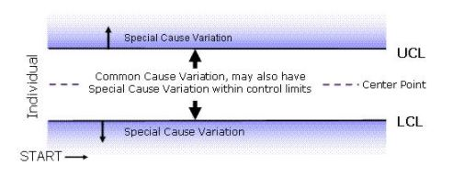
The final stage of the DMAIC process is the control phase. The control phase is extremely important as control measures need to be implemented to ensure all improvements and solutions created in the improvement phase are working, also ensuring there are procedures in place to maintain all the new process improvements. Without any control measures in place all the work that went into creating improvements for a sustainable future will collapse and revert to the old ways. One hugely effective method of monitoring and measuring the improved processes is implementing SPC also known as statistical process control. SPC uses data gained from processes to control and improve the process constantly. One tool that can be used to maintain and monitor each process is SPC charts, these charts are plotted from the data gained from the process that is being monitored. They allow for a visual aid to show the behaviour of the process whilst being able to identify if there are any problems that need to be looked at. (Simplilearn, 2023) states “The three main components of an SPC chart are - a central line (CL) for the average, a lower control line (LCL) for the lower control unit, and an upper control line (UCL) for the upper control unit.” The UCL and the LCL of the charts are called the control limits. These are the standard deviations of the process that are above and below the centre line. If any of the data points, go above or below the control limits then that would indict that the process is no longer in control which is also known as special cause variation. On the other hand, if the data points are within the limits and close to the centre line that would indict the process is in control or known as common cause variation.

Figure 3 - SPC chart example
(Simplilearn, 2023)
As shown above in figure 3, is an example of the special cause and common cause variation of an SPC chart giving an idea of the boundaries that can be set to monitor and maintain processes.

Conclusions
In conclusion, this report has taken a dive into the DMAIC process it has shown the various phases to the process and how its methodology can provide a structured way to improving and sustaining manufacturing processes that are in dire need of support. To each phase there are many options that are available to PESC in which they can implement, however each tool or strategy mentioned is not perfect. They can help massively but they have their limitations such as Kaizen, incredible at continuous improvement if the company culture can change its ways to match Kaizen. The Jidoka principle is amazing however it can become expensive when implementing at first, as sensors or more advanced machinery may need to be acquired.
There is a lot of work to still be done to help PESC reach its goals however the information provided will ensure they have a structured method on how to find the causes of the current problems and find solutions to improve and maintain each process.

References

Institute, S., 2024. Sixsigma Institute. [Online]
Available at: https://www.sixsigma-institute.org/Six_Sigma_DMAIC_Process_Define_Phase_Six_Sigma_Project_Charter.php#:~:text=To%20craft%20a%20precise%20problem,concern%20without%20assigning%20blame%20or
[Accessed 20 04 2024].
Anon., n.d. Lean Six Sigma Definition. [Online]
Available at: https://www.leansixsigmadefinition.com/glossary/fishbone-diagram/
[Accessed 23 04 2024].
Cambridge, U. o., 2016. Decision Support Tools - Kanbans. [Online]
Available at: https://www.ifm.eng.cam.ac.uk/research/dstools/kanbans/#:~:text=A%20Kanban%20system%20is%20a,other%20devices%20can%20be%20used.
[Accessed 24 04 2024].
Commision, C. E., 2024. Pareto Charts & 80-20 Rule. [Online]
Available at: https://www.cec.health.nsw.gov.au/CEC-Academy/quality-improvement-tools/pareto-charts#:~:text=The%20Pareto%20Chart%20is%20a,represented%20by%20the%20curved%20line.
[Accessed 23 04 2024].
Gheorghe, I. & Clocolu, C., 2010. Application of Fishbone Diagram to Determine the Risk of an Event with Multiple Causes. Management Research and Practice, Volume 2(1), pp. 1-20.
Hessing , T., 2019. SixSigmaStudyGuide. [Online]
Available at: https://sixsigmastudyguide.com/measure-phase-dmaic/#:~:text=The%20purpose%20of%20the%20Measure,order%20to%20understand%20the%20problem.
[Accessed 22 04 2024].
N, V. & S, S., 14. Lean Six Sigma. In: A. Coskun, ed. Six Sigma Projects and Personal Experiences. s.l.:InTechOpen.
Simplilearn, 2023. SPC Charts: Overview, When to Use Them and How to Create Them. [Online]
Available at: https://www.simplilearn.com/spc-charts-article
[Accessed 28 04 2024].
UK, T., 2013. What is kaizen and how does Toyota use it?. [Online]
Available at: https://mag.toyota.co.uk/kaizen-toyota-production-system/
[Accessed 28 04 2024].
UK, T., 2016. Jidoka – Toyota Production System guide. [Online]
Available at: https://mag.toyota.co.uk/jidoka-toyota-production-system/
[Accessed 24 04 2024].

