NAME- RAPHAEL JERRY APPOINSAH APPIAH

STUDENT ID – 2337090

PROGRAM OF STUDY.- BSc APPLIED COMPUTING

MODULE NAME –CHANGEMAKERS ;CREATIVITY &VALUE CREATION

MODULE CODE. - ACCA5033

LECTURER NAME. - DR . FAHAD AHMED

UNIVERSITY NAME. - UWTSD. LONDON COMPUS

SUBMISSION DATE - 20 TH MARCH 2026

TABLE OF CONTENTS

Introduction -------------------------------------------------------------- 4

Mind Mapping --------------------------------------------------------------- 5

How Innovation Shapes the world. ---------------------------------------5

References for task 1 --------------------------------------------------------8

Aim, Objectives and Research Area.----------------------------- 9

References for Task 2 -----------------------------------------------------12

Search Tools and Research Database ---------------------------13

Conclusion , ----------------------------------------------------------15

References for task 3. -------------------------------------------- 13

ASSIGNMENT 1. INNOVATION & RESEARCH

INTRODUCTION
Innovation and research have a fundamental position when it comes to the advancement of technology and society at large. Innovation can be defined as the development and implementation of innovative ideas, technologies, and processes that improve existing systems and respond to emerging needs. Innovation is mainly driven by the research process, which helps to generate knowledge and assess the effectiveness of the developed technologies. In the field of applied computing , innovation is mainly driven by the advancement of artificial intelligent, data analytics, and digital technologies. The technologies have been instruments for various organizations to develop innovative solutions to real world problems. Therefore , the incorporation of innovation with research methodologies help computing professionals develop technologies that are reliable and socially beneficial.

TASK 1
MIND MAP
How innovation Shapes the world – AI Powered Student Mental Health.
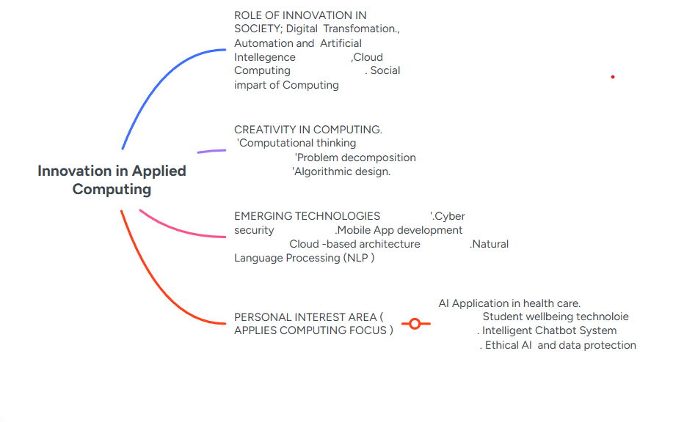

- Innovation in Applies Computing
Innovation in the field of computing has led the development of digital transformations in sectors such as healthcare , education ,finance, and services. Advances in technology , such ad artificial intelligent, cloud technology, data analysis, have led to the development of intelligent systems that are efficient and effective in improving the decision –making process in the development of services by organization . In addition, the ability of computing technology to process large volumes of data is crucial in the development of effective planning and problem solving activities in an organization. { 1} . Technological innovation is crucial in the development of changes in the way modern society operate

- Roles of Innovation in Society;
Innovation in applied computing has a revolutionary impact on modern society since it facilitate digital transformations across various industries ,. For example , Innovations such as automation , artificial intelligence , and cloud computing improve efficiency , operational scalability, and cost reduction . Artificial intelligence base systems help organizations make informed business decision through data analysis. These systems provide real time prediction based on large amounts of data. In addition , innovation in the field of computing contributes to economic growth and competitive advantage through productivity improvements and the development of new business models. { 2 }. In addition to economic impact , innovation in the field of digital computing produces a remarkable social impact.
- Creativity in Computing;
Therefore, creativity in computing is a fundamental concept in creating innovative and efficient technological solutions in computing . Creativity in computing involves computational thinking , which allows for a systematic approach to problem- solving through logical thinking and abstraction . Problem decomposition allows for the decomposing of a complicated problem into simpler components ,while algorithm design allows for efficient and optimized solutions to the problem. Design thinking in software development involves concepts of empathy, experimentation , and iteration , ensuring software development solutions are aligned to meet user needs.{3 } In addition , agile development methodologies in software development involve concepts of collaboration , flexibility, and improvement, all of which are essential in software development solution .
- Emerging Technologies
Emerging technologies are the heart of innovation in applied computing technology . For example , Artificial intelligence (AI )and Machine learning technologies , automation , and personalization services in various sectors. Natural Language Processing (NLP )is essential for developing conversational interfaces that enable Chatbots to offer interactive experiences to users. Cloud computing technologies offer flexibility, scalability, and remote accessibility of digital services. Mobile app development is essential for engaging users of various digital services from cyber threats and building trust among users.. The speed of emerging technologies is mainly based on their usability ,accessibility, and perceived usefulness.{ 4 )
- Personal Interest Areas .( Applied Computing focus )
The main areas of personal interest within the field of applied computing include artificial intelligent (AI ) applications within the healthcare industry, technology supporting student well –being, the concept of intelligent Chatbot systems, and all the concept of ethical AI with strong data protection policies. The world health organization. {5 } States that the current global mental health crisis is increasing significantly, particularly within the lives of young adults who are pursuing higher education . This provides an opportunity for computing professionals to develop digital solutions within this domain while adhering to the principles of AI systems
- Project Ideas
A set of project concept in the domain of applied computing has been evaluated . The project concept are;
- The development of an artificial intelligence- based Chatbot to assist in university mental health services.
- The development of a predictive analytics dashboard to assist in identifying university students at risk of dropping out.
- The development of a secure cloud –based telchealth platform.
- The development of a mental sentiment analysis system to assist in monitoring mental health trends.
All of these project concept involve modern technologies, and secure cloud computing, to address real –world issues in the context of higher education and health care delivery.

References
{1 } J. A. Schumpeter . The Theory of Economic Development. Cambridge , MA, USA. Harvard University Press, 1934
{2 } M. Porter, The Competitive Advantage of Nations. New York, NY,USA; Free press, 1990.
{ 3 } T. Brown , “Design thinking,” Harvard Business Review, vol.86,no.6, pp. 84-92, 2008.
{4 } E.M. Rogers, Diffusion of Innovations, 5thed.New York, NY. Free Press, 2003
{ 5 } World Health Organization , World Mental Health Report. Geneva, WHO,2022

TASK 2
Aim, Objectives And Research Area,
Project Title.
Design and Evaluation of an AI- Based Mental Health Chat-bot for university students.
Q1; AIM and OBJECTIVES;
AIM
The aim of this project is to design, develop, and critically evaluate a prototype of AI- based mental health chatbot for early stage wellbeing support among university students. This project aims to ensure the technical feasibility of the project, in addition to assessing the usability and user acceptance of the system in the context of a higher education institution .
Objective
- Conduct an in dept literature review on the application of AL- based chatbots in the context of digital health and higher education
- Develop the functional requirements of the chatbot and non-functional requirements .
- Develop a safe system design with an interface layer, backend processing layer, Natural Language processing Layer, and encrypted database.
- Develop a working prototype of AI- based framework.
- Conduct usability tests using the system usability scale to obtain quantified performance measures.
- Conduct user acceptance texts using the technology, acceptance model to evaluate the user acceptance of the system in terms of usefulness and ease of use.[ 1 ]
Overall , the project aims to ensure the technical feasibility of the project, in addition to assessing the usability and user acceptance of the system in the context of a higher education institution.
Research Philosophy
This project aims to apply a pragmatist philosophy of research . Pragmatism is an approach to research that emphasizes solving problems and achieving results, rather that adhering to a specific paradigm of knowledge .[ 2 ]
This philosophy of research is particularly relevant in the context of computer science and information systems, where technical feasibility of a system must always be assessed in the context of the real world.
This project has objective and subjective aspects, and the objective aspect, such as the performance of the system, the response time, and the usability score, can be measured quantitatively , where the subjective aspects, such as the user trust, the emotional comfort, and the perceived usefulness, require a qualitative exploration of the data. Although a positivist approach would limit the analysis of the data only to the objective aspects, the interpretive1 [1] [2] [3] [3] [4, 5] aspects of the data, Therefore , a pragmatic approach will be adopted, which combines the two approaches.
As a result , the research will be conducted through a mixed methods approach , where the data collected will be both qualitative and quantitative, including the usability score, the likert- scale data, and the potential correlation between the perceived usefulness and the intention to use the system, and the qualitative data collected through the semi structured interview .This flexibility of the research approach will increase the credibility of the research

Q3
Search Tools and Research Databases
A reliable and structured search approach will be adopted for the research, ensuring the reliability of the research review . [ 3 ] In other words , the research aims has a direct impact on the reliability of the research review.
Search Tools And Database
For the research , the following research tools will be adopted.
- Google Scholar-; For the search of the research
- IEEE Xplore-; for the search of the research
- ACM Digital Library-; For the search of the research
- Science Direct ;- For the search of the research
- Pub –Med,; For the search of the research
This tools will be adopted for the research because they are reliable tools for the search of the research , and the research will conducted through these tools, ensuring the reliability of the research review.

Search Strategy
Boolean search will be adopted for the search of the research , which will increase the relevance of the search conducted.
- AI Chat-bot And mental health.
- NLP AND Student wellbeing
- Digital mental health systems and usability.
Truncation techniques will also be utilized ,
While the inclusion criteria will focus on peer- reviewed scores published over the past ten years to ensure the content is relevant and applicable today, for fundamental theories . [ 4 ] Will be retained for theoretical support.
By using a systematic approach, the results will be more rebust, and the results will be less .

REFERENCES FOR TASK 2

{ 1 } F.D. Davis, :Perceived usefulness , perceived ease of use, and user acceptance of information technology: MIS Quarterly, vol. 13, no.3, pp. 319-340, 1989.
{2 } M. Saunders, P. Lewis, and A. Thornhill , Research Methods for Business Students, 8th ed. Harlow, Pearson, 2019.

{ 3 } A. Booth, A. Sutton, and D. Papaioannou, Systematic Approaches to a Successful Literature Review. London , sage, 2016.

{ 4 } World Health Organization , World Mental Health Report. Geneva, WHO, 2022.

TASK 3

Research Strategies
(Q1) Validity, Reliability, and Generalisability and Ethical Considerations.
However, ensuring the quality of research requires consideration of various factors namely Validity, reliability, generality, and ethical issues. These factors are critical in enhancing the quality of a research project and ensuring that the conclusion draw from a particular study are reliable and applicable in a real –world setting . [ 1 ]. The issue of validity is connected with the degree to which a particular method of research is able to measure a given construct . In this project , Validity is improved through the use of established questionnairs in measuring use experience. For instance, the system usability scale (SUS) is a popular method of measuring user experience in digital systems and applications . Using established question is important in eliminating bias in user experience evaluation .Another method of enhancing validity in a research project is through a process called Triangulation. Is a method of data collection in which researchers use different methods of collection to examine a particular issue of interest .
In this project , triangulation is achieved through a mix of questionnaire , usability test and interviews. This method provides a deeper understanding of user experience in relation to a particular chatbot in providing user experience . [1 ]
- Reliability Measure ;
The consistency of research findings when the study is repeated under similar circumstances. This would minimized any eventualities in which variation in data gathering would have an effect on research findings. The research study would be carried out in a standardized testing environment to ensure all research participants are exposed to similar testing conditions while participating in the usability study for the chatbot, clear definitional precision would be essential in ensuring all research participants interpret research question in similar contexts reliability. [2 ]
- Generalisability Measures ;
To ensure generalisability , this study will aim to recruit 50- 100 participants from a local university. Additionally participants will be recruited from different faculties and different academic years to ensure a diverse sample,. This increased the chances of results being representative of a large population and not limited to a particular course of study.
- Ethical Considerations
They are an essential aspect of the study , especially when dealing with sensitive information such as mental health, moreover, the data collected from the participants will have to be on it own so that no personal information is revealed. The General Data Protection Regulation ( GDPR )will have to be considered so that all the data collected can be safety stored. Ethical considerations are essential in the field of computing, especially when dealing with sensitive information regarding an individual health, as mentioned in the article on digital health technologies ,[ 3 ]

Q2; RESEARCH STRATEGIES AND PILOT DESIGN
The study will use a mixed research strategy that incorporate the use of quantitative data will collected using an online questionnaire that will focus on the usability, satisfaction , and usefulness of that chatbot. In this case , the participants will have the freedom to interact with the system . In addition , the study will use an interview as the data collection instrument.
The pilot study is ton be comprise a sample of 10 students. The purpose of the pilot is to test the chatbot systems system performance. Following the feedback received during the pilot phase of study, both the questionnaire and chatbot system have been improved.

(Q3)
QUATITATIVE AND QUALITATIVE ANALYSIS
The quantitative data is to be analyzed using various forms of descriptive statistics . For example , mean and standard deviation values can be used to calculate the response obtained from the participants . Correlation tests can also be carried out to cheek for relationship between different variables, for instance, between usefulness and intention to use the chattbot. Also, regression analysis can be carried out to cheek how different factors of the technology acceptance model affect user acceptance of technology. [ 2 ] Additionally, the chatbot system usability can be determined using system usability scale scores. [ 4 ]
The qualitative data; is to be analyzed using thematic analysis . Thematic analysis is a method of analyzing data where patterns and themes are searched for the data. In this method of analysis , the responses obtained from the participants are coded and then themes area derived from the coded data. [ 5 ] By using both forms of analysis in the study, a comprehensive evaluation of the chatbot system is possible.

Conclusion
This study show how innovation in applied computing can be harnessed to solve real- world problems, such as ensuring that student have access t mental health support. By developing testing an AI-based chatbot , this study aims to integrate technological development with a systematic approach to research methodology. This application of mixed research methods, including usability testing , is important to fully assess the performance of the system . Ethical issues, including data protection and responsible AI usage, are important aspects of this study. The study has shown that it is possible to integrate innovation , research methodologies, and user- centered design to produce digital technologies that improve access to mental health support for students.

REFERENCES.
[ 1 ] M. Saunders, P. Lewis , and A Thornhill , Research Methods for Business Students, 8th ed. Harlow, Pearson , 2019.

[2 ] F.D. Davis, “ Perceived usefulness, perceived ease of use, and user acceptance of information technology “ MIS Quarterly, vol.13, no.3, pp. 319-340, 1989.

[ 3 ] British Psychological Society , Code of Ethics and Conduct. Leicester ,;British Psychological Society, 2021.

[4 ] A . Field , Discovering Statistics Using IBM SPSS Statistics, 5th ed. London. Sage, 2018.

[5 ] V. Braun and V. Clarke, “Using thematic analysis in psychology “Qualitative Research in Psychology, vol. 2, pp.77-101, 2006.

