
1800354
Ashley James Wakeling

A critical analysis of the relationship between teacher subject knowledge and effective learning and teaching in the primary school.
“Subject Knowledge is central to the operation of the successful teacher” (Denby, 2015). This essay will discuss literature on the topic of subject knowledge for teachers, with focus on the concept within the primary school in Wales. After this, I will analyse and evaluate my own subject knowledge whilst on Professional Teaching Experience (PTE). To comply with The British Educational Research Authority’s ‘Ethical Guidelines for Educational Research’, (Gardner, 2011) the name of the school, staff and students have been anonymised throughout this essay, with the school being hence referred to as ‘The school’, and any names being removed. The school is a medium sized institution in a small village within the Welsh Valleys and caters for pupils from ages three to eleven, with my experience being solely in the foundation phase during this part of PTE. The catchment for the school is among the 10th-20th percentile of the most deprived areas in Wales, placed 347th of 1909 by the Wales Index of Multiple Deprivation (Welsh Government, 2014). “27% of children in the school are in receipt of free school meals, 34% have been identified as having additional learning needs (ALN), far higher than the average in Wales, and a very small minority speak English as an Additional Language (EAL)” (Estyn, 2014). I was placed in a mixed age group class with 19 year one pupils, and six year 2 pupils. All children had birth dates between September 2012 and August 2014. The class teacher had assistance from one full-time learning support officer.
Graham Donaldson writes in his recommendations for the new curriculum in Wales in ‘Successful Futures’, that teachers possessing subject knowledge and then instilling it on the children in a classroom has “stood the test of time” and is certainly a way to achieve a “sound and relevant education” (Welsh Government, 2015; 5). He is also in agreement with some scholars, conceding that there are contrasting approaches now being adopted internationally, which focus on the expected outcomes of learning across the spectrum with success being measured against the ability to master key skills, rather than gain subject knowledge as transferred from teacher to pupil. Donaldson argues that pitting the two ends of the spectrum against one another results in a “subject against skill/competence” results in an “unhelpful polarisation”. As such, the recommendation made to the Welsh Government in this regard is that the newly developed curriculum in Wales should include both an attainment of learning experiences, skills and competence along with assessment of more literal subject knowledge (Welsh Government, 2015; 6) (Appendix 1). It is the case therefore, that the impact of teacher subject knowledge and subject pedagogical knowledge is likely to alter with the changing of the curriculum in Wales over the coming years and this assignment should be read considering this.
To teach, is first to understand, and the teacher should comprehend, in detail, the ideas to be taught in several ways claims Shulman (1987) in his seminal work on the topic ‘Knowledge and Teaching’. Shulman also states that teachers should understand the purpose of the material being taught to pupils, and whilst this is the case for almost all academics in their respective fields; the key “to distinguishing the knowledge base of teaching lies at the intersection of content and pedagogy” (Shulman, 1987; 14). Of course, teachers must know a lot about what they intend to teach a group of pupils, in fact, “the most effective teachers are experts in what they teach” (Barton, 2015; Xiii). He states that subject knowledge to a level where teaching is more effective is far more than a ‘superficial whisk’ through key concepts. Whilst Barton may be referring more closely to secondary education, the argument is nonetheless, appropriate throughout the phases, with Marland believing that the best teachers at all levels continually supplement their subject knowledge, calling it the “Craft of the Classroom” (Marland in Barton, 2015; xiv). Published within the teaching standards to gain Qualified Teacher Status are numerous factors which are in support of the view that knowing your subject is salient to effective teaching (Barton, 2015; 58). They state that teachers must have a secure knowledge of their subject to “foster and maintain pupils’ interest in the subject and address misunderstandings” (Appendix 2). Bentley Davies reinforces this view, stating that should misconceptions be ignored, either accidentally, or to maintain fluency in a classroom discussion, this can do more harm than teaching incorrect facts as the truth (Bentley Davies, 2010; 63). According to Shulman (1987), content knowledge (CK) represents teachers’ understanding of the subject matter taught. However, this knowledge is useless without the ability to make the subject matter accessible to students. The ability to do this with skill is referred to as pedagogical content knowledge (PCK) and consists of two main aspects; knowledge of student’s subject specific conceptions and misconceptions, and knowledge of subject specific teaching strategies (Shulman, 1987). Immediately therefore there is an apparent blurring of CK and PCK as one cannot exist without the other when summarising the effectiveness of teachers on pupils. Shulman (1987) states that the teacher must transform (Appendix 3) the “content knowledge he or she possesses into forms that are pedagogically powerful and yet adaptive”, appropriate to the age, ability and specific requirements of the children you are teaching, making the point valid across the breadth of education.
Rowland et al’s (2003) case study focussed on trainee teacher Naomi, the teacher is criticised for her lack of willingness to engage with proposals brought forward by her pupils, amounting to missed teaching opportunities. Rowland et al argue that this amounts to a lack of ‘contingency’ within pedagogical content knowledge, and shows that whilst a teacher may possess all of the academic ability within the subject they are teaching, if they do not have the “readiness to respond to children’s ideas” and the flexibility to deviate from a lesson plan when it is profitable to do so, they let learners down. This supports a constructivist view of learning as developed by Piaget (1962), valuing the input of children’s contributions and interpreting them as indications that the children are actively engaged with the content at hand. Rowland et al (2003) state that ignoring or dismissing these interjections as ‘wrong’ “can be construed as a lack of interest in what it is that that child (and possibly others)” have learnt from a teacher’s conveying of subject knowledge. Brown and Wragg (1993 in Rowland et al, 2003), argue however, that “our capacity to listen diminishes with anxiety”. In this case therefore, Naomi could be forgiven her lack of ‘contingency’ due to anxiety, resulting from being formally observed. Nonetheless, it could be indicative of uncertainty in subject knowledge and therefore prove the view that subject knowledge again, is principal, above pedagogical knowledge in the transference of understanding to pupils. This is compounded by Shulman’s (1987; 17) discussion of Grossman’s 1985 case study of Colleen (Appendix 8), within which the subject is confident in employing various teaching methods when working within her comfort zone teaching literature. Grossman (1985 in Shulman, 1987; 17) argued that “when teaching a piece of literature, Colleen performed in a highly interactive manner” resulting in high student participation and high student attainment. Her content knowledge of the literature is high, and her ability to teach this has also been well practiced; she encouraged different learning styles and encouraged these appropriately, showing high levels of PCK also. However, whilst Colleen’s PCK is apparently more than adequate, once teaching in an area where “Colleen had received almost no preparation” namely prescriptive grammar, her interactive style disappeared. Students were not given the chance to ask questions, as was the case with Rowland et al’s (2003) case study focussed on Naomi, restricting learning opportunities and preventing increased attainment. It is the case therefore that CK and PCK need to operate in unison to enable pupils the best opportunities to learn. In support of this, Shulman (1987) praises the SK of case study and ‘expert teacher Nancy’, in both her “understanding … and skill as a pedagogue” he states that she encouraged open ended discussion in her lessons in literature, a key aspect of this contingent behaviour. To aid her pedagogical skill, Nancy is said to have “possessed a conceptual framework for her teaching” (Appendix 4), understanding how to organise content, frame it, and then divide it in an efficient manner for assignments and activities. Shulman (1987) went on to claim that her “combination of subject-matter understanding [CK] and pedagogical skill [PCK] was quite dazzling.” Nancy also demonstrated high levels of ability in contingency, planning around illness and scaffolding appropriately when learners were struggling with texts. Shulman (1987; 5) argues that this knowledge, understanding and skill demonstrated with ease by Nancy as an expert teacher, is “displayed haltingly [but] occasionally masterfully, among beginners”. Whilst CK therefore is often of a similar level amongst all in the teaching profession, irrespective of experience, the ability to transfer this knowledge in a meaningful way to the class (PCK) builds with experience. Hattie (2011; 28) reinforces this point, arguing that whilst the amount of knowledge for teaching does not differ with experience, expert teachers “differ in how they organise and use this content knowledge” (Appendix 5).
Hattie (2011; 28) argues in fact that with regard to visible and measured learning in the classroom, it has been shown that “teachers’ subject matter knowledge (SK) had little effect on the quality of student outcomes. One must question the legitimacy of this claim however, and ask whether Hattie was writing within a scale of CK as teaching would not be able to take place if a teacher had an absolute absence of all knowledge of a topic. In accordance with this view, Guerriero (2017; 107) claimed that in a study investigating the quality of teachers CK in mathematics; “Hill, Rowan and Ball (2005) reported a significant relationship to student achievement gains.” However, they did concede that neither certificated qualifications nor courses taken by the teachers related to student achievement. This 2005 study also did little research within the field of PCK, as criticised by Kliekman et al (2012; 91) who went on to claim that despite their being a high correlation between CK and PCK, “CK has a lower predictive power for student progress than PCK”. This seemingly inseparable link between CK and PCK is noted by Shulman (1987) who claimed that CK is a “prerequisite for PCK. PCK implies a transformation of subject-matter knowledge” so it can be used effectively in the classroom. Arthur and Cremlin (2010; 13) argue that whilst inseparable, PCK remains the most important of the seven kinds of teacher knowledge. The ability to apply CK in a way which draws on children’s development and motivations yields the most productive teaching. Lee et al (2007) claim that strong CK does not always lead to the development of PCK and teaching experience alone, is insufficient to develop the ability to ensure that a teacher’s subject knowledge is presented in an accessible way to learners (Brunner et al., 2006 in Kliekman et al, 2012; 94). In fact, Kliekman (2012; 94) goes on to claim that even in-service training tended to have a weak effect on PCK development with training tending to be “fragmented, noncumulative and voluntary”. They argue that a lot of the foundations for PCK which then leads to the most effective teaching is introduced in “learning situations prior to teacher education”, informally constructing PCK, for example, through the “observation of one’s own teachers (Kliekman et al, 2012; 92), although their research did show a definite increase in PCK reliability once teachers were qualified in service (Appendix 6).
Subject Knowledge with reference to pedagogical content knowledge is invariably placed at the top of the list of factors which contribute to the best teaching (Coe et al, 2014; 2). Coe et al (2014) argues that the best teaching is that which “leads to improved student achievement using outcomes that matter to their future success” and will contain all six of their aspects of great and effective teaching (Appendix 7). Coe et al (2014; 18) claim that several studies have found a relationship between the level of a teacher’s knowledge of the content they are teaching, and the attainment of their pupils. Ball (1991; 5 in Coe et al, 2014; 18) states that “it seems intuitively obvious that teachers cannot help children learn things that they themselves do not understand.” Yet academics cannot agree on how CK can be enhanced to ensure that children learn more effectively with Ball et all (2005) arguing that teacher’s qualifications make little difference, and Rockoff et al (2011 in Coe et al 2014; 18) stating that any relationship between “academic qualifications or general ability and student performance [is] disappointing [with] correlations typically very small or non-existent”.
One must argue therefore whether the effectiveness of teachers does in fact vary, subject to subject and phase to phase. In English and literature studies, Shulman (1987; 17) discusses Grossman’s 1985 case study of Colleen (Appendix 8). Teaching behaviour and therefore teaching ability is hindered by or increased by comprehension of the content you are teaching. Grossman (1985 in Shulman 1987) argued that “the flexible and interactive teaching techniques” used when you are confident of your content are “simply not available” when you do not understand the topic you are teaching. This shows CK and PCK as separate entities within this subject. With regards to mathematics however Kliekman et al (2012; 91) claims that CK and PCK are merged into one single body of knowledge. Hill Schilling and Ball (2004) found that primary school teachers of numeracy brought the whole concept together into what was then coined ‘Mathematical Knowledge for Teaching (MKT)’. Kliekman et al (2012) argues that numeracy is most effectively taught in this way as maths is learned more effectively earlier in life with the “pretraining” phase. Feiman-Nemser (1983) thought not only to instil (often traditional) approaches to teaching and learning mathematics but also to influence the development of prospective teachers’ understanding of mathematics (Ball et al., 2001).” Brunner et al (2006 in Kliekman et al, 2014; 91) reinforces this point, stating that in a study with experienced mathematics teachers, job experience did not correlate with scores in a PCK test. This is not the case with teachers of other subjects according to Tochon and Munby (1993 in Arthur and Cremlin, 2010; 74). Their study into expert and novice teachers, found that whilst expert teachers could draw on several types of knowledge at once, a novice teacher tends to consider a single aspect at once, and stick more rigidly to planned lessons. One must consider therefore that whilst CK and PCK alters between taught subject and between different aged pupils in school, it is also greatly varied between experienced and inexperienced teachers, having a direct impact on pupil attainment through these aspects. Coe et al (2014; 38) also draws this conclusion, arguing that the reason scholars and researchers have not achieved congruence across their methods for assessing teacher effectiveness, is that there is not one kind of effectiveness given the enormous number of variables within CK and PCK.
Whilst this brings a conclusion that CK and PCK are both integral to one another in contributing to the effectiveness of teachers, most academics also demonstrate that there is a vast difference between the age of pupils and the subject or area of learning being taught. When looking specifically at the primary school, Rowland et al (2003) argues that both CK and PCK work together and contribute to different parts of foundation; the actual knowledge (CK) and information possessed by teachers; transformation, the PCK ability to convert this raw information into usable information for pupils; connection, the ability to draw links between and “an awareness of the relative cognitive demands of different topics and tasks.” (Rowland et al, 2003). Finally, Rowland et al (2003) mention the need to have skills in ‘contingency’, the ability to cope with situations which were unplanned for and to be able to enhance children’s learning where appropriate. Whilst this research is useful as a base for understanding the two areas of knowledge, the conclusion has to be made that there is far more underlying information as previously discussed.
During my professional teaching experience (PTE), I have experienced both planning and delivery of lessons in which I have had copious amounts of content knowledge relative to the pupils in the classroom, and lessons where my content knowledge was lacking. Due to the level of numeracy required within the foundation phase classroom I was placed in and having worked for the previous two years as an intervention practitioner, assisting lower achieving key stage two children with numeracy, I feel I had particular successes with mathematics during this period of PTE. Whilst I do not have any formal qualification past a B grade GCSE, I feel that my CK was above the required standard, and given past experience, my PCK required little development in order for the children to achieve and surpass learning objectives set throughout the term. This could be because of experience-based confidence and a willingness to take risks and embrace creativity as argued by Dweck (2007, in Denby, 2015; 228) in her theory, the ‘creative mindset continuum’ (Appendix 10). Due to my confidence with this subject area, Dweck (2007) argues that there would be a likelihood to teach in a creative way, encouraging pupil-initiated discussion and open-ended questioning. This is supported by the feedback from a university-based tutor who observed one of the sessions (Appendix 9), who stated that “Your questioning was very good, and you enabled pupils to revise their knowledge of 3D shapes within a familiar context”. My confidence with the topic had enabled me to imaginatively use resources which I had prepared for other lessons. Having flown a drone over the school during the October half term, I was able to use visual aids of the school (Appendix 11) to encourage the children to think about 2D and 3D shapes in their immediate environment, rather than introducing the concept as an abstract concept. Shulman (1987; 17) argues that there is compelling evidence to show that there is a powerful relationship between the comprehension of a teacher and the style of teaching employed, supporting the view of Dweck (2007). He also discusses the profitability, with regards to student attainment, of making content relatable, in his critique of Grossman’s (1985) case-study of Colleen’s literacy lessons, claiming that she was able to speak in more simplistic terms should her pupils be struggling with a particular text (Shulman, 1987; 17). In my numeracy lessons I attempted to incorporate as many of Marzano et al’s (2001 in Grigg, n.d.; 149) aspects of excellent teaching. By using a visual Venn diagram on the board, I was able to ensure that the children could see the similarities and differences between shapes. I was keen to continually show positive reinforcement to the children and allow them to generate and test their own hypotheses about shapes using a feely bag activity in pairs. This pedagogical content knowledge coupled with a secure understanding of the content being covered resulted in highly effective teaching with my “delivery demonstrate[ing] several excellent elements” (Appendix 9) and hence, the children succeeded in their objective.
Whilst my numeracy lessons were successful, much alike to Grossman’s (1985) study on Colleen, I found that an integral aspect to numeracy, taught as a separate entity, more challenging. Colleen was seen to struggle with grammar whilst thriving with literature, I struggled teaching reasoning whilst enjoying teaching numeracy. One specific lesson on reasoning focussed around the learning objective; “To be able to calculate the total number the ways of placing a number of a specified number of colour combinations on one page and to be able to see when all the ways are completed and prove this verbally or on paper.” Whilst the initial lesson (Appendix 13) went well, with the children picking up the concept and being able to use the resources appropriately to draw verbal conclusions, my underlying want to have evidence written in books led to over-scaffolding and the removal of meaning from the lesson. This was criticised by my senior mentor on the placement, noted in The Assisted Reflective Conclusions Model (ARC) from the day (Appendix 14) and then reflected on in more detail in a subsequent ARC form (Appendix 14a). This closing down of learning opportunities is similar to that mentioned in the analysis of Colleen’s performance, with the “uncertainty of content” resulting in an adaptation of my “instructional style to allay anxiety”. Shulman (1987) also argues that a less confident teacher often relies on a highly didactic, teacher directed style which yields only a child’s ability to recite rather than learn deeply and comprehend the reasons for learning (Hattie, 2011). Grigg (n.d.; 149) argues that this direct instruction style is particularly ineffective when teaching primary school level children and can only be used for the “transfer of knowledge” rather than instilling deep comprehension of a concept. It was, as a result of these mistakes in my lesson, that I invited my senior mentor into the following lesson to ensure that I was as effective as possible, allowing her to teach some of my lesson. This approach is supported by Bentley Davies (2010; 63) who argued that seeing your class taught by another teacher, using a plan produced by yourself, can be a highly effective way of gauging your own subject knowledge and learning new techniques. Overarchingly this supports the view that both CK and PCK are required to impart the most effective teaching on pupils, and they exist in a state of perpetual reliance on one another. Barton (2015; 59) quotes Ian Gilbert’s book ‘Why do I need a teacher, when I’ve got Google?’ in this regard. He argues that whilst teachers in the primary school possess subject knowledge ample to the level at which they are teaching, “it’s what you do with that knowledge, how you impart it” that makes a difference to the attainment of pupils, hence my interest in the opinion of my senior mentor and numeracy lead in the school.
In the primary school, you are expected to have good subject knowledge across the spectrum of the curriculum (Denby, 2015; 8) as literacy, numeracy and digital competency skills make up universal learning tools when “deploying any model of learning” (Dewey, 1938, Bruner, 1960, Piaget, 2000 in Denby, 2015; 285). Further to this, Donaldson has, running through the entirety of his review into the new curriculum in Wales, the view that all lessons, regardless of topic should incorporate at least one of these key skills. Bentley Davies (2010; 14) argues that whilst many subjects are still developing, methodology is continually evolving, and it is “the responsibility of an ambitious teacher to continually want to increase subject knowledge.” Considering this, I have focussed on my ability with regards to the Welsh Language. Whilst at present, I feel that my content knowledge is adequate for teaching in the foundation phase, working off planned Welsh lessons (Appendix 17), my incidental Welsh has not been of a good standard, and will need dramatic enhancement before I commence a role within key stage two. Sousa (2012;4 in Denby, 2015; 204) argues that introducing aspects of other lessons into one another, in a cross curricular learning nature is a highly effective instructional technique, hence the important of using incidental Welsh. Arthur and Cremlin (2010; 66) argue that this direction of travel with primary curriculum is synonymous across the ten countries studies by QCA in 2008. Donaldson (Welsh Government, 2015) supports this approach, with a view to increase learning through the development of competencies and skills, whilst considering how children learn most effectively.
In conclusion, it must be argued that content knowledge and pedagogical content knowledge cannot exist without one another and that they are equally reliant on one another to provide the most effective teaching. Kliekman et al (2012) argues that whilst CK and PCK are seen to increase throughout teacher training, because of reflective practices, and building experience and expertise “more and better research on the outcomes of teacher education is urgently needed” (Cochran-Smith & Zeiner, 2005 in Kliekman et al (2012; 91). Whilst content knowledge is generally perceived to be of less importance in the primary school due to its simpler nature, (Coe et al, 2014) I believe that complacency can be detrimental to teaching effectiveness, as exemplified in my discussion surrounding my teaching of reasoning. Shulman’s (1987) work reported that “students of teachers with higher pedagogical knowledge reported higher cognitive activation, better instructional pacing, better student-teacher relationships, fewer disruptions and higher teacher awareness of students comprehension of problems”, leading only to better learning outcomes for the pupils. Therefore, whilst content knowledge is without doubt imperative to effective learning in the primary school in Wales, it is pedagogical content knowledge which results in the most effective teaching and the best attainment for pupils.

Appendices
Appendix 1 (Welsh Government, 2015; 36) – Extract of text from Successful Futures: Independent Review of Curriculum and Assessment Arrangements in Wales.
“The ‘subject against skill/competence’ debate represents an unhelpful polarisation, since both make important contributions to fulfilling the purposes of the curriculum. The structure of the curriculum should therefore ensure that the vital contribution of disciplinary learning is preserved but is supplemented by other aspects that relate directly to the needs of today and provide sound preparation for the challenges of tomorrow. This is in line with findings of a report commissioned by Welsh Government in 2013 which concluded there ‘is evidence, internationally, of a move towards more skills-based curricula that are focused on identifying and defining essential overarching competences alongside the more traditional subject-based curriculum content’.”
(NFER and Arad Research (2013) A Rapid Evidence Assessment on the Impact of Curriculum and Assessment Arrangements within High Performing Countries Welsh Government.)
Appendix 2 (Barton, 2015; 58) – Extract from published teaching standards.
“Teachers Must;
3)a) have a secure knowledge of the relevant subject curriculum and curriculum areas, foster and maintain pupils’ interest in the subject and address misunderstandings.
3)b) Demonstrate a critical understanding of developments in the subject and curriculum areas, and promote the value of scholarship
3)c) Demonstrate an understanding of, and take responsibility for promoting high standards of literacy, articulacy and the correct use of standard English, whatever the teacher’s specialist subject.
3)d) If teaching early reading, demonstrate a clear understanding of systematic synthetic phonics
3)e) If teaching early mathematics, demonstrate a clear understanding of appropriate teaching strategies.,”

Appendix 3 (Shulman, 1987; 15) – The transformation of ideas into taught content.
The steps of transformation of ideas into content that can be taught, making up a key aspect of Pedagogical Content Knowledge. (Rephrased)
- Preparation of material including critical interpretation.
- Representation of the ideas for the children.
- Instructional selections of teaching methods.
- Adaptations of the representations, appropriate to the children.
- Tailoring the adaptations to the specific children you are teaching.
These are the steps for moving from personal understanding to enabling the understanding of others.

Appendix 4 (Shulman, 1987; 3) – Case Study Nancy’s Conceptual Framework for the teaching of Literature. Quoted from Shulman.
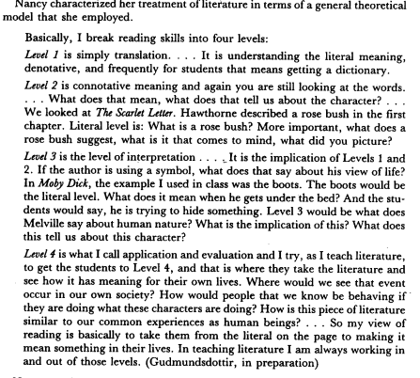

Appendix 5 (Hattie, 2011; 29) – Learning achieved by pupils’ differentiation between experienced and expert teachers with the same content knowledge (CK), employing differing levels of Pedagogical Content Knowledge (PCK).
“Students taught by expert teachers exhibit an understanding of the concepts targeted in the instruction that is more integrated, more coherent, and at a higher level of abstraction than the understanding achieved by students in classes taught by experienced, but not expert, teachers”

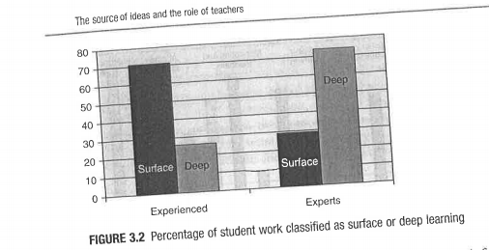

Appendix 6 (Kliekman et al, 2012; 94) – Reliability of CK and PCK throughout teacher training and then into service as reported by Kliekman et al’s study in Germany. Note the jump between the preservice induction phase (similar to that of Professional Teaching Experiences in Wales), and the in-service phase (comparable to post Newly Qualified Teacher Status year completion).
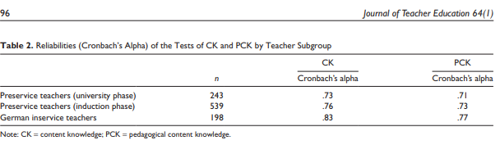

Appendix 7 (Coe et al, 2014; 3)
1. (Pedagogical) content knowledge (Strong evidence of impact on student outcomes) The most effective teachers have deep knowledge of the subjects they teach, and when teachers’ knowledge falls below a certain level it is a significant impediment to students’ learning. As well as a strong understanding of the material being taught, teachers must also understand the ways students think about the content, be able to evaluate the thinking behind students’ own methods and identify students’ common misconceptions.
2. Quality of instruction (Strong evidence of impact on student outcomes) Includes elements such as effective questioning and use of assessment by teachers. Specific practices, like reviewing previous learning, providing model responses for students, giving adequate time for practice to embed skills securely Executive Summary 3 and progressively introducing new learning (scaffolding) are also elements of high-quality instruction.
3. Classroom climate (Moderate evidence of impact on student outcomes) Covers quality of interactions between teachers and students, and teacher expectations: the need to create a classroom that is constantly demanding more, but still recognising students’ self-worth. It also involves attributing student success to effort rather than ability and valuing resilience to failure (grit).
4. Classroom management (Moderate evidence of impact on student outcomes) A teacher’s abilities to make efficient use of lesson time, to coordinate classroom resources and space, and to manage students’ behaviour with clear rules that are consistently enforced, are all relevant to maximising the learning that can take place. These environmental factors are necessary for good learning rather than its direct components.
5. Teacher beliefs (Some evidence of impact on student outcomes) Why teachers adopt practices, the purposes they aim to achieve, their theories about what learning is and how it happens and their conceptual models of the nature and role of teaching in the learning process all seem to be important.
6. Professional behaviours (Some evidence of impact on student outcomes) Behaviours exhibited by teachers such as reflecting on and developing professional practice, participation in professional development, supporting colleagues, and liaising and communicating with parents.
Appendix 8 (Shulman, 1987; 17)
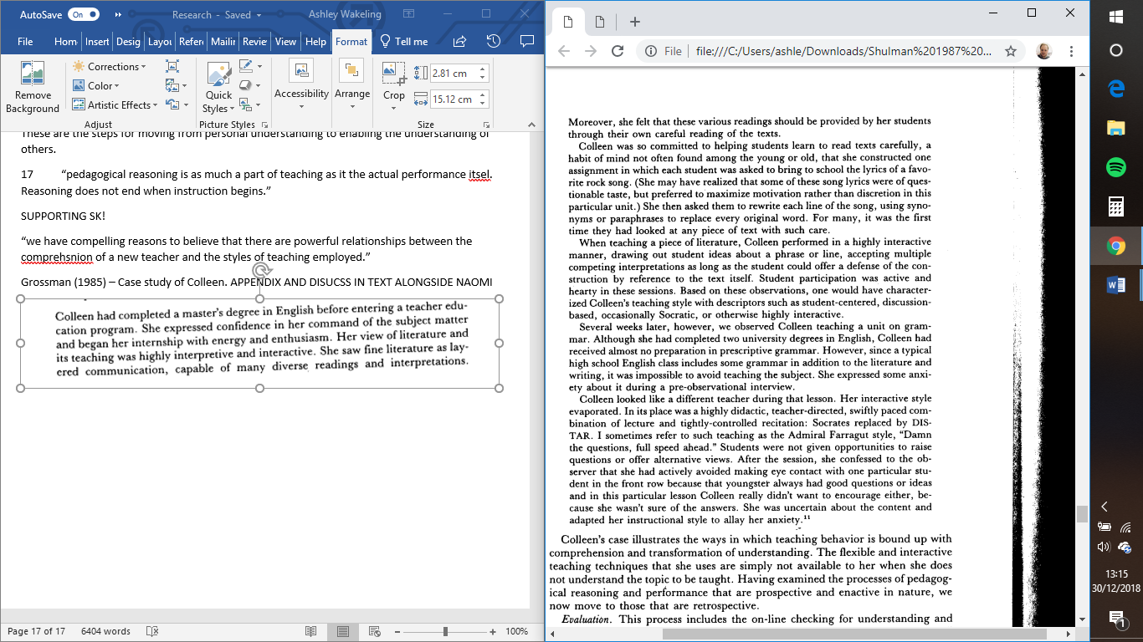

Appendix 9 – University tutor feedback for numeracy lesson on 2D and 3D shapes.
Part 1 Lesson Observation (Areas of strength/Areas for development)
S1: Professional Values and Practice - Good
You have established an excellent working relationship with your class teacher and with other adults within this classroom. You demonstrate a very good level of independence in your teaching and you have a sound engagement with pupils’ learning. You have been planning and teaching for a significant percentage of the class timetable including a wide range of activities.
S2: Knowledge and Understanding - Good
You clearly had a very good level of knowledge of 2D and 3D shapes, and you were able to explain the content of the lesson effectively, demonstrating an ability to use your own subject knowledge in an appropriate way to motivate learners. You are also able to use ICT effectively to enhance your teaching, demonstrated effectively by your aerial photos in today’s lesson.
S3.1: Teaching: Planning, Expectations and Targets - Good
Your planning was detailed and set out a range of activities for pupils of different abilities within the class. Despite this, it was not always easy to see the similarity between your plan and the lesson that took place! Consider adding the detail of your introduction to your plan – in bullet points perhaps – so that someone else would be able to teach it. You had planned several activities that were placed around the room that were based on the topics being studied at the moment - this was excellent practice. You used pictures that you had prepared previously, having taken aerial video and photographs of the school that formed the basis of a number of your activities today. Target: Ensure that your planning reflects the lesson that you intend teaching, e.g. by dating sections or ordering activities in the correct order according to the day that they will be delivered.
S3.2: Teaching: Monitoring and Assessment - Good
You have completed ARCs and you are able to be critical of your own performance and set targets for improvement. You have only recently begun to keep a notebook of pupil observations and you are yet to begin any tracking. You have begun reading records also. You used lollipop stick to choose pupils to answer. Also, you gave excellent feedback orally throughout the lesson. Target: Ensure that your monitoring and assessment on paper is up to date. You might consider completing these during the lesson when carrying out your focused tasks.
S3.3: Teaching: Teaching and Class Management - Good
You effectively used a clapping strategy in order to gain pupils’ attention at the beginning of the lesson. Your introduction was fast paced, with an effective warm up activity, and you engaged well with individual pupils. Your questioning was very good, and you enabled pupils to revise their knowledge of 3D shapes within a familiar context of the school buildings. At times, you tended to speak over pupils’ talking - perhaps you might use a strategy to avoid doing this. Also, consider the length of time that you are keeping pupils on the carpet. You ensured that pupils from each group understood their tasks by asking relevant questions – good. You worked well with your small group and you made a good effort to keep track of the other pupils at the same time. You have a confident manner and your delivery demonstrated several excellent elements.
S4: Welsh Language Standard - Adequate
You used a limited amount of Welsh today. You might find it helpful to plan for your use of Welsh weekly so that you are more likely to use it.

Appendix 10 – Carol Dweck’s Creative Mindset Continuum

Appendix 11 Images of School used to enhance learning of 2D and 3D shapes.
Image 1 – Used to teach 2D shapes, using an aerial view of the school and surrounding area. Also introduced the concept of regular and irregular shapes using the properties of the various playgrounds surrounding the site.

Image 2 – Used to teach 3D shapes. Image used shows the exterior of the classroom that the children are taught in and numerous items within the school playground were appropriate for the learning objectives to identify basic 3D shapes. Namely cylinders, cuboids and an introduction to prisms.


Appendix 12 Lesson Plan for Numeracy Session as observed by University Based Tutor.
Name of Trainee: |  |  | A Wakeling | Session ref: |  | 26.11.2018 (3) Num |  | Date: |  | 21.11.2018 |  |  | Class: |  |  |  | Cynllun Ffocws y Cyfnod Sylfaen  2d
Targed(au) Hyfforddi Personol | Make sure that previously covered numeracy knowledge is incorporated into the learning of new concepts to keep children recalling information and using what they have learned. |  |  |  |  |  |  | Number of learners: |  |  | 25 |  | Age: |  | 5-7 |  | Cynllun Ffocws y Cyfnod Sylfaen  2d
Learning objectives/intentions: |  | Recognise and complete a symmetrical  picture or simple shape.  Identify a line of symmetry for 2D  shapes and complete symmetrical  pictures  Recognise and name regular  and irregular 2D and 3D shapes, understand and use the properties of shape.  Next Steps  Use 2D and 3D shapes and describe how they fit together.  Make increasingly more complex or accurate models with 3D shapes and tessellate 2D shapes. |  |  | Success Criteria |  | Ability to name several different 2D and 3D shapes and the ability to sort them into categories.  To work independently and in a small group to order shapes and identify them in a real-world environment.  Outcome 4  Recognise and name common regular 2D and 3D shapes and describe and experiment with  how they fit together in their play.  They copy, describe and extend patterns including shape and  number. They can sort or match more than one criterion  Outcome 5  They recognise,  name and describe the properties of regular and irregular 2D and 3D shapes, and use them in  increasingly more complex or accurate ways in their play.  They find halves and quarters in practical situations (Symmetry). |  |  |  |  | Meeting learners’ needs: |  | Each group will have must-do activities explained to them at the beginning of each numeracy session. All EP will be accessible to all groups. Must-Do activities will be tailored a little more to the ability of the group not with AW. Challenge activity will be tailored to ability. COOL Challenge activities all presented in a separate document and are part of the enhanced provision accessible in all class activity.
Introduction/plenary tasks | Main activities |  |  |  |  |  |  |  | Resources/  Key Vocabulary |  |  |  |  |  |  | Assessment for Learning (strategies and opportunities)
Introduction  One each of these each session  Using several 2D and 3D shapes from the school stock, ask children whether they are familiar with them.  Photo of a place/thing – go through all the shapes they can see in the photos and talk about how in reality that maybe different.  Use the Venn diagram sorting game with the class on the board. https://uk.ixl.com/math/year-1/sort-shapes-into-a-venn-diagram  3D shape song! YouTube. | Trainee focused task (purpose, outline of trainee’s role and children’s learning):  Group 1 – Need to recap last week and make sure they have completed the 2D shape activity, writing down the facts they know about the basic 2D reception shapes. Name 3D shapes activity from a description. Then move onto drawing the symmetry of 2d picture shapes.  Group 2 – Check their 2D shape work with their facts, work on their understanding of 2D shapes and ask them for what 3D shapes they already know. Cone, Sphere, Cube, Cuboid definitely. Ask the children what is the difference between 2D and 3D, why do we say something is 2D or 3D – Child L/Child K should get this and then be able to explain it to the remainder of the group. Ask, whilst I go and check on other children around the room, whether they can sort the shapes I give them into 2D and 3D. On returning, check through the pile and ask whether they have worked well as a group on the task. Move onto then the 2D symmetry sheets before finally allowing them onto the table with the pre-cut shapes to finish the session and prove their understanding of symmetry with the scissors. Allow them to stick the two halves back onto a piece of sugar paper for evidence collection.  Group 3 – As with Group 2 – Extension – Irregular shapes. Ask whether a triangle is still a triangle if it doesn’t have 3 side the same? What’s a squashed circle? Etc. etc. Do this before they go to the cutting symmetry table. |  |  |  |  |  |  |  | Two dimensional  Three dimensional  Circle/Square/Triangle/Rectangle  Sphere, Cuboid, Cube, pyramids  Prisms, cones,  Points  Corners  Sides  Dice  Globe  2D and 3D shape sets  Baskets labelled on the carpet.  Lots of rubbish for creating models  2D symmetry sheets |  |  |  |  |  |  | Continuous checking children are on task, particularly with the post-it notes game.  Peer assessment with the barrier games.  Self assessment and peer assessment with the sorting into baskets.  Self assessment in the tesselation patterns and pegboards.  Self/Peer assessment in construction zone.  Questions to children and questions to teacher during carpet activities.  What are your questions?  Open ended questioning stucture to encourage independent thinking.
Additional adult tasks (purpose, outline of additional adults’ role and children’s learning):

Labelling post-it notes game around the classroom. Non-moveable objects can have shape labels stuck to them. Backs of chairs rectangles, tables, rectangles, square keys on the keyboards for the computers. Round plates, spherical pompoms etc.

Plenary  Bring all children back to the carpet at the end of the session to discuss what they have learned.  Review the symmetry activity.  Cover irregular and regular shapes for those who were unable to access this. | Independent learning opportunities:  ALL MUST DO – Place an item which has a line of symmetry on it in the ring in front of the teachers chair. They must then tell the teacher where the line of symmetry is at the end of the session.  iPads – Creating symmetrical pictures with our bodies.  Pegboards – Create 2D shapes using the pegs to make outlines.  Tessellation Patterns using shape cut-outs on black sugar paper. (Outcome 5)  Regular/Irregular Shape sorting. (Group 3 before their contact session) (Outcome 5)
Curriculum coverage (range and skills)
Numeracy, Literacy, DCF, ESDGC, YCC
Literacy (LNF)  Writing out names of 3D shapes and using descriptive language to explain them. |  |  |  |  |  |  |  |  | Numeracy (LNF)  All aspects of provision – SAFE BigMaths
DCF  Interactive Whiteboard Games in the introduction. | Thinking |  |  |  |  |  |  |  | ESDGC  Working together on a creation project. |  |  |  |  |  |  | YCC  Shapes on the street outside. Use picture of a location known by all the children. One could be of the playground, and one of the streets in Nantymoel. Nantymoel Clock? Perhaps used Drone Still Shots?

Appendix 13 Reasoning Lesson Plan
Name of Trainee: |  |  | A Wakeling | Session ref: |  | 03.12.2018 (3) Reasoning |  | Date: | 03.12.2018 |  |  |  | Class: |  | Onnen |  | Cynllun Ffocws y Cyfnod Sylfaen  2d
Targed(au) Hyfforddi Personol |  | To maintain the whole class working in pairs that they would not pick themselves. |  |  |  |  |  | Number of learners: |  | 25 |  |  | Age: |  | 5-7 |  | Cynllun Ffocws y Cyfnod Sylfaen  2d
Learning objectives/intentions: | To begin to see a relationship between combinations of doing things. To be able to calculate the total number the ways of placing a number of a specified number of colour combinations on one page. To be able to see when all the ways are completed and prove this verbally or on paper. |  |  |  | Success Criteria |  | Be able to verbally explain methodology in working with materials to work towards a systematic approach |  |  |  | Meeting learners’ needs: |  |  | Non-written emphasis and COOL approach with Play dough.
Introduction/plenary tasks |  | Main activities |  |  |  |  |  |  |  |  |  | Resources/  Key Vocabulary |  |  |  | Assessment for Learning (strategies and opportunities)
Introduction  Have a picture of the snowman on the board, without a hat or scarf and ask what is missing. Take two colours from suggestions in the class – use welsh colours if possible. |  | Trainee focused task (purpose, outline of trainee’s role and children’s learning):  Model the alteration of the hat and scarf colour combinations on the board, making it patently clear that we CANNOT have a red scarf and a red hat for example. Allow children access to Play dough and the scaffolded pictures of the snowmen, allowing them to place the play dough on the paper to see a visual aid of the differences.  Allow them to write down their findings in any way they choose, using the post it notes.  Do not scaffold in any way, the method for writing down their findings until they return to the carpet. |  |  |  |  |  |  |  |  |  | Snowmen Pictures  Play Dough  Post it notes  Grid made up to display findins. |  |  |  | Allowing children to demonstrate their understanding in front of one another.  Checking previous understanding of sharing.
 |  | Additional adult tasks (purpose, outline of additional adults’ role and children’s learning):
Plenary  Bring children all back to the carpet to have a structured discussion surrounding what they had found, how they had chosen to display their findings, and what materials they had used. |  | Use a grid to display the findings and see if they can understand the concept of writing their findings down without assistance.  Use this in the next session – Have grids prepared for the children to trace across – link to coordinates as well although not obviously.
Curriculum coverage (range and skills)

Literacy (LNF)  Oracy in group activities. |  |  |  |  |  |  |  |  |  |  |  | Numeracy (LNF)  Reasoning and working out displaying findings.
DCF |  | Thinking |  |  |  |  |  |  |  |  |  | ESDGC  Problem Solving. |  |  |  | YCC

Appendix 14 ARC Model from initial reasoning lesson on Snowman Hats and Scarfs.
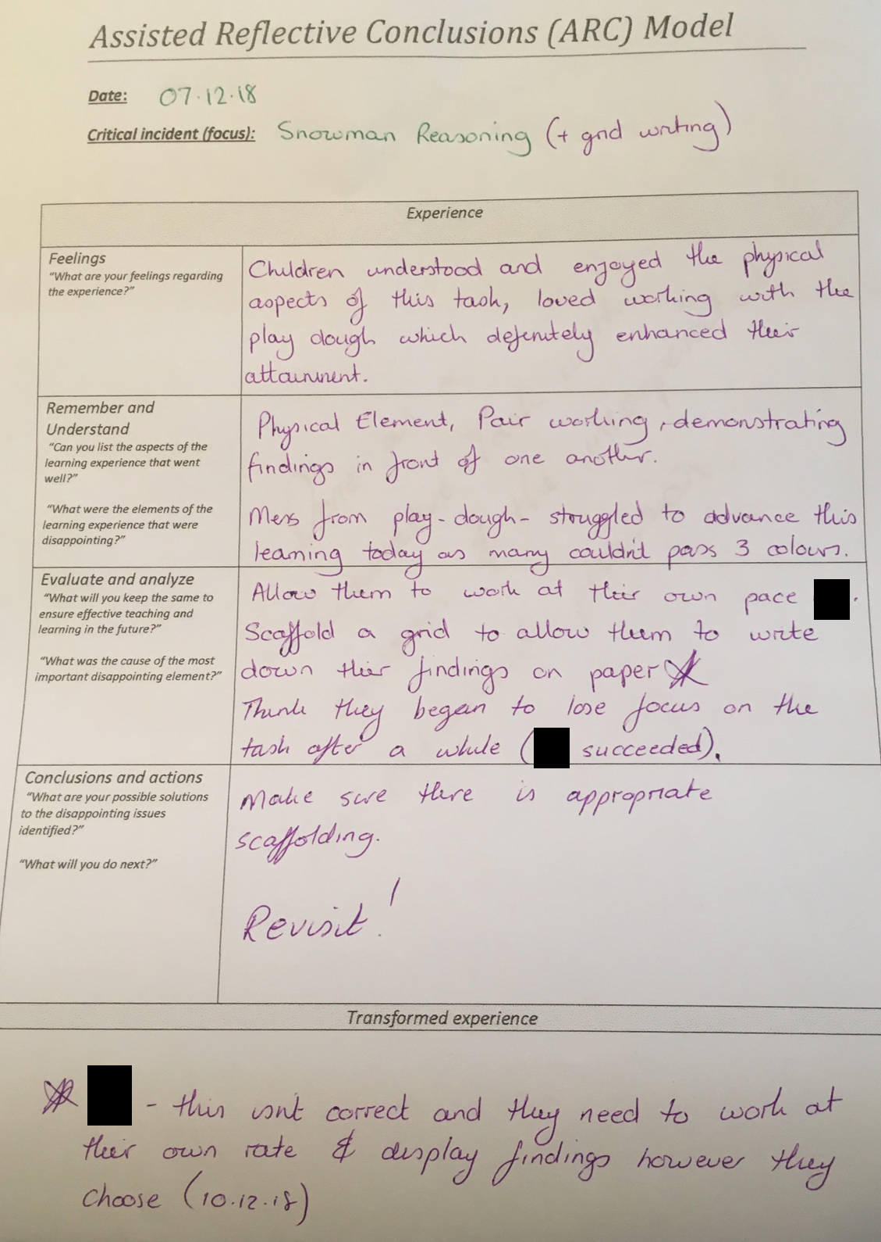
Appendix 14a Subsequently, after feedback from senior mentor, I reflected on the lesson again;
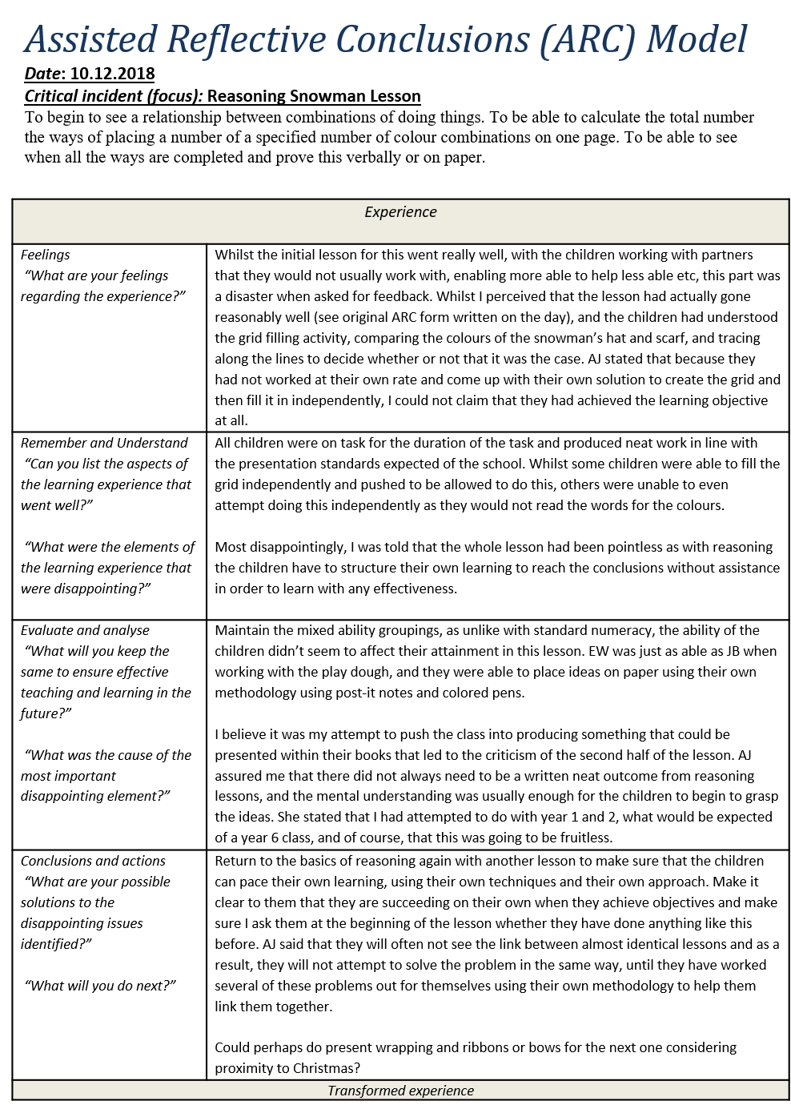
Appendix 15 Example of work produced using over scaffolded grid sheet.
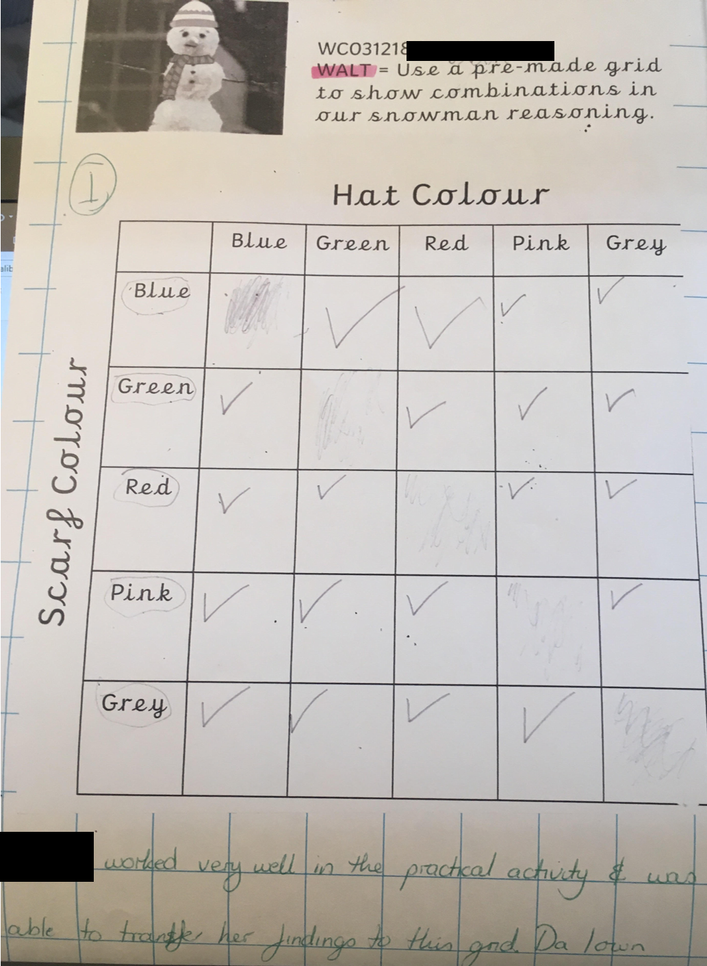
Appendix 16 Lesson plan from lesson mentioned in second ARC form (Appendix 14a) to enable children to work more independently to succeed using their own methodology.
Name of Trainee: |  |  | A Wakeling | Session ref: |  | 03.12.2018 (3) Reasoning |  | Date: | 03.12.2018 |  |  |  | Class: |  | Onnen |  | Cynllun Ffocws y Cyfnod Sylfaen  2d
Targed(au) Hyfforddi Personol |  | To maintain the whole class working in pairs that they would not pick themselves. |  |  |  |  |  | Number of learners: |  | 25 |  |  | Age: |  | 5-7 |  | Cynllun Ffocws y Cyfnod Sylfaen  2d
Learning objectives/intentions: | To begin to see a relationship between combinations of doing things. |  |  |  | Success Criteria |  | Be able to verbally explain methodology in working with materials to work towards a systematic approach |  |  |  | Meeting learners’ needs: |  |  | Non-written emphasis and COOL approach with Play dough.
Introduction/plenary tasks |  | Main activities |  |  |  |  |  |  |  |  |  | Resources/  Key Vocabulary |  |  |  | Assessment for Learning (strategies and opportunities)
Introduction  Using wrapping paper and different ribbons of the same colour as the paper, show that using purple paper and purple ribbon, there is only one way of combining those colours. |  | Trainee focused task (purpose, outline of trainee’s role and children’s learning):  After showing that there is just one way of combining one coloured paper with one coloured ribbon, introduce a second colour and ask a child to come and show the different ways they can see of doing it.  Do not give any hints at to how to write down their methodology and ways of doing things, they need to be able to do this themselves through controlling their own learning and furthering their understanding. |  |  |  |  |  |  |  |  |  | Paper and Ribbons  Play Dough & Snowmen left over from last time  Post it notes and large A3 plain paper. |  |  |  | Have you done anything like this before?  Try to prompt the children to recall what they did with the snowman and the play dough and that they can see similarities with previous tasks.
 |  | Additional adult tasks (purpose, outline of additional adults’ role and children’s learning):
Plenary  Plenary throughout, show children who are showing promise with the task to show the rest of the class and explain what they have done. |  | They must come up with a way of writing down their findings, be it through drawing the presents, or writing the colours.  Scaffold towards the end of the session for those who haven’t been able to find all the ways, a way in which they could have shown their combinations by drawing presents and colouring them in different colours.  Tell the children what ‘I would do’ and whether any of them had managed this.  Keep the paper and ribbons back, explaining that we will touch on this again in the future with more and more colours.
Curriculum coverage (range and skills)

Literacy (LNF)  Oracy in group activities. |  |  |  |  |  |  |  |  |  |  |  | Numeracy (LNF)  Reasoning and working out displaying findings.
DCF |  | Thinking |  |  |  |  |  |  |  |  |  | ESDGC  Problem Solving. |  |  |  | YCC

Appendix 17 Welsh Language Lesson Planning
Name of Trainee: |  |  | A Wakeling | Session ref: |  | 10.12.2018 (1) Welsh |  | Date: | 10.12.2018 |  |  |  | Class: |  | Onnen |  | Cynllun Ffocws y Cyfnod Sylfaen  2d
Targed(au) Hyfforddi Personol |  | Manage the full class for a whole session and maintain relationships between children whilst keeping Edan on task. |  |  |  |  |  | Number of learners: |  | 25 |  |  | Age: |  | 5-7 |  | Cynllun Ffocws y Cyfnod Sylfaen  2d
Learning objectives/intentions: | Recap all the Welsh we have covered this term and use it to create a fact file which we can refer to. |  |  |  | Success Criteria |  | Taking part in the session appropriately and being able to work as a group. Target – Ensuring children work together. |  |  |  | Meeting learners’ needs: |  |  | 1 to 1 assistance for children who require it.
Introduction/plenary tasks |  | Main activities |  |  |  |  |  |  |  |  |  | Resources/  Key Vocabulary |  |  |  | Assessment for Learning (strategies and opportunities)
Introduction  Recap pages from Tedi Twt and display the colours and numbers on the screen. Make a big deal of the welsh corner today and sing the songs for the Welsh days. |  | Trainee focused task (purpose, outline of trainee’s role and children’s learning):  Welsh that I know activity – Recap over all of the Welsh we have covered, days, months, numbers to 10, weather and clothing.  Using the prompt sheet (empty word mat with pictures) ask the children to link the words with the pictures to then stick in their topic books. All of the pages will be used in our class welsh dictionary, and the best will be displayed on the written welsh board.   |  |  |  |  |  |  |  |  |  | A3 blank word mats for each area we have learned this term |  |  |  | Questioning  What Welsh do we know?  Can we put these Welsh words in different categories?  How do you think you can show the different Welsh words in pictures?
 |  | Additional adult tasks (purpose, outline of additional adults’ role and children’s learning)
Plenary  Bring the children back to the carpet with their group’s work to show off to the other groups. |  | EE to work with the lower ability on colours and numbers to 10. Whilst AW to work with the higher ability children on days of the week, clothing, weather and numbers up to 20, along with seasonal words for Christmas. Try not to scaffold too much as the words are around in the classroom for the children to access.
Curriculum coverage (range and skills)
Literacy, Thinking, YCC, ESDGC
Literacy (LNF)  Oracy skills in introduction and plenary. Descriptive Language |  |  |  |  |  |  |  |  |  |  |  | Numeracy (LNF)  Potential to number the pages – Discussion with Welsh numbers.
DCF |  | Thinking  Bring back all the Welsh they have covered this term. |  |  |  |  |  |  |  |  |  | ESDGC |  |  |  | YCC  Welsh Language

Reference List
Arthur, J. and Cremin, T. (2010). Learning to teach in the primary school. London: Routledge.
Barton, G. (2015). Teach now! the essentials of teaching - what you need to know to be a great. Abingdon: Routledge.
Bentley-Davies, C. (2010). How to be an amazing teacher. Bancyfelin [Pays de Galles]: Crown House Pub.
Campbell, A., Gilroy, P. and McNamara, O. (2009). Practitioner research and professional development in education. London: Chapman.
Clandinin, D. and Connelly, F. (1995). Teachers' professional knowledge landscapes. New York: Teachers College Press.
Coe, R., Aloisi, C., Higgins, S. and Major, L. (2014). What Makes Great Teaching? Review of the underpinning research. [online] Suttontrust.com. Available at: https://www.suttontrust.com/wp-content/uploads/2014/10/What-Makes-Great-Teaching-REPORT.pdf [Accessed 29 Dec. 2018].
Denby, N. (2015). Training to teach. Los Angeles, Calif. [u.a.]: Sage.
Estyn, (2014). A report on Nantymoel Primary School Gwendoline Street Nantymoel Bridgend CF32 7PL Date of inspection: June 2014. [online] Estyn.gov.wales. Available at: https://www.estyn.gov.wales/sites/default/files/documents/Inspection%20report%20Nantymoel%20Primary%20School%202014%20%28English%20only%29_0.pdf. [Accessed 23 Dec. 2018].
Fontana, D. (1986). Teaching and personality. Oxford: Blackwell.
Gardner, J. (2011). ETHICAL GUIDELINES FOR EDUCATIONAL RESEARCH. [online] Bera.ac.uk. Available at: https://www.bera.ac.uk/wp-content/uploads/2014/02/BERA-Ethical-Guidelines-2011.pdf?noredirect=1 [Accessed 23 Dec. 2018].
Guerriero, S. (2017). Teachers' pedagogical knowledge: What it is and how it functions. Pedagogical Knowledge and the Changing Nature of the Teaching Profession, pp.99-118.
Grigg, R. (n.d.). Big ideas in education - what every teacher should know. Carmarthen: Crown House Publishing.
Hargreaves, A. and Fullan, M. (1996). Understanding teacher development. [London]: Cassell.
Hattie, J. (2011). Visible learning for teachers & students. London: Routledge, chapter 3.
Kliekman, T., Richter, D., Kunter, M., Elsner, J., Besser, M., Krauss, S. and Baumert, J. (2012). Teachers’ Content Knowledge and Pedagogical Content Knowledge. Journal of Teacher Education, 64(1), pp.90-106.
MacBeath, J. and Mortimore, P. (2001). Improving school effectiveness. Buckingham: Open University Press.
Piaget, J. (1962). Comments on Vygotsky's critical remarks concerning The language and thought of the child, and Judgment and reasoning in the child. [Cambridge, Mass.]: M.I.T. Press.
Reynolds, D. and Cuttance, P. (1996). School effectiveness. London: Cassell.
Rowland, T., Thwaites, A. and Huckstep, P. (2003). The Knowledge Quartet. Proceedings of the British Society for Research into Learning Mathematics, 23(3), pp.97-102.
Shulman, L. (1987). Knowledge and Teaching: Foundations of the New Reform. Harvard Educational Review, 57(1), pp.1-23.
Turnbull, J. (2010). 9 habits of highly effective teachers. London: Continuum.
Welsh Government (2014). Wales Index Multiple Deprivation - Nant-y-moel 1. [online] Wimd.wales.gov.uk. Available at: http://wimd.wales.gov.uk/lsoa/w01001024?lang=en [Accessed 23 Dec. 2018].
Welsh Government (2015). Successful Futures: Independent Review of Curriculum and Assessment Arrangements in Wales. Cardiff: Welsh Government.

Trainee Teacher Naomi was undertaking a “Lower Primary Specialism with high level A* GCSE maths subject knowledge and ‘model’ answers to ‘audits’.” (Rowland et al, 2003)
1. Content (subject) knowledge 2. General Pedagogical Knowledge 3. Curriculum Knowledge 4. Pedagogical Content Knowledge 5. Knowledge of learners and their characteristics 6. Knowledge of educational contents 7. Knowledge of educations ends.
Plan for the mentioned session included as Appendix 12.
Example of work produced during the lesson using heavily scaffolded worksheet (Appendix 15).
Plan for the subsequent lesson. (Appendix 16)
“You used a limited amount of Welsh today. You might find it helpful to plan for your use of Welsh weekly so that you are more likely to use it.” Feedback 26.11.2018

