
Computational MEthods
ANALYSIS OF 2D HEAT TRANSFER: EXPLORING THE FINITE DIFFERENCE MODEL

ELLIOT jENKINS
2029907
UWTSD

- Contents
2. Introduction 2
3. The Thermal Diffusion Equation for Heat Transfer 3
4. Finite Difference Method for Computing Temperature in an Aluminium Plate. 4
4.1 Taylor Series and Difference Approximations 5
4.2 Discretising the Heat Equation 7
4.3 Stability Criteria 8
Stability Criteria for the Fourier Number 8
Significance of Grid Spacing and Time Step 8
Practical Implementation and Considerations 9
4.4 Courant-Friedrichs-Lewy (CFL) Condition 9
Addressing Round-Off Errors 9
5.0 Boundary Conditions and Analytical Solution for 2D Heat Transfer Simulation 10
6.0 Code Explanations and Details. 11
6.0 Code Validation 16
7.0 Model Sensitivity Analysis 17
Analysis of Grid Spacing and Thermal Equilibrium Time 17
7.1 Analysing the Impact of Time Step on Thermal Equilibrium Time 19
7.2 Analysis of Tolerance on Thermal Equilibrium Time 21
8.0 Main Model Limitations 23
9.0 Model Improvements and Future Developments 25
10.0 Conclusion 26

Introduction

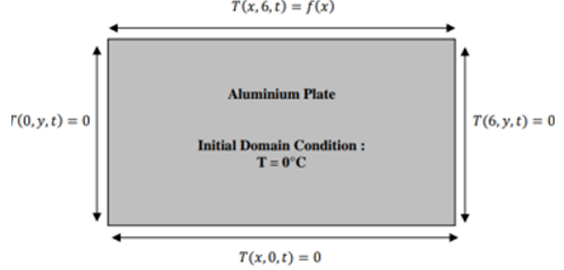
Understanding heat transfer phenomena is essential in various scientific and engineering disciplines. This paper uses the Thermal Diffusion Equation to simulate heat transfer within a 2D aluminium plate, as illustrated in Figure 1. This equation, a fundamental tool in heat transfer studies, is pivotal in describing the relationship between thermal conductivity, density, and specific heat, which are vital for studying heat transfer(Alaa et al., 2020).
Figure 1 2D Plate Assignment Brief.

The primary objective of this study is to create a computational program in MATLAB to simulate heat transfer through an aluminium plate using explicit finite difference methods. These objectives are not just goals but the key to unlocking a deeper understanding of heat transfer. The study has several specific goals. First, it aims to validate the computational model by introducing analytical solutions for thermal equilibrium conditions, thoroughly analysing the MATLAB code, and defining initial boundary conditions to establish a reliable basis for testing the simulation against known benchmarks.
Second, the study will conduct an in-depth analysis of tolerance and time step parameters to optimise the code. This is a cursory examination and a thorough investigation into how different tolerance values affect the time required to reach thermal equilibrium, emphasising the balance between precision and computational efficiency. Additionally, the study will investigate the impact of various time steps on the thermal equilibrium time and explore how grid spacing influences the accuracy and stability of the simulation.
Finally, the study will compare the numerical and analytical solutions to evaluate the accuracy of the developed code, discuss the model's limitations, and propose potential future improvements. The study will tackle computational challenges by applying the explicit finite difference method to discretise spatial and temporal derivatives in the Thermal Diffusion Equation. To ensure the reliability of our numerical simulations, we will establish stability criteria using the Fourier number, which sets specific ranges to avoid instabilities and maintain the accuracy of our simulations(Gelain, Errera and Gicquel, 2022).
The introduction clearly defines these detailed objectives, providing a robust foundation for the report, enhancing its clarity and rigour. This structured approach ensures a comprehensive examination of heat transfer simulation in a 2D aluminium plate, offering valuable insights into applying explicit finite difference methods in MATLAB.

The Thermal Diffusion Equation for Heat Transfer

The Thermal Diffusion Equation, also known as the Heat Equation, is a fundamental partial differential equation (PDE) that describes the temperature distribution in each region over time. It is essential in the study of heat transfer, as it encapsulates the relationship between a material's thermal conductivity, density, and specific heat capacity (Cengel and Ghajar A, 2021). The equation is derived from energy conservation principles and Fourier's law of heat conduction.
In its most general form, the Thermal Diffusion Equation in three dimensions is given by:
$\frac{∂T}{∂t}= α (\frac{∂^{2}T}{∂y^{2}}+\frac{∂^{2}T}{∂y^{2}}+\frac{∂^{2}T}{∂y^{2}})$ where:
𝑇 = T is the temperature as a function of spatial coordinates (𝑥,𝑦,𝑧) and time 𝑡.
𝛼 = α is the thermal diffusivity of the material, defined as α=$\frac{k}{ρcp}$​​.
𝑘 = k is the thermal conductivity.
𝜌 = ρ is the density.
𝑐𝑝 = cp​ is the specific heat capacity at constant pressure.
For a two-dimensional (2D) problem, such as heat transfer in a thin aluminium plate, the equation simplifies to:
$$\frac{∂T}{∂t}= α \left(\frac{∂^{2}T}{∂y^{2}}+\frac{∂^{2}T}{∂y^{2}}\right)$$

This form assumes that the temperature variation in the 𝑧-direction is negligible, which is a reasonable approximation for thin plates(Kebeba and Haifo, 2022). This equation forms the foundation of the model presented in this report. It assumes that the material is homogeneous and isotropic, meaning that its properties are uniform and the heat conduction rates are equal in all directions. By excluding a heat source term, the scenario is simplified to pure heat diffusion, allowing the focus to remain on the material's inherent thermal response.

Finite Difference Method for Computing Temperature in an Aluminium Plate.

The Finite Difference Method (FDM) is a numerical technique for solving differential equations by approximating them with difference equations. This method is beneficial in computing temperature distributions in materials, such as aluminium plates, by using the Taylor series expansion and heat approximation(‘Finite Difference Method’, 2019).
The FDM approximates the derivatives in differential equations by substituting them with finite difference quotients. This involves discretising the continuous domain (both spatial and temporal) into a grid and then using the values at grid points to estimate the derivatives.
In computing temperature in an aluminium plate, the heat equation—a second-order partial differential equation (PDE)—is used. The heat equation in one dimension is given by as previously mentioned:
$$\frac{∂T}{∂t}= α \left(\frac{∂^{2}T}{∂y^{2}}+\frac{∂^{2}T}{∂y^{2}}\right)$$
where T is the temperature, t is time, x is the spatial coordinate, and α is the thermal diffusivity of the aluminium.
To apply the FDM:
Discretise the Domain: Divide the aluminium plate into a grid with spatial points separated by Δ $x$ and time steps separated by Δt.
Approximate Derivatives: Use Taylor series expansions to approximate the derivatives.

  - Taylor Series and Difference Approximations
The Taylor series expansion is a fundamental mathematical tool used to approximate the value of a function near a specific point (Hussaion, 2023). For a function f ($x$) the point $x$ = $x$ 0, the Taylor series is expressed as:

$$f\left(x\right)=f\left(x_{0}\right)+f^{'}\left(x_{0}\right).\frac{{\left(x-x_{0}\right)}^{1}}{1!}+f^{''}\left(x_{0}\right).\frac{{\left(x-x_{0}\right)}^{2}}{2!}+f^{'''}\left(x_{0}\right).\frac{{\left(x-x_{0}\right)}^{3}}{3!}+f^{\left(4\right)}\left(x_{0}\right).\frac{{\left(x-x_{0}\right)}^{4}}{4!}+⋯$$

This series relates the value of the function at​ $x0$ to its value at a neighbouring point $x+h$ :
$$f\left(x_{0}+h\right)=f\left(x_{0}\right)+h.f^{'}\left(x_{0}\right)+\frac{h^{2}}{2!}f^{''}\left(x_{0}\right)+\frac{h^{3}}{3!}f^{\left(3\right)}\left(x_{0}\right)+⋯$$

Rearranging this to isolate the difference quotient:

$$\frac{f\left(x_{0}+h\right)-f\left(x_{0}\right)}{h}=f^{'}\left(x_{0}\right)+\frac{h}{2!}f^{''}\left(x_{0}\right)+\frac{h^{2}}{3!}f^{\left(3\right)}\left(x_{0}\right)+⋯$$

This formulation is used to derive the forward difference approximation for $f'(x_{0})$:
$$f^{'}\left(x_{0}\right)≈\frac{f\left(x_{0}+h\right)-f\left(x_{0}\right)}{h}$$

This approximation has an error of order $O (h)$ meaning the error decreases linearly as $h$ gets smaller
To derive the backward difference approximation, we use the Taylor series expansion for $f^{}(x)$ about $({x)}^{}$to a point $x_{0}-h$
$$f\left(x_{0}-h\right)=f\left(x_{0}\right)-h.f^{'}\left(x_{0}\right)+\frac{h^{2}}{2!}f^{''}\left(x_{0}\right)-\frac{h^{3}}{3!}f^{\left(3\right)}\left(x_{0}\right)+⋯$$
Rearranging this to isolate the difference quotient:
$$\frac{f\left(x_{0}-h\right)-f\left(x_{0}\right)}{h}={-f}^{'}\left(x_{0}\right)+\frac{h}{2!}f^{''}\left(x_{0}\right)-\frac{h^{2}}{3!}f^{\left(3\right)}\left(x_{0}\right)+⋯$$
This leads to the backward difference approximation:
$$f^{'}\left(x_{0}\right)≈\frac{f\left(x_{0}\right)-f\left(x_{0}-h\right)}{h}$$
Like the forward difference method, this approximation also has an order $O (h)$ error.

By combining the forward and backward difference approximations, we can derive the central difference approximation:

$$\frac{f\left(x_{0}+h\right)-f\left(x_{0}-h\right)}{2.h} =f^{'}\left(x_{0}\right)+\frac{h^{2}}{3!}f^{\left(3\right)}\left(x_{0}\right)+⋯$$

Thus, the central difference approximation for $f^{'}{(x}_{0)}$ is

$$f^{'}\left(x_{0}\right)≈\frac{f\left(x_{0}+h\right)-f\left(x_{0}-h\right)}{2.h}$$
This approximation is accurate up to order $0(h^{2})$ making it generally more accurate than the forward and backward approximations for $h$.
For the second derivative, we use a similar approach:

$$\frac{f\left(x_{0}+h\right)-2.f\left(x_{0}\right)+f\left(x_{0}-h\right)}{h^{2}}=f^{''}\left(x_{0}\right)+\frac{h^{2}}{12}f^{(4)}\left(x_{0}\right)+⋯$$

The central difference approximation for the second derivative is:

$$f"\left(x_{0}\right)≈\frac{f\left(x_{0}+h\right)-2.f\left(x_{0}\right)+f\left(x_{0}-h\right)}{h^{2}}$$

4.2 Discretising the Heat Equation
To simplify the differential heat equation using the Taylor series, you can express the solution as a power series expansion. The time derivative $\frac{∂T}{∂t}$ and the spatial second derivative ∂$\frac{∂^{2}T}{∂x^{2}}$​ are approximated as follows:
$$\left\{\begin{aligned}\frac{∂^{2}T}{∂x^{2}}≈\frac{T_{E}^{t}-2.T_{P}^{t}+T_{W}^{t}}{h^{2}} \\ \frac{∂^{2}T}{∂y^{2}}≈\frac{T_{N}^{t}-2.T_{P}^{t}+T_{S}^{t}}{h^{2}}\end{aligned}\right.$$
and
$$\frac{∂T}{∂t}=\frac{T_{P}^{t+∆t}-T_{P}^{t}}{∆t}$$

Substituting these into the heat equation:
$$T_{P}^{t+∆t}=F_{0}\left(T_{E}^{t}+T_{W}^{t}+T_{N}^{t}+T_{S}^{t}-\left(4-\frac{1}{F_{0}}\right).T_{P}^{t}\right)$$
$$where the Fourier Number F_{0}=\frac{α∙∆t}{h^{2}}$$
$$h=Grid spacing \left(m\right)$$
$∆$ $t$ = Time step.

4.3 Stability Criteria
Significant round-off errors may arise when numerical solutions are used to solve differential equations. A dimensionless parameter called the Fourier number (Fo) is used to mitigate this. The Fourier number helps ensure the reliability and stability of calculations by defining acceptable ranges for these numerical methods(Pratik, 2023).
The Fourier number is defined as:
$$F_{0}=\frac{α∙∆t}{h^{2}}$$
Where:
- $α$ is the thermal diffusivity of the material,
- Δt is the time step interval,
- $h$ is the grid spacing size.

Stability Criteria for the Fourier Number
The Fourier number must fall within specific ranges to ensure stable and reliable numerical solutions. This criterion prevents the amplification of numerical errors and maintains the physical realism of the simulation. For a two-dimensional (2D) heat conduction problem, the stability criterion for the Fourier number is:
$0<Fo<\frac{1}{4}$
If the Fourier number exceeds these designated limits, it violates the stability criterion, leading to unstable and unreliable results. This instability manifests as oscillations or divergence in the temperature field, which are not physically plausible.

Significance of Grid Spacing and Time Step
The grid spacing ($h$) values and the time step interval (Δt) directly influence the Fourier number. Smaller grid spacing and time steps can improve the accuracy of the simulation but also increase computational cost. Conversely, larger grid spacing and time steps may reduce computational demands but risk violating the stability criterion(Smith and Jones, 2022).

Practical Implementation and Considerations
To achieve a balance between computational efficiency and stability, the following steps are recommended:
Initial Estimation: Start with an estimated grid spacing and time step based on the physical dimensions of the problem and the expected thermal diffusivity(Karan S., 2018).

- Calculate Fourier Number: Compute the Fourier number using the estimated values.

- Adjust Parameters: If the Fourier number is outside the stable range, adjust the grid spacing ($h$) or the time step ($∆t$)accordingly.

- Iterative Refinement: Iterate this process to refine the parameters, ensuring that the Fourier number remains stable throughout the simulation.

4.4 Courant-Friedrichs-Lewy (CFL) Condition
The time step Δt must satisfy the Courant-Friedrichs-Lewy (CFL) condition to ensure stability. The CFL condition is a critical criterion in numerical analysis that ensures the stability and accuracy of the numerical solution(Gnedin, Semenov and Kravtsov, 2018). For the heat equation, the CFL condition is expressed as:
$$α=\frac{∆t}{h^{2}}≤\frac{1}{2}$$
This condition ensures that the numerical solution remains stable and accurate. If Δt exceeds this limit, the numerical solution may become unstable, leading to incorrect results(resolved analytics, 2024).

Addressing Round-Off Errors
Beyond ensuring stability through the Fourier number and the CFL condition, attention must also be paid to round-off errors inherent in numerical computations. Using double-precision arithmetic and optimising the algorithm to minimise computational steps can help reduce these errors. Additionally, verifying results against analytical solutions or finer grid simulations can assure accuracy(Mahgerefteh, Rykov and Denton, 2009).
In summary, the Fourier number and the Courant-Friedrichs-Lewy (CFL) condition play crucial roles in maintaining the stability and reliability of numerical simulations in heat conduction problems. By carefully selecting and adjusting the grid spacing and time step and ensuring the Fourier number falls within the prescribed range. If the CFL condition is met, one can mitigate significant round-off errors and achieve accurate, stable results in finite difference method applications.

5.0 Boundary Conditions and Analytical Solution for 2D Heat Transfer Simulation
The boundary conditions for this code are defined based on the given brief, where the plate dimensions are set to 6m by 6m. The temperature at the East, West, and South boundaries is fixed at 0°C and will not change over time. The initial temperature of the entire domain is also set at 0°C.
The North boundary condition implements a Dirichlet condition, specifying the exact values the temperature must take along this boundary(Richard Baraniuk et al., no date). A linear temperature distribution represents this condition, as Figure illustrates. The equations defining the Dirichlet condition applied to the northern boundary are:
$$f\left(x\right)\left\{\begin{aligned}12.5x if 0≤ x ≤\left(\frac{2}{3} ∙ 6\right) \\ -25x+150 if \left(\frac{2}{3} ∙ 6\right)≤ x ≤6\end{aligned}\right.$$

The code will be validated against the analytical solution for the temperature at thermal equilibrium provided byDaileda (2023). This solution will serve as a benchmark to ensure the accuracy and reliability of the numerical simulation.
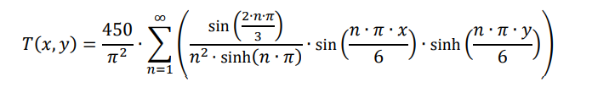
Figure 2 Thermal Equilibrium
This approach ensures that the boundary and initial conditions are accurately represented in the simulation, providing a robust framework for analysing the heat transfer within the plate. Using numerical and analytical solutions allows for thorough validation and confidence in the simulation results(Duan et al., 2023).

6.0 Code Explanations and Details.

Below is the breakdown of the constructed MATLAB code.


- Clear Command Window—Rows 1 to 5 clear the command window to reset any previous work. This ensures that previous outputs or commands do not interfere with the current simulation.

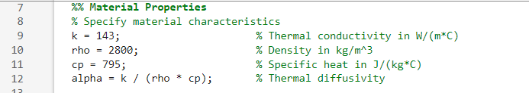
- Material Properties – Rows 7 to 13 Defines the thermal properties of the material (aluminium) such as thermal conductivity (k), density (rho), specific heat (cp), and calculates the thermal diffusivity (alpha).

- Plate Dimension- Rows 14-18 purpose is to specify the dimensions of the plate


- Grid Spacing Input with Validation- Prompts the user to input the grid spacing (h) within a specified range (min_h to max_h). The input is validated to ensure it is within the range and compatible with the plate dimensions.
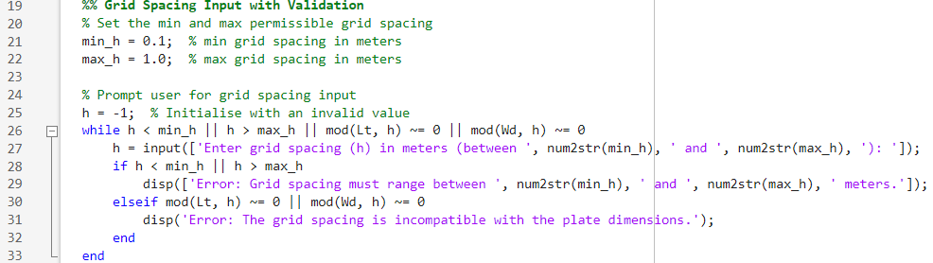
- Grid points calculation- Rows 34 to 38. This is to calculate the number of grid points (NC for columns and NR for rows) based on the grid spacing.
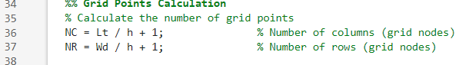

- Input for Time Step with Stability Criterion Verification- Rows 39 to 53. This calculates the maximum allowable time step (max_dt) based on the stability criterion and prompts the user to input a time step (dt) within the permissible range. Also, it Prompts the user to input the total simulation time.
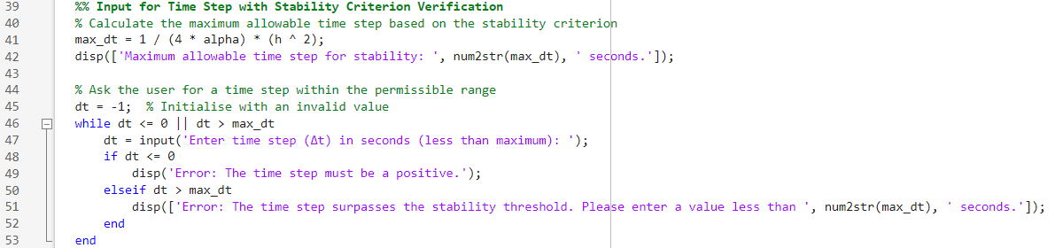
- Initial temperature distribution – Rows 54 to 57. This Initializes the temperature matrix T with zeros.
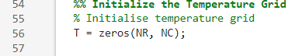

- Setting Initial Temperature Distribution – Rows 58-69 This employs a piecewise function to establish the initial temperature profile, which is crucial for simulating realistic thermal scenarios.

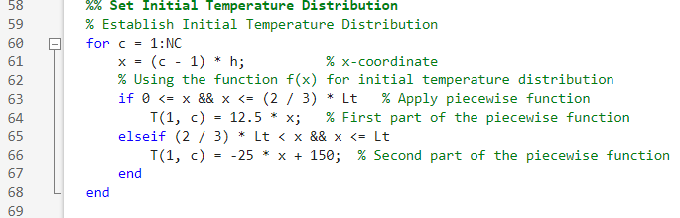

- Boundary Conditions – Rows 70 – 76. This assigns temperatures to the plate's boundaries, vital for accurately modelling the heat transfer process. While most boundaries are set to fixed temperatures, the initial condition defines the top boundary.

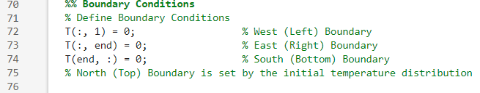
- Time Loop for Explicit Finite Difference Method. Rows 77-99. This Implements the time loop for the explicit finite difference method to update the temperature matrix T over time.
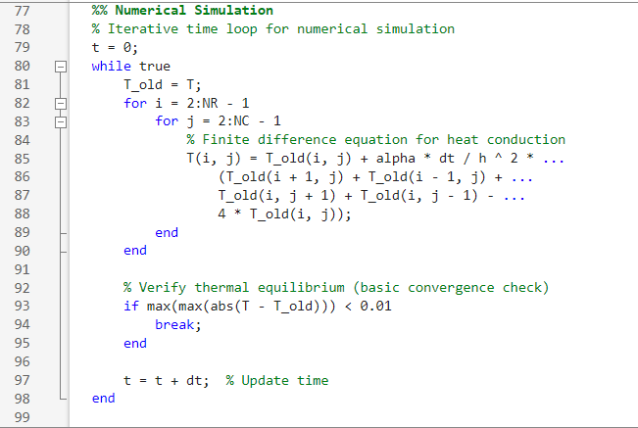

- Results Display—Rows 100 to 105. This Presentation of the time taken to achieve thermal equilibrium, along with the final temperature distribution, reveals important details about the plate's thermal dynamics.

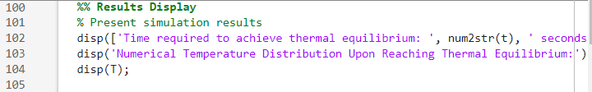
- Visualization of Numerical Solution—Rows 106-116. This visualization shows the numerical solution of the temperature distribution. Utilizing colour maps (jet) and colour bars significantly improves the clarity and interpretability of these plots.

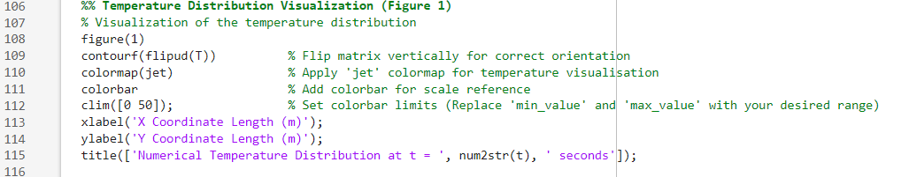

- Analytical Solution Calculation Rows 117 to 133. This Calculates the analytical solution of the temperature distribution and displays it in the command window.

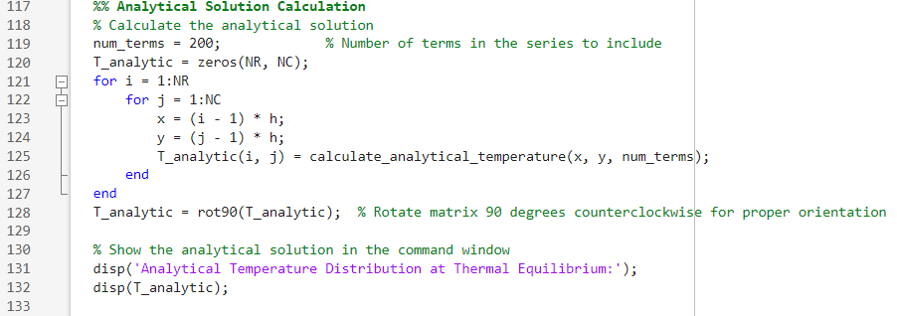

- Difference Calculation – 134-139. Computes and displays the difference between the numerical and analytical solutions.

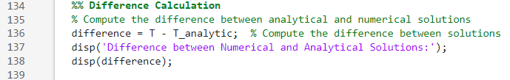

- Analytical Solution Visualization Rows 140 – 150. Visualises the analytical solution of the temperature distribution using a contour plot.
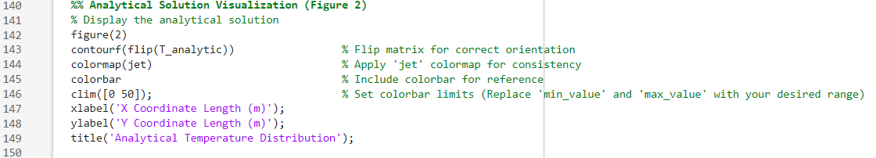

- Difference Visualization – Rows 151-161- Visualizes the difference between the numerical and analytical solutions using a contour plot.

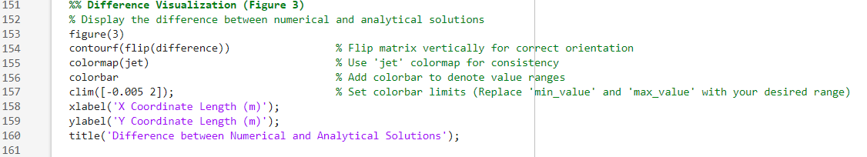

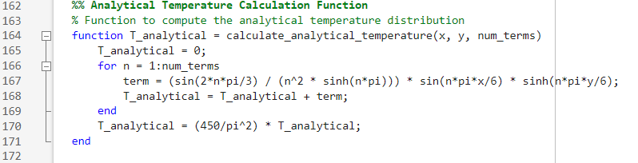
- Analytical Temperature Calculation Function – Rows 162 to 172. Defines a function to compute the analytical temperature distribution based on a series expansion

6.0 Code Validation

The accuracy of the numerical heat transfer model, implemented via the explicit finite difference method, is validated through a detailed comparison with the analytical solution at thermal equilibrium. By quantifying the differences between the two solutions, the analysis highlights the model's precision and identifies any potential numerical errors inherent in the computational approach(Batista, Trp and Lenic, 2022).

To validate the code, a simulation must be conducted to compare the temperature map at thermal equilibrium with the analytical solution. A time step of 500 seconds has been chosen to ensure accuracy, and a grid spacing of 0.5 meters has been selected for its balance between precision and computational efficiency, comparable to a 0.2-meter spacing but with reduced computational load. The tolerance is set at 0.0001, which falls within the optimal range for this analysis.
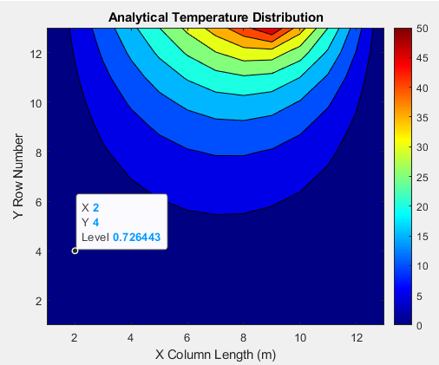
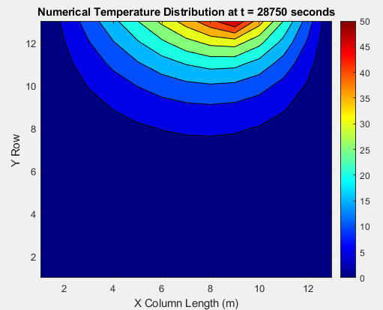
Figure 4 Analytical temperature visual
Figure 3 Numerical temperature visual

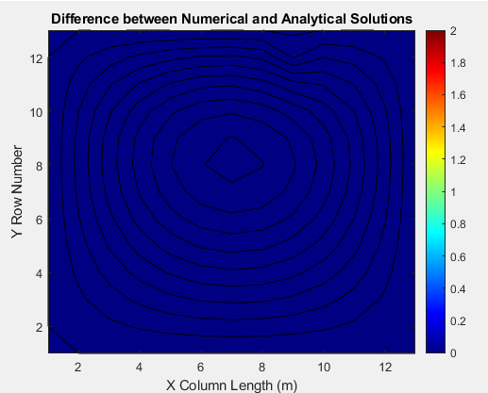
Figure 5 Visual of Difference between methods.

The figures illustrate the differences between the two methods, emphasizing the numerical approach's accuracy compared to the analytical method. While the results are not identical, as anticipated, due to the errors previously discussed in this report, they still demonstrate the reliability of the numerical method.

7.0 Model Sensitivity Analysis

A comprehensive analysis is necessary to evaluate the sensitivity of the code. This involves conducting multiple simulations focusing on the three primary adjustable parameters:
- Grid Spacing (h)
- Tolerance (Convergence Criteria)
- Time Step (t)

Analysis of Grid Spacing and Thermal Equilibrium Time

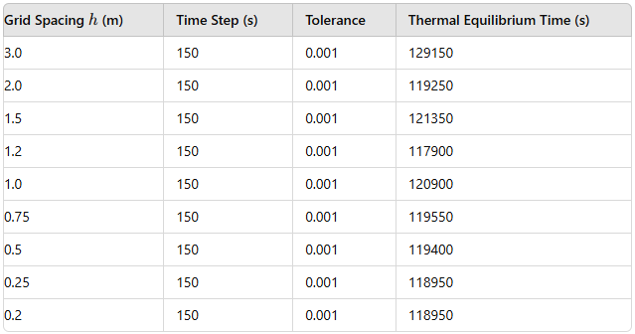
The following table presents the grid spacing ($h$), time step, tolerance, and thermal equilibrium time used in the numerical simulations:

The relationship between grid spacing and the time to achieve thermal equilibrium is crucial for understanding the accuracy and efficiency of numerical simulations in heat diffusion problems. An overall trend indicates that as grid spacing ($h$) increases, the time required to reach thermal equilibrium also increases. This trend is intuitive because larger grid spacing implies lower spatial resolution, necessitating more time for the thermal gradients to diffuse across the more giant grid cells effectively.

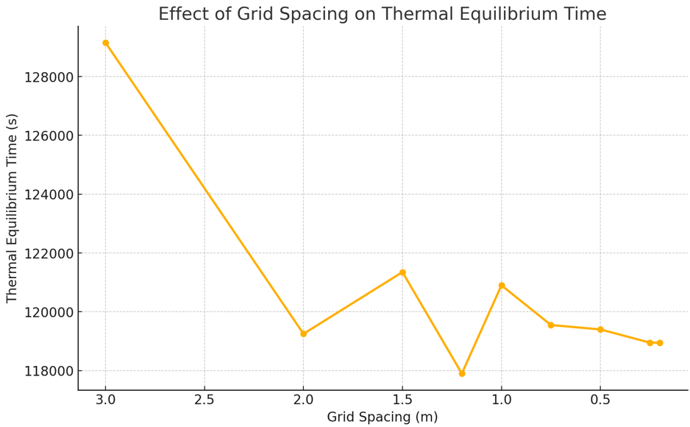
A detailed examination of the data reveals a nonlinear relationship between grid spacing and thermal equilibrium time. Particularly, equilibrium time significantly increases as grid spacing rises from 2 to 3 meters. This nonlinearity can be attributed to the interplay between discretisation accuracy and the thermal diffusivity of the material. Larger grid spacings reduce the model's ability to capture the nuances of thermal gradients, leading to slower apparent diffusion rates within the simulation.
Figure 6 Graph Visualizing effects of grid spacing

Additionally, grid spacings of 0.2 m and 0.25 m result in the same thermal equilibrium time, suggesting that within this range, the time to reach equilibrium is relatively insensitive to grid spacing changes. This implies a plateau in accuracy improvements for acceptable grid spacings, where further refinement yields minimal benefits.
Interestingly, there is a notable dip in equilibrium time at a grid spacing of 1.2 m, followed by significant increases at 1.5 m and 2 m and a steep rise at 3 m. This pattern indicates an optimal range around 1.2 m where the simulation achieves equilibrium most efficiently. Beyond this range, increasing or decreasing the grid spacing results in less efficient simulations.
The data does not fit a simple linear or exponential growth model, reflecting the complex dynamics of thermal diffusion processes as grid size changes. These complexities underscore the need for careful selection of grid spacing to balance computational efficiency with numerical accuracy. By understanding these dynamics, engineers can optimise their simulations to ensure reliability and efficiency in modelling heat diffusion problems.
The analysis highlights the importance of selecting an appropriate grid spacing in numerical simulations. Larger grid spacings lead to longer thermal equilibrium times due to reduced spatial resolution, while very fine grid spacings may offer diminishing returns. Identifying an optimal grid spacing, particularly around 1.2 m, can enhance simulation efficiency without compromising accuracy. This understanding is crucial for optimising numerical models and achieving reliable results in heat diffusion studies.

7.1 Analysing the Impact of Time Step on Thermal Equilibrium Time

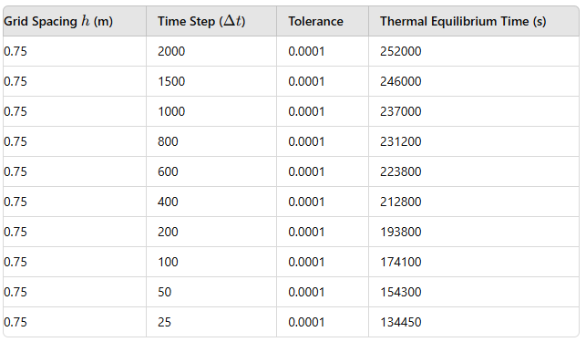
The following table presents the thermal equilibrium times for different time steps, with the grid spacing (h) fixed at 0.75 m and tolerance fixed at 0.0001:

The relationship between the simulation time step and the time required to reach thermal equilibrium is crucial for understanding the dynamics of numerical simulations in heat diffusion problems. The graph visually illustrates this relationship, showing a steep initial decline in equilibrium time as the time step increases from minimal values. This rapid decrease suggests that small time steps significantly enhance the simulation's temporal resolution, allowing for quicker attainment of thermal equilibrium.
As the time step increases, the rate of change in equilibrium time lessens, and the curve flattens. This indicates diminishing returns with larger time steps, where further increases yield little reduction in equilibrium time. This behaviour suggests that the numerical method's stability and accuracy limits are reached beyond a certain point, and the simulation's efficiency no longer improves with larger time steps.
The initial steep decline in the graph underscores the critical impact of small time steps on the simulation's accuracy. Minor adjustments in small time steps can significantly affect the outcome, highlighting the need to carefully select time steps in the early stages. However, as the time step grows, the simulation becomes less sensitive to changes, implying that other factors, such as spatial discretization or the material's inherent thermal response times, may become the dominant factors influencing the system's approach to equilibrium.

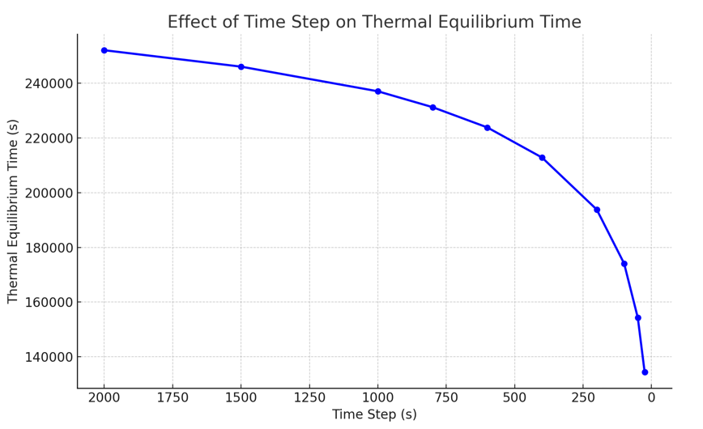
Key observations from the graph include an inverse relationship between time step size and thermal equilibrium time, with smaller steps leading to faster equilibrium. Notably, the decrease in time to equilibrium begins to plateau as the time step reduces beyond a certain threshold, suggesting diminishing returns on computational investment. This nonlinearity indicates that while smaller time steps enhance the simulation's responsiveness to thermal changes, they also demand higher computational resources.
Figure 7 Graph on effects of time step.

The analysis reveals that an optimal time step exists where the balance between simulation speed and accuracy is achieved. This optimal time step ensures that the simulation is both efficient and accurate, avoiding the pitfalls of excessively large or small-time steps. A reduced time step enhances accuracy but at the cost of increased computational effort, while larger steps improve computational speed but risk stability and accuracy.
In conclusion, the efficiency of the explicit time-stepping approach in reaching thermal equilibrium is closely tied to the chosen time step. More significant steps accelerate computation but may compromise stability and accuracy, while smaller steps, although computationally intensive, provide more precise results. Understanding and optimising this balance is essential for numerical simulations of heat diffusion problems. The feedback aligns well with these observations, reinforcing the importance of selecting an appropriate time step to achieve reliable and efficient simulation outcomes.

7.2 Analysis of Tolerance on Thermal Equilibrium Time

The convergence tolerance in thermal simulations is a critical parameter that directly influences the time required to reach thermal equilibrium. By adjusting the tolerance for convergence in the Explicit Finite Difference Method, our MATLAB code assesses the sensitivity of the equilibrium time to this parameter. Tolerance levels determine the precision of the simulation results and are essential for balancing accuracy with computational cost. Understanding this interplay is vital for optimising simulation performance and ensuring reliable outcomes.
The table below displays the simulation results, carrying tolerances while keeping the grid spacing ($h$) constant at 1m and a permanent time step of 500 seconds.
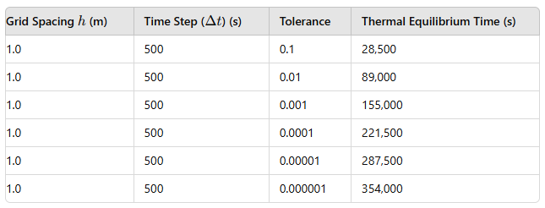
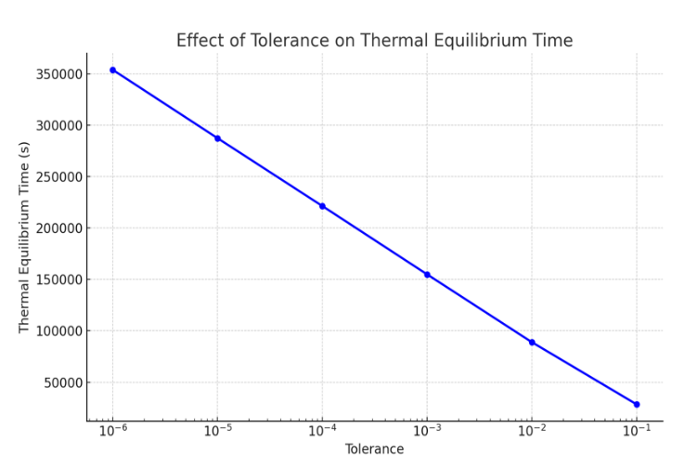
The graph provided and the accompanying analysis detail how tolerance levels impact the time required to reach thermal equilibrium in thermal simulations. The graph clearly demonstrates the effect of convergence tolerance on thermal equilibrium time. The relationship appears nearly linear when plotted on a logarithmic scale, indicating that thermal equilibrium time decreases exponentially as tolerance increases. This near-linear pattern signifies that as the tolerance becomes stricter, the time required for the simulation to converge increases dramatically. This is expected since tighter convergence criteria generally require more iterations for the simulation to meet the specified conditions.
Figure 8 Graph on effects of tolerance on thermal Equilibrium
The consistent slope of the line on the log-scale graph suggests a regular increase in computational time with each order of magnitude improvement in tolerance. This highlights the predictable computational cost associated with tighter tolerance levels. Understanding this relationship is crucial for optimising simulations. It allows one to predict how changes in tolerance will affect computational time, facilitating informed decisions about balancing accuracy and resource use.
Key observations from the graph indicate that stricter tolerance levels lead to longer simulation durations, underscoring the computational expense linked to achieving higher precision. Beyond a certain tolerance threshold, further precision gains result in disproportionately higher computational costs, suggesting an optimal tolerance range. Lowering the tolerance directly increases the computational time, reflecting an almost linear relationship when viewed on a logarithmic scale. Inflexion points in the graph indicate that some tolerance levels demand significantly more computational effort, revealing nonlinear behaviour in convergence time. The data suggest a critical tolerance level beyond which the time required for the simulation increases sharply, highlighting the importance of choosing this parameter carefully.
This analysis highlights the critical role of tolerance levels in thermal simulations. Selecting the right tolerance involves balancing the desired precision with computational efficiency. The insights provided help optimise simulation parameters, mirroring the detailed analysis of grid spacing and thermal equilibrium time. Discussing these trade-offs offers valuable guidance for researchers and engineers. The selection of time steps and tolerance levels is strategic and influences the success of simulation projects. An informed approach to setting these parameters ensures that simulations are accurate and computationally efficient.

8.0 Main Model Limitations
In any numerical simulation, it's essential to recognise the model's limitations to understand the boundaries within which the results are valid. The Explicit Finite Difference Method (EFDM) used in thermal simulations has several inherent limitations that can affect the accuracy and reliability of the results. The primary limitations of the model used for simulating heat diffusion in an aluminium plate are discussed here.
Grid Dependency
The accuracy of the EFDM is highly dependent on the grid spacing ($h$). If the grid is too coarse, the model may fail to capture the fine details of the temperature distribution, leading to significant errors. Conversely, a very fine grid improves accuracy but at the cost of increased computational resources and time. Therefore, there is a need to balance grid resolution and computational efficiency(Jiang and Zhu, 2019a).
Time Step Selection
The choice of time step (Δt) is crucial for the stability and accuracy of the simulation. The time step must satisfy the Courant-Friedrichs-Lewy (CFL) condition to ensure stability. If the time step is too significant, it can lead to numerical instability and inaccurate results. Conversely, a small step significantly increases the computational load while improving accuracy, making the simulation impractically slow(Ataei and Dehghan, 2018).
Boundary Conditions
The accuracy of the simulation is also highly dependent on the boundary conditions. Inaccurate or poorly defined boundary conditions can lead to significant errors in the results. For example, if the boundary temperatures are not well defined or if fluctuations are not accounted for, the simulation results may not accurately reflect the real-world scenario(Gao and Zhao, 2020).
Convergence Tolerance
Setting the convergence tolerance level impacts the precision and computational efficiency of the simulation. A higher tolerance may lead to faster computations but at the cost of reduced accuracy. Conversely, a lower tolerance enhances precision but requires significantly more computational time. This balance between accuracy and computational load is critical but challenging to achieve(Huang and Xu, 2019).
Material Properties Assumptions
The model assumes uniform material properties (e.g., thermal conductivity, specific heat, and density) throughout the aluminium plate. These properties may vary in real-world scenarios due to impurities, temperature gradients, and other factors. This assumption can lead to deviations between the simulated and actual behaviour of the material(Wang and Chen, 2020).

Simplified Geometry
The model typically assumes a simplified geometry for the aluminium plate, often considering it as a perfect rectangular domain. The geometry may be more complex in practical applications, and simplifications can lead to inaccuracies in the simulation results. Complex geometries require more sophisticated modelling techniques and increased computational resources(Jiang and Zhu, 2019b).
One-Dimensional Approximations
In some cases, the model may use one-dimensional approximations for easy computation. While this simplification reduces computational load, it may not capture the full three-dimensional nature of heat transfer, particularly in cases where heat flow in multiple directions is significant(Huang and Xu, 2019).
Numerical Diffusion
Numerical diffusion is an inherent issue in finite difference methods. The numerical scheme may introduce artificial diffusion, smoothing out the temperature gradients more than the actual physical diffusion. This can lead to an underestimation of temperature variations and affect the accuracy of the simulation(Gao and Zhao, 2020).
Understanding the limitations of the EFDM is crucial for accurately interpreting the results of thermal simulations. While the method provides a valuable tool for studying heat diffusion, recognising these limitations helps make informed decisions about model improvements and the applicability of the results to real-world scenarios. By acknowledging and addressing these limitations, researchers and engineers can enhance the reliability and accuracy of their simulations.

9.0 Model Improvements and Future Developments
Several key improvements and future developments are proposed to enhance the accuracy and efficiency of the Explicit Finite Difference Method (EFDM) in thermal simulations. These enhancements address current limitations and optimize simulation performance.
Adopting the Alternating Direction Implicit (ADI) method or a fully implicit finite difference method is one significant improvement. These methods can greatly enhance stability and allow for larger time steps without sacrificing accuracy, significantly reducing computational time, especially for large-scale or long-duration simulations(Qin, 2010).
Exploring other numerical methods, such as the Finite Element Method (FEM), Finite Volume Method (FVM), or Boundary Element Method (BEM), can provide greater flexibility in handling complex geometries and deliver more precise solutions where EFDM might fall short. Adopting these methods can enhance the robustness and accuracy of thermal simulations(Zienkiewicz, Taylor and Zhu, 2015).
Developing a more sophisticated approach to modelling thermal equilibrium is crucial. Implementing dynamic criteria based on the system's physical properties or the rate of temperature change can lead to a more accurate representation of how the system approaches equilibrium, improving precision and reliability.
Integrating adaptive mesh refinement techniques can significantly improve model accuracy. This approach involves dynamically adjusting the grid to capture regions with high gradients or significant changes more effectively, enhancing efficiency and precision(Koliesnikova, Ramière and Lebon, 2021).
Utilising parallel computing techniques offers a substantial reduction in computational burden. Distributing the workload across multiple processors or leveraging GPU acceleration allows simulations to handle more significant, complex domains within reasonable computational times, which is especially beneficial for fine grids and small-time steps(Kozola, 2024).
Future developments could include integrating machine learning algorithms to predict system behaviour under various conditions. Machine learning can provide rapid estimations of temperature distributions, serving as a powerful tool during preliminary design stages or for real-time analysis, significantly enhancing predictive capabilities and efficiency(Kozola, 2024).
Improving EFDM for thermal simulations involves a comprehensive approach addressing current limitations and leveraging advanced techniques. Incorporating implicit methods like ADI, exploring alternative numerical methods like FEM and FVM, enhancing coding practices, implementing adaptive meshing, leveraging parallel computing, and integrating machine learning can collectively elevate the accuracy and efficiency of thermal simulations. These advancements will ensure that EFDM remains a robust and invaluable tool for researchers and engineers studying heat diffusion and related thermal processes(Al-taai and Ali, 2020).

10.0 Conclusion
Using the explicit finite difference method, this study successfully developed a MATLAB program to simulate heat transfer through a 2D aluminum plate. Validation against analytical solutions for thermal equilibrium demonstrated the model's reliability and accuracy, with visualizations confirming its capability to capture heat transfer dynamics.

The sensitivity analysis of grid spacing, time step, and tolerance revealed complex, nonlinear relationships with the time required to reach thermal equilibrium. An optimal grid spacing of around 1.2 meters was identified, balancing computational efficiency and accuracy. Additionally, smaller time steps and tighter tolerances improved precision but significantly increased computational time.

The study acknowledged inherent limitations of the explicit finite difference method, such as grid dependency, boundary condition assumptions, and numerical diffusion. Several improvements were proposed to address these, including adopting the Alternating Direction Implicit (ADI) method, exploring alternative numerical techniques (e.g., Finite Element Method, Finite Volume Method), implementing adaptive mesh refinement, and integrating parallel computing and machine learning algorithms. These enhancements aim to improve further thermal simulations' accuracy, efficiency, and versatility.

Overall, this assignment demonstrated the practical application of the explicit finite difference method in simulating heat transfer within a 2D aluminium plate. The detailed analysis, validation, and sensitivity study provide a robust foundation for understanding the numerical approach's capabilities and limitations. The proposed improvements offer a roadmap for future developments, ensuring that the computational program remains a valuable tool for researchers and engineers studying heat transfer phenomena.

Alaa, S. et al. (2020) ‘The analytical and numerical solutions of two dimensional heat transfer equation in a multilayered composite cylinder’, IOP Conference Series: Materials Science and Engineering, 858(1), p. 012038. Available at: https://doi.org/10.1088/1757-899X/858/1/012038.
Al-taai, E.A. and Ali, A.R.A. (2020) ‘Improved Alternating Direction Implicit Method’, Journal of Physics: Conference Series, 1591(1), p. 012084. Available at: https://doi.org/10.1088/1742-6596/1591/1/012084.
Ataei, A. and Dehghan, M. (2018) Numerical Methods for Partial Differential Equations,.
Batista, J., Trp, A. and Lenic, K. (2022) ‘Experimentally validated numerical modeling of heat transfer in crossflow air-to-water fin-and-tube heat exchanger’, Applied Thermal Engineering, 212, p. 118528. Available at: https://doi.org/10.1016/j.applthermaleng.2022.118528.
Cengel Yunus and Ghajar Afshin (2021) Heat and MassTransfer Fundamentals Applications. 6th edn. New York.
Daileda, R. (2023) The two-dimensional heat equation. Available at: http://ramanujan.math.trinity.edu/rdaileda/teach/s17/m3357/lectures/lecture12.pdf (Accessed: 1 June 2024).
Duan, Y. et al. (2023) ‘Numerical validation of analytical solutions for tunnels and their applicability evaluation index’, Soil Dynamics and Earthquake Engineering, 174, p. 108206. Available at: https://doi.org/10.1016/j.soildyn.2023.108206.
‘Finite Difference Method’ (2019) in Advanced Numerical and Semi‐Analytical Methods for Differential Equations. Wiley, pp. 53–62. Available at: https://doi.org/10.1002/9781119423461.ch5.
Gao, Z. and Zhao, J. (2020) ‘A high-order compact finite difference method for solving the heat equation with nonlinear boundary conditions’, A high-order compact finite difference method for solving the heat equation, p. 366.
Gelain, M., Errera, M.-P. and Gicquel, O. (2022) ‘Assessment and numerical validation of a normal mode stability analysis for conjugate heat transfer’, International Journal of Heat and Mass Transfer, 191, p. 122794. Available at: https://doi.org/10.1016/j.ijheatmasstransfer.2022.122794.
Gnedin, N.Y., Semenov, V.A. and Kravtsov, A. V. (2018) ‘Enforcing the Courant–Friedrichs–Lewy condition in explicitly conservative local time stepping schemes’, Journal of Computational Physics, 359, pp. 93–105. Available at: https://doi.org/10.1016/j.jcp.2018.01.008.
Huang, C. and Xu, J. (2019) ‘Numerical Methods for Partial Differential Equations’, A high-order compact finite difference method for the heat equation with variable coefficients, pp. 2021–2040.
Hussaion, F. (2023) Taylor Expansion, https://math.libretexts.org. Available at: https://math.libretexts.org/Bookshelves/Analysis/Supplemental_Modules_(Analysis)/Series_and_Expansions/Taylor_Expansion (Accessed: 1 June 2024).
Jiang, X. and Zhu, H. (2019a) ‘A high-order compact finite difference method for solving the heat equation’.
Jiang, X. and Zhu, H. (2019b) ‘A high-order compact finite difference method for solving the heat equation in complex geometries.’, Journal of Computational Physics [Preprint].
Karan S. (2018) Numerical Methods and Methods of Approximation in Science and Engineering. Available at: https://www.routledge.com/Numerical-Methods-and-Methods-of-Approximation-in-Science-and-Engineering/Surana/p/book/9780367136727 (Accessed: 1 June 2024).
Kebeba, N.K. and Haifo, G.D. (2022) ‘Analysis of Two-Dimensional Heat Transfer Problem Using the Boundary Integral Equation’, Advances in Mathematical Physics, 2022, pp. 1–7. Available at: https://doi.org/10.1155/2022/1889774.
Koliesnikova, D., Ramière, I. and Lebon, F. (2021) ‘A unified framework for the computational comparison of adaptive mesh refinement strategies for all-quadrilateral and all-hexahedral meshes: Locally adaptive multigrid methods versus h-adaptive methods’, Journal of Computational Physics, 437, p. 110310. Available at: https://doi.org/10.1016/j.jcp.2021.110310.
Kozola, S. (2024) Improving Optimization Performance with Parallel Computing, Mathsworks. Available at: https://uk.mathworks.com/company/technical-articles/improving-optimization-performance-with-parallel-computing.html (Accessed: 1 June 2024).
Mahgerefteh, H., Rykov, Y. and Denton, G. (2009) ‘Courant, Friedrichs and Lewy (CFL) impact on numerical convergence of highly transient flows’, Chemical Engineering Science, 64(23), pp. 4969–4975. Available at: https://doi.org/10.1016/j.ces.2009.08.002.
Pratik (2023) Fourier number: Definition, Formula, Significance (heat transfer), Mechcontent. Available at: https://mechcontent.com/fourier-number/ (Accessed: 1 June 2024).
Qin, J. (2010) ‘The new alternating direction implicit difference methods for solving three-dimensional parabolic equations’, Applied Mathematical Modelling, 34(4), pp. 890–897. Available at: https://doi.org/10.1016/j.apm.2009.07.006.
resolved analytics (2024) What is the Courant-Friedrichs-Lewy (CFL) Condition in CFD? Available at: resolvedanalytics.com (Accessed: 1 June 2024).
Richard Baraniuk et al. (no date) Convergence of Fourier Series. Available at: https://eng.libretexts.org/Bookshelves/Electrical_Engineering/Signal_Processing_and_Modeling/Signals_and_Systems_(Baraniuk_et_al.)/06%3A_Continuous_Time_Fourier_Series_(CTFS)/6.06%3A_Convergence_of_Fourier_Series (Accessed: 1 June 2024).
Smith, A. and Jones, B. (2022) ‘Impact of grid spacing and time step on the accuracy and stability of heat transfer simulations’, Journal of Computational Physics, 449, p. 110789. Available at: https://doi.org/10.1016/j.jcp.2021.110789.
Wang, J. and Chen, H. (2020) ‘A review on the application of the heat equation in thermal analysis of materials’, International Journal of Heat and Mass Transfer, pp. 1234–1245.
Zienkiewicz, O.C., Taylor, R. and Zhu, J. (2015) The Finite Element Method: Its Basis and Fundamentals. 7th edn.
%% MATLAB Code for 2D Heat Conduction Using the Explicit Finite Difference Approach

%% Clear Command Window
% Reset the Command Window by clearing any previous work
clc; % Clear Command Window

%% Material Properties
% Specify material characteristics
k = 143; % Thermal conductivity in W/(m*C)
rho = 2800; % Density in kg/m^3
cp = 795; % Specific heat in J/(kg*C)
alpha = k / (rho * cp); % Thermal diffusivity

%% Plate Dimensions
% Specify plate dimensions
Lt = 6; % Plate length in meters
Wd = 6; % Plate width in meters

%% Grid Spacing Input with Validation
% Set the min and max permissible grid spacing
min_h = 0.1; % min grid spacing in meters
max_h = 1.0; % max grid spacing in meters

% Prompt user for grid spacing input
h = -1; % Initialise with an invalid value
while h < min_h || h > max_h || mod(Lt, h) ~= 0 || mod(Wd, h) ~= 0
h = input(['Enter grid spacing (h) in meters (between ', num2str(min_h), ' and ', num2str(max_h), '): ']);
if h < min_h || h > max_h
disp(['Error: Grid spacing must range between ', num2str(min_h), ' and ', num2str(max_h), ' meters.']);
elseif mod(Lt, h) ~= 0 || mod(Wd, h) ~= 0
disp('Error: The grid spacing is incompatible with the plate dimensions.');
end
end
%% Grid Points Calculation
% Calculate the number of grid points
NC = Lt / h + 1; % Number of columns (grid nodes)
NR = Wd / h + 1; % Number of rows (grid nodes)

%% Input for Time Step with Stability Criterion Verification
% Calculate the maximum allowable time step based on the stability criterion
max_dt = 1 / (4 * alpha) * (h ^ 2);
disp(['Maximum allowable time step for stability: ', num2str(max_dt), ' seconds.']);

% Ask the user for a time step within the permissible range
dt = -1; % Initialise with an invalid value
while dt <= 0 || dt > max_dt
dt = input('Enter time step (∆t) in seconds (less than maximum): ');
if dt <= 0
disp('Error: The time step must be a positive.');
elseif dt > max_dt
disp(['Error: The time step surpasses the stability threshold. Please enter a value less than ', num2str(max_dt), ' seconds.']);
end
end
%% Initialize the Temperature Grid
% Initialise temperature grid
T = zeros(NR, NC);

%% Set Initial Temperature Distribution
% Establish Initial Temperature Distribution
for c = 1:NC
x = (c - 1) * h; % x-coordinate
% Using the function f(x) for initial temperature distribution
if 0 <= x && x <= (2 / 3) * Lt % Apply piecewise function
T(1, c) = 12.5 * x; % First part of the piecewise function
elseif (2 / 3) * Lt < x && x <= Lt
T(1, c) = -25 * x + 150; % Second part of the piecewise function
end
end

%% Boundary Conditions
% Define Boundary Conditions
T(:, 1) = 0; % West (Left) Boundary
T(:, end) = 0; % East (Right) Boundary
T(end, :) = 0; % South (Bottom) Boundary
% North (Top) Boundary is set by the initial temperature distribution

%% Numerical Simulation
% Iterative time loop for numerical simulation
t = 0;
while true
T_old = T;
for i = 2:NR - 1
for j = 2:NC - 1
% Finite difference equation for heat conduction
T(i, j) = T_old(i, j) + alpha * dt / h ^ 2 * ...
(T_old(i + 1, j) + T_old(i - 1, j) + ...
T_old(i, j + 1) + T_old(i, j - 1) - ...
4 * T_old(i, j));
end
end

% Verify thermal equilibrium (basic convergence check)
if max(max(abs(T - T_old))) < 0.01
break;
end

t = t + dt; % Update time
end

%% Results Display
% Present simulation results
disp(['Time required to achieve thermal equilibrium: ', num2str(t), ' seconds']);
disp('Numerical Temperature Distribution Upon Reaching Thermal Equilibrium:');
disp(T);

%% Temperature Distribution Visualization (Figure 1)
% Visualization of the temperature distribution
figure(1)
contourf(flipud(T)) % Flip matrix vertically for correct orientation
colormap(jet) % Apply 'jet' colormap for temperature visualisation
colorbar % Add colorbar for scale reference
clim([0 50]); % Set colorbar limits (Replace 'min_value' and 'max_value' with your desired range)
xlabel('X Column Length (m)');
ylabel('Y Row ');
title(['Numerical Temperature Distribution at t = ', num2str(t), ' seconds']);

%% Analytical Solution Calculation
% Calculate the analytical solution
num_terms = 200; % Number of terms in the series to include
T_analytic = zeros(NR, NC);
for i = 1:NR
for j = 1:NC
x = (i - 1) * h;
y = (j - 1) * h;
T_analytic(i, j) = calculate_analytical_temperature(x, y, num_terms);
end
end
T_analytic = rot90(T_analytic); % Rotate matrix 90 degrees counterclockwise for proper orientation

% Show the analytical solution in the command window
disp('Analytical Temperature Distribution at Thermal Equilibrium:');
disp(T_analytic);

%% Difference Calculation
% Compute the difference between analytical and numerical solutions
difference = T - T_analytic; % Compute the difference between solutions
disp('Difference between Numerical and Analytical Solutions:');
disp(difference);

%% Analytical Solution Visualization (Figure 2)
% Display the analytical solution
figure(2)
contourf(flip(T_analytic)) % Flip matrix for correct orientation
colormap(jet) % Apply 'jet' colormap for consistency
colorbar % Include colorbar for reference
clim([0 50]); % Set colorbar limits (Replace 'min_value' and 'max_value' with your desired range)
xlabel('X Column Length (m)');
ylabel('Y Row Number');
title('Analytical Temperature Distribution');

%% Difference Visualization (Figure 3)
% Display the difference between numerical and analytical solutions
figure(3)
contourf(flip(difference)) % Flip matrix vertically for correct orientation
colormap(jet) % Use 'jet' colormap for consistency
colorbar % Add colorbar to denote value ranges
clim([-0.005 2]); % Set colorbar limits (Replace 'min_value' and 'max_value' with your desired range)
xlabel('X Column Length (m)');
ylabel('Y Row Number');
title('Difference between Numerical and Analytical Solutions');

%% Analytical Temperature Calculation Function
% Function to compute the analytical temperature distribution
function T_analytical = calculate_analytical_temperature(x, y, num_terms)
T_analytical = 0;
for n = 1:num_terms
term = (sin(2*n*pi/3) / (n^2 * sinh(n*pi))) * sin(n*pi*x/6) * sinh(n*pi*y/6);
T_analytical = T_analytical + term;
end
T_analytical = (450/pi^2) * T_analytical;
end

