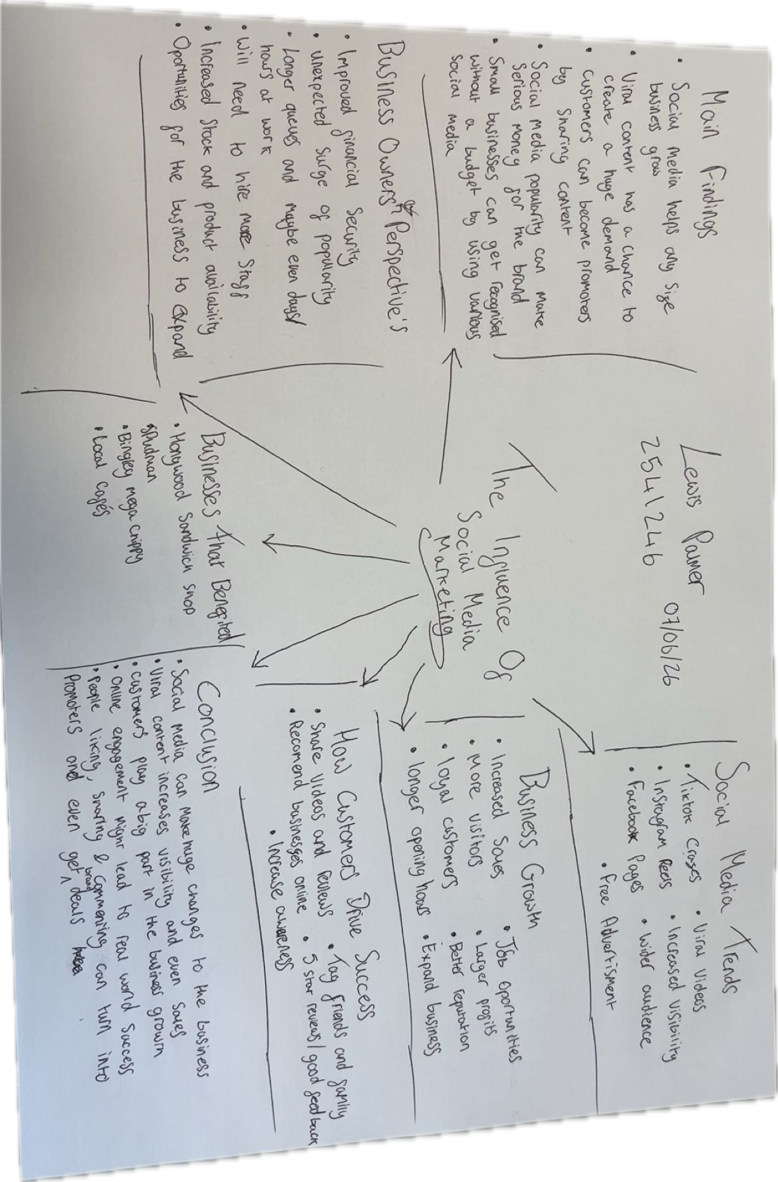


Task 1 – Reading Task Template
Upload your photo of your A3 in-class notes here:

1. Answer these questions using the sentence starters below
a. What is the main idea of the text?
The main idea is that social media and customers who promote the brand are a favourable marketing strategy for low to no budgeting.
b. What are two key points?
One key point is to consider using social media to promote a business
Another key point is engage with customers and it’s a win win for both the customer and owner.
c. What part of the text did you find most important? Why?
The most important part in my opinion is the parts stating the benefits of using social media.
d. Was anything unclear or difficult to understand?
I was not sure about most of it at first but after going through it a few times things started to clear up.
e. How did your group help you understand the text better?
My group helped me by giving my me their opinion and giving their thoughts about my opinion
3. One sentence reflection
Question: What did you find challenging about this task?
The hardest part was trying to keep my keep points as short and understandable as possible and trying to find something new I can add.

