

Programme: MBA – Master of Business Administration
Module: Human Resource Management
Module code: LCMB7000

ASSESSMENT 1-HUMAN RESOURCE MANAGEMENT

Student Name: MOHAMMED ABDUL THAKIE
Student ID: 2241639
Word Count: 2500
Lecturer: GLADIUS KULOTHUNGAN

DATE:23/8/2023

Table of Contents
Overview of the topic 3
a) The current state of the labour market in the UK 3
Background of the labour market in the UK 3
Factors that have impacted the labour market 4
b) The emerging changes in Human Resourcing Strategies in the post-Covid, post-Brexit external environment 5
Definition of Human Resource Strategies 6
Evaluation of the emerging changes in Human Resourcing Strategies in the post-Covid environment 6
Evaluation of the emerging changes in Human Resourcing Strategies in the post-Brexit environment 7
Theories linked with the emerging changes in HR strategies in the UK 9
Conclusion 10
Reference List 11

Overview of the topic
The labour market of the UK has been marked with severe uncertainties and unemployment that has resulted in a crisis within the nation. Additionally, employers are focused on upgrading the skills of the employees by providing them with training to match the skills of the current market. The report chooses to analyse the present state of the labour market in the UK and the changes that are visible in the industry. There have been significant changes in the nation after COVID-19 and following Brexit in the UK. Some employers after COVID-19 have a well-being policy which can enhance job satisfaction in the workplace.

a) The current state of the labour market in the UK

Background of the labour market in the UK
The labour market in the UK has been filled with various challenges which can affect the employment rate in a significant way. The employment rate was seen to increase in May 2023 than the unemployment rate visible in the previous quarter starting from December 2022 to February 2023. Additionally, economic inactivity decreased in a critical manner. The unemployment rate was projected as 76% and it was seen to be increased by 0.2% before the pandemic in December 2019. The economic activity was not at an active rate and it was estimated at 20.8%. The total hours the employees worked were above the pre-pandemic levels. The latest "Labour Force Survey (LFS)", explains that most interviews in the post-COVID-19 era have been taken remotely.
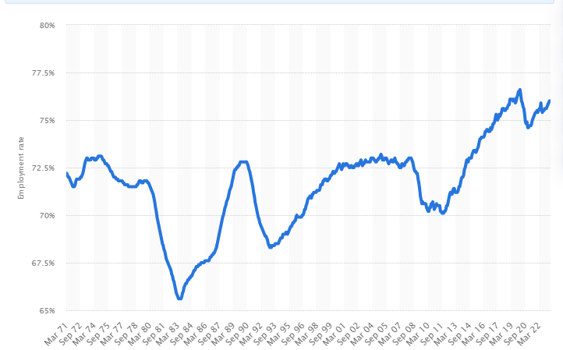
Figure 1: Unemployment rate in the UK in 2022
(Source: Clark, 2021)
The above graph demonstrates the unemployment rate in the UK from 1971 to May 2022. The unemployment rate in March 2020 became 76.3%, compared to 76.1% in June 2019. It can be seen that the unemployment rate in the UK has been increasing since October 2011 and it keeps going up and down. The jobs in the hospitality sector were most vulnerable during the lockdowns and these sectors experienced most jobs being furloughed in May 2020. In May 2023, the employment rate in the UK was seen as 76% when it was 75.9% in May 2022. The net employment balance is explained to measure the difference between organisations that wished to recruit new people and those that wanted to decrease staff. The employment balance in spring 2022 was 36 points and in spring 2023 the employment balance decreased to 27 points. The employers are also focused on

Factors that have impacted the labour market
The economy of Britain made a gloomy start in 2023 with an inflation rate which had a disastrous impact on household income and economists predict a recession as interest rates rise. Brisinger (2023), commented that in December 2022, the job postings increased by 50% since February 2020. The job postings have shown resilience despite the economic headwinds, amongst the cost of living crisis. The "National Minimum Wage Act 1998" is focused on making sure that companies pay the basic wage to the employees (Gov.UK, 2023).
Companies in the UK should pay attention to paying their employees properly. The North East of England has seen strong growth in job requirements by 92%. Consequently, London has seen slower growth and job postings have been low as 28%. The composition of the sectors can have an influence on regional performance in the UK. The regions that have stronger growth will dominate in the industries like distribution and manufacturing. The ratio of unemployed citizens to vacancies marks tightness at a record low of 1.0 in October 2022. There has been a decrease in the economic involvement of the 50-64 groups which has influenced the shrinking of the labour force and increasing labour market tightness. A maximum part of the population of the UK is inclined towards the older age group towards 50 years. The reduced notifications can be a critical indicator of the health of the labour market of the UK. In November 2022, the redundancy notifications increased to 22,580 which are the second highest since March 2021.
The economy of Britain has been going through stagflation and it has impacted the labour market. The number of employees who worked increased as the job vacancies declined. Elliott (2023) suggested that the hours invested by the workers went down and the workdays lost because of strikes were higher in 2022 than in 1989. There was almost no growth in the final quarter of 2022 and the yearly inflation increased by 10%. The years of pandemic have impacted the supply of labour, mostly because older workers have retired from work. The vacancies for job postings have decreased since last year but more than pre-pandemic levels.
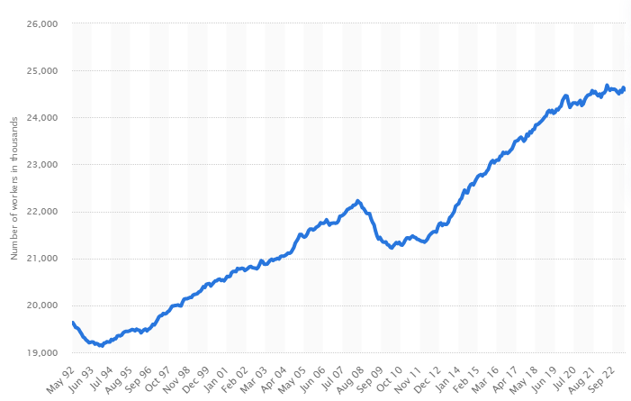
Figure 2: Number of full-time workers in the UK from May 1992 to May 2023
(Source: Clark, 2023)
The above graph shows the timeline of full-time workers from 1992 to May 2023. There were estimated 24.6 million workers in the UK as of May 2023. The labour shortages have allowed other groups of people to look for work. The private industry is not keeping track of the price increases and the resultant tightness on the real income has been a huge factor in the sluggish state of the economy. The “Working Time Regulations 1988", law focuses on the working hours in the UK, which is 8 hours per day and 40 hours a week. This law can help in the protection of employees from getting overworked by companies. According to Guzi et al. (2023, p 5), the employment restrictions in the United Kingdom do not allow immigrants to move into the occupational sectors, which limits the immigrant workers to low-paying jobs and they stay poor.

b) The emerging changes in Human Resourcing Strategies in the post-Covid, post-Brexit external environment

Definition of Human Resource Strategies
The strategy of Human Resources is focused on making an overall plan for managing the human capital and aligning with the objectives of the company. The human resource strategy can create a direction for the major areas of HR like recruiting, performance rewards and development. The HR strategy is seen as a long-term plan for the organisation. The characteristics of HR can be related to the analysis of the company in the external environment. The HR strategies can support the company in planning the distribution of organisational resources and time. The Human Resource Strategy is aimed to generate value for the organisation and contribute to the progress of the company in the future. The mission of the Human Resource Strategy should explain the objective of the organisation.

Evaluation of the emerging changes in Human Resourcing Strategies in the post-Covid environment
The COVID-19 pandemic disrupted the labour markets in the international industry in 2020. Millions of people lost jobs and those who worked in the healthcare sector were forced to work. The recovery of the labour market is influenced by enhanced productivity and innovation. In the post-COVID-19 environment, a human resource manager has to be careful in recruiting employees for companies in the UK. Additionally, remote work has emerged as a continuing trend in the post-COVID-19 era. Moreover, human resource managers in the UK or focused stone create a proper healthcare scheme for their employees to make sure that they are cared for. UK companies prefer to recruit remote workers in order to save money and increase employee engagement. Moreover, companies in the UK are focused on developing a human resource strategy that can address the on-going conflicts and obstacles for the employees. In the aftermath of COVID-19, most employees have become health conscious and the human resource manager should focus on providing health benefits in the workplace environment. The jobs in work grounds with higher levels of physical closeness are likely to see superior alteration after the pandemic, causing knock-on things in other work arenas as business models shift in response to the new normal.
The short- and potential long-term interruptions to these fields from COVID-19 vary. During the pandemic, the disease mostly affected professions where the employees were required to be in close physical contact, like healthcare, customer service and the travel industry.
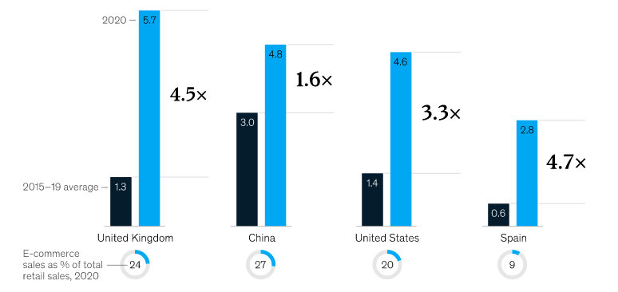
Figure 3: Growth of e-commerce before during COVID-19
(Source: Lund et al. 2021)
The above figure shows the changes in the e-commerce industry during and before the COVID-19 pandemic. In the UK, in 2015-19, e-commerce at a rate of 1.3 per cent and in 2020 it increased to 5.7%, noticing a 4.5 times increase. Several companies are planning to shift to a flexible workplace environment after gaining a positive experience with remote work. In August 2020, a McKinsey survey indicated that the 278 managers who participated in the survey aimed to reduce office space by 30% (Lund et al. 2021). As commented by Stuart et al. (2021, p 905), while responding to COVID-19, job retention should be aimed as a primary practice of HRM. Moreover, the UK has a history of redundancy in the face of dealing with crises. The practice of job retention is seen as a key strategy to

Evaluation of the emerging changes in Human Resourcing Strategies in the post-Brexit environment

The restriction of free movement and the implementation of the post-Brexit migration movement which has represented a major change in the UK labour market. Portes and Springford (2023, p 133), commented that in January 2021, the government of the UK was set to introduce intensive changes to the immigration policy which will end free movement between EU and UK. The goal of the new system was to decrease the migration of low-skilled workers and to encourage companies to train and recruit British citizens. This change has raised concerns in certain business sector areas which were dependent on the low-skilled workers from the EU and the new system should be changed. Before Brexit, employment growth increased by 4.2% in the UK and in the EU was 42.3%. The recently released Census data shows that although there is a low level of unemployment there is a high level of self-employment in the UK. Ridgway (2019) commented the recruitment selection of employees can be affected by Brexit which can change the human resource strategies in organisations. The areas in the management which can be critically impacted are retention of employees, skillset of labour and increase in flexible working. There is no proper body of research describing what Brexit exactly means for the practices of HR. Employee resourcing is a practice of HRM which focuses on the ability to ensure that the company can access the employees and inspire them to achieve the objectives.

In the post-Brexit era, there is no proper detailed policy which educates the employers or the HR manager about the movement of talent within the EU and whether UK companies can recruit them. It is predicted that some of the workers from the EU who were working in the UK might return back to Europe after Brexit. According to Sime et al. (2022, p 4530), in the post-Brexit era, there has also been an increase in xenophobia crimes in the UK against the European people who are living in the UK currently. For recruitment, Brexit may not change anything, since the "war for talent" is not the result of Brexit; it is the aftermath of changing political landscape and changes in immigration policies. However, there is a high level of uncertainty amongst the people which can cause employee relationships to become strained and impact the progress of the organisation.
There has been a supply chain crisis due to Brexit, which also caused chaos at the ports of the UK and a lack of truck drivers. Truck drivers in the aftermath of Brexit require an international permit for driving which can lead to delays in deliveries of products resulting in customer dissatisfaction. Certain industries like gin brewers can be affected in an intense manner. Tetley (2022), commented that almost a third of the business have experienced a loss in their revenues owing to the disruptions and the revenues dropped by 18%. Most businesses have admitted that Brexit has caused the majority of the disruptions in the supply chain. Additionally, small businesses have not been analysed and might have a worse impact due to the changes incorporated by Brexit.

Theories linked with the emerging changes in HR strategies in the UK
The Warwick Model is known as the Human Resource Management Framework that traces the connection between the internal and external environmental factors which can explore the adaptation of HRM in terms of these factors.

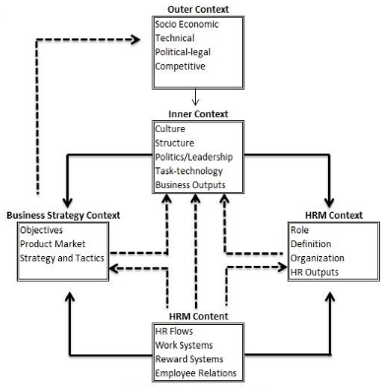
Figure 4: Warwick Model
(Source: Farndale et al. 2020, p 5)
The above diagram shows the components of the Warwick Model which are:
Outer Context (macro-environmental factors) - The context includes the socio-economic and political factors that can impact the HRM strategies.
Inner Context (micro-environment factors) - The context focuses on the culture and structure of the organisation and the technology that is widely used in the company.
Business Strategy Context- The context explains the goals and market of the product of the company which can affect the Human Resource strategies within the company.
HRM Context and Content- The context of HRM includes the organisation and outputs of the Human Resource role. The content is focused on reward systems and employee relations within the organisation.
The external environment for the companies of the UK has experienced the political uncertainty of Brexit and the economic slowdown due to COVID-19 and inflation. The internal environment includes the workplace atmosphere that is focused on planning for resilience in the future. The organisations of the UK are focused on strategizing contingency plans for the growth of their business after exit from the EU. However, with the imposition of the lockdown, the companies had to concentrate on developing remote work timetables so they are able to keep the business going despite the lockdown. McPhail et al. (2020, p 15), commented that as the economy of the UK reopened, the HR managers have to deal with the change in laws with the EU and the panic of the people coming back to work after a long period of lockdown. The HR strategies had to be focused on the safety of the employees and keep the option of remote open for a situation like the pandemic again.

Conclusion
The report evaluated the environment of Human resource strategies in the UK in the post-COVID-19 and post-Brexit era. The unemployment rate was high during the pandemic and at the beginning of 2023 as economists warned of a recession in the UK. Additionally, there were supply chain disruptions caused by Brexit, since truck drivers required international permits for driving. The laws between the EU and the UK changed drastically which has a critical impact on the businesses of the UK. In the UK, different regions in the UK had seen different levels of growth which also influenced the labour market. The strategy of Human Resources should focus on employee retention in the post-COVID era.

Reference List
Brisinger, A. (2023). UK LABOUR MARKET REMAINS RESILIENT HEADING INTO 2023 DESPITE ECONOMIC DOWNTURN. Available at: https://startupsmagazine.co.uk/article-uk-labour-market-remains-resilient-heading-2023-despite-economic-downturn [Accessed 4 Aug. 2023].
Cipd.org (2023). Available at: https://www.cipd.org/uk/knowledge/reports/labour-market-outlook/ [Accessed 4 Aug. 2023].
Clark, D. (2021). UK employment rate 2019. Available at: https://www.statista.com/statistics/281992/employment-rate-in-the-united-kingdom/ [Accessed 4 Aug. 2023].
Clark, D. (2023). Number of full-time workers in the United Kingdom from May 1992 to May 2023. Available at: https://www.statista.com/statistics/1119783/full-time-workers-in-the-uk/ [Accessed 4 Aug. 2023].
Elliott, L. (2023). UK labour market can’t hold out much longer against impact of stagflation. The Guardian. [online] 14 Feb. Available at: https://www.theguardian.com/politics/2023/feb/14/uk-labour-market-stagflation [Accessed 4 Aug. 2023].
Farndale, E., McDonnell, A., Scholarios, D. and Wilkinson, A., 2020. Human Resource Management Journal: A look to the past, present, and future of the journal and HRM scholarship. Human Resource Management Journal, 30(1), pp.1-12. DOI: https://doi.org/10.1111/1748-8583.12275
Gov.UK (2023). National Minimum Wage Act 1998. [online] Legislation.gov.uk. Available at: https://www.legislation.gov.uk/ukpga/1998/39/contents [Accessed 4 Aug. 2023].
Guzi, M., Kahanec, M. and Mýtna Kureková, L., 2023. The impact of immigration and integration policies on immigrant-native labour market hierarchies. Journal of Ethnic and Migration Studies, pp.1-19. DOI: https://doi.org/10.1080/1369183X.2023.2207339
Lund, S., Madgavkar, A., Manyika, J., Smit, S., Ellingrud, K. and Robinson, O. (2021). The Future of Work after COVID-19. Available at:https://www.mckinsey.com/featured-insights/future-of-work/the-future-of-work-after-covid-19 [Accessed 4 Aug. 2023].
McPhail, R., Chan, X.W., May, R. and Wilkinson, A., 2023. Post-COVID remote working and its impact on people, productivity, and the planet: an exploratory scoping review. The International Journal of Human Resource Management, pp.1-29.DOI: https://doi.org/10.1080/09585192.2023.2221385
Milliken, D. and Bruce, A. (2023). UK economy makes slow start to 2023 as inflation weighs. Reuters. [online] 30 Jun. Available at: https://www.reuters.com/markets/europe/uk-economic-growth-unrevised-01-first-quarter-2023-2023-06-30/ [Accessed 4 Aug. 2023].
Portes, J. and Springford, J., 2023. The impact of the post-Brexit migration system on the UK labour market. Contemporary Social Science, 18(2), pp.132-149.DOI: https://doi.org/10.1080/21582041.2023.2192516
Ridgway, M., 2019. Brexit: Human resourcing implications. Employee Relations: The International Journal, 41(5), pp.1033-1045. DOI: https://doi.org/10.1108/ER-11-2018-0310
Sime, D., Tyrrell, N., Käkelä, E. and Moskal, M., 2022. Performing whiteness: Central and Eastern European young people’s experiences of xenophobia and racialisation in the UK post-Brexit. Journal of Ethnic and Migration Studies, 48(19), pp.4527-4546. DOI: https://doi.org/10.1080/1369183X.2022.2085678
Stuart, M., Spencer, D.A., McLachlan, C.J. and Forde, C., 2021. COVID‐19 and the uncertain future of HRM: Furlough, job retention and reform. Human Resource Management Journal, 31(4), pp.904-917. DOI: https://doi.org/10.1111/1748-8583.12395
Tetley, L. (2022). Brexit Remains Biggest Headache in UK’s Recession-Prone Economy.Available at: https://www.bloomberg.com/news/newsletters/2022-11-28/supply-chain-latest-uk-business-struggle-with-brexit [Accessed 4 Aug. 2023].

