

Assessment 1 – Reading Task Template
PART 1: Upload your photo of your A3 in-class notes here:
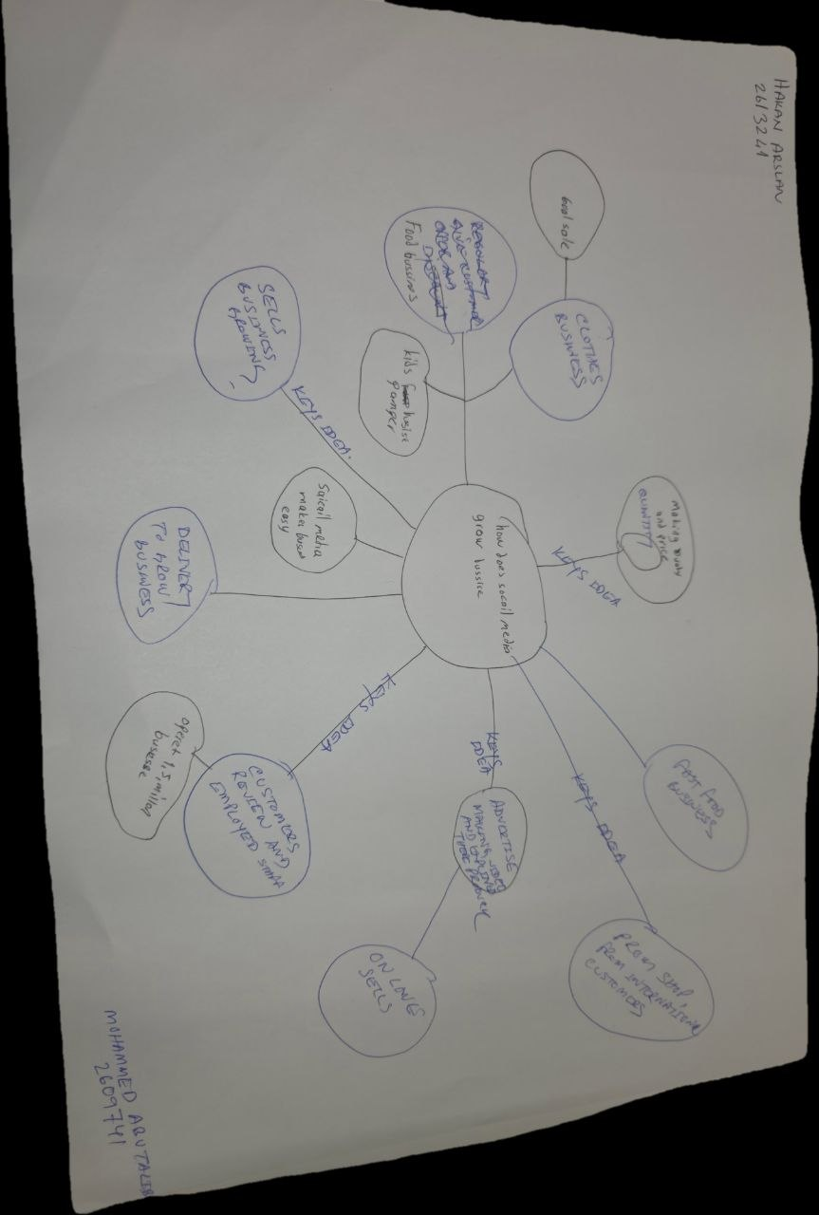

PART 2:
- Answer every question below in 1-3 full sentences.
- Use your own words. Do not use generative AI to answer these questions.
- Include a specific detail from the text when asked.
REMINDER
- The main idea is the overall message of the whole text.
- A key point helps to explain the main idea.
- A specific detail or example from the text shows that the key point is true.

- What is the main idea of the whole text?
The main idea social media platforms like TikTok and instagram allow small local businesses to reach audiences far beyond their local arena,which can significantly increase their customers and success when their content goes viral.

- What is one key point that supports the main idea, and which specific example from the text shows this?
One key point is that viral social media attention can bring customers from very far away for example,customers travel three hours just to visit Hollywoodsandwich shop and try their famous chicken burger after seeing it online.

- What is a different key point that supports the main idea, and which specific example from the text shows this?
Another key point is that businesses do not always need to make their own content,what customer post online is often what really helps them grow.the text explains that binley mega chippy saw its trade increase ten times simply cos people shared videos of the shop on social media.

- Which part of the text do you think is most important, and why?
I think the most important part is the expert explanation that people connect with real,relatable content rather than obvious advertising. This matters cos it shows that the real power of social media for business isnt just about getting lots of views it's about building genuine trust,which is what actually turns viewers into paying customers.

Reflection:
- What did you find difficult in this task (including in-class components), and why was it difficult?
I found it tricky at first to clearly separate the main idea from the supporting points,cos the txt includes so many different examples and stories. It was difficult to decide which message was the most important one rather than just listing all the details I had read.

- What helped you with this difficulty, and how did it help you?
Going through the text paragraph by paragraph and highlighting the key information helped me a lot. It helped me see that all the different examples actually support one big main idea ,that social media help small businesses reach more people, which made it much easier to organise answers clearly.

