Visualisation of IoT data

Smart and connected devices 1
1908090

Contents
Visualisation of IoT data 0
Introduction 2
Security 3
Importing data 5
Viewing, searching and filtering data 6
Visualisations/Graphs 7
Averages 8
Test case diagram 0
Conclusion 1
Bibliography 3

Introduction
The developer was asked to create a web user-interface that a user is able to view and interact with data which has been read from three weather sensors. This data would need to be imported in to a MYSQL database using PHP.
In this report you will learn how the developer accomplished the build including what features the developer decided to implement, how the build went and also how the developer tested the web interface in terms of a test plan.

Security
The first feature the developer had to investigate was how the web-interface could be secured and how to allow only authorised personnel to view and interact with the weather data.
The developer chose to implement a log in system where each authorised personnel would have a username and password in order to access the interface.

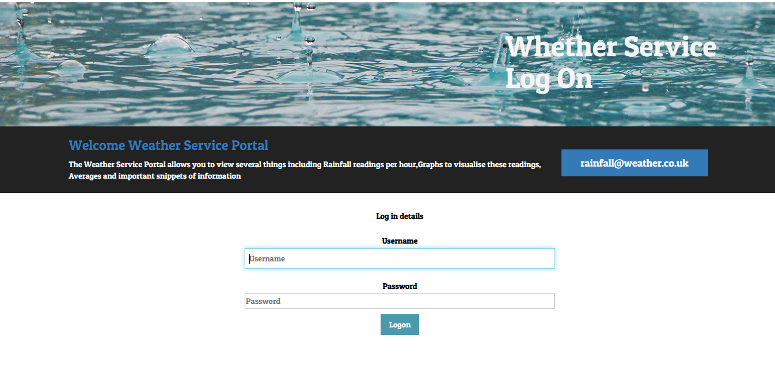
Session variables were used in order to secure the interface. Session variables are used to store individual client’s information on the web server for later use, as a web server does not know which client’s request to be respond because HTTP address does not maintain state. [1]
In this case the developer used a session variable to store the username of the user, when the user moves around the system each page checks that the session variable is still active to make sure that the user is still logged in.
If the user is trying to get to a page but is not logged in validation comes in to play and directs the user back to the log in screen.
When the logout button is clicked a PHP script is run and kills the session so the user will need to log in again.

  - Login Script
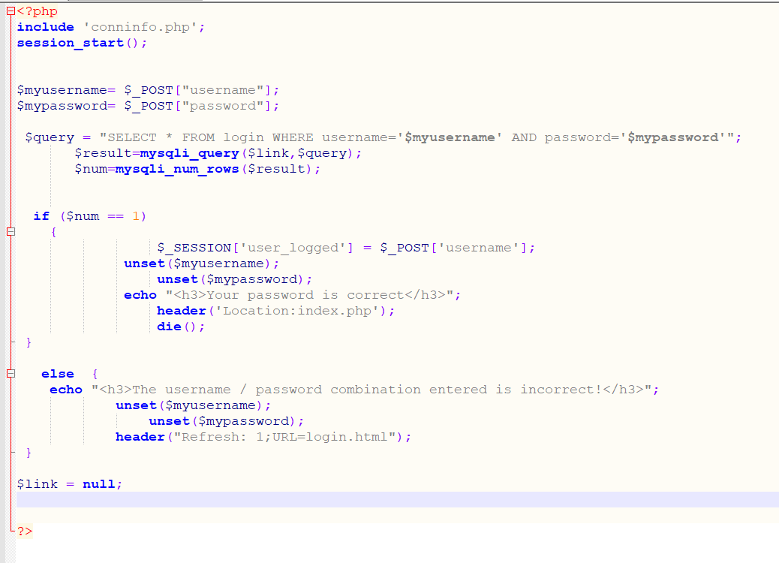
  - Session checking on each page
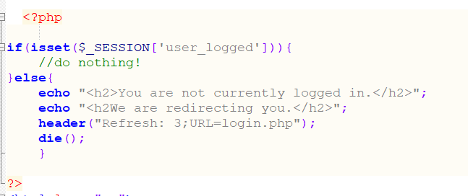

Importing data
The data collected from each sensor needed to be imported in to a MYSQL database via a PHP script.
Each page of the interface the developer created has a button which when clicked will update the data within the MySQL database with the most up to date data from the text files generated by the weather sensor.
The PHP script opens the text file, reads in the data, closes the file, uses an array to store the data, then uses a for loop to split the data as well as putting it back together, then the data is input in to the table within database using an insert statement and then clears the text file to stop duplicate readings.
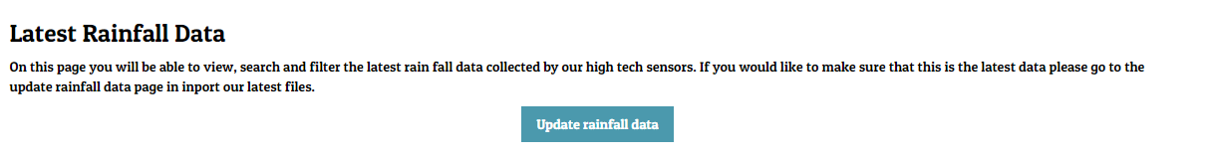

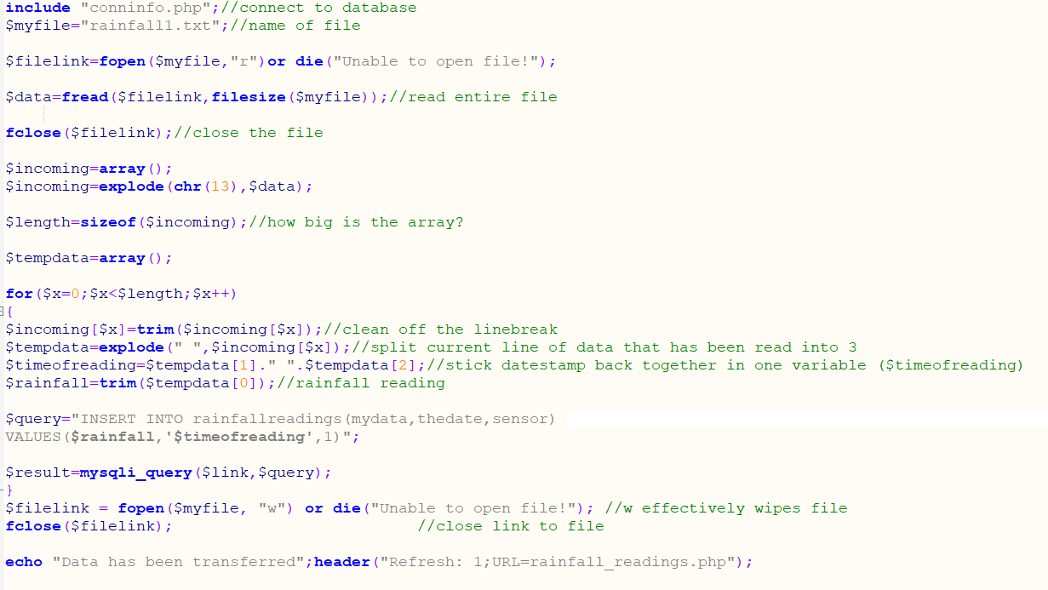

When the button is clicked, and the data transferred the user is alerted if the transfer has been successful. One feature that the developer wants to implement in the future is an alert to the user if there isn’t any data within the text files to transfer.

Viewing, searching and filtering data
One of the prerequisites of the assignment was that the user needs to be able to view the data output by the weather sensors.
The interface that was created allows the user to view all data within a table, the user is also able to filter the data by clicking on the title of the column, this was achieved by implementing a java script.
If the user wants to narrow down the data before viewing it, the developer has implemented a search function where the user can pick which sensor and what date they want to view the data of.
This was implemented by using a dropdown and free text box where the value the user enters get put in to a PHP variable and then the variable is used in a SQL statement to narrow down the data.

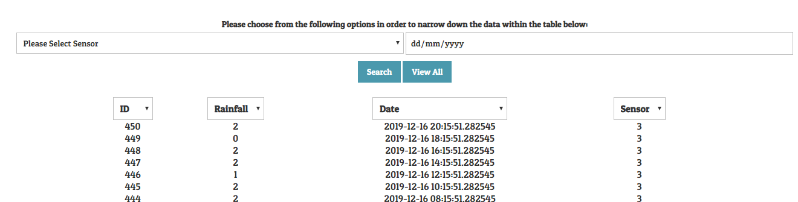

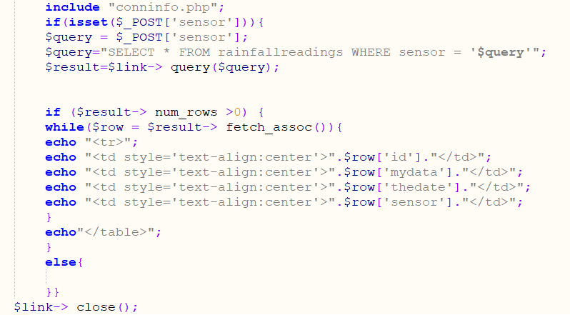

Visualisations/Graphs
The developer wanted to make the data visual in terms of graphs, when scripting the graphs, the developer used a library to help, there are many libraries available that produce graphs but the developer chooses phpMyGraph5.0.
To give the user a good choice of graphs to use, 3 graphs were produced for each sensor:
- Vertical Column Graph
- Line Graph
- Horizontal Column Graph
Nine buttons were places on the visualisation page where the user can pick which one to choose, when the user selects one of these buttons the PHP script (below) which includes the phpMyGraph library is run and gives the user an up to date visual representation of the relevant data.
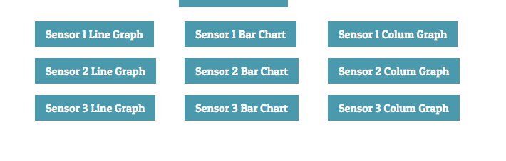
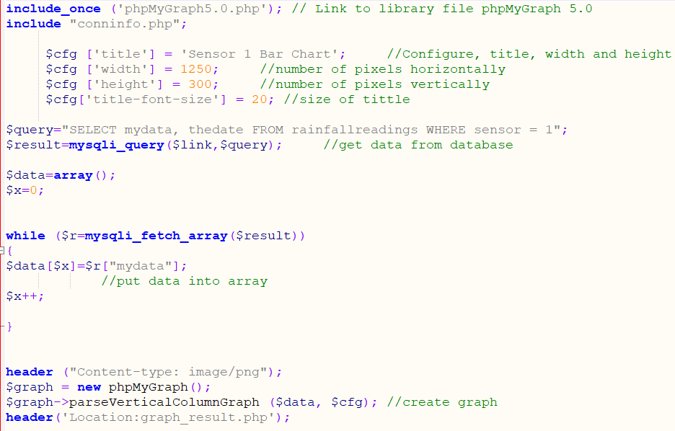

Averages
Having data at your fingertips is great but being able to view important up to date snippets of information giving the user what they were exactly looking for is even better.
Within the user interface there was a page created called averages which gives up to date snippets of information including:
- Highest rainfall in mm
- Date of the highest rainfall reading
- Average rainfall in mm
- Number of dry readings
- Lowest rainfall reading in mm
- Date of the lowest rainfall reading
The information above is all controlled via a dropdown list which the user can choose which sensor they would like the data for. The value of the drop-down list is then transferred into a PHP variable and then the variable is used in a SQL statement that relates to each snippets of information above.
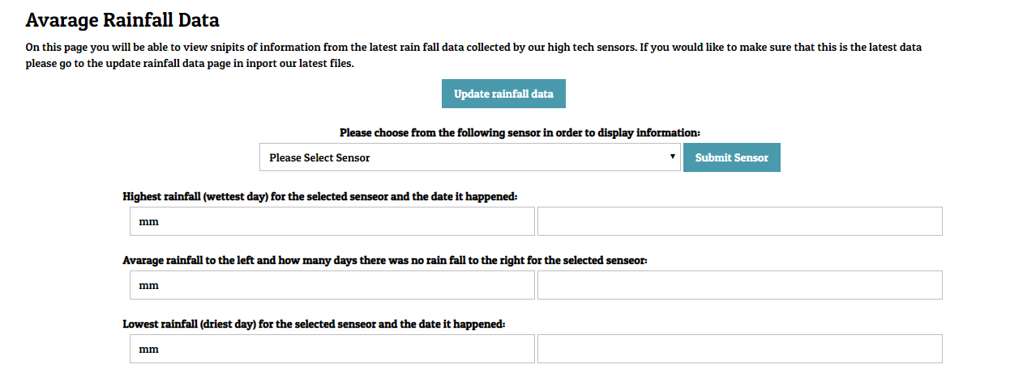

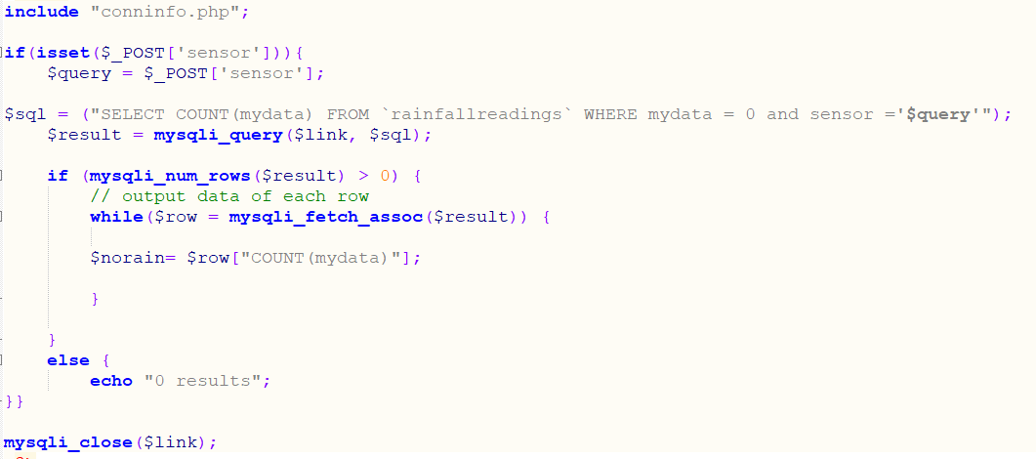

Test case diagram
Objective | Steps | Expected | Outcome
Import data | -Log in  -Go to rainfall_readings  -Click update data | Up to data data is import into the database | Pass
Search via date | -Log in  -Go to rainfall_readings  -Enter a search via a date | Only readings for selected date comeback | Fail – date picker is not working
View Graph | -Log in  -Go to rainfall_graphs  -click a graph | Graph displays | Pass
a

Conclusion
The developer feels that the user interface that was developed worked well and allows the user to follow all prerequisites including:
- Security including log in
- Viewing and interacting with the data collected
- Graph visual representation of the data
In future the developer could have added more validation in to the website in order to alert the user that there is nothing to be imported along with making sure that the date search works.

Bibliography
[1]"PHP Login Form with Sessions | FormGet", FormGet, 2020. [Online]. Available: https://www.formget.com/login-form-in-php/. [Accessed: 28- Feb- 2020].

