Marie Pitson
Marie.pitson@uwtsd.ac.uk
Abstract
The truth about what really is happening with the budget airline, Ryanair.
MANAGEMENT rEPORT oN RYANAIR
Thonuma Hassan 1710575

Executive Summary

This report for the management of Ryanair will cover the current situation that the company is facing . The reader will understand the problems and causes of the organisation to fall apart.
Furthermore, the conclusion will summaries the main findings and will list the important points of the current problems stated.

Contents
Executive Summary 1
Introduction 3
Main Body 4
Current Problems 4
Brexit 4
Mismanagement 5
Alternative Transport Methods 5
The Fishbone 6
Unfair Pay 7
High Staff Turnover Rate 7
Strikes 8
Poor Working Conditions 8
Stakeholder Analysis 9
PESTLE Analysis 10
Conclusion 12
Recommendations 14
Reference List 15
Appendix 20

Introduction

The central theme of this management report on Ryanair is to focus on the three main problems that Ryanair have faced from Brexit, the Mismanagement and the other alternative methods of transport that is used instead of using Ryanair. The main purpose of the organisation is to provide customers with cheap flights rather than spending a lot with other airlines as Ryanair stated to “double the difference” then any other airline (Ryanair,2018).
The company started back in 1984 by Tony Ryan that is the founder of the aircraft, as it started in Ireland the company then passed it down on to the CEO of the company Michael’ O Leary (Tungate,2017).
Since then the organisation have had a few problems as the researcher investigates the main causes to why the organisation has been set back.

Main Body
To elaborate the researcher identified that using various types of models can benefit the organisation to recognise important issues that will affect the establishment by other internal and external factors. Models help by stating the problem and helps the management make quick rational decision to this, by using models such as the Fishbone model, Stakeholder and Pestle Analysis to get the best possible outcome(Science Direct,2018).

Current Problems
Every organisation faces problems as new technology and new laws are being implemented, therefore it is best to keep up to date with the arising issues to ensure that the organisation is working at its best, without effecting the reputation of the business (Hiscox,2017). The researcher has noticed some external and internal problems that will affect the Ryanair establishment.

Brexit
After the referendum most people in Britain chose to leave the European union, as Hunt and Wheeler (BBC News,2018) stated, that over thirty million individuals voted to leave the European Union back in June 2016. However, once Brexit has taken place it could affect other organisations or job’s as it can jeopardise the link with the British connection, also effecting the development of small organisations to develop regarding free trade (BBC News,2018). Ryanair has claimed it may face a hard Brexit, this means close relation and ties with the European countries may be cut as Ryanair provides a free restriction free flight to the UK and EU it may result in a reduction for the EU airlines to enter UK boarders. (Aviation Voice,2017). Most of the bases that Ryanair travel on are owned by EU shareholders, even though the airline is owned by an Irish company, there is a possibility that once Brexit has taken affect the EU airline licence may be at risk as UK shareholders may convert into non- EU nationals (Ryanair,2018).

Mismanagement
Another current problem that Ryanair are facing is the mismanagement of the organisation, once a business is lacking the right leadership skills it effects the performance level of the staff; as they become less motivated, a decrease in profit; resulting in the business being at risk of losing customers or even having a high turnover rate (Cluer hr.2018). One current problem that Ryanair are facing is that pilots are going on strike because of unfair treatment such as promotions or even having annual leave as they have recently changed this, also the method that the base transfers are taken place in (BBC News,2018). It is stated by BBC news (2018), that the chief of Ryanair did discuss the arising issues, however did not take any further action towards it claiming that there was too much conflict going on and leaving without any closure, with having further strikes to occur in the coming days. This will impact on how the business will run as well as having loss of customers, as the staff have gone on strike the business will fail to work effectively enough (Israelstam,2017).

Alternative Transport Methods
Another problem that Ryanair is facing is that customers are having to deal with last minute cancellation without notification just before boarding the flight, this is because Ryanair is trying to improve its ratio of on time flights as it has been recorded to be at its low by eighty percent (Gates,2017). This will then deter the customers to travel with Ryanair as its communication with the service users is not effective enough, as communication is important to allow the individual to take further action if the circumstances have changed (Business,2016). As the company will be at loss the customers can travel with alternative roots such as using the train to travel close destination like Europe or even using other methods such as a boat, initially being much cheaper than travelling also having a more adventurous traveling experience (Boundless,2018).

The Fishbone
The researcher noticed that the organisation needs to improve the problems that Ryanair is facing by underlying the issues and finding a solution. In most cases using the Ishikawa diagram (1969) commonly known as the Fishbone analysis helps with identifying the possible reasons for a problem, it is useful when the team is essentially falling apart and are not performing to a high enough standard (CMS,2018). Initially, the fishbone analysis works effectively enough when the team decides on the main problem by brainstorming ideas on why the organisation is having these issues, or in other words branching out the major causes of the problem (ASQ,2018). There are limitations to the fishbone analysis as the organisation main priority is to focus on the primary causes, this results in the organisation putting all the energy on the two main causes, rather than paying any attention on the minor causes as well, this is known as the convergent approach which enables the organisation to have an increase of achievement, essentially ignoring the minor causes (Fishbone Diagram,2018). In some cases, the fishbone analysis inspires the organisation to identify every problem and try many reasons to figure out the causes, however this leads to the organisation falling under the divergent approach, this has a low success rate as the team do not have the necessary tools or control to fix all the problems that the organisation faces (Fishbone Diagram,2018). The researcher identified that Ryanair has a few internal problems that will affect how the business functions, refer to image 1.1 in the appendices for the Ryanair fishbone analysis.

Unfair Pay
Calder (2018) stated that the employees of Ryanair have been treated unfairly by being threatened, that if the staff call in sick or did not turn up to work the management would cut down the staff pay or would threaten the employee by firing the individual, this is claimed to motivate the staff to come in regardless of the reason. This will lead the staff to misinterpret the message and see the motivational word to be a threat towards them ( Sceince.Direct,2016). Another point of Ryanair having unfair pay was the gender gap between the males and females. Research shows that the females would receive more than the males. Ryanair further mentioned it was because the cabin crew were mainly made up of women and the males were mostly pilots, the pilots would receive more pay than the cabin crew, therefore the bonus payments would go towards the cabin crew it was just coincidence that the majority were females (Scott,2018).

High Staff Turnover Rate
Furthermore, the staff would have long working hours, as some cabin workers would have to work six one-way flights per day. This would include the weekends, and in some cases full time with no breaks, leading the staff to become stressed, exhausted and dissatisfied (Lowbridge,2017). It will also cause the individual to have a lot more health issues such as suffering from fatigue, depression and low self-esteem. Impacting the customer relations with the staff as the employee behaviour would become very unfriendly and frustrated , causing a low performance level (HSE, 2018). Also, the management of Ryanair would cause staff to leave and start to express the views and opinion online to shame the organisation service and morale, as one cabin crew staff stated that the management have no respect towards the workers or customers (Glassdoor,2017). Having put under pressure to make sales constantly from the food, as the staff expressed that the team would be threatened regarding relocation to places away from the staff families, stating that management only care for the money not the wellbeing of the staff (Glassdoor, 2017). This would lead to the employees having a lot of anger towards the management, as the right leadership skills are not being put in place (Heathfiled,2018).

Strikes
In recent cases the pilots of Ryanair are further to go on strike as some of the issues stated have not been addressed resulting in having to cancel flights as there was no one to fly the planes (BBC News,2018). This is because the requirements that the pilots want are not being met, such as having poor working condition and pay (BBC News,2018). In the same way the management are not addressing the staff demands, the pilots intend to further go on strike regarding the management for not having a proper system in place. As pilots are having to switch from European airlines to African bases which becomes difficult for the pilot to see family (Skycop,2018).

Poor Working Conditions
Having poor working condition can be caused by health and safety issues, working hours or even the security of the establishment (Unison,2018). It is stated by law that the employer of the organisation is solely responsible for the condition to be up to scratch and to be safe for all to use (Unison,2018). In addition, the cabin crew of Spain, Portugal, Italy and Belgium want an improvement on how the management support the staff by providing better working conditions. Ensuring that the regulations that are in place are not over the top expectations from selling the airline food (Skycop,2018).

Stakeholder Analysis
Another important model that will help the organisation to analyse its issues is the use of the Stakeholder Analysis, a stakeholder is impacted by the organisation it helps to analyse what support or potential threats there could be for any form of change that may affect the organisation, for it to excel and to progress (Thompson,2018). McGew (2018) stated that the limitation of the stakeholder analysis is that some of the stakeholders have less power and can do very little decision making, as some stakeholder cannot change views or opinion of the higher-ranking stakeholder that have more power. Also, some stakeholders are quite difficult to please and managers cannot satisfy every stakeholder, even with some stakeholders there are those that have a low interest usually regarding the arising issues and the increase of returns on the savings and an increase of cost (McGew,2018). Refer to figure 1.2 in the appendices, for the stakeholder analysis.

Additionally, Ryanair stakeholder for the travel agencies is placed in the minimal effort category, this is because Ryanair has its own website for customers to book a ticket. Also, travel agencies prefer not to get involved as much with Ryanair as it is a low-cost airline, it will be hard to make any profit for the travel agencies as the commission rate would be low considered to other airlines (Finger,2018). More over the category for the stakeholder to be informed such as the Irish airline, Trade union and airports have a high interest and low power, is placed in this group because the three-stakeholder benefit from Ryanair to make money and profit. However, it does not have the power to make legislation or to make decisions for the organisation, for example Trade union is placed for employees who are dissatisfied with the management, it helps the staff to approach the Trade union by joining them but does not have power to change policies (Docslide,2018).
The European Union is placed in the keep satisfied group as it is the most influential stakeholder, as it helps with decision making in the organisation. By benefiting Ryanair to deal with policies, the EU has power over the operation of the business, and creates a legislation that airports must follow, therefore that airports do not handle with different airline companies to offer deals. However, the interest of the EU is low because they do not expect too much from Ryanair (Docslide,2018).
Lastly the key players such as the Ryan family, the head management of the team Michael O’ Leary and the employees have all been put in this group, because without these influential people the business will not run smoothly, and the performance level will be low as the stakeholders hold the highest power to make a difference to the organisation. For example, the employees are very important to the organisation as they deal with customers and maintain the airline, without the staff the performance of the organisation will be low (Docslide,2018).

PESTLE Analysis
The researcher further found out that the use of PESTLE analysis may be beneficial to use for Ryanair, as it helps to focus on the external factors that can influence the organisation to identify the threats and weaknesses monitored by using the SWOT analysis (Professional Academy,2018). The limitations of the PESTLE analysis is that it only focuses on the external factors, some cases the organisation may assume that the external factors may cause problems for the organisation, when essentially it may not (PESTLE Analysis,2016). Also, more funding maybe required to have an expert to assess the situations as weak assessment may cause the business to be at a loss, as the external factors need to be accurate (PESTLE Analysis,2016). In some cases, prioritising the important issues is seen as a difficulty as the organisation struggle on which factor to focus more on, as the external factors change such as environment (PESTLE Analysis,2016). Refer to figure 1.3 in the appendices, for the PESTLE analysis on Ryanair.

Conclusion

To summarise the management report on Ryanair, the internal issues were identified and were placed in the fishbone analysis. As the resources found stated that the Ryanair management was the main effect of the business performance level to be at a low (CMS,2018). In other words, the unfair pay that the staff would encounter, from the management giving threats to motivate the employees to work harder and even having no sick pay was a sign of poor management (Calder,2018). On that note the females would receive more than the males who were mostly pilots in Ryanair, the organisation states it was a coincidence that the cabin crew were mainly made up of female staff (Scott,2018).
Ryanair is also facing issues with a high staff turnover with employees leaving because of a few factors, the first one being that the staff are made to work long hours, in some circumstances without break which would result in the staff having more workload and would affect the employees’ health and wellbeing (Lowbridge,2017). Also, the researcher identified that some ex-employees would share their views and experiences online to expose how the management would disrespect the workers (Glass Door,2017). Without the staff the organisation would fall apart as the employees have a higher power and interest as a stakeholder in the company (DocSlide,2018).
The researcher also stated in the report that strikes from the pilots were being made as the management were not listening to the demands of the pilots (BBC News,2018). Also, the internal issue was that there was no support mechanism in place for employees as the management would have unrealistic expectations from selling cabin food (Unioson,2018).
There is a possibility that Brexit may fall hard on Ryanair as entering the UK boarder would be difficult once the legislations have been drawn up. The organisation profit would be affected as the company will suffer from not developing and growing as an organisation resulting in a loss of profit (Aviation Voice, 2017).

Recommendations
To improve the establishment further producers can be taken into consideration by management:
- Revaluate the HR policy as managers will know how to deal with employees issues. Can help with managing the organisation the ethical and right way, by following the procedures that are created to keep the staff and managers safe (CIPD,2018).
- To improve communication with managers and staff having meetings on a weekly basis can help with the interaction with the managers and will help addressing problems that cabin crew may have or pilots (McQuerrey,2018).

Reference List

ASQ. (2018), ‘Fishbone (Ishikawa) Diagram’, [Online]. Available: http://asq.org/learn-about-quality/cause-analysis-tools/overview/fishbone.html. [Accessed:2018, July, 15]

Aviation Voice. (2017), ‘EU Warns Airlines About Post- Brexit Access’, [Online]. Available: https://aviationvoice.com/eu-warns-airlines-about-post-brexit-access-201703231016/. [Accessed: 2018, July, 13]

BBC News. (2018), ‘Ryanair Pilots Announce Two More One day Strikes’, [Online]. Available: https://www.bbc.co.uk/news/business-44791156. [Accessed:2018, July,13]

Boundless. (2018), ‘The Best Alternative Ways to Travel: Avoid Package Holidays and Try a Boat, Bike, Train or Road trip’, [Online]. Available: https://www.boundless.co.uk/be-inspired/explore/best-alternative-ways-to-travel. [Accessed:2018, July,13]

Business Teacher. (2018), ‘ Ryanair PESTEL Analysis’, [Online]. Available: https://businessteacher.org.uk/pestel/ryanair.php. [Accessed: 2018, July,16]

Business. (2016), ‘Communicate With Customers’, [Online]. Available: https://www.business.gov.au/info/plan-and-start/start-your-business/what-is-customer-service/communicate-with-customers. [Accessed:2018, July,13]

Calder, S. (2018), ‘Ryanair Flight Cancellations: Pilots Threaten ‘Mass Sick Days’ In Wake of Huge Staff Shortage’, [Online]. Available: https://www.independent.co.uk/travel/news-and-advice/ryanair-flight-cancellations-pilots-strike-better-terms-budget-airline-flight-crew-union-mass-sick-a7958651.html. [Accessed:2018, July, 15]

CIPD. (2018), ‘HR Policies’, [Online]. Available: https://www.cipd.co.uk/knowledge/fundamentals/people/hr/policies-factsheet. [Accessed: 2018, July,16]

Cluer Hr. (2018), ‘The Effects of Mismanagement’, [Online]. Available: https://www.cluerhr.co.uk/the-effects-of-mismanagement/. [Accessed: 2018, July, 13]
CMS. (2018), ‘How to Use the Fishbone Tool for Root Cause Analysis’, [Online]. Available: https://www.cms.gov/medicare/provider-enrollment-and-certification/qapi/downloads/fishbonerevised.pdf. [Accessed:2018, July, 15]

Doc Slide. (2018), ‘Ryanair Stakeholder Analysis’ , [Online]. Available: https://dokumen.tips/documents/ryanair-stakeholder-analysis.html. [ Accessed:2018, July, 15]

F.T. com. (2017), ‘Will Brexit Complicate Landing Rights for UK Flights’, [Online]. Available: https://www.ft.com/content/57c0c01c-ef9c-11e6-930f-061b01e23655. [Accessed: 2018, July,16]

Finger, J. (2018), ‘No, One Travel, I Don’t Want to Pay to Print Out My Itinerary’ , [Online]. Available: https://www.elliott.org/the-troubleshooter/onetravel-wont-help/. [ Accessed:2018, July, 15]

Gates, P. (2017), ‘Nine Things you Need to Know About Ryanair Cancelled Flights’, [Online]. Available: https://www.insider.co.uk/news/eight-things-you-need-know-11191508. . [Accessed:2018, July,13]

Glassdoor. (2018), ‘Ryanair Employee Reviews About “Cabin Crew”’, [Online]. Available: https://www.glassdoor.co.uk/Reviews/Ryanair-cabin-crew-Reviews-EI_IE6965.0,7_KH8,18.htm.[ Accessed:2018, July, 15]

Heathfield, S, M. (2018), ‘Reasons Why Your Employees May Have You’, [Online]. Available: https://www.thebalancecareers.com/why-employees-hate-you-1917713. .[ Accessed:2018, July, 15]

Hiscox. (2017), ‘The 10 Biggest Challenges Business Face Today (and Need Consultants for),[Online]. Available: https://www.hiscox.co.uk/business-blog/the-10-biggest-challenges-businesses-face-today-and-need-consultants-for/. [Accessed: 2018, July, 12]

HSE. (2018), ‘Mental Health at Work and Work-Related Stress, ‘[Online]. Available: http://www.hse.gov.uk/stress/mental-health.htm. [ Accessed:2018, July, 15]
Hunt, W & Wheeler, B. (2018), ‘Brexit: All You Need to Know About the UK Leaving the EU’, [Online]. Available: https://www.bbc.co.uk/news/uk-politics-32810887. [Accessed: 2018, July, 12]

Israelstam, I. (2017), ‘What is the Impact of Strikes for Employers and Employees’, [Online]. Available: https://www.skillsportal.co.za/content/what-impact-strikes-employers-and-employees. [Accessed:2018, July,13]

Lowbridge, C. (2017), ‘Ryanair Run Like a Communist Regime’, Says Pilot’, [Online]. Available: https://www.bbc.co.uk/news/uk-england-41384789.[ Accessed:2018, July, 15]

Lumley, R. (2017), ‘O’ Leary Rules Out WIFI on Ryanair’, [Online]. Available: https://www.independent.ie/business/irish/oleary-rules-out-wifi-on-ryanair-flights-35789459.html. [Accessed: 2018, July,16]

McGew, M. (2018), ‘Limitations of Stakeholders’, [Online]. Available: http://smallbusiness.chron.com/limitations-stakeholders-30965.html. [ Accessed:2018, July, 15]

McQuerrey, L. (2018), ‘Ways to Increase Communication Between Managers & Employees’, [Online]. Available: http://smallbusiness.chron.com/ways-increase-communication-between-managers-employees-37810.html. [Accessed: 2018, July,16]

Perkins, M and Varinsky, D. (2017), ‘Heat Waves Will Keep More Airplanes on the Ground in Coming Years, New Research Suggest’, [Online]. Available: http://www.businessinsider.com/airplanes-grounded-heatwaves-climate-change-2017-7. [Accessed: 2018, July,16]

Pestle Analysis. (2016), ‘Potential Limitations of the PEST Analysis and How to Address Them’, [Online]. Available: http://pestleanalysis.com/limitations-of-the-pest-analysis/. [Accessed: 2018, July,16]

Professional Academy. (2018), ‘Marketing Theories- PESTEL ANALYSIS’, [Online]. Available: https://www.professionalacademy.com/blogs-and-advice/marketing-theories---pestel-analysis. [Accessed: 2018, July,16]
Rodionova, Z. (2017), ‘British Based Airlines Worried They Must Move to EU After Brexit or Lose Major Routes’, [Online]. Available: https://www.independent.co.uk/news/business/news/ryanair-easyjet-brexit-uk-airlines-move-eu-europe-lose-major-flight-routes-a7643506.html. [Accessed: 2018, July,16]

Ryanair. (2018), ‘Q & A- Hard Brexit Non- EU Shareholders’, [Online]. Available: https://investor.ryanair.com/brexit/. [Accessed: 2018, July, 13]

Ryanair. (2018), ‘Why is Ryanair’s Lowest Fare Guarantee?’, [Online]. Available: https://www.ryanair.com/gb/en/useful-info/help-centre/faq-overview/Making-a-reservation/What-is-RYANAIRS-lowest-fare-guarantee. [Accessed: 2018, July,16]

Science Direct. (2018), ‘Problem Solving’, [Online]. Available: https://www.sciencedirect.com/topics/neuroscience/problem-solving. [Accessed: 2018, July, 12]

Science. Direct. (2018), ‘Employee Reactions to the Use of Management Control Systems in Hospitals Motivation vs. Threat. [Online]. Available: : https://www.sciencedirect.com/science/article/pii/S0213911117300031. . [Accessed:2018, July, 15]

Scott, K. (2018), ‘Ryanair Reports a 67% Mean Gender Pay Gap’, [Online]. Available: https://www.employeebenefits.co.uk/issues/april-2018/ryanair-gender-pay-gap/. [Accessed:2018, July, 15]

Sky cop. (2018), ‘Summer Holiday Warning: Ryanair Staff Strike,’ [Online]. Available: https://www.skycop.com/summer-holiday-warning-ryanair-staff-strike/. [ Accessed:2018, July, 15]

Thompson, R. (2018), ‘Stakeholder Analysis’, [Online]. Available: https://www.mindtools.com/pages/article/newPPM_07.htm. [ Accessed:2018, July, 15]

Tungate, M. (2017), ‘A Brief History of Ryanair’, [Online]. Available: https://www.managementtoday.co.uk/brief-history-ryanair/any-other-business/article/1449458. [Accessed: 2018, July,16]
Unison. (2018), ‘Working Condition’, [Online]. Available: https://www.unison.org.uk/get-help/knowledge/health-and-safety/working-conditions/. [ Accessed:2018, July, 15]

Appendix
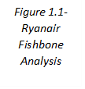
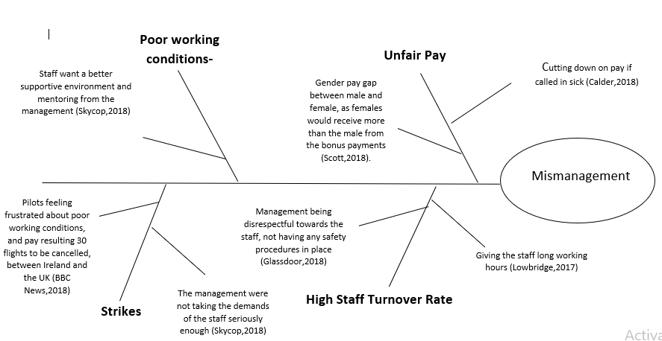

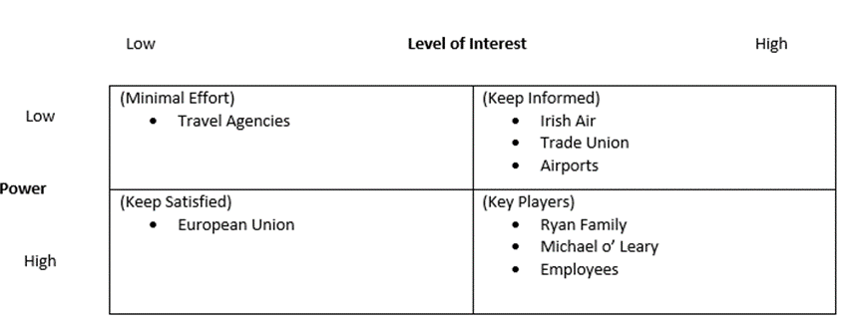

Figure 1.2- Stakeholder Analysis

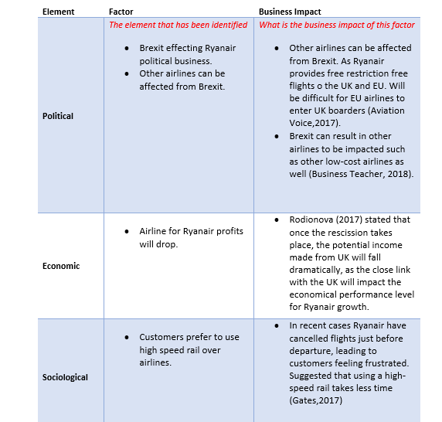

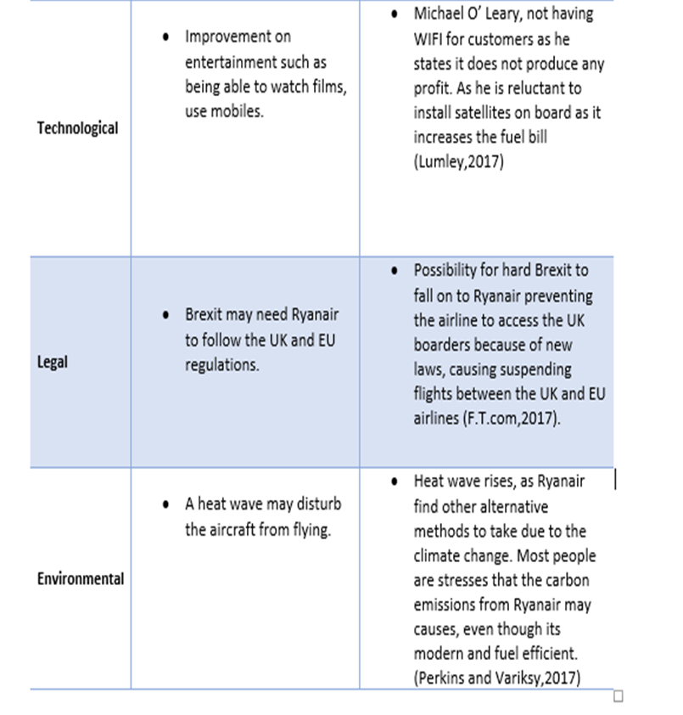
Figure 1.3- PESTLE Analysis

Figure 1.3- PESTLE Analysis

