University of Wales Trinity Saint David
Wales Institute of Science and Art


Eelctronic Control Systems Assignment Part two

Electronic Control Systems (ACHA_4010)

Connor Casey
2103540
19/03/2024
Contents
1 Task 2 1
1.1 Scope Time Division Calculations (4) 1
1.2 Function Generator output sine wave (3) 1
1.3 Unsmoothed Rectifier Wave (3) 1
1.4 Smoothed Rectifier Wave with capacitor (3) 1
1.5 Drop in Voltage Question (4) 1
1.6 Different Voltage Readings Question (5) 1
1.7 Rectifiers use in Automotive applications Question. (4) 1
1.8 Probing Question (4) 1
2 Task 3 2
2.1 Scope Time Division Calculations (4) 2
2.2 Function Generator output square wave (3) 2
2.3 Capacitor charge and discharge wave marked at correct points. (3) 2
2.4 Basic Capacitor Calculations (3) 2
2.5 Capacitor discharge table (4) 2
2.6 Gradient Plot and calculations (4) 2
2.7 Capacitor Uses (5) 2
2.8 Inaccuracies Question (4) 2
3 References 3

Task 2

Scope Time Division Calculations (4)
For time division for a sine wave with 10Hz = 1/(10 X 10) = 0.01S per division

Function Generator output sine wave (3)

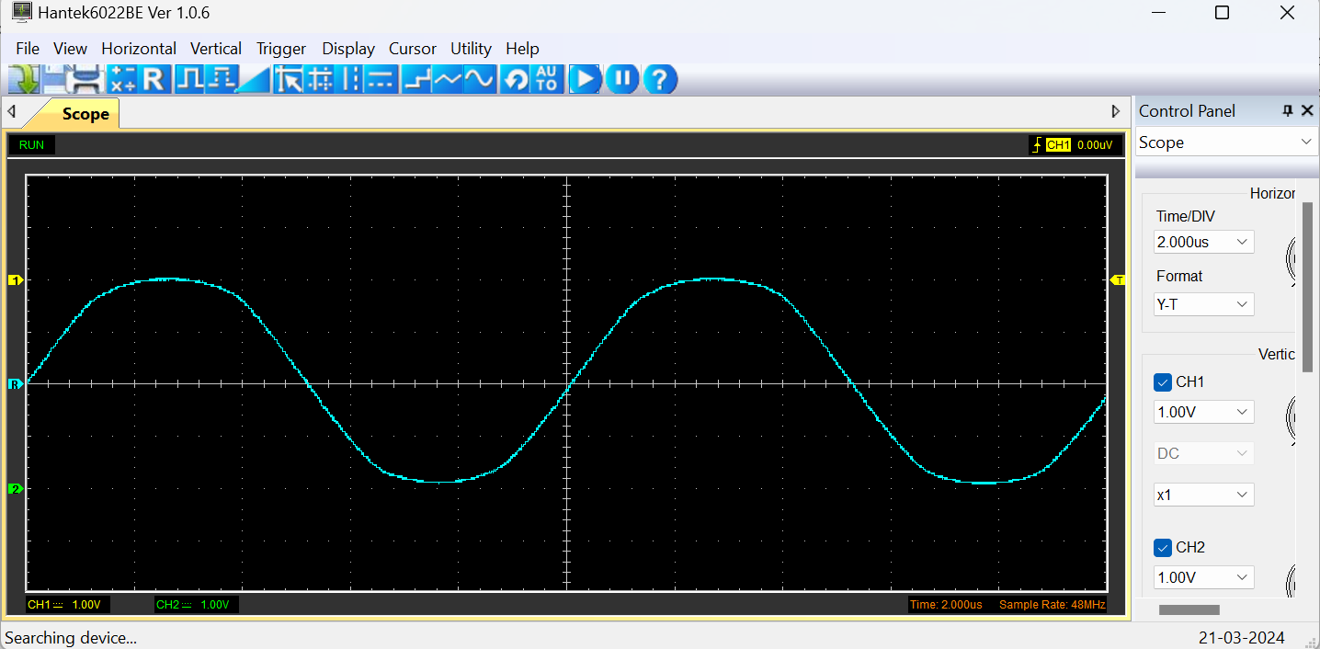

Unsmoothed Rectifier Wave (3)

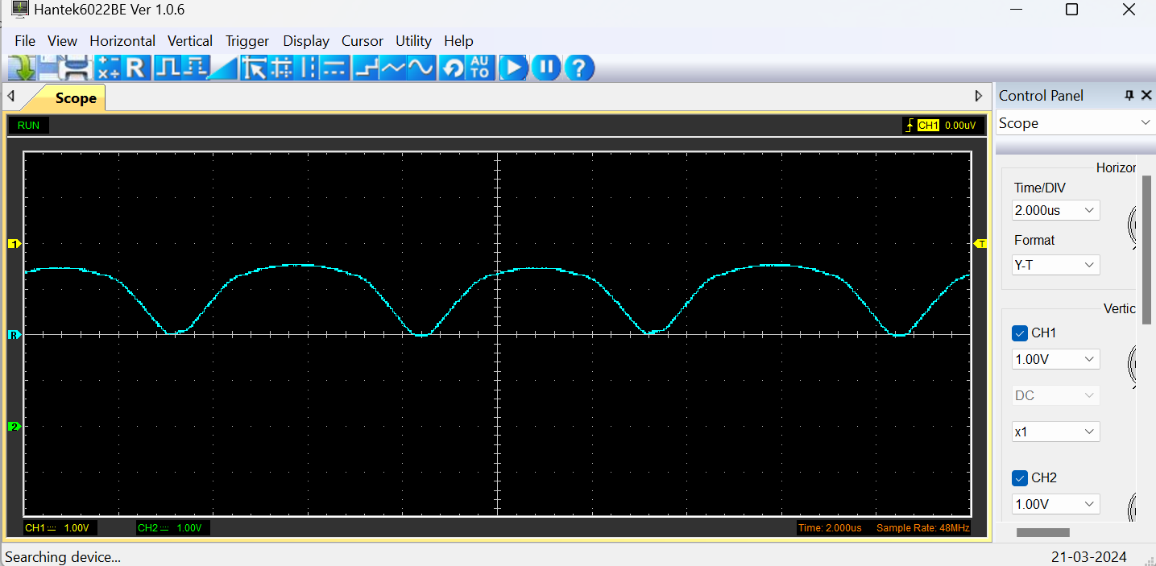

Smoothed Rectifier Wave with capacitor (3)

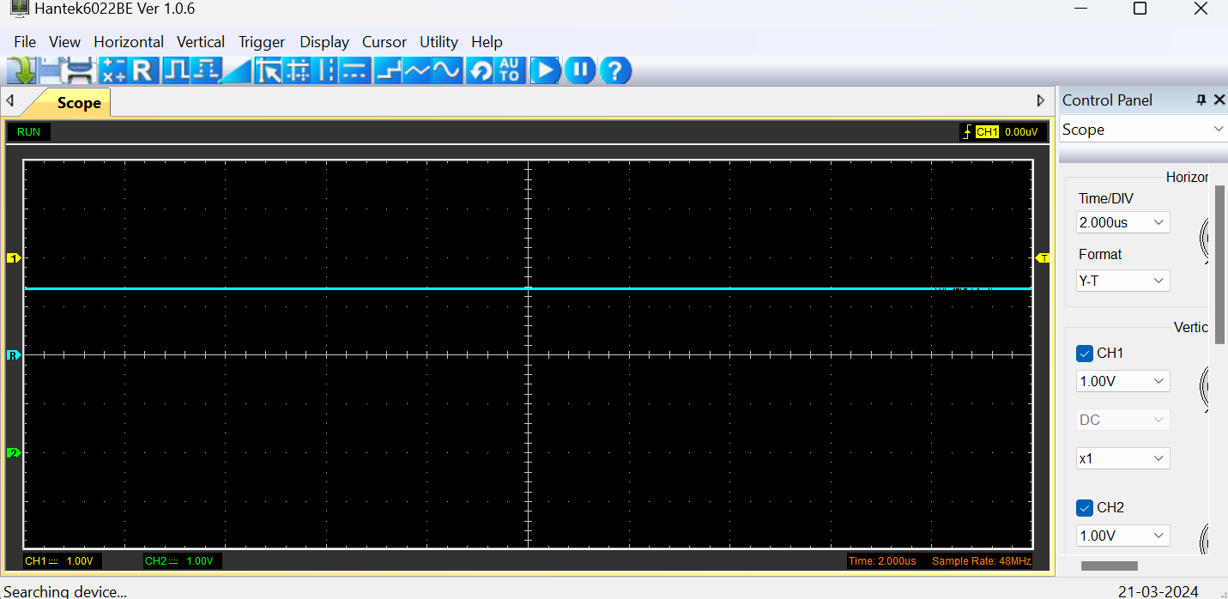

Drop in Voltage Question (4)
Due to the design of the breadboard circuit created there was a voltage drop there are two main reasons that should be considered as to why the circuit had a voltage drop these reasons for voltage drops are:
Diodes in the circuit – diodes act as a voltage barrier that prevents a curtain amount of voltage through them typically 0.7V (Toshiba , n . d )
Resisters in the circuit – the primary function of a resistor is to reduce voltage in the circuit causing the voltage to drop as it passes through the resistor.

Different Voltage Readings Question (5)
Similarly to the last question there would be a voltage drops due to the diodes and resisters in the circuit this is to be expected as the primary function of these devices is to drop the voltage to the required level.
Also, because the wave form was produced using a unfiltered dc rectifier circuit the readings have “ripples” in them due to the waveform being taken before the inclusion of a rectifier in the circuit causing a varying peek to peek voltage (Electrotechnik, n.d)
Also due to us making the rectifier circuit on a simple breadboard that has been used multiple times before and the parts not being ideal this could cause reading inaccuracies.

Rectifiers use in Automotive applications Question. (4)
All modern cars commercial vehicles etc have a rectifier in them typically connected to the alternator to convert the alternating current of the alternator to direct current for use of the battery and vehicle electrical systems. It does this by using diodes as diodes only allow current to flow one way. (DYNAPOWER, 2022)
Rectifiers are important in automotive applications because a cars electrical system can not run solely off alternating current as it would damage multiple electronic pars of the car such as control units, sensors etc also with out a rectifier sending converting AC to DC and sending the DC current to the battery hence recharging it the battery would discharge very quickly causing all the electronic features of the car to not work properly. (Vishay, 2012)

Probing Question (4)
Due to our oscilloscopes being single channel, it was impossible to simultaneously probe both the reading of the function generator and the and the rectifiers to take the readings of both this is unfortunate as we had to take separate readings of each which could lead to inaccuracies.
There are a couple of solutions to this problem, one being that you could use a dual channel oscilloscope, thus allowing for simultaneous probing of the function generator this would allow for more accurate and concise readings and waveforms to be taken at the same time allowing for more accurate calculations for capacitance. (SmartSafe , 2023)

Task 3

Scope Time Division Calculations
R X C = - 100 X 10^3 X 0.1 = 0.01
  - X 20 = 0.2
1/0.2 = 5
5/10 = 0.5 seconds

Function Generator output square wave (3)
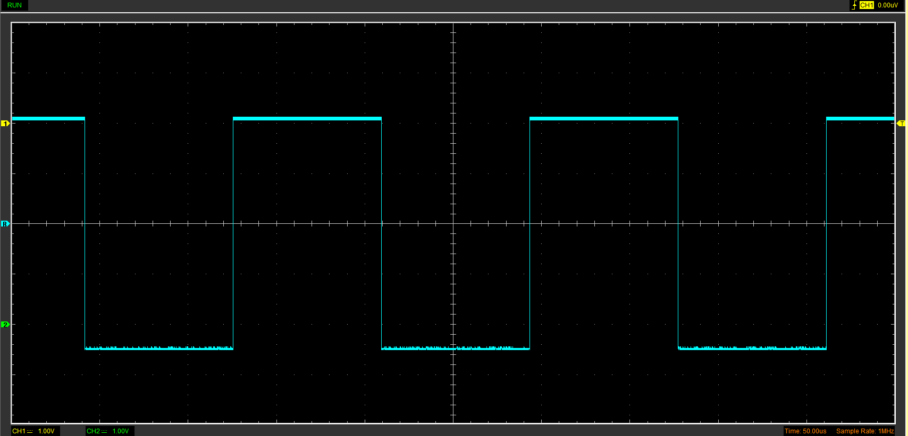

Capacitor charge and discharge wave marked at correct points. (3)
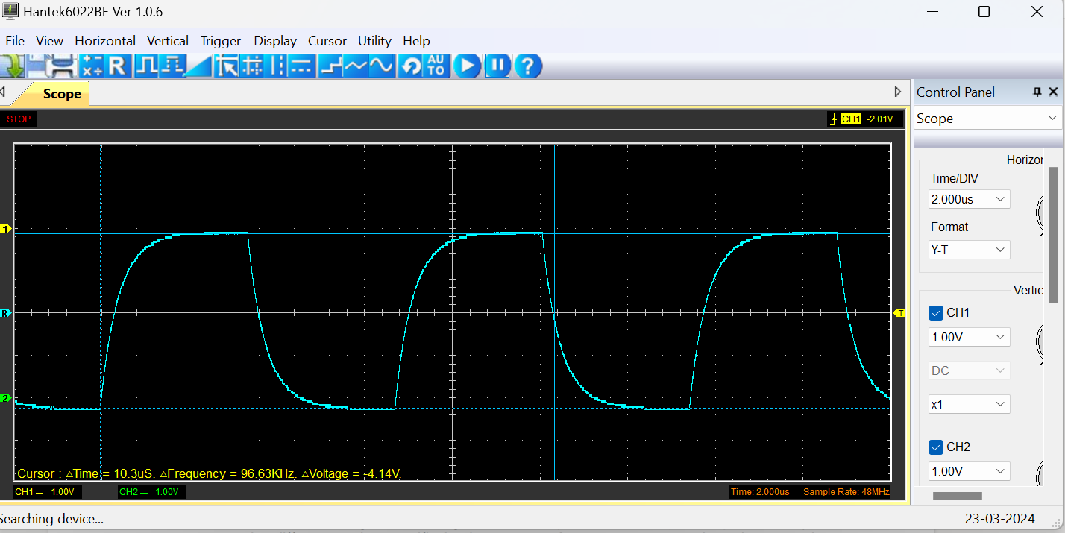
A picture of the capacitor wave form with the beginning of the charging phase marked.
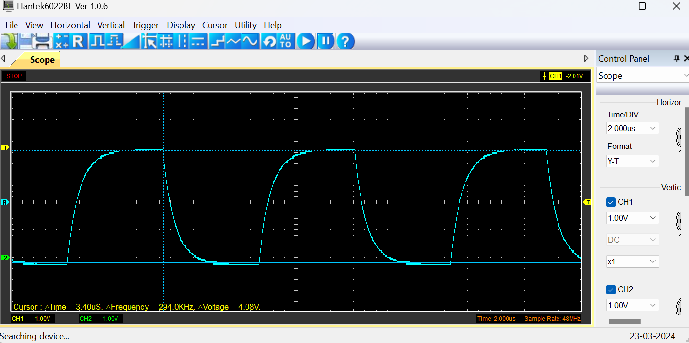
A picture of the capacitor waveform with the beginning of the discharge phase marked.

Basic Capacitor Calculations (3)
(𝑃𝑒𝑎𝑘(𝑉) −𝑆𝑡𝑎𝑟𝑡(𝑉)×63.2%+𝑆𝑡𝑎𝑟𝑡(𝑉) = 𝑉 𝑡𝑜𝑝 𝑐𝑢𝑟𝑠𝑜𝑟

Capacitor discharge table (4)
Time (s) | Voltage (V) | ln (V) | dy = y2 – y1  dy = ln(V)2-ln(V)1 | dx = x2- x1  dx = Time2 – Time1 | dy/dx
0.007099 | 1.6 | 1.280933845 | x | x | x
0.007232 | 0.8784 | 1.057234584 | -0.223699261 | 0.000133 | -1681.95
0.007365 | 0.2824 | 0.825227521 | -0.232007063 | 0.000133 | -1744.41
0.007498 | -0.1882 | 0.594320826 | -0.230906695 | 0.000133 | -1736.14
0.007631 | -0.5961 | 0.339254078 | -0.255066748 | 0.000133 | -1917.8
0.007764 | -0.9098 | 0.086361166 | -0.252892912 | 0.000133 | -1901.45
0.007897 | -1.1294 | -0.13857265 | -0.224933816 | 0.000133 | -1691.23
0.00803 | -1.349 | -0.429245637 | -0.29067 | 0.000133 | -2185.51
0.008163 | -1.5059 | -0.705017353 | -0.27577 | 0.000133 | -2073.47
0.008296 | -1.6 | -0.916290732 | -0.21127 | 0.000133 | -1588.52

Gradient Plot and calculations (4)

To start the using the trendline feature on excel the gradient gives you the average of the trendline so -0.2475 + 1.5606 = 1.3131 then using excel you can work out the average of dy/dx using the average function this gets an average of -1.835.61 then finally the final average of both figures is -917.929.
for the time constant
t as the gradiant = - 1/-0.2475 = 4.04seconds
C = t/R
= 4.04 X 100X10^3 = 404000 Farads

Capacitor Uses (5)
Capacitors are used for a multitude of reasons in general electronics and also in motorsport.
General capacitor uses:
- AC and DC power separation – allowing AC current to pass through sections of the circuit and impeding DC static voltage. (Edington, n.d)
- Temporary energy storage – Capacitors can store a small amount of energy and are able discharge it as temporary power to electronic devices during time of need. (Edington, n.d)
- Noise suppression and filtration – as a compactor impedes DC voltage this naturally filters or stops the “white noise” of DC voltage
- Circuit timing – due to the nature of capacitors and in conjunction with resistors in a circuit you can effectively time functions of a circuit depending on the size of the capacitor and resistor in a circuit.
Automotive capacitor uses:
- Starter motor – due to the torque needed to turn the engine over on start up the starter motor uses a capacitor to speed up the starter motor until it reaches approximately 75% of the starter motors top speed. (Jeremiah Davis, 2021)
- Lighting systems – due to capacitors impeding DC voltage it reduces noise of lights in operation and allows for consistent reliable operation of lighting systems.
- ECUS – capacitors play a key role in regulating voltages and electromagnetic interference allowing for proper function so the so the ecu con properly control electric motors in the car for things such as fuel pumps and fans (Powers, 2015)
Motorsport capacitor uses:
- ERS – formula 1 have incorporated ERS into the engines of the cars ERS (Energy Recovery System) is a system where kinetic energy is stored in capacitors and then discharged to the engine for extra power when the driver chooses. (Imandi, 2020)
- Engine starting – similarly to road cars race cars and bikes starter motors use capacitors to quickly engage to the starter motor and get it at a high enough speed to turn over the engine.
- Data logging and telemetry – capacitors work as temporary power sources so that data logging is uninterrupted in case of in case of primary power source outages they will discharge the power stored when needed.

Inaccuracies Question (4)
There are many reasons to do with the oscilloscope why the results may contain inaccuracies how ever the main 6 are time base centre frequency accuracy, timing instability, vertical noise , bandwidth effects , interleaving or calibration error, and interpolation errors. (Margesan, 2003)
how but more likely in terms of our experiment it would have been the equipment we used for our circuit. We made a simple rectifier circuit using a breadboard and whilst being good for making simple circuits and performing experiments and obtaining results a breadboard suffers from having a low current threshold and the connections being less secure than a counterpart that has been made using soldering (|, 2023)
this means that during our experiments during our scoping the connection could have been loose meaning that there could be many things affecting the readings we got the main thing that could of altered the results due to working on a breadboard are:
- Increased resistance due to potentially loose connections
- Unstable contacts could cause signal fluctuation and dropouts.

References
|, K. M. (2023, April 13). BREADBOARDS . Retrieved from https://www.kevsrobots.com/resources/how_it_works/breadboards.html#:~:text=Limited%20current%20capacity%20%3A%20Breadboards%20are,intermittent%20or%20unreliable%20circuit%20behavior.
DYNAPOWER. (2022, Febuary 2). Rectifiers: Nearly Everything You Need to Know. Retrieved from Dynapower : https://dynapower.com/rectifiers-nearly-everything-you-need-to-know/
Edington. (n.d, n.d n.d). What are capacitors used for? Retrieved from https://www.edingtonagencies.com.au/what-are-capacitors-used-for/#:~:text=capacitors%20used%20for%3F-,Articles,sensing%20and%20signal%20coupling%2Fdecoupling.
Electrotechnik. (n.d, n.d n.d). A website in electrical engineering. Retrieved from Electrotechnik: https://www.electrotechnik.net/2009/03/ripples-in-dc-systems.html
Imandi, R. (2020, September 10). How does Energy Recovery System (ERS) Work in F1? Retrieved from Medium : https://rohitimandi.medium.com/how-does-energy-recovery-system-ers-work-in-f1-45bffbb278b0
Jeremiah Davis, J. C. (2021, July 9). Start and Run Capacitors for Electric Motors. Retrieved from Alabama extensions : https://www.aces.edu/blog/topics/farming/start-and-run-capacitors-for-electric-motors/#:~:text=A%20start%20capacitor%20(figure%205,(intermittent%20or%20brief%20use).
Margesan, T. (2003, December 12). How to Reduce Digitizing Oscilloscope Delta-Time Errors. Retrieved from DESIGNLINES: https://www.eetimes.com/how-to-reduce-digitizing-oscilloscope-delta-time-errors/#:~:text=There%20are%20six%20primary%20sources,and%20interpolation%20(aliasing)%20error%20.
Powers, N. (2015, September 25). Capacitor-Powered Cars: Capacitors in Automotive Applications. Retrieved from Arrow: https://www.arrow.com/en/research-and-events/articles/capacitors-in-automotive-applications#:~:text=Furthermore%2C%20aluminum%20electrolytic%20capacitors%20are,and%20tire-pressure%20monitoring%20systems.
SmartSafe . (2023, December 18). How to Choose Oscilloscope: 2 Channel, 4 Channel or 8 Channel. Retrieved from https://newsmartsafe.com/industry-news/8-channel-oscilloscope#:~:text=The%202%20channel%20oscilloscope%20is,display%20an%20individual%20electrical%20signal.
Toshiba . (n . d , n . d n . d ). How do diodes work . Retrieved from Toshiba Electronincs Devices & Storage Corperation : https://toshiba.semicon-storage.com/eu/semiconductor/knowledge/faq/diode/how-do-diodes-work.html
Vishay, K. (2012). How to select power line polarity protection .

