

Changemakers: Creativity and Value Creation
Professions (BMHP5014)

Student name: Diogenes Cruz
Student number: 2417906
Lecturer’s name: Laila Surani

INTRODUCTION

In this introduction for me Innovation, creativity, value creation, and change are essential drivers of improvement within health and social care. This assignment explores how these interconnected concepts support better outcomes for patients, professionals, and organisations. It examines how innovative practices, such as telehealth and virtual wards, address complex challenges like long waiting times and staff burnout while promoting efficiency and person-centred care. Through systems thinking and reflective learning, the tasks highlight the importance of balancing creative and critical thinking when developing solutions. Leadership is also discussed as a key factor in fostering a culture that encourages innovation and shared purpose. By analysing real-world examples and academic evidence, this assignment demonstrates how embracing creativity and evidence-based change can lead to sustainable improvements in healthcare delivery, value creation, and staff wellbeing. Ultimately, it reflects on how these insights can be applied to enhance professional practice in future settings.

TASK1.
Innovation, creativity, value creation, and change are interconnected concepts that shape how health and social care organisations improve services, respond to complex needs, and deliver meaningful outcomes for individuals and communities.

Innovation
Innovation refers to the introduction of new ideas, methods, or products that create value. It involves applying creative thinking to develop practical solutions that improve existing practices. One definition describes innovation as “new ideas, new ways of looking at things, new methods or products that have value”. Importance in health and social care: Innovation drives improvements in patient safety, service efficiency, and quality of care. It enables organisations to adopt new technologies, redesign care pathways, and respond to changing population needs.
Example: The introduction of telehealth services in community care settings allows remote monitoring of long-term conditions, reducing hospital admissions and improving access for people with mobility challenges.

Creativity
Creativity is the ability to generate original and imaginative ideas. It involves thinking differently to identify new possibilities or solutions. Creativity is described as “coming up with fresh ideas or perspectives… thinking differently to generate novel solutions”. Importance in health and social care: Creativity helps practitioners adapt to complex, unpredictable situations. It supports person-centred care by enabling staff to tailor interventions to individual needs.
Example: A dementia care team designing personalised memory boxes for residents uses creativity to enhance emotional wellbeing and support identity.

Value Creation
Value creation is the process of generating benefits that matter to service users, organisations, or society. In an organisational context, it is closely linked to innovation and involves improving outcomes, efficiency, or experiences. It is defined as the relationship between innovation and how organisations “generate and sustain competitive advantages” through creating value. Importance in health and social care: Value creation ensures that resources are used effectively to improve health outcomes, enhance patient experience, and deliver cost-effective services.
Example: Implementing a falls-prevention programme in residential care creates value by reducing injuries, improving quality of life, and lowering healthcare costs.

Change
Change refers to the process of altering practices, behaviours, systems, or structures to achieve improvement. Innovation and creativity often act as catalysts for change, and change is essential for organisations to remain responsive and effective. Importance in health and social care: Change is necessary to meet regulatory requirements, adopt evidence-based practice, and respond to demographic and technological shifts. Example: Introducing a new electronic health record system requires organisational change, including staff training and workflow redesign, to improve information sharing and patient safety.

TASK 2.
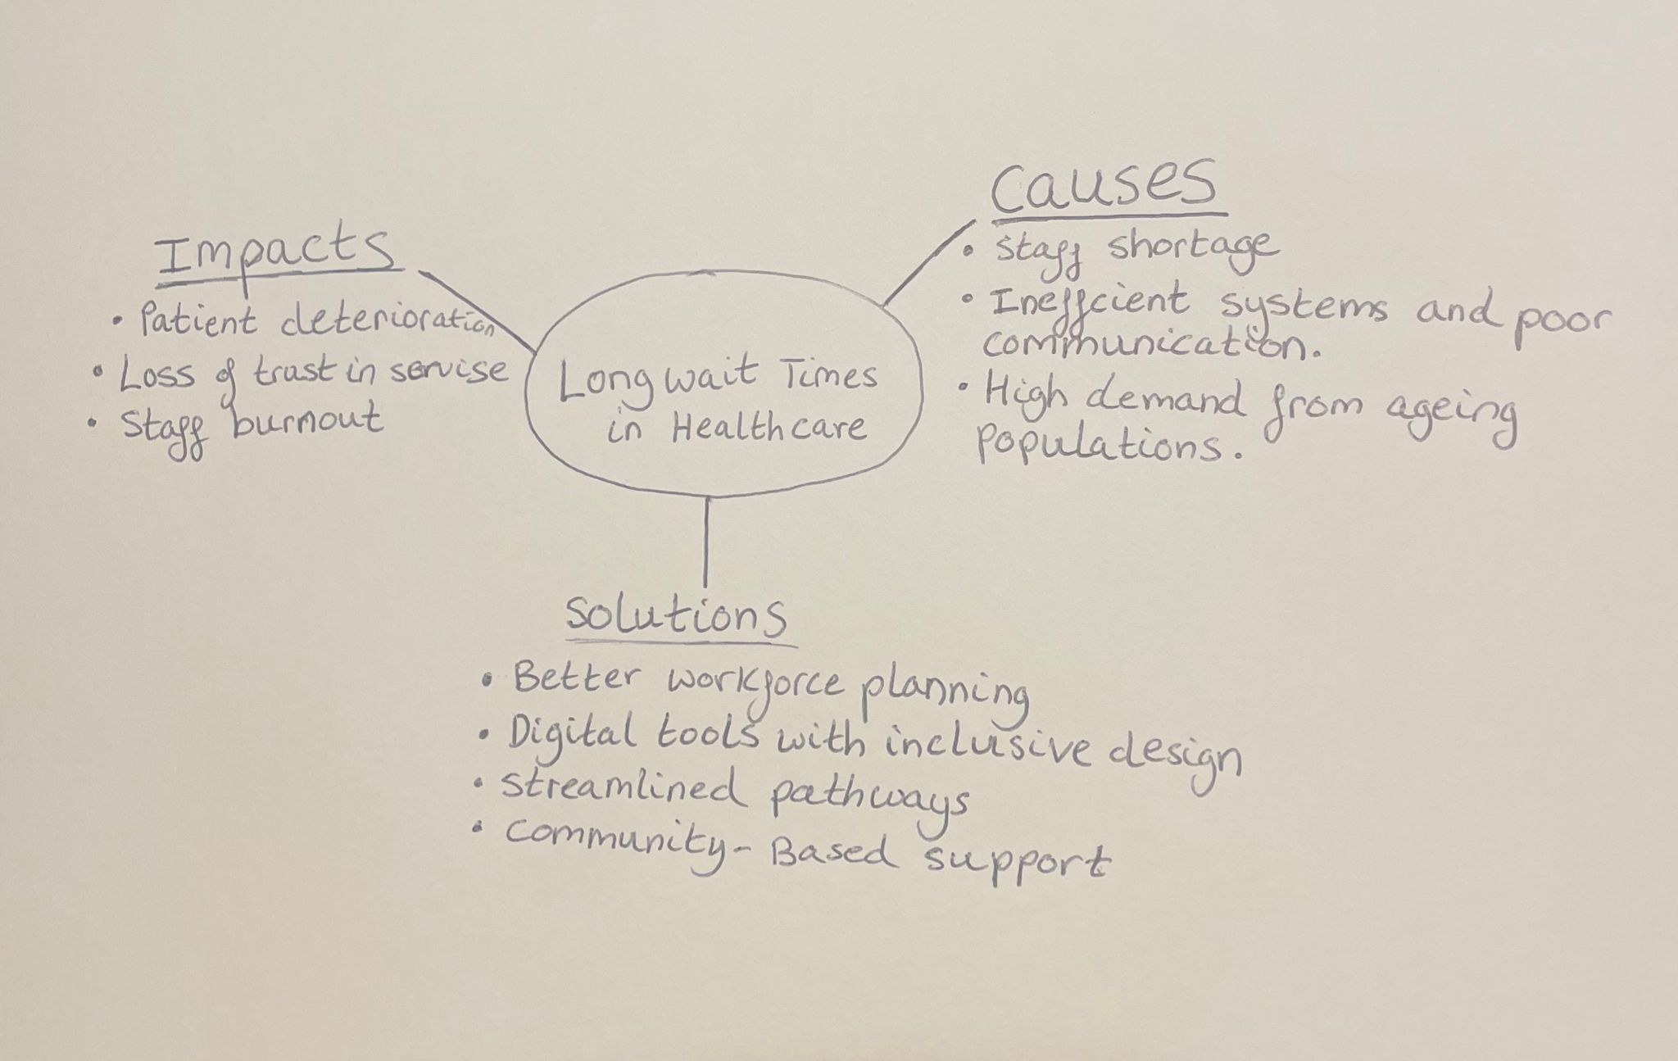

Long wait times are a persistent challenge in health care because they delay diagnosis, increase anxiety, and widen inequalities. Using a systems-thinking lens, the mind map shows how workforce shortages, rising demand, and digital exclusion interact to create bottlenecks. These pressures lead to staff burnout, which further reduces capacity and affects care quality. The Social Determinants of Health highlight that people with low income, limited digital access, or chronic conditions are most affected. If the issue is not addressed, preventable harm increases and services become unsustainable. The map also connects solutions such as inclusive digital tools and improved care pathways to the root causes, so improvements strengthen the whole system.

TASK 3.
Description: In the class activity, we explored divergent thinking-generating many creative ideas and convergent thinking, which involves narrowing options to select the most effective solution. My group was asked to design an innovative way to improve student wellbeing.
Feelings: I felt comfortable during the divergent stage because brainstorming freely felt natural to me. However, I became more hesitant when we had to evaluate and prioritise ideas.
Evaluation: A key moment was when our group could not agree on which idea to develop. I suggested using a pros and cons list, which helped us shift into convergent thinking and reach a decision. This showed me that I can support structure when discussions become unfocused.
Analysis: I realised that I rely heavily on divergent thinking and sometimes avoid challenging others’ ideas. According to (Kolb 1984), learning occurs when experience is combined with reflection, and this activity helped me recognise the value of balancing creativity with critical judgement.
Conclusion: I learned that effective teamwork requires switching flexibly between both thinking styles and contributing confidently at each stage.
Action Plan: Next time, I would participate more actively in the convergent phase by voicing my evaluations earlier and encouraging the group to compare ideas systematically.

TASK 4.
A clear example of UK health innovation is the NHS Virtual Ward model, designed to deliver hospital-level care in people’s homes. The core problem was rising demand for acute beds, long waiting times, and the need to support safe early discharge. Virtual wards use remote monitoring, multidisciplinary teams, and digital tools to manage conditions such as frailty, respiratory illness, and cardiac disease. Creativity played a role in combining existing technologies such as wearable sensors, telehealth platforms, and mobile clinical teams into a new care pathway that feels both familiar and flexible. This aligns with Rogers’ Diffusion of Innovation Theory, as virtual wards spread quickly where staff perceived them as useful, easy to integrate, and beneficial for patients.
The value created includes improved patient experience, reduced hospital admissions, and shorter lengths of stay. Patients benefit from being treated at home, while staff gain more efficient caseload management and systems benefit from increased bed capacity. An NHS South- East evaluation found that virtual wards prevented avoidable admissions and supported earlier discharge across 29 pathways. Parliamentary analysis also reports improved outcomes, higher satisfaction, and reduced pressure on hospitals.
These outcomes suggest the model is transferable to other regions and conditions, provided caregiver support and digital readiness are in place.

Who benefited from the innovation, and how?

Patients
- Better experience: They receive hospital-level care in the comfort of their own homes, which reduces stress and supports recovery.
- Improved outcomes: Remote monitoring allows earlier detection of deterioration, leading to faster interventions.
- Reduced exposure to hospital risks: Lower risk of hospital-acquired infections and deconditioning, especially for frail or elderly patients.

Clinicians and Multidisciplinary Teams
- More efficient caseload management: Digital tools allow staff to monitor multiple patients simultaneously and prioritise those needing attention.
- Greater flexibility: Teams can combine virtual check-ins with targeted home visits, improving workflow.
- Enhanced clinical oversight: Continuous data from wearables and remote devices supports better decision-making.

The NHS and the wider health system
- Increased bed capacity: Virtual wards free up acute beds by supporting early discharge and preventing avoidable admissions.
- Reduced pressure on emergency and inpatient services: Helps manage winter surges and chronic demand.
- Cost-effectiveness: Avoiding admissions and shortening length of stay reduces system-level costs.

What made the approach creative?
The creativity lies not in inventing new technology, but in recombining existing tools into a new care pathway. Key creative elements include:
- Integration of multiple technologies: Wearable sensors, telehealth platforms, remote monitoring dashboards, and mobile clinical teams were woven into a single, coherent model.
- Reimagining the “hospital” as a distributed service: Care is delivered across physical and digital spaces rather than within a building.

Could it be used elsewhere?
Yes, with the right conditions in place, the virtual ward model is highly transferable.

TASK 5
Issue chosen: Staff stress and burnout in healthcare
Two academic sources highlight the complex causes of staff stress in healthcare. A scoping review by (Nagle, 2024) shows that burnout arises from chronic occupational stress linked to workload pressure, emotional demands, and organisational factors such as inadequate staffing and limited managerial support. The review also notes that conceptual models like the Maslach Burnout Framework help explain how emotional exhaustion develops when demands consistently exceed resources.
A second study by (Gemine, 2021) identifies additional stressors during the COVID-19 pandemic, including increased workload, fear of infection, and rapidly changing service demands. Their mixed-methods analysis found that staff with heavier caseloads and insufficient recovery time were more likely to report burnout, aligning with systems-based explanations that link stress to wider organisational pressures.
Both articles agree that workload intensity and organisational conditions are central causes of stress. However, the first emphasises long-standing structural issues, while the second highlights acute pressures intensified by crisis conditions. These findings help explain why burnout is common in real care settings, where staff often manage high patient volumes, emotional labour, and limited resources. Understanding these causes supports targeted interventions such as improved staffing, supportive leadership, and workload redesign.
TASK 6

1. Benefit of Wearable Health Technologies
Wearable health technologies, such as smartwatches and continuous glucose monitors, support chronic condition management by enabling real-time self-monitoring. A key benefit is early detection of deterioration, which helps patients respond quickly to changes in their health. For example, people with heart failure can track heart rate, activity levels, and sleep patterns, allowing clinicians to identify worsening symptoms before they require hospitalisation. Research shows that wearables improve self-management by increasing awareness of daily behaviours and promoting adherence to treatment plans (Wang, 2023). This aligns with the Technology Acceptance Model, as patients are more likely to use wearables when they perceive them as useful and easy to integrate into daily routines. In real care settings, clinicians report fewer emergency visits when patients use remote monitoring devices, demonstrating how wearables enhance safety and reduce avoidable admissions.

2. How Electronic Health Records Improve Communication
Electronic Health Records (EHRs) improve communication by giving healthcare providers shared, up-to-date access to patient information. This reduces duplication, prevents errors, and supports coordinated decision-making across teams. For example, when a patient with diabetes attends both primary care and specialist clinics, EHRs allow each clinician to view medication changes, test results, and care plans instantly. Research shows that EHRs enhance collaboration by streamlining information flow and reducing delays caused by paper-based systems (Kruse, 2018). Systems Theory helps explain this: healthcare functions as an interconnected system, and communication failures in one part affect the whole. In real practice, EHRs reduce missed information during handovers and improve continuity of care, especially for patients with complex needs. This leads to safer treatment and more efficient teamwork.

3. Digital Technology in Preventative Care and Health Promotion
Digital technology supports preventative care by helping people track health behaviours, identify risks early, and receive personalised guidance. Mobile health apps are a strong example: they can monitor physical activity, diet, and sleep, and provide tailored feedback to encourage healthier habits. A study by (Patel, 2021) found that digital health interventions significantly increased physical activity levels and supported long-term behaviour change. This reflects the Technology Acceptance Model, as users engaged more when the apps were simple, intuitive, and clearly beneficial. In real-world settings, community health teams use digital tools to identify individuals at risk of conditions such as hypertension or obesity and offer targeted support before symptoms develop. For instance, step-tracking apps combined with coaching messages have been shown to reduce cardiovascular risk, demonstrating how digital tools strengthen prevention.
TASK7

1. Summary of the NHS Leadership Framework
The NHS Leadership Framework outlines the behaviours and capabilities expected of leaders across all levels of health and social care. It emphasises that leadership is not limited to senior roles; instead, it is a shared responsibility that supports high-quality, compassionate, and safe care. The framework includes behaviours such as inspiring shared purpose, leading with care, evaluating information, engaging the team, holding to account, and developing capability. These behaviours help staff work collaboratively, make informed decisions, and maintain a culture of continuous improvement. The framework is important because effective leadership directly influences patient outcomes, staff wellbeing, and organisational performance. Research shows that strong leadership improves safety culture, communication, and innovation within healthcare settings (West, 2015). It also aligns with transformational leadership principles, where leaders motivate and support teams to adopt new ideas and improve practice (Bass & Avolio, 1994). Overall, the framework provides a clear guide for developing compassionate, evidence-based leadership.

2. Applying One Leadership Behaviour: Inspiring Shared Purpose
A leader who demonstrates inspiring shared purpose can encourage creativity and improve patient care by helping staff understand why innovation matters. By clearly communicating a vision such as improving patient experience or reducing delays leaders create a sense of collective motivation. This behaviour empowers staff to contribute ideas, experiment with new approaches, and feel ownership over improvements. Research shows that when teams share a meaningful purpose, they are more engaged and more willing to adopt innovative practices (West, 2015). Through encouragement, recognition, and open dialogue, leaders can build a culture where creativity is valued and where new solutions directly enhance patient outcomes.
TASK 8
Self-Reflection Journal Entry
Throughout this module, my understanding of creativity, innovation, and value creation in health and social care has shifted from seeing innovation as mainly technological to recognising it as a mindset that supports everyday problem-solving. Using Gibbs’ Reflective Cycle helped me think more deeply about how creative thinking emerges from real challenges, such as improving patient experience or reducing delays. Tasks like analysing the NHS Virtual Ward model changed my perspective by showing how combining existing tools in new ways can create significant value for patients and staff. I also realised that creativity is closely linked to leadership behaviours, especially those that encourage shared purpose and experimentation. This learning will influence my future practice by motivating me to look for small, meaningful improvements in my workplace and to contribute ideas confidently. In future placements, I hope to apply creative thinking to enhance patient care, teamwork, and service efficiency.

Harvard Reference List
Bass, B.M. & Avolio, B.J., 1994. Improving organisational effectiveness through transformational leadership. Thousand Oaks: Sage.
Davis, F.D., 1989. Perceived usefulness, perceived ease of use, and user acceptance of information technology. MIS Quarterly, 13(3), pp.319–340.
Gemine, R., Davies, G., Tarrant, S.., 2021. Factors associated with work-related burnout in NHS staff during COVID-19. BMJ Open, 11(1), pp.1–10.
Kruse, C.S., Stein, A., Thomas, H. & Kaur, H., 2018. The impact of electronic health records on communication and care coordination. JMIR Medical Informatics, 6(2), pp.1–9.
Nagle, E., Griskevica, I., Rajevska, O., 2024. Factors affecting healthcare workers’ burnout and their conceptual models: A scoping review. BMC Psychology, 12(1), pp.1–15.
Patel, M., Phillips, A., & Nolan, C., 2021. Digital interventions for preventative health: A systematic review. Preventive Medicine Reports, 24, pp.1–10.
Wang, Y., Lee, H., Chen, T. & Kumar, S., 2023. Wearable devices and chronic disease self-management: A review of evidence. Journal of Medical Internet Research, 25, pp.1–15.
West, M., Armit, K., Loewenthal, L., 2015. Leadership and leadership development in health care: The evidence base. London: The King’s Fund.
Nagle, E., Griskevica, I., Rajevska, O.. 2024. Factors affecting healthcare workers’ burnout and their conceptual models. BMC Psychology. Gemine, R., Davies, G., Tarrant, S., 2021. Factors associated with work-related burnout in NHS staff during COVID-19. BMJ Open.
Wang, Y., 2023. Wearable devices and chronic disease self-management. Journal of Medical Internet Research.
Kruse, C.,2018. Impact of EHRs on communication and care coordination. JMIR Medical Informatics.

