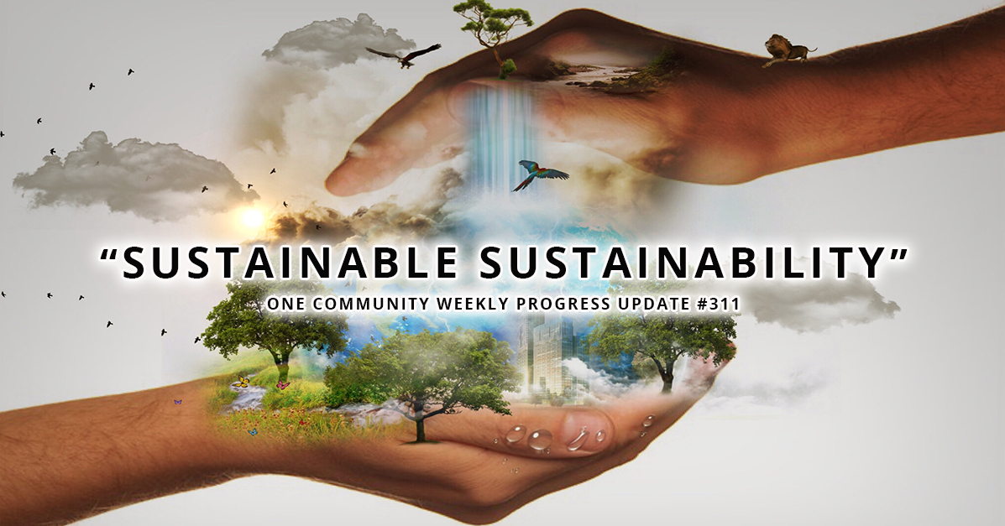  ECOSUPPLIES Bussiness Plan  Sustainable Enterprise | Abstract  ECOSUPPLIES is a leading enterprise that offers sustainable agricultural supplies, such as advanced irrigation systems, bio-pesticides, organic fertilisers, and eco-friendly seeds. The strategic framework for the enterprise's launch and expansion within the dynamic agricultural market is delineated in this business plan. Our objective is to provide producers with high-quality, environmentally responsible products that enhance soil health and crop yield while reducing ecological impact, thereby empowering them. The plan outlines explicit objectives, resource requirements, and thorough analyses, such as PESTLE and SWOT evaluations, to identify critical opportunities and mitigate risks. A comprehensive risk management and contingency strategy is recommended to support initial investments and a break-even period within 24-30 months, as indicated by financial projections. One of the objectives of ECOSUPPLIES is to cultivate robust community relationships and establish enduring partnerships with local agricultural cooperatives and research institutions. Our enterprise is set to spearhead a green revolution in agriculture, providing economic, environmental, and social benefits for a resilient future, by prioritising sustainability and innovation. Making an effect that lasts.

Introduction
ECOSUPPLIES is an innovative sustainable firm in the agriculture sector committed to revolutionising the sourcing, production, and delivery of farming inputs. Our objective is to supply eco-friendly, high-quality agricultural products, including organic fertilisers, bio-pesticides, certified organic seeds, and sustainable irrigation systems, to enable farmers to attain increased yields while maintaining environmental integrity. ECOSUPPLIES aims to establish itself as a reliable partner for farmers and agricultural cooperatives dedicated to ecologically friendly practices by incorporating advanced sustainable methods alongside profound local involvement. This business plan delineates our strategic objectives, operational resources, marketing strategy, and comprehensive analyses (PESTLE and SWOT), along with an initial financial cash flow and contingency plan intended to guide our growth and guarantee long-term sustainability in a swiftly changing agricultural environment (Dyllick and Muff, 2015; Schaltegger, Lüdeke-Freund and Hansen, 2012).

Business Overview
ECOSUPPLIES occupies a pivotal role at the intersection of agricultural innovation and sustainability. Our firm is founded on the principle that contemporary agriculture must shift from dependence on synthetic chemicals and non-renewable resources to ecologically friendly, sustainable alternatives. We procure raw ingredients from organic farms and certified eco-friendly sources, converting these inputs into solutions that improve soil health, preserve water, and diminish the carbon footprint of agricultural methods. ECOSUPPLIES provides an extensive selection of sustainable inputs to assist farms in implementing organic methods, reducing environmental hazards, and eventually enhancing output while respecting natural ecosystems. This methodology exemplifies the transition from conventional business models to genuinely sustainable firms, as articulated by modern sustainability research (Dyllick and Muff, 2015; Febrizal Rahmana and Bawono, 2020).
Objectives and Goals
ECOSUPPLIES aims to facilitate a transition to sustainable agriculture by establishing itself as the foremost supplier of eco-friendly farming inputs in our target markets. Our objectives include achieving a 20% market share in the sustainable agricultural supply sector within five years; diminishing local farming communities' reliance on chemical inputs by providing viable, sustainable alternatives; and promoting innovation via ongoing research and development in agricultural technologies. To achieve these objectives, we will establish strategic alliances with local agricultural research institutions and cooperatives, guaranteeing that our product development is closely matched with the actual requirements of farmers. Additionally, our social aims include the empowering of rural communities via training and employment possibilities, thus strengthening local economic resilience and fostering human capital development (Monday, 2015; Edgeman and Eskildsen, 2014).
Sustainability Framework
ECOSUPPLIES is fundamentally rooted in a comprehensive sustainability model that integrates environmental, social, and economic principles. Our environmentally orientated plan incorporates renewable resources and advocates for organic inputs that enhance soil regeneration and biodiversity. This methodology minimises ecological damage while enhancing long-term crop production through the cultivation of better ecosystems. Social sustainability is achieved through initiatives that promote community involvement, workforce development, and ethical labour practices, guaranteeing that our operations enhance local livelihoods. Our firm is structured to achieve profitability while simultaneously reinvesting in innovation and community advancement. The triple-bottom-line approach-emphasizing profit, people, and the planet-is guided by prominent sustainability frameworks and research that promote a shift from traditional business models to those that authentically incorporate sustainability at all levels (Thompson, 2010).
Resource Requirements
The effective realisation of ECOSUPPLIES' mission necessitates a meticulously coordinated distribution of physical, human, and financial resources. Our physical resources will consist of a central distribution hub and a contemporary production facility outfitted with energy-efficient gear for processing organic materials. This facility will function as a manufacturing site and a research centre dedicated to the development of next-generation sustainable agricultural inputs. Human resources will be essential to our operations; we intend to recruit agricultural scientists, sustainability specialists, production managers, and marketing professionals with proficiency in sustainable supply chains. The leadership team, proficient in the agriculture sector and sustainable business methodologies, will provide support to these personnel, guaranteeing that operational decisions prioritise both profitability and ecological integrity (Edgeman and Eskildsen, 2014). The firm will necessitate initial funding for infrastructure construction, equipment procurement, and research and development. Funding will be obtained through a combination of green venture capital, government grants designed to promote sustainable agriculture methods, and ecologically focused financial institutions. This diversified finance model will provide ECOSUPPLIES with the financial stability necessary to expand operations while complying with our sustainability goals (Cooney, 2009).
Marketing Strategy
ECOSUPPLIES' marketing approach focusses on creating a robust brand identity that appeals to environmentally concerned farmers and agricultural stakeholders. We utilise digital marketing methods, such as a dedicated website and active social media platforms, to demonstrate our dedication to sustainable practices. Our narrative underscores transparency, innovation, and community empowerment, including case studies and success stories from early users of our solutions. Furthermore, we will interact with agricultural cooperatives, participate in industry conferences, and partner with environmental organisations to bolster our credibility and expand our outreach. Our marketing communications are guided by trends indicating a growing demand for sustainable products among consumers and institutions, and our initiatives aim to cultivate enduring partnerships with rural communities and prominent industry influencers (Giesler and Veresiu, 2014; Dwyer, 2018). By coordinating our messaging with the ethical and environmental principles of our target demographic, we want to cultivate a devoted client base and a favourable reputation that will promote enduring growth.
PESTLE
The external context in which ECOSUPPLIES will function offers both opportunities and difficulties that require strategic management. Governments in various regions are actively endorsing green initiatives and sustainable agriculture via subsidies, tax incentives, and regulatory frameworks aimed at fostering ecologically responsible activities. Such policies foster a conducive operational environment for our enterprise (Nichols, 2012). The global transition towards sustainability is evidenced by increasing investments in the green economy, hence establishing a strong market for environmentally friendly agriculture inputs. However, economic instability and variations in commodity prices may impact our cost structures and pricing tactics. Social considerations are very advantageous; a rising awareness of environmental concerns among customers and farmers has led to an increasing demand for sustainable products. Advancements in agricultural science and digital communication provide innovative instruments for product development and market outreach, thereby enhancing our competitive position. ECOSUPPLIES must adhere to a multifaceted array of requirements concerning organic certification, environmental protection, and labour standards, requiring stringent internal controls and continuous legal supervision. Ultimately, environmental factors such as climate change and resource scarcity emphasize the necessity of sustainable practices, strengthening our business proposition while simultaneously presenting operational challenges (Caprotti, 2012; "The business of energy efficiency", 2010; United Nations Interregional Crime and Justice Research Institute, 2011).
SWOT
An internal evaluation of ECOSUPPLIES identifies multiple strengths that enhance the organization's potential for success. Our dedication to sustainability, along with an emphasis on quality and innovation, establishes a significant competitive edge. The combination of research-based product development and strategic alliances with local agricultural institutions enhances our market position. However, the enterprise encounters certain vulnerabilities, such as substantial initial capital investment demands and the difficulty of developing a dependable supply chain for organic inputs in a market predominantly governed by chemical-based alternatives. Opportunities proliferate as global trends increasingly support sustainable agriculture, with farmers actively pursuing eco-friendly inputs that enhance soil health and mitigate environmental deterioration. The increase of governmental assistance and consumer interest in eco-friendly products presents substantial growth opportunities. However, ECOSUPPLIES must contend with issues like competition from existing agricultural suppliers, possible regulatory alterations, and the hazards linked to supply chain interruptions. An adaptive management strategy and proactive risk mitigation measures are crucial for capitalising on opportunities while reducing hazards (Schaltegger, Lüdeke-Freund and Hansen, 2012; Lathabhavan, 2021; Anderson, 2006).

Financial Cash Flow Overview
A first financial study for ECOSUPPLIES indicates a fluctuating cash flow pattern marked by significant initial investments, succeeded by gradual revenue expansion as market penetration increases. Initially, substantial financial investments will be allocated to the establishment of production facilities, procurement of essential equipment, and financing of research and development projects. In this preliminary stage, a net cash loss is anticipated; but, as operations expand and our sustainable solutions achieve market acceptability, revenues are expected to increase consistently. Revenue will mainly derive from the direct sale of agricultural goods, augmented by government subsidies and prospective licensing agreements for intellectual technology produced internally. Variable costs, including raw materials and labour, as well as fixed operating expenses such as facility maintenance and administrative costs, will be meticulously managed to enhance profitability. Our financial forecasts suggest that ECOSUPPLIES will achieve its break-even point within 24 to 30 months, after which positive cash flow will facilitate additional reinvestment in innovation and market expansion. These estimates are supported by research indicating the feasibility of sustainable business models in attaining profitability while providing substantial environmental and social advantages (Jones, 2017; Febrizal Rahmana and Bawono, 2020).
Contingency Plan
Acknowledging the uncertainties specific to the agriculture and sustainability industries, ECOSUPPLIES has devised an extensive contingency plan to mitigate unexpected disruptions. If market conditions are less favourable than expected, we will initially respond by enhancing operational efficiency through cost-reduction strategies, including renegotiating supplier contracts and streamlining production processes. Simultaneously, diversifying revenue streams by broadening our product offerings to incorporate additional services such as agricultural consultation and training workshops will act as a safeguard against economic downturns. Supply chain disruptions, either from regulatory changes, natural calamities, or global economic pressures, will be alleviated by using various sourcing channels and sustaining strategic inventory reserves. A specialised risk management team will consistently oversee market trends, technical innovations, and regulatory changes to adjust our strategy in real time. This proactive risk management approach utilises proven principles of sustainability risk management to guarantee operational continuity and long-term resilience despite unforeseen obstacles (Anderson, 2006; Chofreh et al., 2018). By preserving adaptability in our financial and operational strategies, ECOSUPPLIES is adept at managing internal obstacles and external market volatility while upholding its dedication to sustainability.

Conclusion
ECOSUPPLIES aims to revolutionise sustainable agriculture by integrating strong financial strategies with an unwavering commitment to environmental stewardship, innovation, and community welfare. Our detailed business plan outlines a strategic framework for establishing a venture that offers environmentally sustainable agricultural supplies, promotes local collaborations, and enhances sustainable practices within the agricultural industry. By emphasising renewable resources, ethical production practices, and continuous scientific inquiry, we are prepared to provide goods that promote soil health, minimise ecological impact, and enable farmers to attain higher production and profitability.
Our strategy approach addresses significant market obstacles while leveraging growing opportunities in the agricultural sector. We have established a proactive risk management strategy that anticipates market fluctuations and regulatory alterations, so assuring operational resilience. By employing flexible production methods and fostering continuous innovation, ECOSUPPLIES is poised to manage uncertainties and sustain a competitive advantage. Collaborations with academic institutions, local cooperatives, and community stakeholders strengthen our dedication to sustainable growth and mutual value generation.
Social responsibility and environmental stewardship are fundamental to all aspects of our business. We foresee a future in which sustainable methods are the norm for success in agriculture. As we develop our operations, we will concentrate on investing in advanced technology, enhancing our product offerings, and broadening our market reach to address changing client demands. While doing so, ECOSUPPLIES will not only foster profitable growth but also make a substantial contribution to a more sustainable and resilient agricultural ecology. Our objective is to generate enduring advantages for the environment and the communities we support, guaranteeing that sustainable agriculture stays central to our common purpose.
ECOSUPPLIES is committed to fostering a legacy of sustainable development via innovation, continual enhancement, and community involvement, guaranteeing that future generations receive a prosperous and ecologically balanced agricultural environment. Our dedication persists beyond financial gain.

References list
Anderson, D. R. (2006). The critical importance of sustainability risk management. Risk Management, 53(4).
Caprotti, F. (2012). Environment, business and the firm. Geography Compass, 6, 163–174.
Chofreh, A. G., Gholamzadeh, A., Khanmohammadi, E., Klemeš, J. J., & Varbanov, P. S. (2018). Sustainable enterprise resource planning systems implementation: A framework development. Journal of Cleaner Production, 198, 1345–1355.
Cooney, S. (2009). Build a green small business: Profitable ways to become an ecopreneur.
Dyllick, T., & Muff, K. (2015). Clarifying the meaning of sustainable business: Introducing a typology from business-as-usual to true business sustainability. SSRN Electronic Journal.
Dwyer, P. (2018). Journey to responsible growth. The Purpose Business Insights.
Edgeman, R., & Eskildsen, J. (2014). Modelling and assessing sustainable enterprise excellence. Business Strategy and the Environment, 23(3), 173–187.
Galvao, A. (2008). The next ten years: Energy and environment [Video]. Crossroads 2008 presentation, MIT TechTV beta.
Giesler, M., & Veresiu, E. (2014). Creating the responsible consumer: Moralistic governance regimes and consumer subjectivity. Journal of Consumer Research, 41(October), 849–867.
Høgevold, N., et al. (2014). A corporate effort towards a sustainable business model: A case study from the Norwegian furniture industry. European Business Review, 26(4), 342–365.
Jones, G. (2017). Profits and sustainability: A history of green entrepreneurship. Oxford University Press.
Lathabhavan, R. (2021). Sustainable business practices and challenges in Asia: A systematic review. International Journal of Organizational Analysis.
Monday, J. U. (2015). Local content policy, human capital development and sustainable business performance in the Nigerian oil and gas industry. Journal of Management and Sustainability, 5(1).
Rahmana, F., & Bawono, A. (2020). Sustainable development toward sustainable enterprise. Management Science Letters, 11(2), 657–668.
Schaltegger, S., Lüdeke-Freund, F., & Hansen, E. G. (2012). Business cases for sustainability: The role of business model innovation for corporate sustainability. International Journal of Innovation and Sustainable Development, 6(2), 95–119.
Sze, J. (2018). Sustainability: Approaches to environmental justice and social power. NYU Press.
Thompson, F. M. M. (2010). Social enterprise: Developing sustainable businesses. Palgrave Macmillan.
United Nations Interregional Crime and Justice Research Institute. (2011). Freedom from fear, Issue No.9: Destabilization. United Nations.

