Joshua Albrighton Feasibility Contribution

2.2- Use of building: Past and present.
Present
Currently the site is a carpark. This is owned by Neath Port Talbot Council and is used predominantly by people visiting shops nearby or the two churches nearby.
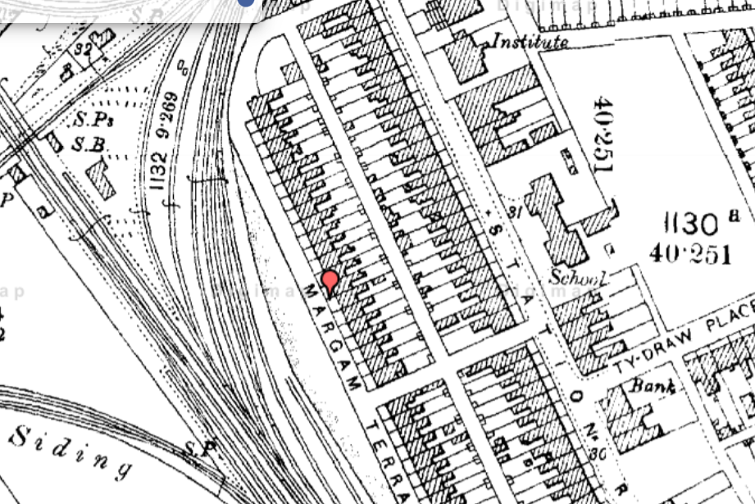
Houses constructed on site during the 1870’s
Using OS maps, we can see that there is record of houses being on the site as far back as the 1870’s. This could be a cause for concern as the standards for building are different to today and materials used may be left on site. The materials that concern us the most about buildings from this time include lead, asbestos and anthrax contaminated animal hair (which was a large concern around historic plaster before controls came in around the 1900’s).

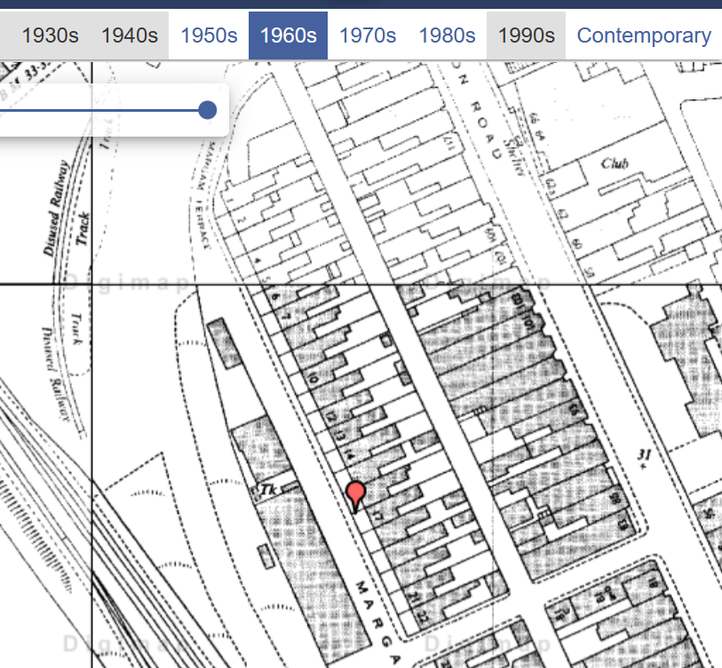
Houses still on site during 1960’s

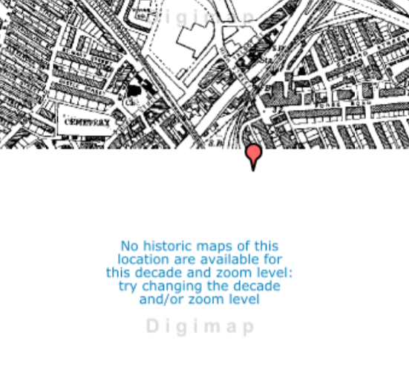
No data of site during 1970’s

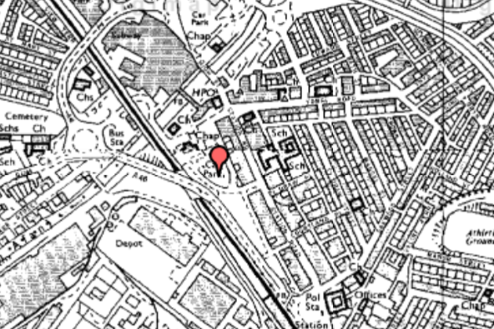
Houses demolished and turned into carpark in 1980’s map.

This data is from the 1970’s, also gathered on OS database and shows that the houses were demolished around this time and replaced with a carpark which is still currently on location. There is still a concern here with the practices used as we do not know the contractors used or any reports from the construction process, so we do not know which materials were found and if they were disposed of. A common practice which is illegal but is still done by many private contractors to cut corners is to mix in asbestos found in buildings with hardcore rubble. This is done to save them the money of disposing of it properly.
Another concern for us is that, with no reports from the construction or no plans of the previous houses we cannot tell if there are sub-structures such as basements or coal chutes that can cause weaknesses in the building’s foundations.

4.1 | Location description  The site is in Port Talbot, Southeast of the River Afan. The site is currently a carpark located on Station Road and is behind Port Talbot shopping centre. To the North of the site there are two churches and running around the site there is a road with a roundabout. The road is currently used for deliveries to the shopping centre. As there are many shops nearby and residencies, the area is busy with foot traffic.

2.3- current/proposed occupancy

Currently the site is a carpark so no occupancy.
Proposed occupancy- The building being proposed will have a reception area, a shop, a café with a play area, toilet facilities for staff and customers, storage facilities, office spaces as well as a mind and body centre equipped with consultation rooms, an internal garden, and a yoga studio. the proposed building will also have a gym section that includes a spa, sauna and steam room, a massage centre, a physio room, a multifunctional studio for classes, changing rooms, toilets, and a pool. The building will also include a separate plant room.

4.3- Site investigation to establish geology, substrata, and site hydrology.
Site investigation ongoing. Refer to geodatabase records:
Record title: Redevelopment of Port Talbot Town Centre Bridges26
Ref No:SS78NE243 Dated: 1969
Could be a concern with how old data is. Site ground may have changed over time, newer equipment could provide more accurate data, borehole data collected roughly 250 metres away from site.

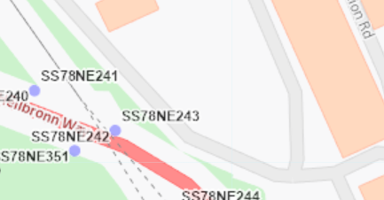

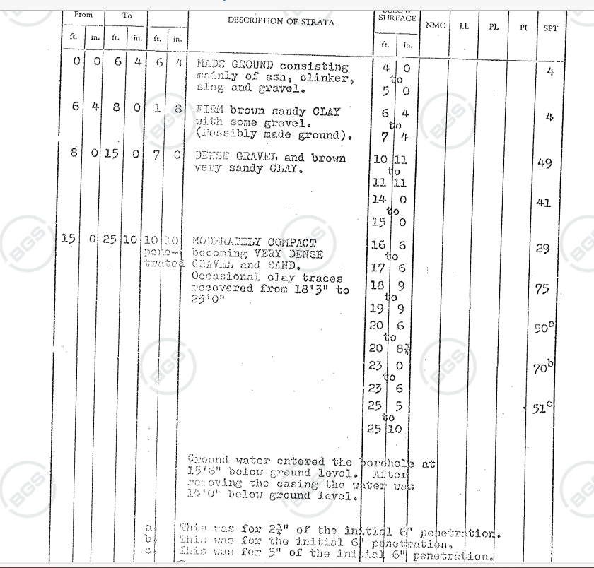

Due to the age of these borehole records and our concerns caused by the old buildings demolished before the carpark was built we are recommending a full ground survey and geotechnical investigation.


Apex Drilling Services can provide a full site investigation, geotechnical installations and investigations and environmentally friendly drilling services.
Geotechnical survey costs between £12,000-£20,000- including borehole investigation, geotechnical installations, in situ-tests, and trial pits.
Site investigation without borehole data likely to cost between £2,000-£5,000.
Even if the client wishes to use existing borehole date, the site will still need sub-structure investigation to ensure there are no weaknesses in the soil left by former structures (Basements)
Expect to be paying towards the higher end of the scale due to size of site. Expect all site investigations to cost roughly £25,000 on the high end.

UXO Reports
After investigation into the history of the site we have discovered a nearby location was previously a target of the German Luftwaffe. This is not an immediate concern however we do recommend, for the safety of all involved to consider a UXO survey.
This will involve hiring a company to look into the historical archives on and around the site to find where bombs were dropped or likely dropped. They will do this by looking into anecdotal evidence, other reports recorded nearby, news, nearby bomb incident records, historical maps, and arial imagery.
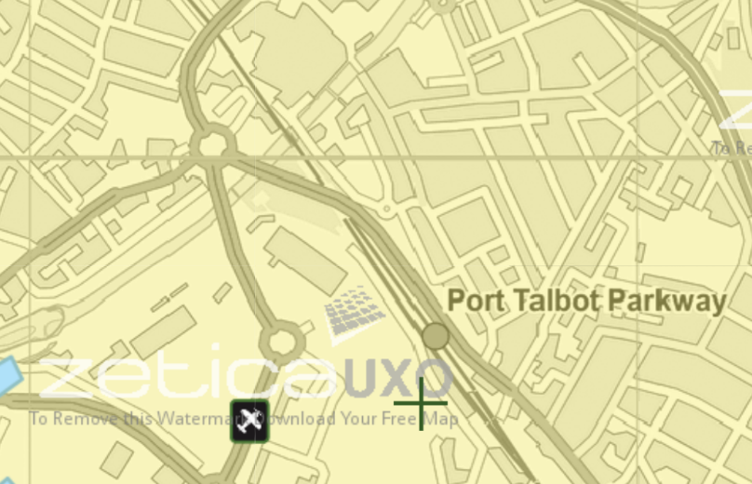
The image below is from a bomb density map of all of the U.K so this is able to give us a very rough idea of where bombs may be. The symbol in the bottom left shows how close the target zone was to the site but it is very hard to locate all of the bombs if there are any UXO’s. it is likely with these bombs that the entrance hole was covered up by debris or vegetation over time so it is within the best interest of the company to hire a company that can complete a UXO survey for the site.

As discussed previously in the feasibility report, there will be another ground investigation and borehole investigation taking place but as a rough guide, based on information given, we will be recommending concrete piled foundations. We are recommending theses foundations as they can transfer the weight of the building down to the lower, more compact gravel rather relying on the higher-level clay. The building is also very large with an uneven structure so the piled foundations can add strength, rigidity, and stability to the structure. The costs of these foundations will be discussed further in the report.

4.14- Site location Plan.
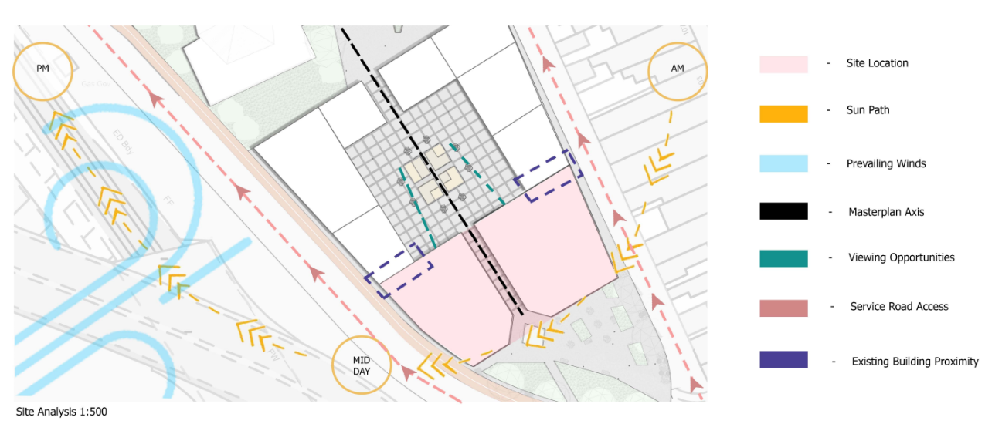

5.1- Development constraints- Planning. Listed building status, Local Plan/ Development Plan Conservation Area, CADW, Tree Preservation Orders, Hedgerow preservation requirements. Adjacent buildings of architectural interest. Planning consent required? Previous planning consents exist?

We will need to get planning consent.
Planning consent in Wales usually takes around 8 weeks unless an environmental impact assessment is required which will extend that period from 8 weeks to 16 weeks. If you do not hear from the local planning authority within the set time period, then you can appeal to the Welsh ministers and a planning inspector will be appointed to the case and make a decision.
If the local planning authority turns down the planning application for reasons you believe to be unacceptable you can also appeal that decision to have a planning inspector appointed to the case.
The issue is that if an appeal is needed this may take several months so if that happens then the whole schedule will be set back.

Listed buildings in near site in Port Talbot:
Bethany Chapel- Grade 2 listed building.
There is one listed building near the site. This building is Bethany Chapel and as you can see from the image below the building is a grade 2 listed building. This building will not be of much concern to us as there are other buildings between the building and our site and there is no possible way we could cause any harm to this building besides from possible gross negligence on any of the contractors behalf.
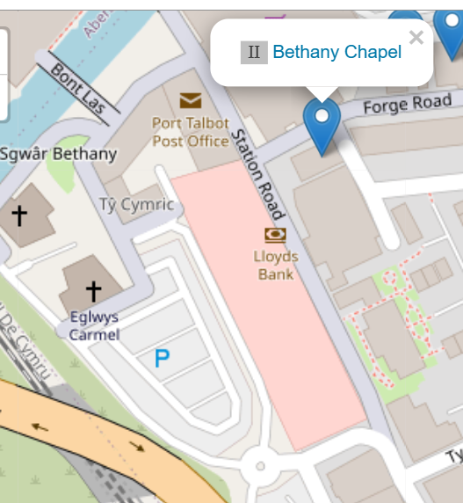

No areas of importance listed nearby on CADW.

The site is not listed as a conservation area.
No hedgerow preservation
No tree preservation orders but council must grant permission
There are no tree preservation orders but Neath Port Talbot Council must grant permission before any tree stumps are removed from the ground.

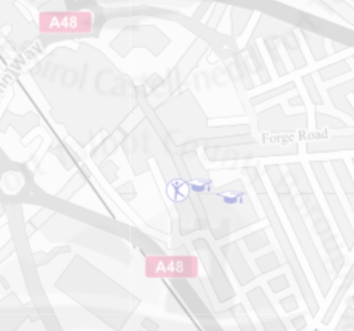

There are public rights of way nearby to this site.
There is one public walkway crossing over the river Afan (highlighted in orange) and one public road (highlighted blue) where access must be maintained as this is the delivery route to the shops nearby.
This isn’t a major concern as the site isn’t set to go up as far as the public walkway and although the plans are to remove the roundabout this will have to be done as efficiently as possible to minimise disruption. We will also need to employ road cleaner or hire tyre washers to ensure that the road is not left in a bad state for other users.

Previous planning applications
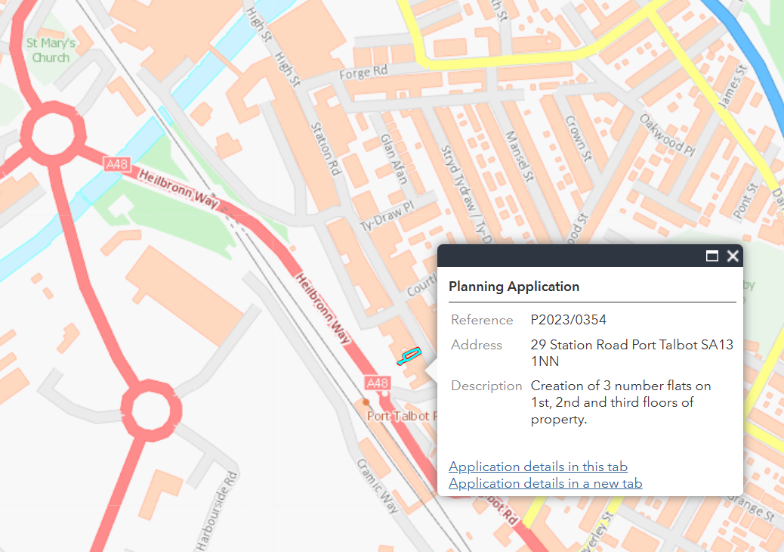
Application denied-
Reason:
The large flat roof dormer proposed is prominent and visually dominant and detracts from the street scene this is contrary to Policy BE1(1), which requires that new development complements and enhances the character and appearance of the site. Other material considerations such as the economic benefits of the development or the provision of new housing are not sufficient to outweigh the detrimental impact on street scene and the proposal is contrary to Policy BE1.

This application should not be of much concern to you as clients as this planning application that was denied was for flats whereas your health centre is not only adding much more economic value, but it is also designed to improve the street scenery with its contemporary architectural style. If your planning application was denied for similar reasons, then that would certainly be seen as cause to appeal.

7.2 - Alternative systems of construction
There are a few different methods of construction that we believe might speed up the process and lower costs in the project. Take these into consideration:
Offsite manufacturing of structural components- columns and beams especially can be manufactured offsite to save project lead time and labour costs.
Precast foundation walls- reduces installation time and labour costs. High strength concrete with rigid insulation in a single panel. Panel includes a cavity on the interior for wiring, plumbing or possibly more insulation. Can also include metal or wood framing to attach drywall.
7.5 - Provision for future expansion/ alteration
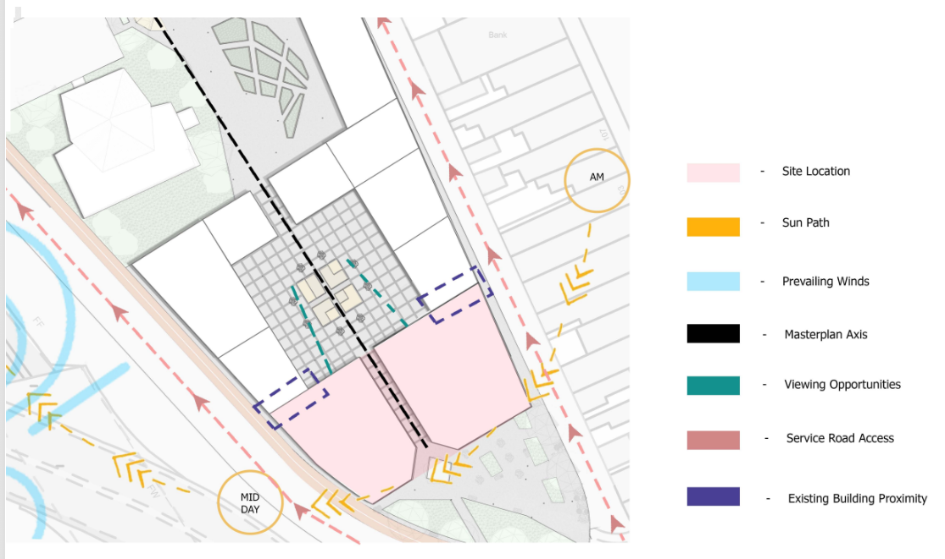
Be mindful of shared wall between health centre and café.
Alterations could be difficult looking at initial drawings with protruding steel top, glass panes, and steel beams showing as facework.
Alterations on the designs could be very costly, possible, but very costly.
This is why, as a company, we strongly recommend that you discuss any possible additions to the building now as they would be very costly.
The only way that this building can be expanded is upwards as the shared wall with the café and the road opposite do not allow for expansion outwards.

11 | Drawings and associated information
11.1 | Site location drawings and aerial photographs  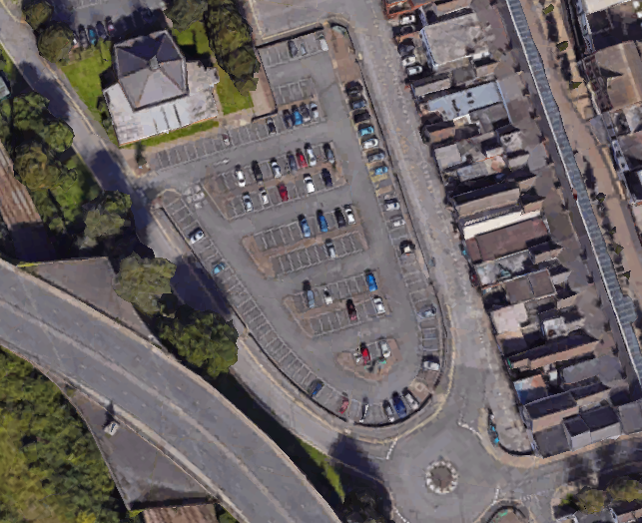
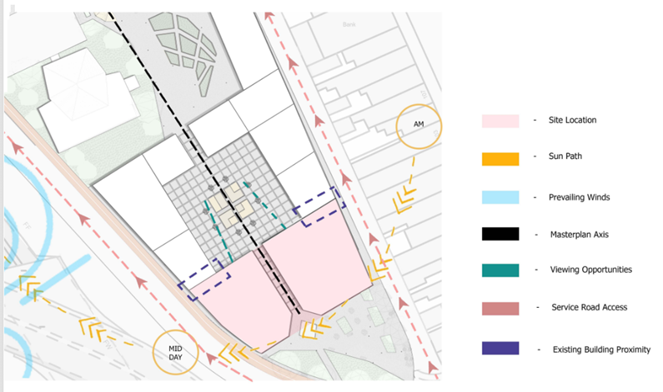

11.2 | Sketch schemes and options

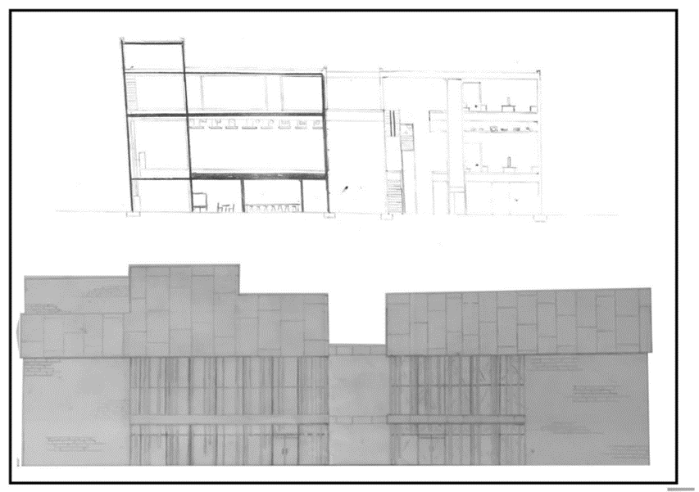

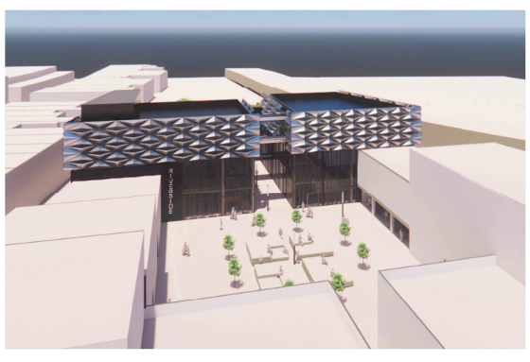

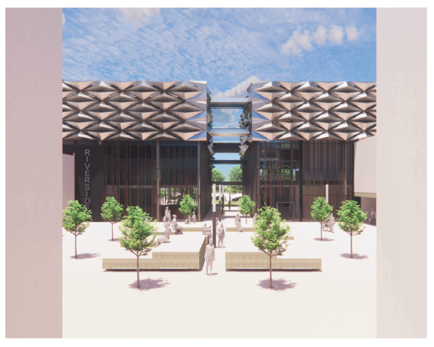

11.3 | Schedule of accommodation  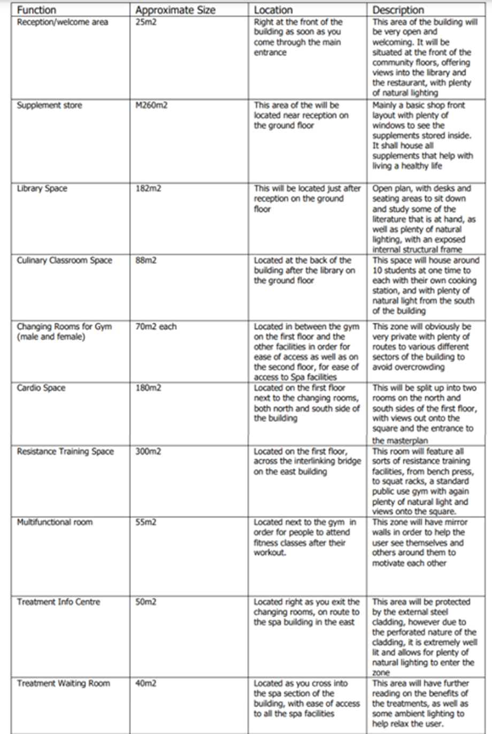  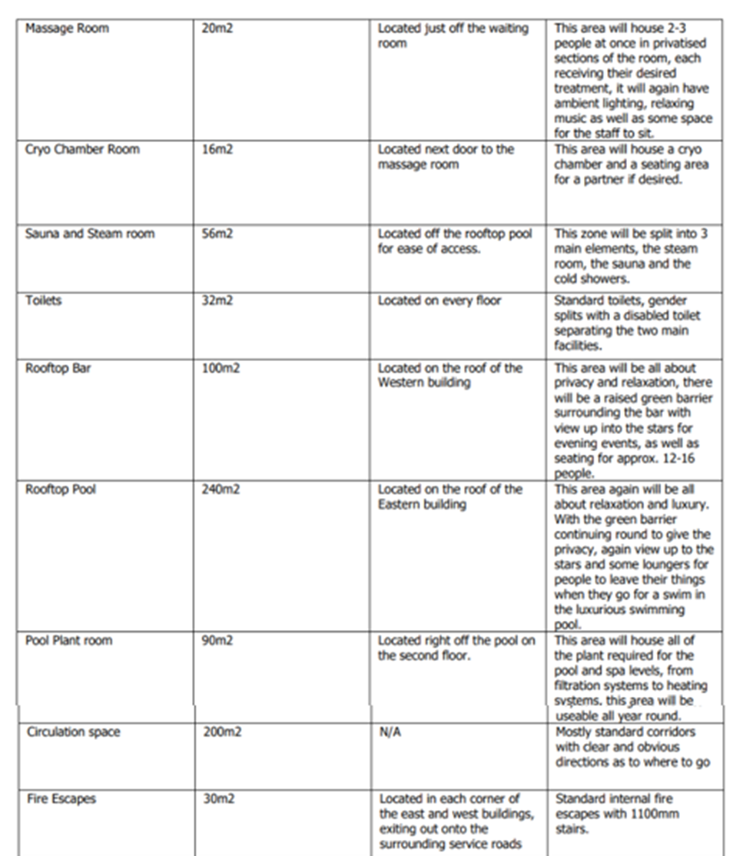
11.5 | Preliminary design



