Dafydd Pett (2405762)
Changemakers: Creativity and Value Creation – Assignment 2
Dafydd Pett
2405762
Changemakers: Creativity and Value Creation
Assignment 2 - Project Management & Innovation
Contents
Introduction 2
Conclusion 8
Reference List 9
Appendices 9

Introduction
The world is consistently evolving and the technology industry is one of the most progressive sectors which is why IT professionals need to keep up to date with the latest advancements and implement them into their IT environment and infrastructure as soon as possible to ensure that systems and applications are kept up to date, efficient and most importantly secure. Within this unit, I will demonstrate the need and implementation of a Security Incident and Event Management system.
Task 1: Project Management
Question 1: Project Management & Planning:
Project Scope
Project Name: Implementation of a SIEM (Security Information and Event Management) System
Problem: Increasing risks to the organisations network due to cyber criminals using a range of cyber-attack techniques which pose a serious threat to the organisation’s environment. Cyber-attacks have increased massively [3] with 50% of businesses and 30% of charities being effected by a breach or attack within the last 12 months.
Project Solution: Implementing a SIEM system which integrates with the range of systems that are used in the organisations environment which will detect, log and report threats to the engineer and suggest the resolution to remove the threat.
Project Aim: Implement a Security Information Event Management System into my organisation in order to protect our network by allowing easy access to monitor, detect and respond quickly to threats due to the ever-increasing cyber-attacks which are taking place on organisations globally.
Project Objectives: Firstly, I will need to research a suitable SIEM system that will work for the size and complexity of my organisations environment and network with the main objective of it being able to integrate with the range of systems and applications that are essential to the everyday running of the organisation. Once a decision has been made on the SIEM to be implemented, I will then need to ask engineers that will be using the SIEM system as well as users of the systems and applications that are linked to the new system for feedback. Once this has all been completed, I will need to provide sufficient training for all engineers.
Project Timeline:

Task | Start Date | End Date | Duration (days)
Research | 18/08/2025 | 01/09/2025 | 10
SIEM Software Selection | 01/09/2025 | 04/09/2025 | 4
SIEM Setup | 04/09/2025 | 12/09/2025 | 7
Pilot SIEM Testing | 12/09/2025 | 19/09/2025 | 6
All Engineers Training | 19/09/2025 | 24/09/2025 | 4
All Engineers Testing | 24/09/2025 | 26/09/2025 | 2
Engineer Feedback Window | 26/09/2025 | 01/10/2025 | 4
Configuration Amendments | 01/10/2025 | 08/10/2025 | 6
Rollout | 08/10/2025 | 17/10/2025 | 7

Schedule & Constraints:
Schedule
- Taskforce will be created to research and initially test SIEM’s
- Weekly catchup meetings to be scheduled which will have an agenda and minutes to ensure we are following the timeline
- Shared OneDrive folders to be created with important documentation and spreadsheets for any research and testing advancements
Constraints
- Lack of time to rollout the SIEM
- Only a small number of staff would have the ability to spend time on the project without it implicating their primary workload
- A budget will be set, and the project must fall inside that budget
Gantt Chart
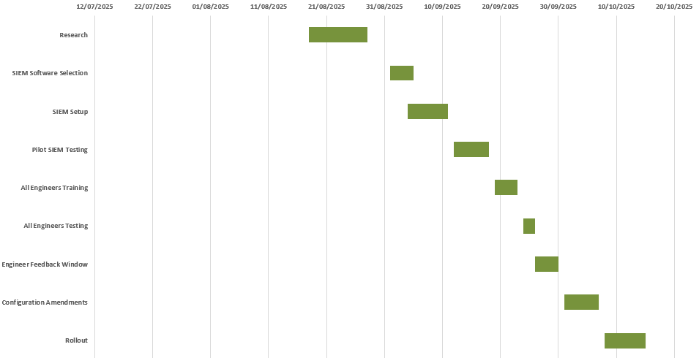
Development Method
I will approach this project using a hybrid development method which is when both predictive and adaptive approaches are applied. This is due to the fact that amendments may need to be made in order to take place and a predictive method wouldn’t allow these changes to be made as the project develops especially during testing, configuration and feedback stages.
Although the adaptive approach allows for changes to be made, [6] feedback is not needed every time that a change is made due to the multiple feedback tasks that have been put in my plan. This is why I believe the appropriate development method would be hybrid.
The hybrid development method I have chosen will allow for us to make decisions, amendments and track our progress in our weekly taskforce meetings and during testing or re-configuration phases of the project.
Question 2: Project Design:
Requirement Specification
- Monitor and log any events
- Be fully encrypted with AES 256 bit
- Link with all active systems and applications
- Show data on the incident and how to resolve the event
- Provide a notification to all engineers so that they can act on the incident
- Easy to use user interface
Flow Chart
[5] The below is the flow chart on what the SIEM would be monitoring and logging and in the case of a event, would the SIEM would do.
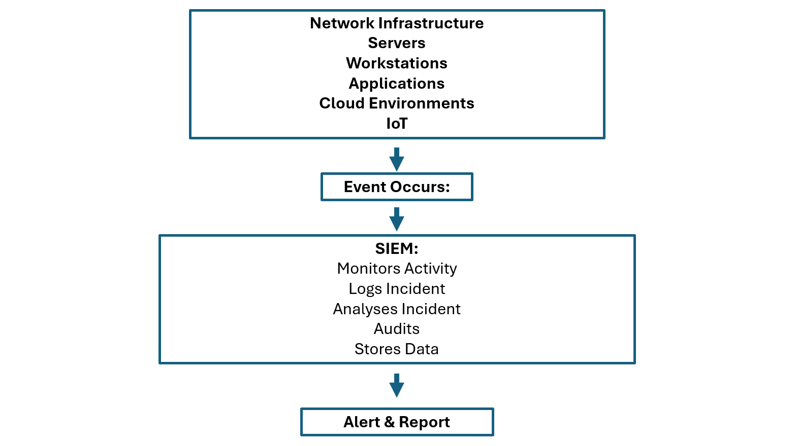

Task 2: Enterprise & Innovation – T2 Innovation
Question 1: Document some key considerations from an example PEST & SWOT analysis for a Tech Company of your choice including some legal & ethical considerations.
Key Google Cloud PEST Considerations [1]:
Political:
ISO
Google have to comply with ISO 27001 which is what is needs to be followed to get an accredited level of information security management. This relates to the structure, policies and procedures that need to be considered when configuring and using the Google Cloud.
Comply with Regulations:
Googles cloud systems need to be linked to systems that hold a large amount of personal information that needs to be protected in line with the General Data Protection Regulation. When regulations change, Google must follow them.
Economic:
Budgeting
Ensure cost is kept reasonable for customers yet allow money in the budget for company innovation.
Training
Provide free training for services so that companies know they won’t have to spend additional money to provide this service.
Cost Benefit
Ensure it is feasible to spend money on Google Cloud Products by displaying a cost benefit analysis which will allow an organisation to see how great the benefit the implementation of using Google Cloud is.
Monthly Charges
Show the customer of Google Cloud the monthly charges and if the cost is variable or fixed so that they can factor in the cost into their budget.
Upgrade Charges
In the event of our infrastructure or organisation getting bigger, is there an option to upgrade the Google Cloud package without loosing the customers.
Social:
Training
Provide strong and in-depth training for all users of Google Cloud.
Target Customer
Changes in population, global economics and can also affect Google’s business
Social Movements
Google conduct and monitor social movements to ensure that their brand image is positive and people still want to have dealings with the company.
Technological:
Advancements
Ensure that it is easy to re-configure and upgrade to adapt to advancements of technology or changes in organisation’s IT infrastructure.
Transformation & Regeneration
In the event of an increase in systems and applications, would Googles product still be suitable and if these changes were to go ahead, does the product allow ongoing upgrades to allow extra features. An example of this could be AI or using 5G instead of 4G.
Encryption
With a large amount of data being stored by Google Cloud, how secure is it and are advanced encryption standards met and used such as AES256?
Key Google Cloud SWOT Considerations – Google [2]
Strengths:
Google have a range of systems such as a SIEM which monitors and logs incidents that would be flagged as suspicious and gives guidance on the next steps to assist engineers.
Developed tools which allows faster response to incidents making the network more secure overall making incident management more positive while complying with industry standards such as ISO 27001
Integration with other Google applications allow an ecosystem to be developed. An example of this is Google SecOps & Bindplane.
Weaknesses
Development and market research can be expensive.
Marketing the applications can be hard and costly.
Integration with some older and non-Google supported applications can be difficult such as Android where Google struggle to integrate.
Opportunities
Ability to spend a lot of time developing new tasks to keep up with emerging trends and tech advancements.
Google are able to use their Cloud infrastructure to keep costs down and implement it into their applications.
Able to create a large Google Ecosystem because of their collaborations with Hardware suppliers. For example, Google are involved with the Chromebook which would allow seamless use of Google applications.
Threats
Large number of competitors doing similar things which could push customers to them if services are not priced reasonably. Competitors with similar business strategies such as AWS & Apple are battling for Monopoly and could undercut Google to achieve this.
Changes in regulations or organisational standards could mean that they would have to make drastic changes to the applications and if they are not followed, fines could be handed out or jobs lost if they departments are no longer required.
Question 2: Related to your project idea describe the concepts, methods, practices and tools you would use to develop, deploy, maintain and evolve the practical element of your project if it was implemented within a large organisation.
Concepts [4]
Threat detection – Real time detection of threats which log and monitor any potential threats showing data such as the location, time and IP address. This will be for all systems and applications used by the organisation.
Incident Response – When a threat has been identified, show the next steps on how to protect the environment from this threat.
Notifications – When a threat is detected, send a notification via both email and SMS to the relevant engineers so that they can act within the agreed service level agreement for high severity incidents.
Methods
Pilot Group – Develop a pilot group of senior engineers to provide feedback, configure and test the SIEM throughout it’s range of stages to ensure it meets the needs of the organisation.
Feedback – Using feedback from senior engineers, we will configure a fully functional SIEM which will integrate all systems and applications in the most practical way for them to act on incidents. Using feedback, we will also ensure the dashboard is designed in the easiest way for it to be used affectively.
ITIL – [7] Using ITIL fundamentals, we will slowly implement the SIEM with the help of our change management officer who will deal with the request, approval and communication of the change.
Phased Rollout – We will take thorough and slow steps to ensure that the SIEM is rolled out successfully with valid communication and a slow but planned implementation is undertaken.
Practices
Encryption – The SIEM will need to be protected by an advanced encryption standard of 256 bit which is virtually uncrackable. SSL protection will also need to be applied on the domain.
MFA – MFA will need to be implemented to allow an additional layer of security.
Training – Provide training to the engineers so that they know why SIEM is important and how to use the system and it’s fixes once it has been implemented. Provide training to users of systems and applications to make them aware of security threats and how to avoid them.
Incident Management – Post incident, change management procedures will need to be put in place for investigation purposes to ensure that the issue won’t be repeated.
Tools
SIEM – Using a variety of pre-existing SIEM’s, we will choose what we believe would fit into our budget and during testing stages, decide what SIEM provider works best for the environment in our organisation.
Databases – [8] Using SQL Databases, we will be able to look into the logs of past events in details for auditing and incident management purposes. As soon as an incident occurs, all data can be put into the SQL database and searched for using keywords when required for audit purposes.
Task 3: Project reflection
The SIEM implementation within my organisation is an essential project to secure the infrastructure and network but also allows me as an individual to upskill and identify areas for future personal improvement.
Using this project, I would be able to develop my personal skills from both a technical and project management perspective due to wide aspects featured in the implementation of a SIEM. With very little experience with SIEM’s, I will be able to understand the importance and architecture of SIEM’s and the integration between all systems and applications furthering my Cyber Security knowledge. Secondly, my project management skills will improve as I will have to factor the project timeline, ISO27001 as well as other policies, procedures, effectiveness and useability which are all essential to ensuring the project is a success.
Using the new skills that I will acquire, I will be able to work on further Cyber Security projects as I will have a further understanding of the systems and applications used and the threats that are posed to them. As IT progresses, there is a guarantee that further SIEM projects will be needed in the future and using my already existing technical and project management skills from this project, I will be able to lead it with confidence which would provide a seamless upgrade of the level of Cyber Security in the environment.
Although I can develop a range of skills from this project, there are some risks and challenges that I will face. Firstly, this project would be the first time I would be working with SIEM meaning I am learning as the project is rolling which puts the projects timeline at risk and the aims during the configuration stages. Due to having a lot of financial pressures within the organisation, this may also have a knock-on effect with the project that I am running which would put limitations in place in many stages of the project.

Conclusion
The SIEM implementation project overall is a great way to protect the organisations network and systems and applications within that environment and how it can combat the rising number of cybersecurity threats. Using industry standards such as ISO 27001 and policies and procedures of the organisation and department, I have managed to scope the implementation of SIEM making ensuring that the integrity of our network is maintained and remains our top priority as an ICT team while also taking pressure off engineers so that they can spend time on other projects giving the organisation a economic benefit.

Reference List
[1] “Google PESTEL Analysis.” [Online]. Available: https://thestrategystory.com/blog/google-pestel-analysis/
[2] “Google SWOT Analysis.” [Online]. Available: https://businessmodelanalyst.com/google-swot-analysis/?srsltid=AfmBOoor9ux1ZkOyqDMPi_4EFcjZMCRmwtel-du6dGll5oEzh-fszH5E
[3] “Cyber security breaches survey 2024.” [Online]. Available: https://www.gov.uk/government/statistics/cyber-security-breaches-survey-2024/cyber-security-breaches-survey-2024
[4] ”10 Must-Have Features to be a Modern SIEM”, [Online]. Available: https://www.exabeam.com/explainers/new-scale-siem/10-must-have-features-to-be-a-modern-siem/
[5] “https://www.oneidentity.com/learn/what-is-security-information-and-event-management.aspx.” [Online]. Available: https://www.oneidentity.com/learn/what-is-security-information-and-event-management.aspx
[6]
“Hybrid Project Management: A Blended Approach to Agile and Waterfall Methodologies.” [Online]. Available: https://www.teamgantt.com/waterfall-agile-guide/hybrid-approach
[7]
“Developing ITIL - Mature Security Incident Response With SIEM”, [Online]. Available: https://cdn-cybersecurity.att.com/blog-content/2011/11/SIEM-for-ITIL-Incident-Response-Part-1.pdf
[8]
“SIEM use case for Databases logs.” [Online]. Available: https://community.graylog.org/t/siem-use-case-for-databases-logs/7321

Appendices

Task | Start Date | End Date | Duration (days)
Research | 18/08/2025 | 01/09/2025 | 10
SIEM Software Selection | 01/09/2025 | 04/09/2025 | 4
SIEM Setup | 04/09/2025 | 12/09/2025 | 7
Pilot SIEM Testing | 12/09/2025 | 19/09/2025 | 6
All Engineers Training | 19/09/2025 | 24/09/2025 | 4
All Engineers Testing | 24/09/2025 | 26/09/2025 | 2
Engineer Feedback Window | 26/09/2025 | 01/10/2025 | 4
Configuration Amendments | 01/10/2025 | 08/10/2025 | 6
Rollout | 08/10/2025 | 17/10/2025 | 7

