
ACCA7022
Advance Statistical programming
Alien Colony Resource Management Simulation

SHAIDHUL HASAN
Student ID.2442113

1.Introduction
This report explains how I built and tested a computer simulation of an alien colony using R. The goal was to create and organize data using only basic loops. I was not allowed to use any of the fast shortcuts like apply(), aggregate(), or rowSums(), so I had to write out every step of the data handling manually.
The simulation covers 30 days (sols) for 6 stations, with each station having 4 teams. To find the daily output for a team, I used a specific formula:
Output = 50 + (Station Number × 3) + (Team Number × 2) + a random number between -5 and 5.
This formula makes sure the production changes based on the station and team while keeping a bit of random variation. In the next sections, I will explain my logic, show my flow charts, and share what I learned from this project

2. Task 1A – Generation of Production Data

2.1 Approach and logic
To create the data, I used three "nested" loops (loops inside loops):
- Outer loop: Counts the days (Sol 1 to 30).
- Middle loop: Goes through each Station (1 to 6).
- Inner loop: Goes through each Team (1 to 4).
This setup (Day → Station → Team) matches how the colony is organized and makes sure the code covers all 720 different combinations. Inside the smallest loop, the computer picks a random noise number between -5 and 5. Then, it calculates the output using the formula: 50 + (Station * 3) + (Team * 2) + Random Noise. Each time it finishes a calculation, it adds a new row of information to the main table.
I chose nested loops because they are easy to track and follow the assignment instructions perfectly. While there are faster ways to do this in R, I didn't use them because the rules strictly say to use loops only and forbid the faster "shortcut" functions.

2.2 Flow chart
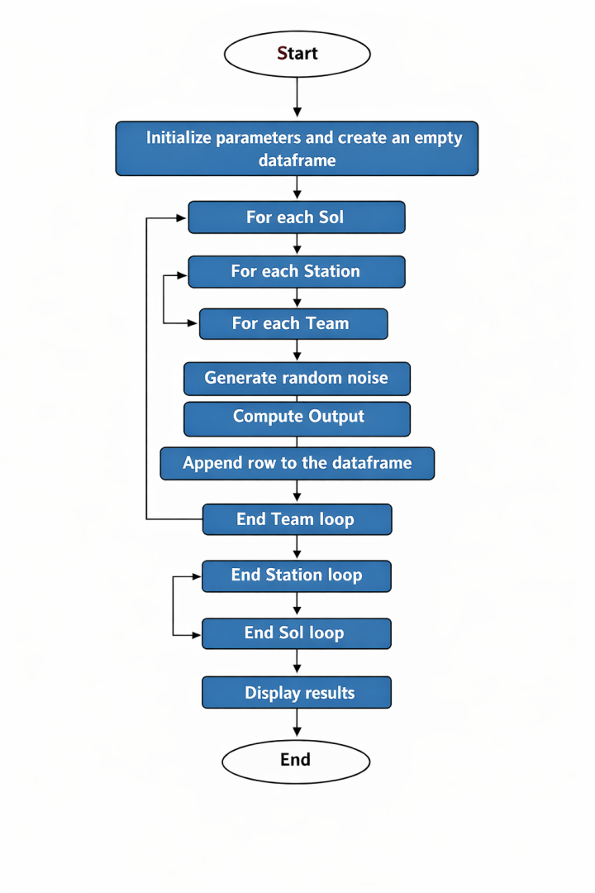
Figure 1: Iterative Logic for the Synthetic Generation of Colony Production Data

2.3 Testing
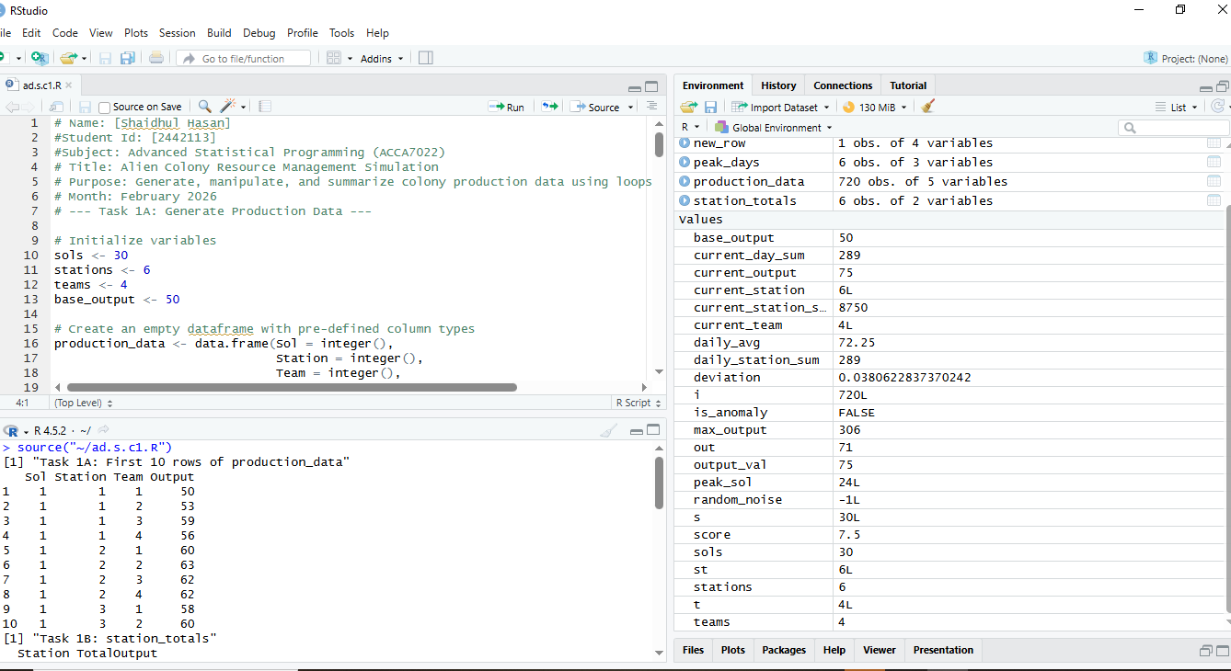
I did a few things to make sure the code was working correctly:
- Row Count: I used the nrow() command to check that the table had exactly 720 rows, which matches all the combinations of days, stations, and teams.
- Value Ranges: I used the summary() command to check the output numbers. I made sure they increased as the station and team numbers got higher and stayed within the right range with the ±5 noise.
- Small Scale Testing: While building the code, I ran a small test with only 1 day instead of 30. This allowed me to check the math with a calculator to ensure the loop logic was perfect before running the full simulation

3. Task 1B – Total Production per Station

3.1 Approach
To find the total production for each station, I made a new table called station_totals with two columns: Station and TotalOutput.
I used a loop to go through each station one by one (from 1 to 6). For every station, I started a "sum" counter at zero. The code then looked at every single row in the main data; whenever it found a row belonging to that specific station, it added that row's output to the counter. Once it finished checking all the data for that station, it saved the station ID and the final total into the new table.
This method does the same thing as a "sum by group" tool, but it follows the rules by using only basic loops. In a normal job, I would use faster shortcuts like aggregate(), but here, the loop shows exactly how the math is being done step-by-step.

3.2 Flow chart
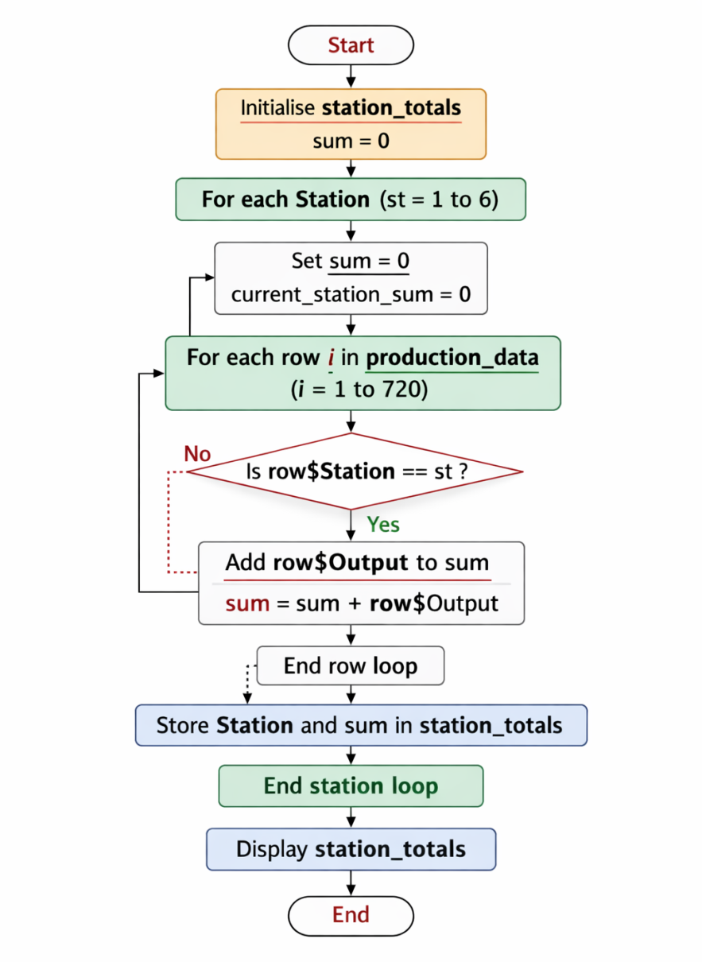
Figure 2: Algorithmic Workflow for Grouped Summation of Station Outputs.

3.3 Testing
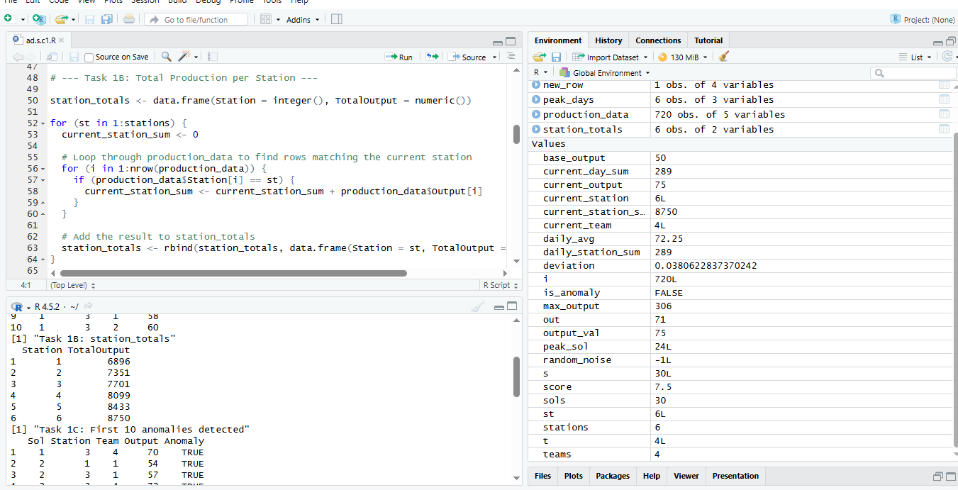
I checked my work in three ways to make sure it was correct:
- Row Count: I made sure the station_totals table had exactly six rows, one for each station.
- Manual Math: I picked one station and added up its production numbers by hand using a calculator. I then compared my answer to the total the code gave me to make sure they matched.
- Logical Patterns: I checked that the total numbers looked right and generally increased as the station numbers got higher. This made sense because the formula I used was designed to give higher-numbered stations more output.

4. Task 1C – Detection of Production Anomalies

4.1 Approach
An anomaly is just a team output that is more than 10% higher or lower than the station’s average for that day. To find these, I used a two-step process for every day and station:
- Step 1: Finding the Average: First, I set a counter to zero and looked through all the data to find the four teams at a specific station for that day. I added their outputs together and divided by 4 to get the daily average.
- Step 2: Checking for Deviations: Next, I looked at those same teams again to see how far their individual output was from that average.
- Final Check: If a team’s score was off by more than 10%, I marked it as TRUE for an anomaly

4.2 Flow chart
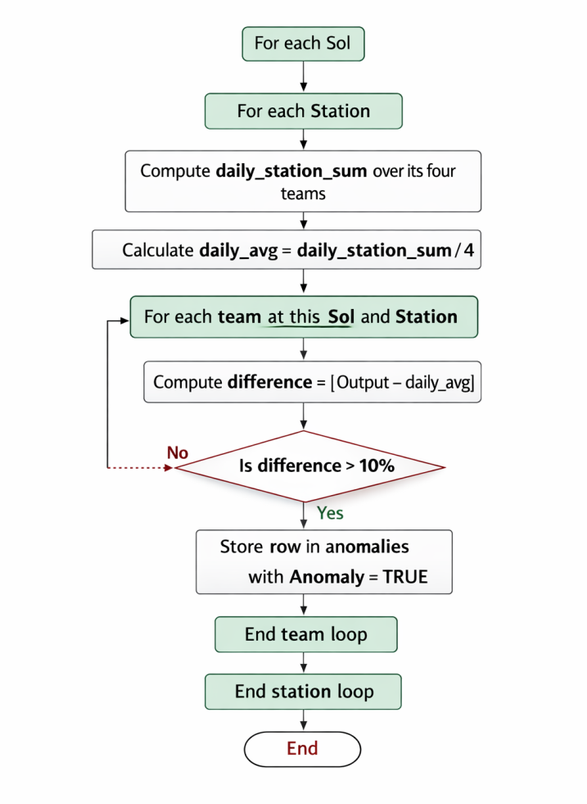
Figure 3: Anomaly Detection Logic

4.3 Testing
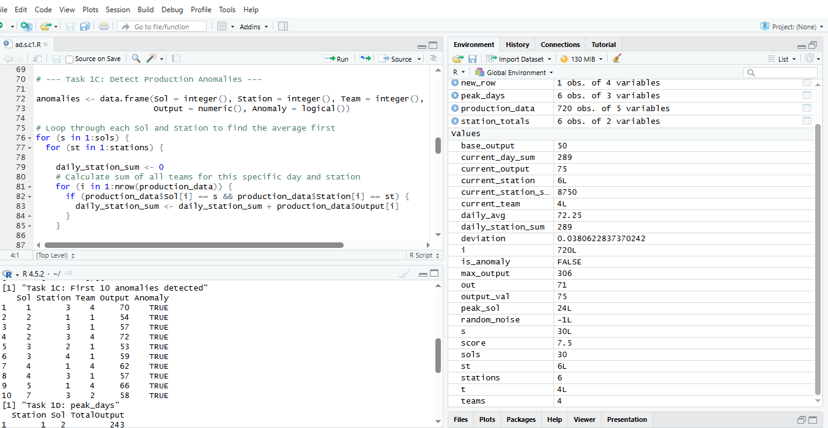

I tested the anomaly detection by picking one day and one station to check by hand:
- Manual Check: I printed the output for the four teams in that group and calculated their average myself.
- Difference Calculation: I subtracted each team's output from the average by hand and compared my results to what the code produced.
- Verification: This confirmed that the code flagged the exact same teams I identified as anomalies.
- Data Inspection: I used the head(anomalies, 10) command to look at the first ten results, making sure they were all correctly marked as TRUE and had the right day, station, and team numbers.

5. Task 1D – Peak Productivity Days

5.1 Approach
The goal of this part was to find the best production day (Sol) for each station. I created a new table called peak_days to store these results.
To do this, I used the following steps:
- Starting Point: For each station, I set up two "bookmarks" to keep track of the highest output found so far and which day it happened on.
- Checking Every Day: The code looked through all 30 days for that station.
- Adding it Up: For every day, it added together the outputs of all four teams.
- Finding the Winner: If a day's total was higher than the previous record, the code updated the "bookmarks" with the new highest number and the new day.
- Saving the Result: Once all 30 days were checked, the best day for that station was saved into the peak_days table.
This process is like looking through a list of numbers by hand to find the biggest one.

5.2 Flow chart

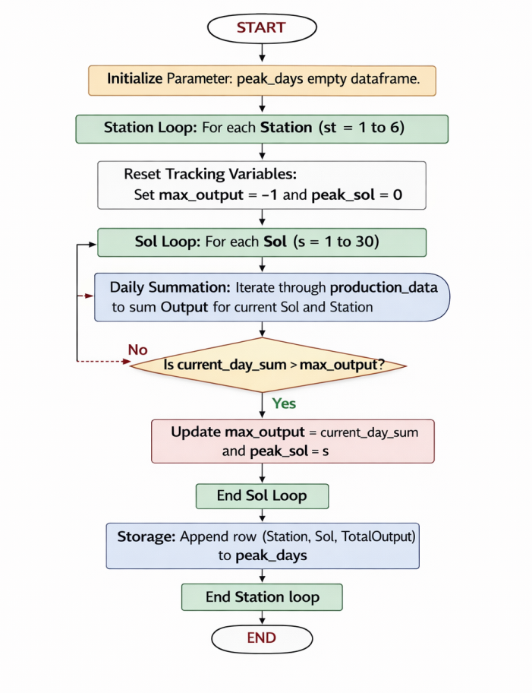
Figure 4: Identify peak productivity days

5.3 Testing
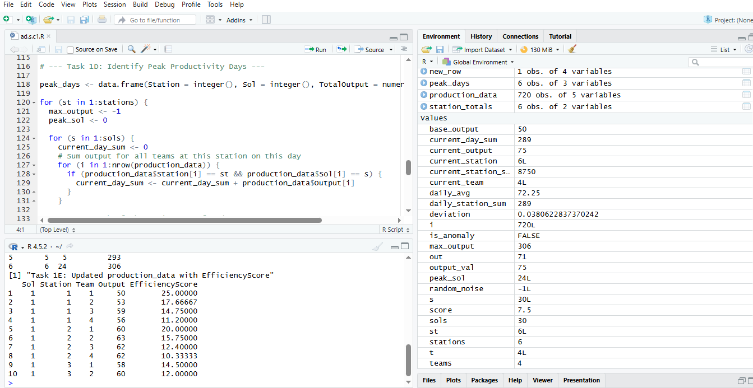
To make sure the peak day results were right, I did the following checks:
- Manual Comparison: I printed out the total output for every single day (all 30 sols) for one station. I looked at the list to find the biggest number myself and then checked if the peak_days table showed that same day.
- The Results Matched: My hand-check and the computer’s result were exactly the same.
- Table Structure: I made sure the peak_days table had exactly six rows—one for each station.

Reasonable Numbers: I checked that all the day numbers in the table were between 1 and 30, which makes sense for a 30-day simulation

6. Task 1E – Efficiency Score

6.1 Approach
I added a new column called EfficiencyScore to the production_data table to show how well each team performed. Following the assignment rules, I used this formula:
EfficiencyScore = Output / (Station + Team).
This score helps compare teams fairly, even if they are at different stations. To follow the "loops only" rule, I did the math step-by-step:
- Preparation: First, I added a new column filled with zeros to the table.
- Row-by-Row Calculation: I used a loop to look at every single row in the data.
- Processing: For each row, I pulled out the Output, Station number, and Team number to calculate the score.
- Saving: I saved the final answer directly into the new EfficiencyScore column for that row.
This manual approach makes it very clear how every score was calculated.

6.2 Flow chart
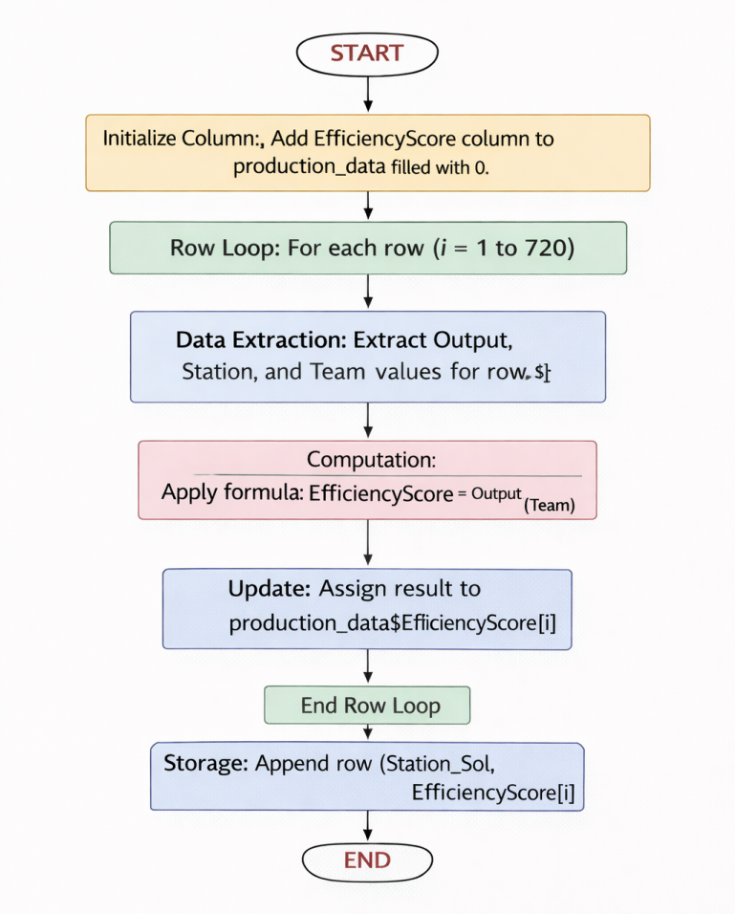
Figure 5: Calculate efficiency Score

6.3 Testing
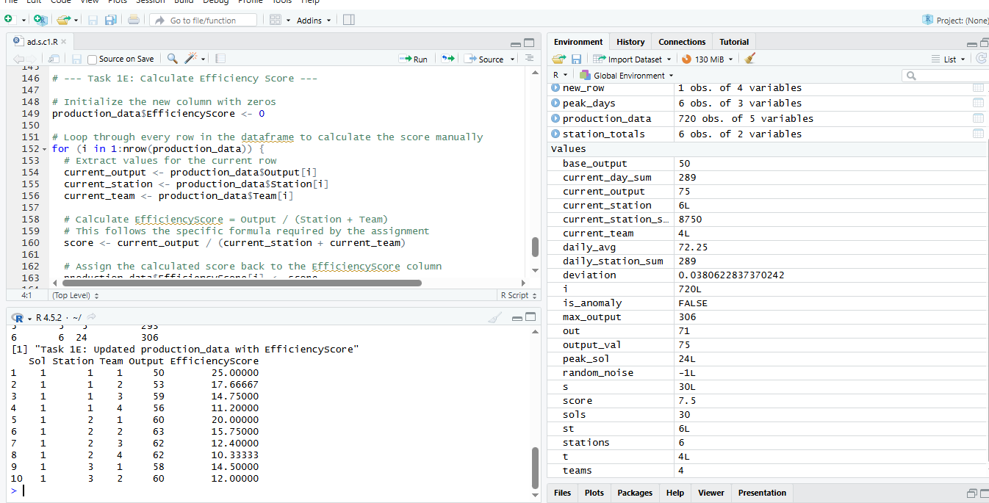

I checked the efficiency scores to make sure the math was correct by doing the following:
- Range Check: I used the summary() command to look at all the efficiency scores at once. This helped me see if the numbers made sense and matched the overall production patterns.
- Manual Recalculation: I picked a few random rows and did the math myself using the formula: Output/(Station+Team).
- Verification: I compared my hand-calculated answers to the ones in the data table. They matched perfectly, which proved the loop was doing the calculations right.

7. Reflection
• Learning Outcomes: This project helped me understand how data is organized and how loops work in R. By writing everything step-by-step without shortcuts, I had to think more carefully about how the computer stores and calculates results.
• Technical Challenges: The hardest part was the anomaly detection because it required two separate steps: first finding the averages and then checking each team's deviation. Breaking this down into clear stages helped me solve a complex problem without getting confused.
• Efficiency Lessons: I learned that using loops and rbind() for everything can make a program slow. If I were doing this for a real job, I would "pre-allocate" space to make it faster or use powerful tools like dplyr.
• Future Improvements: Next time, I would spend more time drawing my flow charts before I start typing any code to catch logic errors early.
• AI Disclosure: I used Gemini 2.0 to research how R loops work and to help organize my report. While the AI helped me understand the concepts, I wrote all the code myself and checked every calculation by hand to ensure it followed the rules.

8. Conclusion
• Summary: I successfully built an alien colony simulation that meets all the requirements for the ACCA7022 assignment.
• Completed Tasks: The project correctly generates data, calculates station totals, finds unusual anomalies, identifies peak production days, and measures team efficiency.
• Final Thoughts: Working without high-level shortcuts taught me the importance of careful logic, testing, and writing clear comments so other people can understand my work.

