AutoPark Management System: Database Coursework
Student Details
Name: Ena Joselin Galo Nunez
Student ID: 2530035
Module: Introduction to Web and Database Concepts (ACCA4023_LON)

Lecturer: Suresh Shanmugasundaram
Submission Date: 21 July 2026, 2:00 PM

Contents
Student Details 1
Scenario Analysis 4
Entity Relationship Diagram (ERD) 6
Data Structure Design 7
Normalisation 13
Sample Data 15
Queries 18
Forms and Reports 20
Validation and Testing 23
Reflection 24
Conclusion 25
References 26
Appendices 27

Introduction
This coursework is based on the design and development of a database for a fictional parking company called AutoPark Management System. The main purpose of the project is to create a system that can organise and manage information about customers, vehicles, bookings, parking spaces and payments.
The database was created in Microsoft Access and contains five main tables connected by primary and foreign keys. During the project, I also created an Entity Relationship Diagram (ERD), queries, forms and reports to make the information easier to manage, search and present. Sample data was added to test the database and make sure that the different parts worked correctly.
This project was a completely new experience for me because it was my first time creating a full database system. Some parts were challenging at the beginning, especially understanding the relationships between the tables, but as I continued working on the project, I became more confident using Microsoft Access. Overall, this coursework helped me understand how databases work in practice and allowed me to develop new skills that I can use in the future.

Scenario Analysis
Scenario: Database Implementation for ‘Auto Park Management System '. Imagine that the operations director of a city-based parking service provider named “Auto Park Management System” has approached you to develop a robust database solution using Microsoft Access. The company currently manages multiple parking sites across the city, but all information regarding vehicle entries, parking slots, customer details, and payments is recorded manually. This has led to frequent errors, data loss, and inefficient use of parking space. The management now wants to automate the parking process through a centralized database system that accurately records and monitors vehicle movements, slot availability, and payment transactions in real time. Your objective is to design and implement a database system that manages information about parking slots, customers (vehicle owners), vehicles, bookings, and payments. The system should also generate reports to help management monitor slot occupancy, revenue trends, and operational performance across multiple parking sites.
The scenario describes a parking company, AutoPark Management System. The company was recording customer, vehicle, parking and payment information manually. This could cause mistakes, lost information and make it difficult to know which parking spaces are available.
To solve this problem, I created a Microsoft Access database. The database stores all the information in one place and connects the different tables. This makes the system easier to use and helps reduce errors. [1]

Entities
The database contains five main entities:
- Customer – stores customer details such as name, phone number and email.
- Vehicle – stores information about each vehicle and links it to a customer.
- Booking – records when a vehicle enters and leaves the car park.
- Parking Slot – stores the parking space number and its current status.
- Payment – records the payment made for each booking.

Attributes of each entity
Each entity contains different attributes that store the required information.
For example:
- Customer: CustomerID, FirstName, LastName, Phone and Email.
- Vehicle: VehicleID, RegistrationNumber, Brand, Colour and CustomerID.
- Booking: BookingID, EntryDate, ExitDate, VehicleID and SlotID.
- Parking Slot: SlotID, SlotNumber and Status.
- Payment: PaymentID, Amount, PaymentDate, PaymentMethod and BookingID.
Relationships between entities
The tables are linked using primary and foreign keys.
One customer can have multiple vehicles.
One vehicle can have multiple bookings.
One parking slot can be used across multiple bookings over time.
Each booking is associated with one payment.
These relationships help keep the data organised and avoid entering the same information more than once.
How the scenario was solved
To address the scenario, I created a database with five related tables in Microsoft Access. Each table stores a different type of information, and the relationships allow the data to work together.
I also created queries to display useful information, a form to simplify data entry and a report to display payment information. Finally, I tested the database to ensure the tables, relationships and queries worked correctly.

Entity Relationship Diagram (ERD)

I created an Entity-Relationship Diagram (ERD) in Lucidchart to show the five tables in my AutoPark Management System database and how they are connected. I used Lucidchart because it allowed me to organise the tables and show the relationships between them in a clear, visual way.
The CustomerTable stores customer information and is linked to the VehicleTable because a customer can have one or more vehicles. The VehicleTable is then linked to the BookingTable, which stores information about each parking booking.
The ParkingSlotTable stores information about parking spaces and is linked to the BookingTable via the SlotID. This helps identify which parking space is used for each booking. The PaymentTable is also linked to the BookingTable, so each payment can be associated with the correct booking.
I used primary keys (PK) and foreign keys (FK) to establish the relationships between the tables. Creating the ERD in Lucidchart helped me better understand how the different tables in my database are connected and how the information works together in the AutoPark Management System. [2]

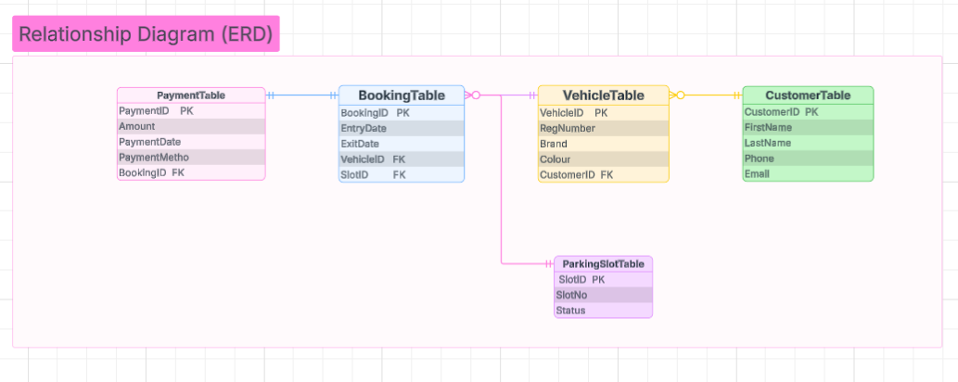Figure 1: Entity Relationship Diagram (ERD) for the AutoPark Management System

Data Structure Design

CustomerTable
Stores customer information, including first name, last name, phone number and email.
Field | Data Type
CustomerID | Number
FirstName | Short Text
LastName | Short Text
Phone | Number
Email | Short Text

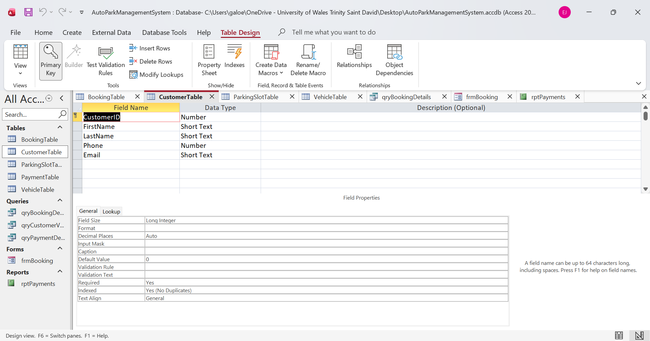figure 1: CustomerTable (Design View)

VehicleTable
Stores vehicle details, including registration number, brand and colour. Each vehicle belongs to one customer.
Field Name | Data Type
VehicleID | Number
RegistrationNumber | Number
Brand | Short Text
Colour | Short Text
CustomerID | Number

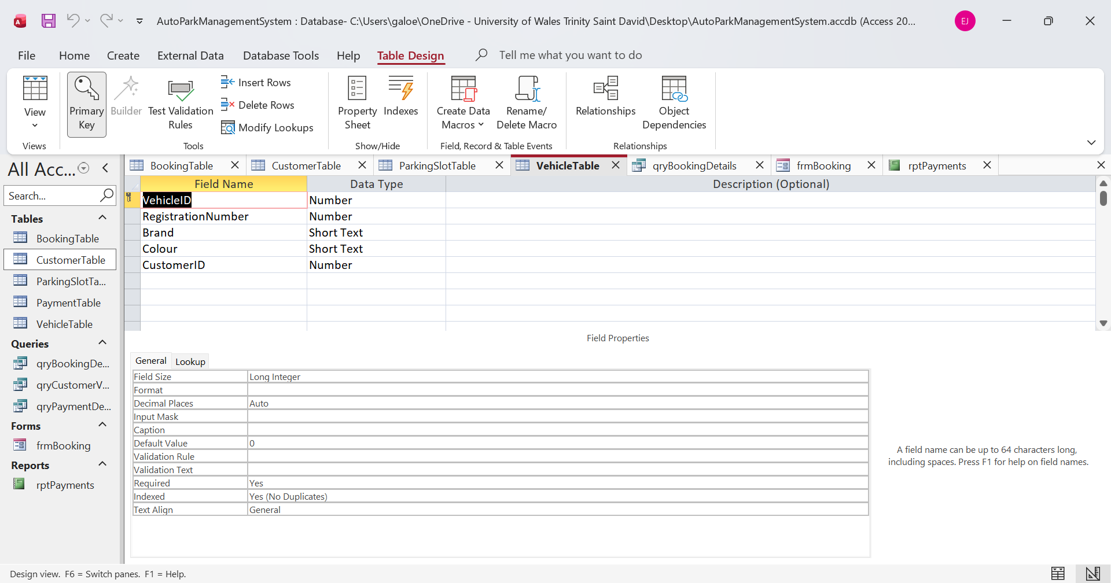Figure 2 VehicleTable (Design View)

BookingTable
Stores booking details, including entry and exit dates, vehicle, and parking slot.
Field Name | Data Type
BookingID | AutoNumber
EntryDate | Date/Time
ExitDate | Date/Time
VehicleID | Number
SlotID | Number

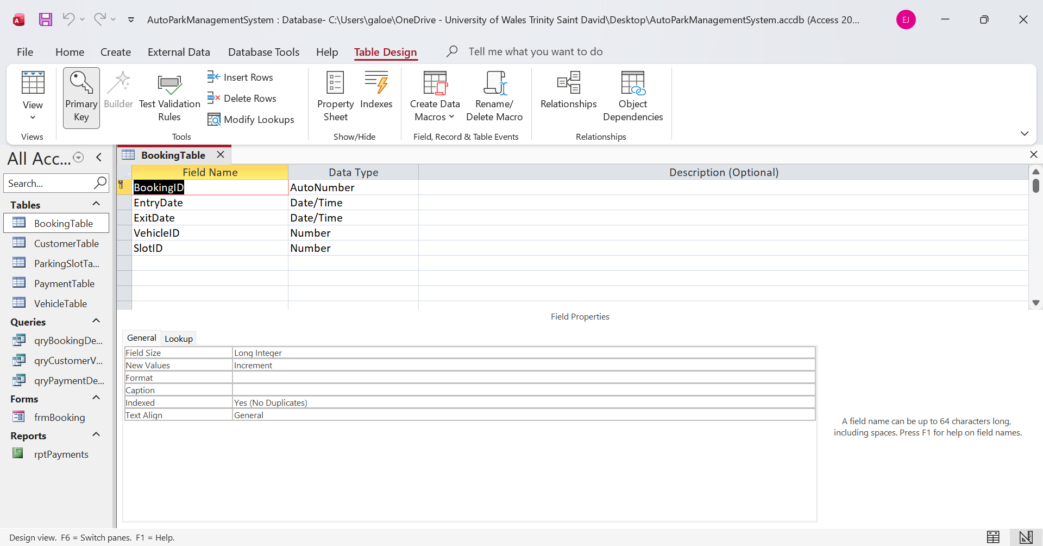Figure 3: BookingTable (Design View)

ParkingSlotTable
Store’s parking slot information, including the slot number and whether the parking space is available or occupied.
Field Name | Data Type
SlotID | AutoNumber
SlotNumber | Number
Status | Short Text

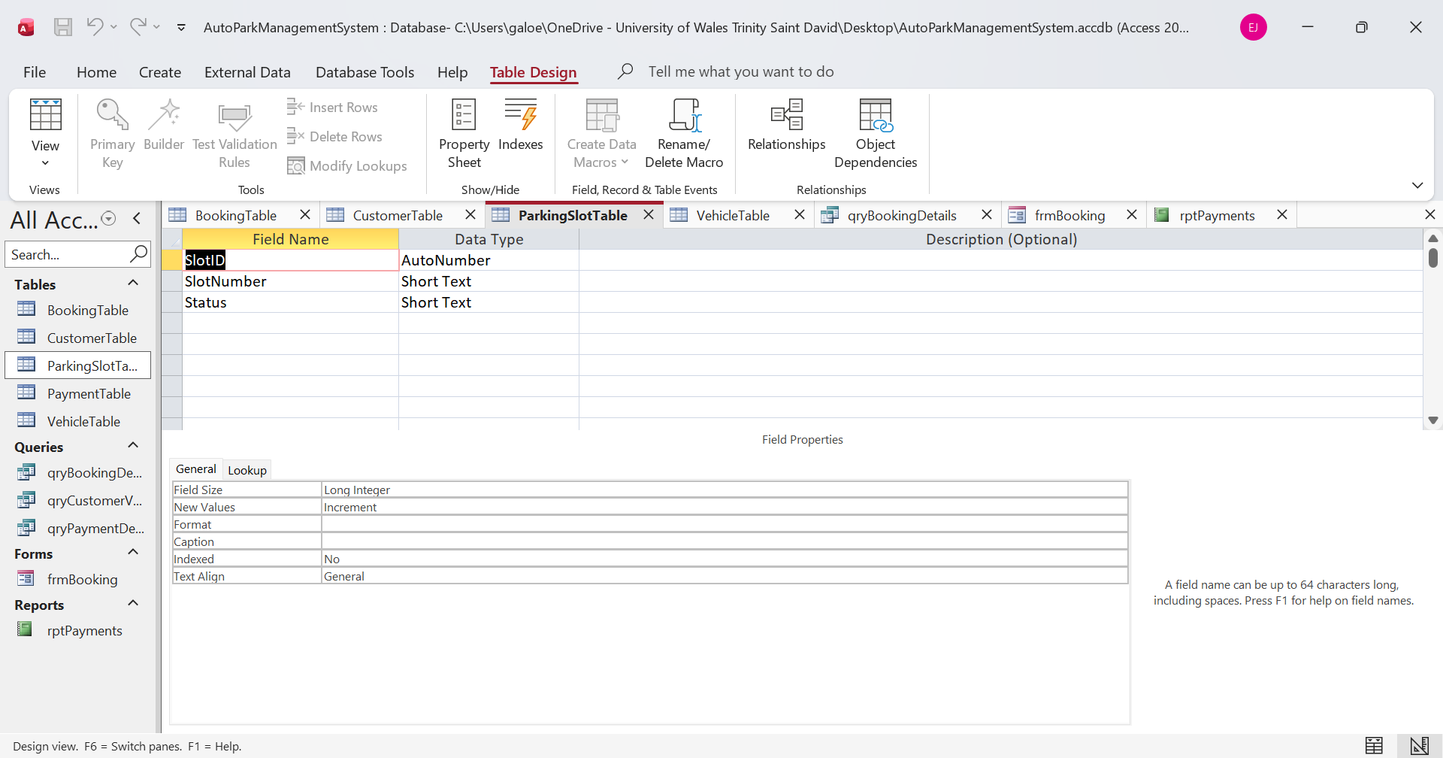Figure 4: ParkingSlotTable (Design View)

PaymentTable
stores payment information, including payment amount, payment date and payment method.
Field Name | Data Type
PaymentID | AutoNumber
Amount | Number
PaymentDate | Date/Time
PaymentMethod | Short Text
BookingID | Number

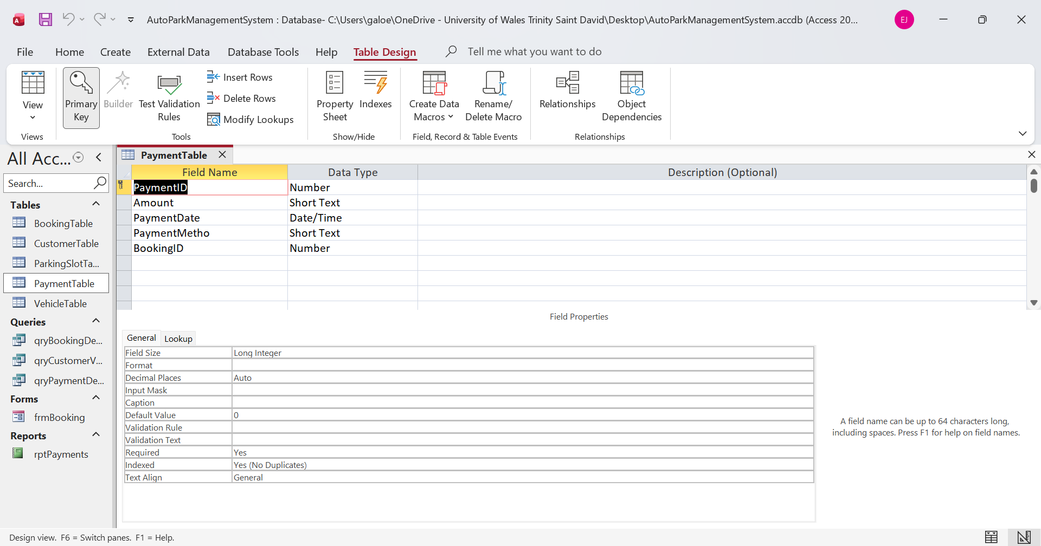
figure 5: PaymentTable (Design View)

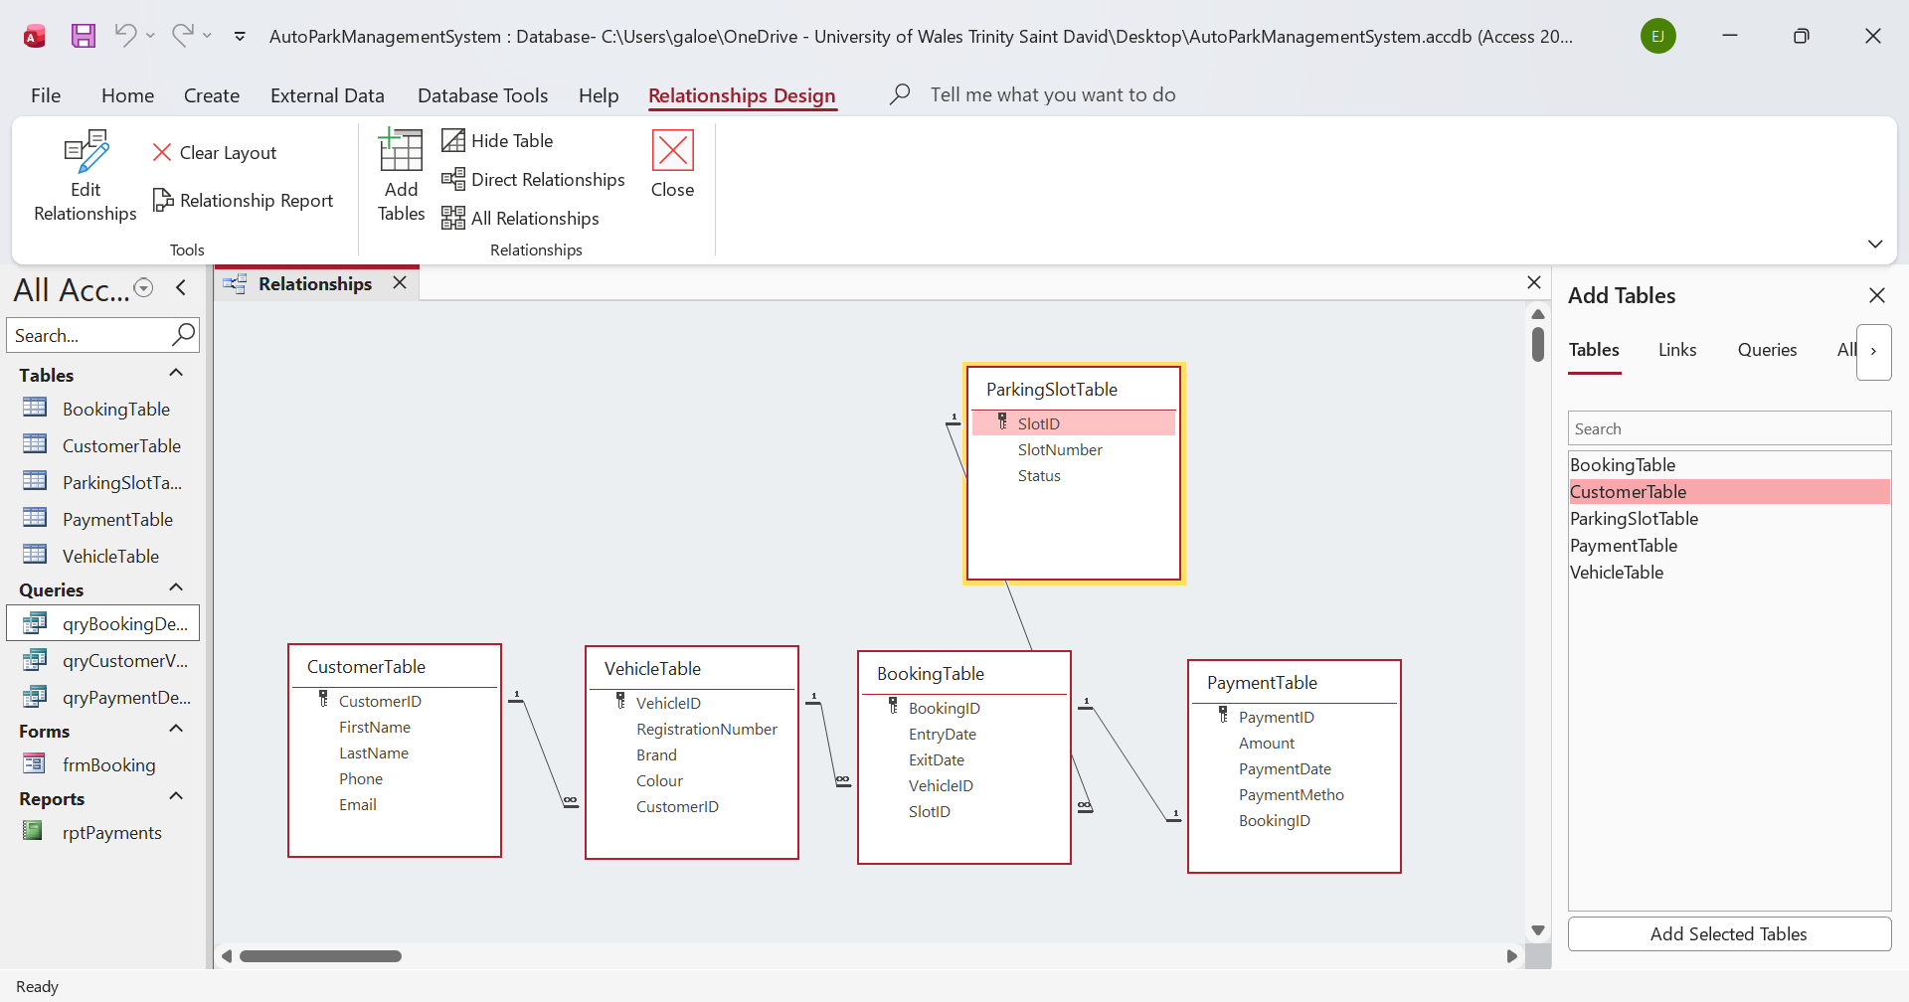
Figure 6: Entity Relationship
CustomerTable → VehicleTable (1: ∞)
VehicleTable → BookingTable (1: ∞)
ParkingSlotTable → BookingTable (1: ∞)
BookingTable → PaymentTable (1: 1)
The Entity Relationship Diagram (ERD) was created in Microsoft Access. It shows the five tables used in the AutoPark Management System and their relationships. Primary keys and foreign keys were used to connect the tables and maintain data integrity. The relationships are one-to-many between Customer and Vehicle, Vehicle and Booking, and Parking Slot and Booking. A one-to-one relationship was created between Booking and Payment.

Normalisation

Normalisation (Up to Third Normal Form - 3NF)
First Normal Form (1NF)
The database was first normalised by ensuring that each table contains unique records and that every field stores only a single value. Each table has a primary key to uniquely identify each record. Repeating groups and duplicate columns were removed. [3]
For example:
- Each customer has a CustomerID.
- Each vehicle has one VehicleID.
- Each booking has one BookingID.
- Each parking slot has one SlotID.
- Each payment has one PaymentID.
This ensures that every record is unique and all attributes contain atomic values.
Second Normal Form (2NF)
The database was then normalised to Second Normal Form by separating data into different tables according to their purpose. Information about customers, vehicles, bookings, parking slots and payments is stored independently.
Foreign keys were used to connect the tables.

For example:
- Customer information is stored only in CustomerTable.
- Vehicle information is stored only in VehicleTable.
- Booking information is stored only in BookingTable.
- Payment information is stored only in PaymentTable.

This removes unnecessary duplication and improves data consistency.
Third Normal Form (3NF)
Finally, the database satisfies Third Normal Form because all non-key attributes depend only on the primary key. There are no transitive dependencies between non-key fields.
For example:
- The customer name is stored only in CustomerTable.
- Vehicle details are stored only in VehicleTable.
- Payment information is stored only in PaymentTable.
- Booking records reference only the related customer, vehicle, and parking slot via keys.
This structure reduces redundancy, prevents update anomalies and maintains data integrity.
Normalisation Decisions
The database was designed up to Third Normal Form (3NF) to improve efficiency and reduce duplicated data. Each table stores only one type of information, and relationships between tables are maintained using primary and foreign keys. This design makes the database easier to maintain, improves data accuracy, and ensures that updates need to be made only in one place.

Sample Data

Sample data was added to each table to test the database. A minimum of five records was entered into CustomerTable, VehicleTable, BookingTable, ParkingSlotTable and PaymentTable. The data was created for testing purposes and represents realistic customers, vehicles, bookings, parking slots and payments.
The sample data helped verify that the relationships, queries, forms, and reports worked correctly.
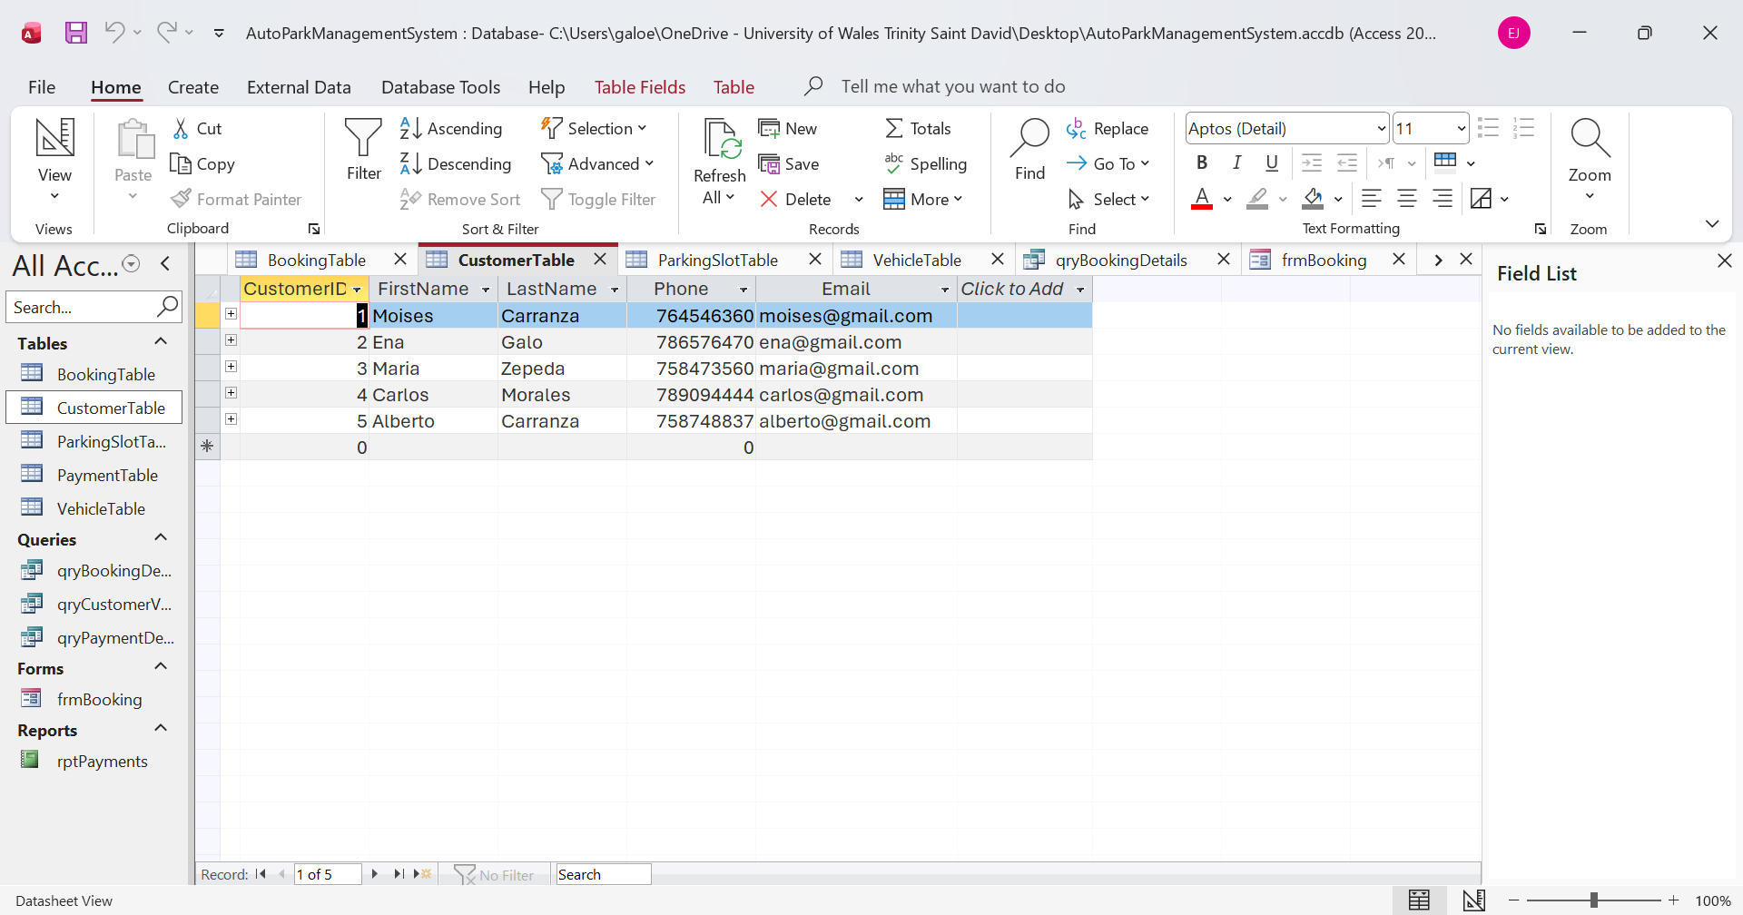Figure 1: CustomerTable (Datasheet View)
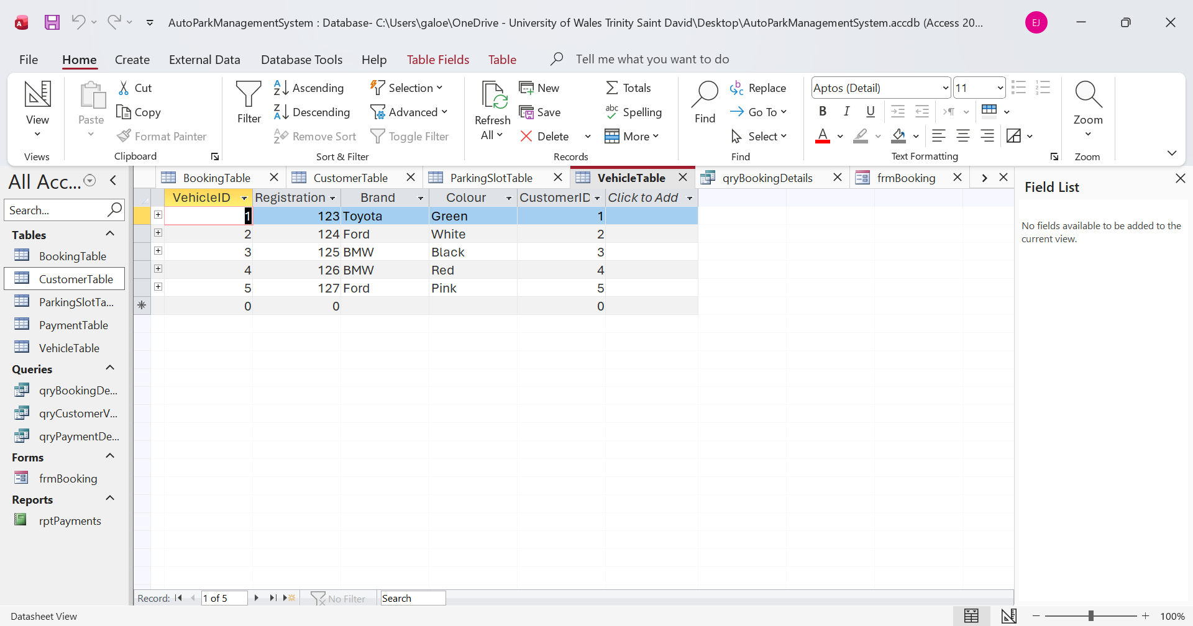Figure 2: VehicleTable (Datasheet View)
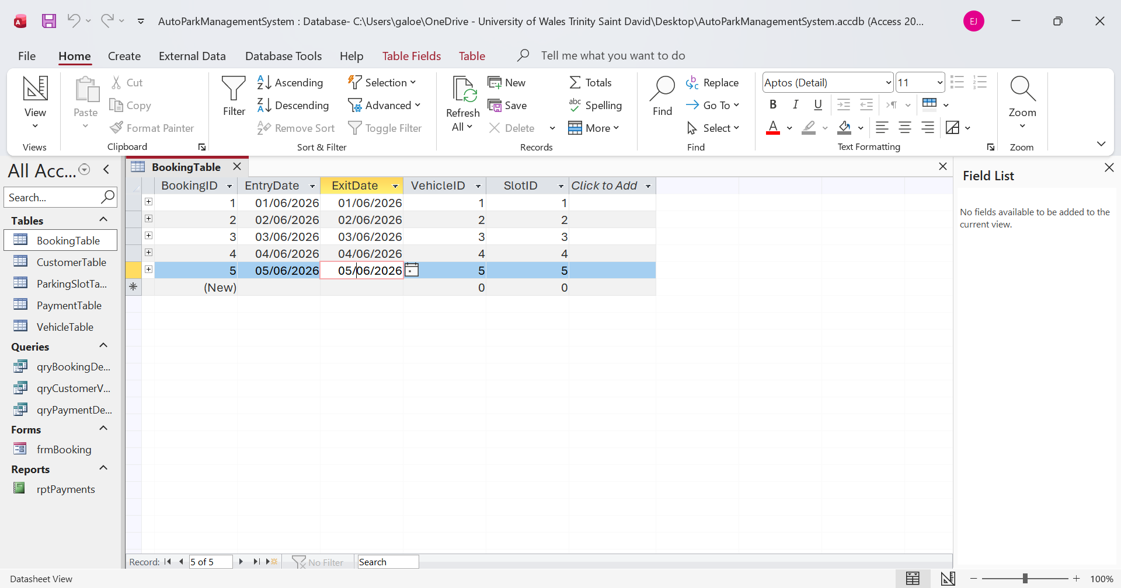
Figure 3: BookingTable (Datasheet View)

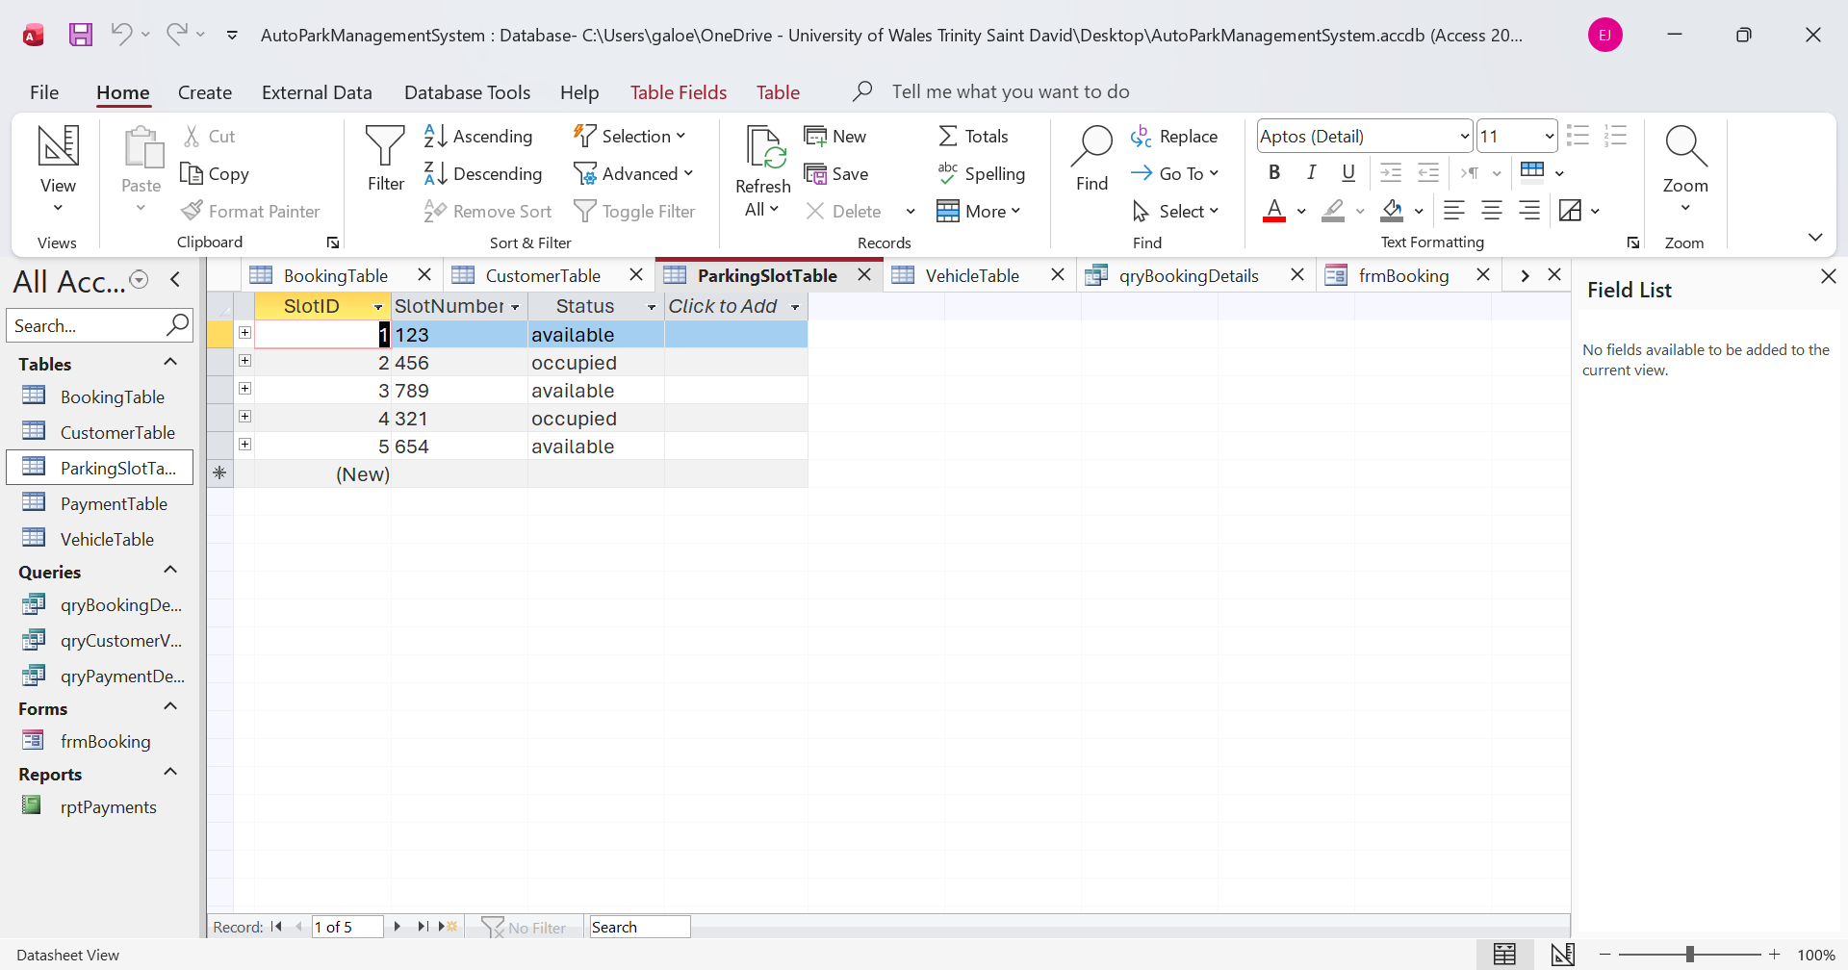
Figure 4: ParkingSlotTable (Datasheet View)
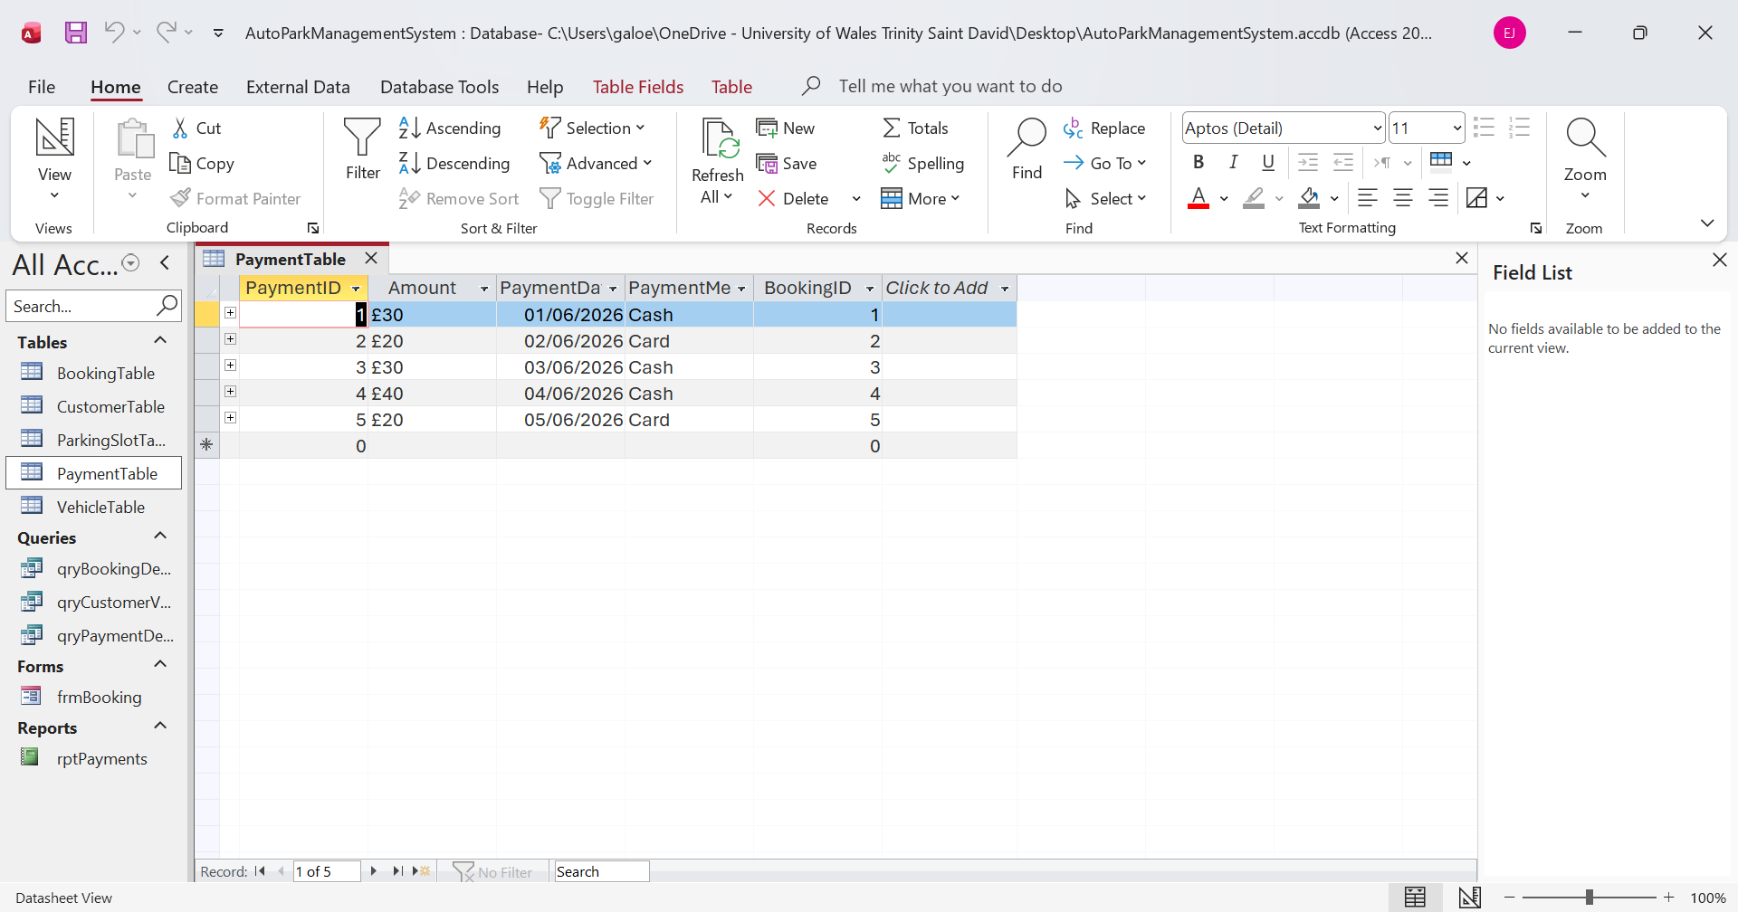
Figure 5: PaymentTable (Datasheet View)

Queries

Queries were created in Microsoft Access to help retrieve and organise information stored in the database. Instead of manually searching through each table, users can quickly find the information they need with the queries. This makes the database easier to use and helps save time when looking for specific records.
For this project, three queries were created using the Simple Query Wizard. Each query has a different purpose and displays information from one or more related tables. The queries were also used to verify that the relationships between the tables were functioning correctly and that the data was displayed accurately.
The following sections describe each query and explain its purpose within the AutoPark Management System. [4]

qryCustomerVehicle: displays customer information and vehicle details. This query allows staff to see which vehicles belong to each customer.

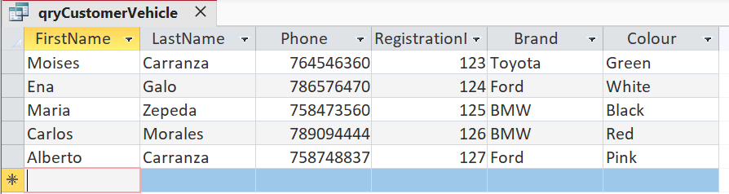
Figure 1: qryCustomerVehicle

qryBookingDetails: displays booking information, including the booking ID, entry date, exit date, parking slot number and parking slot status. This query helps staff manage parking bookings.
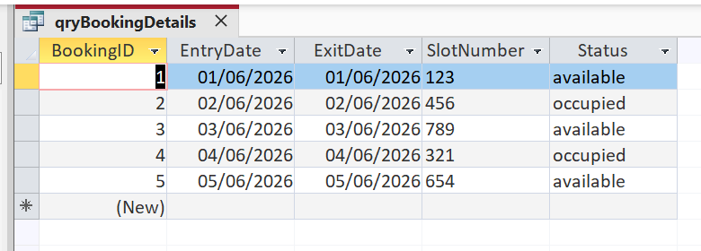
Figure 2: qryBookingDetails

qryPaymentDetails: displays payment information, including the payment amount, date and method. This query helps staff to track customer payments.
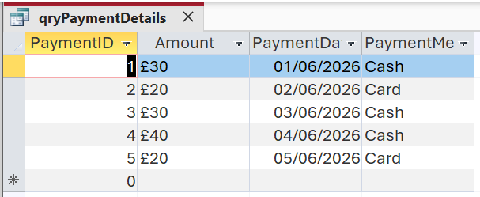
Figure 3: qryPaymentDetails

Forms and Reports

Forms and reports were created in Microsoft Access to make the database easier to use. Instead of opening the tables each time, the forms provide a simple way to enter new information and view existing records. This makes the system more organised and easier for the user to understand.
The reports were created to present the stored information in a clear and structured format. They allow the data to be viewed in a more professional way and can also be printed if needed. Reports are useful because they summarise the information and make it easier to read than looking directly at the tables.
Overall, the forms and reports improve the database's usability. They help users work with information more efficiently and make the AutoPark Management System easier to manage day-to-day. [5]

Forms
The frmCustomer form is used to enter and view customer information. It allows users to easily manage customer records without opening the table directly.
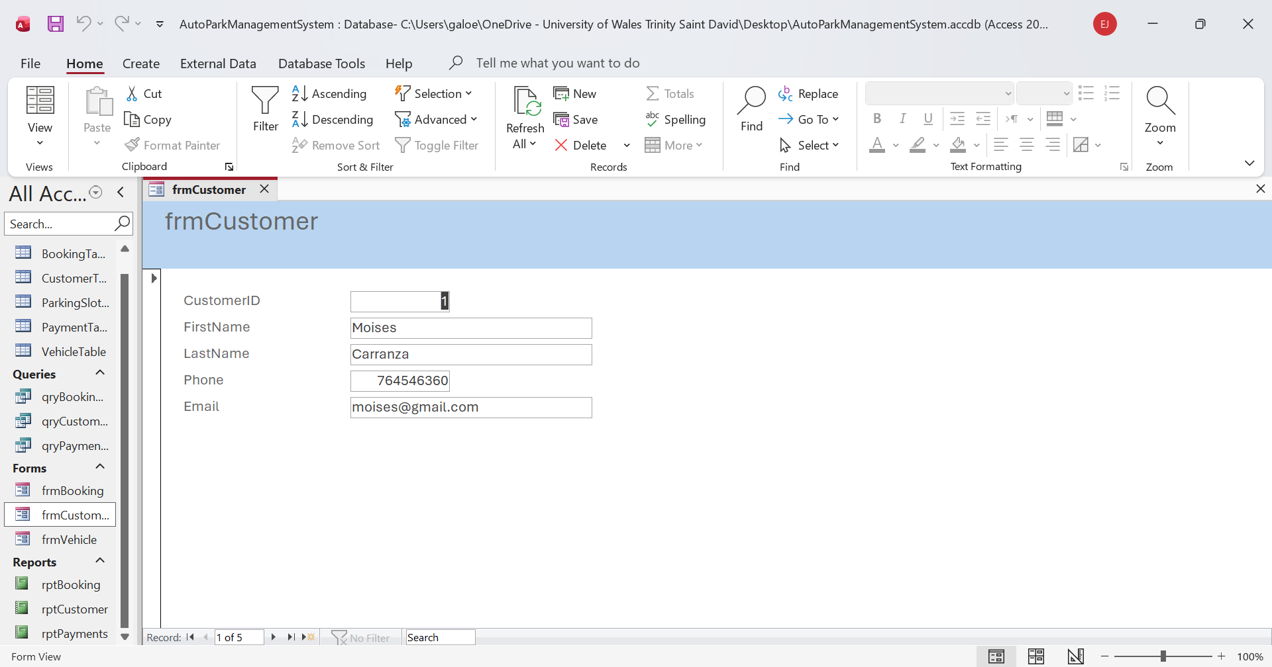Figure 1: frmCustomer

The frmVehicle form is used to enter and view vehicle information. It stores details such as the registration number, brand and colour of each vehicle.
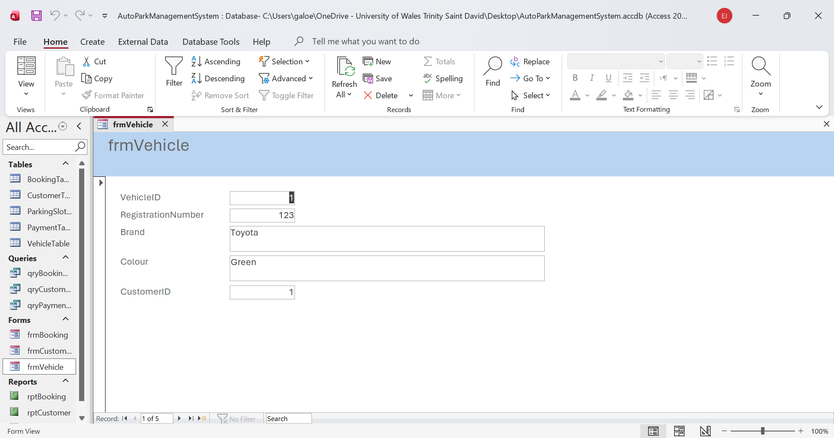Figure 2: frmVehicle

The frmBooking form is used to manage booking information. Users can view the booking details, including the entry and exit dates, vehicle, and parking slot.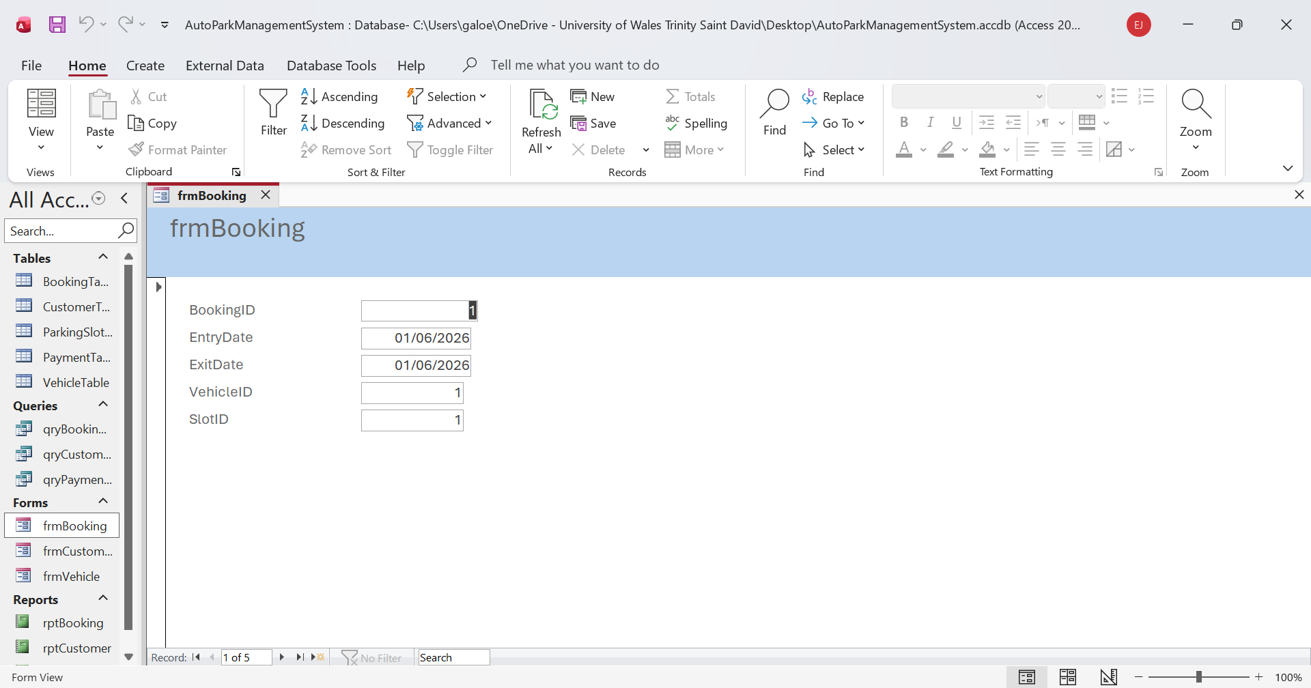
Figure 3: frmBooking
Reports
The rptCustomer report displays customer information in a clear format. It can be used to review customer records or print customer details.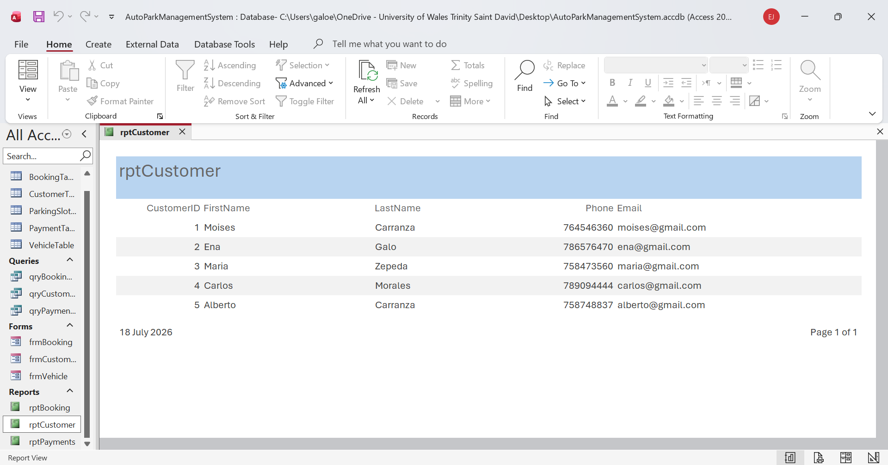Figure 4: rptCustomer

The rptBooking report displays booking information, including booking dates and parking slot details. It helps staff monitor parking bookings.
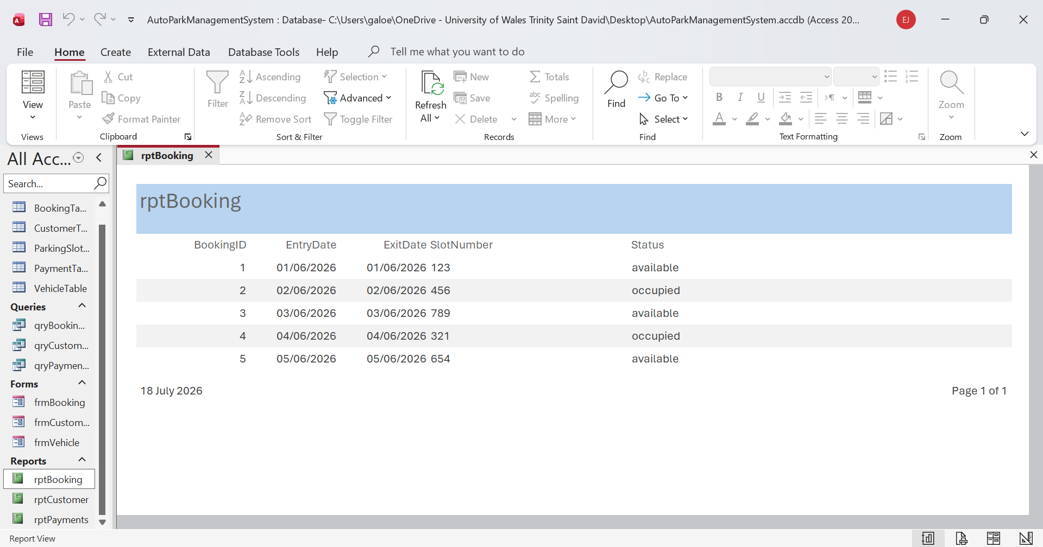Figure 5: rptBooking
The rptPayments report displays payment information, including payment amount, payment date and payment method. It helps staff keep track of customer payments.
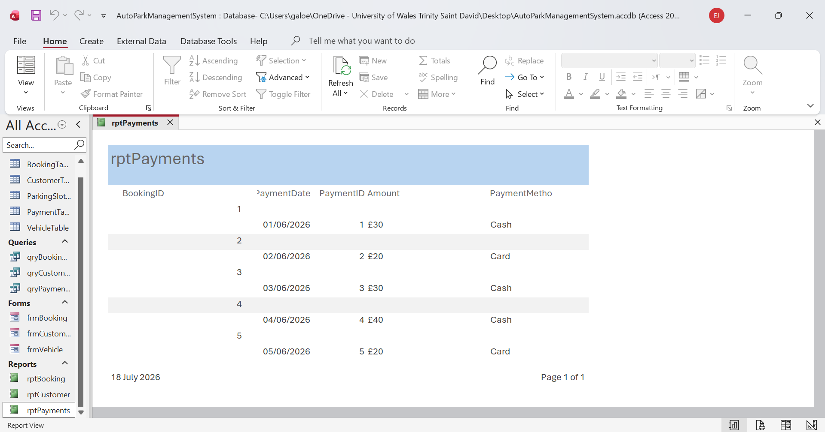
Figure 6: rptPayments

Validation and Testing

After finishing my database, I tested everything to make sure it was working correctly. I opened all five tables and checked that the information I entered was saved correctly.
I also checked the relationships between the tables. At first, I had some problems creating the relationships because some of the fields had different data types. I checked the fields, changed the data types where needed, and tried again. After making these changes, the relationships worked correctly.
I opened and tested my three queries to confirm they displayed the information I wanted. I also tested the three forms to ensure I could view the records correctly. Finally, I opened the three reports and checked that the information was displayed clearly.
After testing the different parts of my database, everything worked as expected. This testing helped me find and fix some mistakes and ensured that my final AutoPark database was working correctly.

Reflection
This project was a completely new experience for me, as it was my first time creating a database in Microsoft Access. At the beginning, I found it difficult to understand how the different parts of the database worked together.
One of the main challenges I faced was creating the relationships between the tables. I had some problems because some data types did not match. I had to check the tables and make some changes before I could successfully create the relationships. I also found some parts of creating queries, forms and reports difficult at first because I had never done this before.
Even though the project was challenging, I enjoyed working on it and learned a lot throughout the process. As I continued with the project, I started to understand Microsoft Access better and became more confident using it.

Improvements for Future
If I had more time to improve the AutoPark Management System, I would add more information about the different parking locations and create more advanced queries. I would also improve the design of the forms and reports to make them easier to use and more professional.
In the future, I would also like to learn more about Microsoft Access and databases to create more advanced database systems. This project was a good first experience for me and helped me understand the basic concepts of creating and managing a database. [6]

Conclusion
In conclusion, I successfully created the AutoPark Management System database using Microsoft Access. The main purpose of the project was to create a database to store and organise information about customers, vehicles, parking slots, bookings, and payments.
During the project, I created five related tables and connected them using primary keys and foreign keys. I also created queries to display useful information, forms to make it easier to view and enter data, and reports to present it clearly.
After completing the database, I tested the various parts to ensure they were working correctly. Although I encountered some difficulties during the project, especially when defining relationships between tables, I was able to resolve them and complete the database.
Overall, I believe the database meets the basic requirements of the AutoPark Management System scenario. This project also helped me learn more about Microsoft Access and understand how the different parts of a database work together.

References

[1] | D. Howe, Data Analysis forData base design, Butterworth-Heinemann: published by Edward Arnold 1983, 2001.
[2] | S. B. a. R. Earp, Database Design Using Entity-Relationship, New york.: Press LLC , 2003.
[3] | M. Demba, “Algorithm for relational database,” International Journal of Database Management Systems, vol. 5, pp. 5-10, 2013.
[4] | D. L. B. B. Yuval Lev Lubarsky, “Incorporating Deep Learning Design in Database Queries,” pp. 1-10, 2026.
[5] | D. P. McFedries, Microsoft Office Access 2007 Forms, Reports, and Queries, Copyright, 2007.
[6] | P. S. R. De Steven Roman, Access Database Design and Programming, Inner Join Books, 2003.

Appendices

The appendices include additional screenshots from the AutoPark Management System database. These screenshots provide extra evidence of database development and show the different objects created in Microsoft Access.
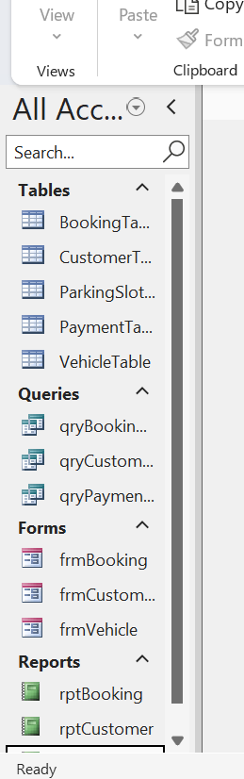
Figure 1: Database Objects
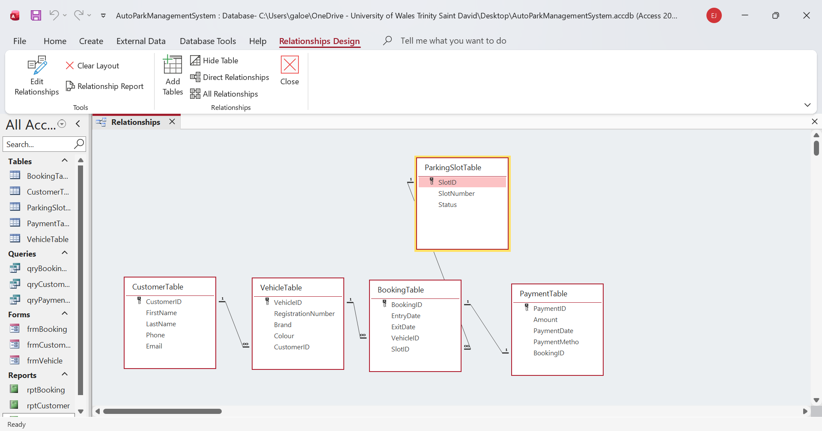Figure 2: Relationships

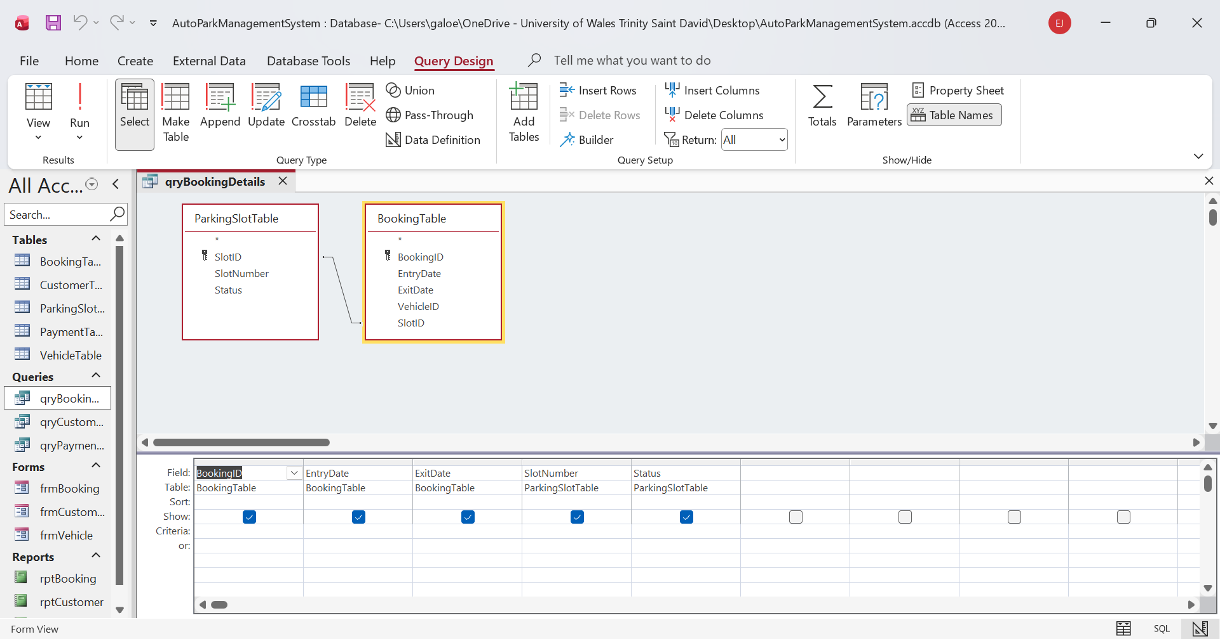Figure 3: Query Design View
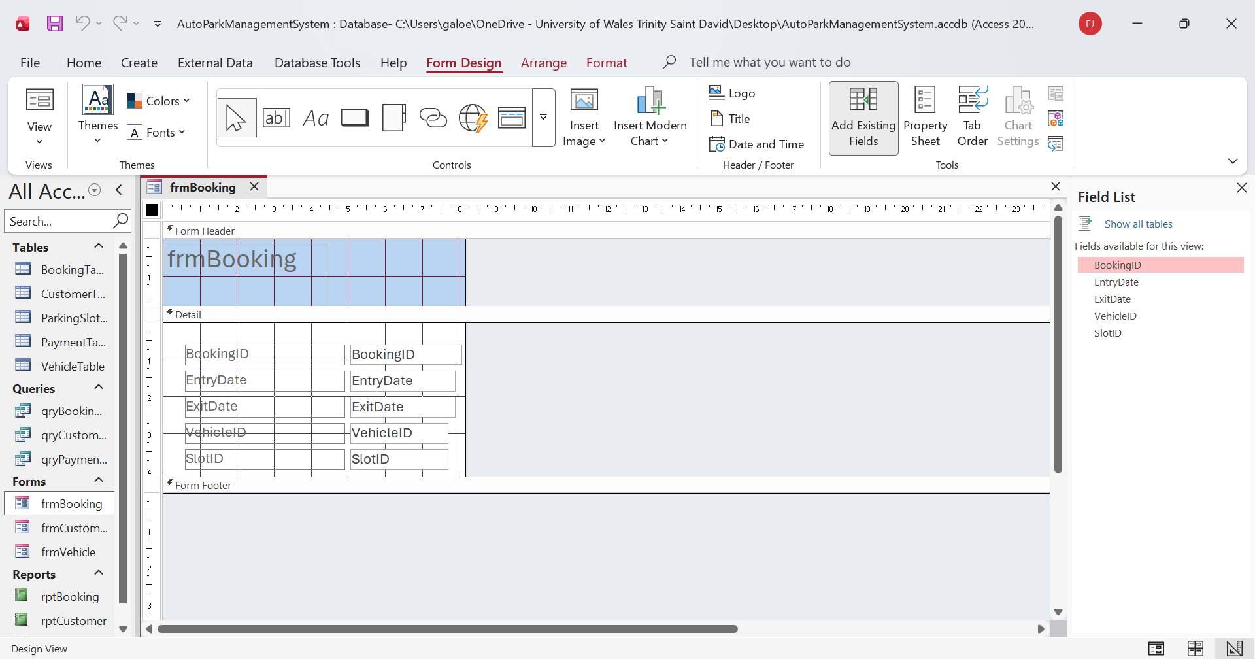Figure 4: Form Design View

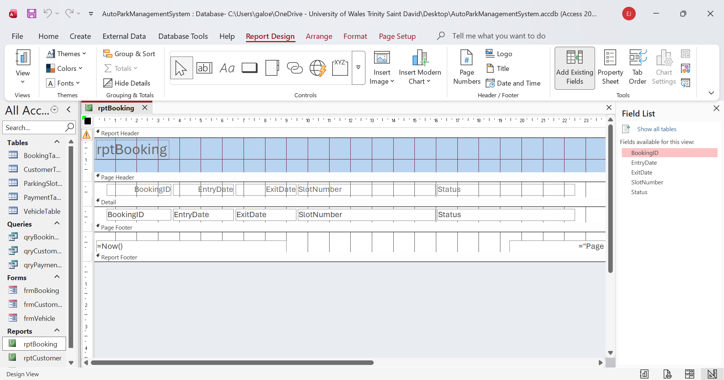Figure 5: Report Design View

