

Wireless Networks and Simulation (Carlene) (ACCB5004)
Design and Evaluation of Wireless Sensor Networks
Shaun Holborow (1704229)
Course: Computer Networks and Cyber Security
Faculty name: SOAC
Date of Submission: 5thMay 2020

Contents, figures and acronyms go here...

Abstract

Introduction

When it comes to wireless networks, various technologies are required in order to design and implement said networks. This requires sound understanding of the role, concepts and principles surrounding computer network simulation before simulation models can be created, configured by protocol, tested and finally analysed critically to ensure that said networks meet the real world requirements of simulation tools.
For this to be achieved, research and evaluation of available modulation schemes is required before the design and implementation of a Wireless Sensor Network (WSN) can be done to understand the differences of each scheme in terms of performance.

Related Work

Functions of Modulation:

Part of communication systems is modulation which is the process of changing the properties of a periodic waveform known as "carrier signal" with a modulating signal that usually contains information to be transmitted, radio stations for example use FM (Frequency Modulation) or AM (Amplitude Modulation) to broadcast these radio waves.[1]
Modulation comes in two types, analog and digital. Analog signal is a continuous time varying signal where as a Digital signal is a discrete/non-continuous.[2]
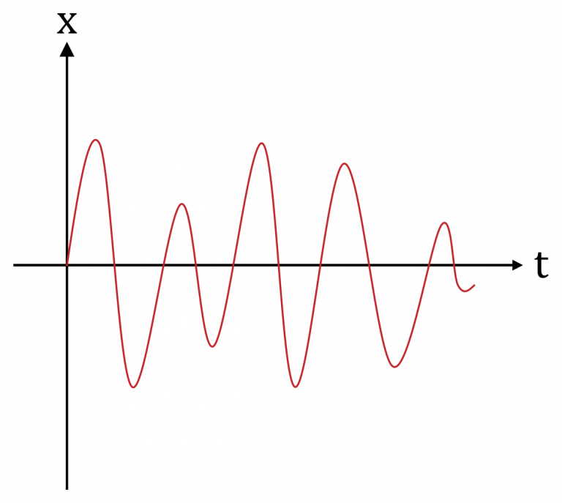
Figure 1 - Analog Signal[2]
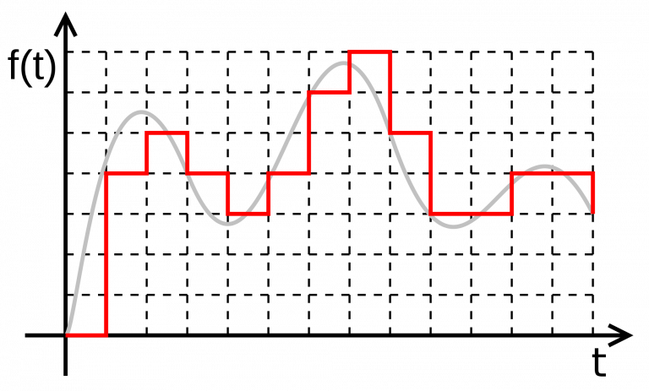
Figure 2 - Digital Signal[2]

Fundamentals of chosen Modulation Technique

For the author to proceed with the experiment, a modulation technique had to be chosen from a list of 3, the choices were BPSK(Binary Phase Shift Keying), QPSK(Quadrature Phase Shift Keying) or QAM(Quadrature Amplitude Modulation).

The author decided to go with the modulation technique QAM with the main reasoning being the prior experience from using it as well as its pros like lower SNR, better spectral efficiency etc.

Problem Formulation

Implementation

In order to provide a suitable implementation for said modulation scheme, appropriate simulation software was required thus Packet Tracer was deemed appropriate for this task and was used to create said implementation.

Results/Findings and discussions

Conclusion

References:

[1]"Types of Modulation : Analog And Digital Modulation", WatElectronics.com, 2020. [Online]. Available: https://www.watelectronics.com/types-of-modulation-techniques-with-applications/. [Accessed: 05- May- 2020].
[2]"What are Analog and Digital Signals, and Their Differences", ElProCus - Electronic Projects for Engineering Students, 2020. [Online]. Available: https://www.elprocus.com/differences-between-analog-signal-and-digital-signal/. [Accessed: 05- May- 2020].

