A Preliminary Site Investigation and Foundation Assessment for a Proposed Development at Swansea
Emily Aston
Contents

Introduction 3
Site Details 3
Historical Appraisal 5
Geological Appraisal 7
Environmental Appraisal 10
Archaeological Appraisal 11
Conceptual Ground Model 12
Site Investigation Strategy and Summary 13
Conclusion 16
References 17
Appendices 18

Introduction
This report presents a preliminary site investigation for a proposed 2,000m² mixed-use development on the Swansea foreshore between County Hall and the Marriott Hotel within Swansea Marina. The scheme consists of a restaurant, café bar, ice-cream parlour and associated facilities, with a manager’s apartment.
The report evaluates historical development, ground conditions and environmental risks to inform geotechnical investigation strategy and preliminary foundation recommendation. Analysis is supported by borehole data from the nearby Meridian Tower development, considered representative of local stratigraphy.
The preliminary assessment is intended to inform project feasibility, identify principal geotechnical environmental risks, and reduce the potential for unforeseen ground-related constraints affecting design, construction and cost.

Site Details
The site is located on the Swansea foreshore within Swansea Marina, between County Hall and the Marriott Hotel, bounded by commercial buildings, shared parking and pedestrian waterfront routes (Appendix 1).
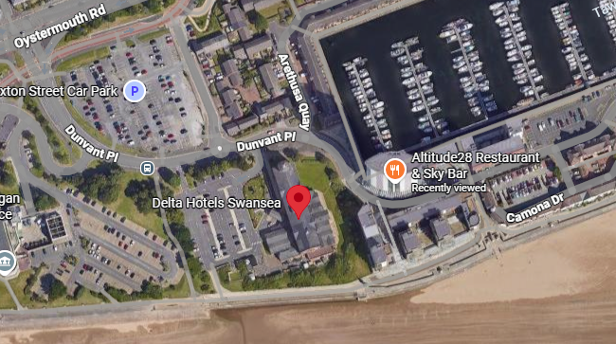

Appendix 1 (Google Maps, 2026).
Current land use comprises a developed urban marina environment of commercial, residential and leisure facilities. The proposed 2,000m² mixed-use scheme includes a ground-floor hospitality units with an upper-level manager’s apartment (Swansea Council, 2020).
The site occupies reclaimed former dockland within the historic South Dock, opened in 1859 and redeveloped during the 1980s through land reclamation and infilling, creating the present marina environment (Swansea Docks, 2024; History Points, 2024).
Aerial imagery and site reconnaissance indicate predominantly hardstanding ground, and surrounding infrastructure, suggesting a high likelihood of buried services (Appendix 2).
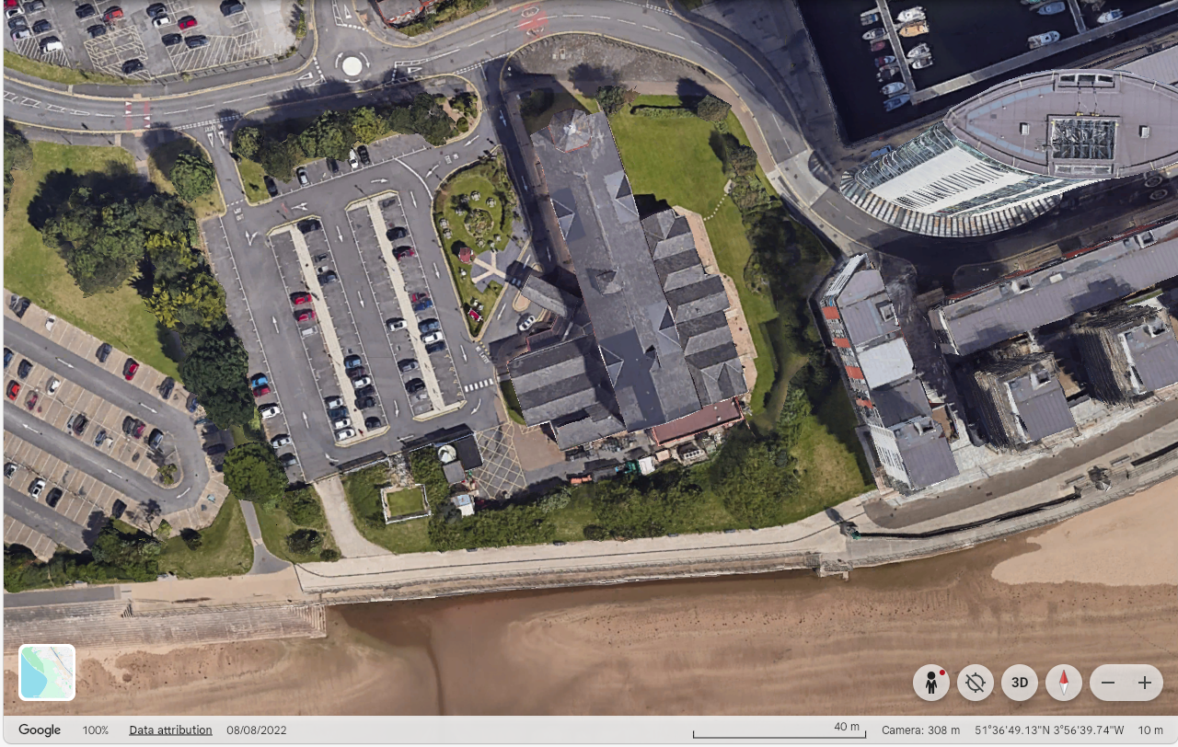
Appendix 2: Aerial view of site showing hardstanding and surrounding infrastructure Google Earth 2026.
Adjacent structures, retaining walls, buried basements and overhead constraints may restrict investigation point placement, rig access and work clearance. Nearby structures and utilities should therefore be assessed to avoid adverse effects from drilling loads or vibration (BS 5930:2015).
Buried and overhead facilities should be identified prior to intrusive investigation through desk study, PAS 128 utility searches, field reconnaissance, CAT/GPR surveys and inspection pits, with safe offsets maintained in accordance with HSG47 and HSE guidance.
Due to the active public location, investigation and construction activities must consider pedestrian safety, traffic management, noise, dust and air quality and potential shallow groundwater influence on ground conditions and construction operations (Environment Agency, 2021).
Overall, the site is characteristic of reclaimed urban waterfront location, with historic dockland influence, constrained access and likely made ground conditions representing key considerations for geotechnical assessment.

Historical Appraisal
The historical development of the Swansea Marina area directly influences anticipated ground conditions. Ordnance Survey mapping and historical records indicate that the site lies within the former South Dock, constructed 1859 to support Swansea’s industrial expansion, particularly coal export, shipping and copper smelting (History Points, 2024) (Appendix 3).

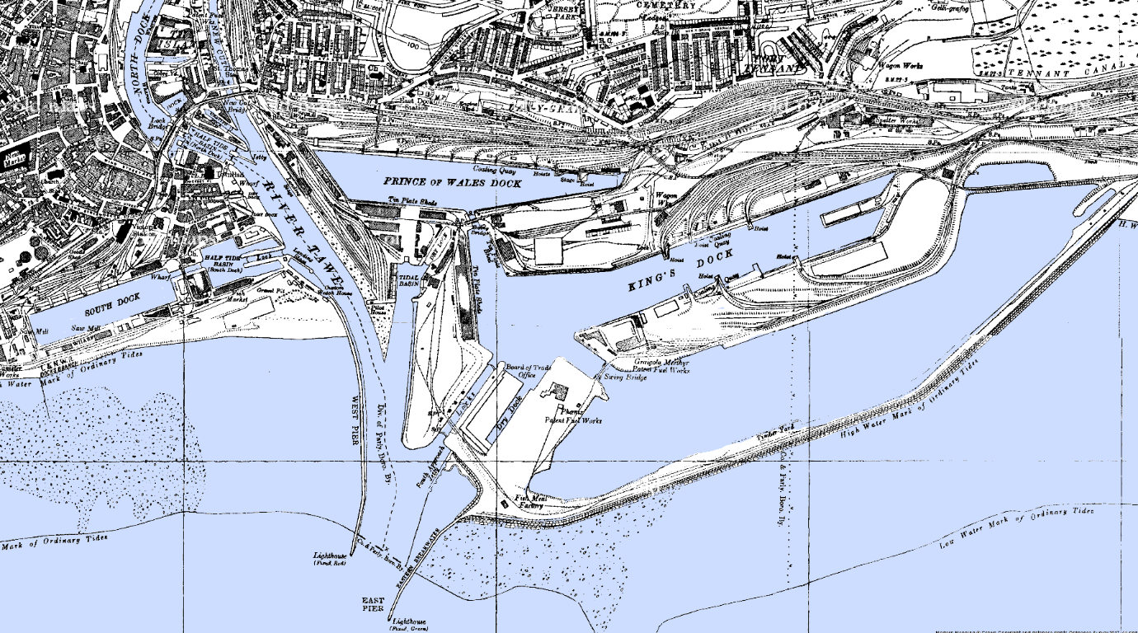
Appendix 3: Ordnance Survey map showing the South Dock and surrounding dock infrastructure (c.1900) (John's Homepage)
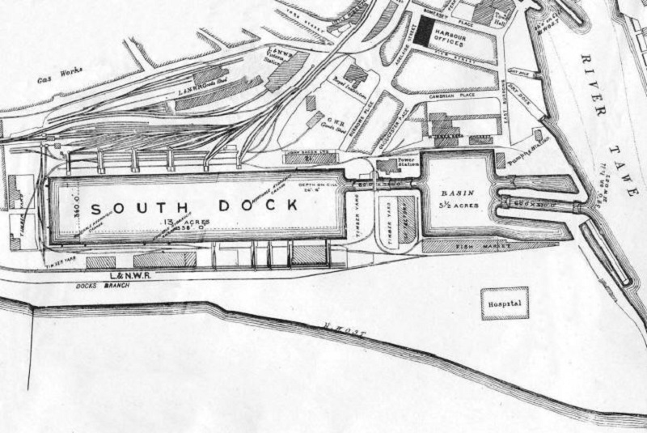
During the late 19th and early 20th centuries, the site and surrounding area contained extensive dock infrastructure, including quays, warehouses, rail links and maritime works (Swansea Docks, 2024) (Appendix 4). These structures have since been demolished or built over, infilled or built over through redevelopment.

Appendix 4: Industrial activity within Swansea docklands during peak operation (https://www.swanseadocks.co.uk/docksnewsite/maps.html)
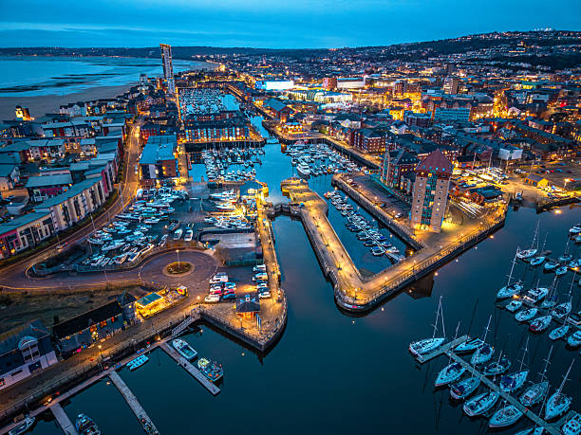
Following the closure of the dock in 1969, the area was transformed through land reclamation and marina redevelopment during the 1980s forming the present Swansea Marina environment (Swansea Marina, 2024) (Appendix 5). These works likely introduced substantial volumes of made ground, including uncontrolled fill and potential industrial residues.
Appendix 5: Swansea Marina following redevelopment of former dockland area (https://www.istockphoto.com/photos/swansea-marina-wales)
The site is expected to contain variable made ground associated with former dock operations, reclamation and redevelopment representing a key geotechnical constraint due to variability, buried obstructions and potential contamination.

Geological Appraisal
Geological conditions have been interpreted from borehole data from the nearby Meridian Tower development, considered representative of the local Swansea Marina stratigraphy (British Geological Survey, 2024) (Appendix 6).
Borehole records indicate upper layers of variable artificial ground associated with historic dock infilling and land reclamation. This made ground is likely to compromise heterogeneous fill, including demolition debris, industrial residues and uncontrolled materials resulting in variable strength, and poor bearing reliability.
Underlying this superficial sand and gravel deposits of marine or estuarine origin with no significant glacial till indicated, consistent with the site’s coastal setting (BGS, 2024). These deposits are expected to provide more competent bearing strata, although variable density may create localised zones of reduced capacity.
At greater depth, bedrock of the South Wales Coal Measures Group is anticipated and may be relevant to deeper piled solutions.
No direct evidence of mining activity beneath the site has been identified; however, the wider Swansea area’s coalfield history suggests that regional mining legacy should be acknowledged. Site-specific subsidence risk is considered low relative to made ground settlement concern.
Overall, the geological profile is characterised by variable made ground overlying more competent superficial deposits, with principal risks relating to settlement, groundwater interaction and bearing variability.
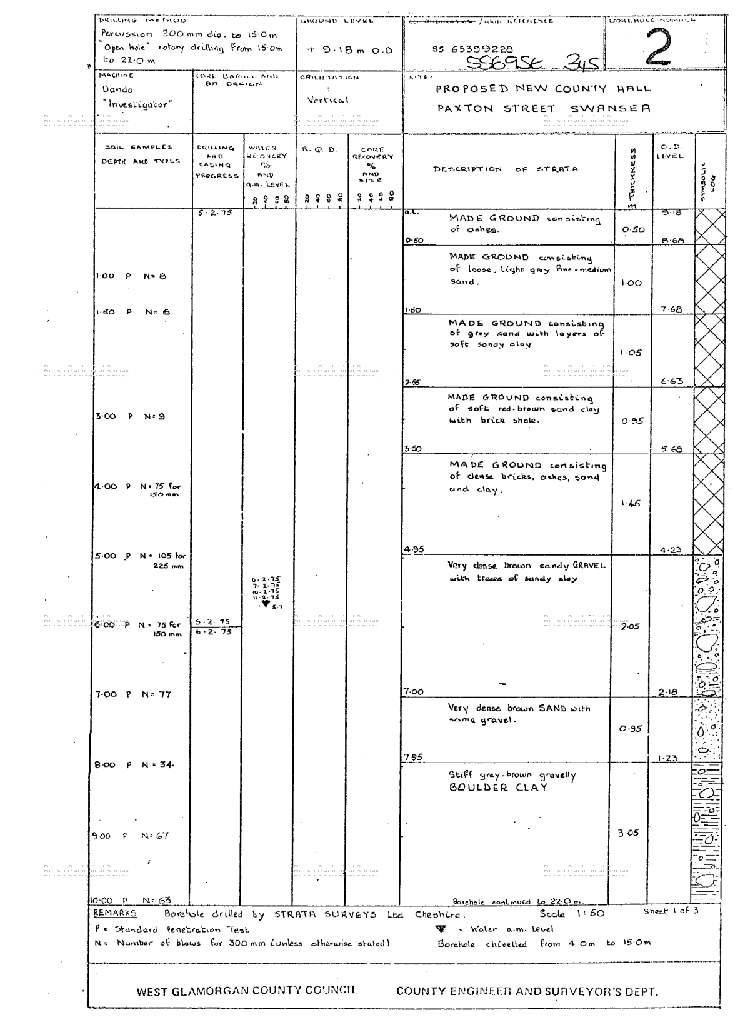
Appendix 6: Borehole log (https://www.bgs.ac.uk/information-hub/borehole-records/)

Environmental Appraisal
Environmental conditions are strongly influenced by the site’s former dockland and industrial use. Historic coal export, shipping and copper smelting activities, within South Dock may have generated contaminants including heavy metals, hydrocarbons and industrial residues (Swansea Docks, 2024). Consequently, dock infill made ground represents the principal potential contamination source.
Construction activities may introduce further environmental risks through fuel spills, concrete washout and disturbance of contaminated soils all of which may mobilise pollutants if not properly controlled.
Hydrogeological conditions are shaped by the site’s coastal position adjacent to Swansea Marina and Swansea Bay. A shallow groundwater table is anticipated and the underlying granular deposits, with possible tidal influence increasing contaminant migration.
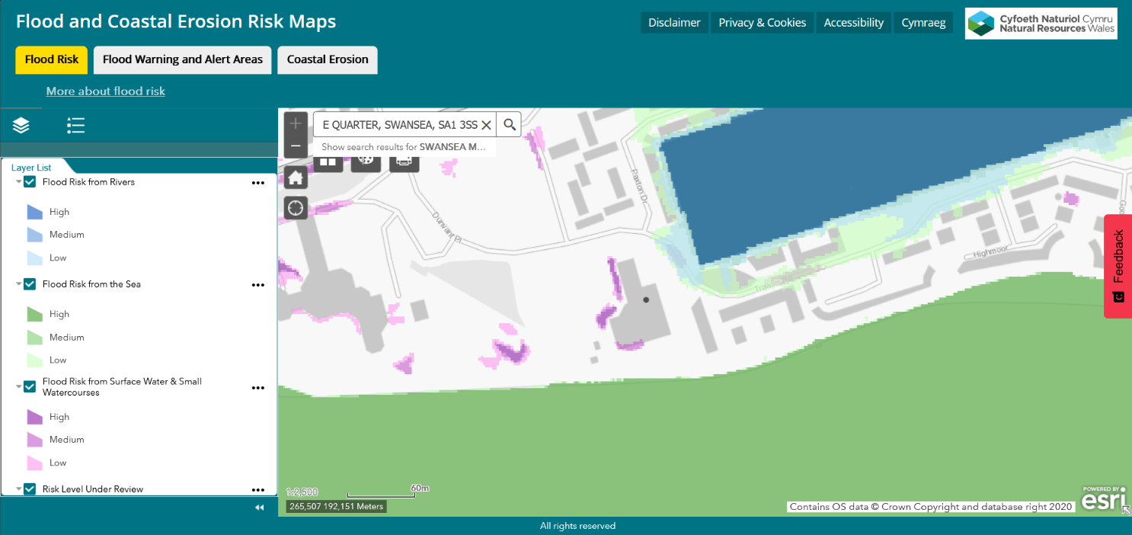
Natural Resources Wales flood mapping indicates potential coastal and tidal flood risk due to the site’s waterfront location (Natural Resources Wales, 2025) (Appendix 7). Surface water accumulation may also occur due to extensive hardstanding and urban drainage constraints. A preliminary summary of flood risks is provided in Appendix 8.

Appendix 7: Based on Natural Resources Wales flood mapping, the site’s proximity to Swansea Bay suggests potential exposure to coastal and tidal flood risk (Natural Resources Wales, 2025).

Source of Flooding | Risk Level | Comments
Coastal / Tidal | Medium-High | Waterfront location adjacent to Swansea Bay
Groundwater | Medium | Shallow water table expected
Surface Water | Low-Medium | Urban drainage and hardstanding present
Rivers | Low | No major river directly adjacent to site
Appendix 8: Preliminary summary of potential flood risks based on Natural Resources Wales flood mapping.
Ecologically, the urban marina setting presents limited immediate constraints; however, nearby coastal habitats and marine environments and wider Swansea Bay receptors may be sensitive to contamination, runoff or disturbance. While no Sites of Special Scientific Interest (SSSI) is located directly on site, local flora, fauna, water environments and community receptors should be considered, together with potential noise, dust and air quality impacts. Seasonal ecological constraints, such as nesting or protected species activity, may also influence investigation timing where relevant.
Overall, the primary environmental risks are contamination within the made ground, shallow groundwater and potential pollutant migration to surrounding water environments. These factors should form a key component of site investigation and environmental management planning.

Archaeological Appraisal
Archaeological potential at the site is primarily linked with its the former use as part of the South Dock and associated dock infrastructure (History Points, 2024). Historical mapping indicates that the site and surrounding area previously contained quays, warehouses and transport links, which may have left buried foundations or structural remnants (Appendix 9).
However, extensive dock infilling, land reclamation and marina development during the late 20th century are likely to have significantly disturbed much of the original archaeological record (Swansea Marina, 2024). Consequently, the likelihood of encountering intact archaeological remains is considered relatively low.
Despite this, buried dock structures, obstructions or voids associated with former maritime infrastructure may still be present and could affect intrusive investigation or foundation works. Archaeological risk is therefore considered low to moderate, with buried structural remnants representing both a heritage and geotechnical consideration.
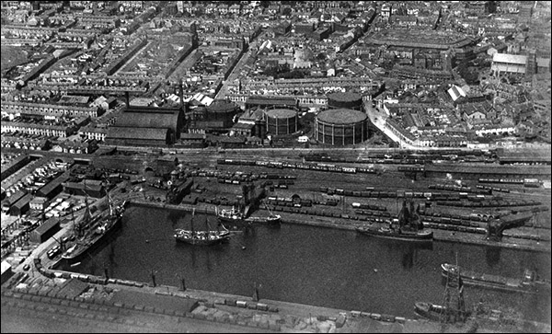
Appendix 9: The South Dock in 1923 (History Points, 2024)

Conceptual Ground Model
A preliminary conceptual ground model identifies the principal site hazards site as arising from historic dockland use, made ground and associated industrial activity. The primary contamination sources are likely to include heavy metals, hydrocarbons, industrial residues and uncontrolled fill materials within made ground derived from dock infilling and land reclamation.
Additional physical hazards may include buried dock structures, obstructions, former services, voids and, although considered low risk, potential unexploded ordnance (UXO). In practice, buried infrastructure and made ground variability represent the more probable constraints.
Potential pathways include direct contact during excavation, groundwater migration, surface runoff, soil gas movement and disturbance during piling or intrusive investigation. The site’s shallow groundwater table and coastal setting increase the potential for contaminant migration.
Potential receptors include construction workers, future occupants, vegetation, surrounding water environments, structures, and buried services including water, electricity and telecommunications infrastructure. Ground gas, including methane, carbon dioxide and radon, should also be considered due to variable made ground conditions.
Overall, the principal risks are made ground variability, contamination, groundwater influence, buried obstructions and potential ground gas hazards. These factors should form the primary focus of detailed geotechnical, environmental and ground gas investigation.
Source | Pathway | Receptor
Made ground contamination | Groundwater migration | Swansea Bay / groundwater / vegetation
Heavy metals / hydrocarbons | Direct soil contact | Construction workers / occupants
Buried obstructions / services | Excavation / piling | Foundations / water / electricity / data
Ground gas / radon | Soil gas migration | Occupants / enclosed structures
UXO (low probability) | Excavation disturbance | Workers / construction operations
Appendix 10: Preliminary Conceptual Ground Model

Site Investigation Strategy and Summary
Based on the preliminary desktop, geological and environmental assessment, the full geotechnical investigation should primarily focus on risks associated with historic dock infilling, particularly variable made ground.
The greatest expected risk is the made ground variability due to its uncertain composition, potential contamination and possible buried obstructions. Determining the depth, extent and engineering properties of this material should therefore be the principal investigation priority.
Secondary priorities include confirming the density and continuity of the underlying sand and gravel deposits, assessing shallow groundwater conditions, contaminant migration potential identifying buried services.
Accordingly, the investigation should prioritise trial pits within shallow made ground, boreholes with Standard Penetration Testing (SPT), dynamic sampling, contamination testing, groundwater monitoring using standpipes or piezometers, and buried services detection to inform safe foundation design and construction feasibility.
These recommendations are informed by BS 5930:2015, BS 8004:2015, PAS 128 and HSG47 guidance relating to safe ground investigation, foundation design and utility detection.
Key stakeholders include Swansea Council Planning and Building Control, Natural Resources Wales, utility providers and, where required, archaeological or environmental consultees. Early liaison is necessary to confirm planning constraints, flood risk, buried infrastructure and regulatory compliance.
Foundation Recommendation
Based on the preliminary historical, geological and environmental assessment, bored cast-in-situ reinforced concrete piles are considered the most appropriate foundation solution for the proposed Swansea Marina development.
Variable made ground associated with historic dock infilling and land reclamation is likely to comprise heterogeneous fill, industrial residues and buried obstructions resulting in poor bearing reliability and settlement risk. This makes shallow foundations unsuitable without significant ground improvement.
Bored cast-in-situ piles can transfer structural loads through weak artificial ground into deeper, competent sand and gravel deposits, reducing differential settlement risk and improving stability. They are also well suited to this constrained urban marina setting due to lower vibration and noise levels than driven piles, reducing risk to adjacent buildings, buried services, retaining structures and waterfront infrastructure.
Accordingly, bored cast-in-situ reinforced concrete piles are recommended due to their suitability for reclaimed dockland, improved load transfer and compatibility with site’s constraints.

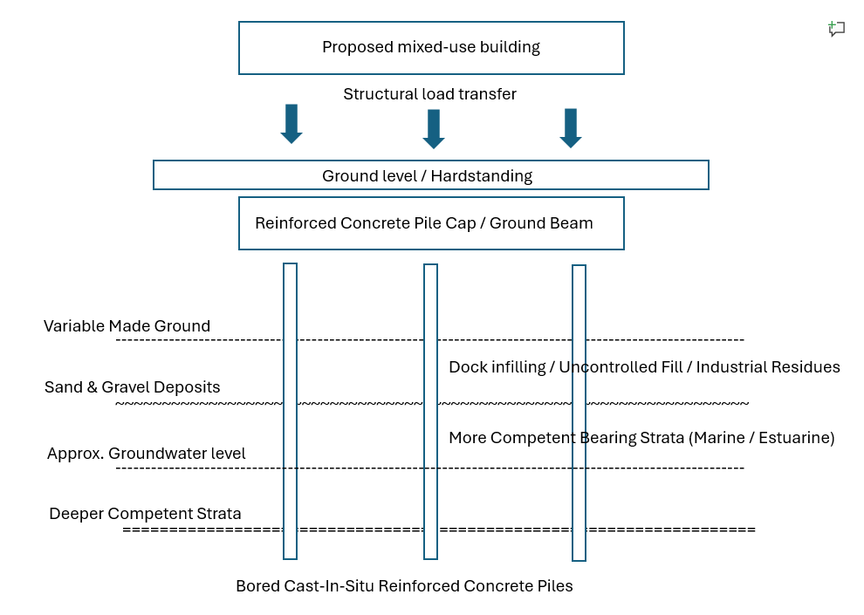
Appendix 11: Preliminary piled foundation concept transferring loads through made ground into competent strata.
Alternative shallow foundations, such as strip or pad foundations, would be more vulnerable to settlement and may require extensive ground improvement.
Accordingly, piled foundations are recommended as the most suitable preliminary solution due to their ability to mitigate made ground variability, groundwater influence and uncertain near-surface conditions.

Conclusion
This preliminary assessment identifies the proposed Swansea Marina site as presenting significant geotechnical and environmental challenges associated with its historic dockland use, reclaimed land and variable made ground.
The principal risks are made ground variability, potential contamination, shallow groundwater influence and buried obstructions all of which should form the primary focus of the full geotechnical investigation.
Intrusive investigation incorporating boreholes, Standard Penetration Testing (SPT), groundwater monitoring, contamination assessment and buried services detection is essential to accurately define site conditions.
A piled foundation system is considered the most suitable preliminary solution due to its ability to transfer structural loads through weak artificial ground into more competent underlying strata, thereby reducing settlement risk and improving long-term stability.
This phased approach reduces the likelihood of unforeseen ground conditions, programme delays and avoidable construction risk.
Overall, the findings provide a clear basis for specialist geotechnical investigation and informed foundation design, supporting the safe and feasible development of the site.

References
- British Geological Survey (BGS) (2024) GeoIndex Onshore: Geological data for Swansea. Available at: https://www.bgs.ac.uk (Accessed: 26 April 2026).
- British Standards Institution (2014) PAS 128: Specification for underground utility detection, verification and location. London: BSI.
- BS 5930:2015 (2015) Code of practice for ground investigations. London: British Standards Institution.
- BS 8004:2015 (2015) Code of practice for foundations. London: British Standards Institution.
- Environment Agency (2021) Flood risk and coastal management guidance. Available at: https://www.gov.uk (Accessed: 22 April 2026).
- Google Earth (2026) Swansea Marina aerial imagery. Available at: https://earth.google.com (Accessed: 20 April 2026).
- Google Maps (2026) Swansea Marina location map. Available at: https://maps.google.com (Accessed: 20 April 2026).
- Health and Safety Executive (HSE) (2014) HSG47: Avoiding danger from underground services. London: HSE Books.
- Health and Safety Executive (HSE) (2003) Avoiding danger from overhead power lines (AIS8). London: HSE Books.
- HM Government (2020) The Construction Playbook. Available at: https://www.gov.uk (Accessed: 20 April 2026).
- History Points (2024) Swansea Marina history. Available at: https://historypoints.org (Accessed: 21 April 2026).
- Natural Resources Wales (2025) Flood Risk Assessment Wales Map. Available at: https://naturalresources.wales/flooding/check-your-flood-risk-on-a-map-flood-risk-assessment-wales-map/ (Accessed: 28 April 2026).
- Public Health England (2023) UK Radon Map. Available at: https://www.ukradon.org (Accessed: 28 April 2026).
- Swansea Council (2020) Swansea Marina development context. Available at: https://www.swansea.gov.uk (Accessed: 20 April 2026).
- Swansea Docks (2024) History of Swansea docks and industrial activity. Available at: https://www.swanseadocks.co.uk (Accessed: 20 April 2026).
- Swansea Marina (2024) Swansea Marina redevelopment. Available at: https://en.wikipedia.org/wiki/Swansea_Marina (Accessed: 20 April 2026).

Appendices
- Appendix 1: (Google Earth 2026).
- Appendix 2: Aerial view of site showing hardstanding and surrounding infrastructure (Google Maps, 2026).
- Appendix 3: Ordnance Survey map showing the South Dock and surrounding dock infrastructure (c.1900).
- Appendix 4: Industrial activity within Swansea docklands during peak operation.
- Appendix 5: Swansea Marina following redevelopment of former dockland area.
- Appendix 6: Borehole log
- Appendix 7: Based on Natural Resources Wales flood mapping, the site’s proximity to Swansea Bay suggests potential exposure to coastal and tidal flood risk
- Appendix 8: Preliminary summary of potential flood risks based on Natural Resources Wales flood mapping.
- Appendix 9: The South Dock in 1923 (History Points, 2024.
- Appendix 10: Preliminary Conceptual Ground Model
- Appendix 11: Preliminary piled foundation concept transferring loads through made ground into competent strata.

