James Evans (2025643)

REFLECTIVE ESSAY Design for Industry 4.0 ACPA7001

Contents page

Introduction 2
Design principles 3
Robotics 6
Design for Circular Economy 7
Design for de-assembly 8
Design for assembly 9
Additive manufacture and Generative design 10
Conclusion 11
References 12

Introduction

Industry 4.0 (I4) is the next revolution in manufacturing building on the back of industry 3.0 technology IT systems and automation. By using Automation, cloud computing, 3d printing, big data and analytics, the Internet Of Things (IOT) the current manufacturing production systems can evolve by adopting these technologies and embrace the “smart factory’s” or Cyber Physical Systems of the future, failure to do so will result in the risk of being “left behind” by their competition. This paper will highlight emerging opportunities for steel producers like tata steel based in Port Talbot and their development for I4 and discuss changes currently adopted by steel mills. Steelworks are modernising party due to the advanced manufacturing capabilities of I4, these technology enablers are pushing steelworks from industry steelworks 3 into steelworks 4.
Steel is a strategic material required for making many products, its properties have been valuable even before the first industrial revolution. Furthermore, steel plants that have positive environmental, economic and social aspects will be part of the important concept of sustainability for manufacturing industries.
A key barrier connected with steelworks 4.0 and its implementation, is the digitalization of processes not just within the organisation but its entire supply chain.
There is clear difference between industry 3.0 and 4.0, but this difference is the level of technology, industry 3.0 was limited to physical systems but 4,0 main focus is on cyber physical systems which is both real and virtual in tandem.

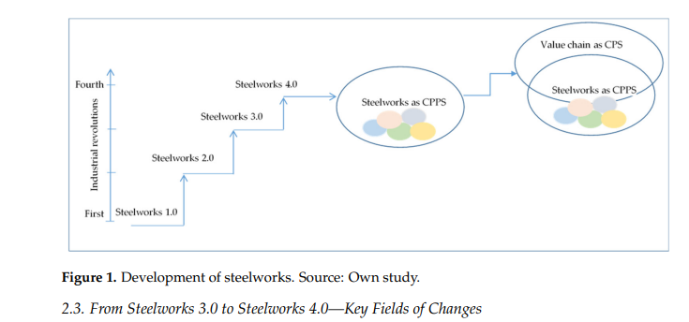
(Gajdzik and Wolniak, 2021)

The I4 technologies and six design principles for implementing industry 4.0 can be seen in the image below followed by a detailed description of the principles and how they need or could be incorporated in the steel industry.
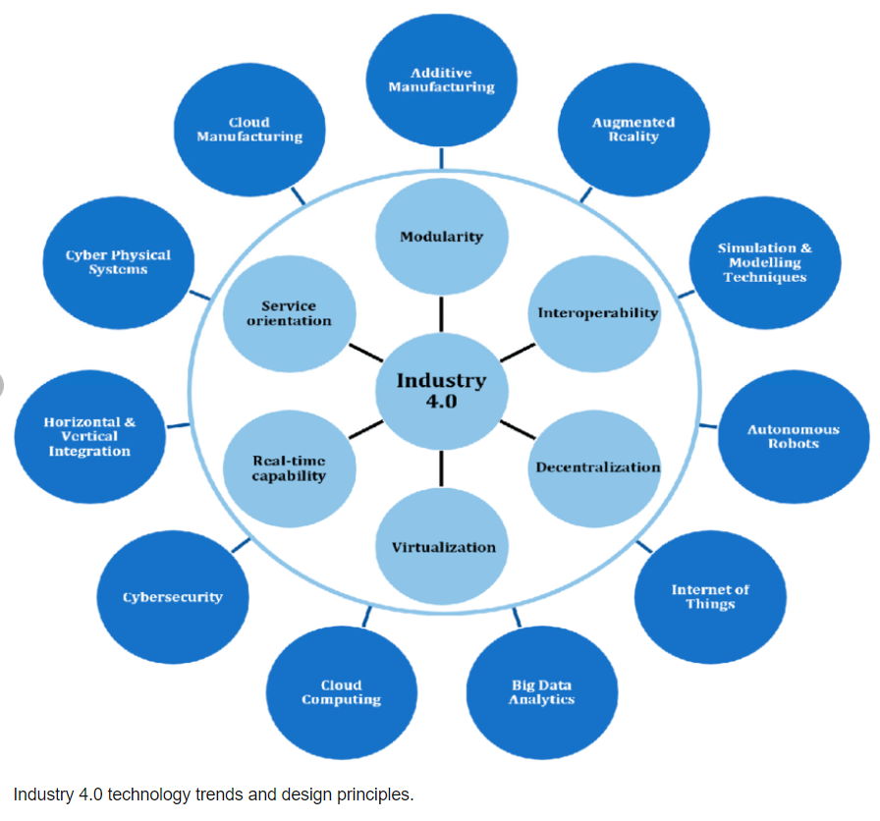
(Butt, 2020)

Tata Steel are already thought to be pioneers in adopting advanced analytics for their steel fabrication, moreover, applying digital services across the whole supply chain. There biggest market is the automotive industry, a large customer of steel produce. The first steps for design for I4 and investment is digitalisation of processes to improve efficiency of equipment and eliminate wasted resources.

Design principles

Interoperability
Interoperability is the ability of all objects, machinery and humans across the manufacturing industry to communicate, and coordinate its activities by exchanging data. By interconnecting everyone with everything machine based, is essential in taking advantage of the analysis provided by big data to increase the efficiency and gaining process optimisation. Adopting and inserting new technology would only have a limited capacity if the systems and products cannot communicate information with the other systems and products. Moreover, humans and machines would remain limited to standard operations without interoperability. Interoperability is Impossible without interconnectivity so the steel industry must design their systems, digitise their processes and operations by utilising cloud computing for their software programs and to store their data. secondly, they should start integrating open-source software or platforms, for example, android Apache open office, Linux, WordPress etc into their business operations. This information that is openly exchange between their systems helps business can alleviate the costs of information collection and reduce any unnecessary duplicates of information collected.

Virtualisation
This can refer to different scenarios, the first is a virtual resource that is created from several resources that are physical, secondly, they are virtual resources that can be created from multiple physical resources. First scenario the hardware environment of a manufacturer like TATA can be simulated with the creation of digital ‘twins’ of their physical assets using big data gathered from sensors. During the second scenario, the software would be used to split one of the physical servers into several servers that are virtual and act like the unique physical devices. 3D models or Digital twins can be used to optimise the machinery’s performance, allowing the ‘what if’ scenarios, by running these scenarios the potential impact of new machinery or systems could be tested and optimised.
Real time capabilities
The real time capabilities are utilising big data and analytics in real time, allowing for immediate decisions to be made Ad-Hoc or “on the fly”. This can enable Tata to analyse what’s happening in their multiple departments and supply chain to see potential areas to improve and increase productivity. Furthermore, it can highlight micro trends, inefficiencies, anomalies or actual failures. With new technology like IOT and their companies have access to real-time big data. But the barrier is processing, analysing and utilising the data for the operations and products can be optimised. Cloud computing allows information to be managed in real-time removing the time constraints that hindered progress previously.

Decentralisation.
Achieving decentralisation is something that manufacturing industries have embraced previously, by moving their systems away from a central computer, aids flexibility and scalability. Using the cloud for storing Data is decentralisation and with I4, all the technology can be decentralised, allowing the creation of potential decentralised systems worldwide. With advanced manufacturing techniques like 3D, it is now possible for companies to have micro factories in multiple areas like the jewellery industry. Using decentralised ledger technology in the form of blockchain they can trace where precious metal materials have come from to reduce fraud, in the steel industry it can be used to trace where iron ore or other key materials have been mined, shipped, its origin and date.

Modularity
Modularity is important for manufactures striving for agile systems, not liner systems, it is particularly useful when there are varying orders and batch sizes. Product development needs to be customised and can be achieved by adding new technologies to the business. Modularity can be defined as the ability of a component or system being added or removed efficiently. Designing for I4 this way allows rapid integration and response to requirements of customers’ needs and removing potential malfunctions by allowing interchangeable modules. This can help TATA steel gain flexible material processing and systems, module workstations, tools and machinery (Butt, 2020).

Peters, (2017) discusses that to digitalise a business or industry is a prerequisite for adoption of I4, but digitisation is only one part, I4 should be seen as a philosophy or a paradigm shift, not just a technology. A key enabler is to analyse and implement these enablers for I4 to best suit the Steel industry.
3 key components are, smarter connections, services and technologies. Enablers to achieve this are AI, digital twins, mixed reality (AR, VR), drones, blockchain. Digital twins, artificial intelligence, augmented/virtual/mixed reality, blockchain, and drones. Smarter connections require the use of the Internet of Things (IoT across the entire value chain). They are achieving this by working with multiple institutions to standardize and develop their system components.
Tata has limitations of mass customisation and reacting to customer demands for their processes and products. It would be highly ineffective financially and productivity wise if they were to stop production to trail new products or processes, to remove this barrier Tata Steel have partnered with multiple universities for research, development and innovation like the Steel & Metals Institute in Swansea. SINTEC facilities enables simulation of processes, testing with compositional analysis of materials during extreme temperatures in atmospheres of reactive gas such as carbon monoxide, hydrogen, sulphur dioxide, and carbon dioxide, simulating processes like steelmaking at lab scale, The Pilot area can create small batch sizes of bespoke alloys which can also be post processed through hot and cold rolling techniques and analysed using a range of equipment. Furthermore, simulations of products can be utilised for stress and fracture data (Steel and Metals Institute, 2022). All this information gathered can be filtered back to production at the steel plants to create greener products and processes. Providing essential and unique facilities for R&D will lead to cutting edge technologies that will address the ambitious decarbonisation and net zero targets set out by the government (GOV.UK, 2021). These activities for making steel will allowing designers to create smarter products and lead to smarter services in which their systems will generate material models and data, and create intelligent algorithms leading to a useful data package about the life cycle of steel.
Tata are designing developments for new digital services for the smart factories of the future, examples of this is are in their dynamic process control, quality management, and predictive maintenance. This type of adoption and investment will manifest into increased value for the customer. Furthermore, by monitoring key developments in their customers industry sector they can adjust their production strategically for the automotive market.

Robotics
I4 utilises the automation of process manufacturing and advances it by introducing flexible mass production and customized products.
Allowing machines to cooperate with workers or work independently allowing for a customer-oriented production area that can maintain and predicted failures. Machines become independent and able to collate data, analyse it, and suggest process improvements (luenendonk, 2017).

Designers need to consider key benefits of advanced efficiency when using robotics in production and explore the modern advances in technology to ensure optimised manufacturing processes are used. moreover, designers have to understand responsibilities of moral and ethical issues during advanced and increased uses of this automation. Robotics already has a historical impact of job losses, introducing robots in industry 3.0 assembly lines had a detrimental impact on the work force, resulting in skilled workers being made redundant in favour of fewer staff who could maintain multiple robots.

Advantages
Tata steel implementing robotic systems in their production lines. Increased health and safety of staff. Higher accuracy of work, minimised or zero errors and defects. Reduced scrap increased Quality of final produce. Robots performing repetitive and potentially dangerous tasks such as draining the molten metal furnaces or dangerous inspections.
Removing the need for employees to work in confined spaces. They can operate 365 days 24/7 resulting in a higher throughput

Disadvantages

Tata steel using robotic systems in production lines will need new expertise in operating these robotic systems. Employees will need advanced training in robotic operation and maintenance. Robotics especially at this level of industry will have large financial capital costs (DesTechWiki 2021).
Tata could move to third generation robots that are autonomous, and need little to no interaction from humans.

Design for Circular Economy
Increased worldwide population has impacted on the consumption of raw materials, the need for a shift to circular economy from the linear model is extremely important. Steel is a strategic material and is 100% recyclable while still maintaining its quality and mechanical characteristics (Broadbent, 2016). Furthermore, steel can be repurposed for building materials, this makes it suitable for the paradigm shift of a circular way of designing, developing, building longer lasting products ad repurposing used materials (Tata Steel in Europe, 2019). ‌ Engelmann et al., (2021) proposed it was possible to use steel as a material service and used a company producing steel drums for industry as an example for the proposed steel circular economy, designing superior Products is a key business model to reduce and dematerialise consumption of resources between service providers, manufacturers and its customer base. Their research designed a material service system (MSS) concept and applied it to a real-world case study. They first designed and modelled a method that represents the flow, transformation and who owned resources for all stakeholders in the supply chain. Secondly, they tested the method using the case study. They achieved positive results indicating their MSS could drastically transform the steel industry, it was realised it could effectively work with a product service system with a recondition of product system, reintroducing the waste drums back into the industry.
Tata applying circular strategies at their product planning stage using industrial designers will have a positive environmental impact. Product design has a large influence on sustainable practices. big data analysis for designing circular products as well as limiting human biases in prototyping and testing are key reasons of implementing digital technologies in all manufacturing industries. Digitalization assets in the ecosystem, collaboration with humans and as an advancing human skillset. Ghoreishi and Happonen, (2020) study suggested there are circular design tools and strategies which help organisations develop their product designs by harnessing artificial intelligence leading to advances in product circularity. Real-time data and analysis abilities aid massive data analysis which reduces the time it would traditionally take in I3 and in turn less energy consumption would be needed. furthermore, rapid prototyping and rapid testing will reduce waste in design process. Moreover, AI collates and transmits precise data and information on products and materials and their availability, what condition they are in and how accessible they are, which allows for easy monitoring and enacts remote maintenance as well as circular economy opportunities.

Design for Disassembly
I4 has led to a paradigm shift amongst product designers, architect and customer bases with sustainability of key materials needed for manufacturing industries (Soh, Ong and Nee, 2015). This has resulted in a significant opportunity for steel producers like Tata, designers can now imagine and erect buildings that when it reached the end of its life, instead of being demolished and scrapped, the structural steel components would be disassembled and repurposed on other products or buildings resulting in an extension of their products.
Fokker 7|8, is a brand-new distribution centre located in the Netherlands and was the first optimised logistics building worldwide. Tata and Delta Development Group worked together and designed the fully circular distribution centre. The designers predominate focus was ensuring the ability to reuse components and materials in later stages of the life cycle of the product by Designing with only bolted or screwed connections instead of welded connections for the primary steel structure support. This collaboration also resulted in 100% of the material data captured and put into a material passport (Tata Steel in Europe, 2020). The idea of a passport for materials was developed by Thomas Rau, architect, who had been striving to build a database for materials in buildings and the potential for reuse and repurpose. He stated, “we have to start thinking of buildings as material depots.” (Wainwright, 2020).

Design for Assembly
‌
Design for Assembly (DFA), aim is to streamline the manufacturing process making it consistent but also faster and easier to make products. A key part is to simplify product structure by minimizing numbers of components and reducing the amount of assembly sections required, this is a crucial aspect coupled with subtracting features deemed unnecessary that do not increase functionally of products (Mital et al., 2014).
Guidelines to help designers have been proposed previously in the 60s and 70s, and in the 1970s developments were made for numerical evaluation methods. This allowed for accurate estimates for cost and time analysis between manual and automatic assembly.
Principles for manual and automatic assembly are not too different from each other, but there are some notable differences. Robots traditionally can be limited in their motion range and capabilities compared to their human counterparts, Design for Automated Assembly (DFAA), shifts focus for unique tools and holders that could be retrofitted onto robots or co-bots, examples are parallel grippers, electro-magnets or suction cups.

Currently Tata Steel based in South Wales at Port Talbot operate two blast furnaces to create their steel products. These blast furnaces are responsible for high Co2 levels and are limited to using up to 30% recycled steel and the remaining steel has to be raw mined materials due to the process involved in the harsh hazardous environment in creating their product. Tata were and are early adopters of both industry 3 & 4 technology. However, because of their high carbon footprint and resource consumption Tata should focus their resources for the future by implementing intelligent smart electric arc furnaces. The developments of I4 can make a fully automate process steel making plant that can utilise 100% percent recycled steel and has a range of innovative components that reduces energy consumption, increases product yield and allows for new exciting greener product development.
When the industry was in operation before automation, sensors and process control, it was the operators of the plant that personally monitored the performance and wrote the best settings for production equipment. Automating this with thousands of sensors that consistently collect data in real time and can monitor the whole plant is made possible by increased connectivity, large rises in data that can be collected and computer power. It’s these advancements that have led the emergence of deeper understanding via potent analytics and new human to machine interactions involving AI, VR and AG. Advance robotics can remove the need for humans to enter harsh or dangerous environments that are in multipole locations across a steel mill (Scipolo, ‌& Zuliani, 2018).

Tata need to continue pushing the boundaries and designing new product materials, invest heavily in R&D to aid these material breakthroughs that are currently being developed that possess unique characteristics. These advancements in materials science have created smart materials that can have programmable properties that respond or behave to stimuli from both internal and external factors. Designing materials and products with diverse qualities, some examples are but not limited to, self-healing, thermo-, memory shape electro-, piezoelectricity, and unique phase-change attributes (Kang et al., 2022).

Additive manufacturing and generative design.

Tata steel may not at first seem like a company that could adopt 3d printing for their production mills due to the product and quantity produced, however, for smaller parts for operational function, repair and prototyping it is a process that would reap multiple benefits. Design for Additive Manufacturing (AM) has advantages over designing for traditional methods such as machining (Brossard et al, 2020). Predominantly it gets parts to customers in rapid time. The two key benefits for this technology are flexibility and design freedom. AM removes the design limitations that are prevalent in machining, you can create features that are complex or make parts that are simple, there are few limitations to the design process, the design can be optimized, however the designer wants it to be. It removes time wasted by multiple visits to machine workshops to investigate what can be achieved in traditional ways. AM allows greater design freedom while still achieving knurling, threads or multiple-material products (Miles, 2022).
Fusion 360 utilises CAM, CSD, PCB and CAE software to simulate and create models, creating multiple iterations or simulating each iteration. This process provides important analysis, such as forces and stresses to identify defects of flaws in real time to avoid reworking parts at cost to the company (Buonamici, et al, 2020). Parts can be drawn, simulated and printed within hours in some cases avoiding postal delays or supply chain issues. Fusion 360 and other similar packages can also utilise generative design (GD) that explores the process requirements to align with the product requirements, it increases material efficiency by applying concentrated materials in the areas that require it and thinning the material out in areas of minimal or no stress. By simulating this type of product in GD software it’s possible to understand and pinpoint where these stresses are, then adapt accordingly. The software can be updated with key product needs, to achieve its final state, the GD program will then generate multiple iterations that meet the requirements of the product designer (Mountstephens &Teo, 2020).

Fears of job losses in industry 4.0

It’s a fair concern that certain technologies like AI and automation could reduce the number of employees or opportunities for humans, however GD should be seen as another “tool in the toolbox” for designers and developers. GD is a form of AI that requires the human element for the parameters at the start of the design process, it’s a good example of how humans and new technology can work together to create superior products.
Integrating GD techniques into existing design workflows for manufacturers will probably need to consider training and hiring specialists, the mindset required for GD may not be easily accessible to many established designers, a paradigm shift in mindset within the design community and industry is needed before mass adoption of this technology.

Conclusion
TATA steel’s objective should be a fully integrated ecosystems that is developed by access of information between all stakeholders across the value chain and continue pushing the boundaries and designing new products, and development of materials.
I4 is revolutionary approach will change manufacturing processes and products. It will guide global manufacturers to an increased level of optimisation and productivity. Furthermore, customers will benefit from a higher level of personalised products that haven’t been available previously. As outlined in this paper, the rewards will be extreme.
It’s important to realise, there are also many challenges that will need to be overcome systematically to enable a stable transition. Big corporations and governments need to work together, Pushing R&D and experimentation in manufacturing fields are imperative.
By accumulating design for supply chain, manufacturing, assembly and disassembly the benefits would be immense, using the different advice and “rules” during the design phase is a big task but most of them have varying intrinsic overlaps and create a streamline process. This methodology will benefit all areas of product design.
The experimentation and research of new materials will enhance product sustainability, achieve light weight attributes, nanomolecular, and programmable qualities., Early adopters of cutting-edge materials development across all industries will reap the benefits of emerging technology.
Ethical considerations regarding privacy, security, and potential unemployment need deeper analysis, the future is promising.

References
Allen, L., Atkinson, J., Jayasundara, D., Cordiner, J. and Moghadam, P.Z. (2021). Data visualization for Industry 4.0: A stepping-stone toward a digital future, bridging the gap between academia and industry. Patterns, 2(5), p.100266. doi:10.1016/j.patter.2021.100266.

Broadbent, C. (2016). Steel’s recyclability: demonstrating the benefits of recycling steel to achieve a circular economy. The International Journal of Life Cycle Assessment, 21(11), pp.1658–1665. doi:10.1007/s11367-016-1081-1.
‌Brossard, M,. et al. (2020). How generative design could reshape the future of product development | McKinsey. [online] Available at: https://www.mckinsey.com/business-functions/operations/our-insights/how-generative-design-could-reshape-the-future-of-product-development.[Accsessed [15/05/22]
‌Buonamici, F., Carfagni, M., Furferi, R., Volpe, Y. and Governi, L. (2020). Generative Design: An Explorative Study. Computer-Aided Design and Applications, 18(1), pp.144–155. doi:10.14733/cadaps.2021.144-155.
Butt, J. (2020). A Conceptual Framework to Support Digital Transformation in Manufacturing Using an Integrated Business Process Management Approach. Designs, 4(3), p.17. doi:10.3390/designs4030017.
DesTechWiki. (2021). 4.6 Robots in Automated Production | Design Technology. [online] Available at: http://www.ruthtrumpold.id.au/destech/?page_id=376 [Accessed 15 Jun. 2022].

Engelmann, A., Zeeuw van der Laan, A., Aid, G., Nybom, L. and Aurisicchio, M. (2021). DEVELOPING THE MATERIAL-SERVICE SYSTEM CONCEPT: A CASE STUDY OF STEEL INDUSTRIAL DRUMS. Proceedings of the Design Society, 1, pp.1223–1232. doi:10.1017/pds.2021.122.

Gajdzik, B. and Wolniak, R. (2021). Transitioning of Steel Producers to the Steelworks 4.0—Literature Review with Case Studies. Energies, 14(14), p.4109. doi:10.3390/en14144109.

Ghoreishi,. M & Happonen, A,. (2020). New Promises AI Brings into Circular Economy Accelerated Product Design: Review on Supporting Literature.
GOV.UK (2021). Net Zero Strategy: Build Back Greener. [online] GOV.UK. Available at: https://www.gov.uk/government/publications/net-zero-strategy. [Accessed 15 Jun. 2022].

‌Kang, M., Seong, M., Lee, D., Kang, S.M., Kwak, M.K. and Jeong, H.E. (2022). Self‐Assembled Artificial Nanocilia Actuators. Advanced Materials, p.2200185. doi:10.1002/adma.202200185.
‌Miles, D,. (2022). Generative Design: What Is It and What Are the Benefits? [online] Available at: https://redshift.autodesk.com/what-is-generative-design/ [Accessed 20 May 2022].
Mital, A., Desai, A., Subramanian, A. and Mital, A. (2014). Product development : a structured approach to consumer product development, design, and manufacture. Amsterdam: Elsevier.
‌Mountstephens, J. and Teo, J. (2020). Progress and Challenges in Generative Product Design: A Review of Systems. Computers, 9(4), p.80. doi:10.3390/computers9040080.
‌‌luenendonk, M. (2017). Industry 4.0: Definition, Design Principles, Challenges, and the Future. [online] Cleverism. Available at: https://www.cleverism.com/industry-4-0/ [Accessed 16/06/22]
‌Peters, H. (2017) How could Industry 4.0 transform the Steel Industry? In Proceedings of the Future Steel Forum, Warsaw, Poland, 14–15 June 2017; PowerPoint-Präsentation. Available online: https://futuresteelforum.com/content-images/speakers/Prof.-DrHarald-Peters-Industry-4.0-transform-the-steel-industry.pdf (accessed on 10 may 2022).

Scipolo, ‌V., Zuliani, D., (2018) “Industry 4.0 – The Evolution of Intelligent EAF Steelmaking”, METEC 2019 Dusseldorf, Germany, June 25-29, 2019. https://www.researchgate.net [Accessed 1/06/22]
Steel and Metals Institute. (2022). Steel and metals innovation and decarbonisation. [online] Available at: https://www.samiswansea.co.uk/ [Accessed 14 Jun. 2022].
Soh, S.L., Ong, S.K. and Nee, A.Y.C. (2015). Application of Design for Disassembly from Remanufacturing Perspective. Procedia CIRP, 26, pp.577–582. doi:10.1016/j.procir.2014.07.028.

Tata Steel in Europe. (2022). Automotive - Digitalisation. [online] Available at: https://www.tatasteeleurope.com/ts/automotive/industry-themes/digitalisation [Accessed 8 Jun. 2022].

Tata Steel in Europe. (2019). Designing sustainable buildings for disassembly and reuse. [online] Available at: https://www.tatasteeleurope.com/construction/blogs-news/blogs/blog/designing-sustainable-buildings-for-disassembly-and-reuse [Accessed 1 Jun. 2022].
‌Tata Steel in Europe. (2020). Steel and the four R’s. [online] Available at: https://www.tatasteeleurope.com/construction/blogs-news/blogs/steel-and-the-four-rs. [Accessed 1 Jun. 2022].
‌Wainwright, O. (2020). The case for ... never demolishing another building. The Guardian. [online] 14 Jan. Available at: https://www.theguardian.com/cities/2020/jan/13/the-case-for-never-demolishing-another-building. [Accessed 1 Jun. 2022].
‌ Vanegas, P., Peeters, J.R., Cattrysse, D., Tecchio, P., Ardente, F., Mathieux, F., Dewulf, W. and Duflou, J.R. (2018). Ease of disassembly of products to support circular economy strategies. Resources, Conservation and Recycling, [online] 135, pp.323–334. doi:10.1016/j.resconrec.2017.06.022.
‌
‌

‌

‌

