
APPENDIX GA36a

LEVEL 4 ASSESSMENT SPECIFICATION

Student name: | Benjamin Phillips | Student ID number: | 1810539/1
Programme: | BSc/HND Computing (All Streams)
Module: | Internet Technology and Security
Module code: | ACCA4018 | Contribution to Overall Module Assessment (%): | 50%
Lecturer: | Kemi Ademoye | Internal Verifier:
Assignment Title: | HTML & CSS Web Development | Word count (or equivalent): | 1500 - 2000 words
Submission deadline: | 8th February 2019 | Return date of provisional marks & written feedback:
Submission method: | All written assessments, where practical and possible, must be submitted via Turnitin unless otherwise instructed by the Lecturer. (Please DO NOT put this assessment specification into Turnitin or it will match many similarities with other students’ submissions.)  Alternative submission method (if applicable):  Late submission of the assessment will result in a late penalty mark. Penalties for late submission: Up to one week late, maximum mark of 40%. Over one week late, 0%. Only the Extenuating Circumstances Panel may approve a change to submission dates.
Academic honesty / referencing: | Academic honesty is required. In the main body of your submission you must give credit to authors on whose research and ideas your work is based. Append to your submission a reference list that indicates the books, articles, etc. that you have used, cited or quoted in order to complete this assessment.

Module Learning Outcomes
(from module syllabus)
Demonstrate an understanding of the standards, concepts, principles and practice required in the implementation of websites and to select and deploy web languages to implement websites

TASK DESCRIPTION

In order to demonstrate your understanding of the standards, concepts, principles and practice required in the implementation of websites, you are required to complete the tasks outlined below.

Task 1: Design and hand-code a website using web standards
- Design and hand-code a website that is made up a reasonable number (minimum of 5) of relevant and related pages using web standards.
Possible examples of websites include a site:
- for an organisation of your choice, which may be fictitious in nature
- to promote a personal interest or hobby, a favourite band, a town/city, etc.
- Create a compressed (zipped) file containing your completed Website files and upload to the link provided on Moodle.

Task 2: Report
You are required to produce a specification report containing relevant documentation of your research and web development work as a single Word document file with the following sections:
- Title Page
- Containing your name, student number, course and the module name and the date
- Table of Contents:
- Outlining all other sections making up the report
- ‘Introduction’ section
- An abstract: a short summary description of the contents of the report
- ‘Requirements’ section:
- A brief introduction to the website, describing its purpose and subject matter, the target audience and its relevance.
- ‘Implementation’ section:
- Screen shots of all of the pages of the completed website (not code).
Note: If any of the pages are very long, it is okay to provide a cropped view showing a reasonable amount of content.
- Validation
Validate both your HTML and CSS code of your completed website and provide the validation results. If you have any errors, provide a brief description of how you corrected the error or what you think the errors are in cases where you are unable to correct the error. Please do not describe every single error – a general statement will do!
The validators can be found at:
  - HTML (http://validator.w3.org/) - you are only required to validate the HTML of your home page
  - CSS (http://jigsaw.w3.org/css-validator/) – you are only required to validate your website’s main CSS
- 'Evaluation' section:
- An Accessibility Evaluation of the Website.
With reference to WCAG 2.1, briefly discuss the accessibility of your website with respect to the four principles that provide the foundation for Web accessibility as applicable to your website. Some tools that may help you include:
  - Visual Studio
  - http://contrastchecker.com/
  - http://juicystudio.com/services/luminositycontrastratio.php
  - Google Chrome Extensions:
    - aXe
    - WAVE Evaluation Tool
  - Firefox Extensions:
    - AI Inspector Sidebar
- An evaluation of the completed website taking into consideration its design (look and feel), usability (functionality) and content (information), including recommendations for future improvements.
- An evaluation of your website’s on-page Search Engine Optimisation (SEO).
- References:
- Any information sources (e.g. relevant journals, books, online sources and articles) that you have consulted.

Submission Details
You are required to complete the tasks outlined in the 'Task Description' section and to submit:
- An electronic version of your Report via Turnitin.
- Upload the zipped files for Task 1 containing your web development work to Moodle.

GUIDANCE FOR Students IN THE COMPLETION OF TASKS

NOTE: The guidance offered below is linked to the five generic assessment criteria overleaf.

- Engagement with Literature Skills
Your work must be informed and supported by scholarly material that is relevant to and focused on the task(s) set. You should provide evidence that you have accessed an appropriate range of sources, which may be academic, governmental and industrial; these sources may include academic journal articles, textbooks, current news articles, organisational documents, and websites. You should consider the credibility of your sources; academic journals are normally highly credible sources while websites require careful consideration/selection and should be used sparingly. Any sources you use should be current and up-to-date, mostly published within the last five years or so, though seminal/important works in the field may be older. You must provide evidence of your research/own reading throughout your work, using a suitable referencing system, including in-text citations in the main body of your work and a reference list at the end of your work.

- Knowledge and Understanding Skills
At level 4, you should be able to demonstrate knowledge of the underlying concepts and principles associated with your area(s) of study. Knowledge relates to the facts, information and skills you have acquired through your learning. You demonstrate your understanding by interpreting the meaning of the facts and information (knowledge). This means that you need to select and include in your work the concepts, techniques, models, theories, etc. appropriate to the task(s) set. You should be able to explain the theories, concepts, etc. to show your understanding. Your mark/grade will also depend upon the extent to which you demonstrate your knowledge and understanding.

- Cognitive and Intellectual Skills
You should be able to present, evaluate and interpret qualitative and quantitative data, in order to develop lines of argument and make sound judgements in accordance with basic theories and concepts of your subject(s) of study. You should be able to evaluate the appropriateness of different approaches to solving problems related to your area(s) of study and/or work. Your work must contain evidence of logical, analytical thinking. For example, to examine and break information down into parts, make inferences, compile, compare and contrast information. This means not just describing what! But also justifying: Why? How? When? Who? Where? At what cost? You should provide justification for your arguments and judgements using evidence that you have reflected upon the ideas of others within the subject area and that you are able to make sound judgements and arguments using data and concepts. Where relevant, alternative solutions and recommendations may be proposed.

- Practical Skills
At level 4, you should be able to apply the basic underlying concepts and principles to evaluate and interpret these within the context of your area of study. You should be able to demonstrate how the subject-related concepts and ideas relate to real world situations and/or a particular context. How do they work in practice? You will deploy models, methods, techniques, and/or theories, in that context, to assess current situations, perhaps to formulate plans or solutions to solve problems, or to create artefacts. This is likely to involve, for instance, the use of real world artefacts, examples and cases, the application of a model within an organisation and/or benchmarking one theory or organisation against others based on stated criteria.

- Transferable Skills for Life and Professional Practice
Your work must provide evidence of the qualities and transferable skills necessary for employment requiring the exercise of some personal responsibility. This includes demonstrating: that you can communicate the results of your study/work accurately and reliably, and with structured and coherent arguments; that you can initiate and complete tasks and procedures, whether individually and/or collaboratively; fluency of expression; clarity and effectiveness in presentation and organisation. Work should be coherent and well-structured in presentation and organisation.

Guidance specific to this assessment:

Assignment Marking Scheme

- Engagement with Literature Skills (5%)
Marks will be awarded based on you demonstrating your engagement with literature skills and the use of appropriate reference sources to support your work.

- Knowledge and Understanding Skills (20%)
Marks will be allocated based on the appropriate use and quality of Web standards (HTML and CSS) used to implement your Website and the outcome and interpretation of your validation and accessibility testing.

- Cognitive and Intellectual Skills (30%)
Marks will be awarded based on the quality of the documented Evaluation section of the report.

- Practical Skills (40%)
Marks will be awarded based on the quality and functional use of the website. The overall design of the Website, including the design (creativity and look and feel), usability (functionality) and content (information) will also be taken into account.

Note:
You may be required to provide a demonstration of the implemented website.

- Transferrable Skills for Life and Professional Practice (5%)
Marks will be awarded based on the written and presentational quality of the report.

Student FEEDBACK FORM

This section details the extent to which the assessment criteria are demonstrated by you, which in turn determines your mark. The marks available for each category of skill are shown. Lecturers will use the space provided to comment on the achievement of the task(s), including those areas in which you have performed well and areas that would benefit from development/improvement.

Generic Assessment Criteria | Marks available | Marks  awarded
1. Engagement with Literature Skills
.
Little or no evidence of reading and/or reliance on inappropriate sources.  Views and findings mostly unsupported and non-authoritative.  Referencing conventions used incoherently or largely absent. |  | 1
 | 5 | 1
2. Knowledge and Understanding Skills

Limited knowledge and understanding of the basic underlying concepts and principles within the subject area. Some elements may be missing. |  | 8
 | 20 | 8
3. Cognitive and Intellectual Skills

Limited attempt at evaluation of the underlying concepts and principles, tending towards description.  Can interpret qualitative and quantitative data but with some errors.  Some evidence to support emerging arguments and judgements but these may be underdeveloped or with a little inconsistency / mis-interpretation. |  | 12
 | 30 | 12
4. Practical Application Skills

An adequate awareness and mostly appropriate application of basic methods, materials, tools and/or techniques.  Basic appreciation of the context of the application.  Can identify problems in particular contexts and propose basic alternative approaches or solutions though there may be errors. |  | 17
 | 40 | 17
5. Transferable Skills for Life and Professional Practice

Work is poorly presented in a disjointed manner. It is loosely, and at times incoherently, structured, with information and ideas often poorly expressed. Weak use of language and/or inappropriate style. Flawed approach to individual or group work, meeting only partial obligations to others. Limited evidence of the skills for employment requiring the exercise of some personal responsibility. | 5 | 2

Assessment Mark (Assessment marks are subject to ratification at the Exam Board. These comments and marks are to give feedback on module work and are for guidance only until they are confirmed. ) | Late Submission Penalties (tick if appropriate) |  | 40%
 | Up to 1 week late (40% Max) |  | 40%
 | Over 1 week late (0%) |  | 40%

GENERIC ASSESSMENT CRITERIA

Level 4
In accordance with the Framework for Higher Education Qualifications, at the end of Level 4 students will be expected to have demonstrated knowledge of the basic underlying concepts and principles of a subject, and an ability to evaluate and interpret these within the context of that area of study. They should be able to present, evaluate and interpret qualitative and quantitative data in order to develop lines of argument and make sound judgements in accordance with basic theories and concepts of their subject(s) of study. They will have learned how to evaluate different approaches to solving problems, and will be able to communicate the results of their study/work accurately and reliably, and with structured and coherent arguments. They will be able to undertake further training and develop new skills within a structured and managed environment and will have the qualities and transferable skills necessary for employment requiring the exercise of some personal responsibility.

Level 4 | FAIL | MARGINAL FAIL | SATISFACTORY  (3rd / Pass) | GOOD  (2.2 / Pass) | VERY GOOD  (2.1 / Merit) | EXCELLENT  (1st / Distinction) | EXCEPTIONAL  (1st / Distinction)
Category | 0-29% | 30-39% | 40-49% | 50-59% | 60-69% | 70-84% | 85-100%
Engagement with literature (including reading, referencing,  academic conventions and  academic honesty) | Little or no evidence of reading and/or reliance on inappropriate sources.  Views and findings mostly unsupported and non-authoritative.  Referencing conventions used incoherently or largely absent. | Poor engagement with essential reading. No evidence of wider reading. Reliance on inappropriate sources, and/or indiscriminate use of sources. Heavily reliant on information gained through class contact. Inconsistent and weak use of referencing. | Engagement with a limited range of mostly relevant and credible sources but with some reliance on information gained through class contact. Some omissions and minor errors.  Referencing conventions evident though not always applied accurately or consistently. | Engagement with an appropriate range of literature, including sources retrieved independently. Some over-reliance on texts rather than other sources. Referencing may show minor inaccuracies or inconsistencies. | Engagement with a wide range of literature, including sources retrieved independently.  Selection of relevant and credible sources. Generally sound referencing, with no/very few inaccuracies or inconsistencies. | Engagement with an extensive range of relevant and credible literature. Consistently accurate application of referencing. | Exceptional engagement with an extensive range of relevant and credible literature. High-level referencing skills consistently applied.
Knowledge and understanding (Knowledge of the basic underlying concepts and principles of a subject.) | Major gaps in knowledge and understanding of the basic underlying concepts and principles of the subject matter. Inclusion of irrelevant material. Substantial inaccuracies. | Gaps in knowledge of the basic underlying concepts and principles, with flawed or superficial understanding. Some significant inaccuracies and/or irrelevant material. | Limited knowledge and understanding of the basic underlying concepts and principles within the subject area. Some elements may be missing. | Knowledge of the basic underlying concepts and principles is accurate with a good understanding of the field of study but lacks depth and/or breadth. | Competent knowledge of the basic underlying concepts and principles. Exhibits very good understanding. | Excellent knowledge and understanding of the basic underlying concepts and principles of the subject. | Exceptional, detailed knowledge and understanding of the basic underlying concepts and principles
Cognitive and intellectual skills  (Evaluate underlying concepts and principles of a subject and interpret qualitative and quantitative data in order to develop lines of argument and make sound judgements.) | Wholly or almost wholly descriptive work. Little or no evaluation of the underlying concepts and principles.  Failure to develop arguments, leading to illogical or invalid judgements. Minimal or no use of  evidence to back up views. | Largely descriptive work, with superficial evaluation of the underlying concepts and principles. Weak interpretation of data, flawed development of arguments and judgements. Information accepted uncritically, uses generalised statements made with scant evidence and unsubstantiated opinions. Ideas sometimes illogical and contradictory. | Limited attempt at evaluation of the underlying concepts and principles, tending towards description.  Can interpret qualitative and quantitative data but with some errors. Some evidence to support emerging arguments and judgements but these may be underdeveloped or with a little inconsistency / mis-interpretation. | Good evaluation of the underlying concepts and principles. Can interpret qualitative and quantitative data, with minor errors.  An emerging ability to use evidence to support the argument.  Mostly valid arguments and logical judgements. | Sound evaluation of the underlying concepts and principles. Can interpret qualitative and quantitative data accurately. Ability to devise arguments using evidence to make mostly appropriate and valid judgements. | Excellent evaluation of the underlying concepts and principles. Can interpret qualitative and quantitative data accurately and with some insight. Excellent ability to devise arguments using evidence and make appropriate and valid judgements. | Exceptional evaluation of the underlying concepts and principles based evidence. Outstanding interpretation of qualitative and quantitative data.  Exceptional ability to devise arguments using evidence and make wholly appropriate and valid judgements.
Practical skills  (Different approaches to solving problems in particular contexts.) | Limited or no use of taught, basic methods, materials, tools and/or techniques.  Little or no appreciation of the context of the application.  Very weak evidence of different approaches to problem-solving in particular contexts. | Rudimentary application of taught, basic methods, materials, tools and/or techniques but without consideration and competence. Flawed appreciation of the context of the application.  Weak evidence of different approaches to problem-solving in particular contexts. | An adequate awareness and mostly appropriate application of basic methods, materials, tools and/or techniques.  Basic appreciation of the context of the application.  Can identify problems in particular contexts and propose basic alternative approaches or solutions though there may be errors. | A good and appropriate application of basic methods, materials, tools and/or techniques.  Clear appreciation of the context of the application.  Good evidence of different approaches to problem-solving in particular contexts and proposes mostly appropriate solutions. | A very good application of a range of basic methods, materials, tools and/or techniques.  Very good consideration of the context of the application. Very good evidence of different approaches to problem-solving in particular contexts and proposes appropriate solutions. | An advanced application of a range of taught, basic methods, materials, tools and/or techniques.  The context of the application is well considered, and insightful.  Excellent evidence of different approaches to problem-solving in particular contexts and proposes appropriate solutions. | Exceptional levels of application and deployment skills in particular practical contexts. Outstanding identification of problems in particular contexts and formulation of wholly appropriate, thoughtful solutions / different approaches.
Transferable skills for life and professional practice  (Communicate the results of their study/work accurately and reliably, and with structured and coherent arguments; the qualities needed for employment requiring the exercise of some personal responsibility within a structured and managed environment.) | Work is poorly structured, disorganised, inaccurate and/or confusingly expressed. Very weak use of language and/or very inappropriate style. Failure to work effectively individual or as part of a group. Little or no evidence of the skills for employment requiring the exercise of some personal responsibility. | Work is poorly presented in a disjointed manner. It is loosely, and at times incoherently, structured, with information and ideas often poorly expressed. Weak use of language and/or inappropriate style. Flawed approach to individual or group work, meeting only partial obligations to others. Limited evidence of the skills for employment requiring the exercise of some personal responsibility. | Mostly ordered presentation and structure in which relevant ideas / concepts are reasonably expressed. Work may lack coherence and/or accuracy in places. Can work as part of a group, meeting most obligations to others but perhaps with limited involvement in group activities.  Demonstrates the basic skills for employment requiring the exercise of some personal responsibility, with some areas of minor weakness. | Mostly coherent, organised and accurate work, in a suitable structure and is for the most part clearly expressed. Can work effectively independently and/or as part of a team, with clear contribution to group activities.  Demonstrates the skills for employment requiring the exercise of some personal responsibility, with some areas of strength and some of minor weakness. | Work is accurate, coherent, fluent, well-structured and organised.  Can work effectively independently and/or as part of a team, with very good contribution to group activities. Demonstrates very good skills for employment requiring the exercise of some personal responsibility, with just occasional minor weakness. | Work is coherent, very fluent and is presented professionally. Can work effectively independently and/or as part of a team, with an excellent contribution to group activities. Demonstrates excellent skills for employment requiring the exercise of some personal responsibility with an appetite for further development. | Work is accurate, exceptionally coherent, very fluent and presented well. Can work effectively independently and/or as part of a team, with an exceptional contribution to group activities. Demonstrates exceptional skills for employment requiring the exercise of some personal responsibility with an appetite for further development.

THIS DOCUMENT IS ALSO AVAILABLE IN WELSH

08/02/2019

Internet Technology and Cyber Security
HND Computing Year 1
Benjamin Phillips
132867
Contents
Introduction 1
Requirements 1
Implementation 1
Evaluation 8
References 11

Introduction
The following report will display all the required details about the website that has been produced, including screenshots of the image as well as explanations of features that have been included. The report will also explain why the website was produced, what precautions have been made in order to support any viewers who have disabilities as well as containing all required references. A validation report will also be included to examine errors that may be present.

Requirements
The website that has been produced is designed towards fans of the NBA (National Basketball Association), primarily newer fans who have only just begun showing an interest and would like to learn more about the league and the sport in general. The main reason that this idea was used is because when I first began having an interest in the sport it was difficult for me to begin learning about the league as well as all the other basics of basketball, as I live in the UK where basketball isn’t one of the main sports talked about and viewed over here it was difficult to find other people if I had any questions. This information of course could be found on the internet however it was often overcomplicated, and multiple websites would need to be viewed in order to gain the required information so I believe the website that I have produced will have all the required beginner information all in one place rather than scattered around several locations. The target audience is people who are interested in the NBA or basketball in general.

Implementation
Home Page
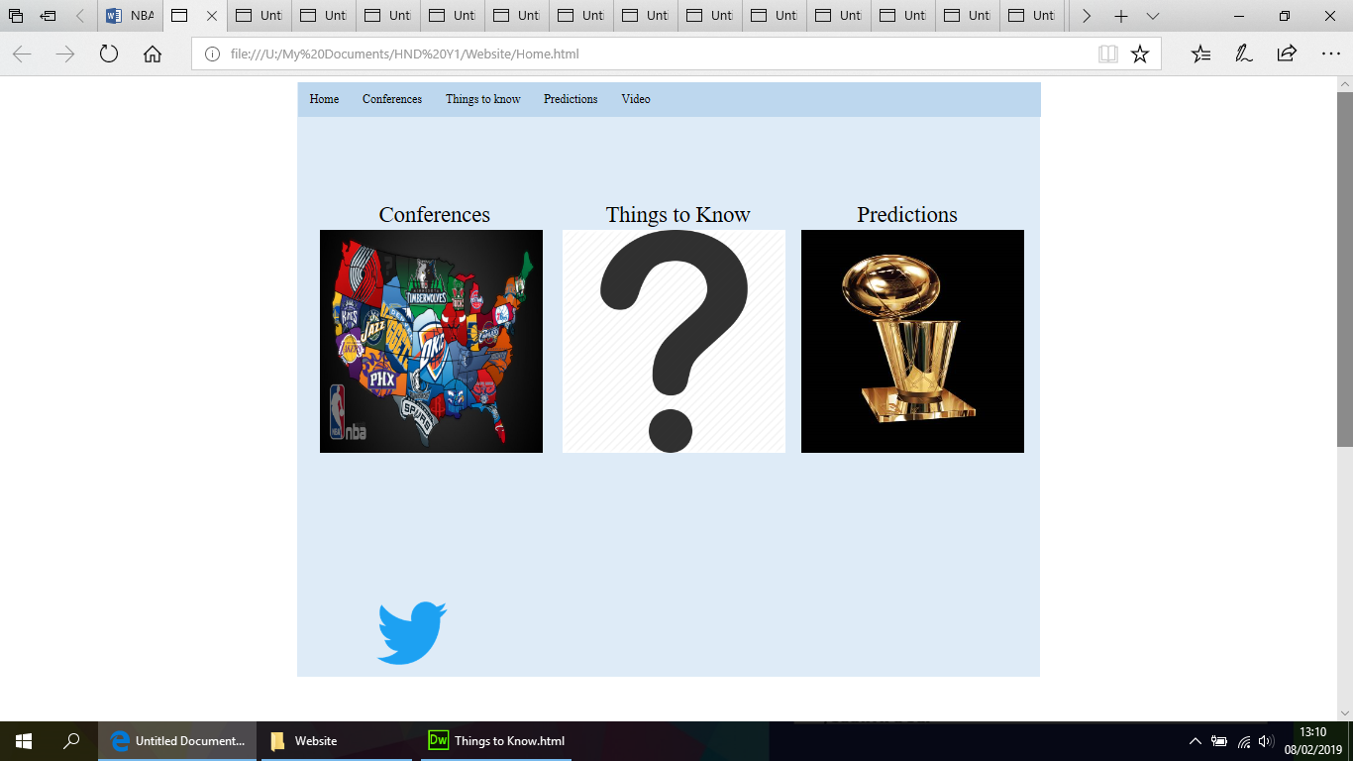
Conference Page

East Teams Page
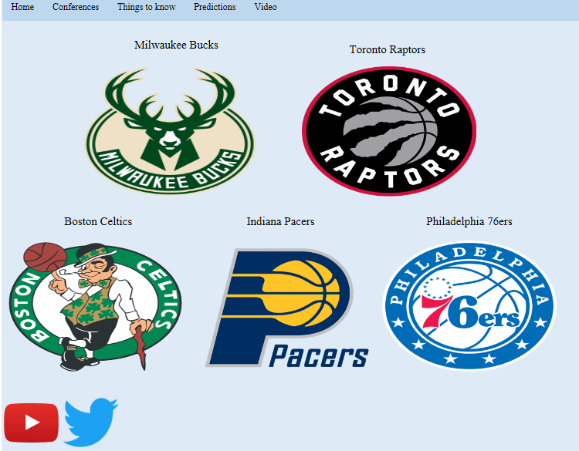
West Teams Page
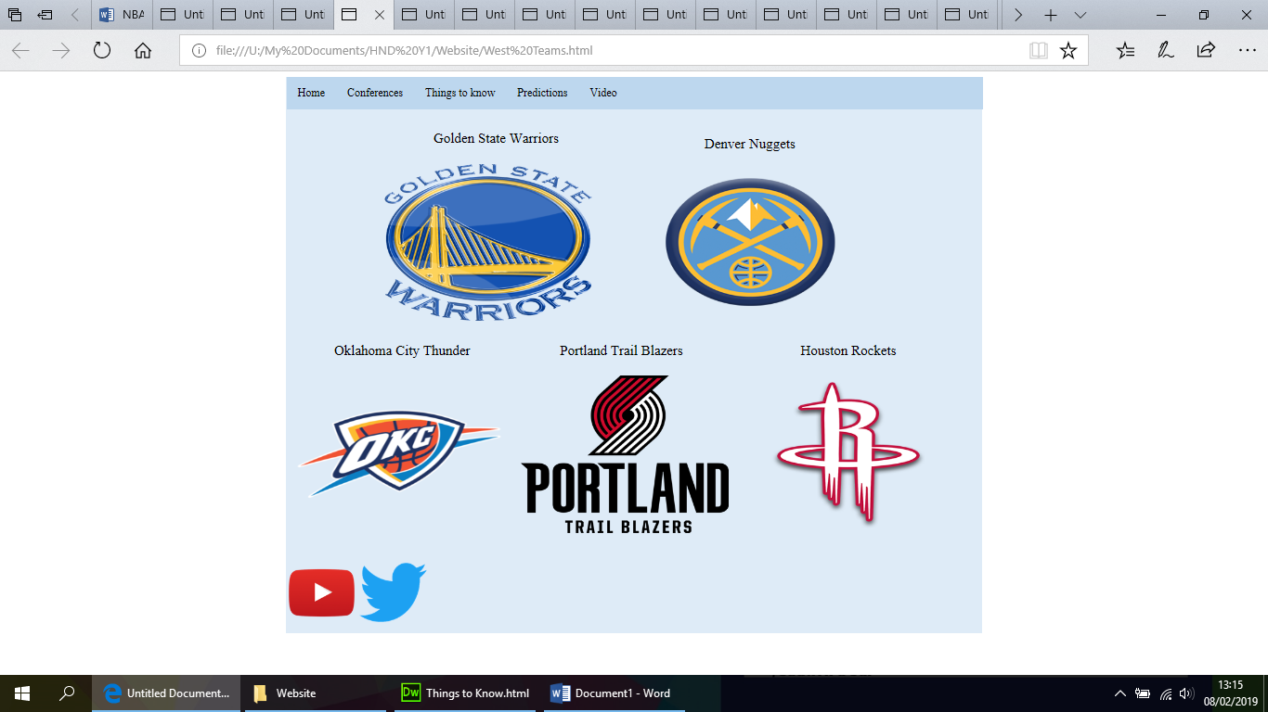
76ers Page
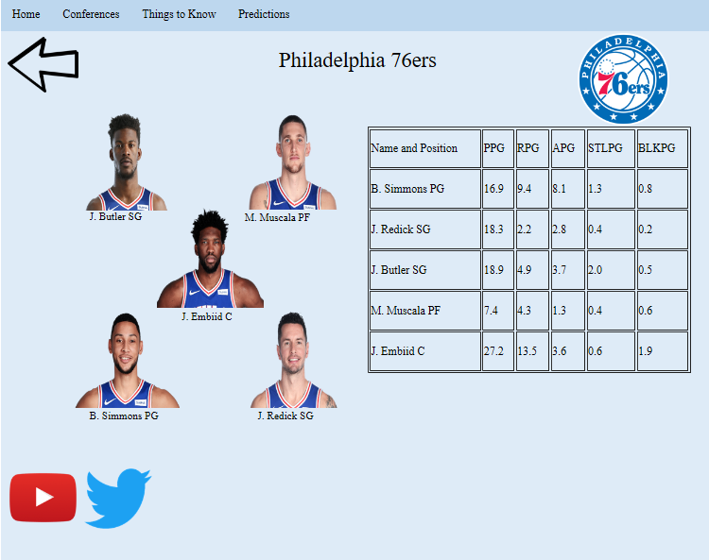
Bucks Page
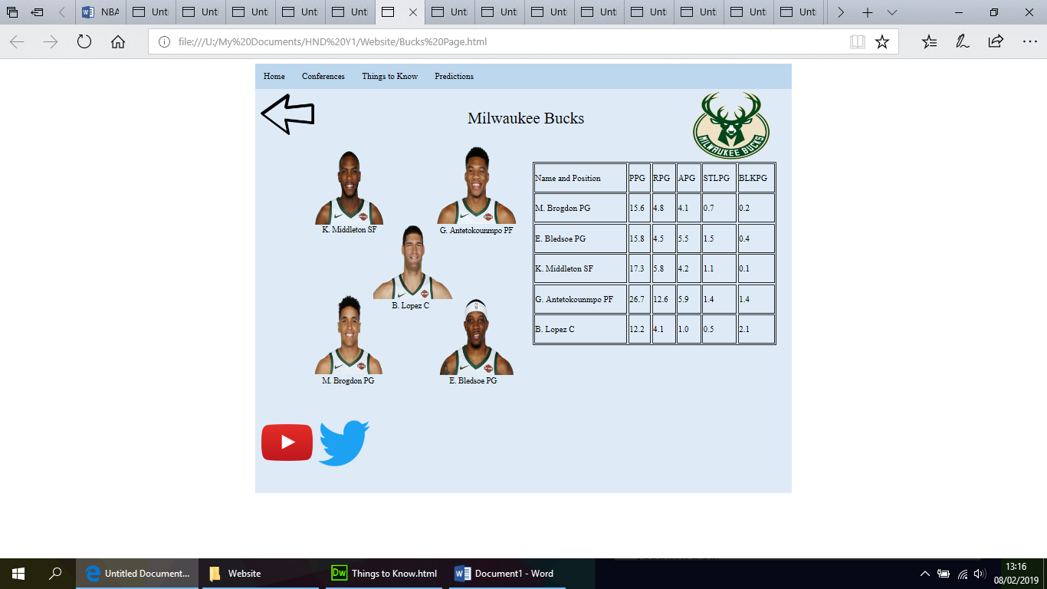
Celtics Page
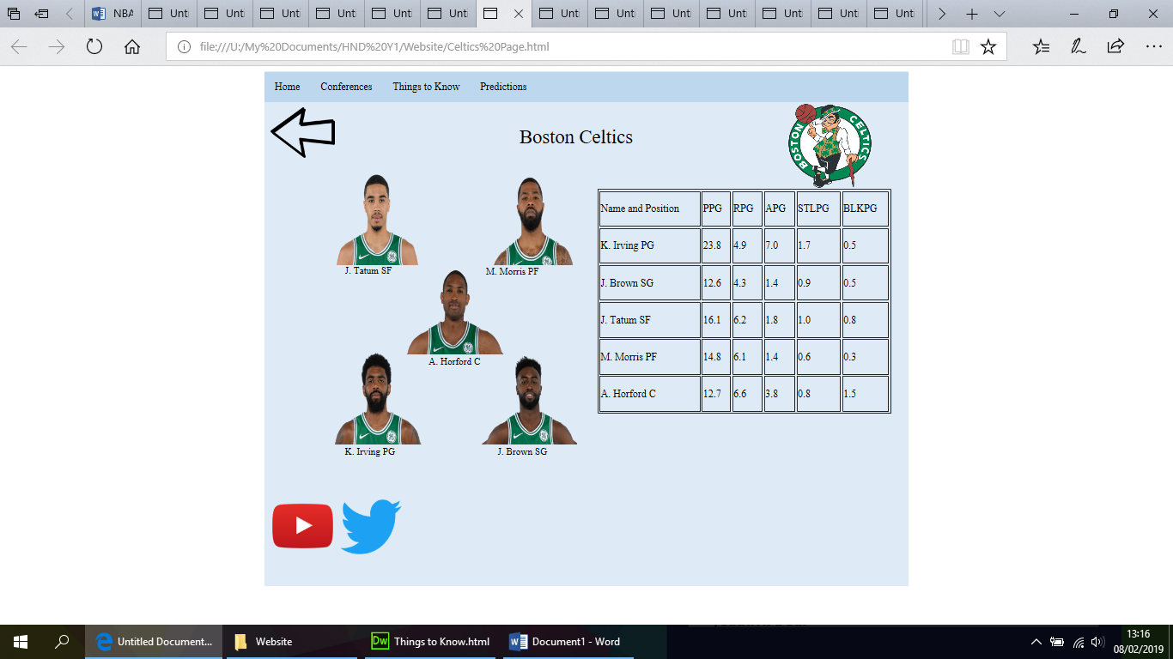
Pacers Page
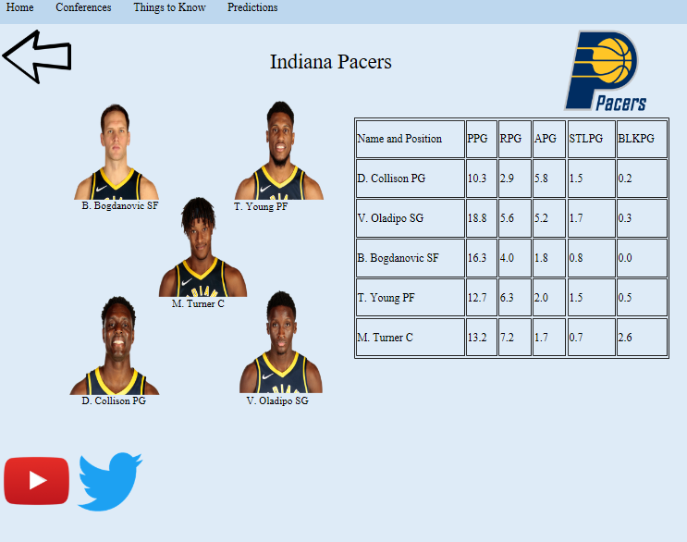
Raptors Page
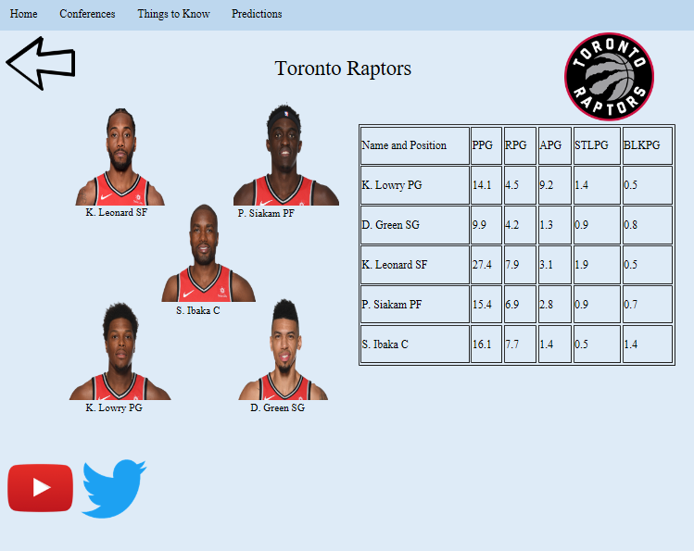
Blazers Page
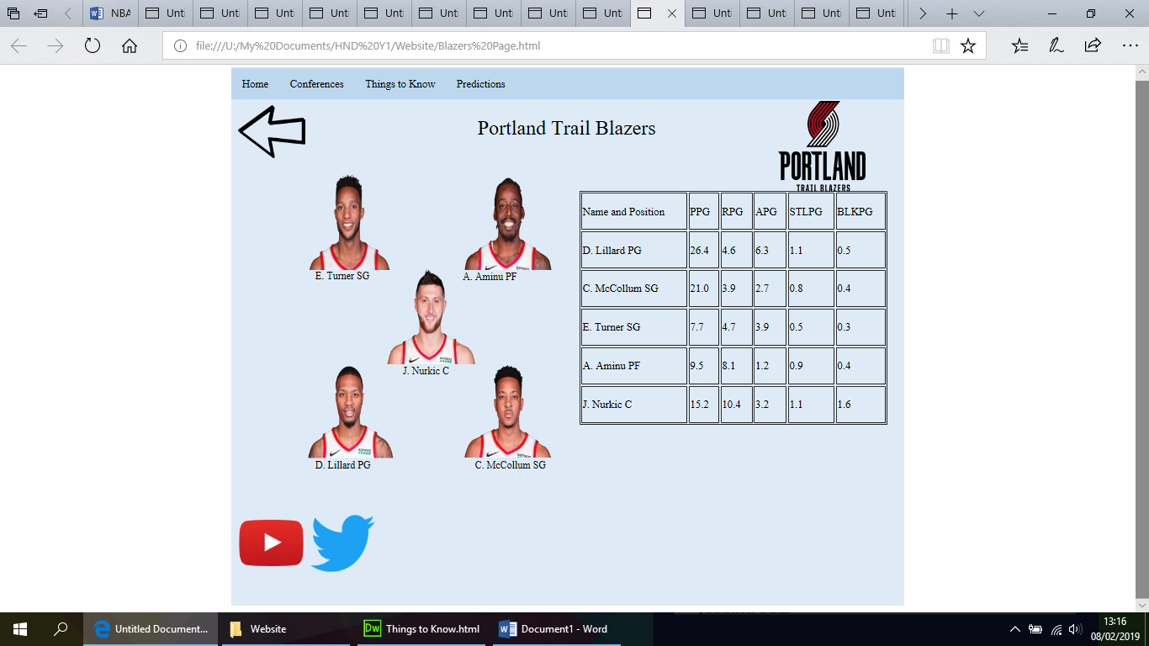
Nuggets Page
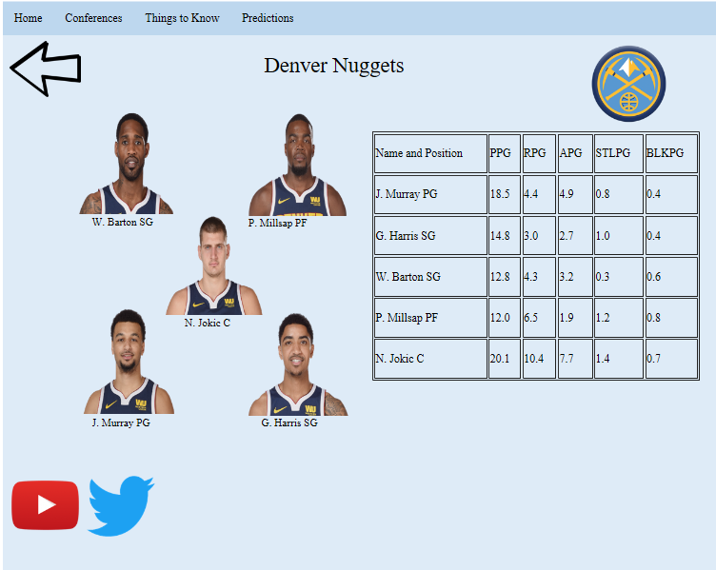
Rockets Page
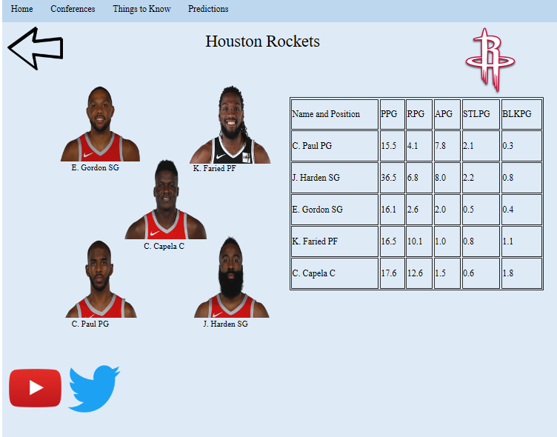
Thunder Page
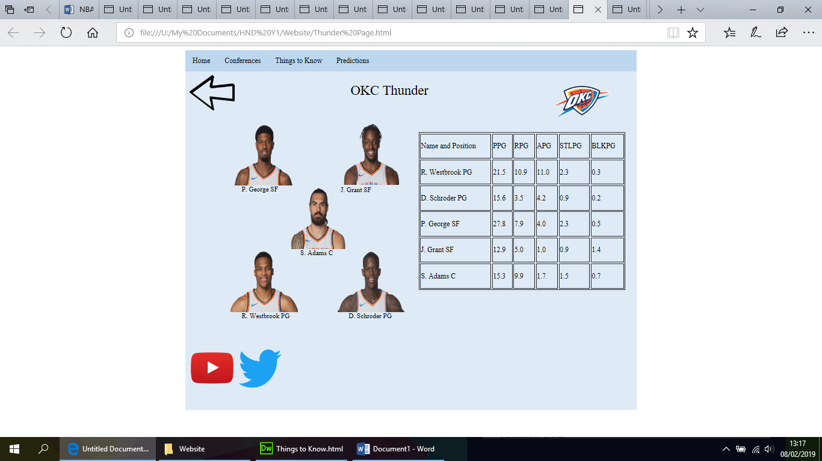
Warriors Page
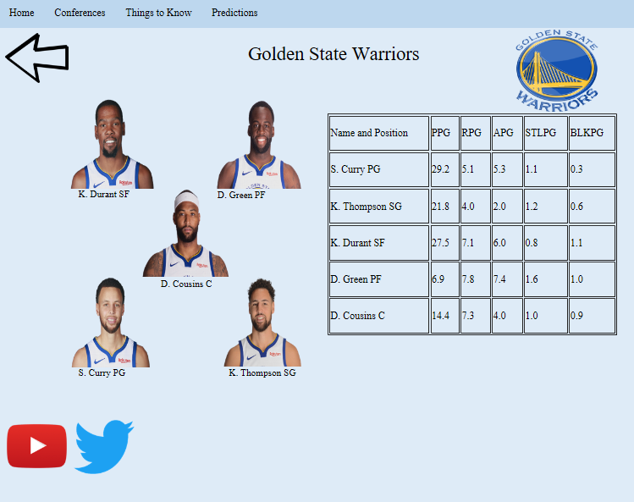
Predictions Page
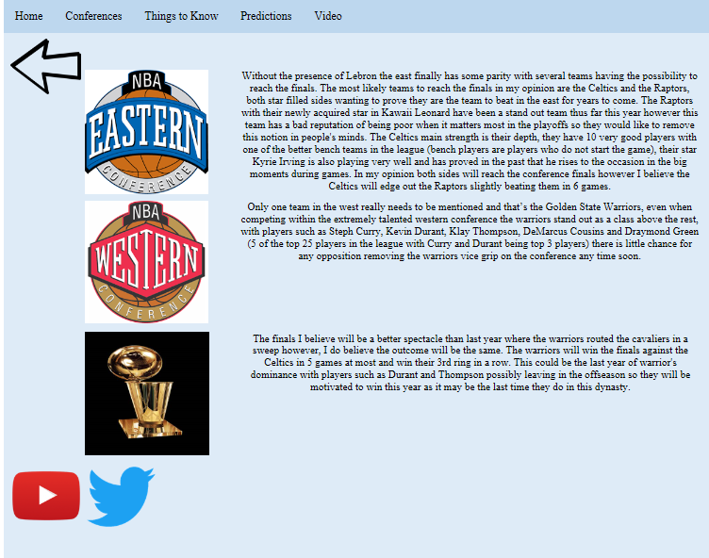
Things to know page
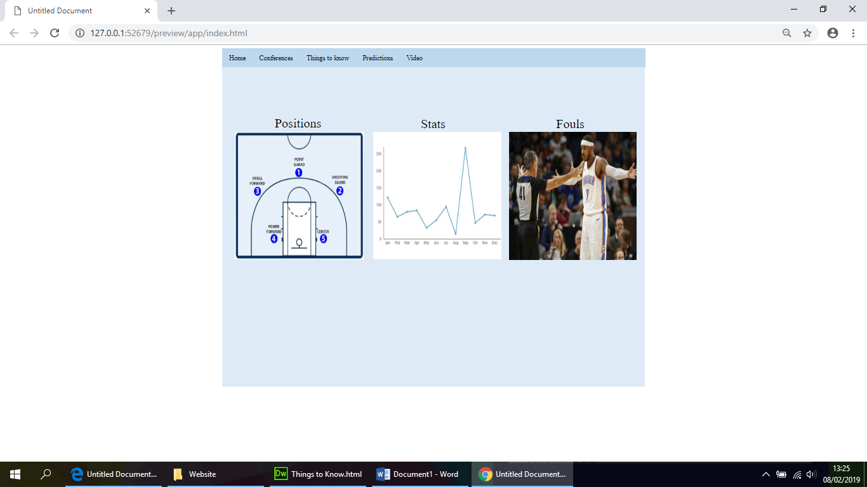
Positions Page
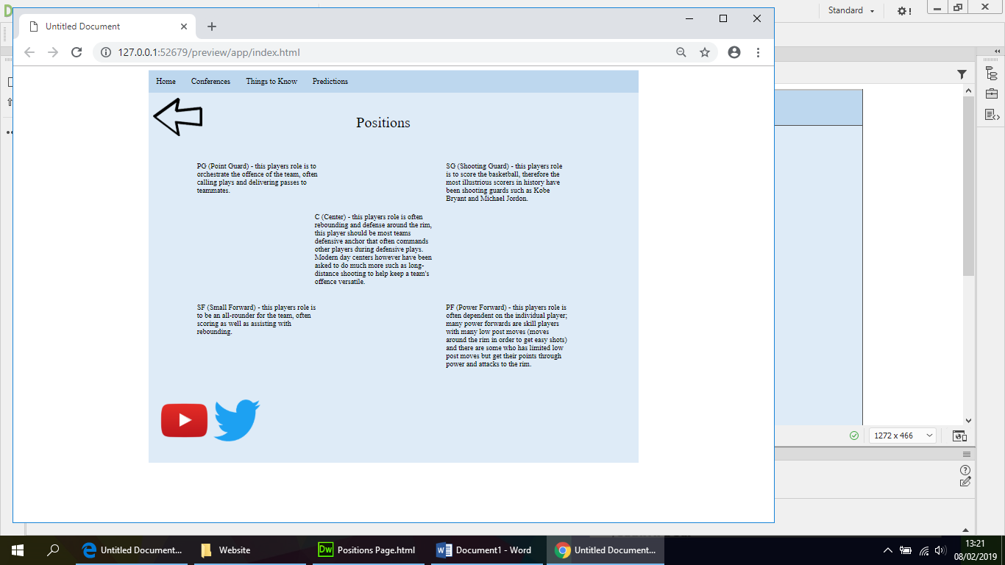
Fouls Page
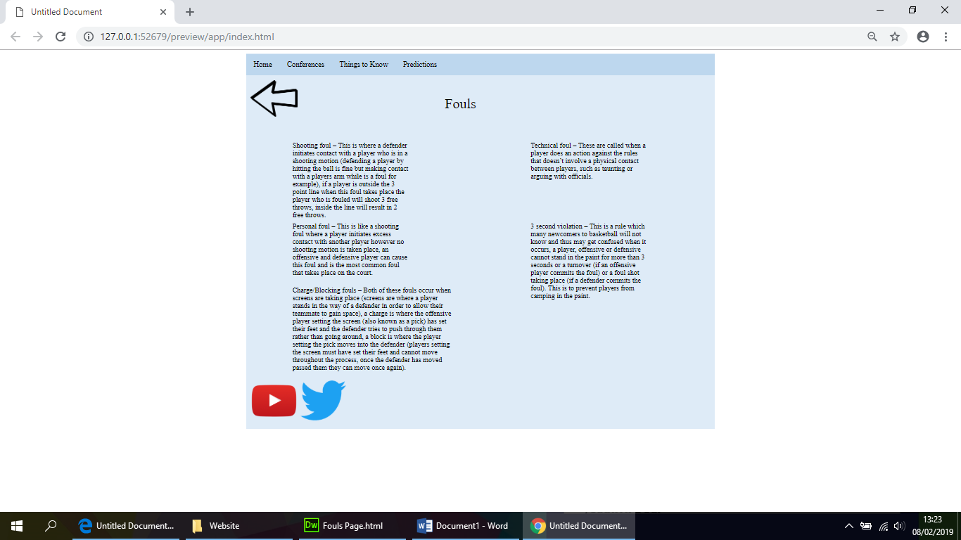
Stats Page
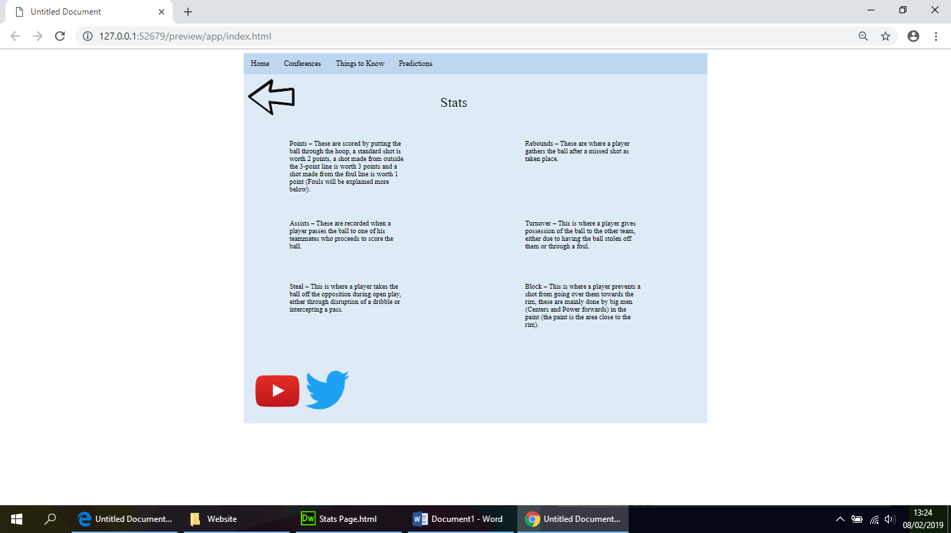

Validation
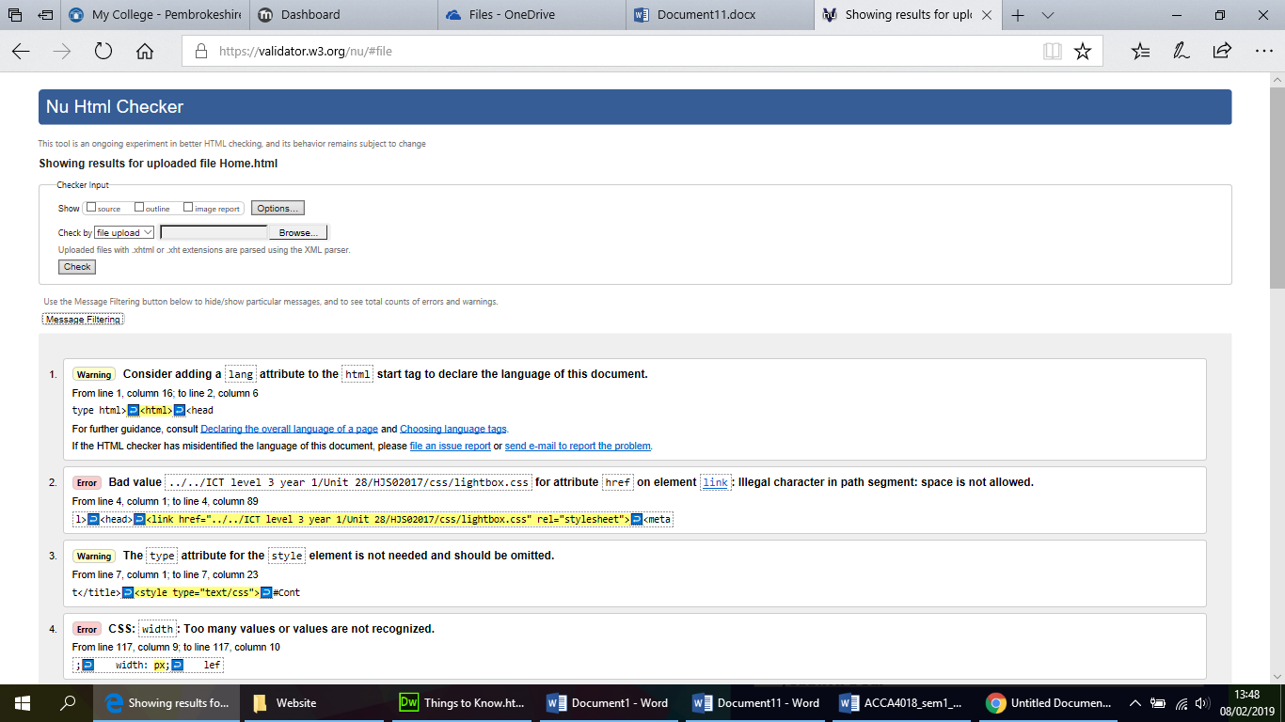
A few errors and warnings were present on the page which can be fixed in future updates to the website.
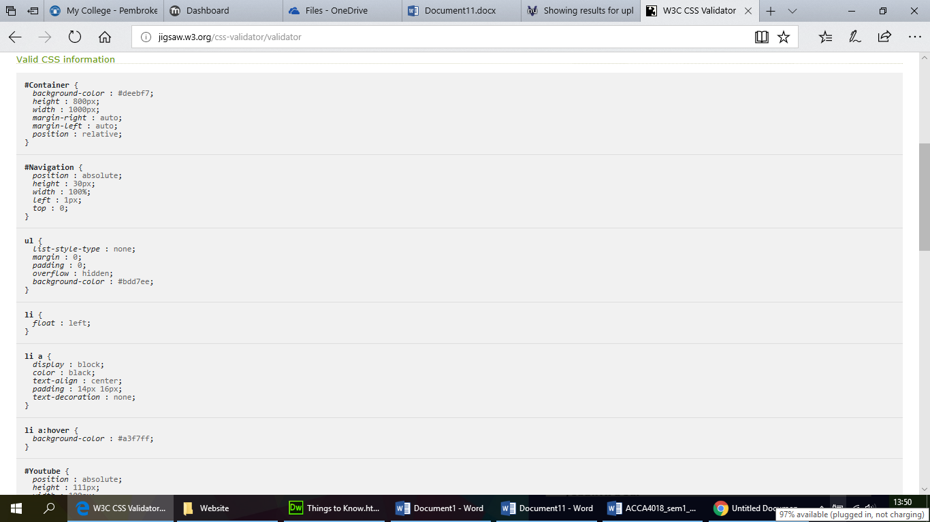
It appears that the CSS information is valid on the website.

Evaluation
Features:
Navigation bar
This is primarily how the viewer is going to get around the website, the navigation bar is present on all of the pages allowing the viewer to always reach their desired location (the navigation also helps prevent the viewer from getting lost around the website as links to the main pages such as the home page are present, this also prevents any dead ends from being present within the website).
Photo Gallery
A photo gallery using lightbox is also implemented within the site which allows the user to get a larger version of the image they clicked on as well as other images similar to the subject of the originally clicked image, for example if the user has clicked on an image of the Boston Celtics logo a gallery will open up containing more images related to the Boston Celtics such as players.
Information/Content
All the information present on the website has come from my personal experience/knowledge of the sport and league. I did however take the precaution of checking some of the details in order to make sure that it was all correct (references to sites used for this verification are displayed below). The website contains information such as the basics of basketball that a new fan of the sport will want to know and understand such as all positions of the players and an explanation of each role, a list of all of the most common fouls that take place during a game as well as an explanation of what all the stats mean such as rebounds and assists. There is also information related to the NBA specifically such as an explanation of both conferences as well as details on the top 5 teams of each conference (stats for the starting 5 players of each of these teams is also present for viewers to see which players are more productive than others, pictures of these players are also included to help the viewer identify the players if they were to watch a game). There is also a predictions section in the website where I display my person opinion of how I believe the NBA season will conclude this year, teams I specified to win each conference and the title are described in this area.
Video
A video was included in the website displaying highlights of the NBA, this will allow the user to witness the highs of the NBA rather than just reading text, seeing stats and viewing images.

Accessibility

The screenshot above displays the installation of this software.
In order to make the website more accessible to viewers who may have disabilities such as difficulty with sight i have taken the precaution of using the software JAWS and FUSION which effectively is a screen reader and a magnifier that can be used to view the pages of the website effectively or have the reader say what the details on each page are. The purpose of this is to allow all viewers to use and enjoy the website without their disability being an obstacle in this matter.
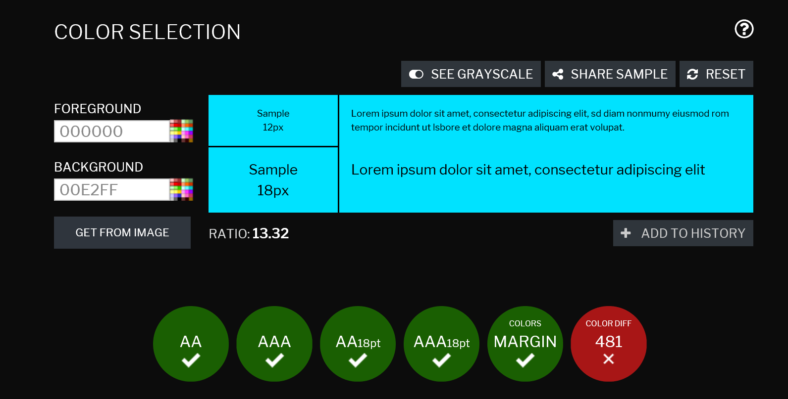
This colour contract checker shows that all of my colour choices are correct apart from for people who suffer from certain colourblindness, if they do have this disability then both colours will appear very similar resulting in difficulty reading, with this discovery a change in colours will have to be made in future projects.
Language
This website is only available in English as I am an English speaker and most NBA fans will understand the English language so I believed this language would be the best choice, translations to other languages can be made in the future if necessary.
Future improvements
- I believe in future projects a more aesthetically pleasing website can be produced in order to engage the viewer.
- Details on all the NBA teams could have been included however I decided to stay with the top 5 of each conference in order to limit the size of the website.
- A larger variety of colours could have been used for different pages to prevent using the same type repeatedly which can be repetitive.
- Contact details could have been included in order to allow viewers to contact me with any questions or possible additions/adjustments that can be made to the website.

References
https://www.basketball-reference.com/ - used to gain access to stats of players.
http://www.espn.co.uk/nba/team/stats/_/name/ - used to determine who is starting for each time as well as pictures of these players.
https://www.skysports.com/nba?gr=www - used to keep up to date with news on NBA in order to form predictions and analysis

