Virtualised NEtworks
Network Operating systems and services
Jacob Nicklin (2305180)
UWTSD – Networks and Cybersecurity

Contents
2 Task 1 2
2.1 Research on Hypervisors 2
2.1.1 Type 1 Hypervisor 2
2.1.2 Type 2 Hypervisor 2
2.2 Research on IP Addressing 2
2.2.1 Role of IP Addressing and how data moves 2
2.2.2 Routers and Switches 3
3 Research on Routing 4
3.1 What are Routing Protocols? 4
4 Research on Network Services 5
4.1 VPNs 5
4.2 DHCP 5
4.3 Active Directory Domain Services 5
4.4 Certificate Authorities 5
5 Task 2 6
5.1 Screenshots 6
5.1.1 Windows 6
5.1.2 Linux 8
5.1.3 Failed Connections 11
5.1.4 Settings 12
5.1.5 Addressing Table 12
6 Bibliography 13

Task 1

Research on Hypervisors

Type 1 Hypervisor
A type 1 hypervisor is a hypervisor which runs directly on a host’s or user’s hardware to control and monitor the virtual machine. Also known as “bare metal” hypervisors, these hypervisors offer greater performance to the machines they are working on [1]. This is due to the Type 1 hypervisor not needing to negotiate with operating system resources or working against the flow of the operating system layer [2]. Type 1 hypervisors can have fast scalability for larger enterprises who can afford to buy physical servers and hardware to support expansion. They are also more secure than a type 2 hypervisor due to there being no present host operating system which reduces the risk of instability and vulnerability greatly. [2] However, in order to configure and manage a type 1 hypervisor, it requires administrator knowledge. [2]

Type 2 Hypervisor
A type 2 hypervisor runs within a traditional operating system such as Windows, Linux or MacOS. A hosted hypervisor adds a software layer atop the host’s existing OS. Type 2 hypervisors are a much more preferred option when a user does not have the resources or ability to fund a type 1 hypervisor, it also allows a user’s machine to run multiple operating systems at the same time, slowing them communicate and work together within a host’s device. [2] Some well-known Type 2 Hypervisors are “Hyper-V” and “VirtualBox” which make setting up a Type 2 Hypervisor extremely simple and allow a user to implement ISO images so they can run a OS to suit their needs such as Window Server or Debian Linux. [3] Type 2 hypervisors are also much more suitable needs to basic user knowledge, not requiring administrator knowledge to work or manage. [2]

Research on IP Addressing

Data movement and role of IP Addressings
For data to be transferred from one computer to another, it needs to travel through series of networks that is made up of networks, creating the internet. Data will firstly be broken into packets by the sending machine. [4] These packets all have a packet “header” at the front, which helps the receiving device identify what to do with each packet that passes into the router. [5]
TCP/IP protocols are a communication framework, split into four layers which dictate communication. These four layers all have different duties in the movement of data.
The network access layer handles the physical and technical infrastructure, changing code into transmissible data, which allows devices to communicate when sending and receiving information.
The internet or network layer, controls the routing of internet traffic. After a packet has been broken down into bits, it is the network layer’s responsibility to reassemble the packet at the destination.
The transport layer ensures that anything sent between communicating devices is properly received, it performs acknowledgments once it has divided data into a packet, checking it has received the packets properly and also checking a receiving machine has received the packets. [6]
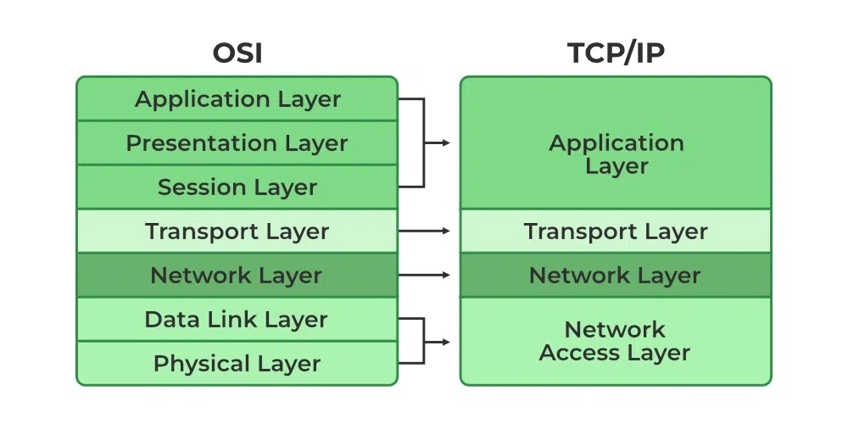
The application layer is the layer a user interacts with. This could be an email service such as Outlook or Google mail. This allows a user to interact in creating an email, which is sent, broken down into the packets, and then received. [6]
Figure 1: How the different layers are structured and how the OSI model fits into the TCP/IP layers. [15]
IP addresses give a unique identifying number to every single device that connects to the internet, this allows networks to communicate to each other through both the internet and Local Area Network (LAN). By having a unique identifying number, it helps a network determine where a packet needs to be received. Without any IP addresses, data would not be able to pass through a network. [7] IP addresses are split into two types; IPv4 addresses; Ipv6 addresses. IPv4 addresses are the most commonly used addresses, having a limited amount of IP addresses to assign. IPv6 addresses are a newer form of addressing, with a near infinite number of addresses that can be assigned.

Routers and Switches
Routers and switches are used for directing data across the internet. Routers connect different networks by forwarding data packets using IP addresses, working as centre for devices to connect. Switches operate within a network, directing data to specific devices using MAC addresses. Together, they optimise data flow, prevent congestion, and maintain seamless connectivity across the internet.

Research on Routing

What are Routing Protocols?
Routing protocols specify how routers pass packets along a network; routers do this millions of times a second. The router uses routing protocols to find the best possible path for data to reach its destination host.
There are two types of routing. Static routing, which is where a network administrator will use static tables to manually configure a router. This way of configuring means that a network design or parameters are expected to stay at a constant rate, with an expected amount of traffic. This can lead to significant issues such as network congestion and less flexibility with a network.
Dynamic routing lets routers configure dynamic routing tables; the routers will look for the fastest path for a packet from the host machine to the receiving machine. The dynamic rules are kept constantly up to date, allowing a router to manage network traffic and conditions. [8]
Depending on the size of an organisation, different routing protocols can be used. Larger organisations such as enterprises or cloud providers will certainly use dynamic routing protocols such as BGP, a Path-Vector protocol, is crucial for ISPs, managing global routing but requiring careful configuration. [9]
Smaller enterprises are better using static routing protocols, as they are easier to setup and easier to manage. BGP is a desirable choice to ensure efficiency, but a network could also use OSPF, which is similar to BGP but uses mathematical calculations to determine the quickest path, rather than looking at all the paths.
Efficient routing protocols can contribute to extremely secure systems. Google’s cloud systems use BGP dynamic routing along with web filtering means google is able to handle nearly all of the internet’s traffic passing through its search system, along with defending against constant Ddos attacks, with the largest being a Ddos attack of 398 million requests per second. [10]

Routing protocols vary based on network size and requirements. Distance Vector protocols such as RIP or RIPv2 use hop counts but have slow convergence, making them suitable for small networks (albeit outdated).
Link-State protocols such as OSPF or IS-IS, build a network map, offering fast convergence and efficiency for large enterprises. [9]
Hybrid protocols, such as EIGRP, combine both. This improves speed and scalability but can be different for both small and larger enterprises. [8]

Research on Network Services

VPNs
VPNs or Virtual Private Networks, provide a safe way to transmit data across unsecured networks, creating an encrypted tunnel between two endpoints. The tunnelling mechanism protects data from eavesdropping, interception and protection from unauthorised users. VPNs also log user activity, meaning enterprises can keep an eye on any unauthorised intrusions or suspicious activity that might have occurred in the present or past. A good practice is to also use strong encryption to ensure any intruders struggle to break into a VPN tunnel and keep the software up to date. [11]

DHCP
Dynamic Host Configuration Protocol are client/server protocols that automatically provide a device with an IP address and automatically configure other network related configurations such as Default Gateways and Netmasks. [12]
Due to every device needing a unique IP address, a DHCP server can manages a pool of useable IP addresses. This means that there is less time needed for network configuration from a network administrator on IP addresses by letting the DHCP configure the TCP/IP networking.

Active Directory Domain Services
ADDS provides a method for storing directory data and makes the data accessible to certain users, for instance, administrators who need to modify user account information. Security is integrated with Active Directory through authentication, whether that be through logon or multi-factor and access control to directories. With a single network logon, administrators can manage directory data and organization throughout their network and access their resources. ADDS also does not assign permissions to each individual user, rather putting them into groups and then giving them permissions, which makes it much more efficient to sort for network administrators. [13]

Certificate Authorities
Certificate Authorities are authentication measures handed out by certain organisations such as banks, government organisations. Certificate authorities make use of cryptographic keys that can encrypt data to prevent entry to certain data files or whole websites. These certificates provide validation and verification to each user who enters a website.
There are only a handful of authorities that handle the granting of certificates, such as GoDaddy [14], which grants SSL certificates, which create secure encryption keys. Without the SSL certificate, web browsers will warn a user with a “not secure” warning before they enter a website, discouraging net traffic away from an enterprise’s website. The certificates also prevent attackers from creating false versions of the website. [14]

Task 2

Screenshots

Windows
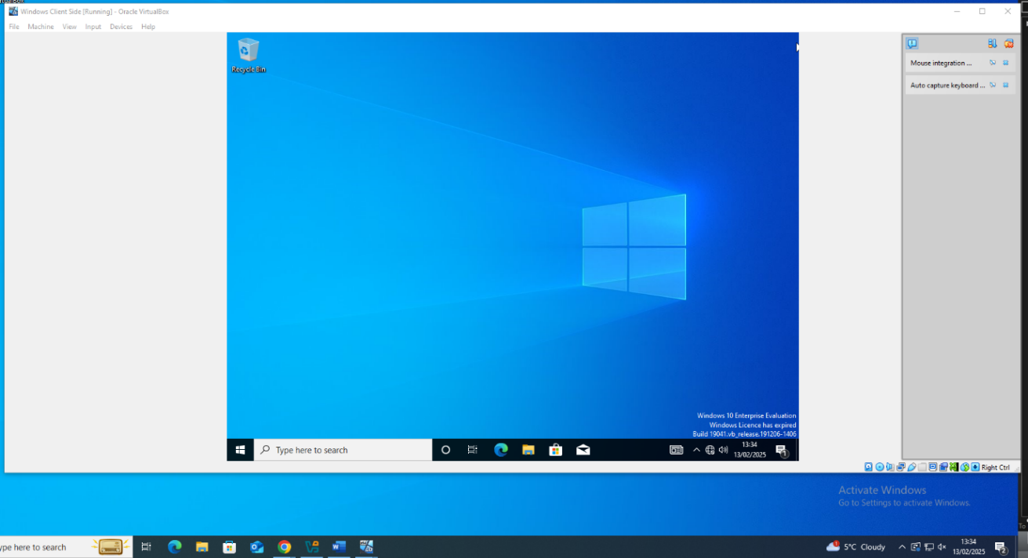
The first step was to setup the Windows Server and Client through VirtualBox and its network configurations. Internal networks (with promiscuous mode enabled) on all machines were essential before moving onto the rest of Task 2. In the below screenshot the Windows Client was the first to be installed and run smoothly, along with ensuring the date and time were correctly set as the same as the host machine.
Figure 2: Client Side
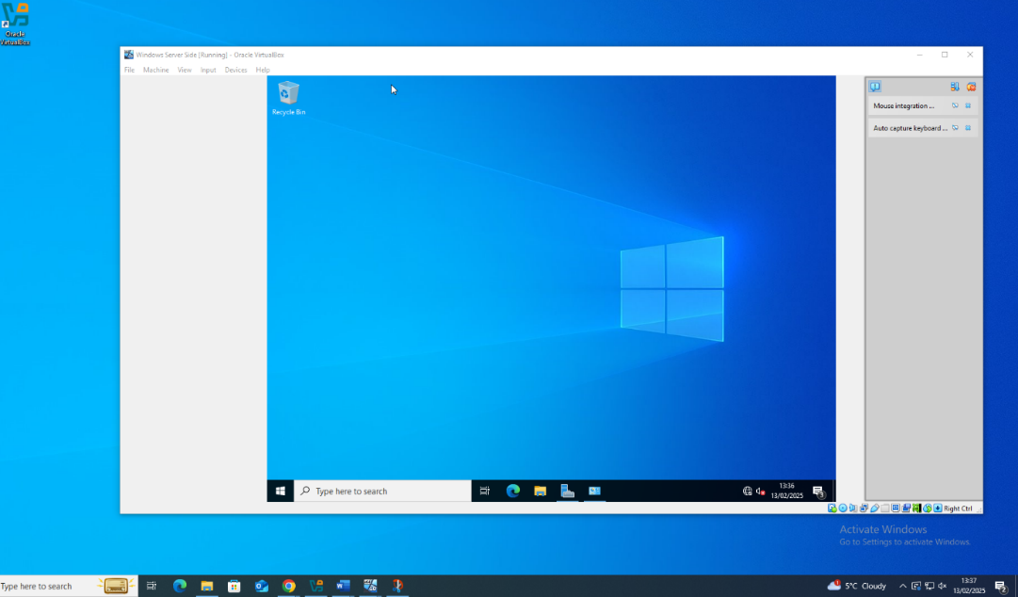
Secondly was the Server side, although not opened, the server icon is visible within the taskbar, indicating the difference of Operating Systems between the client and the server for the windows V.Ms.
Figure 3: Server Side

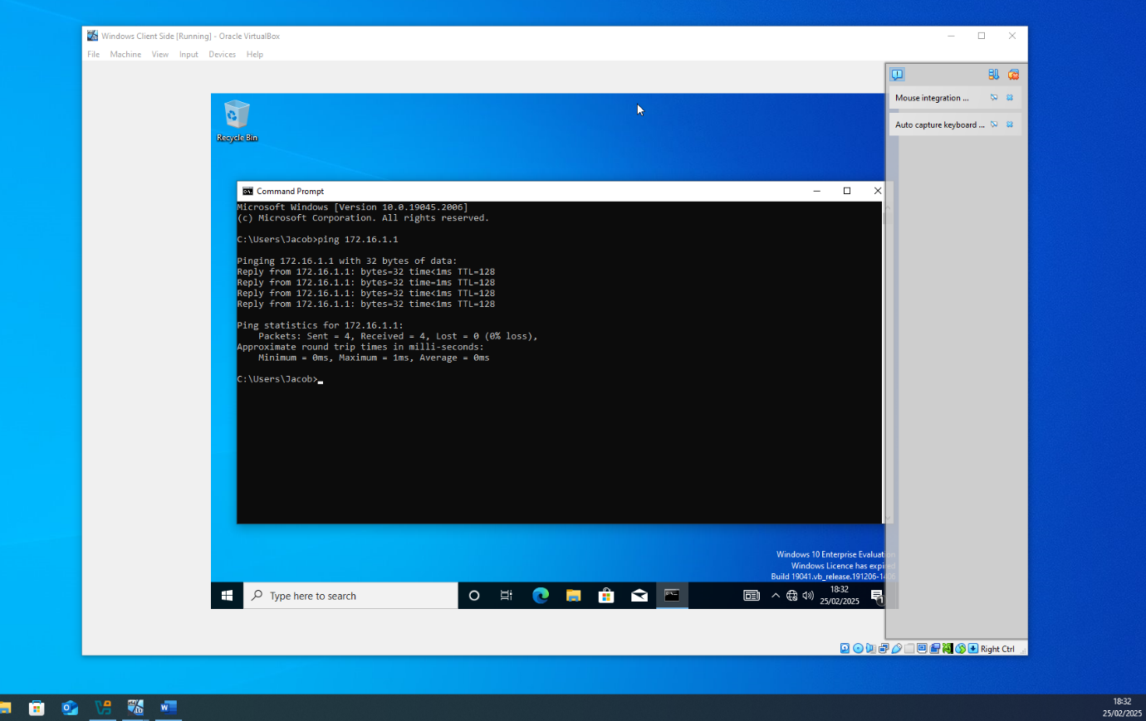
The next step was to assign IP addresses to the two virtual machines. Following the IP addressing table (see figure 14), IP addresses were assigned to the Windows client and Server, along with /24 subnet masks to ensure that if multiple users were to connect to the server, there were sufficient available IP addresses. The first test was a client ping through the command prompt, which successfully pinged (figure 4).
Figure 4:Windows Client to Server ping.
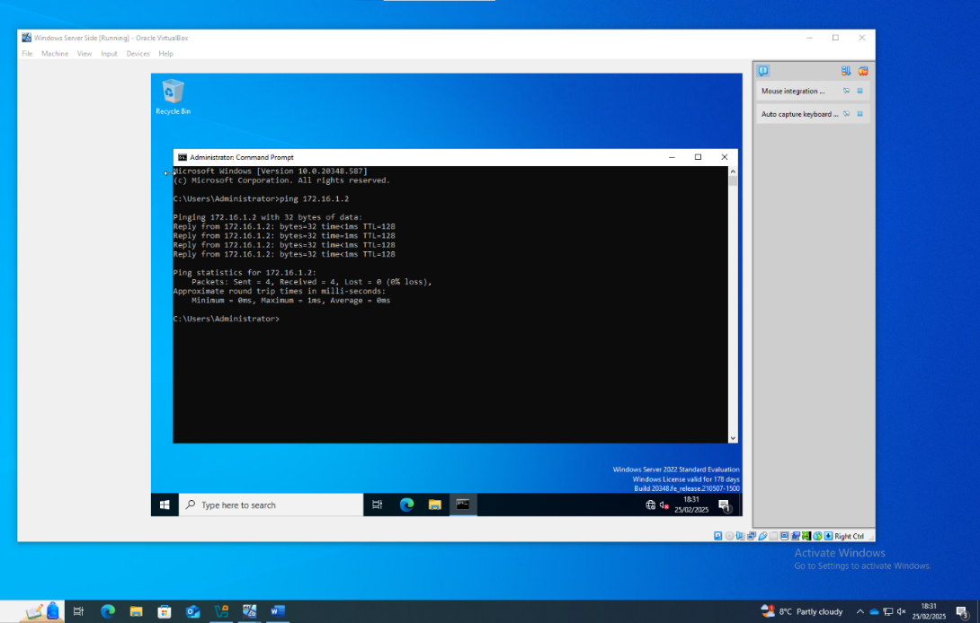
Secondly, the connection was tested between the Server to the Client to ensure the connection ran both ways. A successful ping on both sides indicated that the network (172.16.1.1/24) was now fully functional. (figure 5)
Figure 5: Windows Server to Client ping.

Linux
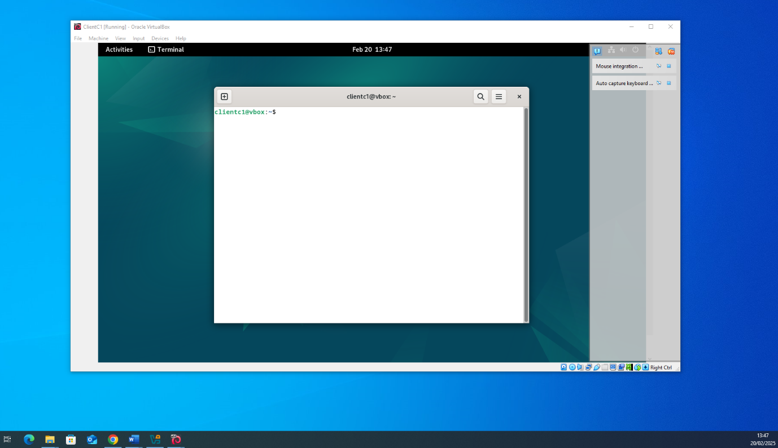
After the successful network connection of Windows, the next step was to move to the Linux Debian Distro virtual machines. Firstly, the Debian 12.5.0 client was setup, using a graphical interface.
Figure 6: Linux Debian Client
Next, the Linux server was setup, using the same installation as the client, but turning off some features in the installation and turning on SSH server to give a much more basic command interface. The date and time were both automatically synchronised to the host machine as well.
Figure 7: Linux Debian SSH server with Date and Time
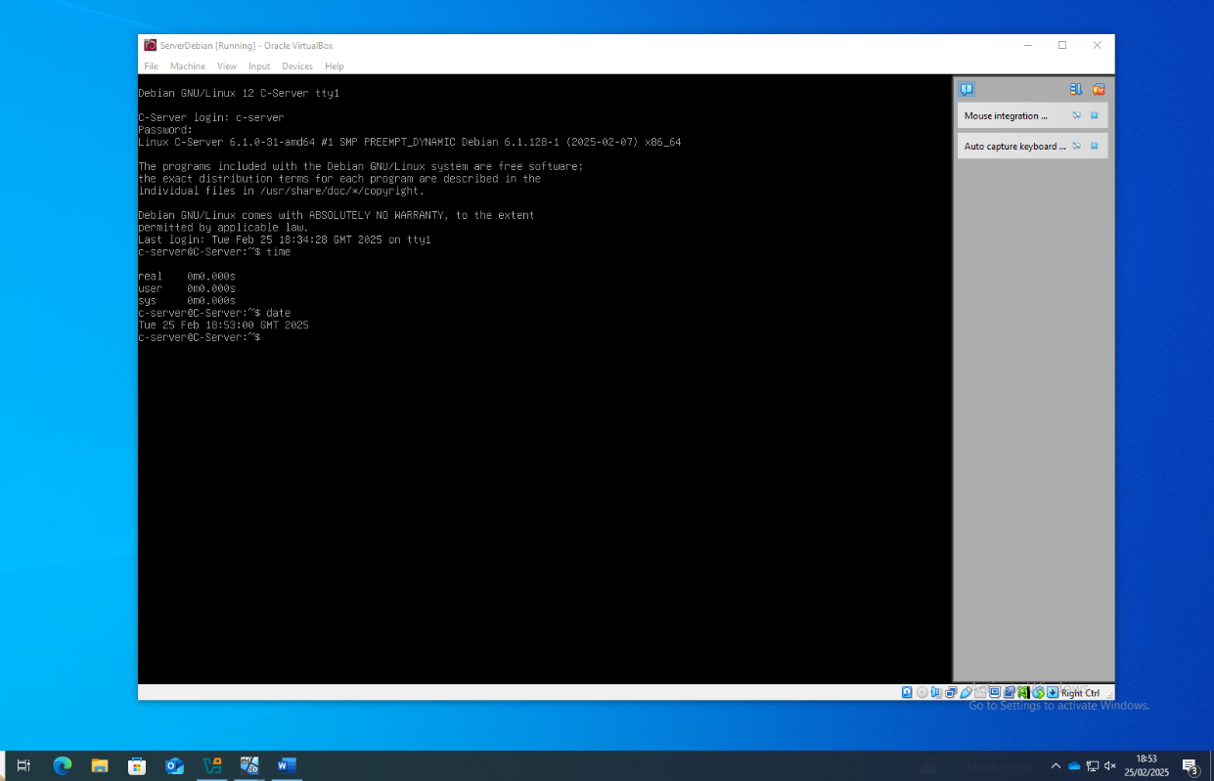

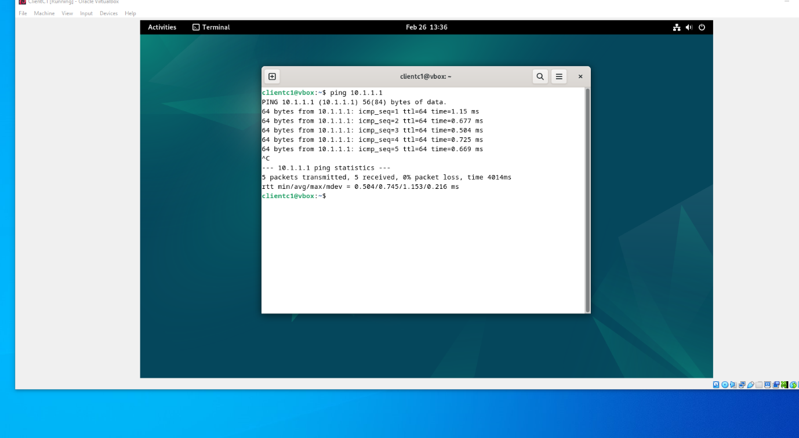
As with the windows VMs, both the Linux client and the SSH server were assigned IPs, although the Linux Operating systems provided a much more challenging approach to assigning the IPs, having to be directly commanded into the VMs. Once the IP addresses and appropriate subnet mask of /24 was set, a ping test was performed, resulting in a successful connection from the Client to the Server.
Figure 8: Linux Client pinging the Linux SSH server.
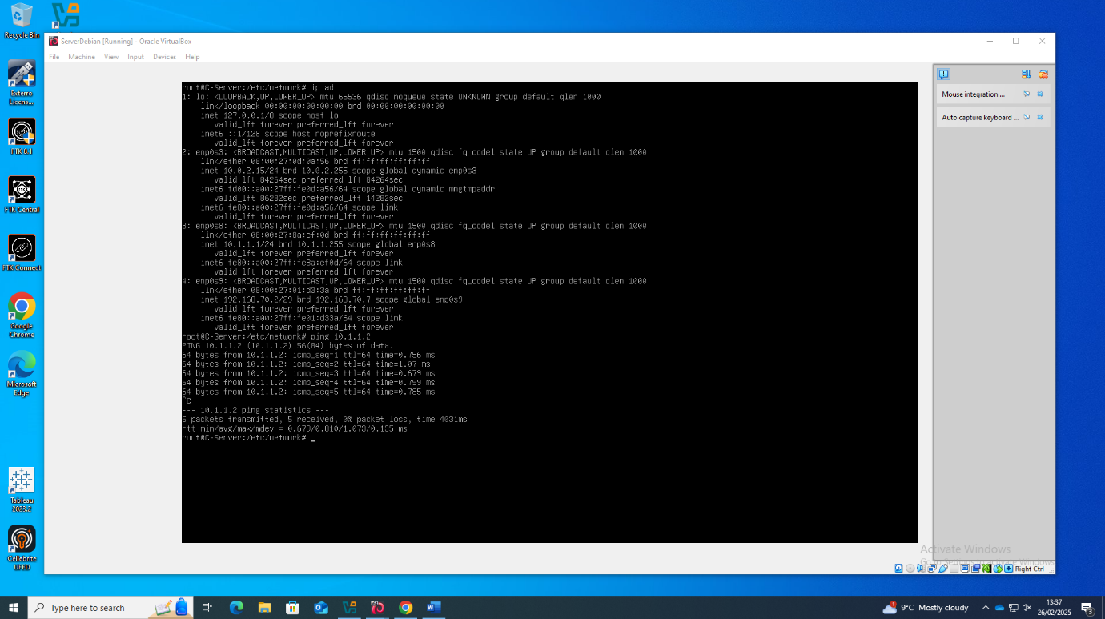
Next, the connection between the Debian SSH Server and Client were tested. Another successful ping connection means the network (10.1.1.1/24) was in an up state, able to connect both ways and fully functional.
Figure 9: Linux SSH Server pinging the Linux client.

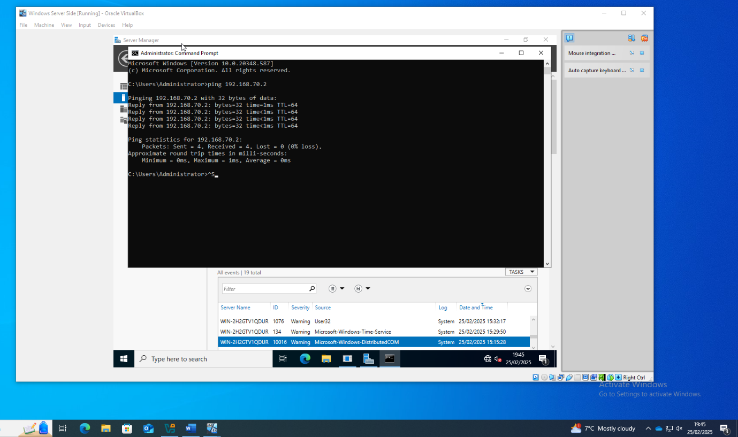
After the connection of both servers to their respective clients, the servers needed to connect to each other on their own network. This network needed to be a /30 subnet mask to ensure no other users can connect other than the two servers, along with taking up the Adapter 3 port. The screenshot below is the Windows Server successfully pinging the Linux SSH Server.
Figure 10: Windows Server pinging the Linux Server
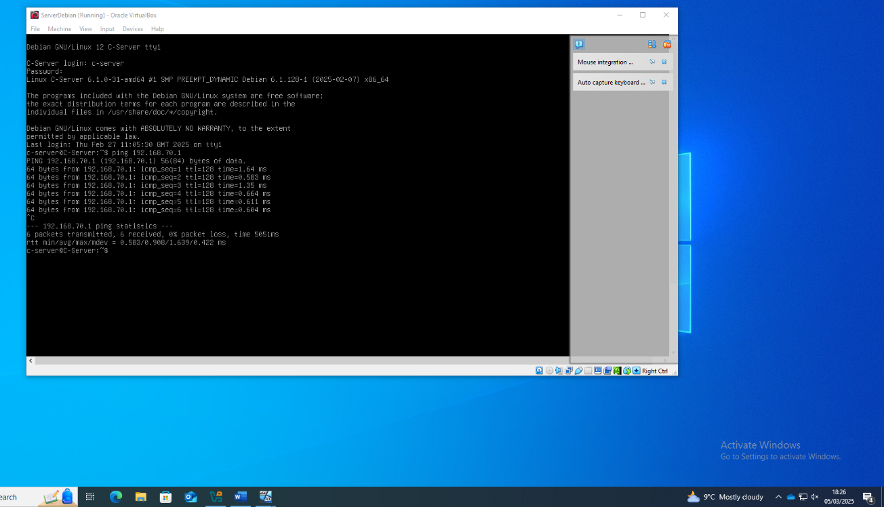
Once the Windows Server was connected to the Linux Server, the SSH Server needed to ping back to the Windows Server. Through the nano editor, the external network in the SSH was assigned the IP and subnet mask it needed to connect through. Another ping test was performed (Figure 11) in which a successful connection was made to the Windows Server, meaning that the 192.168.70.1/30 private network (made to be as secure as possible making it private) was up and running.
Figure 11:Linux Debian SSH Server pinging the Windows Server

Failed Connections
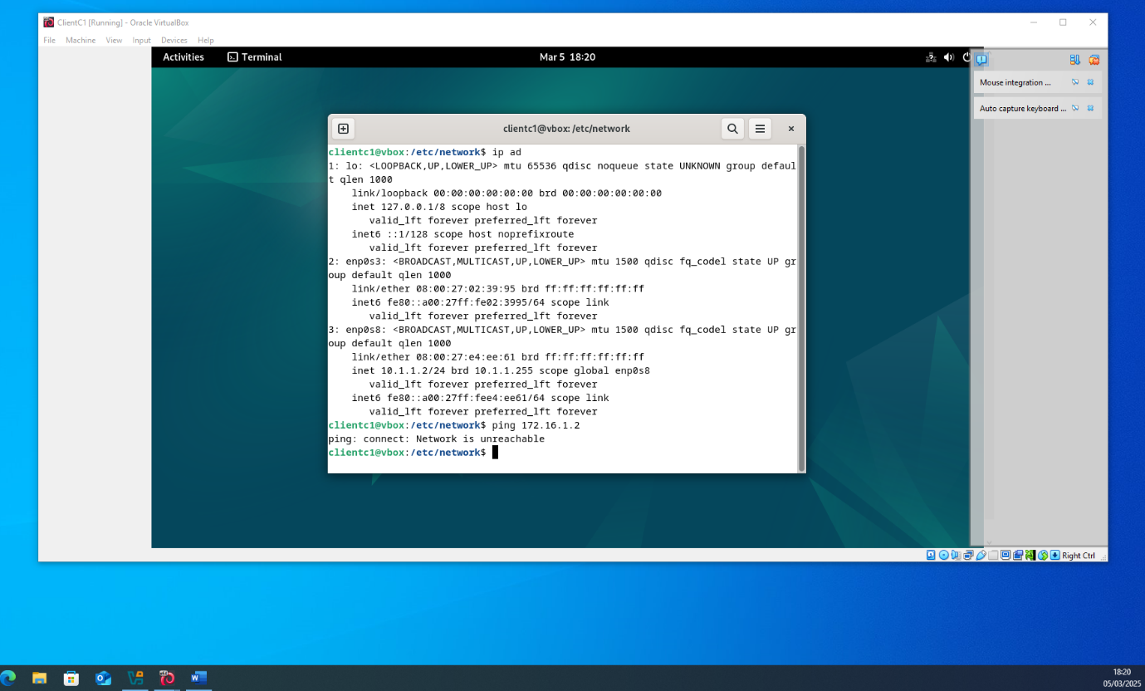
Once both the clients were connected to their servers and the servers were connected to each other, it was logical to test the connection of the Windows Client to the Linux Client. However, unlike the previous successful connections, this was an unsuccessful connection to each other due to the lack of DNS server setup and Firewall setups, along with lack of Domain Controller setup. Firstly, the Linux Client gave the “Network is unreachable” error (Figure 12).
Figure 12: Linux Client fails to ping Windows Client

Settings
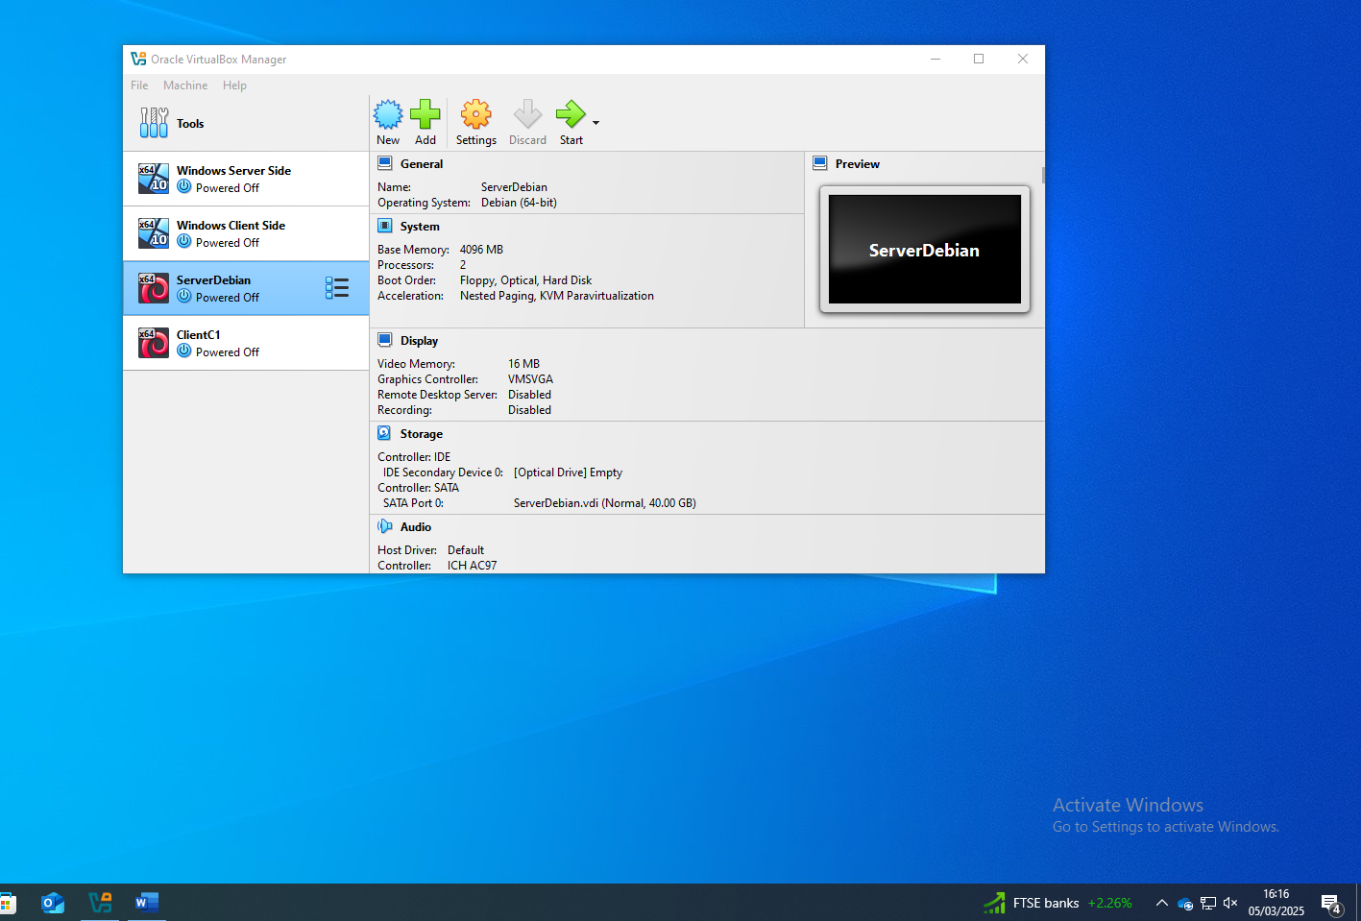
Four Virtual Machines were needed for the entire task, two servers and two clients. The servers were given 4096mb of Ram to make sure operations would run smoothly through them due to them needing to also connect two ways, to a client and to the other server. (Figure 13)
Figure 13: All four Virtual Machine Operating systems used within VirtualBox.

Addressing Table
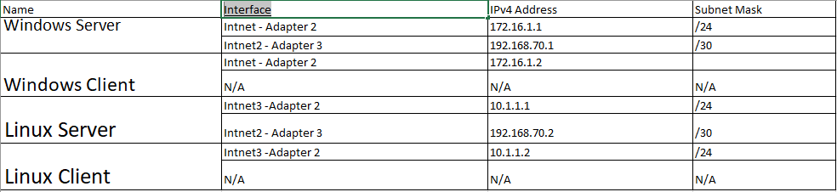
Figure 14 is the Addressing Table used to help structure the network, using a self-designed scheme and relevant subnet masks to accommodate for security within the server-server network or the server-client network.
Figure 14: Network Addressing Table with relevant interface connections, IP addresses and Subnet Masks

Bibliography

[1] | G. A. Z. L. Erick Bauman, A Survey on Hypervisor-Based Monitoring: Approaches, Applications and Evolutions, Dallas: University of Texas, 2015.
[2] | AWS, “What is a Hypervisor,” Amazon Web Services, December 2024. [Online]. Available: aws.amazon.com/what-is/hypervisor/. [Accessed 13 February 2025].
[3] | AceCloudHosting, “Hyper-V vs VirtualBox,” AceCloudHosting, 9 March 2023. [Online]. Available: https://www.acecloudhosting.com/blog/hyper-v-vs-virtualbox/#:~:text=While%20Hyper%2DV%20is%20a,sets%20of%20strengths%20and%20shortcomings.. [Accessed 27 February 2025].
[4] | CloudFlare, “What is the Internet,” 2025. [Online]. Available: https://www.cloudflare.com/learning/network-layer/how-does-the-internet-work/. [Accessed 30 January 2025].
[5] | E. K. E. Hoffman, “FYI on "What is the Internet?",” University of Illinois, May 1993. [Online]. Available: https://www.rfc-editor.org/rfc/rfc1462.html. [Accessed 3 March 2025].
[6] | AVG, “What is TCP/IP,” AVG, 4 June 2021. [Online]. Available: https://www.avg.com/en/signal/what-is-tcp-ip#:~:text=There%20are%20four%20layers%20of,when%20the%20data%20is%20received.. [Accessed 4 March 2025].
[7] | Fortinet, “What is an Ip-Address,” Fortinet, [Online]. Available: https://www.fortinet.com/resources/cyberglossary/what-is-ip-address#:~:text=What%20is%20the%20use%20of,%2Darea%20networks%20(LANs).. [Accessed 4 March 2025].
[8] | AWS, “Routing Protocols,” Amazon, 2024. [Online]. Available: https://aws.amazon.com/what-is/routing/#:~:text=A%20routing%20protocol%20is%20a,protocols%20and%20exterior%20gateway%20protocols.. [Accessed 5 March 2025].
[9] | CloudFlare, “what-is-BGP,” CloudFlare, 2025. [Online]. Available: https://www.cloudflare.com/learning/security/glossary/what-is-bgp/. [Accessed 4 March 2024].
[10] | G. C. Services, “Google mitigated the largest DDoS attack to date, peaking above 398 million rps,” Alphabet Inc, 10 October 2023. [Online]. Available: https://cloud.google.com/blog/products/identity-security/google-cloud-mitigated-largest-ddos-attack-peaking-above-398-million-rps. [Accessed 4 March 2025].
[11] | M. O. Akinsanya, “VIRTUAL PRIVATE NETWORKS (VPN): A CONCEPTUAL REVIEW OF SECURITY PROTOCOLS,” Engineering Science & Technology Journal, vol. V, no. 4, pp. 1452 - 1472, 2024.
[12] | M. Learn, “DHCP,” Microsoft, 29 July 2021. [Online]. Available: https://learn.microsoft.com/en-us/windows-server/networking/technologies/dhcp/dhcp-top. [Accessed 5 March 2025].
[13] | M. Learn, “Active Directory Domain Srevices Overview,” Microsoft, 20 February 2025. [Online]. Available: https://learn.microsoft.com/en-us/windows-server/identity/ad-ds/get-started/virtual-dc/active-directory-domain-services-overview. [Accessed 4 March 2025].
[14] | GoDaddy, “Ssl Certificate,” GoDaddy, 2025. [Online]. Available: https://www.godaddy.com/en-uk/web-security/ssl-certificate. [Accessed 4 March 2025].
[15] | SuperUser, “SuperUser,” Stack Exchange, 16 May 2016. [Online]. Available: https://superuser.com/questions/1076255/what-layer-of-the-tcp-ip-do-mac-addresses-and-ip-addresses-belong-to. [Accessed 4 January 2025].
[16] | A. Microsoft, “What is a VPN,” Microsoft, 2024. [Online]. Available: https://azure.microsoft.com/en-us/resources/cloud-computing-dictionary/what-is-vpn#:~:text=A%20VPN%2C%20which%20stands%20for,and%20firewalls%20on%20the%20internet.. [Accessed 30 April 2024].

