WORKSHEET 2 – TESTING (Carrots)

- Original code:
using System.ComponentModel.Design;
using System.Runtime.CompilerServices;

internal class Program
{
private static void Main(string[] args)
{
int Carrot = 64;

Console.WriteLine("Please input the length of your vegetable bed");
int Length = 0;
Length = Convert.ToInt32(Console.ReadLine());

Console.WriteLine("Please input the Width of your vegetable bed");
int Width = 0;
Width = Convert.ToInt32(Console.ReadLine());

int VegetableBed = Length * Width;
Console.WriteLine("This is the size of your vegetable bed " + VegetableBed);

int Result = VegetableBed / Carrot;

Console.WriteLine("You can Grow " + Result + " Carrots in your vegetable bed");

}
}

- Code Testing

For each test below, run your code and enter the values provided. Provide a screenshot of the programme output. Did the programme behave correctly or did it do something unexpected? Fill in a box for each test below.

Input:

- Enter dimensions: Width 45 Length 85
- Enter dimensions: Width 7 Length 25
- Enter dimensions: Width -16 Length -20

Logic:
- Enter dimensions: Width 27 Length 30. The result should be 9 carrots.
- Enter dimensions: Width 32 Length 32. The result should be 16 carrots.
- Enter dimensions: Width 7 Length 16. The result should either be 0 carrots, or you may have accounted for this in your validation at the input phase.

Test:
Input - Enter dimensions: width 45 length 85

Screenshot(s) of output:
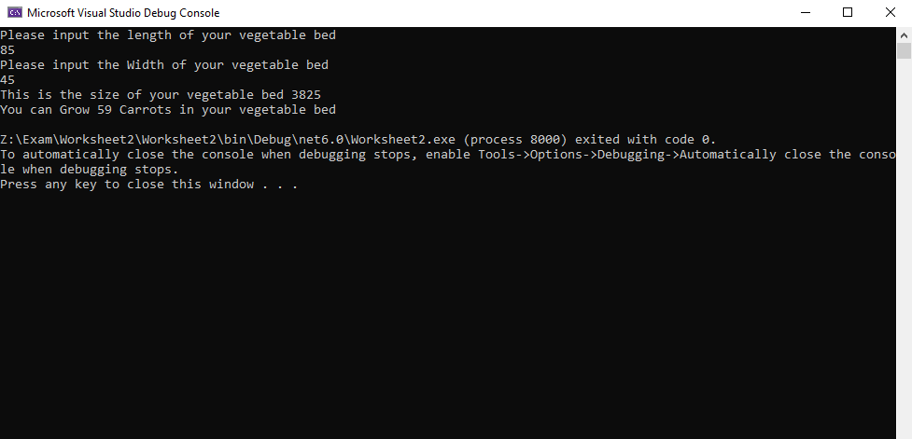
Result: Did the programme behave as expected ie syntactically and logically correct?
YES/NO (delete as appropriate)
If NO, what went wrong?
YES

Test:
Enter dimensions: width 7 length 25

Screenshot(s) of output:
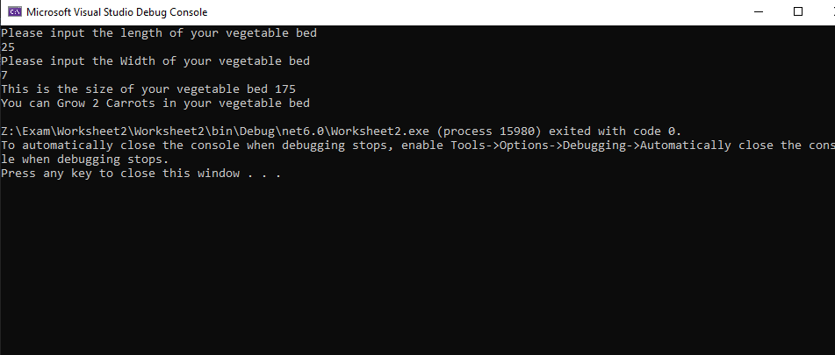
Result: Did the programme behave as expected ie syntactically and logically correct?
YES/NO (delete as appropriate)
If NO, what went wrong?
No because the dimensions for each carrot is 8 x 8 and the width is only 7 so it’s taking the overall area and seeing how many carrots can fit, its not considering the shape of the vegetable bed. I could’ve put a validation to stop any numbers below 8 being inputted due to the space needed for the carrots to grow

Test: Enter dimensions: Width -16 Length -20

Screenshot(s) of output:
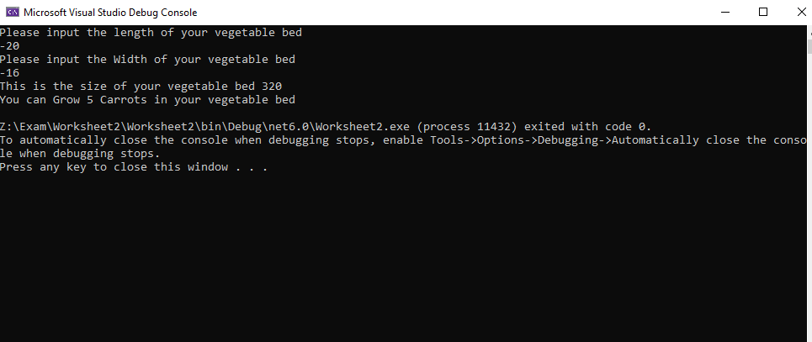

Result: Did the programme behave as expected ie syntactically and logically correct?
YES/NO (delete as appropriate)
If NO, what went wrong?
No because you can’t have negative length and width I would need to add a validation check to stop negative numbers being inputted

Test:
Enter dimensions: Width 27 Length 30. The result should be 9 carrots.

Screenshot(s) of output:
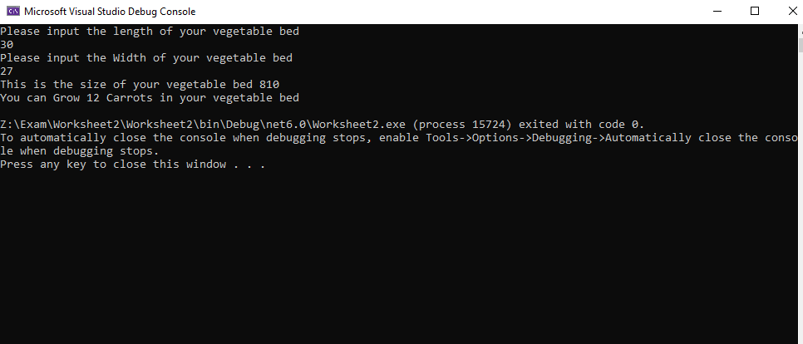
Result: Did the programme behave as expected ie syntactically and logically correct?
YES/NO (delete as appropriate)
If NO, what went wrong?
No because it hasn’t taken into account the shape of the vegetable bed, for example if there was left over space u cant put carrots in the empty gaps because there isn’t enough room for them but the program sees it as enough because its only dividing the size needed for the carrots by the area of the vegetable plot

Test:
Enter dimensions: Width 32 Length 32. The result should be 16 carrots.
Screenshot(s) of output:
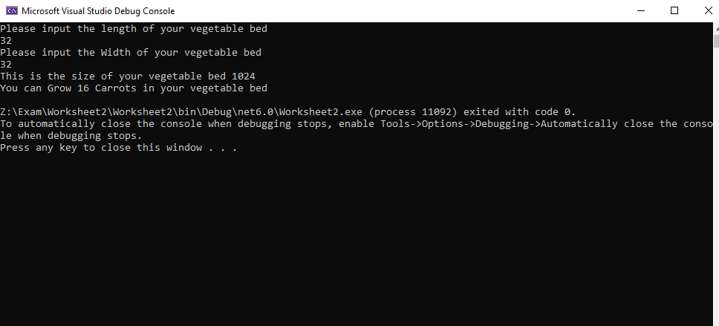
Result: Did the programme behave as expected ie syntactically and logically correct?
YES/NO (delete as appropriate)
If NO, what went wrong?
Yes

Test:
Enter dimensions: Width 7 Length 16. The result should be 0 carrots.
Screenshot(s) of output:
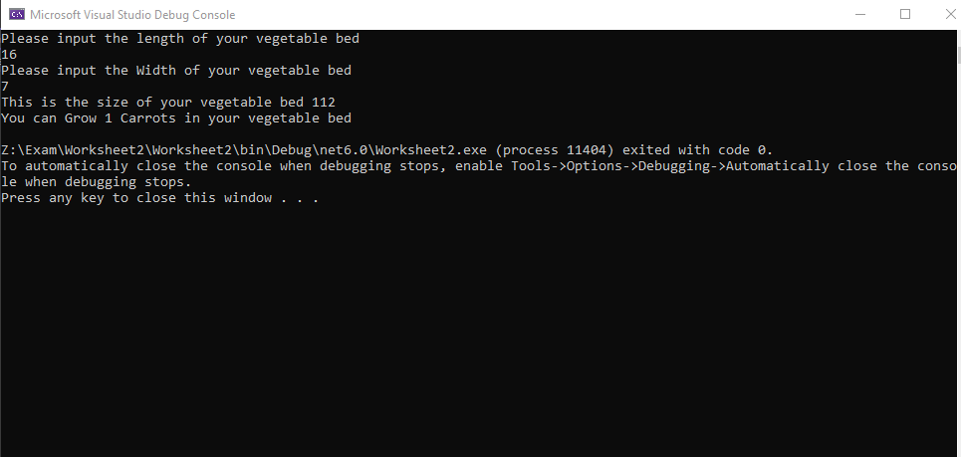
Result: Did the programme behave as expected ie syntactically and logically correct?
YES/NO (delete as appropriate)
If NO, what went wrong?
No because the programme needs to be able to visualise the vegetable box and then see if the dimensions of the carrot growth space can fit in, at the moment its just saying it can due to the overall area for the carrot is less than the area of the vegetable bed

- Consider the results of the above tests and revisit your code in order to solve any problems discovered at the testing phase. (Note: you may not be able to solve all of them, but solve as many as you can.)

Paste your revised code here:

