Assignment 2

Written Assignment

Module Name: Managing People

Module code: LCBB5004

Student: Marius Scorcea (1921886)
Lecturer: Piyumika Gamage

Contents
INTRODUCTION 3
MAIN BODY 3
The causes and effects of employee attrition within the Nursing Industry in the UK 3
CAUSES 4
EFFECTS 5
MONETARY AND NON-MONETARY RETENTION SCHEMES USED BY NHS FOR NURSING PROFESSIONALS 7
MONETARY RETENTION SCHEMES 7
NON-MONETARY RETENTION SCHEMES 8
SHORT TERM AND LONG TERM RECOMMENDATIONS TO IMPROVE NURSE RETENTION IN NHS 10
CONCLUSION 11
REFERENCES 12

INTRODUCTION

This report is briefly analysing the causes and effects of employee attrition within the Nursing Industry in UK from an HR Consultant point of view.
Also, it will present the non-monetary and monetary schemes that NHS is using in order to address this issue, a critical evaluation of these schemes and what can be done in order to improve the situation in terms of short-term and long-term recommendations.
Despite the NHS shortages flatlined in the last years, recently has been recorded an increase in nurses quitting on NHS especially among younger workers.
Between 2021-2022 the number of nurses that left NHS were 25% bigger than previous year and 2/3 of them were under 45 years old.
,, Data from NHS England and NHS Improvement show a vacancy rate of 11.8% as at 30 June 2022 within the Registered Nursing staff group (46,828 vacancies). This is an increase from the same period the previous year when the vacancy rate was 10.3% (38,814 vacancies).’’
NHS Vacancy Statistics England April 2015 – June 2022

MAIN BODY

The causes and effects of employee attrition within the Nursing Industry in the UK

In June 2022, over one year period, almost forty-one thousand NHS nurses in UK gave up their jobs – which equivalates to one of nine. This was the higher value registered in the last 10 years, with 6000 more employees than the previous peak, 5 years ago. The leave rate registered at this time was 11,5 %.
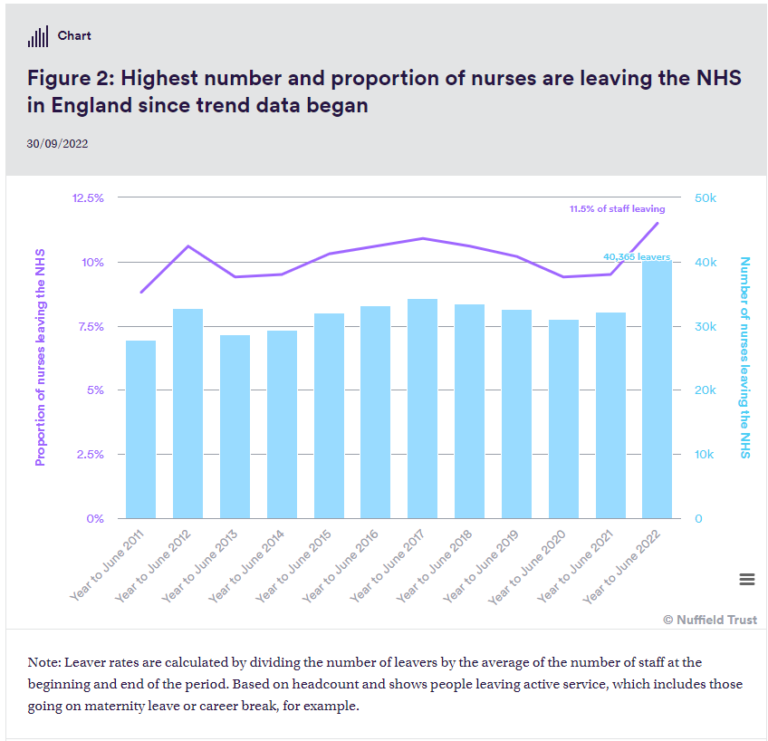

CAUSES

- High turnover rate determines a lot of vacancy, and the registered nurses feel stressed, dissatisfied and overworked. Three out of four nurses complained about the stress they must put up with.
- The nurses are affected by a lack of clarity regarding their role and the have the feeling that they cannot control their job performance. This is mainly due to poor communication which is not developed on multiple channels.
- NHS nurses are suffering because of an ineffective communication with their managers especially in critical situations. Managers and supervisors are not always available for their teams, ignoring their opinion in critical work issues.
- There is poor recognition or rewards for the nurses’ accomplishments.
Dan Ariely, in his book Payoff: The Hidden Logic That Shapes Our Motivations, said: ,,When we are acknowledged for our work, we are willing to work harder for less pay, and when we are not acknowledged, we lose much of our motivation.’’
- NHS nurses struggle with the feeling that there is no opportunity to grow. Ignoring the importance of the professional development for nurses is not a smart thing to do as nurses need to keep up to date with all the new information, techniques in order to deal in an efficient way with all new diseases processes and the complexity of patient population.
- Inappropriate trust, communication and collaboration between co-workers, this is du to the poor leadership and lack of teamwork.
- Nurses get stuck trying to pick up the slack for the less experimented nurses. The shortages in this NHS area, especially of qualified personnel are the main reasons for the stress and anxiety of more experimented nurses which need to work harder to cover others thus determining them to quit as result of burn out.

EFFECTS

The increased level of attrition among NHS nurses has a huge impact on patient care and hospital finances.
Nurses shortages leads to a poor care of the patient and the ability of meeting his needs will be affected. Also, brings a lot of stress on other staff which needs to cover this gap and they end up worn out.
Financially wise, the cost of replacing a professional nurse, fully trained is £12,000 and each year a Trust is spending over £3.6 million to replace nurses. (Farrh, 2022).
A high employee turnover rate is a big concern for any company or organisation and NHS is no different. When the attrition rate is high there will be negative effects on both, company and employees. Hiring always new staff, training them will lead to a poor organizational culture and the targets of the organization are affected as well.
Some of the NHS nurses attritions effects are:
- Company revenue and profitability is affected, it is expensive to hire new people on regular basis, to spend money on trainings and in the end they will leave NHS.
- Workplace morale – professional NHS nurses end up being overworked as they workloads is increased due to shortages and lack of experience of other staff. Many of them give up facing such a challenge and a disengagement behavior is fostered, setting up a negative example for the new employees.
- The workforce effectiveness is affected by the replacement of the experienced NHS nurses and the focus on the goal is lost.
- Service quality is poor. If the experienced nurses are leaving, the employee number is low, provided training is not enough the service will not be outstanding, patients will be affected and their health will be put at risk.
- The employee turnover will rise as a result of people leaving the company for not being able to cope with the pressure, the work condition etc. Other employee will start asking themselves if they are in the right place.

MONETARY AND NON-MONETARY RETENTION SCHEMES USED BY NHS FOR NURSING PROFESSIONALS

MONETARY RETENTION SCHEMES

NHS is trying to offer the best to their employees that is why they put in place several policies and schemes that will contribute to staff retention and their wellbeing.
Annual leave, death in service, pay, payroll giving, pensions along to few well developed and defined strategies are meant to bring effectiveness and good quality of NHS services.
Annual Leave
The holiday that runs over one year period is of 30 days. On top of this they have 4 days between Christmas and New Year that they can take.
In February, each ear, the staff has the chance to buy or sell up to one week of working leave under NHS terms and conditions.
Death in service
This is a benefits that full time employees can have. The entitlement is of four times annual salary.
Payroll giving
Is a flexible scheme that allows to any income tax payer in UK to contribute on a tax-free basis to a charity fund of its choice, Charity Trust is administrating this scheme for NHS.
Pensions
The NHS pension plans is administrated by Scottish Widows and any employee is automated enrolled after 60 days of working with NHS. NHS is contributing with 6% and the employee with 3% of his basic pay.
This are benefits and perks that are meant to attract and retain the staff, nothing out of the extraordinary, most of the company are providing similar perks to their employees.
Nevertheless, NHS has more elaborate schemes to attract people, one of this scheme is The ‘Golden Hello’ scheme
Nurses from band 5, 6 and 7 are offered a premia of 2500 pound if they are ‘New to the Trust’. This is for the nurses that will provide services for children and young adults that have mental issues.
In 2018 May, the health and social care secretary informed the House of Commons of his department decision of giving £10,000 golden hellos to the postgraduate nurses for fields that are facing hard time in recruiting people such as mental health and learning & disabilities area. (Hunter, 2022)

NON-MONETARY RETENTION SCHEMES

Considering that the reason for nurses leaving is the poor career development, work-life balance and poor working relationships, NHS has to tackle this issues in order to retain and motivate the staff. (NHS Trust, 2022)
The trust of the employees, the leadership culture, the communication and high morale of the nurses are improved through various schemes and processes what measures they can take in order to improve the nurses experience working with NHS. Based on this, they created a Monthly leavers reports in which follow up measures are presented.
Stay Conversation Guidance is a guide launched together with the new PDR process and it is there to help and encourage NHS managers to have regular informal communication with the staff in order to find out what it motivates them and how they can help them to fulfil their goals.
Nurse Retention Focus Groups it is a project that is developed together with the Corporate Nursing team and should discover what makes people stay with NHS.
Retaining Colleagues in Late Career through this policy NHS is supporting people to work for more years through flexible retirement possibilities. The experienced nurses are retained by the help of more attractive options. A series of Pre-retirement seminars were hold in order to explain the NHS offers for older employees.
Health and well-being support is available for NHS nurses, for instance the menopause awareness sessions which are held to support a certain category of staff.
Career Development - in order to ensure the staff retention, the Corporate Nursing are developing an alternative career pathway into nursing and they are recruiting inexperienced people and through a constant effort, trainings, seminars they are further advanced into specialist clinical roles, management, education or research roles based on their abilities and choice.
Flexible working – ‘We work flexible’ is part of the NHS People Promise. A culture of flexible working as a part of a healthy work-life balance is created, NHS is advertising now flexible working jobs and they even created Working Carers Passport which can be used to access this flexible working hours.
Supporting New Starters – the recruitment & on-boarding experience is improved by sustained actions for Equality, Diversion and Inclusion and NHS recruitment is a value based one. The Trust used Inclusion Advisors and Cultural Ambassadors to develop and support this area.
Even though NHS put in place various schemes in order to attract the staff, NHS nurses retention remains a problem.
The so called ‘Golden Hello’ scheme was not implemented successfully to all areas, some voices even claimed that there was no payment made from those £10,000 promised yet.
The efforts that NHS is doing trying to develop an healthy organizational culture based on Equality, Diversion and Inclusion is to be appreciated and also the fact that NHS is trying to educate his managers in how to communicate and solve staff problems and concerns is a huge project that takes time but the effort must be appreciated.

SHORT TERM AND LONG TERM RECOMMENDATIONS TO IMPROVE NURSE RETENTION IN NHS

The strategies on long term and short term regarding the employee retentions are part of HRM (Human resources management) approach. Is giving the guide line on people development within an organisation, what policies regarding equity, consideration, organizational learning, performance through learning can be established so that the staff needs are fulfilled. (Armstrong, 2017).
NHS nurses retention can be improved through several measures.
As short-term measure NHS can make more use of Open days programmes, recruitment fairs and exhibitions as means to inspire local communities and young people to choose a career in NHS. A simple stall on the hospital hallway with experienced personnel that will share they journey in NHS might bring very good results.
Long-term measures are more complex.
For instance regular feedback from employees will bring recognition and reward for har workers, in this way nurses will be kept engaged in the working process.
Online and in person courses are a good way to support a career development plan, maximising NHS nurses skills and their growth potential.
NHS should offer incentives for the nurses that are overworked and go beyond their norm, motivate them through special programs that will enrich their employee experience.
In order to build a strong team, bring the people together for different events, volunteering activities being the best way to liaise people and make them feel the same.
The manager should go more for ‘shared leadership’, ‘shared governance’, ‘distributed leadership’ and ‘shared accountability’ . Like this the staff are right in the middle of decision-making process and this system will inspire the nurses to offer a high-quality patient care service and the managers will act upon staff voice and concerns.

CONCLUSION

NHS nurses attrition is a serious matter which affects not only the NHS employees or economy, it affects also the national health as the patients are deprived of quality services and sometimes even their life may be at stake.
The politicians together with the NHS Trust leaders have to ensure god and fair working condition for NHS nurses as their role is of utmost importance in the well-functioning of this huge apparatus that is NHS.

REFERENCES

Ariely, D. (2019) Payoff: The hidden logic that shapes our motivations. Simon & Schuster Audio
Armstrong, M. (2017) Armstrong’s handbook of human resource management practice. 14th ed. London, England: Kogan Page.
Farrah, M. (2022), The NHS staff retention review: It’s costs and impacts, Available at: https://www.nurses.co.uk/blog/the-complex-costs-of-failing-to-retain-nhs-staff/, (Accessed: April 21, 2023).
Holmes, J. (2022), The NHS nursing workforce – have the floodgates opened? The King’s Fund. Available at: https://www.kingsfund.org.uk/blog/2022/10/nhs-nursing-workforce, (Accessed: April 28, 2023).
Hunter, W. (2022). Exclusive: £10,000 golden hello for postgraduate nurses in struggling specialisms not yet paid, Available at: https://www.nursinginpractice.com/latest-news/exclusive-10000-golden-hellos-to-lure-postgraduate-nurses-to-struggling-specialisms-not-yet-paid/, (Accessed: April 21, 2023).
ITA Group (n.d) 7 things that cause nurse turnover (and 8 things that stop it), Itagroup.com. Available at: https://www.itagroup.com/insights/employee-experience/7-things-cause-nurse-turnover-8-things-to-stop-it, (Accessed: April 25, 2023).
Kaddourah, B., Abu-Shaheen, A. K. and Al-Tannir, M. (2018) “Quality of nursing work life and turnover intention among nurses of tertiary care hospitals in Riyadh: a cross-sectional survey,” BMC nursing, 17(1). doi: 10.1186/s12912-018-0312-0.
NHS Employers, (n.d.), Employee benefits, Available at: https://www.nhsemployers.org/jobs/employee-benefits, (Accessed: April 21, 2023).
NHS Employers, (2022), Improving staff retention, Available at: https://www.nhsemployers.org/publications/improving-staff-retention (Accessed: April 22, 2023).
NHS SBS, (n.d.), Workforce analytics. Available at: https://www.sbs.nhs.uk/article/16949/Workforce-Analytics (Accessed: April 21, 2023).
NHS Trust, (2021), Retaining our staff, Available at: https://www.swbh.nhs.uk/wp-content/uploads/2021/06/013a-Retention-June-21-Final.pdf, (Accessed: April 21, 2023).
Palmer, B., Rolewicz, L. (2022), Peak leaving? A spotlight on nurse leaver rates in the UK, Available at: https://www.nuffieldtrust.org.uk/resource/peak-leaving-a-spotlight-on-nurse-leaver-rates-in-the-uk, (Accessed: April 23, 2023).
Recognize, (2022), High Employee Turnover? He Real Causes & Effects, Available at: https://recognizeapp.com/cms/articles/effects-of-employee-turnover, (Accessed: April 21, 2023).

