


The Ethics Dilemma: Is Greed Good?

The Importance of Ethical Considerations in Modern Businesses

Student Id:2224462
Student Name: Xiaotong Feng

Module Code and Name：Global Ethics (BMBM6008)
Executive Summary
Business activities make profits by providing more valuable products and services to the market, thus achieving sustainable development and growth of the organization. It has to be said that profits for enterprises can maintain innovation, hire talent, expand business and so on (Velasquez, 2020). More importantly, business activities also affect the quality of community development all the time, such as providing and creating jobs, improving the quality of life, which also means that enterprises shoulder a greater mission and responsibility. Business ethics is one of the important factors to support the long-term development of enterprises, which is also a topic worth discussing. This paper will analyze and discuss the importance of business ethics in the context of modernization.
Contents
Introduction 1
Objectives 2
Main Body 2
Objective 1 2
The Philosophical Basis of Ethics 2
Objective 2 3
The Influence of Ethical Theories on Business Decision Making 3
Objective 3 8
Explore and Analyze Practical Cases that Violate Business Ethics 8
How Can Religions and Governments Regulate Business 10
Conclusion 12
References 14

Introduction
Business ethics is a recognized moral standard that is used in specific business situations or activities (Velasquez, 2020). It helps individuals analyze and assess whether a business activity conforms to ethical norms and standards.
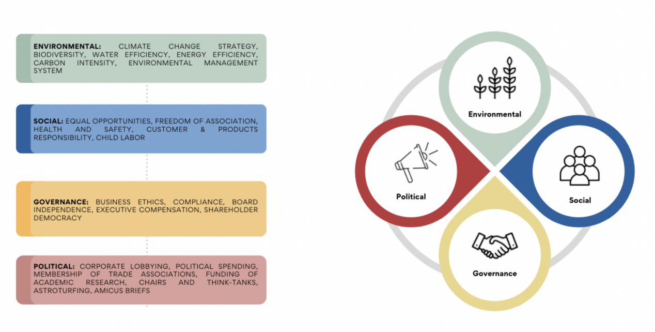
Figure 1: FRAMEWORK ON CORPORATE BEHAVIOR: ENVIRONMENTAL,SOCIAL,GOVERNANCE& POLITICAL (ESG&P) RESPONSIBILITY (Treviño and Nelson, 2016)
In modern times, business ethics is not just about a company's profitability and market share, but also plays a vital role in the decision-making process (Treviño and Nelson, 2016). This is because ethics has a significant influence in the business world, ranging from corporate reputation, employee and customer loyalty, strategic partnerships, and social acceptance. In fact, many companies still prioritize short-term gains over the long-term value that business ethics can bring, which contradicts the principles of sustainable development and harms society.
Greed may bring short-term benefits to a company. However, in the long run, businesses should prioritize ethical considerations in their decision-making processes. Especially in today's business landscape, companies should embrace modern business development concepts such as social responsibility, innovative growth, green economy, and sustainable development. This helps companies establish a responsible and trustworthy image in the market, leading to success and mutual benefits with society. This article will critically analyze the importance of internal management and ethical decision-making within organizations and their wide-ranging impact on the social environment. While incorporating practical business perspectives, critical thinking will also be emphasized to highlight the academic value of this article.

Objectives
Objective 1: Analyze the philosophical basis of ethics and its impact on business decisions in order to understand the importance of business ethics in modernization.
Objective 2: Explore and analyze actual cases of business ethics violations to highlight the consequences and impact of unethical business practices.
Objective 3: Examine the role of religion and government in regulating business practices to understand their impact on promoting ethical behaviour and ensuring responsible corporate behaviour.

Main Body

Objective 1

The Philosophical Basis of Ethics
Ethics is a discipline that focuses on the study of human morality and standards (Treviño and Nelson, 2016). It governs the choices made by individuals and groups. Ethicists also strive to establish a normative standard by discussing different ethical theories and perspectives, which helps people resolve moral dilemmas or uncertainties and promotes progress and development at both individual and societal levels (Beauchamp and Bowie, 2018). This article will specifically analyze business ethics, which is an important branch of ethics. Business ethics emphasizes that companies should be honest, engage in fair competition, achieve sustainable development, and be socially responsible.
However, from the perspective of businesses themselves, their purpose is to engage in market activities (Beauchamp and Bowie, 2018). Adhering to business ethics often requires additional costs and even the abandonment of certain business practices (Crane and Matten, 2016). For example, chemical companies must adapt to more environmentally friendly materials and production methods in order to comply with environmental regulations and embrace the concept of sustainable development. This means they must incur higher costs. Additionally, business ethics require companies to engage in fair competition and refrain from unethical practices, which significantly restricts their market activities. This poses a considerable challenge for businesses.

Objective 2

The Influence of Ethical Theories on Business Decision Making
This part will focus on enumerating some ethical theories, such as utilitarianism, deontology and ethical ethics, and discussing their respective impacts on business decision making (Wood and Mitchell, 2015). These theories can help enterprises to comply with business ethics and provide some noteworthy factors to ensure that enterprises make effective decisions in business ethics.
Utilitarianism
Utilitarianism typically refers to the pursuit of maximum benefits with the least cost in business. In business decision-making, the goal of a company is undoubtedly to maximize profits and gain a larger market share (Ferrell, Fraedrich, and Ferrell, 2018). However, companies often tend to narrowly define happiness and pain in this process. Happiness can be diverse, and if a company only attributes its happiness index to gaining more economic benefits and better meeting customer needs, it is likely to overlook other aspects of happiness, such as employee satisfaction, corporate reputation, and sustainable development.
Utilitarianism focuses more on short-term maximization of benefits. It is important to note that this focus can easily lead companies to engage in behaviors that contradict ethics and social responsibility (Fisher, Lovell, and Valero-Silva, 2017). Actions that harm the environment and exploit labor will be magnified under the influence of utilitarianism. This phenomenon goes against the common interest of public development, let alone the vision of companies achieving sustainable and long-term development.
Deontology
Deontological ethics emphasizes that businesses should not only comply with laws and regulations but also protect the legitimate rights and interests of consumers in their actual operations. However, in reality, the formulation and enforcement of relevant laws and regulations in the business field are not always perfect. Legal loopholes and weak regulation often exist. In such scenarios, businesses may attempt to exploit these legal loopholes in pursuit of greater commercial benefits.
Deontological ethics also dictates how businesses should treat their employees and shareholders and specifies the obligations they should fulfill. However, it is a complex task for businesses to balance their pursuit of interests and their responsibilities. Moreover, societal standards for corporate obligations are constantly evolving. For businesses, the challenge lies in how to quickly adjust to new obligations while maintaining their commercial operations. They must have a well-thought-out plan to accommodate diverse perspectives and make decisions when facing conflicts of interest. Balancing the pursuit of profits while adhering to ethical behaviors is not an easy task, and it places stricter demands on businesses.
Virtue Ethics
Virtue ethics is also recognized for its positive impact in the business field. By providing training to employees, businesses can enhance their moral awareness and sense of responsibility, thereby preventing unethical behavior in the overall operations (Wood and Mitchell, 2015). Furthermore, businesses can establish their own corporate culture and development vision to ensure efficiency. By promoting their internal values, businesses can remind employees to regulate their personal behaviors when making decisions.
However, virtue ethics emphasizes individual character and integrity, which means that environmental and external factors may be overlooked when making decisions. Even if employees possess good moral qualities, they may be influenced by external temptations or pressures due to loopholes or deficiencies in the corporate system. It is important to note that there is a potential conflict between individual ethics and economic interests. The limitations of virtue ethics should also be acknowledged, as it currently lacks the ability to resolve the conflicts between deontological ethics and consequentialism. Virtue ethics overlooks the fact that businesses, in the process of decision-making to balance interests and consequences, may also overlook certain moral rules.
When discussing whether a company adheres to ethical principles, it is important to critically analyze multiple factors. Blindly endorsing or opposing can hinder decision-making (Fisher, Lovell, and Valero-Silva, 2017). The key lies in considering the advantages, limitations, and challenges of critical thinking.
Different individuals are influenced subjectively by the ethical principles they follow in different contexts. This implementation can sometimes lead to controversy and conflicts, making it difficult to reach a consensus. Specifically, in business decision-making, some people prioritize economic benefits, while others focus on sustainable development and environmental protection. Decisions made from different perspectives are prone to conflict and divergence. In this process, managers also face more complex business decisions, as achieving consistency in decision-making becomes challenging. Ethical issues in the business domain are not just personal matters; they involve the interests of multiple individuals and are influenced by perspectives from a larger group of people.
Ethical theories sometimes tend to overlook the influence of institutional environments on moral behavior when considering individual ethical factors. Even if individuals possess ethical values, it is difficult for them to make ethical business decisions when the culture or systems created by a company do not support or encourage ethical behavior.
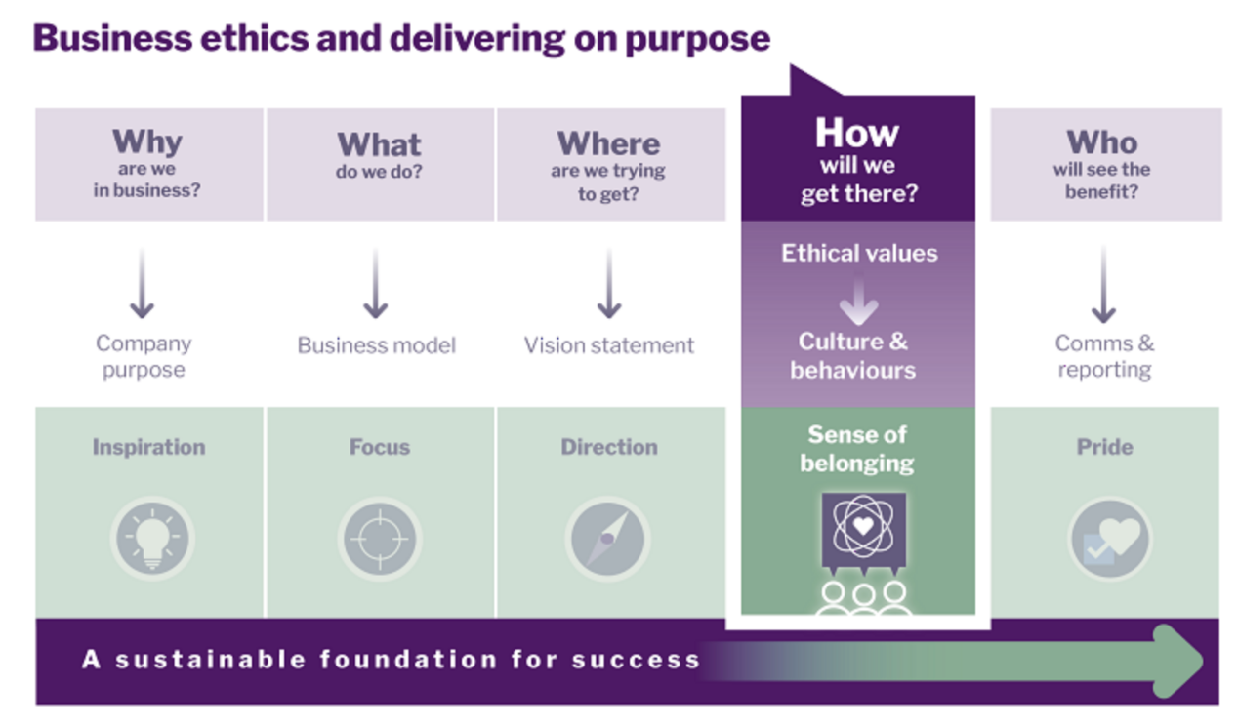
Figure 2: Business Ethics and Delivering on purpose (Frederick and Post, 2016)
Moreover, in business decision-making, companies often prioritize economic interests due to the need for profitability (Frederick and Post, 2016). This easily leads companies to neglect the ethical standards they should abide by. Even if a company's vision leans towards green economy and sustainable development, it is still prone to making decisions that contradict business ethics and principles after considering various economic factors. Conflicting interests create numerous obstacles for making business ethical decisions. It is often challenging for companies to effectively enforce self-monitoring measures (Jennings, 2018). Moreover, in many cases, companies resort to searching for legal loopholes, despite the risk to their reputation, which is a common phenomenon in the business world. When decisions are associated with financial interests, companies sometimes go to great lengths to evade ethical standards in pursuit of benefits.

Objective 3

Explore and Analyze Practical Cases that Violate Business Ethics
Bribery and corruption are commonly used tactics by businesses that do not adhere to ethical principles (Johnson, 2016). Bribery is typically the exchange of valuable things to influence someone's behavior or decisions in order to gain advantages and seek benefits. Bribery and corruption are widespread in the business world. In fact, companies often resort to these tactics when seeking special permits. Moreover, once these practices occur in the business world, they create complex chains of interests. This discussion will analyze the ethical implications of business ethics from a relatively simple logical perspective as a background, but such analysis is still applicable.
Governments often use their power for personal gain, abuse their authority, or approve partnerships or business activities that do not comply with regulations. Some enterprises, seeking to gain high market share or quickly enter new markets, target government officials with the intention to approach them (Lawrence and Weber, 2020). However, the market tends to favor justice. Unfair or unethical competitive methods may generate short-term profits or facilitate long-term benefits for businesses, but even large companies are inevitably subjected to justifiable sanctions (Ferrell, Fraedrich, and Ferrell, 2018). For example, a large American pharmaceutical company was fined $425 million for bribing government officials to secure the smooth market approval of its drugs in China. Similarly, a real estate company that attempted to obtain land development rights from government officials was ultimately unsuccessful and fined $170 million (Mizzoni, 2017). These negative cases severely disrupt market competition and the overall market order. If businesses were to emulate such inappropriate behavior, economic development principles would cease to exist, leading to market chaos and a deterioration of market integrity.
Companies even engage in behaviors that contradict business ethics towards their stakeholders, such as employees. They mistreat workers, violating their human rights in order to reduce production costs. For instance, Apple has faced criticism for labor abuse in the Chinese market, including forcing employees to work excessive overtime, providing poor working conditions, and giving disproportionately low wages compared to employee output (Treviño and Nelson, 2016). Furthermore, pharmaceutical companies may release drugs to the market without sufficient testing, concealing consumer rights to information and demonstrating irresponsibility towards their stakeholders. Additionally, in the financial sector, companies manipulate or fabricate data for private gain. These examples violate the principles of honest business operations and hinder the reputation of companies and even unsuspecting investors.
However, it is undeniable that some companies actively uphold their business ethics. The business world is not always dark, and scholars and researchers need to approach such phenomena with critical thinking (Velasquez, 2016). For example, Unilever is committed to protecting the environment and focuses on efficient use of renewable energy to enhance the sustainability of their agricultural supply chains, thereby establishing a highly positive image in the market. Starbucks, a global coffee chain giant, has also launched social responsibility initiatives. Specifically, it not only creates management plans from an employee perspective but also procures sustainable coffee beans while encouraging sustainable development among farmers and plantations.

How Can Religions and Governments Regulate Business
The previous negative cases have emphasized the significant role and influence of both government and religious and cultural backgrounds on business conduct (Werhane, Freeman, and Pritchard, 2017). Governments, on one hand, can impact businesses to engage in unethical practices through various factors and directions. Moreover, religious and cultural backgrounds shape the business conduct guidelines that companies adopt in different regions and countries. Religion and government play indispensable roles in regulating business behavior. Religion can influence local market activities based on morals and values, as companies need to meet the expectations of the local people, apart from producing valuable products.
Governments should establish stricter standards for business behavior. It is essential for governments to strengthen their management internally, eliminate bribery instances, ensure the legitimacy of government decisions, and enhance transparency. Many companies also attempt to exploit legal and administrative loopholes for market activities (Wood, Hunt, and Marshall, 2017). Therefore, it is crucial for governments to promptly identify shortcomings in the system, establish a sound standard system, continuously regulate commercial transactions and contractual behaviors, and protect consumer rights. However, overly cumbersome regulations on business conduct can significantly impede business freedom. Additionally, the differences in various cultures and religions make it more difficult to generate business decisions.
For companies, they can establish multinational or cross-regional teams to conduct business activities flexibly through decentralized governance and unified strategies (Wood, Hunt, and Marshall, 2017). Local governments should also cooperate with each other and make joint efforts to create a sustainable business environment. Translated version:
"In the previous negative cases, it has been emphasized that governments play a significant role in influencing businesses to engage in behavior that does not meet ethical standards. Additionally, the religious and cultural backgrounds also influence the business conduct guidelines adopted by companies in different regions and countries. Religion and government have an undeniable impact on regulating business behavior. Religion can influence local market activities based on morals and values. To please the local people, companies need to not only produce valuable products but also meet their expectations.
Governments should establish stricter standards for business behavior. Internally, governments should also strengthen their management to prevent the occurrence of bribery and ensure the legitimacy and transparency of government decisions. Many companies attempt to exploit legal and administrative loopholes for market activities (Wood, Hunt, and Marshall, 2017). Therefore, it is necessary for governments to promptly identify shortcomings in the system, establish a sound standard system, continuously regulate commercial transactions and contractual behaviors, and protect consumer rights. However, excessively cumbersome regulations on business conduct can have a significant impact on business freedom. The differences in culture and religion make it more difficult to generate business decisions.
For companies, they can flexibly conduct business activities by establishing multinational or cross-regional teams, adopting decentralized governance, and unified strategies (Velasquez, 2020). Local governments should also cooperate with each other and make joint efforts to create a consistent and sustainable business environment.

Conclusion
The text provides a theoretical explanation of ethics and discusses their influence on business decisions. Managers should analyze them rationally and refer to them during business decision-making to ensure compliance with business ethics requirements (Velasquez, 2020). Companies have a responsibility towards both internal and external stakeholders in addition to their own growth. Influential companies must also consider whether their business practices positively impact certain directions and trends.

Business ethics have always been a significant topic. Despite understanding the long-term benefits of adhering to ethical standards in theory, companies often engage in unethical decisions driven by greed for short-term gain. Numerous previous cases have demonstrated that such decisions may yield short-term benefits but can have detrimental effects on companies in the long run, including damage to reputation and legal troubles resulting in more severe losses.
It is acknowledged that striking a balance between profitability and adherence to business ethics is challenging for companies, particularly multinational corporations faced with complex ethical standards. Companies are also being compelled to transform amidst the trends of sustainable development and green economy. Outdated production processes and management methods no longer suffice. Managers face the significant challenge of whether they are willing to invest resources and funds in research and development to adapt swiftly. Nonetheless, history has shown that justice and compliance with business ethics are always the prevailing trend. Consequently, greed-driven profit-seeking is an ineffective approach to long-term company development.

References
Beauchamp, T. L., and Bowie, N. E. (2018). Ethical theory and business. Upper Saddle River, NJ: Pearson.
Crane, A., and Matten, D. (2016). Business ethics: Managing corporate citizenship and sustainability in the age of globalization. Oxford, UK: Oxford University Press.
Ferrell, O. C., Fraedrich, J., and Ferrell, L. (2018). Business ethics: Ethical decision making and cases. Boston, MA: Cengage Learning.
Fisher, C. M., Lovell, A., and Valero-Silva, N. (Eds.). (2017). Business ethics and risk management. New York, NY: Routledge.
Frederick, R. E., and Post, J. E. (Eds.). (2016). Business and society: Stakeholders, ethics, public policy (15th ed.). Boston, MA: McGraw-Hill Education.
Jennings, M. M. (2018). Business ethics: Case studies and selected readings. Boston, MA: Cengage Learning.
Johnson, C. E. (2016). Organizational ethics: A practical approach. Thousand Oaks, CA: SAGE Publications.
Lawrence, A. T., and Weber, J. (2020). Business and society: Stakeholders, ethics, public policy (16th ed.). Boston, MA: McGraw-Hill Education.
Mizzoni, J. (2017). Ethics: The basics. New York, NY: Wiley.
Ferrell, O. C., Fraedrich, J., and Ferrell, L. (2018). Business ethics: Ethical decision making and cases (12th ed.). Boston, MA: Cengage Learning.
Shaw, W. H., Barry, V., and Sansbury, G. (2019). Moral issues in business. Boston, MA: Cengage Learning.
Solomon, R. C., and Hanson, K. (2017). The philosophy of business ethics: A collection of essays. Oxford, UK: Oxford University Press.
Treviño, L. K., and Nelson, K. A. (2016). Managing business ethics: Straight talk about how to do it right. Hoboken, NJ: Wiley.
Velasquez, M. (2020). Business ethics: Concepts and cases. Boston, MA: Pearson.
Velasquez, M. (2016). Business ethics: Concepts and cases. Boston, MA: Pearson.
Werhane, P. H., Freeman, R. E., and Pritchard, M. S. (2017). Business ethics: A managerial, stakeholder, and social contract approach. Chicago, IL: Skyhorse Publishing.
Werhane, P. H., and Painter-Morland, M. (2018). Business ethics: The moral foundation for effective leadership, management, and entrepreneurship. Dordrecht, Netherlands: Springer.
Wicks, A. C., Gilbert, D. R., and Freeman, R. E. (2017). Business ethics: A stakeholder and issues management approach (6th ed.). Boston, MA: Cengage Learning.
Wood, G. T., Hunt, J. D., and Marshall, G. W. (2017). Business ethics: A case study approach. Boston, MA: Cengage Learning.
Wood, R. E., and Mitchell, M. S. (2015). Business ethics: A textbook with cases. Boston, MA: Cengage Learning.

