Student Name: Cameron Lee Gallent
P Number: 1804551
Programme of Study: Transport Design
Module: ADAD4010

One of the biggest obstacles we as humanity face is climate change. Nothing is more life threatening to our whole species and every living being on Earth than the rising temperature of our planet. It would be easier to say it was no cause of our own but sadly it is the latter. These past two centuries have saw pollution levels skyrocket due to human expansion and industrial revolution. The more fossil fuels we burn through the more harmful gasses like CO2 get released into our atmosphere. These gasses react like a blanket by trapping heat, in turn warming up the planet which will inevitably wreak havoc on ecosystems adjusted to specific climates.

Location
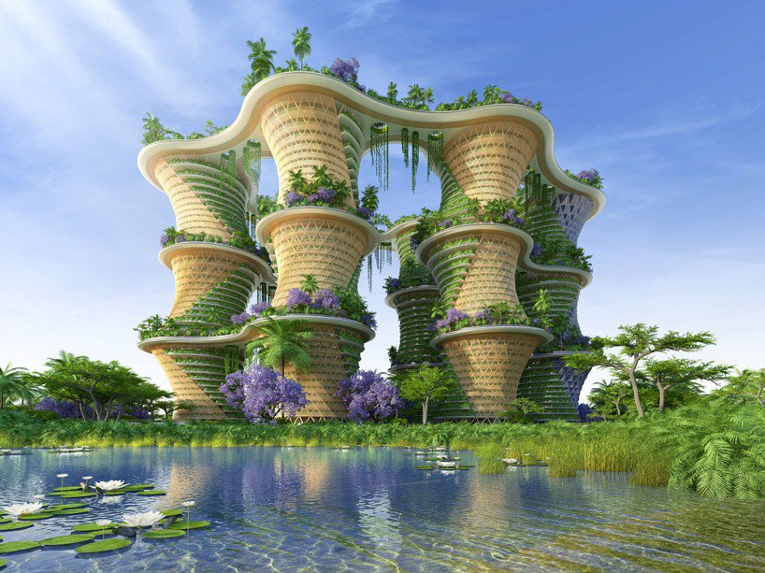
Fig.1
The exhibition is held in an exquisitely designed piece of architecture called Hyperion’s created by Vincent Callebaut. This structure shows a great combination of structural engineering and nature co-existing together in perfect harmony. Not only does this structure pose as a beacon to the idea of keeping nature in our lives, but what’s inside is also just as interesting and powerful. Each room represents a specific ecosystem/ environment including the species of animals that live in the habitat. The focus of the exhibition is to show the damage that climate change is currently causing as well as what is likely to come if rates continue. The idea is primarily educational and targeted towards people of all ages. But what makes this museum different is its high-tech technology which focuses on stimulating all the senses to achieve the goal of inspiring people to change the way they live by letting nature back into their lives. While also encouraging people to respect and protect it at all costs.
Start of exhibition
After gazing at the spectacular view outside, on entry people are given immersive VR glasses and transported into another world while guided by a guide approx. 1 guide per 20 guests. Guests can see ecosystems and otherworldly dimensions flying past their eyes. This is done to give them the shock factor before the tour. I want to offer them that intense awe of human capability, but as they move into each room shatter that idea completely. I want people to see the other side of humanity and realise the extent of the damage we are causing. The outside will be completely different in contrast to most of the inside. The inside aims to give an almost depressing realisation of the current and future condition. This is inspired from ‘Dismaland’ (Banksy, 2015) a theme park in Weston-super-Mare. Banksy created art inspired by political events and tragedies that strike the world. In the theme park was a collapsed horse-drawn carriage which signifies the passing of Princess Diana. Banksy is also famous for Street Art, one example is of his work is in Port Talbot called ‘Sleepness Nights’. The piece of art which shows a child exposed to ashes signifies the pollutants being spewed out by Port Talbot steel works every day.
Room 2
Using VR guests are escorted into a tropical rainforest where life is thriving, and skies are blue. Guests can explore for a period until the forest starts to gradually transform in to a barren wasteland. The guide explains that the forest was live recorded a time ago before the land was used for industrial purposes, and the current state you see is what is looks like now. All wildlife stripped of their homeland. The idea of the room is to engage the audience on a personal level and witness the damage instead of reading figures which gives a vague perception. The idea of involving the audience directly derives from a book called ‘French Lieutenant’s Woman’ by John Fowles which explains the story then engages the reader directly. This is an effective way to make a connection between the audience and the environment/story.
Room 3
To engage the audience’s emotions further everyone is acquainted with a curious Toolache Wallaby. The animal is part of the VR experience and is personal to each visitor. To enhance the connection VR makes is seem as though the Wallaby is following you only. This room contains all kinds of animals in different habitats lined next to each other. Audiences can see the animals in their nests and burrows moving around. Towards the end VR glasses are asked to be removed and the truth is revealed, tombstone-like memorials replace each habitat showing the years the creatures became extinct due to human interference. The little Toolache Wallaby which was once following you around also disappears. Visitors are made aware that the Toolache Wallaby became extinct in 1939 due to overhunting.
A similar idea of a piece that was made by Damien Hirst called, ‘The Physical Impossibility of Death in the Mind of Someone Living’ (1991) revolves around a Tiger Shark in a glass box placed in a museum. It became a spectacle simply because the shark was in an unnatural environment. People were able to have a different perception of the shark instead of seeing it in the media. This also creates the ‘Effect Theory’ which is the feelings you feel inside when you witness something in person.
Room 4
This room could be described as the most immersive room. Guests are taken to an oil refinery and are free to explore the decaying lands. Animals and rivers are doused with oil, and the air is a bleak black. The scenes are apocalyptic. Fake, non-toxic smog is pumped into the room which creates a heavy smell. There is also an option to pick up an oil covered bird, which is a dummy made to look real by VR. Using the same 1st person encounter technique used in Room 3, this time you see the damage people are causing as the bird gasps it’s last breath.
Room 5
Room 5 focuses on the greedy over-consumption of humanity and the corporations that influence it. Audiences are taken through a live panoramic show of humans at their greediest, as if a virus has hacked the VR. Hundreds of windows expand across people’s gaze of people ransacking stores and causing fires. The windows multiply rapidly showing the chaos like an infectious disease. A boardroom meeting then appears showing business men laughing hysterically as their bundles of cash grow higher and higher next to them. The planet cuts over the screen showing a surreal animation of sky scrapers and smoke stacks grow until they scrape the atmosphere. Money bills drown the planet just as fast as the trees disappear into dust. The screen begins to melt as if the film is burning, then the screen goes blank. For a couple of seconds, the audience is left in total darkness. This effect is done to make them realise what dark future lies ahead if we carry on.
The notion of opposing to carry on the way we are hints towards an uprising against corporations who carelessly chew through resources without giving back. A book called The Postmodern Condition (Lyotard, 1979) ties in well with humanities current condition. Lyotard states, “I define postmodern as incredulity towards metanarratives”, which explains that if a lot of people have strong beliefs in something, it makes that ideology almost impenetrable. One example is the belief that Britain is a great and powerful country. If less and less people began believing in that, in theory, the country’s state would gradually become decline. The main message people should take from Lyotard is the fact if people wake up and stand up to corporations they would crumble under the lost beliefs. We don’t need to everything they advertise; the next new iPhone will not make you much happier than you were before.
Room 6
This room takes on a shift in tone. To inspire the audience to make a difference and allow audiences to leave with some hope for the future they are shown the good side of humanity. Guests are shown people volunteering a couple of hours a week to keep nature safe. People are shown planting trees, living minimalist lifestyles, and enjoying what the outdoors has to offer. The long exposure to the dull and depressing tone of rooms 1-5 should make audiences crave nature’s beautiful scenery and respect it more.

Conclusion
Globally taking care of the planet should be on every person’s agenda. Countries put too much value in their economies to compare and show off like children. Earth should be treated like the sanctuary it is. More economically developed countries need to support (such as America and Britain) less economically developed countries (such as India and China) to tackle their emissions. India and China are in a rapid development stage which is causing a lot of pollution. This rapid development along with having the biggest populations in the world is having a tremendous affect on the planet. These types of countries need to be guided towards investment in renewable energies suited to their ecology, such as wind turbines and marine current turbines. Consumerism must also change especially in countries like America where many products are over-sized. People must change their diet avoiding so much meat on their plates, not only is it not healthy it is also a leading factor to most of the world deforestation.

Sources
https://skepticalscience.com/The-CO2-Temperature-correlation-over-the-20th-Century.html
https://en.wikipedia.org/wiki/The_French_Lieutenant%27s_Woman_(film)
https://www.neatorama.com/2011/02/02/7-animals-humans-brought-to-extinction/
https://en.wikipedia.org/wiki/Terry_Eagleton
https://en.wikipedia.org/wiki/The_Physical_Impossibility_of_Death_in_the_Mind_of_Someone_Living
https://en.wikipedia.org/wiki/Affect_theory
https://nation.cymru/culture/when-banksy-came-to-port-talbot/
https://www.wisegeek.com/which-industries-pollute-the-most.htm
https://en.wikipedia.org/wiki/The_Postmodern_Condition

