
Student name: Catalin Anca
Student ID: 2024817

Module name: Independent Project
Module code: BMHP6020
Lecturer’s name: Bianca Sanfilippo

Assessment: Component 1, Element 2: Methodology Poster
Project title: An Exploration of the Lived Experiences of People Living with Dementia in the UK
Word count: 528 (poster text, excluding references)

An Exploration of the Lived Experiences of People Living with Dementia in the UK
Methodology Poster • Systematic Literature Review • Catalin Anca (2024817) • BSc (Hons) Health and Social Care • BMHP6020 Independent Project

  Figure 1: Person-centred support (Direct Media, n.d.)  Introduction & Rationale  Dementia is the UK’s leading cause of death (Alzheimer’s Research UK, 2025). These figures (Alzheimer’s Society, 2024; NHS England Digital, 2025) measure its scale but say little about living with it. People with dementia are under-represented in research, and access to support is unequal, especially for minority ethnic groups (Alzheimer’s Society, 2025). This review focuses on their own accounts.  Aim & Research Question  Aim: To explore the lived experiences of people living with dementia in the UK, including impacts on daily life, identity, relationships and access to care.  Research question: What are the lived experiences of people living with dementia in the UK?  Objectives:  - Discuss lived experiences of dementia in the UK.  - Examine barriers to timely diagnosis and care.  - Recommend person-centred, culturally sensitive dementia care.  SPIDER Framework  SPIDER, designed for qualitative evidence, is used instead of PICO (Cooke, Smith and Booth, 2012). |  | Research Design  This is secondary research: a systematic literature review of ten peer-reviewed primary studies. It takes an interpretivist, qualitative approach because lived experience is subjective and best understood through people’s own words (Aveyard, 2023).  Why a systematic review? It is transparent and replicable, and draws on many participants’ accounts without recruiting people whose capacity to consent may fluctuate (Mental Capacity Act 2005).  Search Strategy  Databases: ProQuest, PubMed, CINAHL, Google Scholar.  Filters: peer-reviewed, English, 2016–2026; reference lists hand-searched.  Inclusion & Exclusion Criteria  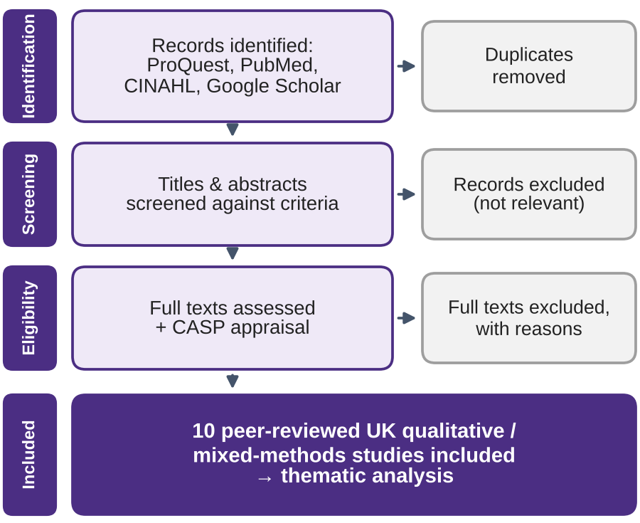  Figure 2: Study selection following PRISMA 2020 (Page et al., 2021) |  |   Figure 3: Family and community support (Kampus Production, n.d.)  Critical Appraisal  Each study is appraised with the CASP Qualitative Checklist (CASP, 2024), which covers validity, rigour, ethics and value. Author, year, sample, method and findings are recorded in a data extraction table.  Data Analysis  Findings are analysed using Braun and Clarke’s (2006) six-phase thematic analysis (Figure 4). Because the method is not tied to one theory, themes can be interpreted through Kitwood’s (1997) person-centred care theory, which sees personhood and identity as sustained through relationships.  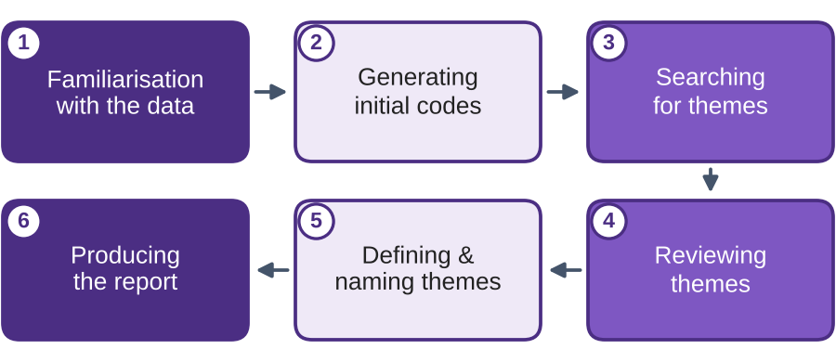  Figure 4: Six phases of thematic analysis (Braun and Clarke, 2006)  Ethical Considerations  Only published, anonymised data are used, so there is no contact with participants, but UWTSD ethics procedures still apply. Participants’ words are reported accurately and in context, and a reflexive diary helps limit personal bias.  Limitations  - Findings depend on what earlier studies asked.  - A single reviewer may introduce selection bias.  - UK, English-language studies limit transferability.  - Few studies include people with advanced dementia.
  982,000  people living with dementia | 1.4 million  projected by 2040 | 1 in 3  have no formal diagnosis | £42 billion  cost per year
  S | Sample: People living with dementia in the UK
  PI | Phenomenon of Interest: Lived experience: daily life, identity, relationships, access to care
  D | Design: Interviews, focus groups, observation
  E | Evaluation: Views, feelings and experiences
  R | Research type: Qualitative or mixed methods
  ("lived experience*" OR "living with") AND (dementia OR Alzheimer*) AND ("United Kingdom" OR UK)
  Inclusion | Exclusion
  Peer-reviewed articles | Non-peer-reviewed sources
  Primary qualitative / mixed methods | Secondary research (reviews)
  Based in the UK | Based outside the UK
  People living with dementia | Not about people with dementia
  Published 2016–2026 | Published before 2016
References
Alzheimer’s Research UK (2025) Dementia is still the UK’s biggest killer – where do we go from here? Cambridge: Alzheimer’s Research UK. Available at: https://www.alzheimersresearchuk.org (Accessed: 4 July 2026).
Alzheimer’s Society (2024) How many people have dementia in the UK? London: Alzheimer’s Society. Available at: https://www.alzheimers.org.uk (Accessed: 4 July 2026).
Alzheimer’s Society (2025) Facts for the media about dementia. London: Alzheimer’s Society. Available at: https://www.alzheimers.org.uk (Accessed: 4 July 2026).
Aveyard, H. (2023) Doing a literature review in health and social care: a practical guide. 5th edn. London: Open University Press.
Braun, V. and Clarke, V. (2006) ‘Using thematic analysis in psychology’, Qualitative Research in Psychology, 3(2), pp. 77–101. doi: 10.1191/1478088706qp063oa.
Cooke, A., Smith, D. and Booth, A. (2012) ‘Beyond PICO: the SPIDER tool for qualitative evidence synthesis’, Qualitative Health Research, 22(10), pp. 1435–1443. doi: 10.1177/1049732312452938.
Critical Appraisal Skills Programme (2024) CASP checklist: for qualitative research. Available at: https://casp-uk.net/casp-checklists/CASP-checklist-qualitative-2024.pdf (Accessed: 12 October 2026).
Direct Media (n.d.) Caregiver nurse [Photograph]. StockSnap (CC0). Available at: https://stocksnap.io/photo/caregiver-nurse-TBEMNLXLVQ (Accessed: 12 October 2026).
Kampus Production (n.d.) A group of people smiling together while sitting near the table [Photograph]. Pexels. Available at: https://www.pexels.com/photo/7551617/ (Accessed: 12 October 2026).
Kitwood, T. (1997) Dementia reconsidered: the person comes first. Buckingham: Open University Press.
Mental Capacity Act 2005, c. 9. Available at: https://www.legislation.gov.uk/ukpga/2005/9/contents (Accessed: 12 October 2026).
NHS England Digital (2025) Primary Care Dementia Data, December 2025. Leeds: NHS England. Available at: https://digital.nhs.uk (Accessed: 4 July 2026).
Page, M.J., McKenzie, J.E., Bossuyt, P.M., Boutron, I., Hoffmann, T.C., Mulrow, C.D. et al. (2021) ‘The PRISMA 2020 statement: an updated guideline for reporting systematic reviews’, BMJ, 372, n71. doi: 10.1136/bmj.n71.

