Wales Academy of Voice and Dramatic Arts

Alice By Heart: Final Production

Reflective Essay

By

Kailyn Nieva Todd-Rosal (2404772)

BA Musical Theatre – ADPB6003

I acknowledge the use ChatGPT [ ChatGPT ] between June 14th and June 25th to support the editing, paraphrasing, and refinement of my written work. I used the prompt(s):
[Structuring]
[Enhancing word count]
[Grammar Correction]

Alice by Heart Company
Director: Dan Phillips
MD: Iestyn Griffiths
Choreographer: Eddie Ladd
Design: Cory Shipp
Lighting: Garrin Clarke
Sound: Josh Bowles
Design Associate: Jessica Staton
Design assistant: Ashley Knibbs
Stage & Production manager: Fliss Bulbulia

Introduction
Just like Alice Spencer taking Alfred to Wonderland, my experience of Alice by Heart invited me into a world where imagination and reality coexist. As I reached the final stage of my degree, this production has become more than a performance; it has reflected my own journey through theatre training with its challenges, discoveries, and rewards over the past two years.
Using Gibbs’ Reflective Cycle, I will navigate this production’s creative choices, rehearsal process, and performances, while considering how the production has influenced my ongoing development as a musical theatre performer. (The University of Edinburgh, 2024)


Davies, A. (2026) ‘Afternoon’ moment from dress run. In: Alice by Heart: WAVDA

Description
Alice by Heart, is a pop-rock musical written by Steven Sater and Jessie Nelson, featuring music by Duncan Sheik that follows a young girl sheltering in a London Underground station and uses the world of Alice’s Adventures in Wonderland, the 1865 novel by Lewis Carroll, to navigate experiences of grief, love, loss, and imagination. (Stageagent.com, 2019) (Carroll, 1865)
Our director, Dan Philipps, reimagined this story in a contemporary Cardiff location, setting it in an office building where individuals from diverse backgrounds seek refuge in the world of chaos and uncertainty. He also explained that the production would be staged in traverse at Haywood Black Box Theatre and warned that the process would be both intense and challenging.
Following the casting process, I was given the roles of the Mock Turtle and Child One.
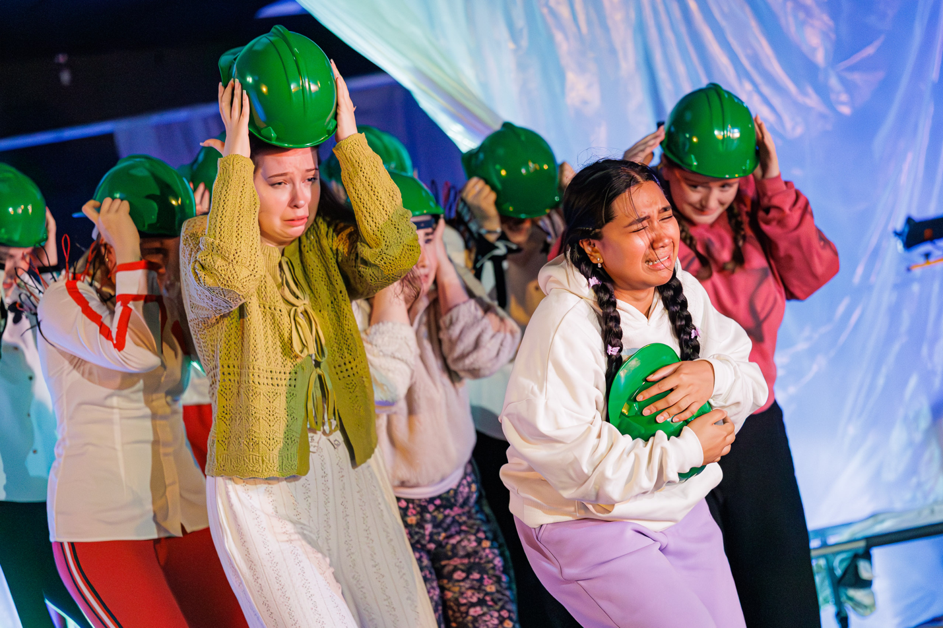
Davies, A. (2026) ‘Mock Turtle’ moment from dress run. In: Alice by Heart: WAVDA
Our director guided us collaboratively creating the world of the musical through devising tasks. Through timeline building, speed dating exercises, and character hierarchy work, I developed Marina Hollow, a child lost in Cardiff’s St. David’s shopping centre, who is taken to a shelter by Harold Pudding. I also worked heavily on developing the Mock Turtle’s character in Wonderland.
In addition to my main characters, I participated in several ensemble numbers, contributing through singing and choreography by Iestyn Griffiths and Eddie Ladd.

The 4-week process concluded with four performances, requiring me to integrate and apply the skills I had acquired during my training at WAVDA.

Feeling
At the beginning of the project, I felt a whirlwind of excitement, as it offered a final opportunity to create and perform with my fellow cast members.
Dan’s vision of a traverse-style theatrical experience left me intrigued; however, I also felt somewhat disappointed, as an aspects of the concept appeared similar to our previous project.
During rehearsals, I experience a mixture of confidence and detachment. There were moments when I felt fully prepared and engaged, particularly when rehearsals were a safe space, productive, and collaborative. However, there were periods during the rehearsal process when a sense of tension lingered within the space. As a result, some cast members appeared less engaged and positive with the process and became fearful of making mistakes or expressing creative ideas to the creative team. This effect from others made me feel uneasy.
There were occasions I repeatedly missed the cue for ‘Shell of Grief’ wrong. As a result, I felt frustrated with myself, and being asked to repeat it in front of the company left me feeling intimidated and embarrassed. I was particularly anxious about performing my introduction again, so I spoke with Iestyn to figure out a solution. Once we had resolved the issue, I felt a great sense of relief and regained my confidence.

Evaluation
One of the most successful aspects of production was the collaborative environment established within the company. Everyone was always ready to work with each other; this aspect gave me a lot of encouragement to work.
Another positive aspect was the opportunity to apply techniques learned throughout my degree. Skills in acting through song, character development, vocal technique, and rehearsal discipline were essential in preparing the production. By using Stanislavski’s method of identifying a character’s wants, objectives, and the concept of subtexts, I was able to understand and portray the character’s motivations in a believable and realistic way.
Being well-prepared and completing work in advance, such as memorising lines, harmonies, and being familiar with all the ensemble songs, gave me a significant advantage, allowing me more space to experiment and respond effectively to the creative team’s direction.

Analysis
The rehearsal process highlighted the importance of independent and collaborative work in creating a successful performance. When the process environment felt supportive and productive, I was more confident in contributing ideas and experimenting with character choices. However, periods of tension within the space appeared to reduce some performers’ willingness to engage creatively. This demonstrated how the atmosphere of the room can influence both individual confidence and the effectiveness of ensemble work.
The use of Stanislavski, Meisner, and Hagen’s technique was particularly valuable in developing my performance. By identifying wants and objectives (BBC, 2019), listening and reacting (Cash, 2023), I gained a deeper understanding of both my characters' motivations and journey.

Conclusion
Overall, this production has been a significant learning experience that has strengthened my development as a musical theatre performer. Through applying techniques I have learnt over the past years, I have gained a lot of experience and knowledge from having a safe space to explore. In addition to the successes and good feedback from audiences, I am happy to know that all the work I have done throughout the rehearsal process has boosted a lot of confidence and motivated me to do more throughout my career.

Action Plan
In future productions, I want to further develop my ability to remain consistent and confident under pressure. I will achieve this by increasing rehearsal discipline, additional independent practices, physically through choreography, and musically.
I also intend to deepen and develop my understanding of acting methodologies with the given acting tools, as well as learn from other people. I know this will help me make more experienced and confident performers.
Overall, my goal is to become the best version of myself by working hard, maintaining a positive mindset, and carrying a little piece of Wonderland into every performance.

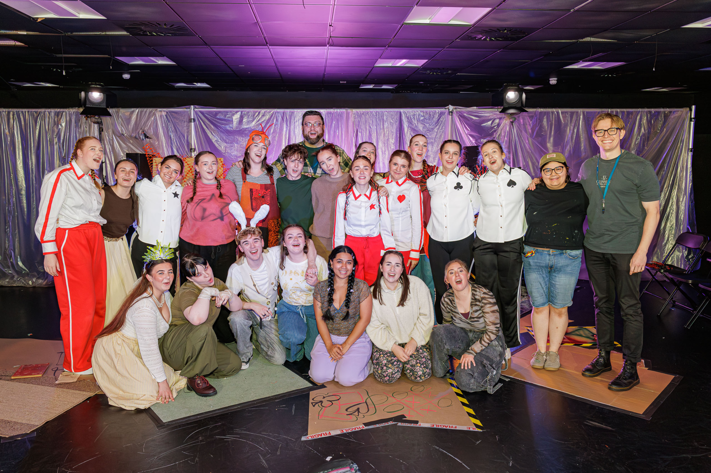.
Davies, A. (2026) Full Company: Alice by Heart: WAVDA
Access to personal research
Alice by Heart Mock Turtle: Subtext Notes
Character Development Notes

Bibliography:
Stageagent.com. (2019). Alice by Heart (Musical) Plot & Characters | StageAgent. [online] Available at: https://stageagent.com/shows/musical/32385/alice-by-heart.
The University of Edinburgh (2024). Gibbs’ Reflective Cycle. [online] The University of Edinburgh. Available at: https://reflection.ed.ac.uk/reflectors-toolkit/reflecting-on-experience/gibbs-reflective-cycle.
Caroll, L. (1865) Alice’s Adventures in Wonderland. London: Macmillan and Co.
BBC (2019). Naturalism and Stanislavski - Revision 5 - GCSE Drama - BBC Bitesize. [online] BBC Bitesize. Available at: https://www.bbc.co.uk/bitesize/guides/zxn4mp3/revision/5.
Cash, J. (2023). The Meisner Technique: 6 Valuable Acting Lessons For Students | The Drama Teacher. [online] thedramateacher.com. Available at: https://thedramateacher.com/meisner-technique/.
References:
Lane, J. (2023). What Are Given Circumstance in Acting? [online] Backstage.com. Available at: https://www.backstage.com/magazine/article/given-circumstances-acting-explained-76219/.
Alice by Heart YouTube

