Saint Francis of Assisi

The Christian concept of ‘patron’ is thus defined by the Cambridge Dictionary: “a saint who is believed to give special help to a particular place, activity, person, or type of object”.
Saint Francis of Assisi was described as “the most Italian of the saints, the holiest of the Italians” by Pope Pius XII at the time of his proclamation on the 18th of June 1939 as patron of Italy together with Saint Catherine of Siena.
Francis of Assisi was, in the 13th century, the reformer of a new idea of church: no longer an élite church but a church which listens to everyone, even to the ones who could not speak, the sick, the poorest. Founder of three orders, still existing today: the Friars Minor, the Poor Clares and the Secular Franciscan Order. All three orders respect a common principle, which of living as mendicants.
What does it mean? Living getting rid of all material goods and to live on alms and charity alone, in order to be on the same level as the last, the poor, to be able to see with their eyes.
What did it mean then? Change a model that the church used to have, that of a clergy surrounded by riches and material goods that did not allow them to see the concrete problems of the people and, therefore, help them by creating a functioning community.

I
How current is the figure of St. Francis?
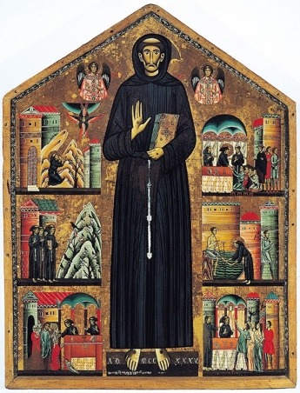
A saint 'at your fingertips', which everyone can feel like their peer. The church returns, with him, to be in contact with the real community. The path he leads to perform, to his faithful and followers, is to strip himself of what is superfluous, to feel what our soul feels once we are alone among ourselves.
Respect for others, beyond their social or cultural characteristics, brings man back into contact with God in a positive way. The Canticle of the Creatures is his most important work, in which, speaking and praising all the creatures that populate the world, it refers metaphorically to humanity.
“Francis of Assisi is for me the man of poverty, man of peace, the man who loves and preserves creation, and nowadays humanity have a not so good relationship with creation”. Thus spoke Pope Francis on the day of the press review after his election. He chose to call himself as the Saint of the poor, desiring a poor and humble church.
Figure 1 – Bonaventura Berlinghieri, Altarpiece of Saint Francis, 1235
St. Francis of Assisi is therefore a common thread between “all times and places”, underlines Mary Heimann, he changes the idea of ​​church: no longer reserved only for the world of the clergy but for all the people of God. His influence was a key point for many of the years following his death, throughout Italy and beyond. Art and literature take their cue, sometimes make him the subject of their works.
“[…] how I wish a poor Church for the poor”, added Pope Francis, recalling the values of the church supported by the Saint: a church of the poor, for the poor, with the poor.
The concept of ‘poor’ as blessed is a fundamental part of the church of Francis. Of the poor, in the sense that it places as a priority the social and religious needs of the Father's privileged ones. For the poor, which is considered vicarius Christi: asks for charity and justice, without being in possession of anything. With the poor, the church begins a process of change, no longer sees the poor from the point of view of the rich, but "with the eyes of the poor", thus, succeeding in guaranteeing greater "justice, communion and participation".
According to Gianluigi Pasquale, there are three anchors that make the thought of Francis current: “the search for God, the need for a brother, caring for the world and nature”. In fact, Pope Francis underlined how, this current historical moment, made of wars and misunderstandings, led him to choose the name of “the Poor of Assisi”, because “[…] we all need to learn to embrace whoever is in the need”, just as St. Francis embraces the leper and eats from his own plate, making the choice of poverty become concrete. His example of extreme poverty can bring him back into contact with peace, which only those who have nothing can have. In the Laudes Creaturarum dominates the evangelical idea of human brotherhood is understood as “harmonious relationship between man and nature, the universe and God”. Saint Francis, at the request of his father, who was a man linked to worldly pleasures, to have every asset back, responds by stripping and remaining naked in front of the bishop, an image of sacredness. And it is here that the values of which Pasquale speaks are seen, the poverty of not having anything left brings him into contact with God and makes him feel in need of a brother, of someone who shares his ideas.
In Italian culture, but also throughout Christendom, Saint Francis has left a tradition that is still respected today, even by those who are not believers. The staging, for the first time, of the episode of the Nativity of Jesus, in Italian presepe, reconstructing the episode with real people who acted as actors. Both Thomas of Celano and Saint Bonaventure tell how in a cave near Greccio, in 1223, humans and animals worked together to recreate the scene. But why did Francis, for the first time in history, want to recreate this scene? To understand this, it is useful to analyze what was happening in the Europe of the 13th century.
According to Peters, the scenario in which the mendicant orders are inserted, of which the Franciscan family, created by the homonymous saint, is part, is of extreme conflict. Papacy and Empire contend for power, sometimes not seeing its borders anymore, and in addition to this external conflict the Catholic Church was also confronted with the internal one of the struggles against heresy which did not recognize the corporeity of Christ. Francis answered both problems. He opened the doors of the church to the laity, making it a view also accessible to those who preferred the values of the empire. He also calmed the church inside, concretely engaging his followers in preaching works, reaching as far as Egypt.

II-III
The miracle of stigmata: a path between textual and visual sources

What is a miracle? The philosopher Hume defines him as “a violation of the laws of nature”, or “an infraction of a law of nature by a particular volition of a supernatural being”; even Spinoza defines a miracle as “a violation of the order of nature”. The Oxford English Dictionary combines both definitions explaining the meaning as “an extraordinary and welcome event that is not explicable by natural or scientific laws and is therefore attributed to a divine agency”, Treccani Dictionary adds, in general, that a miracle is defined as any fact that arouses wonder, surprise, astonishment, as it overcomes the limits of the normal predictability of what happens or goes beyond the possibilities of human action. In Middle Ages “[…] people “believed” in miracles only to the extent of feeling the heart warm at their pious encouragement”. All definitions have divergences and things in common more or less obvious, but there is one thing which unites them: the impossibility of having a unitary definition. Everything is determined by how one thinks and how one judges it, a miracle per se does not exist, if not considered as such by humans.
One of the most contested, inexplicable and peculiar miracles in history, is that of the appearance of stigmata, which, as the Oxford Dictionary of Christian Church reports, is “the reproduction of the wounds of the Passio Christi in the human body”. Saint Francis of Assisi is the figure whom among all saints, is mostly related to this event. He is one of the most famous saints of the Catholic religion, countless hagiographies have been written about him, including the ones composed by Thomas of Celano and Bonaventure of Bagnoregio, who both, certainly, wanted to show a character in continuous growth towards improvement. The two friars also wrote about the miracles performed by Francis, both alive and posthumous. Among the many miracles told, that of the sacred stigmata is the most representative of the figure of Francis and his intercession; also, the Legenda Maior and Tractatus de miraculis Sancti Francisci , could be connected particularly by this miracle. In fact, Thomas tells more about how Francis received them, while Bonaventure explains their miraculous power and their credibility, giving space to posthumous miracles connected to this. Therefore this miracle has a double aspect: both active and passive.
Active because Francis himself receives the miracle, becoming able to experiencing the pain and suffering that characterized the Passio Christi. But, once dead, this gift, which had been given to him in life, continued to bring benefit, which leads us to the explanation of the miracle understood as passive. In fact, other miraculous events occurred, involving people engaged in prayer towards the Saint of Assisi, who receive the stigmata. A case for all is that of the healing of the man of Lerida.
The iconography that derives from these two events is very rich but, often, repetitive. In fact, Francis is usually represented in art with body details which are characteristic and from which him could be recognized. The presence of stigmata is certainly one of these, but also, very useful is the typical tunic which was the reference clothing of the Franciscan friars, which is still preserved today, almost intact, in the Crypt of the Basilica of Saint Francis in the city of Assisi. The place that contains most of the artworks which refer to the Saint, is precisely the Basilica itself, which is considered very important for several reason: its connection with the moment of the canonization as saint of the Friar of Assisi, its position in the city, its architecture. In fact, as Thode says, the body of St Francis was originally preserved in the Church of Saint George, also in Assisi, but the day following his canonization (not even two years after the Francis’ death, on July 1228), Pope Gregory IX laid the first stone right there, where, a few years later, it would have become the Basilica. That place has an allegorical meaning: on the edge of the city on the hill where all the criminals were executed, and therefore the poorest, the last.
Moreover, the structure of the Basilica also leads the visitor to take a physically metaphorical journey. In fact, the goal of its construction is to be able to visit the tomb of the saint, but to do this the 'pilgrims' must first know life. The upper part can therefore be defined as an 'educational' place where, through the frescoes, we learn history, only after this journey, descending into the crypt, the environment becomes gloomy and solicits the soul to meditation, in honor of Francis.
The cult of St. Francis sees an enormous impact on art in the following centuries, as Vincent Moleta explains, the Italian artistic culture sees a rebirth from the moment in which appeared artworks regarding the Saint giving ideas to Renaissance and pre-Renaissance artists. The Basilica of Assisi is the most profound example of this change in the art world, “the frescos are the lights and shadows of a choice of Christian life” explained Lunghi. The Franciscan churches were enriched with greater popular art; the frescoes which surround the Basilica’s walls are a strong example: the artists with the naturalistic style give space to a powerful realism to instruct, explain, illuminate the common people. Here are all the significant scenes of the life of the Saint, as if the painter (or the painters) have followed step by step the hagiographies already available, although only a few years had passed since his death. From birth to death, through miracles. And it is in this section that the episode of the stigmata is found. First received by Francis himself and then used to give respite and peace to those in need.
The second chapter of the Tractatus tells how, in the church of Verna, where Francis lived for the last years of his life, a crucified seraph, who seemed Jesus on the cross, appeared to him.
The event is something new for Francis who does not understand initially and then, as Thomas described it, “[...] the wounds of the nails began to appear in his hands and feet, in the same manner in which he had before seen above him in the crucified man [...] Even the right side, as if pierced by a spear, was marked by a red scar, which often emitting blood, soaked the tunic and robe with that sacred blood.” During the event Francis is not alone, with him there is friar Elia, his presence was fundamental to analyze and understand what happened, a detail to analyze and understand. Thomas also emphasizes the accuracy of the event, continues: “We have really seen these things that we tell, with the hands with which we write we have touched them, and what we witness with our lips we have seen with moved eyes”. More numerous were the witnesses, the publica fama increased, which was the first step in the canonization process. Francis is also called Alter Christus having been given the gift of the stigmata, which Jesus Christ had had before him. This miracle gave him the chance to have a ‘fast track’ in the canonization process. Despite the ‘verification’ of the truthfulness of the wounds of the Passio Christi, by Pope Gregory IX, Francis is elevated to the rank of saint not even two years after his death. In addition to the miracle of the stigmata, a note that gave him much advantage was his struggle against heresy. Never had it been only theoretical, but above all practical. Thomas of Celano tells how he sent his followers, the Friars Minor, to profess the creed, above all by supporting the existence of Christ as a body, not only as a soul, a thought that was at the base of the beliefs of the major groups of heretics, Cathars and Waldensians. Metaphorically, this thought of being with the last, on their side forever, is one of the main values that characterize the Rule of St. Francis, also called First Rule.
The nineteenth scene of twenty-eights of the cycle of frescoes of the “Legend of Saint Francis” of the Upper Basilica of Assisi Francesco, the artist Giotto of Bondone gave shape to the miracle of the stigmata. Francis is kneeling and with his arms wide open as he receives his wounds from a seraph who has the appearance of Christ. But at the center of the picture there is nothing but rays which depart, joining the points where Jesus had received the wounds to the feet, to the hands and to the side of Francis. that oblige the viewer to move his head as if to experience the dynamism of the scene. These lines that the spectator must follow by moving the head, give life to the dynamism of the scene. The seraph stands in the air, his body with open arms, floating in the air, looks like the body of Christ on the cross. In front of him, Francis, who seems to be reflected in the body of the latter, so as to create a relationship of perfect identification.
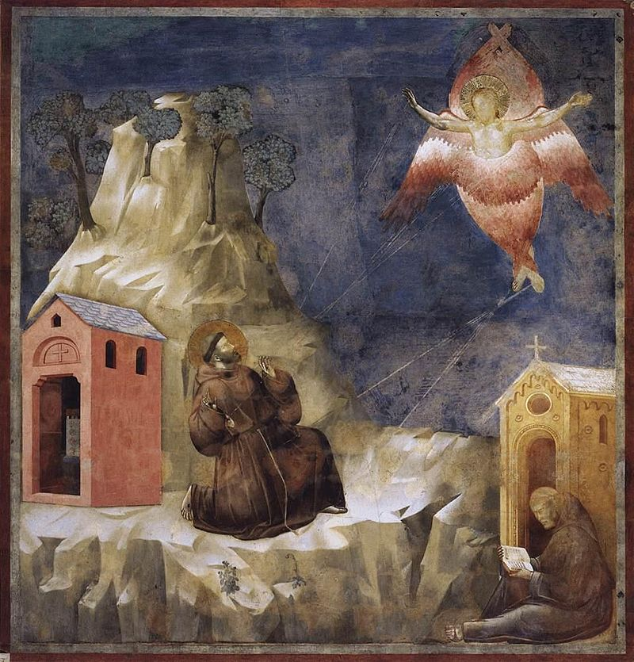
Figure 1- Giotto di Bondone, Stigmatization of St Francis, Upper Basilica, Assisi

A post-mortem miracle by Francis, underlines the curative and connected dimension with God of the stigmata. This is the healing of the man, mortally wounded in Lerida, Catalonia. The episode has a different moral value depending on the source used to analyze it. Thomas of Celano recounts the ferocious struggles of the kingdom of Castile in which, once, an innocent man was involved, a devout man to Saint Francis, who invokes him in a convent of friars. Believed to be incurable, if not dead, the man miraculously treated by Francis, gets up. Which promptly happened, thanks to the miraculous intervention of St. Francis.
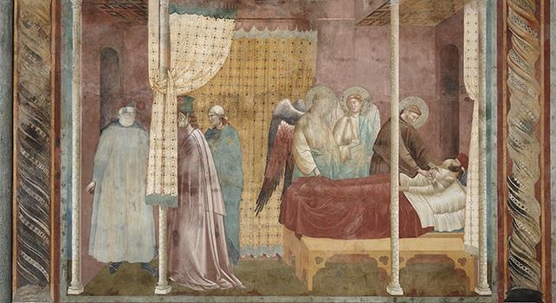
Figure 2 - Giotto di Bondone, Guarigione dell'uomo di Lleida, Upper Basilica, Assisi
Figure 3 - Giotto di Bondone, Stigmatization of St Francis, Upper Basilica, Assisi

Bonaventure of Bagnoregio, removes any hint of a historical conflict in Catalonia nor speaks of the convent in which the man goes. He mentions, instead, in the same way as Celano, the loss of hope in healing, when a man dressed as a monk approached his bed, untied his bandages and smeared an ointment on his wounds: it was Francesco. In front of Giotto's painting, there is a written sentence, visible in the underlying frame, that informs just how Francis healed the man. In the picture we see all the elements both of one and of the other source the left half of the picture portrays a consultation of the doctors, behind them we see the wife of the wounded, who listens worried. The right half, instead, portrays the injured man lying on a mattress with Francis, who leaned over him together with two angels handed him a jar with medicine.
An important mention made by Lunghi, is the similarity of the action of the Friar with that of the ‘penitent’ women: Francis, unlike the doctors who dressed to impress the sick, is exercising a work of mercy in favor of a wounded person, principle pivotal to the Friars Minor who were committed to the service of city hospitals, just as women, even before devoting themselves to contemplation and penance, were committed to assisting the poor and pilgrims who asked for help. ‘Affective piety’ is a description of the suffering and suffering that women experience, referring in particular to Mary. According to Caroline Walker Bynum this aspect, of rather feminine than masculine piety, has been little studied. The work of Bynum resulted in a vein of thought that believes that the body's meditations involved in 'affective piety' are considered to be related to femininity rather than feminine.

IV
The origins of the Franciscan family: places and beliefs

The places of the saints are fundamental in reference to the events that characterize their lives. Their city, the house where they were born and died, the church where they preached and the one in which their body is kept.
Approaching the story of Saint Francis, one also approaches places that characterize his entire life.
The frame that contains all the most important places is Assisi, his city.
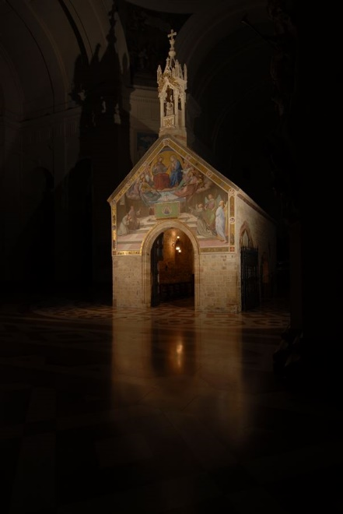
That is, in fact, the place where he was born and died, where he had a vocation, where he stripped himself of his possessions, where he changed his way of life, from an earthly life to a spiritual life.
If you enter into this frame, this city meets the places that have marked its path as a devout man.
Among these, two are fundamental: the small church of the Porziuncola and the Basilica of Saint Francis of Assisi. The first is linked to St. Francis still alive and to his initiative of founding the so-called Franciscan family, composed by the three orders under the guidance of himself. The second is linked to the cult of St. Francis and what he meant by death, is a ‘route’ inside the story of his life and the foundation the Orders.
The little church of the Porziuncola, which name indicates the small portion of land on which it stood, is located inside the Basilica of Santa Maria degli Angeli in Assisi.
It was the third church sheltered by Saint Francis after having had the vision under the crucifix of San Damiano to repair the house of Jesus.
Figure 1 - The Porziuncola, Papal Basilica of Saint Mary of the Angels in Assisi
This was the place where Francis, together with his first followers, on February 1209, decided to find the Order of Friars Minor, also known as Franciscans, entrusting the protection to the Virgin Mother of Christ, to whom the small church is dedicated.
This place is also fundamental with regard to the history of the formation of the Second Order, that of the nuns called Poor Clares, corresponding to the female of the Order of Friars Minor.
Chiara Offreduccio, later Saint Claire, went there and received from the Saint, between 1212 and 1214, the religious dress, starting her Order.
The other important place for the history of the Saint is the Basilica of Saint Francis of Assisi. From 1251, the year of its completion, it is recognized as the official church of the Franciscan Order.
According to tradition, St. Francis, before dying, expressed the desire to be buried in the place called collis inferni, hill of hell, right where the Basilica rises. This place was in fact used to host executions of criminals, those who, committing crimes, go to hell. So, metaphorically, he decided to stay forever with those who were considered the last of the community. Legend has it that the name of the hill was later changed to collis Paradisi, hill of Heaven, once the Saint's body was placed in the homonymous Basilica. This metaphor of being on the hill of criminals, of the marginalized, of the poor and of the last brings to some fundamental principles of one of the most important Order among the mendicants, that of the Franciscans.
From the latin word mendicare, to beg, the Mendicant Orders “were committed by vow to the renunciation of all possessions, common as well as individual”, begging to live and do not own anything are the key instructions.

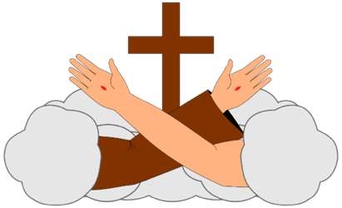


Figure 2 – Official Emblem Benedictines Order
Figure 4 – Official Emblem Franciscan Order
Figure 3 – Official Emblem Dominican Order

The Mendicant orders are distinguished, historically, in three main groups: the Benedictines, the Dominicans and the Franciscans. The Benedictines were a monastic organization that sees as fundamental values the practice of poverty and the preference for hermitism or, at least, for solitude.
The Dominicans have as their main purpose the struggle against the spread of medieval heresy identified in the Cathars and Waldensians groups, in fact their emblem is saying clearly “to praise, to bless, to preach”, are words which are in addition to the colors white, used as purity and chastity, and black, as renunciation and penance. The star indicates the predestination which together with the lily transmits the integrity and morality which, with the palm, represents the concept of martyrdom. the circular form symbolizes the spreading of the evangelical message around the whole world. According to Vauchez, the Franciscans, in addition to begging, were characterized by concern for others, extreme openness to the world that marked their apostolate and also in “showing the utmost reverence to the pope”, as Peckham said. Moreover, because they were friars, unlike the monks, they were not bound to a stable bond to life with a single monastery but, on the contrary, according to the needs of the local population, they moved from place to place. Regarding their emblem, as is explained by Andreozzi, is an episode narrated by Saint Bonaventure to explain its meaning:”[…]and while the sons were all around him, the patriarch of the poor, the holy man, almost blind and now near death, folded his arms and spread his hands on them in the form of a Cross and blessed all the friars, present and absent, in the power and in the name of the Crucifix”. This indicated that the blessing was imparted by Saint Francis “in the power and in the name of the Crucifix”, the two arms, are depicted as one nude (that of Christ) and the other dress (that of Francis).
Thus, the Franciscan family, united, under these four foundation-stones, three different Orders founded in three consecutive moments.
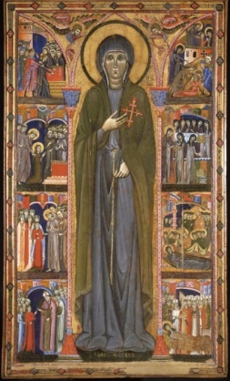
At the base there is the formation of the Ordo fratrum minorum, namely that formed by St. Francis in 1209, there are three different rules. The first rule, also called proto-rule, dated 1209, in which Francis declares the principles and, precisely, the rules that govern the life of the Franciscans; a second rule of 1219, called chapter "of the mats" or non-stamped rule, codified the obligations of the friars minor; and, last of all, the one still in force today, the Regula branded, approved and drafted in more juridical forms, on November 29, 1223 by Pope Honorius III, in the latter Francis also ceded the reins of the command to Friar Elia.
As was said before, in addition to the order of the Friars Minor, Saint Francis Rule under the leadership of Francis, also the order of the Poor Clares was founded. It was a feminine order, of which Clare was the leare, she was canonized as saint in 1255 after a life dedicated to dedication. This altarpiece of Saint Clare, created by Maestro of Saint Clare, painter of Giotto's school, is a composition of episodes that cross the life of the saint, in a counter-clockwise direction. His humility is visible on the day of the palms, followed by the gift of the palm by the bishop. The arrival at the Porziuncola accompanied by some friends, where she lays her rich clothes and wears the habit while Francesco cuts her hair. And other events that lead to the moment of death (which corresponds to the beginning of the life of a saint), a time when a large crowd left the city towards San Damiano and the funeral was celebrated by the Pontiff himself. The relationship between Saint Francis and the popes, Innocent III, Honorius II and Gregory IX it’s one of the best. According to Robson “the friars became instruments of papal reforms throughout Christendom”.
Figure 5 – Maestro of Saint Clare, Altarpiece of Saint Clare, 1283
The last one is the Third Franciscan Order, also called the Secular Franciscan Order, which troubled origins are described in various sources and historical documents. The question of where the foundation took place is very confusing. From the writings of Thomas and Bonaventure it may be inferred that the foundation by Saint Francis was made in 1212 in Alviano. It is characteristically made up of Christians who, by a specific vocation, commit themselves to live the Gospel in the manner of St. Francis of Assisi, observing a specific rule approved by the Church, confirmed by Pope Paul VI in 1978.
In conclusion it is important to see how, the entire project of the Franciscan family, realized what Francis had perceived in the moment of his conversion: every man is equal when he is naked before God.
Franciscanism is open to the whole 'human community' not only to the Christian religion, as Bini said: “It should also be remembered that the Franciscan charism has given life, a more unique than rare event, to Franciscan families in other Christian denominations: Anglican Franciscans and Poor Clares, Hindu Franciscan groups," friends "of St. Francis in every culture and religion”.

Bibliography

Primary sources:
- Gospel:
  - LK 6:20
  - MT 11: 25-26
- Thomas of Celano, Vita prima Sancti Francisci (1229)
- Thomas of Celano, Vita secunda Sancti Francisci (1246)
- Bonaventure of Bagnoregio, Legenda maior Sancti Francisci (1262-1263)
- Bonaventure of Bagnoregio, Legenda minor Sancti Francisci (1262-1263)
- Thomas of Celano, Tractatus de miraculis Sancti Francisci, (1247-1257)
Modern sources:
- Cambridge Advanced Learner's Dictionary and Thesaurus, Cambridge University Press - available at https://dictionary.cambridge.org/dictionary/english
- Oxford English Dictionary, Oxford University Press available at https://en.oxforddictionaries.com/
- Treccani Vocabolario della lingua italiana, available at http://www.treccani.it/vocabolario
- New Catholic Encyclopedia available at https://www.encyclopedia.com
- Cross F.L., The Oxford Dictionary of the Christian Church, Oxford University Press, (2005)
- J. Morwood, Pocket Oxford Latin Dictionary: Latin-English, Oxford University Press
- Pope Pio XII, Breve pontificio with which the Holy Father proclaims Saint Francis of Assisi and Saint Catherine of Siena primary patrons of Italy, (L’Osservatore Romano, June 1939)
- Pope Francis, Audience to media representatives speech of the Holy Father Francis at Paul VI Hall, Libreria Editrice Vaticana (March 16, 2013) available at http://w2.vatican.va/content/francesco/it/speeches/2013/march/documents/papa-francesco_20130316_rappresentanti-media.html
- Heimann M., The secularization of St Francis of Assisi, British Catholic History, vol. 33 (May 2017), pp. 401-420
- Boff L., Saint Francis: A Model for Human Liberation, SCM Press, (1982)
- Sorrell R. D., St. Francis of Assisi and Nature: Tradition and Innovation in Western Christian Attitudes toward the Environment, Oxford Scholarship Online, (2011), chap. VIII.
- Pasquale G., Attualità di san Francesco nel mondo contemporaneo, Credere Oggi, vol. 170 (2009), pp. 9-2.
- Cataldi P., Parafrasi e commento: nove letture di poesia da Francesco d'Assisi a Montale, Palumbo (2002), chap II.
- Peters E., Heresy and Authority in Medieval Europe, University of Pennsylvania Press, (1980)
- Hume D., An Enquiry Concerning Human Understanding, Oxford World's Classics (2008), section X.
- Spinoza B., Tractatus Theologico-Politicus, chap. VI
- Justice S., Did the Middle Ages Believe in Their Miracles? University of California Press, Representations, Vol. 103, No. 1 (2008), pp. 1-29
- Bynum C. W., Jesus as Mother: Studies in the Spirituality of the High Middle Ages, University of California Press, (1982)
- Thode H., Francesco d'Assisi e le origini dell'arte del Rinascimento in Italia, Donzelli Editore, 1993 pp.167 ss.
- Cricco G. and Di Teodoro F.P., Il Cricco di Teodoro. Itineriario nell’arte. Da Giotto all’età Barocca, Zanichelli (2010)
- Moleta V., From St. Francis to Giotto. The influence of St. Francis on early Italian art and literature, Franciscan Herald Press, 1983, pp. 1-2
- Lunghi E., Giotto e i pittori giotteschi ad Assisi: guida alle opere di Giotto e dei pittori umbri del Trecento nelle chiese e nei musei di Assisi, La Rocca (2012)
- Sorrell R. D., St. Francis of Assisi and Nature: Tradition and Innovation in Western Christian Attitudes toward the Environment, Oxford Scholarship Online, (2011), chap. VIII
- Cacciari M., Doppio ritratto. San Francesco in Dante e Giotto, Adelphi, (2012)
- Barlow F., Thomas Becket, University of California Press, (1997)
- Bonsanti G., The Basilica of St. Francis of Assisi, H.N. Abrams, (1998)
- Powell J. M., Mendicants, the Communes, and the Law, Church History, Vol. 77, No. 3 (2008), pp. 557-573
- Vauchez A., Apogeo del papato ed espansione della cristianità (1054-1274), Borla-Città Nuova,(1997)
- Pecham J., Expositio super regulam fratrum minorum, VIII, pp.391-437
- Moorman J.R.H., Richest of poor men. The spirituality of St Francis of Assisi, DLT (1977)
- M. J. P. Robson The Franciscans in the Middle Ages, Vol. 1, Monastic orders, chap. I
- G. Bini, Presentazione della Famiglia francescana, available at https://web.archive.org/web/20101128120914/http://ofm.org/2/min/10assisi.html

Pictures:

- Bonaventura Berlinghieri, Altarpiece of Saint Francis, 1235
https://it.wikipedia.org/wiki/San_Francesco_e_storie_della_sua_vita#/media/File:Bonaventura_Berlingieri_-_St_Francis_of_Assisi.jpg
- Giotto di Bondone, Stigmatization of St Francis, Upper Basilica, Assisi, available at https://it.wikipedia.org/wiki/San_Francesco_riceve_le_stimmate_(Assisi)#/media/File:Giotto_di_Bondone_-_Legend_of_St_Francis_-_19._Stigmatization_of_St_Francis_-_WGA09145.jpg
- Giotto di Bondone, Guarigione dell'uomo di Lleida, Upper Basilica, Assisi
https://www.fotosacroconvento.it/archive/it/1/RTN
- The Porziuncola, Papal Basilica of Saint Mary of the Angels in Assisi
http://www.porziuncola.org/porziuncola-12-1.html
- Official Emblem Benedictines Order https://it.wikipedia.org/wiki/Ordine_di_San_Benedetto#/media/File:Coat_of_Arms_of_the_Order_of_Saint_Benedict_(simple).svg
- Official Emblem Dominican Order
https://en.wikipedia.org/wiki/Dominican_Order#/media/File:EscOrdendePredicadores2Wikipedia.png
- Official Emblem Franciscan Order https://it.wikipedia.org/wiki/Ordine_francescano#/media/File:FrancescoCoA_PioM.svg
- Maestro of Saint Clare, Altarpiece of Saint Clare, 1283
http://www.assisisantachiara.it/wp-content/uploads/2012/01/003-e1328205674890.jpg

Definition of ‘patron saint’ from the Cambridge Advanced Learner's Dictionary & Thesaurus, Cambridge University Press available at https://dictionary.cambridge.org/dictionary/english/patron-saint, accessed April 2019.
Pope Pio XII, ‘Breve pontificio with which the Holy Father proclaims Saint Francis of Assisi and Saint Catherine of Siena primary patrons of Italy’, L’Osservatore Romano, (June 1939)
Pope Francis, ‘Audience to media representatives speech of the Holy Father Francis at Paul VI Hall’, Libreria Editrice Vaticana (March 16, 2013) available at http://w2.vatican.va/content/francesco/it/speeches/2013/march/documents/papa-francesco_20130316_rappresentanti-media.html
Figure 1, https://it.wikipedia.org/wiki/San_Francesco_e_storie_della_sua_vita#/media/File:Bonaventura_Berlingieri_-_St_Francis_of_Assisi.jpg
M. Heimann, ‘The secularization of St Francis of Assisi’, British Catholic History, vol. 33 (May 2017), pp. 401-420
L. Boff, ‘Saint Francis: A Model for Human Liberation’, SCM Press, (1982), chap. IV.
R. D. Sorrell, ‘St. Francis of Assisi and Nature: Tradition and Innovation in Western Christian Attitudes toward the Environment’, Oxford Scholarship Online, (2011), chap. VIII.
He inspired artists such as Giotto, Cimabue, Simone Martini, for art and Jacopone da Todi, for literature.
L. Boff, ibidem, Chap. II
LK 6:20
MT 11: 25-26
L. Boff, ibidem, pp. 48-59
G. Pasquale, ‘Attualità di san Francesco nel mondo contemporaneo’, Credere Oggi, vol. 170 (2009), pp. 9-2.
Thomas of Celano, ‘Vita prima Sancti Francisci’, (1229), chap. X and Bonaventure of Bagnoregio, ‘Legenda Maior Sancti Francisci’
P. Cataldi, ‘Parafrasi e commento: nove letture di poesia da Francesco d'Assisi a Montale’, Palumbo (2002), chap II.
Thomas of Celano, ibidem,
Thomas od Celano and Bonaventure, ibidem
E. Peters, ‘Heresy and Authority in Medieval Europe’, University of Pennsylvania Press, 1980
For example, the case of Saint Thomas Becket, first counselor to King Henry II, later appointed Archbishop of Canterbury, the highest office of the English church.
Thomas of Celano, ibidem,
D. Hume, ‘An Enquiry Concerning Human Understanding’, Oxford World's Classics (2008), section X.
Spinoza, Tractatus Theologico-Politicus, VI
‘Miracle’ on Oxford English Dictionary https://en.oxforddictionaries.com/definition/miracle accessed April 2019
http://www.treccani.it/vocabolario/miracolo/
S. Justice, ‘Did the Middle Ages Believe in Their Miracles?’, University of California Press, Representations, Vol. 103, No. 1 (2008), pp. 1-29
‘Passion of Christ’ in Oxford Dictionary of the Christian Church, Oxford University Press, (2005)
Thomas of Celano, Vita prima Sancti Francisci (1229) and Vita secunda Sancti Francisci (1246)
Bonaventure of Bagnoregio, Legenda majior Sancti Francisci and Legenda minor Sancti Francisci
Thomas of Celano, Tractatus de miraculis Sancti Francisci, (between 1247 and 1257)
Bonaventure of Bagnoregio, Legenda majior Sancti Francisci
Thomas, ibidem. Cap. II
Bonaventure, ibidem, Mir., II
Thomas of Celano, Vita prima Sancti Francisci, III and Bonaventure of Bagnoregio, Leggenda Maior, XIII 3,2
San Bonaventura da Bagnoregio, Legenda Maior Mir. I,5
Henry Thode, ‘Francesco d'Assisi e le origini dell'arte del Rinascimento in Italia’, Donzelli Editore, 1993 pp.167 and following
G. Cricco and F.P. Di Teodoro, ‘Il Cricco di Teodoro. Itinerario nell’arte. Da Giotto all’età Barocca’, Zanichelli, (2010)
V. Moleta, ‘From St. Francis to Giotto. The influence of St. Francis on early Italian art and literature’, Franciscan Herald Press, (1983), pp. 1-2
Elvio Lunghi, ‘Giotto e i pittori giotteschi ad Assisi: guida alle opere di Giotto e dei pittori umbri del Trecento nelle chiese e nei musei di Assisi’, La Rocca, (2012)
R.D. Sorrell, ‘St. Francis of Assisi and Nature: Tradition and Innovation in Western Christian Attitudes toward the Environment’, chap. 8, Oxford Scholarship Online, (October 2011)
Vita prima of Saint Francis was composed between the end of 1228 and 1229 by Thomas who was commissioned by Pope Gregory IX to write an official legend for the canonization of Francis, which took place in February 1229.
Thomas of Celano, Tractatus de miraculis Sancti Francisci, chap. II
Thomas of Celano, Second Life of St Francis, chap. III, 94
Thomas, ibidem. Tractatus de miraculis Sancti Francisci, chap. II
The presence of witnesses, in this case the other friars, is a fundamental element for the subsequent canonization as saint.
M.Cacciari, ‘Doppio ritratto. San Francesco in Dante e Giotto’, Adelphi, 2012
A very similar case is that of Thomas Becket who was canonized saint only two years after his death. It is important to note that the 'fast track' in Becket's canonization process was delimited by two factors: the fact that he was killed in his own church, and for this reason considered a martyr and the push for recognition by churchmen, friends (for example John of Salisbury) and the French archbishops. The latter communicated the names of the murders to the Pope. F. Barlow, ‘Thomas Becket’, University of California Press (1997)
Thomas of Celano, ibidem, Vita prima Sancti Francisci
Thomas, ibidem, I, 9-13
Figure 1 - https://it.wikipedia.org/wiki/San_Francesco_riceve_le_stimmate_(Assisi)#/media/File:Giotto_di_Bondone_-_Legend_of_St_Francis_-_19._Stigmatization_of_St_Francis_-_WGA09145.jpg
G. Cricco and F.P. Di Teodoro, ibidem, pp. 377-78
E. Lunghi, ibidem,
Thomas, ibidem. Tractatus de miraculis Sancti Francisci, chap. II
Bonaventure, ibidem, Legenda Maior
Figure 2 - https://www.fotosacroconvento.it/archive/it/1/RTN
Both Thomas and Bonaventure, ibidem
Lunghi E., ibidem
Bynum,C. W., ‘Jesus as Mother: Studies in the Spirituality of the High Middle Ages’, University of California Press, (1982)
Thomas of Celano, The First Life of St. Francis
Figure 1http://www.porziuncola.org/porziuncola-12-1.html
Bonaventure of Bagnoregio, Legenda Maior, II, 1
Thomas, ibidem, IX, 356
Definition of “Poor Clares” in F.L Cross, The Oxford Dictionary of the Christian Church, Oxford University Press, 2005
Bonsanti G., The Basilica of St. Francis of Assisi, H.N. Abrams, 1998
Henry Thode, ‘Francesco d'Assisi e le origini dell'arte del Rinascimento in Italia’, Donzelli Editore, 1993, pp.167-
The hill where the Basilica stands is on the bounds of Assisi, almost outside. In fact, often, the hill that was on the borders and above the cities, was used as a place to execute those who committed crimes, so that it was visible to all citizens. As an example, see the manuscript Vatican MS Lat 4015, in which, among other depositions in favor of the canonization of Thomas of Cantilupe as a saint, one was the story of William Cragh a criminal who was hanged on the hill on the border of the city of Swansea in Wales, where everyone could see him.
Definition of “mendicare” on J. Morwood, ‘Pocket Oxford Latin Dictionary: Latin-English ‘, Oxford University Press
"Mendicant Orders." New Catholic Encyclopedia, Encyclopedia.com. 8 Apr. 2019 - https://www.encyclopedia.com
J. M. Powell, Mendicants, the Communes, and the Law, Church History, Vol. 77, No. 3 (2008), pp. 557-573
Figure 2 -https://it.wikipedia.org/wiki/Ordine_di_San_Benedetto#/media/File:Coat_of_Arms_of_the_Order_of_Saint_Benedict_(simple).svg
Figure 3 - https://en.wikipedia.org/wiki/Dominican_Order#/media/File:EscOrdendePredicadores2Wikipedia.png
Figure 4 - https://it.wikipedia.org/wiki/Ordine_francescano#/media/File:FrancescoCoA_PioM.svg
“Benedectines” on Enciclopedia Federiciana Treccani, section by Giorgio Picasso in Federiciana (2005), which is an encyclopedia based only on the events regarding the period of king Federico II of Svevia. Available at http://www.treccani.it/enciclopedia/benedettini_%28Federiciana%29/ accessed on April 2019
“Dominicans”, Cross, ibidem.
A.Vauchez, ‘Apogeo del papato ed espansione della cristianità (1054-1274)’, Borla-Città Nuova, (Roma 1997)
J. Pecham, ‘Expositio super regulam fratrum minorum’, VIII, pp.391-437
G. Andreozzi, ‘Ritorno a Francesco’, Atti del Congresso sula formazione francescana del Terzo Ordine Regolare di San Francesco (Assisi, 8-19 lugho 1979), Roma 1980 (= Speciale Acta Ordinis, vol. II, fasc. 7, 1980, pp.1-380).
According to J.R.H. Moorman, ‘Richest of poor men. The spirituality of St Francis of Assisi’, DLT (1977), the four foundation-stones are: humility, simplicity, poverty, prayer.
Vauchez, A., ibidem
Figure 5 - http://www.assisisantachiara.it/wp-content/uploads/2012/01/003-e1328205674890.jpg
M. J. P. Robson ‘The Franciscans in the Middle Ages’, Vol. 1, Monastic orders, I
Thomas and Bonaventure, ibidem
G. Bini, ‘Presentazione della Famiglia francescana’, available at https://web.archive.org/web/20101128120914/http://ofm.org/2/min/10assisi.html

