DS 1 Template

My Screenshots/Photos

Screenshot/Photo 1
Google Maps
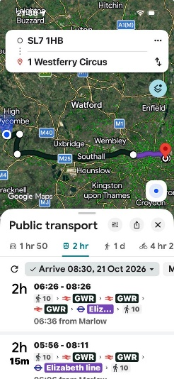
It shows how I use Google Maps to find directions.

Screenshot/Photo 2
Google Translate
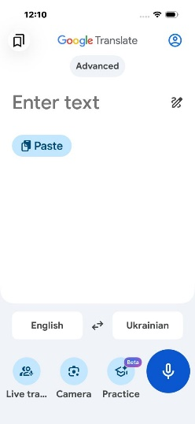
I use Google Translate for translation.

Screenshot/Photo 3
Tesco App
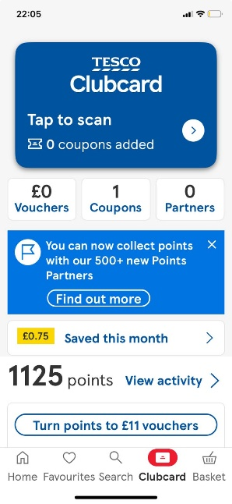
I use the Tesco app to collect points and get discount when I shop.

Screenshot/Photo 4
iRobot App
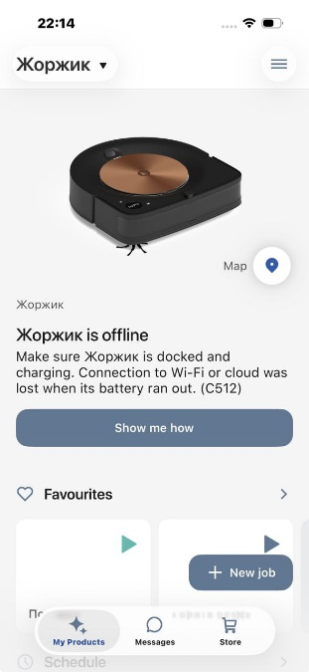
I use my iRobot app to control my robot vacuum cleaner.

Screenshot/Photo 5
Amorino Academy App
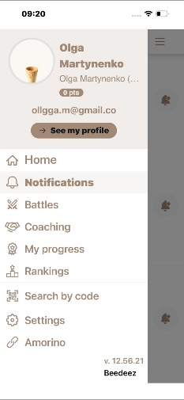
I use an Amorino Academy App to check the latest information for my work.

Screenshot/Photo 6
Outlook Calendar
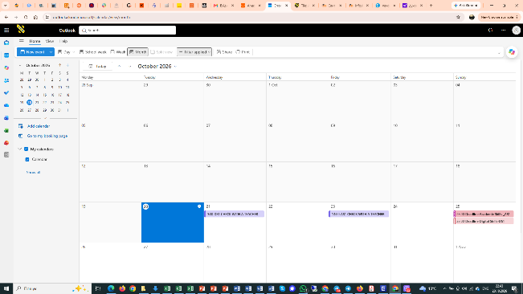
I use Outlook Calendar to organise my appointments and meetings.

My Short Reflection

- I use these tools more often in my life: Google Maps, Google Translate and the Tesco app.
- I used to write down all my events on a paper calendar, but now I have started to use Outlook Calendar.
- I would like to improve my skills in using Outlook Calendar because it's not convenient bring a paper calendar with me all the time.
- I sometimes feel nervous about using Google Translate because I worry that the translation might be wrong.
- I use digital tools to make my life easier. For example: Google Maps to find the fastest or shortest route to a place.
- I hope this module will help me to use digital skills in more areas of my everyday life.
- Digital skills are important for me because I can spend less time doing some work, fix problems faster and check information quicker.

