DS 1 Template

Konya Gamanga

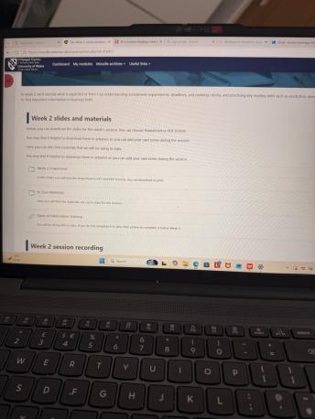
This screenshot shows me using Module to access my university lessons, including the Week 2 slides, class materials and session recording . I use Module regularly to keep up with my studies, check what work I need to complete and go back over lesson materials when I am studying at home .

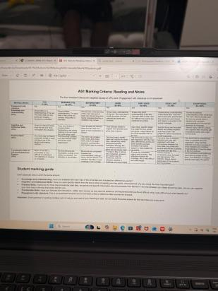
This image shows that , I am checking the marking criteria for my Reading and Notes assessment to understand what my lecturer expects and how the different grades are awarded . I use this guild to check whether I have explained the main idea. Included different key points and examples from the text, and reflected on what I found difficult and what helped me, so I know where my word needs improvement.

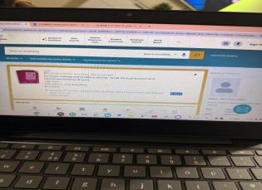 I used the university online library to find Decision Making and Problem Solving by John Adair and checked the author, edition and whether I could access it online. Checking these details helps me choose academic resources for my course and find books I can use when studying at home.

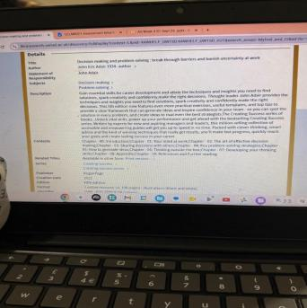
In this screenshot, I am checking the details of Decision Making and Problem Solving by John Adair in the university’s online library. I look at the author, edition, description and chapter list to get an idea of what the book covers. This helps me decide whether it is useful for my course and which chapters to read.

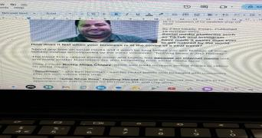
In this image, I am reading a BBC article for a class activity about how TikTok and Instagram can help businesses attract customers. I used the text to practise scanning for names, numbers and key words, which helped me find specific information more quickly without reading every word from the beginning.

My Short Reflection

I use digital tools to access my lessons, find information and prepare work for my university modules. I often use these tools: Module, the university online library and digital documents on my laptop. Module helps me review weekly slides, find class materials and check assessment instructions and marking criteria. When searching the online library, I check the author, edition, description and chapter list of books such as “Decision Making and Problem Solving” to decide whether they will support my learning. Reading the BBC article helped me practise scanning for names, numbers and key words, including information about Murat’s staff and how far customers travelled. At first, scanning was difficult because I normally read everything from the beginning, but I feel confident when I can now find specific details more quickly. Using an assessment template helps me organise my notes and answers and check that I have completed each section before submitting through Module. I want to improve my online searching and scanning skills by practising with different academic resources and longer texts, using more specific search words and organizing useful information into clear notes or mind maps.

