Modern and traditional construction, managing the design and construction process/ civil engineering technology

- Student name-Jean-Paul Marshall

- Student id number-2023697

- Lecturer’s name-Rhodri Thomas

- Submission deadline-09/01/2023

- Word count-2500

Contents
Introduction
Location information
Awards
Geology of Nottingham
Ground type in the area
History of the build location
Estimated excavation works
Analyse and discuss the superstructure materials
Design
Green strategy
Strength
Stability
Fire safety
Aesthetics
Environmental impact, badgers
Sustainability
Building dimensions
Cad drawing of the building
Conclusion
Building regs
References

Introduction
This essay is going to highlight the given topics, foundation requirements, location information, ground types of weather factors, history of the build location, estimated excavation works, superstructure materials, design, characteristics, environmental impact, and sustainability. The building we will be looking at is the GSK Carbon neutral laboratory for sustainable chemistry, university of Nottingham

Foundation requirements (analyse and discuss) and estimated excavation works
When calculating the foundations of this build the architect and engineers needed to calculate a few different areas, these compromised of the ground type, building size and weight, the use of the building, the items that will or could be stored/used in the building and the amount of people that would use the building, this all forms a calculation for weight the foundation will have to bare. When looking at the foundations of this building we can see they where raft foundations, raft foundations are formed by using concrete and reinforced concrete that cover the entire footprint of the building. This method was designed by john wellborn (Hoffman, 1988), they are designed to spread the load of the frame across the entire foundation. They used this foundation type due to the ground type in this area as described in ground types below, the only downside to using this type of foundations is they are prone to settlement over time, but this is normally calculated into the design and if the subbases are correctly compacted there will be minimum settlement. Using the raft foundations was the best foundation choice for this build when looking at the fundamentals of ground type, building type, weight, and use. The use of pile foundations where not needed as the ground was bore tested previously as described and there was a building on the location previously. When looking at the excavation of the site we would have to look at what was there currently and work towards the plan of the building. So, looking at the footprint size and weight calculations along with the ground types and depths needed. To work this out look without no foundation information, I would look at the footprint size and weigh bearing needed and use the correct formula for doing this volume of excavation=length x width x depth its important to remember that you remember that the measurement is in cubic feet so 1m3=35.3147feet3. so, by using this method I would estimate the excavation to be around 25000 m3.

Location information
The GlaxoSmithKline Carbon Neutral Laboratory for Sustainable Chemistry is located at university park Nottingham England NG72ND, it is surrounded by buildings of the same nature, such as the British nuclear medicine society. This has a lot of history within the manufacturing industry dating back to 1800s and further. Some of these include the auxiliary fire station that closed on 18th of august 1941, the rally factory, players cigarette factory which was partly knocked down to make room for the jubilee campus and the triumph factory to name just a few (nanrah, 2021) (times, 2022) There are known coal mines nearby such as the Wollaton mine which opened in 1874 and closed in 1961. It’s also worth noting that there are several other coal mine locations some which are Bestwood, Cinderhill and cots gave, the last mine to close was Annesley in the year 2000 (society, 2022).
Ground type in the area
Originally Nottingham started its life built beside the river Trent and was built on sandstone that offered a well-drained location above the river marshes, The area is made up from Palaeozoic rocks on the northwest side and Mesozoic strata to the southeast side. There is an underlying carboniferous which is coal bearing, alluvial deposits, lime stones, permo-trassic mudstones and weak sandstone. There is an artificial deposit covering most of the original geology and is made up from social, industrial, and mineral extraction mainly coal, clay, aggregates, and oil. With the extraction of natural resources in this area it has caused some repercussions such as abandoned mineshafts that can collapse and subside, artificial cavities in sandstone and contaminated land from the industrial use. There is also reported minor earthquakes in the area due to the gathering of natural resources and should be considered in any planning stage of building in this area (F.G.bell, et al., 2009). These findings are backed up with core hole samples of the area and surrounding area and are viewable on the British geological survey (survey, varies). It is also noted in the planning permission request that there is measures put in place to investigate and plan to manage the escape of gaseous emissions, the investigations used where a geo site investigation by castle rock in May 2004 reference 040209N and 040209N(1) and a letter and gas protection measure drawing from ward Cole, dated 2005. The management protocols include installing permeable gas membrane that will be lapped and tapped, ventilation of confined spaces and a continuous passive venting layer under the floor slab, that ventilates passively (council, 2005)

Awards
BREEAM Awards 2018 Winner
Award for Carbon neutral laboratory at The University of Nottingham Innovation Park:

Weather factors
According to the .gov website there is no risk to flooding in this area (GOV>UK, 2022) and according to (date, 2022) there hottest month is 16 Celsius and the coldest is January at Celsius. This information is important for when we look at the materials used in the construction as we can work out the expansion and contraction of the materials, this is referred to as coefficient of thermal expansion (kollman, et al., 1975). The wettest month is November with an average of 70.7 mm of rain fall and an annual average of 691.3 mm, this information with the windiest month which is January with average wind speeds of 9mph gives us more information on how the weather will affect the build and what needs to be implicated in the design stage from the foundations to the cladding used.

History of the build location
The location of the now GlaxoSmithKline Carbon Neutral Laboratory for Sustainable Chemistry building used to be a factory for Raleigh bicycle company, the Raleigh bicycle company moved into this factory in 1966. The company is an icon one for Nottingham and made around a million bikes a year and was the biggest producer of bikes in the world (Nanrah, 2021). There have been recordings of contamination of this site, the recommendations where clean capping for asbestos, a barrier to stop infiltration, radon gas protection (Bre, 2022)

Analyse and discuss the superstructure materials
The walls, frame and floors of the build are constructed from pefc and fsc timber sourced from Europe approximately 500 tonnes of timber sourced from 100 mature spruce trees that would cover the size of two football pitches as well as German spruce, Austrian spruce, and American red cedar
(notingham, 2022) Pefc is an organisation that certifies timber that is environmentally friendly and sustainable (pefc, 2022). FSC forest stewardship council is an organisation that is responsible for promoting sustainable timber (home, 2021). The system used for joining and forming the main supporting timbers was the resix system, the framing system is used Widley across construction due to its structural strength, ability to transfer loads through its beams, Colum’s to the ground. It also creates big areas that are not boxed in. The timber sections are prefabricated of site thus speeding up the build process and keeps the site footprint smaller as you don’t have to store them on site. The walls and floors were made in the same way. Doing them in this way made the build eco friendly (sham, et al., 2017). As shown the use of lamination of the wood, epoxy and steel bar is unnoticeable in jointing and strong.

Design
The building was designed by Fairhurst’s design group for the use as a sustainable chemistry premises for Nottingham university, it has a distinctive volumetric design, it is made up of two storeys spread across 4500m2. It was designed to be resource and energy efficient. The design, material choice and form where very important as they would come together to make the build carbon neutral (Earchitect, 2018) The use of computational dynamics was important in the design as it shows how fluids flow and where there might be a problem won’t pages 421-472 (Anon., 2011). They used thermal modelling in the design process as stated in CIBSE AM11 this is directed at internal comfort. The fume cupboards where designed, installed and tested to BS EN 14175. This is the standard to protect users from dangerous vapours. A carbon model was incorporated early in the project design so that it could guide them through the project. They hired an ecologist to help on the site with biodiversity and they played a part in the design of the grass roof. The roof was designed with dry swale, trap gully and filter drains to in place to disperse running water. The design incorporated the carbon calculator and that helped choose the correct materials and lent on the timber build design (Bre, 2022).

Green strategy
From design to build they had protocols in place so they stayed on track and within the limits, to do this they incorporated a number of protocols such as they made the principal contractor to register with the considerate construction scheme this made sure they managed the build in a way that was within the lines for resource usage, pollution and energy consumption, there was natural ventilation for the labs from the roof and create a visual feature. The roof is 45 percent covered with solar panels, there is a leak detection meter and meters are linked up to different tasks to identify usage. Ecologists were hired to look after the site and monitor biodiversity (Bre, 2022).

Frame—glulam timber frame
The floors, exterior walls and roof deck are made from cross laminated timber prefabricated of site, The use of cross laminated timber not only offers a faster build time, a low environmental impact and design flexibility but it offers some sought after characteristics such as being lightweight, strong, great acoustic properties, fire resistant, greater thermal properties, and seismic resistance (association, 2018)

Fire safety
There was a fire in the early stages of the build, fire services said it spread so fast as it was naturally ventilated as there was no roof, windows or doors as well as not having a fire system in place. It was then said the design team implemented a 200mm thick cross laminated design and changed the roof ridge design purchased from a German manufacturer (waite & thomson, 2014). When constructing any building there is building standards that must be always followed in this case that building standards are in Fire safety: approved document B. BS 476-1 is the protection against a spreading flame and the heat released from the material that is on fire, BS 13501-1 is the classification of construction products and building elements and these are put in ratings of protection (gov.uk, 2020).

Aesthetics
The cladding is made up of red cedar boarding with a terracotta and has a grey colour, this was used on top of wood hangers. They used this to fit in with the other materials used in the nearby buildings that are mainly zinc or metallic in nature. The building has a south facing pitch clad, the north face is sloping green roof made up of timber and grass (Lijeh, 2016)

Sustainability
When looking at the sustainability of this build, there are several factors to consider, there is the construction of the building, the manufacture of all the materials used, energy consumption over its lifetime and eventually the demolition or retrofit of the building. The construction of the carbon neutral laboratory consists of natural building materials mainly timber, the energy the building will use in its day to day running will come from solar panels and biofuel. By using these methods, the building will create more power than it uses, thus creating a deficit that will eventually cover the embodied carbon from the construction. The building incorporates brand new technology and well-known principles such as air, light and heat movement. It’s worth mentioning here that there is a 70 percent reduction in embodied carbon in this build compared to a conventional build of this type, the building its self-captures wind to use as ventilation, uses solar panels and bio fuel to power itself, collects and re uses rain water, merges in with the landscape, shuts down power when not in use and then wakes up when in use (GSK, 2012).

Building dimensions
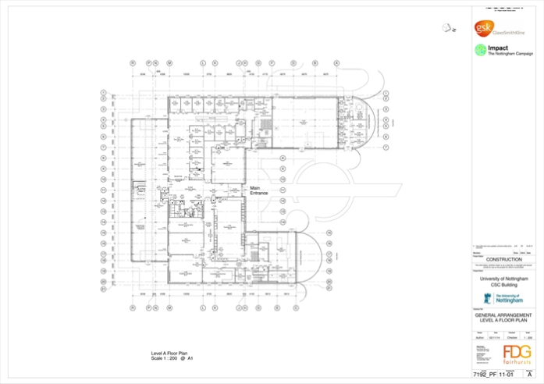
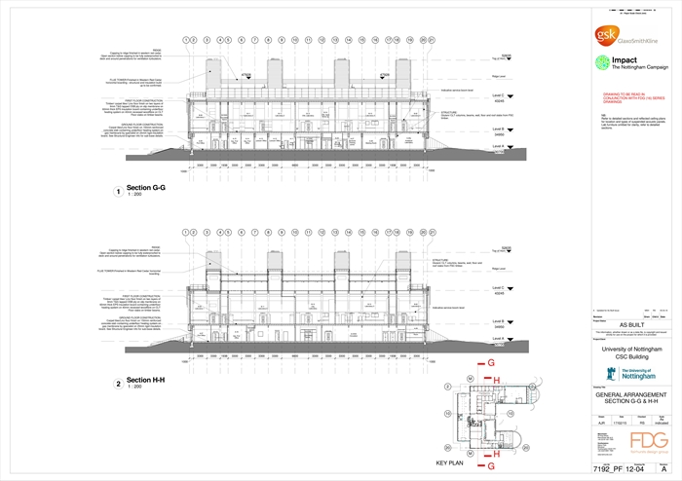
(GSK, 2012) (RIBA, 2018)
Conclusion
When looking at the design of this building, you can see that it’s a head of its time, the design includes the use of modern technology incorporated with proven and well research techniques when it come to the use of resources not only in the build itself but the future running, and upkeep and energy uses. The aesthetics of the building have been designed not only to fit in with the surrounding buildings and wildlife but to blend in and incorporate them. Its important to add this point the choice of materials are not only low in carbon but supplied the characteristics they needed when it came to minor earthquakes, weather protection, aesthetics, design, and speed of construction. Construction was done in a traditional but modern way using traditional methods in a modern way allowing them to build big open areas with the engineering characteristics they needed for strength, durability, and aesthetics. What is impressive is their goal for carbon neutrality, every detail of this building from the design to the construction to the lifetime of this building was well thought out and implemented. It was so impressive it won several awards and was dubbed the green university. They had a fire in the early stages that destroyed most of the build and set back the completion date, but they factored the loss of carbon and re calculated this into there goals and still come to the same plan, that is they will be carbon neutral with in twenty-five years, a most impressive result.

References
Anon., 2011. fluid mechanics (fith edition). In: fluid mechanics (fith edition). cambridge, massachusetts: Academic Press.
association, T. e. w., 2018. Cross-Laminated Timber (CLT). [Online]
Available at: https://www.apawood.org/cross-laminated-timber
[Accessed 1 December 2022].
Bre, 2022. GlaxoSmithKline’s Carbon Neutral Laboratory for Sustainable Chemistry achieves BREEAM Outstanding. [Online]
Available at: https://bregroup.com/case-studies/breeam-new-construction/glaxosmithklines-carbon-neutral-laboratory-for-sustainable-chemistry-achieves-breeam-outstanding/
[Accessed 30 november 2022].
council, N., 2005. Town and country planning act 1990 aplication for planning. [Online]
Available at: https://publicaccess.nottinghamcity.gov.uk/online-applications/files/C4C02A4B17AAA2EB69C339E9A70ECA39/pdf/04_02682_PFUL3-DECISION_NOTICE-334583.pdf
[Accessed 1 December 2022].
date, t. a., 2022. time and date. [Online]
Available at: https://www.timeanddate.com/weather/uk/nottingham/climate
Earchitect, 2018. GlaxoSmithKline Carbon Neutral Laboratory for Sustainable Chemistry. [Online]
Available at: https://www.e-architect.com/birmingham/glaxosmithkline-carbon-neutral-laboratories-for-sustainable-chemistry
F.G.bell, Culshaw, m., forster, A. & Nathanial, C., 2009. The engineering geology of the Nottingham area, UK. Engineering geology for tomorrows cities, 22(1), pp. 1-24.
gov.uk, 2020. Fire safety: Approved Document B. [Online]
Available at: https://www.gov.uk/government/publications/fire-safety-approved-document-b
[Accessed 30 November 2020].
GOV>UK, 2022. check for flooding in nottingham. [Online]
Available at: https://check-for-flooding.service.gov.uk/location?location=Nottingham+
GSK, 2012. GSK and University of Nottingham collaborate to create Centre of Excellence for sustainable chemistry. [Online]
Available at: https://www.gsk.com/en-gb/media/press-releases/gsk-and-university-of-nottingham-collaborate-to-create-centre-of-excellence-for-sustainable-chemistry/
[Accessed 13 December 2022].
Hoffman, D., 1988. The Architecture of John Wellborn Root, University of Chicago Press, Chicago. 2 ed. Chicargo: University of Chicago Press.
home, e., 2021. ALL ABOUT FSC CERTIFIED LUMBER & WOOD PRODUCTS - WHY FSC CERTIFICATION IS IMPORTANT. [Online]
Available at: https://www.ecohome.net/guides/3610/what-is-fsc-certified-lumber-or-wood-and-why-choose-it/
[Accessed 30 november 2022].
kollman, F., kuenzi, E. & stamm, a., 1975. Principles of wood science and technology. In: illustrated, ed. Principles of wood science and technology. california: Springer-Verlag, p. 45.
Lijeh, I., 2016. Carbon Neutral Laboratory: Out of the ashes. [Online]
Available at: https://www.building.co.uk/focus/carbon-neutral-laboratory-out-of-the-ashes/5084942.article
[Accessed 30 november 2022].
nanrah, G., 2021. The well-know factories lost over the decades. [Online]
Available at: https://www.nottinghampost.com/news/history/well-known-nottinghamshire-factories-lost-5942894
Nanrah, G., 2021. What it was like to work at Raleigh in Nottingham before the manufacturer relocated. [Online]
Available at: https://www.nottinghampost.com/news/nottingham-news/what-like-work-raleigh-nottingham-4990725
notingham, u. o., 2022. School of chemistry. [Online]
Available at: https://www.nottingham.ac.uk/chemistry/research/centre-for-sustainable-chemistry/the-carbon-neutral-laboratory.aspx
[Accessed 30 november 2022].
pefc, 2022. what is pefc. [Online]
Available at: https://www.pefc.org/discover-pefc/what-is-pefc
[Accessed 30 november 2022].
RIBA, 2018. ​​The GSK Carbon Neutral Laboratories for Sustainable Chemistry. [Online]
Available at: https://www.architecture.com/awards-and-competitions-landing-page/awards/riba-regional-awards/riba-east-midlands-award-winners/2018/the-gsk-carbon-neutral-laboratories-for-sustainable-chemistry
[Accessed 13 11 2022].
sham, F. a. b. s., sing, k. e. & hui, l. l., 2017. prefabricated timber framing system. [Online]
Available at: https://www.slideshare.net/LinHui2/prefabricated-timber-framing-systems-78278757
[Accessed 26 november 2022].
society, N. m. r., 2022. Nottinghamshire coalfield-nottingham area. [Online]
Available at: https://www.nmrs.org.uk/mines-map/coal-mining-in-the-british-isles/derbynotts/nottingham/
survey, B. g., varies. Bore hole materials. [Online]
Available at: https://webapps.bgs.ac.uk/data/bmd/bmdResult.cfm?BORE_NAME_VALUE=&SHEET_50K=Nottingham126&SHEET_10K=&Depth_Operator=gt&Depth_value=&page=6
[Accessed 1 November 2022].
times, l., 2022. lenton times. [Online]
Available at: https://www.lentontimes.co.uk/streets/triumph_road.htm
waite, r. & thomson, P., 2014. Fire destroys Fairhursts-designed university lab. [Online]
Available at: https://www.architectsjournal.co.uk/archive/fire-destroys-fairhursts-designed-university-lab
[Accessed 30 November 2022].

Interesting videos
(56) What is Raft Foundation? Raft Foundation explained in details. - YouTube
Raft foundation and how they are constructed
(56) Time lapse: GlaxoSmithKline Carbon Neutral Laboratory for Sustainable Chemistry - YouTube
Time lapse video of the full build
(56) Burning GSK carbon neutral laboratory for sustainable chemi - YouTube
The fire that devastated the build in the early stages

