BA (Hons) Leadership and Management Skills for the Workplace

LCLM5002 Developing and Managing Individuals and Teams

Component 2- Individual Report

Lecturer Doreen Nyaa Amundam

Ayan Tifow 2420687


Table of Contents
Cover Page | Page 1
Table of Contents | Page 2
Introduction | Page 3
Key HR Challenges  a) Technological Advancements | Page 4
b) Talent Acquisition and Retention | Page 5
c)Diversity, Equality and Inclusion | Page 6
Contemporary HR Practices to address these challenges | Page 7
Table 1.1 Key Issues and Solutions | Page 8
Conclusion and Recommendations | Page 8 & 9
References | Page 10

Human Resource Challenges in the Department for Work and Pensions

Introduction
The Department for Work and Pensions is one of the largest employers within the United Kingdom public sector. The organisation is responsible for administering welfare benefits, pensions and financial support services to millions of citizens. Due to the scale of its responsibilities, the department operates within a complex and highly regulated environment that requires an adaptable and capable workforce. Employees must be able to respond to policy changes, technological developments and evolving public expectations while maintaining high standards of service delivery.
In recent years the organisation has experienced a range of human resource challenges. Rapid technological advancement, increasing competition for skilled employees and growing expectations around Diversity, Equity and Inclusion have placed additional pressure on workforce management. These challenges mean that the human resource function must move beyond traditional administrative roles and adopt a more strategic approach that supports organisational transformation and workforce sustainability.
Technological innovation has significantly reshaped the way government services are delivered. Digital platforms are now used for benefit applications, case management and communication with service users. While these systems can increase efficiency and improve accessibility, they also require employees to develop new digital competencies. The transition towards digital service delivery accelerated following the COVID 19 pandemic, when remote working and online service provision became essential.
At the same time, the public sector faces increasing competition from private organisations in attracting skilled professionals. Private sector employers often provide higher salaries, flexible working arrangements and faster career progression opportunities. As a result, government departments must develop innovative recruitment strategies and emphasise the social value of public service in order to attract and retain talented individuals.
Another important consideration is the growing emphasis on Diversity, Equity and Inclusion. Public sector organisations are expected to demonstrate fairness, equality and representation within their workforce. A diverse and inclusive workplace is essential not only for legal compliance but also for improving organisational decision making and reflecting the communities that the department serves.
This report analyses three key human resource challenges faced by the Department for Work and Pensions. These include technological advancement, talent acquisition and retention, and Diversity, Equity and Inclusion. The report also evaluates contemporary human resource practices that can address these issues and concludes with recommendations that support sustainable workforce development.

Key HR Challenges
a) Technological Advancement


Technological advancement refers to the rapid integration of digital tools, automation systems, artificial intelligence and data driven decision making within organisations. In the context of the Department for Work and Pensions, this transformation includes the introduction of online benefit application systems, digital case management platforms, robotic process automation and data analytics used to inform policy decisions.
One of the main challenges associated with technological advancement is the speed of innovation. New digital systems are frequently introduced at a pace that exceeds employees’ ability to adapt. Public sector organisations often rely on legacy systems that were developed many years ago and must continue to operate while new technologies are implemented. In addition, government departments must comply with strict regulatory and security requirements. These factors can slow digital transformation and create difficulties when integrating modern technologies into existing systems (CIPD, 2022).
Another challenge is the presence of digital skills gaps within the workforce. Many employees joined the organisation before the widespread use of advanced digital technologies and may lack expertise in areas such as data analytics, artificial intelligence or digital service management. Without appropriate training and professional development opportunities, employees may struggle to operate new systems effectively. Research indicates that digital skill shortages represent a significant challenge for both public and private sector organisations (Bersin, 2018).
Resistance to change also represents a significant issue. Technological change can disrupt established work routines and create uncertainty among employees. Some staff may worry that automation will replace certain roles or reduce job security. When employees feel excluded from decision making processes related to technological change, they may demonstrate reluctance to adopt new systems. Change management literature suggests that resistance often arises when employees feel uncertain about how technological transformation will affect their roles and responsibilities (Kotter, 2012).
A further concern involves digital inequality within the workplace. Employees may have different levels of confidence and experience when using digital technologies. Some employees may require additional support in order to participate fully in technology driven work environments. If these differences are not addressed, inequalities in digital capability can emerge, potentially affecting productivity and employee engagement.
b) Talent Acquisition and Retention


Talent acquisition and retention refer to an organisation’s ability to attract skilled professionals and maintain their long term commitment to the organisation. For the Department for Work and Pensions, these issues have become increasingly significant in a highly competitive labour market.
One major challenge is competition for skilled employees. Government departments must compete with private sector organisations, particularly within areas such as technology, data analysis and policy research. Private companies often offer higher salaries, greater financial incentives and faster career progression opportunities. In contrast, public sector organisations operate within structured pay scales and promotion frameworks, which may appear less attractive to potential candidates (CIPD, 2022).
Employer branding also influences recruitment outcomes. Younger professionals increasingly seek organisations that offer dynamic work environments, innovation and meaningful career opportunities. If the public sector is perceived as bureaucratic or slow moving, it may struggle to attract highly skilled individuals despite offering job stability and the opportunity to contribute to public service.
Workforce demographics present an additional challenge. Many government departments have a significant proportion of experienced employees approaching retirement age. This creates risks related to the loss of institutional knowledge and expertise. Without effective succession planning strategies, organisations may struggle to replace experienced staff or transfer their knowledge to younger employees.
Employee engagement and job satisfaction also influence retention levels. Research suggests that rigid organisational structures, limited autonomy and slow promotion processes can reduce motivation and increase turnover intentions among employees (Armstrong and Taylor, 2023). If employees perceive limited opportunities for professional development or career advancement, they may seek opportunities in other organisations.

c) Diversity, Equity and Inclusion

Diversity, Equity and Inclusion represent an important area of focus for modern human resource management. These concepts refer to organisational practices designed to ensure that individuals from different backgrounds have equal opportunities, fair treatment and a sense of belonging in the workplace.
Within the United Kingdom, employment equality is supported by legislation such as the Equality Act 2010. This legislation requires employers to prevent discrimination and promote equal opportunities regardless of characteristics such as gender, ethnicity, disability, religion or sexual orientation. Public sector organisations must also comply with Public Sector Equality Duty requirements that promote fairness and accountability.
Despite these legal frameworks, representation gaps remain within many organisations. Research indicates that individuals from ethnic minority backgrounds, disabled employees and members of the LGBTQ plus community remain underrepresented in senior leadership roles. Limited representation may reduce diversity of thought within decision making processes and affect organisational credibility (Shore et al., 2011).
Another challenge arises when diversity initiatives focus primarily on numerical representation without addressing workplace culture. Employees must feel respected, valued and psychologically safe to contribute effectively. Without inclusive leadership and supportive organisational cultures, diversity policies may fail to achieve their intended outcomes.
The concept of intersectionality also highlights that individuals may experience overlapping forms of inequality based on multiple aspects of their identity. For example, an employee may experience challenges related to both gender and ethnicity. Human resource policies must therefore recognise the complexity of employee experiences and avoid simplistic approaches to diversity management (Crenshaw, 1989).

Contemporary HR Practices to address These Challenges
Modern organisations must adopt strategic human resource practices in order to respond effectively to technological change, workforce competition and the need for inclusive workplaces. Contemporary HR approaches focus on workforce development, organisational flexibility and inclusive leadership.
One important practice involves continuous learning and digital upskilling programmes. As digital technologies become increasingly integrated into organisational processes, employees must regularly update their knowledge and competencies. Structured training programmes focusing on digital literacy, data analysis and emerging technologies can help employees adapt to new systems more effectively. Continuous professional development also improves employee confidence and reduces resistance to technological change (Marchington et al., 2021).
Another useful practice involves the development of digital champion networks within teams. Digital champions are employees who possess strong technological skills and can provide guidance to colleagues during digital transformation initiatives. Peer learning can often be more effective than formal training programmes because employees may feel more comfortable seeking assistance from colleagues. These networks also help organisations build internal expertise and reduce reliance on external consultants.
To address recruitment and retention challenges, organisations can develop a strong Employer Value Proposition. An Employer Value Proposition communicates the benefits of working within the organisation, including career development opportunities, organisational values and work life balance. For public sector organisations, emphasising the opportunity to contribute to society and improve citizens’ lives can be particularly appealing to potential employees (Taylor, 2022).
Flexible working arrangements also represent an important contemporary HR practice. Hybrid working models allow employees to divide their time between office and remote work environments. Flexible working arrangements can improve job satisfaction, increase productivity and enhance work life balance. These policies can also expand recruitment opportunities by allowing organisations to attract candidates from a wider geographical area (CIPD, 2023).
Human resource strategies that promote Diversity, Equity and Inclusion are also essential. Inclusive recruitment practices such as structured interviews, diverse selection panels and transparent evaluation criteria can reduce unconscious bias during hiring processes (Armstrong and Taylor, 2023). These strategies help organisations attract candidates from diverse backgrounds and improve fairness in recruitment decisions.
Employee resource groups represent another useful initiative. These groups provide support networks for employees who share similar backgrounds or experiences. Employee resource groups can also provide valuable feedback to senior leadership regarding workplace challenges and opportunities for improvement. However, for these initiatives to be effective they must be supported by strong leadership commitment and integrated into wider organisational strategies.

Conclusion and Recommended Solutions
The Department for Work and Pensions face a range of significant human resource challenges that affect workforce capability and organisational performance. Technological advancement, talent acquisition and retention difficulties and the need to strengthen Diversity, Equity and Inclusion practices represent three major issues that require strategic attention.
Technological change continues to transform how public services are delivered. While digital systems improve efficiency and accessibility, they also require employees to develop new skills and adapt to evolving work practices. To address this challenge, the organisation should expand digital training programmes and invest in continuous professional development opportunities. Encouraging employee participation in digital transformation initiatives can also reduce resistance to change and improve system adoption (Kotter, 2012).
Talent acquisition and retention remain critical priorities for the organisation. Competing with private sector employers requires the development of attractive employment conditions and clear career progression pathways. Strengthening employer branding by emphasising the value of public service can help attract individuals who are motivated by social impact. Succession planning programmes should also be implemented to ensure knowledge transfer between experienced employees and newer staff members.
Diversity, Equity and Inclusion must remain central to organisational strategy. While legal frameworks provide a foundation for equality, genuine inclusion requires cultural change and leadership commitment. Inclusive recruitment strategies, leadership development programmes for underrepresented groups and workplace training on cultural awareness can help create more equitable work environments. Building an inclusive culture where employees feel valued and respected will improve engagement, innovation and organisational performance (Shore et al., 2011).
Table 1.1 HR Challenges, Key Issues, HR Practice and Implementation Strategies
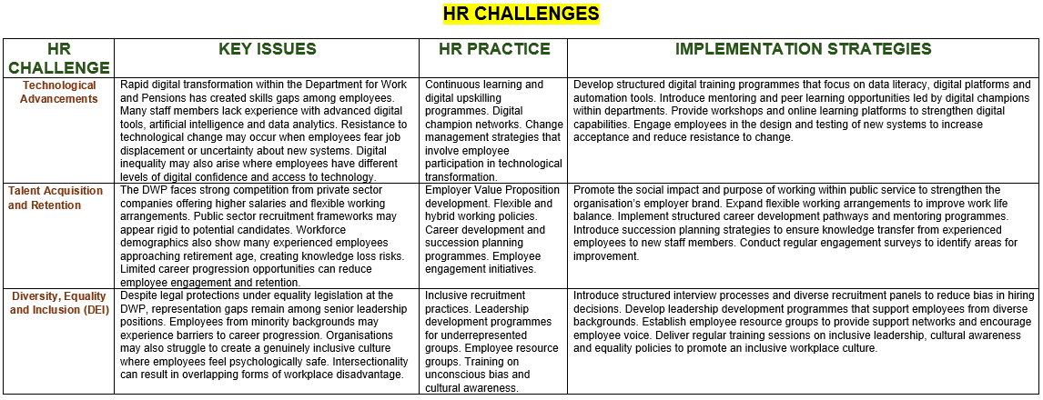
Overall, addressing these challenges requires an integrated human resource strategy that combines workforce development, inclusive leadership and organisational flexibility. By investing in digital skills, strengthening recruitment practices and fostering inclusive workplace cultures, the Department for Work and Pensions can develop a resilient workforce capable of meeting future public service demands.



