3/24/2025
University of Wales Trinity Saint David
London campus
University of Wales Trinity Saint David
London campus
E-Portfolio Link: https://2518401.wixsite.com/karamvir-dhanoya
Module Name: Learning In the Digital Era
Module Code: ACCA 4025

Student Name:Karamvir Singh Dhanoya
Student ID:2518401
Group: 4
Lecturer’s Name: Dipo Dunsin

LDE Assignment 1
E-Portfolio
Table of Contents
Introduction 1
Main Body 1
Task 1: Essential Academic and Employment Skills for the future career Path 1
Task 1 (a): Report on Essential Academic and Employment Skills 1
Task 1 (b): Evaluation of Task 1 (a) based on Similarity report 1
Task 2: Collaborative Mind Map and Individual Poster 1
Mind Map (Collaborative) 1
Poster (Individual) 1
Task 3: Virtual Collaboration and RefWorks 1
Report on Virtual Collaboration 1
Step-by-step process of using RefWorks with visuals 1
Task 4: E-Portfolio Creation and Evaluation 1
Task 4 (a): E-Portfolio Creation 1
Task 4 (b): Illustrative Review of E-Portfolio tool Selection 1
Conclusion 1
References 1
Task 1 References: 1
Task 2 References: 1
Task 3 References: 1
Task 4 References: 1

Introduction

Main Body

Task 1: Essential Academic and Employment Skills for the future career Path

Task 1 (a): Report on Essential Academic and Employment Skills
Nowadays when the professional world moves fast it is also very important to acquire the necessary employability skills to succeed in academic and work [1]. Recent studies show that adaptability, collaboration, emotional regulation and digital literacy are some of the competencies that are being sought by employers and form the basis of job readiness in the long term [4]. Indicatively, a semi-systematic review found a range of global employability skills that appeared in the 21st century work environment [5], which included adaptability and interpersonal abilities [3]. Besides, the ability to collaborate with others, to go beyond technical skills, becomes a defining factor of performance in any field [1]. Systematic review of pedagogical strategies identified that collaboration and working in a team are key competencies in professional practice and that digital and algorithm-enhanced approaches can additionally contribute to their enhancement. [1]. Lastly workplaces that invest in the training of emotional competencies, including emotional intelligence and regulation, show moderate positive impacts on teamwork and organisational performance of employees [5] [2].
All these findings indicate that domain-specific knowledge should not be the focus of study and employment-orientated individuals, but meta skills (e.g., self-management, communication, collaboration) should be prioritised to succeed in dynamic situations [1]. Having organised reflective time, practice and technological assistance, the learners will be able to develop a solid skill set that will satisfy not only the academic need but also the needs of the workplace [2].

Task 1 (b): Evaluation of Task 1 (a) based on Similarity report
Looking at my Turnitin report, I received a 27% percent similarity score, in many cases, student submissions and typical academic wordings. There were no flags or integrity, which indicated that my citations were done in accordance with the IEEE standards. To do even better I will paraphrase some of the technical expressions and change the structure of the sentences. Overall, the report demonstrates the appropriate use of the sources and originality. I would mark my work as good, as there was good research and proper referencing.
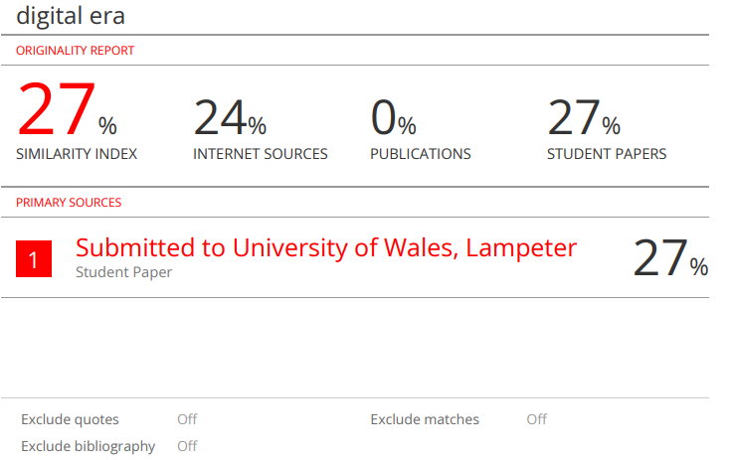

Task 2: Collaborative Mind Map and Individual Poster

Mind Map (Collaborative)
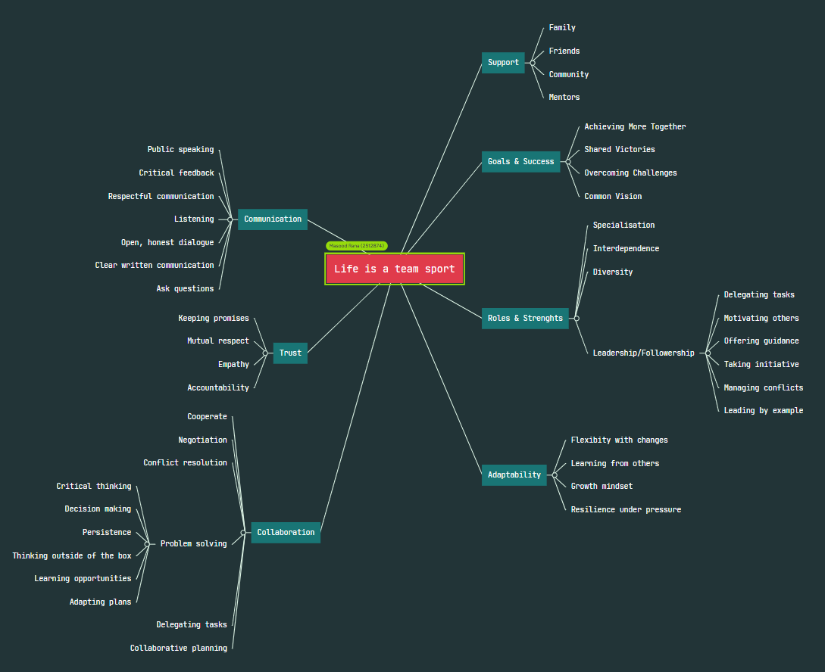

Link to Mind map

https://mm.tt/map/3856264788?t=OTYSnddAZ2

Academic Poster
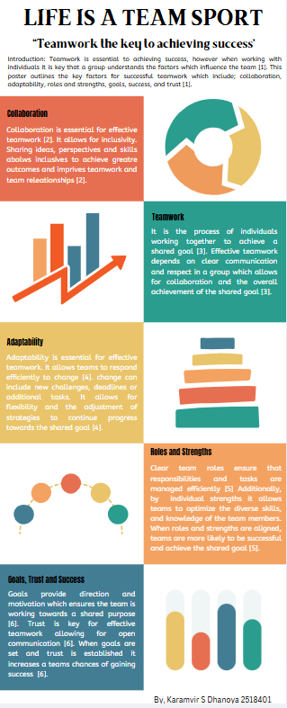
Link to Academic Poster:
https://www.canva.com/design/DAG4zkrHugs/YdhNQc323p1SQD8JtjQ1nw/edit?utm_content=DAG4zkrHugs&utm_campaign=designshare&utm_medium=link2&utm_source=sharebutton

Task 3: Virtual Collaboration and RefWorks

Report on Virtual Collaboration

Unit 3- Topic 3: The New Norming
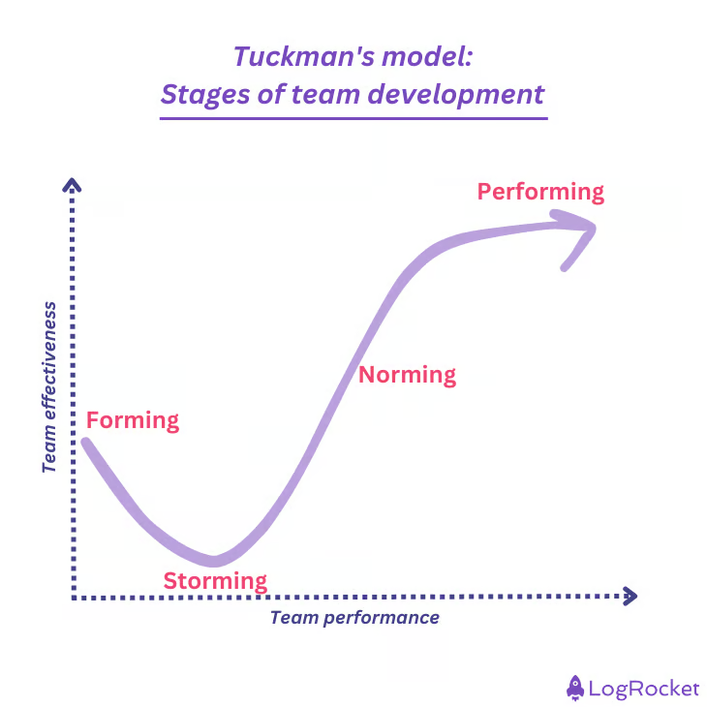
Figure 1- Team development and group development model [2]
Tuckman's team development
Forming, Storming, Norming, performing this model was created to make a more successful and effective team. A description of these 4 stages are listed below.
Forming: this is the stage where the team starts to make connection and start to understand their roles
Storming: this is the stage where tension starts to build up in the group and certain boundaries are exceeded due to different individuals' personality traits. [1]
Norming: This is the stage where individuals start to get along with each other they follow the group leader they start to discover each others strengths and weaknesses and more respect is divided with each other in the group
Performing: This is the stage where we can finally see more love in the group and each other are doing the work to their maximum potential. [1]
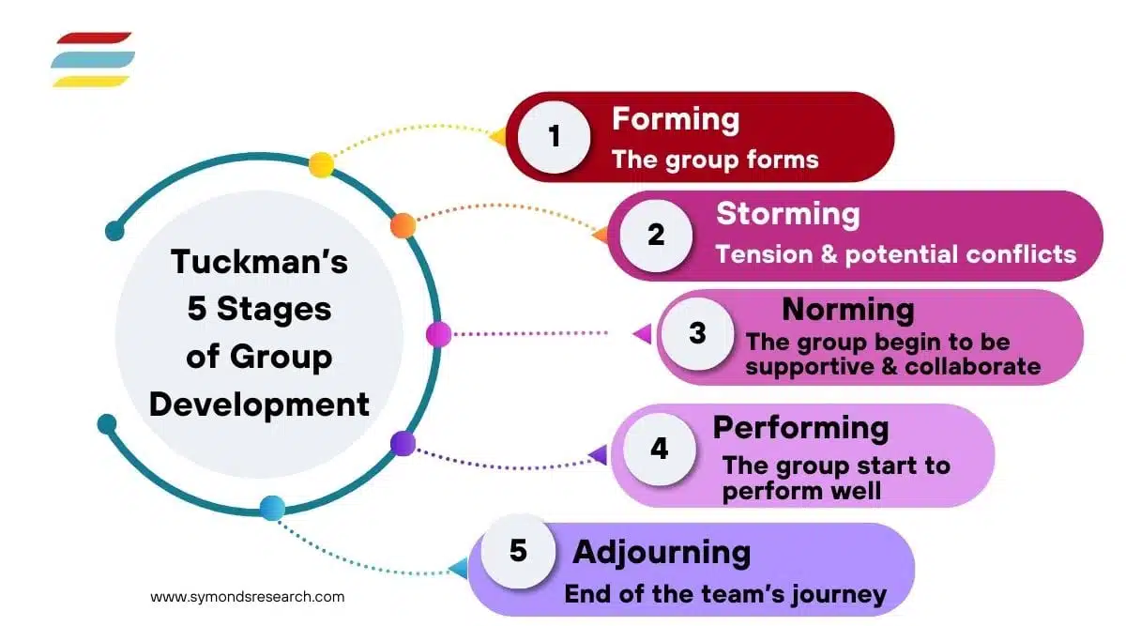
Figure 2 Diagram of group development
For this part of the assignment i have decided to go Deeper into the word norming.
Norming
Norming is all about the individuals are actually giving out the opinions within the group instead of listening to the leader and just following him they are giving their own thoughts also.

Step-by-step process of using RefWorks with visuals
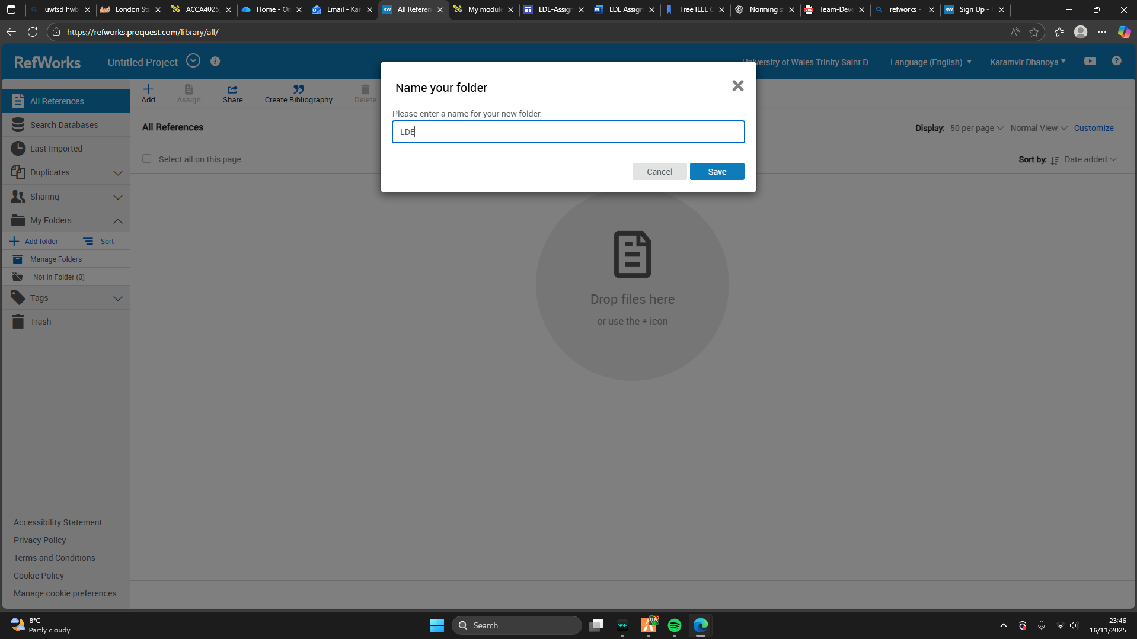
1) I created a new folder and named it LDE so that it's easier to use and understand and also saved it.
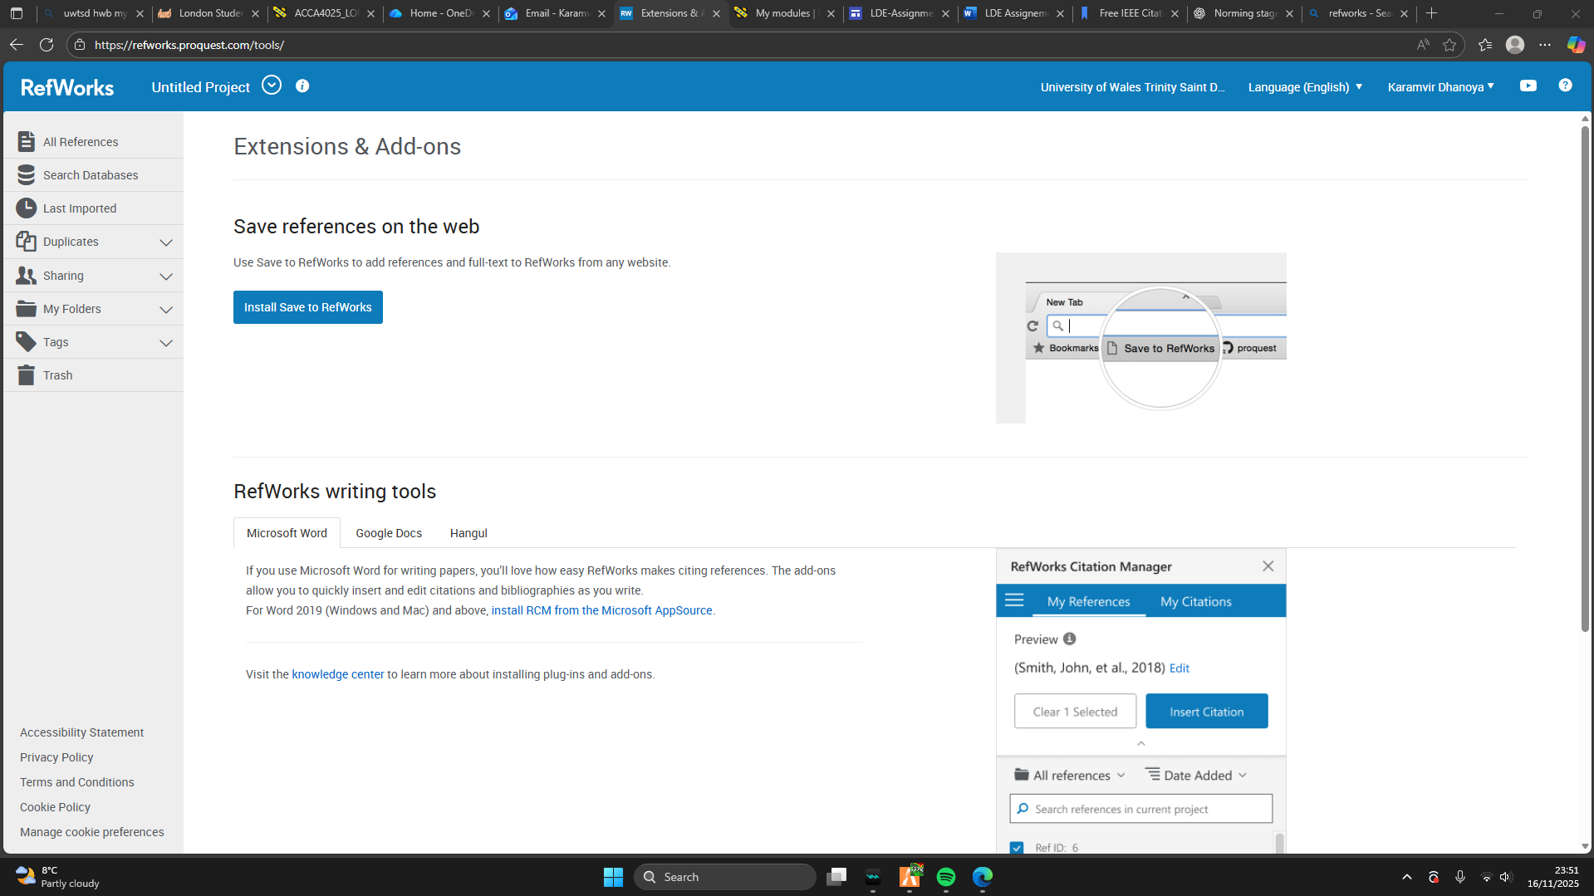 2) installing RefWorks on my toolbar to make the app more accessible

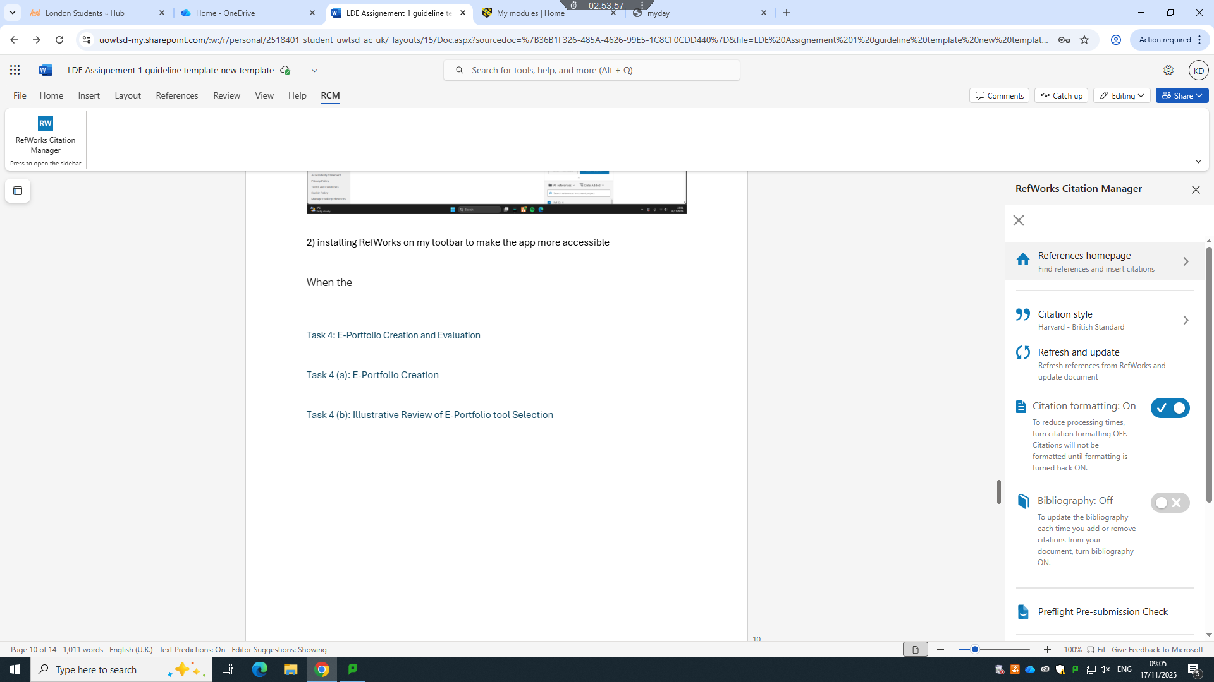
3) When the RefWorks sidebar is visible after I logged on it was very important that I to make sure that I chose the right citation style for my work for example I have chosen the uwtsd IEEE referencing style.

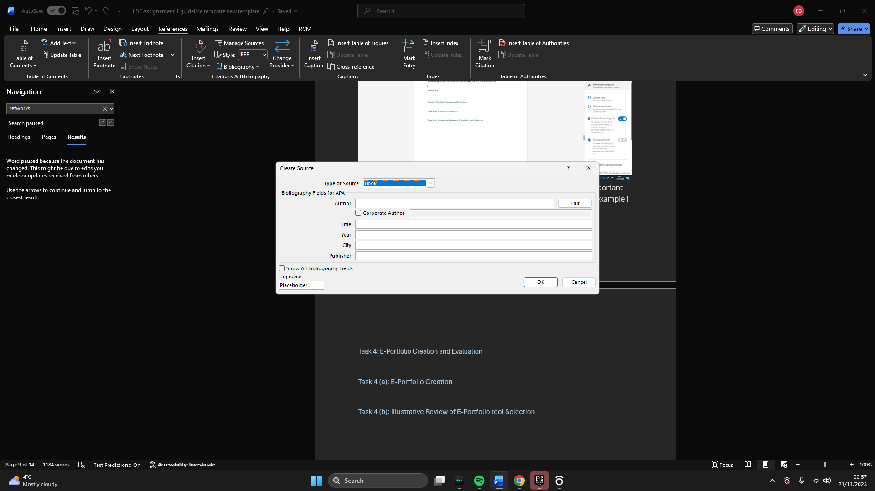4) this is how I entered the references I chose I wrote them all up accordingly what I can see on the reference.

Task 4: E-Portfolio Creation and Evaluation

Task 4 (a): E-Portfolio Creation

Task 4 (b): Illustrative Review of E-Portfolio tool Selection

Conclusion

References

Task 1 References:
[1]D. Colledani, E. Robusto, and P. Anselmi, “Assessing key soft skills in organizational contexts: development and validation of the multiple soft skills assessment tool,” Frontiers in Psychology, vol. 15, Oct. 2024, doi: https://doi.org/10.3389/fpsyg.2024.1405822.
[2] Mehler, M., Balint, E., Gralla, M. et al. “Training emotional competencies at the workplace: a systematic review and meta-analysis.” BMC Psychol 12, 718 (2024).
[3] Spencer, E. and Lucas, B., 2021. Meta-Skills: Best practices in work-based learning - A literature review. University of Winchester, 2021.
[4] The Skills Imperative 2035: what Does the Literature Tell Us about Essential Skills Most Needed for Work? 2022.
[5] A. M. Ruiz-Ortega and María Pilar Berrios-Martos, “The Role of Emotional Intelligence and Frustration Intolerance in the Academic Performance of University Students: A Structural Equation Model,” Journal of Intelligence, vol. 13, no. 8, pp. 101–101, Aug. 2025, doi: https://doi.org/10.3390/jintelligence13080101.

Task 2 References:
[1] P. R. Cohen and H. J. Levesque, “Teamwork,” Noûs, vol. 25, no. 4, p. 487, Sep. 1991, doi: https://doi.org/10.2307/2216075.
[2] A. Barfield, “Collaboration,” ELT Journal, vol. 70, no. 2, pp. 222–224, Mar. 2016, doi: https://doi.org/10.1093/elt/ccv074.
[3] D. Shah, “Transformational Teamwork: The Virtues and Values of Collaboration,” Marshall Journal of Medicine, vol. 2, no. 3, Jul. 2016, doi: https://doi.org/10.18590/mjm.2016.vol2.iss3.1.
[4] D. Webster, “The Power of an Adaptable Team: Thriving Through Change,” Centreforteams.com, Mar. 08, 2024. https://www.centreforteams.com/blog/the-power-of-an-adaptable-team
‌[5] T. Friedlander, “The Power of Team Dynamics: Leveraging Strengths-Based Leadership to Build Unstoppable Teams,” HCI Consulting, Sep. 24, 2024. https://www.innovativehumancapital.com/article/the-power-of-team-dynamics-leveraging-strengths-based-leadership-to-build-unstoppable-teams
‌ [6] B. Kitch, “10 ways to build trust in a team | Mural Blog,” www.mural.co, Dec. 13, 2022. https://www.mural.co/blog/build-team-trust
‌

Task 3 References:
[1] Hughes and Keith, "Forming, Storming, Norming, and Performing - Tuckman's Model for Nurturing a Team to High Performance." https://www.mindtools.com/abyj5fi/forming-storming-norming-and-performing (accessed Nov 3).
[2] B. Krawczyk, “The Tuckman model: 5 stages of team development,” LogRocket Blog, Jul. 19, 2023. https://blog.logrocket.com/product-management/tuckman-model-5-stages-team-development/

Task 4 References:

