"Discuss how you would plan and design a project management process for the workplace"

Introduction
As discussed in the first assignment, I don’t think that one methodology perfectly fits the organisation, or the department in which I work. As such, I recommended a hybrid approach to project management, taking elements from both traditional and agile methodologies to best achieve a project management system and therefore completing projects. I will discuss the elements of each methodology that I think should be used within this approach.
A project that I’ve recently worked on is replacing signage on all Welsh campuses. Within this project my role was to ensure that the numbering of the rooms was accurate. I will also discuss how this could now be planned within this new methodology and how that would improve the process and the outcome of the project.
Hybrid Approach
Due to the size and variety of project activities within my organisation, it was difficult to align with just one methodology. Some projects are small-scale and sit alongside BAU activities and others are much larger and are colleagues’ sole focus for a period of time. I work in the Estates department, and even here the projects can vary from remedial maintenance to new builds. This problem is observed in other higher education institutions, who have also researched a hybrid approach as a solution.
Many of the projects, particularly within Estates, are grant-funded or partially-funded. With these types of projects, there is a certain amount of planning and design of the project that needs to take place in order to obtain funding and be given the go-ahead to proceed. There is also a new focus on business cases, where these have to go to a senior level or committee in order to have permission to proceed and be given the budget to execute the project. In order to be able to put together a business case or an application for funding, the project needs to be planned to a certain point, including scope, timescale, and brunch. As such, from the waterfall method, the Requirements and Design phases would be helpful in front-loading the information and therefore being able to fill in any required documentation. By doing this, the project team will have all of the requirements for the project, including a detailed understanding of the aim of the project, being able to create a brief. One way of gathering this information, is following a template such as Project Canvas which considers all key elements of the project. During the Design phase, a solution to the initial problem or a scope for the project can be outlined; this includes the scope, budget requirements, timescales, team requirements. Both of these phases of the waterfall method can be used to complete any Business Cases and Funding applications required. Also, considering risks and mitigations at this stage is essential to foresee any potential issues, this is built in to the more traditional methods and helps to avoid many of the risks associated with a project. This level of forward-planning is beneficial within a larger organisation that has more governance to adhere to, including reporting to different councils and stakeholder meetings.
Once the planning piece has been undertaken, and the project given the go-ahead, I think more agile methods are needed. In the traditional methods, if there is any variation to the planning, it requires going back to the beginning of the project and working back through the steps again. Since many projects need to be completed within an academic year, there isn’t always time or resource to be able to do this. Therefore, having more scope for flexibility within the project at this stage is needed in order to ensure that it can be completed within the timeframe required. Another issue is that usually staff are expected to complete projects as well as continue with their BAU tasks, so flexibility on the project is important.
The core Agile principle of continuous feedback and improvement should be incorporated. This ensures that the project is progressing in the way that is necessary for the university and its staff and students and can incorporate other ideas and changes into the project. Often, during the initial phases of the project, it is only one team that is involved, meaning that only one view is considered. When you start incorporating stakeholder engagement, there may be other opportunities for improvement, including other issues that could also be incorporated into the project, or other maintenance issues in the same area that could be resolved at the same time.
Some departments within the university work in sprints, although I’m not sure that this would necessarily work for every project. It is particularly difficult to manage sprints with BAU as everyone needs to focus on the work involved in the sprint. The benefit of a sprint is that it breaks the work down into tasks and focuses on completing each task and then reviews the tasks and they can be incorporated to improve the following tasks and sprints.
Another element of the traditional methods that could be incorporated into this methodology is the more formal handover to BAU. Within Estates this is something that is already done, particularly with larger projects such as new buildings, as the building will need to become operational. Currently, we have a template that is followed, with all of the possible considerations for handover to operational delivery, which prompts actions if applicable. This process works well, but may need to be considered for a wider range of projects within Estates.
Context of project
The initial purpose of this project was to ensure that there was clear signage on all rooms. There had been a number of complaints and issues of people being unable to find the correct room or the signage being unclear. The main driver for this project was student experience, but also impacted other building users. The project was originally within another team within Estates, but as there was an impact within my remit of Space Management, I was brought in on the project to review the location data.
One issue that was discovered was that there were inconsistencies within the room numbers, with some rooms having multiple numbers or references. There were also inaccuracies within the floorplans where works had taken place (such as rooms being knocked into one) but floorplans hadn’t been updated. There were also complications in the various systems and documentation that referred to room names or numbers, with the numbers varying on each system, causing problems for the end users. In some cases, rooms had up to 4 different references.
The original deadline was set as September 2023 in order to be in place by the beginning of the teaching period. Once it was discovered that there was more work to be done than simply replacing door signs, we opted for a phased approach and aimed to get the busier and student-facing areas done by September, with other areas being done throughout the year. There were also a number of teams involved in the project across the university.
Due to time and budget constraints, as well as feedback from stakeholders, the project was placed on hold in August 2023 with a new deadline of September 2024. As there is now a break in the project, as well as my findings from the course, I am reviewing the project and setting out a new, revised plan in order to be able to deliver this by the next academic year.
Review of project to date
The main issue facing the success of this project was the scope, which increased significantly once the project was underway. Initially, the project was simply replacing signage, but the issues in room numbering caused more preparation to get to that stage and the number of systems and documents that would need to be changed as a result was not originally considered. The increase in work required, as well as the number of teams implicated in this project, meant that the initial scope underestimated the work involved. This also led to the timescale being unrealistic given the new scope.
The physical signs required also needed to be reviewed as some campuses and buildings already had adequate and consistent signage. A template needed to be agreed, in terms of what information would be included on the door; this had to meet marketing and accessibility guidelines. There was also a need to do an analysis of what spaces were used for, particularly office spaces that had changed occupants.
One other failure of the project was in the stakeholder engagement, mainly due to the ever-increasing scope. I think there was also a lack of a communication plan, and a lack of understanding on who’s feedback was required; some stakeholders would have experienced a greater change than others depending on their location.
Defined roles were not established as part of this project. Each team was working in isolation, with no oversight of the whole project, meaning that certain elements were missed, including the stakeholder engagement piece.
Project Planning
In view of these issues in the first iteration of this project, as well as the proposed project management process outlined in the first assignment, it is now possible to re-plan the project. As discussed, a hybrid approach is recommended for my workplace and department, using elements from traditional and agile methodologies as well as project tools such as Project Canvas.
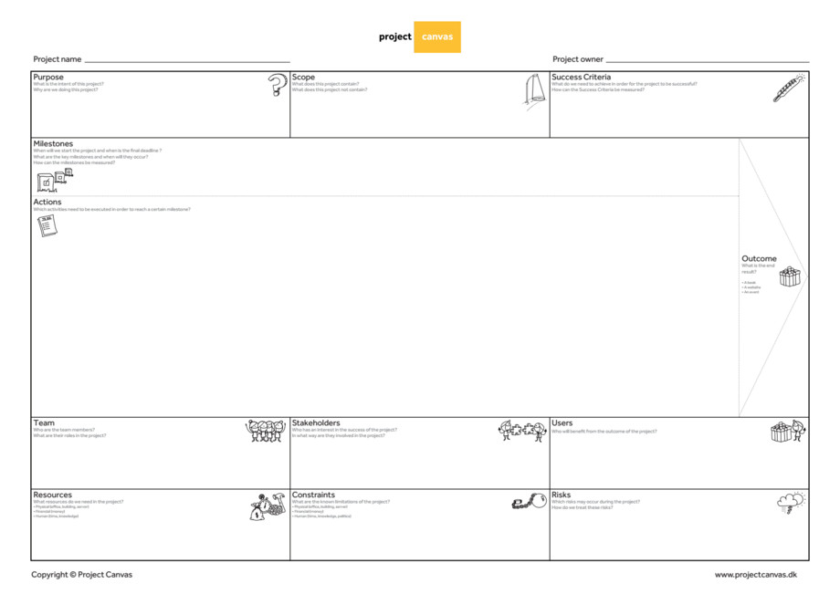
Project Canvas is a good planning tool, which can be used to front-load information as is done in traditional project management methodologies such as waterfall. This is beneficial within the university as this can be used to form any formal proposals that are required, such as when funding is being applied for. This template simplifies the process, with each element with a space on the grid to be completed. By completing this grid, I was able to identify all of the key elements of the project including, scope, budget, timescale, responsibilities, stakeholder list, risks and mitigations; all of these elements could be used to scope out the project. This information could also be used to complete a business case for the work to be undertaken as is now required by senior management. This tool is helpful to effectively plan out the project and ensure that all elements are considered before beginning.
One key element is to establish roles and responsibilities; in this project, there are complexities around the scope which covers multiple teams across the university. By planning the required steps and assigning them to a team, it is clear who is responsible for each task within the project and the deadline attached.
From the agile methodologies, the more flexible approach of being able to incorporate feedback as the project progresses would be helpful. In this case, the stakeholder engagement may lead to a slightly different approach in different buildings or campuses based on the activity within those areas. I also think that it would be possible to create sprints in this particular project, splitting the work into campuses or buildings and then using feedback on those and incorporating these into next buildings. This continuous improvement would be beneficial as lessons can be learnt as the project progresses through the buildings and campuses.
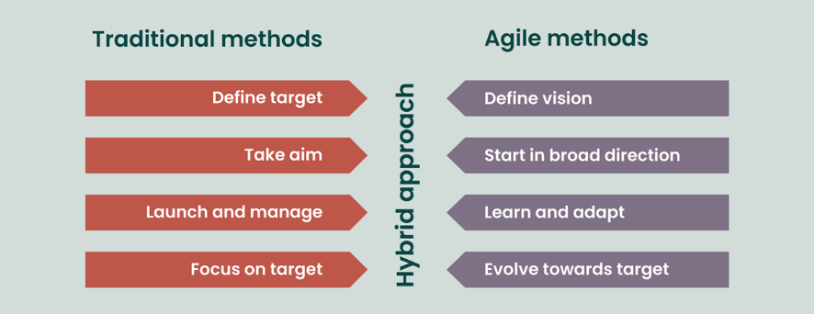
The main principle is that there needs to be a planned-out approach with flexibility built in. This should lead to a more efficient method of planning and executing this project.
Conclusion
The more hybrid approach takes the best elements from traditional and agile methods. The forward planning and consideration of all aspects of the project including the risks, scope, budget and timescales before starting the project can ensure realistic expectations and avoid the scope becoming too large. It can also help to ensure that documentation relating to the project and relevant governance is completed as accurately as possible. The forward-looking approach can also help with resources and ensuring that staff have time to complete this alongside their usual tasks when required. The flexibility of agile methods is helpful in ensuring that staff feel confident to raise other benefits that could be incorporated into the project and also avoiding delays of re-planning the project for smaller changes. The continuous improvement, which is key in agile methodologies, is also beneficial, ensuring that there’s a feedback loop and that stakeholders are able to make positive changes to the project as it’s progressing. Incorporating elements from both works well in a larger, varied organisation as it can be scaled to the size and type of project.
References
Texts
Project Management Institute (2017) A guide to the Project Management Body of Knowledge: (PMBOK guide). (6th ed) Newtown Square, PA: Project Management Institute.
Griffin, C. & Roldan, M. (2013). Swimming up the waterfall: agile processes in a waterfall world. Paper presented at PMI® Global Congress 2013—North America, New Orleans, LA. Newtown Square, PA: Project Management Institute
Websites
- https://www.projectcanvas.dk/ (accessed 11:29 25/02/2024)
- https://www.apm.org.uk/resources/find-a-resource/agile-project-management/difference-between-agile-and-waterfall-approaches/?_gl=1*1t4opnf*_up*MQ..&gclid=CjwKCAjwjMiiBhA4EiwAZe6jQy67_ataLPEDPU0npFbTAvZaVKYnOrQ4ejnl9fFMbQpPpHYCLrz2BxoCdWQQAvD_BwE&gclsrc=aw.ds (accessed 15:42 28/02/2024)
- https://www.apm.org.uk/resources/find-a-resource/agile-project-management/agile-methods/ (accessed 15:46 28/02/2024)
- https://business.adobe.com/blog/basics/waterfall#common-stages-in-a-waterfall-process (accessed 06:27 29/02/2024)

Griffin, C. & Roldan, M. (2013). Swimming up the waterfall: agile processes in a waterfall world. Paper presented at PMI® Global Congress 2013—North America, New Orleans, LA. Newtown Square, PA: Project Management Institute.
https://www.projectcanvas.dk/ (accessed 11:29 25/02/2024)
https://www.apm.org.uk/resources/find-a-resource/agile-project-management/agile-methods/ (accessed 15:46 28/02/2024)

