BMSW4008 Digital Skills for Personal and Professional Growth

Word Count: 2700 Words

Student Name: Helena Kandracova
Student ID:2331019
Table of Contents
Introduction 3
Task 1 Questionnaire Analysis 4
Task 2 Website Design and Marketing Material 6
Task 3 Importance of Microsoft Excel 8
Task 4 Short Advertising 13
References 14
Appendices 17
Appendix 1 Survey Questions 17
Appendix 2 Microsoft Excel 17
Appendix 3 Transcript for Video Presentation 17

Introduction
This report explores the application of digital skills in both personal and professional contexts, focusing on innovative marketing approaches and analytical tools. Using a combination of questionnaire analysis, website development, data modelling with Microsoft Excel, and digital advertising, the report examines how emerging technologies—such as holographic menus—can be integrated into modern business strategies. Each section demonstrates the importance of digital proficiency in enhancing customer experience, supporting business decisions, and effectively promoting new products.

Task 1 Questionnaire Analysis
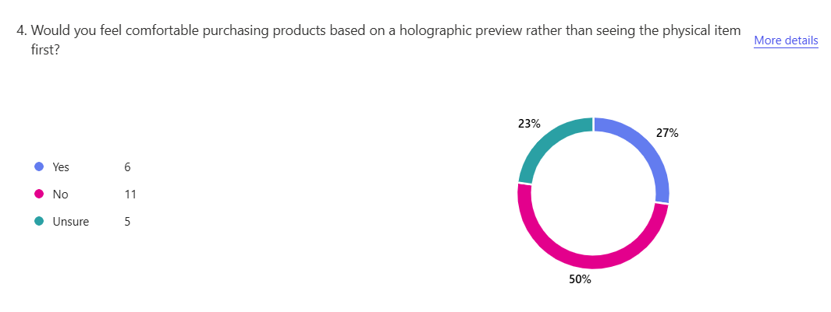
Figure 1. Would you feel comfortable purchasing products based on holographic preview rather than seeing the ohycical items first?
The above response recorded the intention of the customer to purchase the product using the holographic projection rather than the physical form, through the results it had been found that the respondents have stated that 6 respondents were willing to use this, while 11 respondents were more inclined towards the orthodox approach and the remaining are not sure. This might be because of the age gap among the respondents as they found that they belong to a relatively higher age group. This resulted in impacting the ability of the people to adapt to the new technological concepts (Kavitha, et al., 2022). Further influencing the ability of the customers, to purchase and learn new technology. As older respondents are less likely to purchase the technological innovation and accept the holographic presentation (Vinifa, et al., 2024).
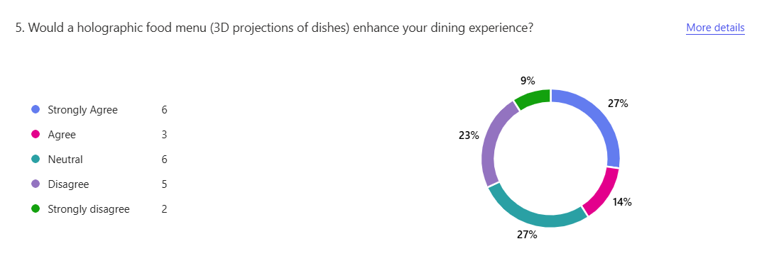
Figure 2. Would a holographic food menu (3D projections of dished) enhance your dining experience?
The above response states whether the holographic projection of the food menu could enhance the dining experience of the customers. Through the response, it was found that 6 respondents strongly agreed that the holographic food menu could aid in enhancing their experience. 3 respondents found that they agreed with the situation of the food menu 6 respondents were neutral on the perception as they found that the holographic menu could aid in improving the experience while the rest neglected the intention of accepting the holographic menu. It recorded the intentions of the customers to accept the menu that are necessary for building the customer experience and accepting the intentions for purchasing the product and even meeting the customer demand (Haleem, Arous and Amer, 2021; Surya, Sampathsree and Swetha, 2024).
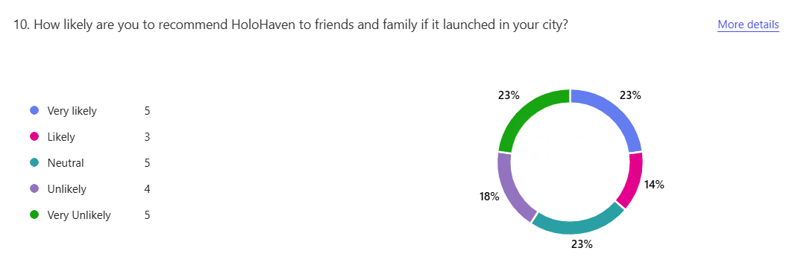
Figure 3. How likely are you to recommend HoloHaven to friemnds and family if it launched in your city?
The above response recorded states whether the respondents would recommend the HoloHaven to friends and family if they were launched in the city. 5 respondents stated that they are more likely to recommend to their friends and family about the product. 3 are likely to recommend the services offered by the company to customers and friends. 5 respondents had a neutral approach to this. 4 respondents are less likely and the remaining 5 are very least likely to do so. This was possible because of the changing intentions of the customers and keeping strong intentions for building the customers. This is the reason for implications and promoting the product to a wider audience (Çöl, İmre and Yıkmış, 2023; Moya Ruiz, 2023; Dampage, et al., 2021).

Task 2 Website Design and Marketing Material
URL of Website: https://holohaven.weebly.com/
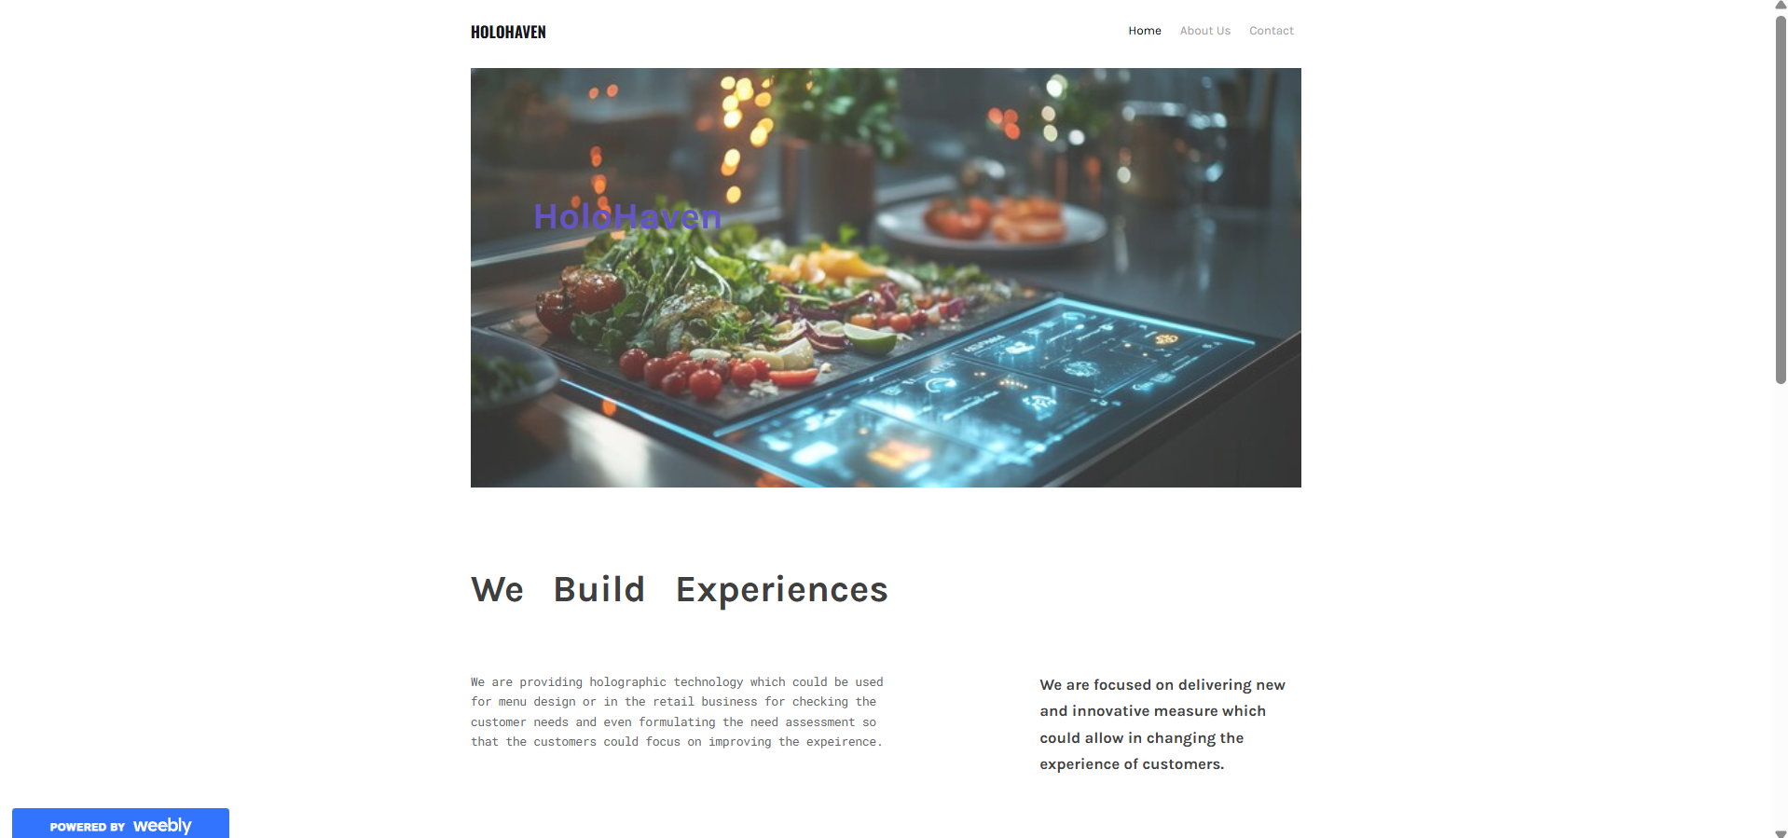
Segmentation
Beyond segmentation, the survey also contributed to the generation of content and site structure. User feedback told us that innovation and usability had to be balanced. Others were worried about the complexity of accessing holographic shopping functionality, prompting me to incorporate guided walkthroughs and user feedback on the home page. This helped to orient first-time visitors through the features of the site. Second, studies showed that a top number of users had a visual confirmation in place before purchasing, hence translating into deep demand for high-definition holographic product images and interactive 3D showrooms (Negüzel and Mil, 2021). The tactic was also enforced while executing a successful call-to-action campaign through feedback. Users were more likely to interact with brands that offered them personalised advice and exclusive member benefits, which the survey also indicated. Thus, I launched features like dynamic search history-based recommendation and an opt-in membership scheme offering early access to upcoming ranges before the crowds. Not only are they more interactive but also they generate more conversions by targeting individual consumers' needs highlighted in the survey (Motowilowa, et al., 2024). For SEO purposes, answers from the questionnaire were used for keyword optimisation approaches and content.
Analysis of Questionnaire Data
It was important to be able to break down and use survey information in the design of a successful website and campaign. Breaking down feedback allowed me to break down the audience, produce more successful content, and for search engines. The ability to use this information gave us incredible insight that we were able to use in helping inform the design of websites as well as marketing materials used in gaining potential buyers. Audience segmentation was the biggest use I had for questionnaire results (Chai, et al., 2022). The results showed some patterns of consumer taste, behaviour, and expectations. Segmentation of the respondents by demographic, interest, and buying behaviour helped me make the site content attractive to certain groups of customers. For example, some of the respondents stated that they were greatly interested in being engaged in an experiential shopping experience with the use of holographic technology. This discovery allowed me to design website pages that highlighted the interactive aspects of the company such as virtual fitting rooms and AI personal shopping assistants (AYLAN, 2023). In addition, by setting out the parameters of age and technological comfort, I was able to modify the elements of usability of the site to put high-tech customers as well as less-so customers at ease as much as possible with advanced digital technology. The survey also helped identify customer motivation. A few of the participants had expressed a need for sustainability and reduced fashion waste, so these guided the way I would phrase the brand message. The website highlighted environmental advantages, such as reduced returns because of virtual try-on technology and a made-to-order retail strategy. With these points of information, I was able to craft a marketing narrative that would appeal to green consumers, which the survey had found were most interested in the concept (Negüzel and Mil, 2021).
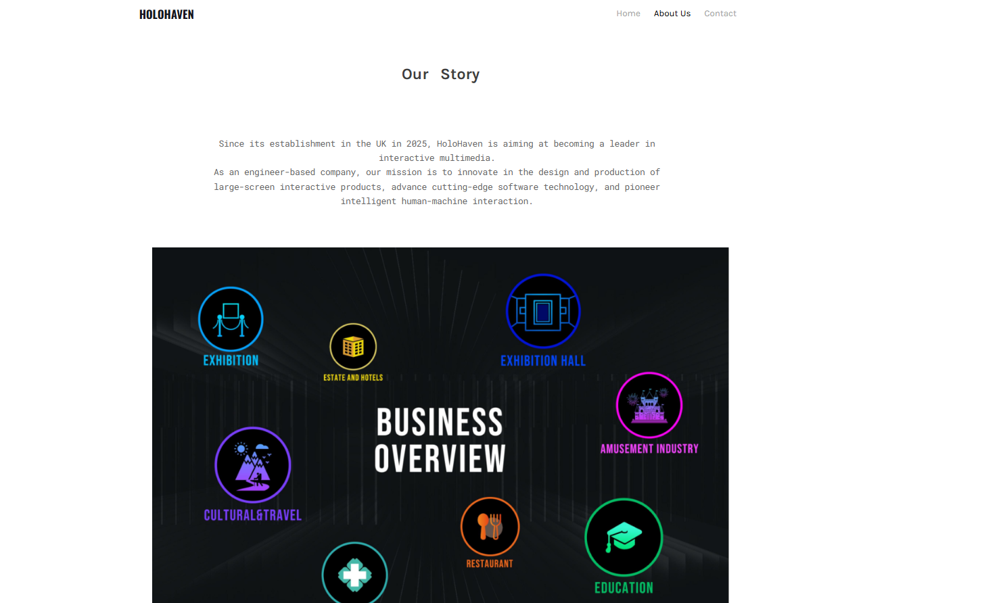

SEO Strategy
Through the search behaviour and keyword usage of respondents, I discovered the top keywords and phrases the prospects utilised when searching for distinctive shopping and dining. The majority of the respondents searched for words such as "holographic shopping," "AI-retail," and "virtual dining experiences." Incorporating such highly intent-driven keywords in website copy, meta tags, and blog posts increased organic search positions and exposures. The survey also uncovered to us what kind of content engaged the audience the most. They largely hungered for content and informative data instead of run-of-the-mill ads (Iskender, Sirakaya-Turk and Cardenas, 2023). Based on this discovery, I created an SEO-conscious content marketing plan comprising blog posts, video guides, and customer testimonials. Blog posts like "The Future of Holographic Shopping" or "How AI is Revolutionising the Retail Experience" were ideally optimised with business-centric keywords to fight for organic search traffic. This placed the brand at a leadership level in a thought leadership category as well as optimising engagement in favor of informative content. Both mobile optimisation and user experience were the domains within which questionnaire feedback was driving the website design.
SEO Strategy
Through the search behaviour and keyword usage of respondents, I discovered the top keywords and phrases the prospects utilised when searching for distinctive shopping and dining. The majority of the respondents searched for words such as "holographic shopping," "AI-retail," and "virtual dining experiences." Incorporating such highly intent-driven keywords in website copy, meta tags, and blog posts increased organic search positions and exposures. The survey also uncovered to us what kind of content engaged the audience the most. They largely hungered for content and informative data instead of run-of-the-mill ads (Iskender, Sirakaya-Turk and Cardenas, 2023). Based on this discovery, I created an SEO-conscious content marketing plan comprising blog posts, video guides, and customer testimonials. Blog posts like "The Future of Holographic Shopping" or "How AI is Revolutionising the Retail Experience" were ideally optimised with business-centric keywords to fight for organic search traffic. This placed the brand at a leadership level in a thought leadership category as well as optimising engagement in favor of informative content. Both mobile optimisation and user experience were the domains within which questionnaire feedback was driving the website design.
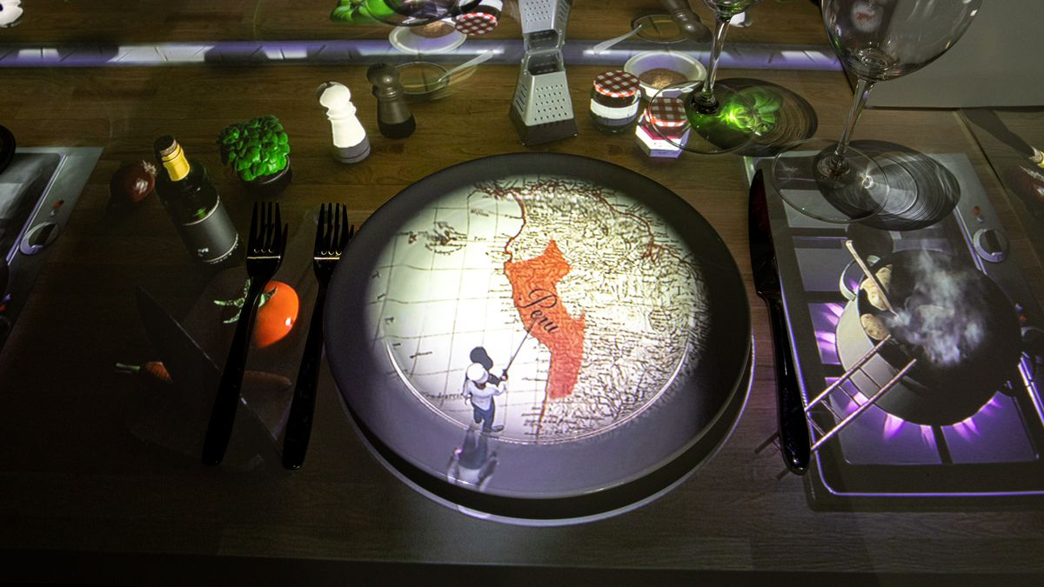
The indication received was of a very, very high ratio of target user group viewing restaurant and shopping guides through mobile. This resulted in mobile-first design being prioritised at the highest level, along with fast loading time, responsive layout, and fewer navigation links on smaller screens. SEO tactics like image size optimisation, structured data markup for rich search results, and secure websites via HTTPS also enhanced search rank and user trust (Leung and Loo, 2022). Apart from on-page optimisation, the survey also generated link-building and social media marketing. Most of the respondents indicated exposure to new brands through social media and influencer recommendations (Can, 2021). This insight necessitated adding social proof elements on the website, including Instagram feed and reviews. I also collaborated with fashion and tech influencers to develop backlink opportunities that improved domain authority and search engine ranking. The survey also offered useful data on social media campaign ad targeting and pay-per-click ad targeting.
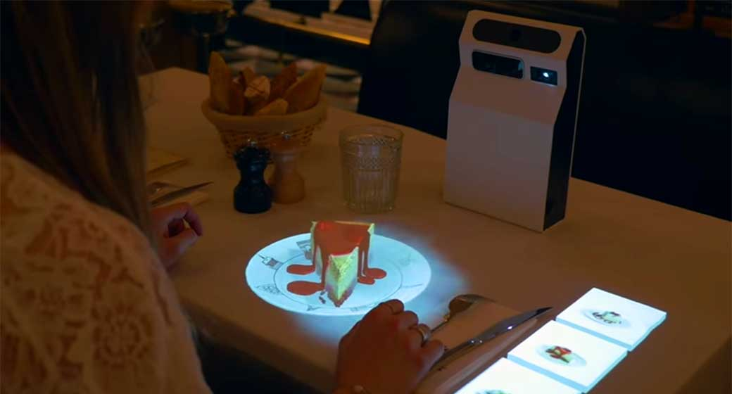

Task 3 Importance of Microsoft Excel

1 Year Projection
Category | Calculation | Amount (£)
Revenue Projection
Target Customers | 15,000 customers
Average Orders/Month | 3 orders per customer
Total Orders/Year | 15,000 × 3 × 12 | 540000
Revenue per Order | Fixed Price | £30
Total Revenue | 540,000 × £30 | 16200000
Cost of Goods Sold (COGS)
Ingredient Cost/Order | Fixed Cost | 16
Packaging Cost/Order | Fixed Cost | 2
Delivery Cost/Order | Fixed Cost | 6
Total COGS/Order | 16+2+6 | 24
Total COGS | 540000*24 | 360000
Gross Profit | Revenue - COGS | 15840000
Gross Profit Margin | (£1,800,000 / £5,400,000) × 100 | 10227.27%
Operating Expenses
Marketing & Advertising | Estimated Cost | 250000
Salaries & Wages | Staff & Management | 500000
Technology & Website | Maintenance & Updates | 300000
Rent & Utilities | Office & Storage Costs | 400000
Customer Service/Admin | Support & Administration | 250000
Miscellaneous Costs | Other Business Expenses | 100000
Total Operating Expenses | Sum of Above | 1800000
Net Profit | Gross Profit - Operating Expenses | 14040000
Net Profit Margin | (£550,000 / £5,400,000) × 100 | 1282.05%
Break-Even Analysis
Fixed Costs (Operating Expenses) |  | 2500000
Contribution Margin/Order | £30 - £20 | £10
Break-Even Orders | 2500000/10 | 2500000

3 Year Projection
Category | Year 1 | Year 2 | Year 3
Revenue Projection
Target Customers | 8,000 | 3,000 | 10,000
Average Orders per Customer/Month | 3 | 3 | 3
Total Orders per Year | 24000 | 9000 | 30000
Revenue per Order | 25 | 25 | 25
Total Revenue | 600000 | 225000 | 750000
Cost of Goods Sold (COGS)
Ingredient Cost per Order | 5 | 5 | 5
Packaging Cost per Order | 4 | 4 | 4
Delivery Cost per Order | 6 | 6 | 6
Total COGS per Order | 15 | 15 | 15
Total COGS | 360000 | 135000 | 450000
Gross Profit | 240000 | 90000 | 300000
Gross Profit Margin | 4000.00% | 4000.00% | 4000.00%

Figure 4. Total Revenue of Three Months
Microsoft Excel, in the meantime, has with time continued to be the best and most viable tool of the new era. It continues to be an essential resource in business as a business computer program, scholarly and research software, pedagogy tool, and individual device. The most distinctive feature of Excel is its ability to offer management of money, management of information, decision-making, and automation. In the data era when data is the highlight in everything, having a basic proficiency in Excel has become a necessary skill to have among professionals of every trade (Remenyi, Onofrei and English, 2022). The most obvious reason Excel has become this much sought-after thing today is that it can handle ridiculous quantities of data. Businesses churn out humongous quantities of data that need to be sifted through, analysed, and interpreted. Excel is simple to sort, save, and play with data. With the help of functions such as VLOOKUP, pivot tables, and conditional formatting, Excel makes it easy to make conclusions from unpretty sets of data (Mount, 2024). It thus turns into a highly useful tool in data analysis and business intelligence where conclusions are drawn from firmly ensnared options. Excel is also a critical finance planning and management tool, and as such it is also a critical tool to be utilised by business owners, accountants, and financial analysts.
Excel makes financial modelling, forecasting, and budgeting easy due to its advanced functions and formulas. Organisations utilise Excel to create expenses, cash flows, and financial statements. Automation of the calculation assists in removing the room for errors to be committed and improving the precision of the reports (Mount, 2024). Excel also assists firms in preparing for financial situations utilising the goal seek and scenario analysis tools, thus preparing them strategically. Another feature that is a testament to how much Excel is essential is how it is utilised in automation and improvement in productivity (Tu and Akhter, 2023). Functions that were formerly cumbersome to accomplish using the services of manual labour hours are now theoretically possible to automate using Excel's built-in functionality and macros. Visual Basic for Applications (VBA) enables the user to create tailored automation scripts, introducing even more ease into the process. Excel automation has extremely deep implications in business activities, particularly in business activities engaged in repetitive data entry, report generation, and activity tracking. Being capable of automating procedures and removing lengthy and laborious processes, Excel is a highly useful application tool for the modern work environment. Application extends from corporations and banking institutions to organisations and research institutions.
Excel is applied by scientists and students for analysing data, plotting data, and conducting research. Excel is an easy application in science and social studies by hypothesis testing, regression analysis, and correlation coefficient. Excel is also used by researchers as a teaching tool where they use it to illustrate mathematics concepts, analyse surveys, and develop problem-solving instructional aids (Tu and Akhter, 2023). Ease of use and accessibility make Excel the number one tool to use for business and learning processes. Apart from its analytic potential, Excel is also an important utility to use while working with data visualisation. Providing charts, graphs, and dashboards, as it can do, is of greatest concern for reporting data to businesses and individuals. Data visualisation simplifies communication, and hence it becomes possible for the stakeholders to envision patterns and trends immediately (Tu and Akhter, 2023). It possesses certain charting functions that Excel has, such as the bar chart, line graph, scatter plot, and heat map, which all also further facilitate the presentation of data. The software allows reports and presentations where the data is utilised to make decisions. It is because of the ease with which Excel and other computer programs and technology are used that it is utilised today in the computer age.
It is highly compatible with business intelligence software, cloud computing environments, and databases and can be shared and collaborated on in real-time. The users can also edit and view their Excel sheets remotely using cloud-based services like Microsoft 365, which provides collaboration and remote working features. Excel's ability to support various types of files and its compatibility with tools such as Power BI, SQL database, and CRM applications optimise the use of Excel, and it is now integrated into business processes (Tu and Akhter, 2023). Excel's pervasive use across so many fields is a testament to how widespread its use has become. Physicians utilise Excel to keep track of patient histories, analyses and schedules. Supply chain and logistics use Excel to track inventory, route plan, and report performance. Ad agencies use Excel to segment, measure campaigns, and forecast sales. The software's flexibility has made it an irretrievable program in so many sectors and always evolving to keep up with a data-driven world.
While data analysis software and AI-based software have been designed innovatively, Excel remains a basic skill for every professional. Its ease, powerful list of functions, and regular updations make it an indispensable tool in the modern era. Organisations even put a lot of emphasis on Excel skills while recruiting employees as it is a representation of analytical brains, problem-solving skills, and hard work (Tu and Akhter, 2023). Whether novice or old, Excel has a learning curve that can be designed to fit the level of one's experience to help one gain useful technical knowledge in the long term. Since the nature of technology is always changing, so is Excel, and it is integrating artificial intelligence and machine learning capabilities into its operations.
Power Query, data analysis toolpak, and AI-insights are Revolutionising the way the world works with data. Since Microsoft is continuing to make Excel stay in the game for the future by keeping updated with the changing digital world, it is going to be part of the kit forever. In short, the role of Excel today cannot be exaggerated. Since it can handle data, do calculations on finances, automate things, boost productivity, and interface with other systems, it's a central system in all business sectors across the world. Business, learning, and academic research rely on Excel as part of decision-making and solving problems. All this technological upheaval at breakneck speed is such that acquiring Excel is not only a prudent thing to do but something that firms and individuals have to do if they want to be players in the data-driven global economy of the time.

Task 4 Short Advertising
The advertising shows proper storytelling on how the products are being showcased. In the storytelling approach, the main thing which is shown using the advertising is the approach of how the technology is used for promoting the product in the market. Further, the storytelling is expected to identify the usability of the product by showcasing the non-tech-savvy people how the technology could be used so that the usability could be improved drastically. Moreover, it has been stated that advertising is required. Further, the advertising is designed the improve the knowledge of the customers and even focuses on providing an approach on how the technology could be used for promoting the approach for meeting the goals and even formulating the right knowledge that could allow in shaping the intentions for meeting the goals and even the future which the brand is seeing for developing the brand. Further, the storytelling approach has been used in the perspective storytelling in which the advertisement is focused on showing an elderly person going to a hologram restaurant and using the technology to order the dishes.
https://youtu.be/oNLFH8Op_DY?si=IvKeTJRBPIdJiIlF

References
AYLAN, K.C. (2023) 'NEW TECHNOLOGIES IN EVENTS. SOCIAL, HUMAN AND ADMINISTRATIVE SCIENCE, p.1. https://www.researchgate.net/profile/Alihan-Celtek/publication/377078483_Electronic_Flight_Bag_EFB_Fat_Finger_Cases_In_The_Cockpit/links/6594663a6f6e450f19c48ae9/Electronic-Flight-Bag-EFB-Fat-Finger-Cases-In-The-Cockpit.pdf#page=9
Can, Ü. (2021) ‘A conceptual assessment of current trends in the restaurant industry accompanied with future forecasts’. Journal of New Tourism Trends, 2(2), pp.209-219. https://dergipark.org.tr/en/download/article-file/2086289
Chai, J.J., O'Sullivan, C., Gowen, A.A., Rooney, B. and Xu, J.L. (2022) ‘Augmented/mixed reality technologies for food: A review’. Trends in Food Science & Technology, 124, pp.182-194. https://www.sciencedirect.com/science/article/pii/S0924224422001509
Çöl, B.G., İmre, M. and Yıkmış, S. (2023) ‘Virtual reality and augmented reality technologies in gastronomy: A review’. Efood, 4(3), p.e84. https://iadns.onlinelibrary.wiley.com/doi/pdfdirect/10.1002/efd2.84
Dampage, U., Egodagamage, D.A., Waidyaratne, A.U., Dissanayaka, D.W. and Senarathne, A.G.N.M. (2021) ‘Spatial augmented reality based customer satisfaction enhancement and monitoring system’. IEEE Access, 9, pp.97990-98004. https://ieeexplore.ieee.org/iel7/6287639/9312710/09469789.pdf
Haleem, W.M.A., Arous, S. and Amer, T. (2021) ‘Potentials benefits of applying three dimensional hologram technology (3DHT) in the hotel industry’. J. Fac. Tour. Hotels-Univ. Sadat City, 18. https://mfth.journals.ekb.eg/article_172665_af09b61a9239a61688b5083e1fb1ecc2.pdf?lang=en
Iskender, A., Sirakaya-Turk, E. and Cardenas, D. (2023) ‘Restaurant menus and COVID-19: implications for technology adoption in the post-pandemic era’. Consumer Behavior in Tourism and Hospitality, 18(4), pp.587-605. https://www.researchgate.net/profile/Ali-Iskender/publication/373043271_Restaurant_menus_and_COVID-19_implications_for_technology_adoption_in_the_post-pandemic_era/links/64d7c88325837316ee09516a/Restaurant-menus-and-COVID-19-implications-for-technology-adoption-in-the-post-pandemic-era.pdf
Kavitha, M., Venkatesh, J., Salma, S.K. and Moosa, S.R. (2022, June) ‘Virtual reality (Hologram) based food supply system in smart restaurant based menu ordering system’. In 2022 7th International Conference on Communication and Electronics Systems (ICCES) (pp. 449-454). IEEE. https://ieeexplore.ieee.org/abstract/document/9835976/
Leung, R. and Loo, P.T. (2022) ‘Co-creating interactive dining experiences via interconnected and interoperable smart technology’. Asian Journal of Technology Innovation, 30(1), pp.45-67. https://www.academia.edu/download/65562521/Co_creating_interactive_dining_experiences_via_interconnected_and_interoperable_smart_tec.pdf
Motowilowa, J., Vergari, M., Kojić, T., Warsinke, M., Möller, S. and Voigt-Antons, J.N. (2024) ‘Exploring Augmented Table Setup and Lighting Customization in a Simulated Restaurant to Improve the User Experience’. arXiv preprint arXiv:2411.10230. https://arxiv.org/pdf/2411.10230
Mount, G. (2024) Modern Data Analytics in Excel: Using Power Query, Power Pivot, and More for Enhanced Data Analytics. " O'Reilly Media, Inc.".
Moya Ruiz, B. (2023) GlassFood: The holographic healthy smart recipe app. https://ddd.uab.cat/pub/tfg/2022/tfg_1334169/first_delivery_bruno_glassfood.pdf
Negüzel, F.K. and Mil, B. (2021) ‘cHaPTER XX VIRTUaL REaLITY In GaSTRonoMY: EVaLUaTIon of REaLITY THEoRIES’. The evaluations and researches in social sciences and humanities, p.378. https://www.academia.edu/download/102377926/The_20Evaluations_20and_20Researches_20in_20Social_20Sciences_20and_20Humanities.pdf#page=385
Puspitasari, R. and Wahmuda, F. (2022) ‘Penerapan Teknologi Sterilisasi dan Visualisasi Hologram pada Redesain Furnitur Ruang Publik Komersial’. Ars: Jurnal Seni Rupa dan Desain, 25(1), pp.79-84. https://journal.isi.ac.id/index.php/ars/article/viewFile/6439/2589
Remenyi, D., Onofrei, G. and English, J. (2022) An introduction to statistics using Microsoft Excel. UJ Press.
Surya, U., Sampathsree, N. and Swetha, M. (2024, June) ‘Virtual Reality For Eco-Conscious Customer Engagement’. In 2024 International Conference on Innovations and Challenges in Emerging Technologies (ICICET) (pp. 1-7). IEEE. https://ieeexplore.ieee.org/abstract/document/10616271/
Tu, J.J. and Akhter, S. (2023) ‘Exploring the role of entrepreneurial education, technology and teachers’ creativity in excelling sustainable business competencies’. Economic research-Ekonomska istraživanja, 36(1). https://hrcak.srce.hr/file/442397
Valencia-Arias, A., Cardona-Acevedo, S., Martínez Rojas, E., Ramírez Dávila, J., Rodriguez-Correa, P., Palacios-Moya, L., Teodori de la Puente, R., Agudelo-Ceballos, E. and Benjumea-Arias, M. (2024) ‘Trends in Smart Restaurant Research: Bibliometric Review and Research Agenda’. F1000Research, 13, p.1505. https://onlinelibrary.wiley.com/doi/pdf/10.1111/fcsr.12476
Vinifa, R., Prasad, N.V., Santhosh, A. and Amarnath, M. (2024, April) ‘Contact-less Food ordering System in Restaurants using hologram’. In 2024 10th International Conference on Communication and Signal Processing (ICCSP) (pp. 444-447). IEEE. https://ieeexplore.ieee.org/abstract/document/10544019/

Appendices

Appendix 1 Survey Questions

Appendix 2 Microsoft Excel

Appendix 3 Transcript for Video Presentation

