Nathan Jones (P151484)

CAE & Stress Analysis – M5X02064

Executive Summary
This report intends to understand what is finite element analysis and motion simulation, look at how these processes impact how a component is designed and the improvements that these techniques pass onto the completed product.
These two techniques will be discussed, giving a brief history of where the technique came from and how there are implemented into industry.
A review of the manufacturing features used in the design on a gearbox housing will then be described to understand what features are available through the use of CAD and the decision making as to why a feature is chosen will be drawn up.
Once a review of the completed gearbox assembly has been concluded a motion simulation will be analysed to review the velocity changes upon the output shaft dependant on which gear is being driven.

Table of Contents
1. Executive Summary 1
2. Introduction 3
3. Findings 4
3.1 Finite Element Analysis & Motion simulation 4
3.1.1 What is Finite Element Analysis? 4
3.1.2 What is motion simulation? 5
4. Gearbox design 6
4.1 Sketch 6
4.2 Extrude 7
4.3 Extrude cut 7
4.4 Delete/keep bodies 8
4.5 Mirror 8
4.6 Fillets 9
4.7 Mates 10
5. Motion simulation of design 11
6. Conclusion and recommendation 13
7. Works Cited 14

Figure 1 - Gearbox housing 6
Figure 2 - Sketch feature 6
Figure 3 - Extrude feature 7
Figure 4 - Extrude cut feature 7
Figure 5 - Delete/keep bodies feature 8
Figure 6 - Mirror feature 8
Figure 7 - Fillet feature 9
Figure 8 - Mates 10
Figure 9 - Solid body contact 11
Figure 10 - Angular velocity graph 11
Figure 11 - Redundant mates 12

Introduction

This report is going to look at what finite element analysis (FEA) and motion simulation is, how it is currently being used in industry, why it is used and what are the pros and cons are of using it. As well as this a brief history of FEA and motion simulation will be discussed and how using these techniques can be used to help with the design, optimisation and improvement of current and new products.
This report will then go onto looking at a completed CAD assembly of a 2 geared gearbox, it will look at the techniques which where used to create the gearbox housing, why these techniques were used and how they could potentially be improved. Once the assembly has been created a motion simulation of the velocity change on the output shaft will be shown and a graph to describe how the gearbox is working will be concluded.

Findings

Finite Element Analysis & Motion simulation

What is Finite Element Analysis?

Finite element analysis (FEA), or finite element method (FEM) is a numerical method which is used to approximately solve a wide variety of engineering problems (Segerlind, 1984), these problems can range from “stress analysis, heat conduction or several other areas” but is also used to analyse fluid flow, electromagnetic fields, and solid mechanics problems (Cook, et al., 1989). To solve these problems, mathematical equations are created which can range anywhere from 20 to 20,000 equations dependant on the problem in question (Segerlind, 1984).
In a journal written by (Thomee, 2001) it is discussed that a major breakthrough in FEA came during 1951, which agrees with (Fish & Belytschko, 2007) who discuss FEA/FEM as we know it today evolving from the aerospace industry around the 1950s, (Zhuming, 2018) also discusses how FEA was first used to analyse stress over the wings of an aircraft.
When FEA was first introduced many industries were sceptical of its uses due to the lack of digital technology available at the time but a group of researchers soon realised its potential and began developing element analysis in Swansea (Fish & Belytschko, 2007).
When looking at FEA there are two main section in which the analysis comes under, one being discrete elements and the other being continuum elements, these sections depend on what the analysis is trying to measure (Segerlind, 1984). For discrete element analysis this tends to look at structural joints and frameworks whereas continuum element analysis is used “to approximate solutions to heat transfer, fluid mechanics, and solid mechanics problems” (Segerlind, 1984).
Due to the many uses of FEA it has now become the default tool for many design engineers when it comes to the design of systems and products, this is simply down to the wide variety of tasks which can be solved through the use of FEA (Zhuming, 2018), these tasks can allow engineers to reduce the amount of physical prototypes they need to create due to the modelling and design being completed digital, speeding up the development and design stages and allowing better products to be created (Rao, 2018).

What is motion simulation?

Motion simulation conveniently links in with FEA when looking at the aspects of engineering design, due to motion simulation allowing design engineers to test how the product will operate under a set amount of conditions. When performing motion simulation it manages to give a great deal of feedback on the design due to it showing the designer what mates are redundant, a visual representation of the product under load, to see where any faults in the design will occur and to test how different driving conditions effect the design.
When motion simulation is used to show the redundant mates it will also indicate which mates are redundant, as an unconstrained component within a motion study has 6 degrees of freedom, by utilising the available mates you are able to reduce the number of redundant mates to improve the efficiency of the design (Dassault Systems, 2019).
Motion simulation is very useful when looking to create alterations to a component within certain industries, when looking at how an internal combustion engine could be improved, there is a wide number of components which could be altered to make minor improvements and the use of simulating the new component within the engine allows the engineers to understand what is going on internally (Martins & Rego, 2001), without having to make a physical prototype.

Gearbox design
When looking to use CAD to design a product there are a wide variety of features which can be generated in order to optimise the finished components (Dassault Systems, 2019). Many of the features which have been used in (Figure 1.) will be described as well as reasoning as to why these features were used, the effect in which these have on the design and how they could be altered.
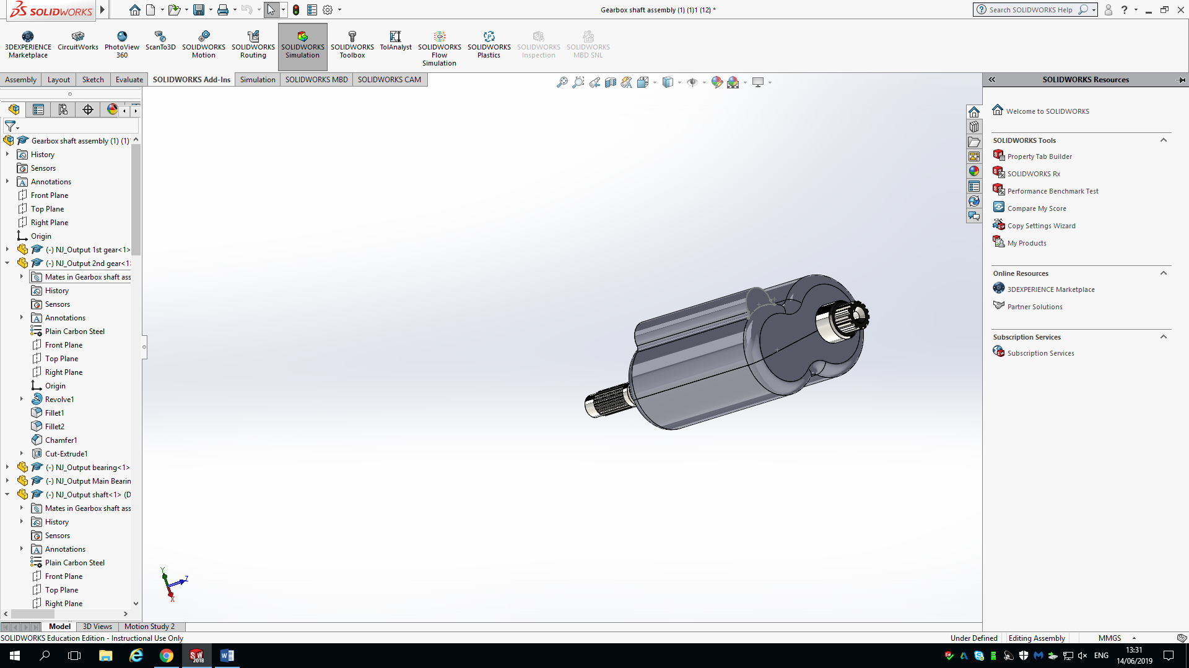Figure 1 - Gearbox housing
It can bee seen that the gearbox was created in two section which have been mounted together with one of the sections having a boss that allows the selector fork to slide within, this allows all components to be contained within the housing bar the input and output shafts.

Sketch

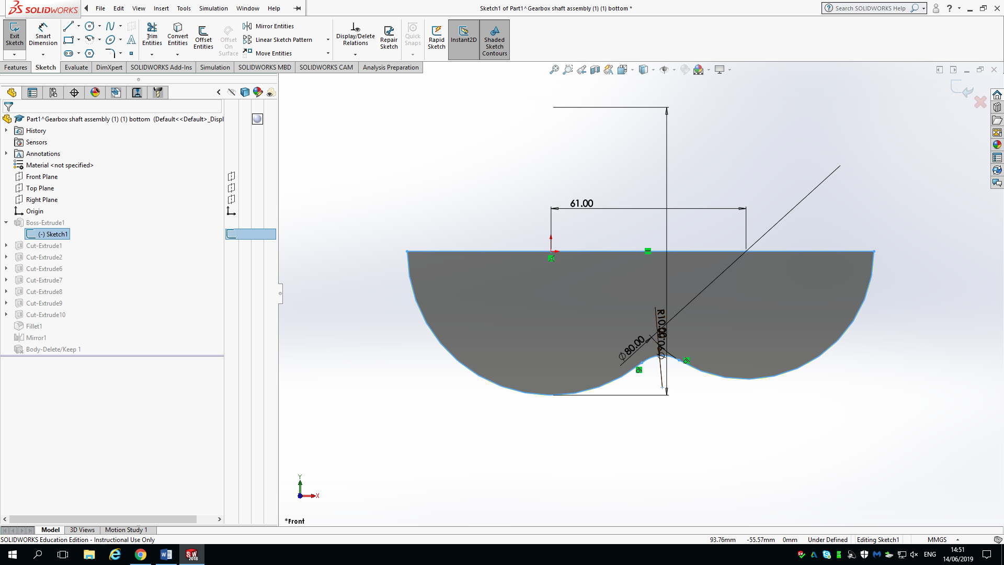Figure 2 - Sketch feature

As seen in (Figure 2.) this feature is the first feature which is required in order create a CAD drawing, this is a 2-dimensional view of the original outline of the proposed gearbox housing which will then require additional features to achieve the final model. When creating a 2-dimensional sketch it is important to include as many features in the sketch stage to reduce additional features being required and to speed up the design phase (Weismantel, 2013).

Extrude

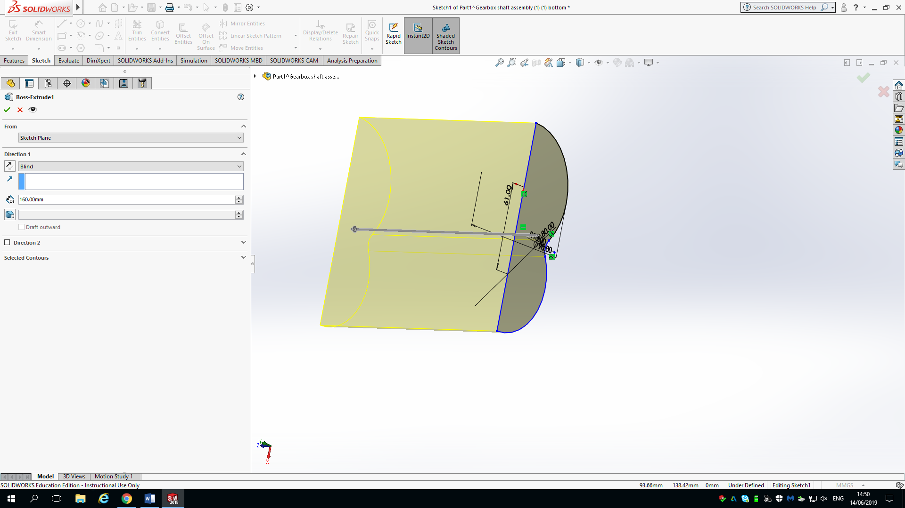Figure 3 - Extrude feature
(Figure 3.) shows the extrude feature, this is one of the most common features used in 3-dimensional CAD (LearnSolidworks, 2016). The reason this feature is so popular, is down to the fact it is one of the primary methods used to convert from a 2D sketch to a 3D model. This feature was used to create the bottom half of the gearbox housing by extruding the sketch by 160mm.

Extrude cut

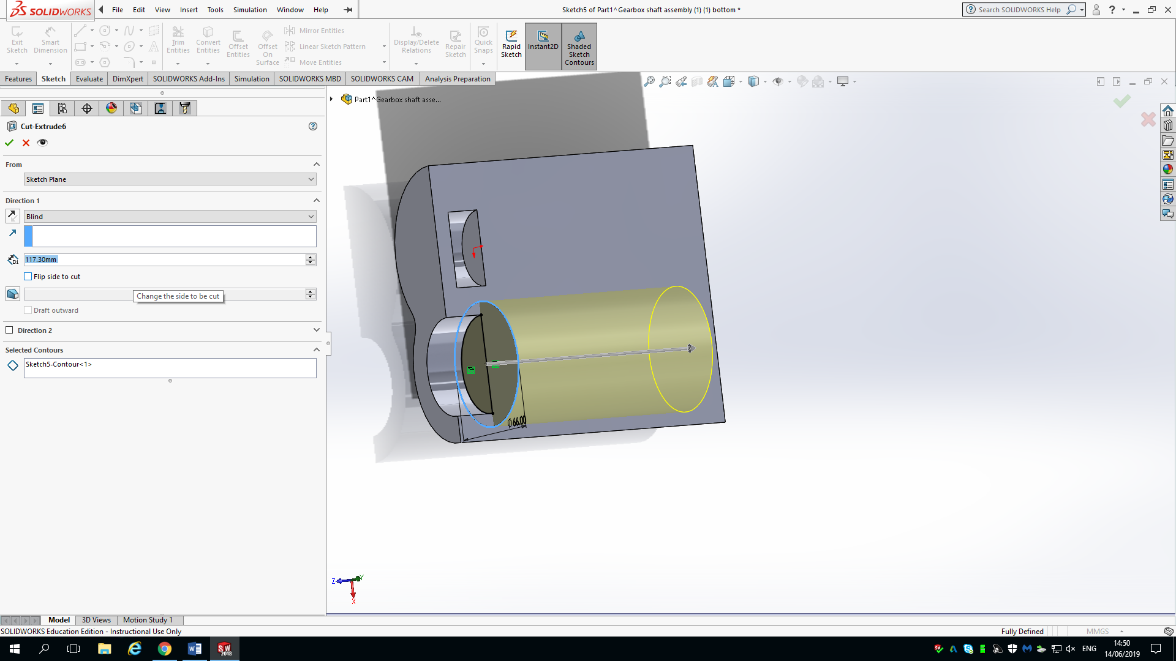Figure 4 - Extrude cut feature
Extrude cut is a very similar feature to the extrude feature which was discussed in section 4.2, but the main difference is that this feature is used to remove material as oppose to add material. When looking at (Figure 4.) it can be seen that this feature was used to create a cut out in the housing to locate the bearings. The use of this feature could have been reduced if the initial sketch had been optimised, but would still of been needed when creating offset cut outs.

Delete/keep bodies

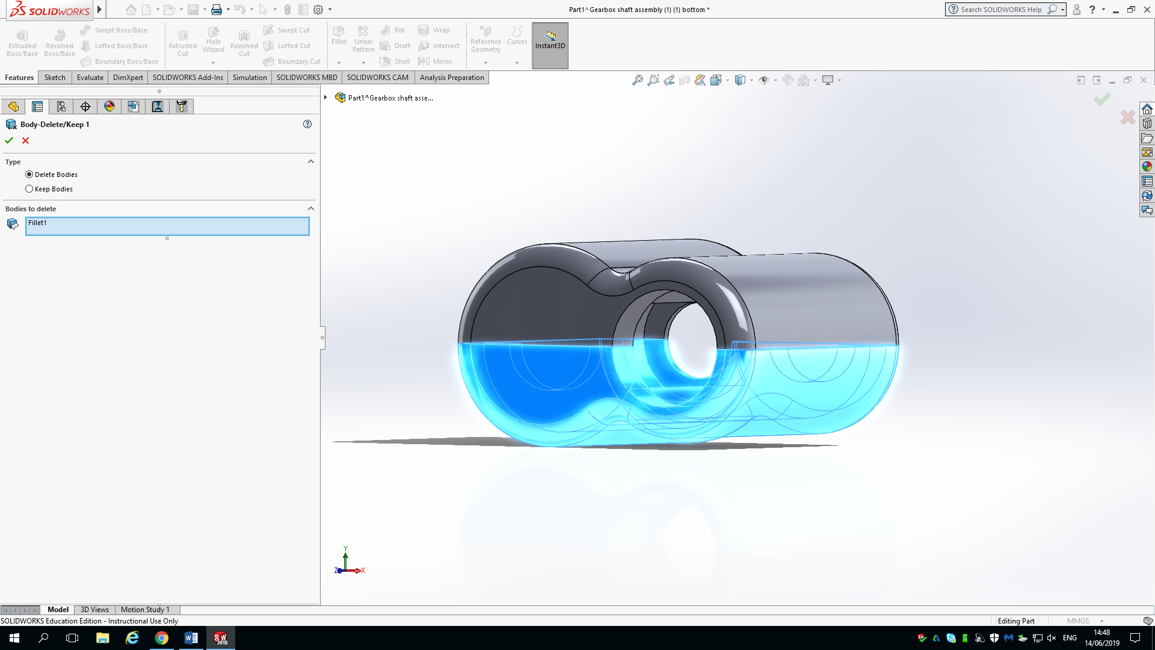Figure 5 - Delete/keep bodies feature
This feature was used alongside the mirror feature which will be discussed in section 4.5 due to the way this feature works, it is used to keep/delete a specific body within a model as seen in (Figure 5.), this helps to reduce design time and to utilise components with “multiple configurations” (Dassault Systems, 2019). This feature allowed for the bottom half of the housing to also be mirrored to create the top half and then deleted meaning only one sketch was required to create the housing.

Mirror

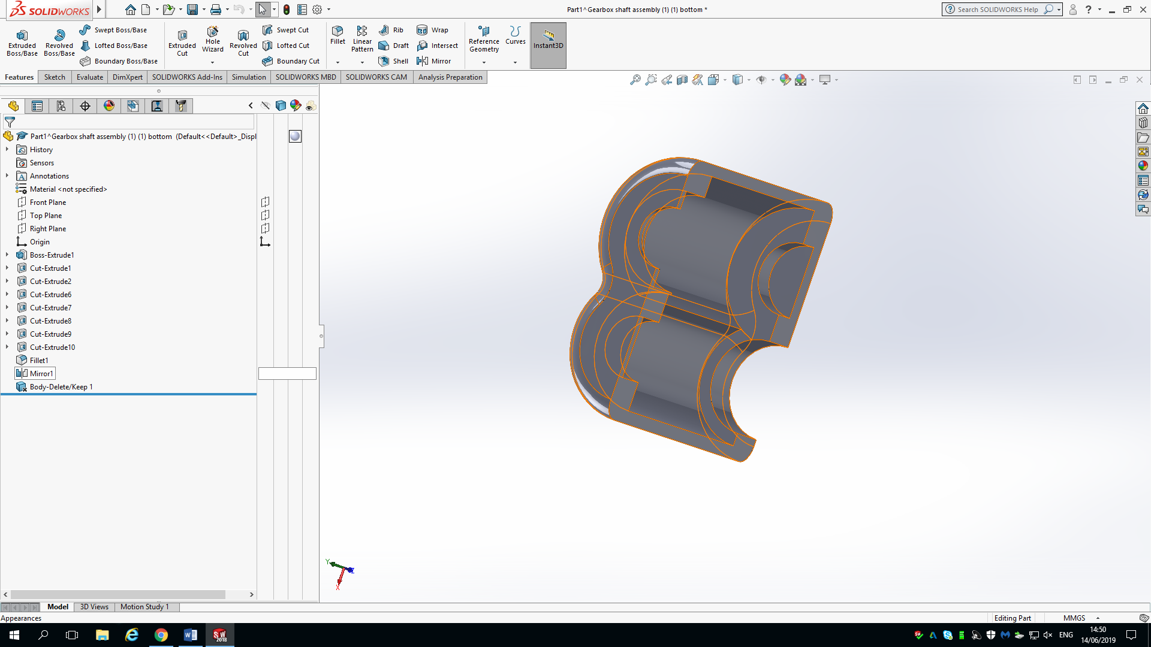Figure 6 - Mirror feature
This feature was briefly mentioned throughout section 4.4, this was due to the way it is used with other features, the mirror feature can be seen in (Figure 6.). This feature is used to create a reflected model about a plane or axis identically mirroring all dimensions of the original sketch or model, this allows for a model with identical dimensions but reversed locations based on the mirrored plane, as mentioned in section 4.4 this was the ideal feature to use to replicate both halves of the gearbox and reduce design time.

Fillets

Figure 7 - Fillet feature
The use of a fillet is to create a curved radius between two or more faces, it can be seen on (Figure 7.) that is has been used to create a curved contour around the housing of the gearbox in order to reduce the space in which the housing occupies but also to distribute stress uniformly as oppose to a chamfer or plain edge and reduce stress concentration throughout the component (Vadakkan, 2016), this agrees with (Pilkey & Pilkey, 2017) who discuss filleted edges having a substantial stress reducing ability.

Mates

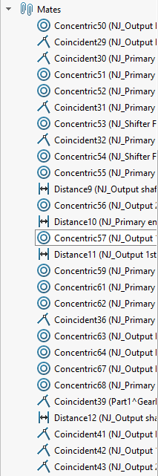Figure 8 - Mates
(Figure 8.) shows the mates which where used to successfully assemble the housing for the complete gearbox, it can be seen that mates such as distance, coincident and concentric have been heavily used, these are known as standard mates. There are also other mates such mechanical and advanced mates, these can be used as oppose to standard mates where the use of limit mates can be used to replace distance mates and hinge mate can be used to replicate a coincident and concentric mate in order to reduce the number of mates required (Dassault Systems, 2019), doing this reduces the size of the feature tree and can speed up the assembly time but will also help in the motion simulation stage of the design.

Motion simulation of design
When performing motion simulation, there is a variety of different features which can be applied in order to simulate what is required. Throughout the simulation of the gearbox, the main outcome was to analyse how the output shaft was effected dependant on which gear was being driven on the primary shaft, and to optimise the efficiency of the design. Looking at (Figure 9.) it can be seen that solid body contact mates have been used for the whole duration of the simulation as these define what components interact and how these components interact (Dark, 2017).
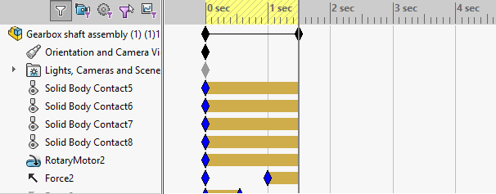Figure 9 - Solid body contact
As well as (Figure 9.) showing the use of solid body contacts, it also shows that a rotary motor is being used for the entirety of the simulation and this is to ensure that the primary shaft is permanently being driven, it can also be seen that a ‘Force 2’ is applied half way through the simulation and this it used to alter push the selector fork into the other gear, to provide a change in the output shaft velocity.
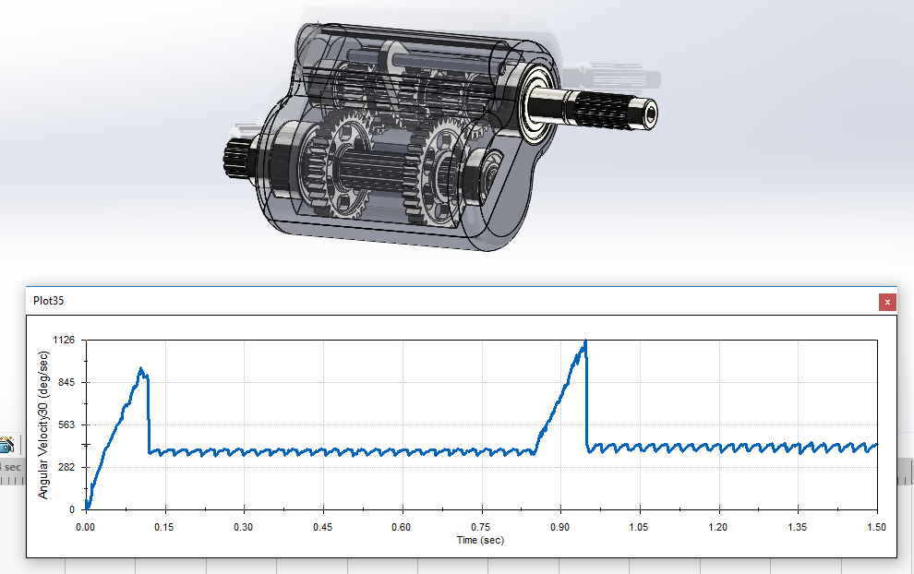Figure 10 - Angular velocity graph
When looking at the graph displayed in (Figure 10.) it can be seen that there are some abnormalities within the graph, this could be down to the forces being applied to the selector fork, the gears between the two shafts being ever so slightly to tight or the selector fork not engaging correctly.
The graph does also show that when the gears are changed there is a slight increase in velocity although the motor maintains the same speed, this is due to the gear ratios being different for the primary shaft and the output shaft. This increase confirms that the shafts are mounted correctly and the gears are operating as expected.
As discussed in section 4.8 with regards to reducing the number of mates required it can be seen in (Figure 11.) that there are 28 mates left redundant, prior to creating rigid group 3, there were 36 redundant mates, using mates such as hinge mates also helped to reduce this, as it reduces the amount of degrees of freedom left once the mate is in place (Dassault Systems, 2019).
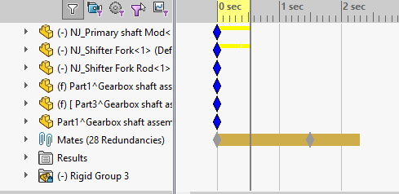Figure 11 - Redundant mates

Conclusion and recommendation
When looking at how the gearbox design and assembly went it can be seen that the housing was completed using a wide variety of techniques, allowing for a fairly efficient design. It can be seen that the housing completed its intended task, of housing the gear mechanisms and allowing the mechanisms to operate.
Looking at the complexity of the design it can be seen that although many techniques were used the actual housing as a unit is quite basic, this is due to it not having an oil fill/drain plugs, a way of securing the two halves of the housing, not being able to mount the housing and the lack of cooling included in the design. The complexity of this housing could have been improved had my personal skills on Solidworks been to a higher standard.
The use of equations in the design phase would have been a better option though if after the motion simulation had been completed, it was found that different size bearings would have been better it would be a lot easier to alter these dimensions if an equation linked the housing and the bearing diameters.
After looking at the graph produced following the motion simulation there could have also been improvements within the design to allow for a smoother transition between gears but also a smoother constant velocity.

Works Cited
Cook, R., Malkus, D. & Plesha, M., 1989. Concepts and Applications of Finite Element Analysis. 3 ed. Canada: John Wiley & Sons.
Dark, R., 2017. AskEngineer. [Online]
Available at: http://kb.goengineer.com/go/default.aspx?kbID=344
[Accessed 16 6 2019].
Dassault Systems, 2019. Delete / Keep Body. [Online]
Available at: https://help.solidworks.com/2019/english/SolidWorks/sldworks/HIDD_DVE_FEAT_DELETE_BODY.htm?verRedirect=1
[Accessed 13 6 2019].
Dassault Systems, 2019. Features. [Online]
Available at: https://help.solidworks.com/2019/english/SolidWorks/sldworks/c_Features_Top.htm?verRedirect=1
[Accessed 12 6 2019].
Dassault Systems, 2019. Mates. [Online]
Available at: https://help.solidworks.com/2019/english/SolidWorks/sldworks/c_Mates_Overview_Assemblies.htm?id=9345ab84db37444d81315e1733c87f91#Pg0
[Accessed 15 6 2019].
Dassault Systems, 2019. Motion Analysis Overview. [Online]
Available at: https://help.solidworks.com/2019/English/SolidWorks/motionstudies/c_Motion_Analysis.htm?verRedirect=1
[Accessed 15 6 2019].
Fish, J. & Belytschko, T., 2007. A First Course in Finite Elements. 1 ed. Chichester: John Wiley & Sons .
LearnSolidworks, 2016. Boss/Base Extrude Feature. [Online]
Available at: https://learnsolidworks.com/solidworks_features/bossbase-extrude-feature
[Accessed 13 6 2019].
Martins, J. & Rego, R., 2001. Valve Motion Modelation for Use in Airflow Engine Simulation, Detroit: SAE Technical Paper Series.
Pilkey, W. & Pilkey, D., 2017. Peterson's Stress Concentration Factors. 3 ed. Virginia: John Wiley & Sons.
Rao, S., 2018. The finite element method in engineering. 6 ed. Florida: Butterworth-Heinemann.
Segerlind, L., 1984. Applied Finite Element Analysis. 2 ed. New York: John Wiley And Sons.
Thomee, V., 2001. From finite differences to finite elements. Journal of Computational and Applied Mathematics, 128(1), pp. 1 - 54.
Vadakkan, S., 2016. An answer most designers might find difficult. ( Fillet Vs Chamfer), UAE: Precise Group.
Weismantel, L., 2013. Reduce, Reuse, Recycle Your Sketches. [Online]
Available at: https://blogs.solidworks.com/solidworksblog/2013/03/reduce-reuse-recycle-your-sketches.html
[Accessed 12 6 2019].
Zhuming, B., 2018. Finite element analysis applications: a systematic and practical approach. 1 ed. Indiana: Academic Press.

