

Assignment
Term 2
Level 5
Programme Ba: Business Management
Module: Data Handling And BI
Module Code: Lcbb5000
Lecturer: Anupam Mazumdar
Assignment Title: Written Essay
Rajeshwari Bingi: 2229271

Table of contents…….

1 The Sales Trend Over the month…….
2 The most frequently Purchased product……………..
3 Products that customer purchase in each transaction……..
4 The most profitable segment customers……………………
5 The recommended Strategy for the business to gain more profit………
6 Male and Female students……………………………….
7 Qualified students for reduced/free lunch………………………………………………
8 The mean and median students qualified and not qualified for reduced/free lunch………..
9 Example of Clustering……….....……………………………………………………..
10. The advantages and disadvantages of using SPSS and Excel….........……………….
11. Conclusion………………………………………….………………………………….
12. References………………………………………………………………………...……

Introduction
In today's cutthroat business world, knowing how customers act and how sales move is key to make plans that boost profits. Data analytics now lets companies see deep into how they work helping them to make choices based on facts that boost productivity and make customers happier.The following report covers most aspects of the sales data study, focusing on the trends in sales, what people like, how customers buy, and what makes money. It is aimed at giving actionable tips that will help a company fine-tune its plans for better bottom-line results. The analysis refers to sales data from an online store. We will see the trends of monthly sales, which are going to help us track periodic patterns in sales that come and go, understand the frequency of sales for different products, and determine customer purchasing behaviour in each sale. We will also determine which types of customers are most profitable and point out some actions to maximize profits based on our findings. Using the tools of data study will help one get to know his market better, guess what the customer will want, and hence make more money.

2. The Sales Trend over the months:
Any successful firm should be able to identify the trends in sales that may have an impact on financial planning, marketing activity, inventory management, and strategy. In this analysis, we have gone through the sales data of two months—November and December 2019—with a view to finding trends that will help guide business decisions.
It was consolidated on a monthly basis, whereby the total sales value was calculated for the respective periods. From the analysis, it can be deduced that the sales were way higher in November 2019 than in December 2019. To be specific, the total sales in November added up to about £360,018, while that of December stood at approximately £164,862. This large difference probably points out a seasonal trend: peak sales occur in November, likely due to pre-holiday shopping, and then drop in December after the initial rush for holidays.

Visualization of sales trends:
A line graph indicated the trends of sales over the two months. Clearly, the graph shows that November is the peak, and the sales gradually go down as December progresses. The highest sale day in December was on the 5th, with sales of £43,626, an indication of a huge surge early in the month of December, probably driven by last-minute shoppers for the holidays.
Interpretation of Results:
The analysis indicates that November is imperative to sales, with events such as Black Friday and the kick-off for holiday shopping. December slightly declines, probably due to the fact that people complete early holiday shopping. This insight would show more emphasis should be placed on marketing and inventory toward November when peak shopping occurs. This could also help build momentum into December sales early on.
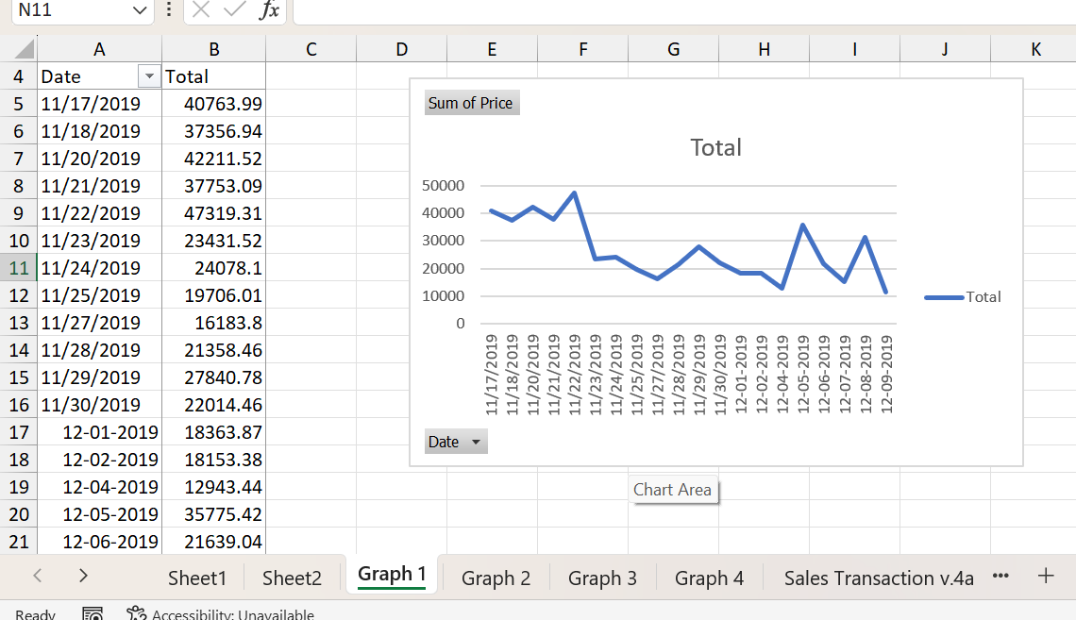

3. Most Frequently Purchased Products
Knowing which products sell frequently is very important in attaining proper inventory management, marketing, and sales strategies. Businesses can therefore manage their inventory levels optimally, tailor promotions on high-demand products, and improve customer satisfaction since stocks of the demanded products will be available.
Data Analysis:
In all, the quantity of each product sold was summed for the time under study. The top ten most frequently sold items were determined; "Asstd Design 3d Paper Stickers" top the rank, with 12,632 pieces sold. Other high-volume sale products were "Rabbit Night Light", which had 11,251 units sold, and "Popcorn Holder", which had 11,238 units sold.
Interpretation of results:
These results suggest that these are trend products in demand from the customer, either by utility, appeal, or low price. High sales volume from these items should already presuppose that the target market likes these products. This information is most valuable for any business when it comes to making decisions regarding restocking and marketing. Having these high-demand products in the house at all times will ensure avoiding lost sales and increasing customer satisfaction. These could be the products highlighted in the going-to-market campaigns, which would draw the attention of more customers and ensure more sales.
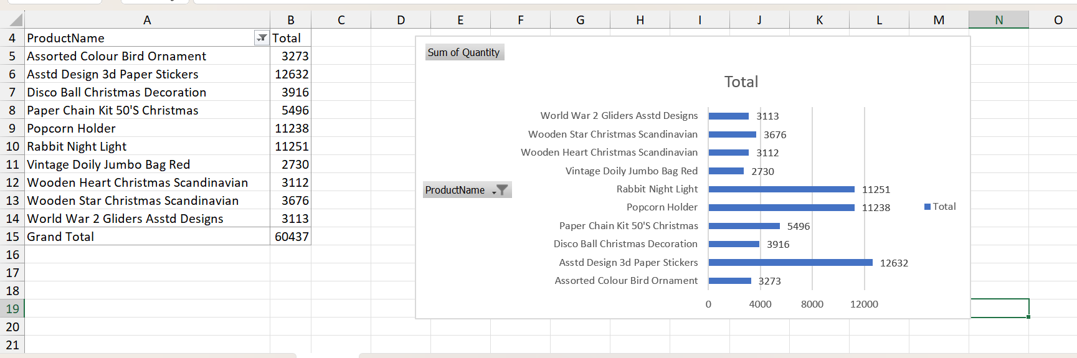

4. Products purchased in Each Transaction:
Products bought in any particular transaction show customer purchasing behavior: whether customers prefer to buy a single item or many at one time. An analysis of this kind can inform strategies in cross-selling, bundling, and personalized marketing.
Data Analysis:
Analyzing transaction data to establish the number of products purchased per transaction, it was evident that some transactions contained single products while others contained multiple products. For example, Transaction ID 577130 contained a "Rustic Seventeen Drawer Sideboard," while Transaction ID 577078 contained numerous products, such as "Christmas Lights 10 Reindeer" and "Recycled Acapulco Mat Turquoise," among others.
Interpretation of results:
Single- and multi-item transactions prove variability in clients' shopping habits, whereby some may be focused on very expensive goods, and others take advantage of sales to clear as many items as possible in a single buy, either by marketing campaigns or due to interest in a full product line.
It means that with the knowledge of these trends, organizations will be able to formulate some working marketing strategies. For instance, customers who often make many purchases could be given discounts or package deals. On the other hand, cross-selling techniques or recommendations could suggest that single-item purchasers view a wider range of products.

5. The most profitable customer Segments:
It is necessary to identify the most profitable customer segment. This will assist in focused marketing efforts towards these segments of customers and reduce customer attrition. Any company would be better positioned to maximize profitability when its strategies can be based on knowledge of customers who generate the most revenues.

Data Analysis:
Customer data was analyzed to identify the top ten most profitable customers with regards to customer spend. Customer No. 16446, based in the United Kingdom, was the highest spender, having generated £501,359.05. In general, though, it was established that most of the top-spending customers were based in the UK, while some other European countries, such as the Netherlands, Ireland (EIRE), and Norway, formed part of this list.
Interpretation of results:
These findings indicate that the UK is the market worthy of a business operating with the largest customer base and the most share price. This kind of information may allow for tailoring marketing and customer connection in such a way that ensures these valued customers are retained. Special marketing campaigns, for example, may be designed only for such customers, where loyalty programs or special offers could be provided to them in order to foster closer relationships and repeat buying.
Apart from this, the presence of high-value customers in countries like the Netherlands and Norway has been perceived as an opportunity to diversify market channels. Target marketing across these regions will help a company gain more customers and improve overall profitability.
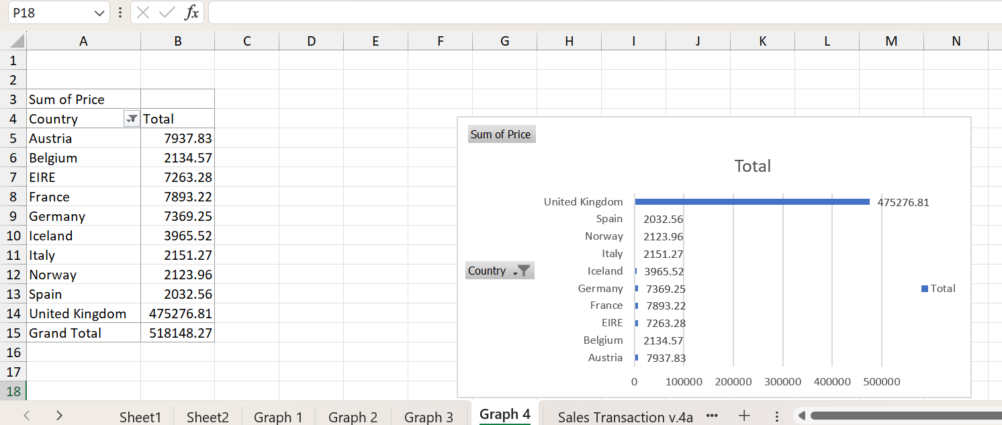

6. Recommended Strategy to increase Business profitability:
Some of the strategies that could be advocated in enhancing the profitability of the business, based on sales trends and popularity analysis and customer segments analysis are:
a)Focus on high-Demand products
Make sure to always have some of the best-selling products like "Asstd Design 3d Paper Stickers" and "Rabbit Night Light" on hand at all times. Because of the popularity and high profit of such products, there is clearly a case for maintaining sufficient levels of stock by touting these items to maximize sales.

b) Targeted Marketing campaign
Design personalized marketing campaigns on the most profitable customer segments, especially those based in the UK. These would include special discounts, early access to new products, and loyalty rewards aimed at encouraging repeat purchases.
c) optimize Sales during peak Periods
The sales trend analysis places November as being one of the peak periods in sales. This could be driven by events such as Black Friday and holiday shopping. Focusing advertising and promotional activity during this period would yield maximum sales for businesses. Limited-time discounts in the beginning of December will also help the company keep up the momentum.

d) cross selling and bundling strategies
As such, businesses should display a bundle offer or cross-sell other complementary products to customers buying multiples of products in a single transaction, thus raising the average transaction value and customer satisfaction.
e) explore market expansion opportunities
The analysis identified, in that respect, profitable customers from countries such as the Netherlands and Norway. One should carefully consider increasing presence in those regions through targeted marketing campaigns and, if necessary, investigating partnership opportunities with local distributors or retailers.

f) customer retention programs
Put in loyalty programs, whereby the customer is rewarded by repeat purchases in terms of points-based systems, special members-only discounts, or early birds on sales events. Businesses can ensure a steady flow of income and long-term customer loyalty by retaining their customers.
(Part-2)

HOW MANY STUDENTS ARE Male and Female students
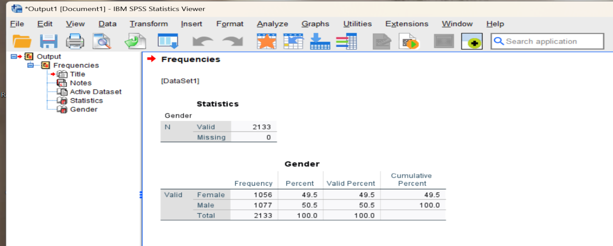

Male and Female students:
The total number of school students is 2133 out of them 1077 are and 1056 students are female 1056 students are female
As shown in the above figure, 50.5% of the school students are male & 49.5% are female.
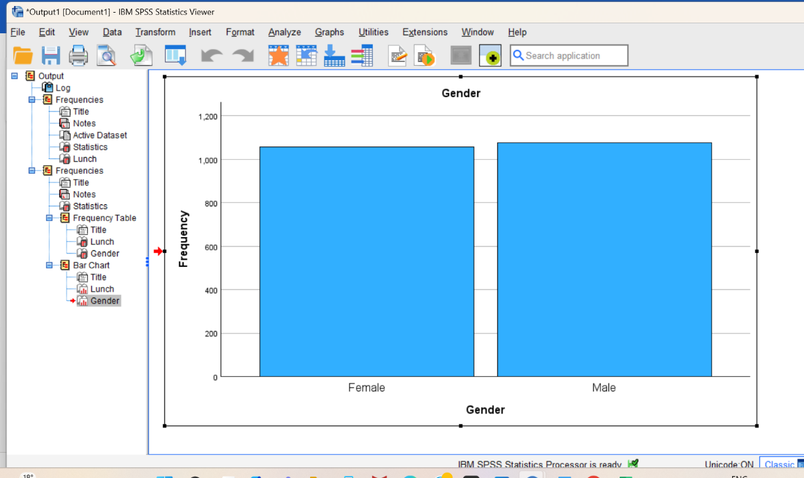

How many students Qualify and do not qualify for reduced/free lunch?
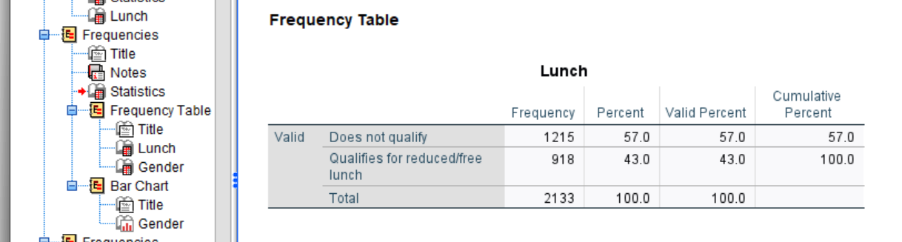
From the above figure, out of 2133 students, 918 qualified and 1215 students were not qualified for reduced/free lunch.

Qualified Students for Reduced/free lunch:
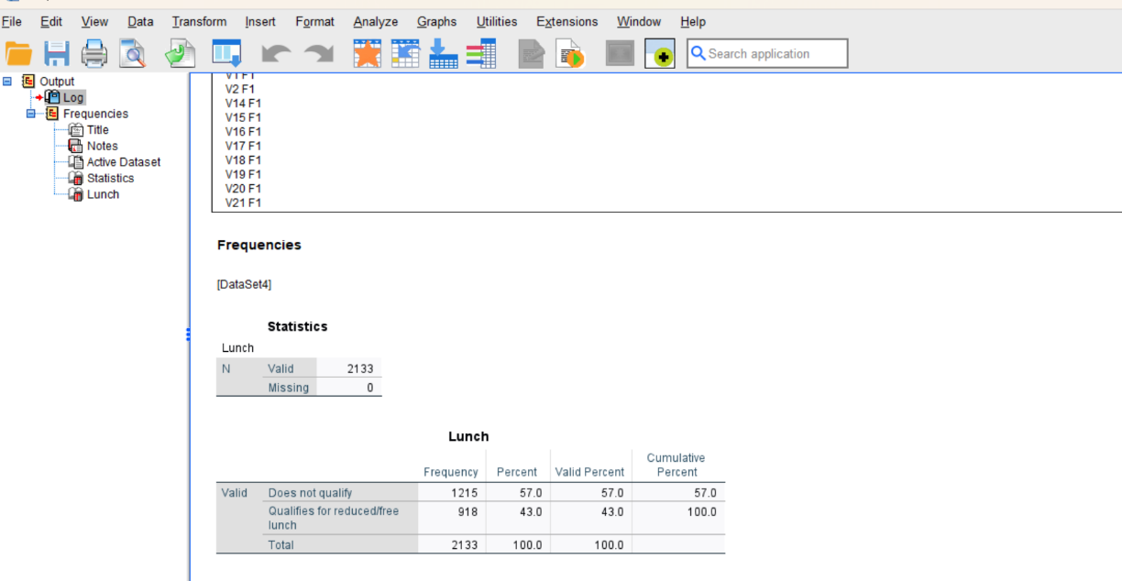

The Mean and Median students qualified and not qualified for reduced /free lunch

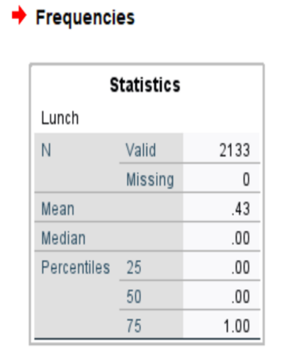
Example of clustering :
Open SPSS
Click on the file
Select import data
Click on excel , open file name studentscore.csv
Data preparation
Checked the data displayed appropriately
Click on analyze
Select descriptive analysis
Select frequencies from descriptive analysis
Interpreting the results
SPSS will generate an output window with several tables.
The advantages and disadvantages of using SPSS and Excel.
Advantages of SPSS
Such software is able to generate new variables from existing ones, according to MacInnes (2016).
Sophisticated statistical tests that you can run: SPSS has many of the most advanced statistical tests programmed in.
Multiple file formats: you can open Excel, SAS, Stata, tab-delimited files, and many others in SPSS.
Platform compatibility: Researchers can work on diverse systems since SPSS is compatible with a number of operating systems, including Windows, macOS and Linux (URI, 2019).
Good use case: cluster analysis (2013) Field says that this is a ‘really good use case for SPSS’ (2013, 2017)
Full support for the analytic workflow: For every step in the analytic process, SPSS does the work for you, from data preparation and management to analysis and reporting.
Disadvantages of SPSS
Commercial license: SPSS is not free. Even students cannot use it freely, as it requires a paid license. The paid license fee is discounted.
Testing: The usability of SPSS remains shaky for those users who are frequent users of MS Excel.
Graph editing: Graph editing is tedious in SPSS, and there are so few graph editing options.
Poor quality graphics: Graphics produced by SPSS are of low quality. Options in this tool for graphs are quite limited.
Output is less easy to edit: The output from SPSS can be hard to edit (UT Austin, 2012).
Sluggish performance: Depending on the hardware on which it is installed, the program could perform sluggishly.
Add-on modules are complex: Some of the add-on modules in SPSS are not user intuitive.
Advantages of Excel:
Excel is designed intuitively, and with an intuitive interface, so users with any level of ability will be able to use it with ease. It does not take a heavily ingrained complex programming language to run a variety of data manipulations, calculations, and visualizations.
Flexibility: Excel is a one-stop shop for running calculations, visualizing, and storing data. It suits the vast variety of data analysis tasks, from the shortness of projects to the large and/or collaborative nature of some work with people who may not be familiar with specialized tools because it can cater to a vast variety of data formats and functionalities.

Broad availability and good integration: being part of the Microsoft Office suite, Excel is hardly rare and can leverage good integration with other Office-related applications, thus making data transfer and cross-platform collaboration easy.
Built-in Functions and Formulas: Excel has a huge number of built-in functions and formulas powerful enough to perform many everyday statistical analyses and financial modeling tasks, and it is even quite good at data management​, Data consultants.
Customizability: Excel allows end-users to create their own macros and automate repeated tasks to expedite work in conducting tasks that are regularly repeated in data analysis​.
Disadvantages of Excel:
Limited Scalability: Excel really is not intended to be used with huge data files or complex calculations. With large data sets, performance can become an issue, either in the form of slow processing time or even crashes themselves.
Manual entry of data and the associated risks of error: One of the major drawbacks of using Excel is manual entry of data, which increases the potential for human error. Furthermore, even errors in data entry or formulae have significant impacts and are usually quite difficult to trace. ​
Absence of Features for Advanced Data Analysis: Excel can only be used for very basic to moderately complex analyses but is not compatible with advanced data analytical features one would get in a program like Python, R, or SQL. This would be more easily done—for example—by big data or Machine Learning techniques.

References.
- Banker, R.D., Cokins, G., & Cvetkoska, V. (2023). Data analytics to support planning, controlling, and decision-making in management accounting. Management Accounting Quarterly, 24(2).
- Leech, N.L., Barrett, K.C., & Morgan, G.A. (2014). IBM SPSS for intermediate statistics: Use and interpretation. Routledge.
- Salcedo, J., & McCormick, K. (2017). SPSS statistics for data analysis and visualization. John Wiley & Sons.
- Tumrate, C.S., & Laxmikant, S. (2024). Data preparation in machine learning approach. In: Deformation and fracture in materials: Advances in experimental and numerical studies, p.54.
- Serikov, B. (2024). Customer relationship management in a logistics company in the digital economy. Logistics Quarterly.
- Dol, S.M., & Jawandhiya, P.M. (2024). Data visualization for the dataset collected from the education sector using Python. In: 2024 1st International Conference on Communications and Computer Science (InCCCS), pp.1-6. IEEE.
- Belghith, M., Ammar, H.B., Elloumi, A., & Hachicha, W. (2024). A new rolling forecasting framework using Microsoft Power BI for data visualization: A case study in a pharmaceutical industry. Annales Pharmaceutiques Françaises, 82(3), pp.493-506.
- Ibisu, A.E. (2024). Development of a gamification model for personalized e-learning. arXiv preprint arXiv:2404.15301.
- Apandi, S.H., Sallim, J., Mohamed, R., & Ahmad, N. (2024). Data pre-processing of website browsing records: To prepare quality dataset for web page classification. JOIV: International Journal on Informatics Visualization, 8(1), pp.239-246.
- Rahman, A. and Muktadir, M.G., 2021. SPSS: An imperative quantitative data analysis tool for social science research. International Journal of Research and Innovation in Social Science, 5(10), pp.300-302.
- Okagbue, H.I., Oguntunde, P.E., Obasi, E.C. and Akhmetshin, E.M., 2021. Trends and usage pattern of SPSS and Minitab Software in Scientific research. In Journal of Physics: Conference Series (Vol. 1734, No. 1, p. 012017). IOP Publishing.

