

LOCATION: Swansea | LLEOLIAD: abertawe
LEVEL 7 | LEFEL 7
EXAMINATION PERIOD | CYFNOD ARHOLIADAU
November 2019 | tachwedd 2019

MODULE CODE: ACCA7017
IMPLEMENTING IP ROUTING
PRACTICAL TEST 1

Name :

Student ID :

Date & Time :

This is an individual practical lab-test, held under examination conditions. You will be assigned four Routers, you should configure these Routers based on the following specifications.

The routers that you will configure are: R1, R2, and R3.

This paper is marked out of 100.

You will have 2 hours to complete this task.

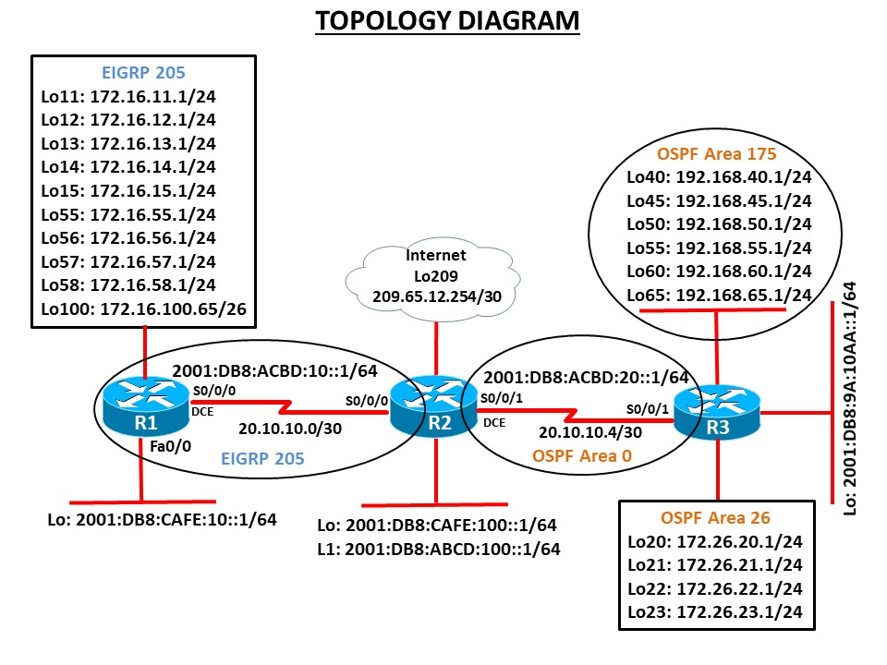

Final configuration
R1#sh run
Building configuration...

Current configuration : 1935 bytes
!
version 15.1
no service timestamps log datetime msec
no service timestamps debug datetime msec
no service password-encryption
!
hostname R1
no ip cef
ipv6 unicast-routing
!
no ipv6 cef
!
key chain R1chain
key 1
key-string FIRST-KEY
!
interface Loopback0
no ip address
ipv6 address 2001:DB8:CAFE:10::1/64
ipv6 eigrp 205
!
interface Loopback11
ip address 172.16.11.1 255.255.255.0
!
interface Loopback12
ip address 172.16.12.1 255.255.255.0
!
interface Loopback13
ip address 172.16.13.1 255.255.255.0
!
interface Loopback14
ip address 172.16.14.1 255.255.255.0
!
interface Loopback15
ip address 172.16.15.1 255.255.255.0
!
interface Loopback55
ip address 172.16.55.1 255.255.255.0
!
interface Loopback56
ip address 172.16.56.1 255.255.255.0
!
interface Loopback57
ip address 172.16.57.1 255.255.255.0
!
interface Loopback58
ip address 172.16.58.1 255.255.255.0
!
interface Loopback100
ip address 172.16.100.65 255.255.255.192
!
interface GigabitEthernet0/0
no ip address
duplex auto
speed auto
shutdown
!
interface GigabitEthernet0/1
no ip address
duplex auto
speed auto
shutdown
!
interface Serial0/0/0
bandwidth 128
ip address 20.10.10.1 255.255.255.252
ip authentication mode eigrp 205 md5
ip authentication key-chain eigrp 205 R1chain
ip summary-address eigrp 205 172.16.8.0 255.255.248.0 5
ip summary-address eigrp 205 172.16.48.0 255.255.240.0 5
ipv6 address 2001:DB8:ACBD:10::1/64
ipv6 eigrp 205
clock rate 64000
!
interface Serial0/0/1
no ip address
clock rate 2000000
shutdown
!
interface Vlan1
no ip address
shutdown
!
router eigrp 205
network 172.16.0.0
network 20.10.10.0 0.0.0.3
!
ipv6 router eigrp 205
eigrp router-id 1.1.1.1
no shutdown
!
ip classless
!
ip flow-export version 9
end

R2#sh run
Building configuration...
Current configuration : 1901 bytes
!
version 15.1
no service timestamps log datetime msec
no service timestamps debug datetime msec
no service password-encryption
!
hostname R2
!
no ip cef
ipv6 unicast-routing
!
key chain R1chain
key 1
key-string FIRST-KEY
!
interface Loopback0
no ip address
ipv6 address 2001:DB8:CAFE:100::1/64
ipv6 eigrp 205
!
interface Loopback1
no ip address
ipv6 address 2001:DB8:ABCD:100::1/64
ipv6 eigrp 205
!
interface Loopback209
ip address 209.65.12.254 255.255.255.252
!
interface GigabitEthernet0/0
no ip address
duplex auto
speed auto
shutdown
!
interface GigabitEthernet0/1
no ip address
duplex auto
speed auto
shutdown
!
interface Serial0/0/0
bandwidth 128
ip address 20.10.10.2 255.255.255.252
ip authentication mode eigrp 205 md5
ip authentication key-chain eigrp 205 R1chain
ipv6 address 2001:DB8:ACBD:10::2/64
ipv6 eigrp 205
!
interface Serial0/0/1
bandwidth 128
ip address 20.10.10.5 255.255.255.252
ip ospf authentication message-digest
ip ospf message-digest-key 1 md5 SECRETPASS
ipv6 address 2001:DB8:ACBD:20::1/64
ipv6 eigrp 205
clock rate 64000
!
interface Vlan1
no ip address
shutdown
!
router eigrp 205
redistribute ospf 1 metric 10000 100 255 1 1500
redistribute static
network 20.10.10.0 0.0.0.3
distribute-list OSPF26-FILTER out ospf 1
!
router ospf 1
router-id 2.2.2.2
log-adjacency-changes
redistribute eigrp 205 subnets
network 20.10.10.4 0.0.0.3 area 0
default-information originate
!
ipv6 router eigrp 205
eigrp router-id 2.2.2.2
no shutdown
!
ip classless
ip route 0.0.0.0 0.0.0.0 Loopback209
!
ip flow-export version 9
!
!
ip access-list standard OSPF26-FILTER
remark Used with DList to filter OSPF Area 26 Network 172.26.20.0
deny 172.26.20.0 0.0.0.255
permit any
!
end

R3#sh run
Building configuration...

Current configuration : 2603 bytes
!
version 15.1
no service timestamps log datetime msec
no service timestamps debug datetime msec
no service password-encryption
!
hostname R3
no ip cef
ipv6 unicast-routing
!
no ipv6 cef
!
interface Loopback0
no ip address
ipv6 address 2001:DB8:9A:10AA::1/64
ipv6 eigrp 205
!
interface Loopback20
ip address 172.26.20.1 255.255.255.0
ip ospf network point-to-point
!
interface Loopback21
ip address 172.26.21.1 255.255.255.0
ip ospf network point-to-point
!
interface Loopback22
ip address 172.26.22.1 255.255.255.0
ip ospf network point-to-point
!
interface Loopback23
ip address 172.26.23.1 255.255.255.0
ip ospf network point-to-point
!
interface Loopback40
ip address 192.168.40.1 255.255.255.0
ip ospf network point-to-point
!
interface Loopback45
ip address 192.168.45.1 255.255.255.0
ip ospf network point-to-point
!
interface Loopback50
ip address 192.168.50.1 255.255.255.0
ip ospf network point-to-point
!
interface Loopback55
ip address 192.168.55.1 255.255.255.0
ip ospf network point-to-point
!
interface Loopback60
ip address 192.168.60.1 255.255.255.0
ip ospf network point-to-point
!
interface Loopback65
ip address 192.168.65.1 255.255.255.0
ip ospf network point-to-point
!
interface GigabitEthernet0/0
no ip address
duplex auto
speed auto
shutdown
!
interface GigabitEthernet0/1
no ip address
duplex auto
speed auto
shutdown
!
interface Serial0/0/0
no ip address
clock rate 2000000
shutdown
!
interface Serial0/0/1
bandwidth 128
ip address 20.10.10.6 255.255.255.252
ip ospf authentication message-digest
ip ospf message-digest-key 1 md5 SECRETPASS
ipv6 address 2001:DB8:ACBD:20::2/64
ipv6 eigrp 205
!
interface Vlan1
no ip address
shutdown
!
router ospf 1
router-id 3.3.3.3
log-adjacency-changes
area 175 range 192.168.0.0 255.255.128.0
passive-interface default
no passive-interface Serial0/0/1
network 20.10.10.4 0.0.0.3 area 0
network 192.168.40.0 0.0.0.255 area 175
network 192.168.45.0 0.0.0.255 area 175
network 192.168.50.0 0.0.0.255 area 175
network 192.168.55.0 0.0.0.255 area 175
network 192.168.60.0 0.0.0.255 area 175
network 192.168.65.0 0.0.0.255 area 175
network 172.26.20.0 0.0.0.255 area 26
network 172.26.21.0 0.0.0.255 area 26
network 172.26.22.0 0.0.0.255 area 26
network 172.26.23.0 0.0.0.255 area 26
!
ipv6 router eigrp 205
eigrp router-id 3.3.3.3
no shutdown
!
ip classless
end

R3#

