School of Sport, Health & Outdoor Education

Assessment Criteria

Student No./Name: 1501726/Dawn Rees_

Module: Health and Social Inclusion
Code: SHSS6031

Personal Evaluation – to support your academic progress please complete the section below BEFORE submitting your work.
What do you consider to be the best aspects of this work? | Understanding of the distribution of wealth and inequalities in income.
Which aspects do you consider could have been improved in this piece of work? | The introduction and other sections could be better supported and some areas such as housing and education could have been expanded
What have you found most satisfying whilst undertaking this submission? | Researching inequalities in health.

CRITERIA | Learning  Outcome | GRADE
CRITERIA | Learning  Outcome | Unsatisfactory  - 39% | Satisfactory  40 – 49% | Good  50 – 59% | Very Good  60 – 69% | Excellent  70% + | %
Background knowledge and understanding of the chosen aspect of Health and Inclusion, setting the theme in appropriate context | 3 |  |  |  |  |  | 30%
Ability to select, synthesise and evaluate appropriate sources relating to chosen theme | 1 |  |  |  |  |  | 30%
Evidence of independent research using a range of sources and the ability to present key findings clearly | 1,2,3 |  |  |  |  |  | 30%
Problem-solving skills in locating appropriate material within secondary sources, internet and primary material. | 3 |  |  |  |  |  | 10%
It is expected that students will present work that is proof read and follows the School Reference Guide and Assessment Checklist. Therefore a range of 0 – 10 marks will be deducted for poor referencing, spelling, grammar, punctuation, and presentation |  |  |  |  |  |  | 0/10

Health inequalities: The social and material circumstances that impact public health outcomes.

This essay will discuss in detail the rules by which different social groups order their lives and make sense of their experiences of health. Further discussion will highlight the circumstances which affect the health of individuals and groups, how this may affect health prevention strategies, with an explanation as to why ‘normal’ health varies between groups. Furthermore, the latest policies which consider health and behaviour maintenance will be highlighted. To illustrate the above points further, the health issue, Chronic Heart Disease (CHD) shall be discussed in detail.

Background
Medical technology has advanced greatly in the past century and its development has enhanced the general health of the population. However, equal access to health care is yet to be achieved as inequalities persist in society. Reducing health care inequalities has significant importance and understanding why such inequalities exist despite modern advancements is vital amongst health care professionals, researchers and advisors in government, to achieve that goal. Association between health and social class has always been an issue, and despite improvements in health and the welfare state in all sectors of society throughout the years, this inconsistency remains. Discrepancies are identified in all aspects of health, including maternal and infant mortality, life expectancy and general level of health. This failure to close the social gap is a disgrace to some, but others see no issue, society believes if parameters are improving in all levels of society, there seems no need for concern. There is evidence to suggest such inequalities exist, and The Office for National Statistics highlights this releasing a report indicating that marked differences remain in all parameters of health across social classes despite the decades of health care provided by the NHS (Steel, 2015). The report indicates that women continue to live longer than men, but the gap is decreasing with changes in lifestyle and health care impacting both sexes.

The issue is complicated however, due to the inequality identified in the report amongst local areas, which has increased during a 20-year period. Another report from The Office for National Statistics shows that the life expectancy of males in deprived areas compared to males in more affluent areas was 9 years shorter and that they were in ‘good’ health within that shorter life for less time (70.5% compared to 84.9%). Females faired better, with those in deprived areas having a life expectancy of 6.9 years shorter than their less deprived counterparts, with less time in ‘good’ health (66.2% compared to 82.9%) (Olatunde, 2015). Life expectancy for men at age 65 was greater in Chelsea and Kensington (21.6 years) and at its lowest in Manchester (15.9 years). Women of this age had a life expectancy greater in Camden (24.6 years) with Manchester women at the lowest (18.8 years) (White and Edgar, 2010).

This outcome is discussed extensively in The Marmot report (2010) “Fair Society, Healthy Lives”. Marmot states that “People living in the most deprived areas will on average die 7 years earlier than people living in the richest neighbourhoods. Even more disturbing, people living in poorer areas not only die sooner but spend more of their lives with disability - an average total difference of 17 years”. Marmot also suggests that health inequalities will cost the NHS more than £5.5 billion per year, with illnesses such as obesity alone set to rise from £2 billion per year to approximately £5 billion per year by 2025. The outcome of the review was to see health inequalities tackled with urgency and as one of societies core priorities alongside the issue of climate change. The review further argues that a future that is sustainable must be created through action to reduce health inequalities, suggesting that active transport, sustainable communities and food production, and zero carbon houses will create health benefits throughout society. It is clear from this evidence that health inequalities amongst social classes not only exist but continue to do so despite medical advances in health. Furthermore, the term social class and its understanding is over-simplified and could incorporate many factors which create inequality such as wealth, status, culture, employment and background. These many factors mean that the affiliation amongst ill health and class is not simple by any means, there are several diverse influences on health, some of which include social class. Evidence from (Yang, Eldridge and Merlo, 2009) using the method of multilevel analysis demonstrates this by highlighting health inequalities, including those households living in the same street. Similar research from (Seaman, Leyland and Popham, 2016; Barr, Higgarson and Whitehead, 2017) supports this further.
Sigerist, (1943) wrote, following the understanding of Virchow, “The task of medicine is to promote health, to prevent disease, to treat the sick when prevention is broken down and to rehabilitate the people after they have been cured. These are highly social functions and we must look at medicine as basically a social science” (Black Report, 1908, p. 1.11). This statement is an important one and highlights that it is improved social conditions that have had the greatest influence on health improvements such as longer life expectancy and lower infant mortality etc, rather than the impact of medical discoveries alone. A study from (Byers, 2010), highlights the idea that social inequalities have greater influence, the research indicated that despite medical improvements such as early cancer detection and treatment, inequalities in cancer mortality rates are primarily associated to social class and race. The understanding here indicates that social class has a definite impact on health outcomes, the lower down in the social class you are the more likely you are to suffer ill health. To explore this issue in depth, coronary heart disease (CHD) shall be discussed.

CHD: Ill health issue associated with health and social inequalities?
The most common form of cardiovascular disease is Coronary heart disease (CHD). It happens when coronary arteries are narrowed by a build-up of atheroma, a fatty material inside their walls. This narrowing of the arteries is known as angina and can cause pain and discomfort and even lead to a heart attack if a blockage occurs (BHF, 2018). Cardiovascular diseases such as CHD, were the biggest cause of death in 2012 according to statistics from the British Heart Foundation (BHF, 2012). The report also shows that in 2010 almost 180,000 people died from heart diseases with approximately 80,000 deaths being from CHD. Premature deaths from heart disease in the UK totalled around 46,000, the highest proportion affected were men at 68%, with nearly one in twelve women and one in seven men dying from coronary heart disease in the UK. Deaths from CHD have been falling in younger age groups but at a slow rate than their elder counterparts however, there is some research that suggests these rates are beginning to level off (Allender et al., 2008). A social health model (shown below) developed by Dahlgren and Whitehead (1992) is widely used to illustrate how numerous factors of health result in unequal dispersal of health consequences within populaces.

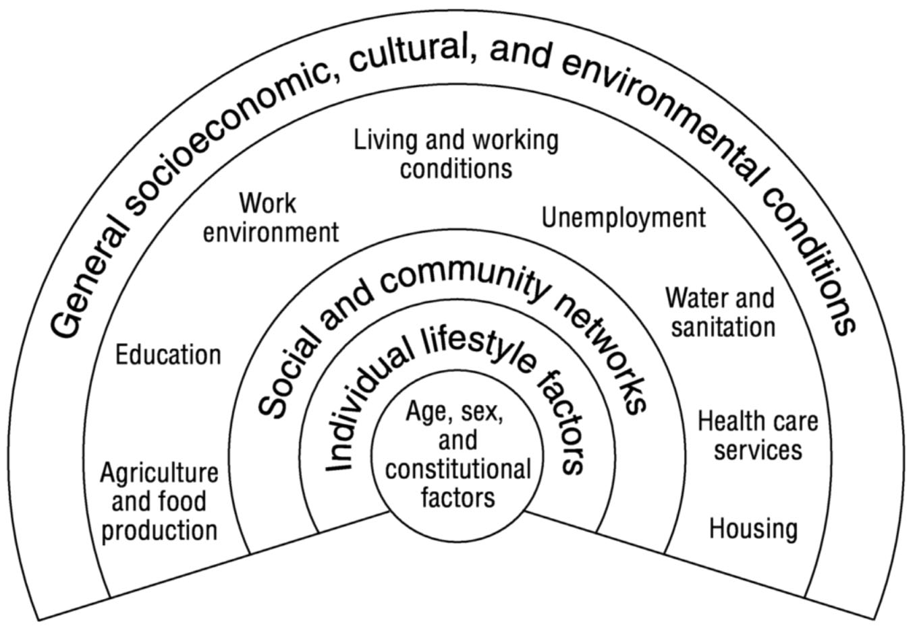
Determinants of health (Dahlgren and Whitehead, 1992)
The relationship between the individual, disease and their environment are mapped out. At the centre is the individual, with characteristics that are fixed and cannot be altered by policies such as age. Surrounding these characteristics are modifiable health influences. Spending capacity from government can be affected by these general conditions, influencing health and social policy priorities directly (PHE, 2017). Marmot, (2010) found that CVD has the greatest impact on health inequalities. Treatment of CHD has positive effects and can be prevented through simple interventions. To allow treatment-focused and preventative measures to be structured effectively, understanding where CHD is impacting lives more is required. The inequalities of CHD are prolonged by many factors such as socio-economic status, differentiating in rates of CHD and its risk factor, lack of health understanding in some poorer groups, differences in area, i.e. postcode lottery, genetic factors predisposing risk and access to services. The socio-economic gradient highlights significant health inequalities including wealth, income, profession and educational attainment. Such socio-economic health inequalities are highlighted in research from (Torssander and Torssander, 2008) which indicates that mortality rates were 50% higher in the poorest areas from CVD related illness compared to the least deprived areas.

Individual-level measures taken from the most recent data indicate that death rates in 2001/03 from CHD were higher in the lowest socio-economic group and lower in the higher socio-economic group. Women had higher CHD death rates than men in similar roles with female workers in routine jobs five times more likely to have the disease than those in professional or managerial jobs (Bhatnagar et al, 2014). The intricacy of health inequalities is highlighted in these findings, despite a higher rate of men having premature death from CHD than women, inequalities are more apparent among women from different socio-economic groups. Those with other health issues are at risk of CVD related illness too, a report from (NHS, 2012) states that individuals with mental health issues are more likely to have long-term health problems such as CHD. It further states that those with severe mental health issues have less access to health promotion and intervention and will often have a shorter life span. Unhealthy lifestyle choices such as smoking, inactivity and poor food consumption also pose greater risk of CHD, Bhatnagar et al, (2014) highlights a marked relationship between rates of CHD and socio-economic status. The reasearch found that lower socio-economic groups are more likely to adhere to health risk taking behaviours than those of a higher socio-economic group. Health literacy can also impact the outcome of an individuals health and the risk of developing CHD. If individuals do not have the capacity to understand, process and obtain basic health requirements, health inequality risk is greater (NHS, 2015).

Individuals with low health literacy have poorer health outcomes, their understanding of disease and self-care is lacking, they are likely to have lower self-esteem and manage their ill health poorly, take up less health screening and have lower medication compliance, individuals with low health literacy are aslo more likely to have hospital admissions. Furthermore, low health literacy can decrease an individuals likelihood of participating in health promoting behaviours (Taggart et al., 2012). Large sections of society have shown to be impacted by health literacy, making the issue a significantly important one. In a study from (Bostock and Steptoe, 2012) the health literacy of a large subject group was observed aged >52. The study focused soley on the subjects ability to take asprin following the instructions set out with the mediction. The results found that a third of older adults had difficulty reading and understanding simple health related written information. This lack of understanding is linked to higher mortality, which has consequences for the relaying of information and delivery and design of services provided.
Other health issues that can increase risk of CHD may be genetic related such as Familial hypercholesterolaemia (FH). The genetic condition FH affects one in 500 people and those with FH have abnormaly raised levels of cholesterol at birth. FH can vastly increase the the risk of premature death from CHD if untreated, and where possible, it is encouraged that’s family history details are well documented (BHF, 2018). Certain ethnic groups have higher CHD risk however, its relationship to illness and risk factors are multifaceted. South Asian men have a higher risk of CHD with a 46% mortality rate and women have a 51% mortality rate compared to non-Asian populace. South Asian people also have higher risk factors of high blood pressure and diabetes (Mindell et al., 2014). However, dietary intakes of saturated fats and salt consumption and incidence of high cholesterol levels are higher in the white population in the UK compared to Black ans Minority Ethnic groups (Scarborough et al., 2011). To plan and better target services, an understanding of the complex relationship of health inequalites and the incidence of the highest risk factors is paramount. The social model of health from Dahlgren and Whitehead (1992) has fixed charactersitics of ethnicity and geneitics, and cannot be altered therefore, there needs to be progress in addressing inequalites linked with fixed characterisitcs with better access to information and services for target groups.

Another notable marker of CVD inequalities in the UK is Geography. CHD rates are sharply divided in the North/South of England, CHD incidence is 50% hifher in the North compared to the South. Throughout the UK however, Scotland obstinately has the highest rates of mortality from CVD (Scarborough et al., 2010). Rates of CVD have been falling since the late 1970’s however, with diabetes and obesity on the rise, certain CVD risk factors are increasing in incidence (Scholes et al., 2012). Some sections of the population are likely to be affected by these risk factors more than others. To highlight this further, one study from (Kearney, 2010) indicated that risk factors displayed clear social gradients, with quantiles being greater in affluent areas. The study included risk factors such as consumption of fruit and vegetables, physical activity and obesity for analysis. In 2005, the World Health Organisation (WHO) Commision on the Social Determinants of Health was established to produce evidence on steps to take to improve health equity. Three broad reccomendations from the commision’s report were set out to realize this. They were, tackle the unequal dispersal of money, resources and power, improve daily living conditions and understand and measure the problem with assessment of the impact of the action (CSDH, 2008).
The WHO further states that lack of coronary care units is not the cause of heart disease, but by the way in which people live their lives, which are ultimately shaped by their living environments. Therefore, the primary action on social determinants of health must come from means beyond the health sector if individuals are to achieve better health equity and social policies, economics and politics should be people centred. The Marmot Review (2010) shares a similar view, noting that reduction in health inequalities necessitates action on six policy objectives. The first is to give every child the best start in life, second is to permit all children, young people and adults the ability to maximise control over their lives, third is to create fair employment and work for everyone, fourth is to guarantee a healthy standard of living for everyone, fifth is to produce and develop sustainable and healthy communities and places and the final objective is to strenghthen the impact and role of health illness and inequality prevention (Marmot, 2010). The objectives outlined here fit well with practical measures that aim to tackle inequalities in CHD at the healthcare, public health and policy health levels.

As discussed earlier, life expectancy has improved for men and women in the last 30 years however, disparities remain, making life expectancy a key indicator of health inequality. Life expectancy variations between the wealthiest and most deprived areas has risen. Life expectancy inequalities between local authority communities increased by 0.1 years for men with no change for women (IHE, 2018). CHD mortality rates show a similar picture, a study from (Asaria et al., 2012) examined data between 1982 and 2006 throughout 8,000 areas in England and found that deaths from CVD have more than halved across England. Decline rates for men and women over 65 years old in the poorest communities was smaller than that of the richest areas, increasing the gap. Deaths from CVD in the best performing 1% of areas fell nearly 5 times more than the worst performing 1% of areas for men over 65 years of age, for women the disparity was ten-fold. Bringing down death rates for CVD is an issue for continued concern. Local authorities are taking up public health issues, designating budgets to support them however, there is the risk of health budgets taking a reduction as they compete with other services such as education. If health inequalities are to be limited, services such as cardiovascular screening and prevention programmes must continue to have importance so that they don’t get cut as a consequence (Parkinson, 2012).
Recent data on CHD mortality reflects the amount of CHD deaths per 100,000 individuals in specified areas. The numbers indicate that regional inequalities remain and occur along a North-South divide in England. The national average CHD mortality rate for England shown in (figure 1) is 74.21. Many regions had rates above the average, the North East had a rate of 80.61, the North West had 89.48, the East Midlands had 79.66, Yorkshire and Humberside had 86.63 and West Midlands had 75.33 (PHE, 2013).
Figure 1. Coronary heart disease mortality in England showing the North South divide
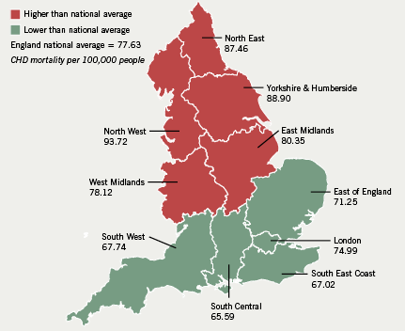
The North West have the highest CHD deaths compared to the South East of England which has the lowest. Further evidence produced from (PHE, 2017) suggests that health inequalities are still a prominent issue amongst social classes. In England there are health disparities amongst those living in the North and South of the country particularly in health issues such as CHD indicated in (figure 2)
Figure 2. Deaths caused by heart disease, stroke and cancers made up half of the gap in life expectancy between the most and least deprived quintiles in England
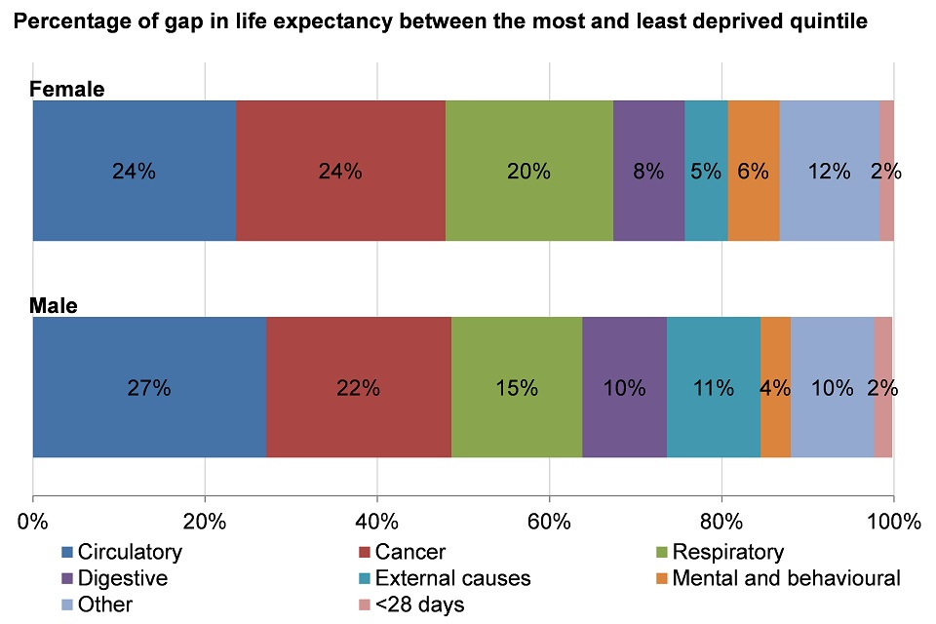
This table shows that in both males and females, circulatory issues such as CHD, cancer and respiratory issues are the 3 top causes of death and contribute to lower life expectancy amongst the most and least deprived individuals. Figures indicate 24% of deprived females and 27% of deprived males are more likely to die from circulatory disease than their least deprived counterparts with respirational causes of death contributing 20% to the gap in females and 15% to the gap in males (PHE 2017). The most recent data for individual-level measures comes from 2001/03. Death rates in 2001/03 from CVD, CHD and stroke were all highest in the lowest socioeconomic group and lowest in the highest socioeconomic group, with a clear gradient across the social groups. This inequality was more striking in women than men, with the CHD death rate in female workers with routine jobs five times higher than those with managerial or professional jobs.

To measure socioeconomic differences in health, individual and area-level measures can be used. Factors such as an individual’s income, wealth, occupation, education or these factors combined make up the basis of individual-level measures and area-level measures tend to be based on an areas resources, geographical features, population or these factors combined (BHF, 2012). There are many risk factors, medical and lifestyle, that can attribute to CHD and related deaths. Individuals with medical health issues such as high blood pressure, diabetes or high blood cholesterol are at greater risk of developing CHD. People with high blood pressure are up to three times more likely to develop heart disease, with diabetes doubling those chances. Adaptable lifestyle risk factors such as smoking, physical inactivity and poor diet contribute significantly to the risk of CHD, smoking is attributed to an estimated 20,000 UK deaths from cardiovascular disease each year. Other risk factors such as age, gender, ethnicity and family history can significantly increase risk of developing CHD, air pollution can have an impact too with up to 40,000 premature deaths being associated with this environmental issue (BHF, 2018). The global strategy for achieving health for all proposed in 1977 by The World Health Organization (WHO) is fundamentally directed towards achieving greater fairness in health within and between populations. In other words, everyone should have an equal opportunity to develop and maintain good health through fair and equal access to resources for health (WHO, 2018). Targets in the United Kingdom (UK) as part of the global strategy, aim to improve the health of the deprived groups and the population as a whole. The aims also have focus on closing the gap in health inequalities (PHE, 2016).

To tackle health inequalities, a gradient approach directs focus towards the systematic variances in life expectancy and living ideals associated with an individual’s social status in the socio-economic hierarchy. Focus needs to centre around the causes of health inequality and health damaging behaviours linked with an individuals unequal position within this hierarchy (Graham, 2009). To reduce the socio-economic gradient, the improvement of health and position amongst the poor relative to other groups has significant importance. A review on tackling health inequalities form The Department of Health (DofH) recognises that achieving real, continued improvement requires rigorous action throughout government and with other sectors. Local communities should have the power to address health inequalities in their areas by working in partnership with all services that have a role to play (Blears, 2002).

Marmot (2010) identifies that focus on the most disadvantaged in society alone is not enough to reduce health inequalities, Graham (2009) supports this, stating that policies need to be associated with unified improvements in health across all socio-economic groups if the social gradient is to improve, and that the rate of improvement increases on each level of the socio-economic ladder. Published in 1999, The White Paper: Saving Lives: Our Healthier Nation, aimed to improve the health of the population, especially for the poorest in society, with the intent of narrowing the health gap (DofH, 1999). The paper states that it is not the role of the governement alone to improve health inequalities but that of the individual themselves. As a govenrnment, a pledge to “tackle air pollution, unemployment, low wages, crime and disorder, and poor housing” was made in the report (DofH, 1999, p. 4). It also indicated that a ‘nanny’ state approach was avoidable and that individuals had a responsibility to prevent ill health by avoiding habits that increased illness and disease such as smoking and drinking, and increase habits such as healthy eating and exercise. Narrowing the gap in health inequalities between the wealthiest and poorest is paramount however, such issues have not improved since the White Paper was produced. Graham, (2009) suggests that narrowing the gap between the wealthy and poor needs major improvement and consistency, with focus on raising the health of those in the lower socio-economic groups to a level of those in higher socio-economic groups. However, focusing on the poorest in society can leave other intermediate groups who may experience poor health, in obscurity, subsequently compromising health throughout the socio-economic hierarchy (Marmot, 2008).
Targests set for achievement by 2010 in The White Paper included the reduction of CHD deaths in people under 75 years, by two fitfhs, saving 200,000 lives (DofH, 1999). Programmes were implemented with a budget of £96m. The proposed targets in the White Paper report were met, with evidence from the British Heart Foundation indicating premature deaths from CHD were reduced by 60% by 2010. In Wales the target of a one third reduction in CHD mortality in 65 -74 year olds by 2012 was met in 2006 and the targets for the inequality gap to be reduced by 40% by 2010 were reached in 2005 and 2008 respectively (BHF, 2012). In 2001, the national health inequalities Public Service Agreement target was introduced to focus on the reduction of inequality around life expectancy and infant mortality by 2010. The target for life expectancy inequality was to reduce the gap by 10% between the fifth of areas with the poorest health and the populace as a whole. The same reduction was set as a target for infant mortality by 2010, closing the gap of the death rate between routine and manual occupation groups and the populace as a whole. The Marmot review suggests the data for the two targets “show substantial improvements in life expectancy and infant mortality for all groups, including those in disadvantaged groups and areas” (Marmot, 2010). Where there has been decline in CVD, the majority of such has been attributed to reductions in significant risk factors such as smoking and cholesterol levels through the prescription of smoking cessation programmes and statins. However, the report from the CQC which documented this decline, indicates that CVD disparities continue despite such interventions because the rate of improvement reducing risk factors amongst deprived groups is slower than their wealthier counterparts (CQC, 2009). The report went on to further state that GP’s are less inclined to document CVD in the poorest areas meaning insufficient access to treatment.

Research from (Wiltshire, Lee and Williams, 2017) on multiple unhealthy behaviours such as smoking, excessive alcohol use, poor diet and low levels of physical activity, has also identified inequalites between socio-economic groups, outlining suggestions for tackling health disparities. The research found that the number of people engaging in unhealthy behaviours were down but those individuals were from higher socio-economic groups. The gap between the wealthy and the poor is widening amongst those who partake in three or more risky behaviours, the research found that the less educated were five times as likely to engage in unhealthy behaviours compared to their more educated counterparts.
The Marmot Review suggests that education is one measure of social position and can impact the outcome of health and social inequality stating that “People with university degrees have better health and longer lives than those without” (Marmot, 2010). The review further states that if those above the age of 30 without a degree saw a death rate reduction to that of their counterparts with degrees, approximately 202,000 premature deaths a year would be achieved. The health and wellbeing of the nation rests in the hands of the government, and it is their responsibility to implement health equality for everyone. The governement has implemented a range of initiatives over the last 15 years to tackle health inequalites. Such initiatives include Sure Start, supporting children of disadvantaged families in the early years, and Health Action Zones, set up to include multi-agency partnerships in 26 areas of England with a budget of £4-5 million per year, per zone. Local authority areas were also ‘spearheaded’ if they were in the lowest fifth nationally for three or more of the following five issues: cancer mortality rate in under 75s, cardiovascular disease mortality rate in under 75s, Index of Multiple Deprivation 2004 score and Male life expectancy at birth/Female life expectancy at birth. However, the House of Commons Health Committee carried out an investigation of governement policies in 2009 and found Sure Start had not demonstrated any significant improvements in health for either parents or children policy and that Health Action Zones were poorly funded (HCHC, 2009).

Throughout this essay the division between the wealthy and the poor and their health outcomes have been discussed with emphasis on CHD. It is clear that health inequalities exists between these socio-economic groups and will continue to do so under the current government based on the policies outlined for health in their manifesto. Although life expectancy has improved overal in recent years, life expectancy inequalities have increased, which indicates that far more needs to be done to improve the causes of health inequalities. Medical advancements are making progress in fighting illness and disease but the gap only widens between groups when only the wealthy can afford such procedures through private care, and the poor are left without care due to NHS finance cuts year after year. Will the gap ever close? This research worryingly, has indicated not so.

Word count: 4480

References

Allender, S., Scarborough, P., O’Flaherty, M and Capewell, S. (2008). 20th century CHD morality in England and Wales: population trends in CHD risk factors and coronary death.. BMC Public Health , Volume 8, p. 141.
Annandale, E. (2000) Gender Inequalities in Health, Buckingham: Open University.
Asaria, P., Fortunato, L., Fecht, D., Tzoulaki, I., Abellan, J., Hambly, P., de Hoogh, K., Ezzati, M and Elliott, P. (2012). Trends and Inequalities in Cardiovascular Disease Mortality Across 7932 English Electoral Wards, 1982-2006: Bayesian Spatial Analysis,. International Journal of Epidemiology, 41(6), pp. 1737-1749.
Barr, B., Higgerson, J and Whitehead, M. (2017). Investigating the impact of the English health inequalities strategy: time trend analysis.. BMJ, Volume j3310, p. 358.
Bhatnagar, P., Wickramasinghe, K., Williams, J., Rayner, M and Townsend, N. (2014). The epidemiology of cardiovascular disease in the UK 2014. Heart, Issue 1.
British Heart Foundation. (2012). Coronary heart disease statistics: A compendium of health statistics 2012 edition , London: British Heart Foundation.
British Heart Foundation. (2018). CVD STATISTICS – BHF UK FACTSHEET. [Online]
Available at: file:///C:/Users/user/AppData/Local/Packages/Microsoft.MicrosoftEdge_8wekyb3d8bbwe/TempState/Downloads/bhf-cvd-statistics---uk-factsheet.pdf
[Accessed 21 March 2018].
British Heart Foundation. (2018). Familial Hypercholesterolaemia (FH). [Online]
Available at: https://www.bhf.org.uk/heart-health/conditions/familial-hypercholesterolaemia
[Accessed 23 March 2018].
Black, D. (1980). The Black Report 1: 1 Concepts of Health and Inequality, s.l.: Department of Health and Social Security DHSS.
Blears, H. (2002). TACKLING HEALTH INEQUALITIES: 2002 Cross-Cutting Review, s.l.: Department of Health.
Bostock, S and Steptoe, A. (2012). Association between low functional health literacy and mortality in older adults:longitudinal cohort study OPENACCESS. British Medical Journal, p. 334.
Byers, T. (2010). Two decades of declining cancer mortality: progress with disparity.. Annual Review of Public Health. , Volume 31, pp. 121-32. .
Commission on Social Determinants of Health. (2008). Closing the gap in a generation: health equity through action on the social determinants of health. Final Report of the Commission on Social Determinants of Health, Geneva: World Health Organization.
Care Quality Commission. (2009). Tackling Cardiovascular Disease and Health Inequalities by Prescribing Statins and Stop Smoking Service, London: Care Quality Commission .
Dahlgren, G and Whitehead, M. (1992). Social Model of Health – Dahlgren & Whitehead. [Online]
Available at: http://www.nwci.ie/download/pdf/determinants_health_diagram.pdf
[Accessed 21 March 2018].
Department of Health (2012), Draft guidance on Joint Strategic Needs Assessments and joint health and wellbeing strategies; January 2012, page 5. [Online] Available at: http://healthandcare.dh.gov.uk/files/2012/01/JSNAs-and-joint-healthand-wellbeing-strategies-draft-strats.pdf [Accessed 22 March 2018].
Department of Health and Social Care. (1999). Saving Lives: Our Healthier Nation, s.l.: The Stationery Ofﬁce.
Graham, H., (2009). Understanding health inequalities. 2nd ed. s.l.:s.n.
Great Britain, Health and Social Care Act. (2012) c.7 s.195(1), [Online] Available at: http://www.legislation.gov.uk/ukpga/2012/7/ pdfs/ukpga 20120007e n.pdf [Accessed 21 March 2018].
House of Commons Health Committee. (2009). Health Inequalities: Third Report of Session 2008-2009, London: House of Commons Health Committee.
Institute of Health Equity. (2018). IHE analysis of Eurostat Life Expectancy Data, s.l.: UCL Institute of Health Equity press release.
Jones, H. (1994) Health and Society in the Twentieth Century Britain, London: Longman.
Kearney, J. (2010). Food consumption trends and drivers. Philosophical Transactions of the Royal Society B, Volume 365, pp. 2793-2807.
Lawrence, C. (1994) Medicine in the Making of Modern Britain 1700 - 1920, London: Routledge.
Marmot, M., (2010). Fair Society, healthy lives, London: University College London.
Marmot, M., Friel, S., Bell, R., Houweling, T and Taylor, S. (2008). Closing the gap in a generation: health equity through action on the social determinants of health. The Lancet, 372(9650), p. 8–14.
Mindell, J., Knott, C., Ng Fat, L., Roth, M., Manor, O., Soskolne, V and Daoud, N. (2014). Explanatory factors for health inequalities across different ethnic and gender groups: data from a national survey in England. Journal of Epidemiol Community Health, Volume 68, pp. 1133-1144. .
National Health Service, Mental Health Network. (2012). Long-term health gains: Investing in emotional and psychological wellbeing for patients with long-term conditions and medically unexplained symptoms, London: NHS Confederation Events & Publishing. .
National Health Service, The Health Literacy Place. (2015). Health literacy and health inequalities. [Online]
Available at: http://www.healthliteracyplace.org.uk/evidence/health-literacy-and-health-inequalities/
[Accessed 22 March 2018].
Notes, L. (2018). Concepts of Health and Illness: Section 4. Lay Health Beliefs and Illness Behaviour. Camarthen: UWTSD.
Olatunde, O. (2015). Life Expectancy at Birth and at Age 65 by Local Areas in England and Wales: 2012 to 2014, s.l.: The Office for National Statisitics.
Page, R. M. & Silburn, R (Eds.) (1999) British Social Welfare in the Twentieth Century, London: Macmillan.
Parkinson, C. (2012). Over-65s heart death gap 'wider' between rich and poor. [Online]
Available at: http://www.bbc.co.uk/news/health-20179498
[Accessed 26 March 2018].
Public Health England. (2013). Heart Hotspots: CHD Mortality – National Data by SHA , England: Health and Social Care Information Centre .
Public Health England. (2016). Strategic plan for the next four years: Better outcomes by 2020. [Online]
Available at: https://www.gov.uk/government/uploads/system/uploads/attachment_data/file/516985/PHE_Strategic_plan_2016.pdf
[Accessed 14 March 2018].
Public Health England. (2017). Reducing health inequalities: System, scale and sustainability. [Online]
Available at: https://www./PublicHealthEngland/reducing-health-inequalities-system-scale-and-sustainability
[Accessed 21 March 2018].
Scarborough, P., Morgan, R., Webster, P and Rayner, M. (2011). Differences in coronary heart disease, stroke and cancer mortality rates between England, Wales, Scotland and Northern Ireland: the role of diet and nutrition. British Medical Journal Open, 1(1).
Scarborough, P., Nnoaham, K., Clarke, D., Capewell, S and Rayner, M. (2010). Modelling the impact of a healthy diet on cardiovascular disease and cancer mortality. Journal of Epidemiology and Community Health, 66(5).
Scholes, S., Bajekal, M., Love, H., Hawkins, N., Raine, R., O'Flaherty, M and Capewell, S. (2012). Persistent socio-economic inequalities in cardiovascular risk factors in England over 1994-2008: A time-trend analysis of repeated cross-sectional data.. BMC Public Health, 12(129).
Seaman, R., Leyland, A and Popham, F. (2016). Increasing inequality in age of death at shared levels of life expectancy: A comparative study of Scotland and England and Wales.. SSM Population Health, Volume 2, pp. 724-731.
Steel, K. (2015). Inequality in healthy life expectancy at birth by national deciles of area deprivation: England, 2011 to 2013, s.l.: Office for National Statistics.
Taggart, J., Williams, A., Dennis, S., Newall, A., Shortus, T., Zwar, N., Denney-Wilson, E and Harris, M. (2012). A systematic review of interventions in primary care to improve health literacy for chronic disease behavioral risk factors.. BMC Family Practice, 13(49).
Torssander, E. and. Torssander, J. (2008). Social class and cause of death. European Journal of Public Health, 18(5), pp. 473-478.
White, C, and Edgar, G. (2010). Inequalities in healthy life expectancy by social class and area type: England, 2001-03.. Health Statisitics Quarterly , Volume 45, pp. 28-56.
Wiltshire, G., Lee, J and Williams, O. (2017). Understanding the reproduction of health inequalities: physical activity, social class and Bourdieu’s habitus. Sport, Education and Society, 1(1).
World Health Organisation. (2018). Executive summary: Achieving health for all. [Online]
Available at: http://www.who.int/whr/1998/media_centre/executive_summary6/en/
[Accessed 14 March 2018].
Yang, M., Eldridge, S and Merlo, J. (2009). Multilevel survival analysis of health inequalities in life expectancy.. International Journal of Equity In Health. , 8(31).

