

University of Wales Trinity Saint David
School of Engineering
Calculation on Piston, Rod, Crankshaft Assemblies
Advanced Engine Design
M6X00410
Ainsley Martin
P149894
10/02/2020

Contents
1. Introduction 5
2. Part 1 6
2.1 Masses 6
2.1.1 Conrod 6
2.1.2 Piston 6
2.1.3 Gudgeon Pin 6
2.2 Calculations 7
3. Part 2 12
3.1 Point A 13
3.2 Point B 15
3.3 Point C 16
4. Part 3 19
4.1 Part A 19
4.2 Part B 20
4.3 Part C 21
4.4 Part D 22
4.5 Part E 23
4.6 Part F 24
4.7 Part G 27
4.7.1 Modified RPM 27
4.7.2 Modified Material 27
4.7.3 Modified Material with Wasted Shank 28
4.8 Part H 30
5. Part 4 31
6. Conclusion 35
7. References 36
8. Appendix 37

Graph 1 - Bending Stress 8
Graph 2 - Shear Stress 9
Graph 3 - Combined Stress 9
Graph 4 - Nominal Hoop Stress (A) 13
Graph 5 - Nominal Hoop Stress (B) 15
Graph 6 - Nominal Hoop Stress (C) 16
Graph 7 - Alternating Load 21
Graph 8 - Shear Stress Crankshaft 31

Table 1 - Conrod Masses 6
Table 2 - Piston Masses 6
Table 3 - Gudgeon Pin Figures 6
Table 4 - Part 2 Stress Concentration 18
Table 5 - Part A Measurements 19
Table 6 - Part D figures 22
Table 7 - Part 3f Stress Concentrations Dimensions 25
Table 8 - Part 3 F Stress Concentrations 25
Table 9 - Modified Material Results 27
Table 10 - New Bolt Area 1 Dimensions 28
Table 11 - New Bolt Area 2 Dimensions 28
Table 12 - New Bolt Area 3 Dimensions 28
Table 13 - Modified Material with Wasted Shank Results 29
Table 14 - Crankshaft Figures 31
Table 15 - Masses used for Crankshaft 31
Table 16 - Dimensions for Stress Concentration for the Crankshaft 33
Table 17 - Stress Concentrations for Crankshaft 33
Table 18 - Results for Crankshaft 33

Equation 1 - Mass of Gudgeon Pin Out 7
Equation 2 - Second Moment of Area 7
Equation 3 - Piston Acceleration 7
Equation 4 – Gudgeon Pin Inertia 7
Equation 5 - Gas Force 7
Equation 6 - Net Force 7
Equation 7 - Bending Moment 8
Equation 8 - Bending Stress 8
Equation 9 - Shear Stress 9
Equation 10 - Combined Stress 9
Equation 11 - Actual Range 10
Equation 12 - Mean Stress 10
Equation 13 - Allowable Range 10
Equation 14 - Fatigue Safety Factor 10
Equation 15 - Nominal Hoop Stress for A and C 12
Equation 16 - Nominal Hoop Stress for B 12
Equation 17 - Allowable Range with Stress Concentrations 18
Equation 18 – K Cap over K Bolt Ratio 19
Equation 19 – Bolt Stiffness 20
Equation 20 - Alternating Load 21
Equation 21 - Highest Inertia Force 21
Equation 22 - Alternating Stress 21
Equation 23 - Clamping Force 22
Equation 24 - Circumferential Friction Force at Threads 22
Equation 25 - Bolt Head Friction 22
Equation 26 - Torque Needed to Overcome Head Friction 22
Equation 27 - Bolt Stress Minimum 23
Equation 28 - Bolt Stress Range 23
Equation 29 - Maximum Bolt Stress 23
Equation 30 - Mean Bolt Stress 23
Equation 31 - Minimum Bolt Diameter 28

Figure 1 - Goodman Diagram for Part 1 11
Figure 2 - Conrod Points 12
Figure 3 - Goodman Diagram Part 2 (A) 14
Figure 4 - Goodman Diagram Part 2 (B) 15
Figure 5 - Peterson Stress Concentration Diagram Part 2 (C) 17
Figure 6 - Goodman Diagram Part 2 (C) 18
Figure 7 – Measuring to 2nd Engaged Thread 20
Figure 8 - Peterson Stress Concentration Diagram Part 3 (F) 24
Figure 9 - Goodman Diagram Part 3 (F) 26
Figure 10 - New Bolt Design 30
Figure 11 – Old Bolt Design 30
Figure 12 - Peterson Stress Concentration Diagram Part 4 32
Figure 13 - Goodman Diagram Part 4 34
Figure 14 - Part 1 Excel 37
Figure 15 - Part 2 (A) Excel 38
Figure 16 - Part 2 (B) Excel 39
Figure 17 - Part 2 (C) Excel 40
Figure 18 - Part 3 (a) Excel 41
Figure 19 - Part 3 (B) Excel 42
Figure 20 - Part 3 (C) Excel 42
Figure 21 - Part 3 (D) Excel 42
Figure 22 - Part 3 (E) Excel 43
Figure 23 - Part 3 (F) Excel 44
Figure 24 - Part 3 (G) Excel Modified RPM 45
Figure 25 - Part 3 (G) Excel Modified Material 46
Figure 26 - Part 3 (G) Excel Modified Material and Wasted Shank 47
Figure 27 - Part 4 Excel 48

Introduction
This project will investigate the forces acting on a piston, connecting rod (conrod) and the crankshaft from a Ford 1.6 GTDI engine. Initially the forces on the gudgeon pin will be investigated and these will be used to determine a safety factor for the pin. Next the forces and thus safety factors will be investigated at three different points on the conrod, for these stress concentration factors will need to be considered due to the different radiuses on the conrod. The conrod bolt and cap will also be investigated, the results from this investigation will then be used to create a new bolt that can withstand the same forces as the original bolt but should have improved performance. The engine will be modified by increasing the rpm; therefore, the new bolt will need to withstand these new forces. Finally, the crankshaft of the engine will be investigated to determine its safety factor, checking if it is able to withstand the forces required.

Part 1

Masses

Conrod
Table 1 - Conrod Masses
Part | Mass (kg)
Conrod | 0.2674
Conrod Caps | 0.1038
Conrod Bolts | 0.03519
Gudgeon Pin | 0.08022
Total Conrod Mass | 0.40639

Table 1 shows the masses for the conrod.

Piston
Table 2 - Piston Masses
Part | Mass (kg)
Gudgeon Pin (Pin) | 0.08022
Piston | 0.2577
Piston Ring | 0.00549
Circlip | 0.00077
Total Piston Mass | 0.445063

Gudgeon Pin
Table 3 - Gudgeon Pin Figures
D1 (mm) | 21
D2 (mm) | 15.44
L1 (mm) | 16.295
L2 (mm) | 5.46
Neutral axis (y) (mm) | 10.5
I (mm^4) | 6756.853613
Mass of pin (kg) | 0.020225162

Table 2 shows the masses for the piston. To calculate the total piston mass, the mass of the gudgeon pin, piston, three piston rings and two circlips were added together.

The mass of the pin protruding out of the conrod needed to be calculated to find the inertia of the gudgeon pin.
Equation 1 - Mass of Gudgeon Pin Out
$$Mass of Gudgeon Pin Out=4*π*{\left(\frac{D_{1}}{2}\right)}^{2}- {\left(\frac{D_{2}}{2}\right)}^{2}*7800$$

The neutral axis (y) is calculated using half of D1.
To calculate the second moment of area (I) the following equation is used
Equation 2 - Second Moment of Area
$$I=\left(\frac{π}{4}\right)*(D₁⁴-{D₂}^{4})$$

Calculations
To complete the calculations required cylinder pressure at each crank angle from -360° to 360° was provided for each rpm. From this data the acceleration of the piston can be calculated using equation 3.
Equation 3 - Piston Acceleration
$$Piston Acceleration=Rω^{2}*\cos\left(θ\right)+\left(\frac{R}{l}\right)*Rω^{2}*2cos⁡(θ)$$

R is the crank throw, $ω$ is the angular velocity, l is the length, $θ$ is the crank angle.

D1 is the outside diameter of the pin, D2 is the inside diameter of the pin, 7800 is the density of steel.
From the acceleration the inertia of the gudgeon pin can be calculated.
Equation 4 – Gudgeon Pin Inertia
$$Gudgeon Pin Inertia=Piston Acceleration*Mass of the Gudgeon Pin$$

The gas force is calculated as it is needed to find the net force. The gas force will place the pin into tension, therefore cracks will start here
Equation 5 - Gas Force
$$Gas Force= Average Pressure*\frac{{\left(π*bore\right)}^{2}}{4}$$
The bore being used is 0.079m

Equation 6 - Net Force
$$Net Force =Gas Force-Inertia Force (Piston)$$

The bending moment is calculated as this will allow the stresses acting on the pin to be calculated
Equation 7 - Bending Moment
$$Bending Moment=\left(\left(\frac{Net Force}{2}\right)*4\right)-Pin Inertia*L2$$

L2 is the distance from point A to the centre of gravity of the pin. The bending moment is the torque that bends the pin.
Equation 8 - Bending Stress
$$Bending Stress=\frac{Bending Moment*Y}{I}$$
The bending stress is the stress acting on the pin whilst it is bending (acting down).
C
B
A
Graph 1 - Bending Stress
From Graph 1 it can be seen that as the compressive bending stress (Maximum bending stress) increases the tensile bending stress (minimum bending stress) will also increase. When looking at the compressive stress it shows at point ‘A’ there is a sharp increase in stress. This could be due to the turbo beginning to spool at this point, this would cause a rise in the gas force and therefore cause an increase in the stress experience on the pin. After this point the stress continues to increase but at a smaller gradient. At point B there is a small drop in stress, this could be due to the turbo reaching its maximum available boost. The stress beings to increase after this point, this could be due to the engine rpm continuing to increase which would cause the gas force to continue increasing until the engine reaches maximum power at 5700rpm.(Slaney, 2017). After this point the stress decreases as the engine has reached its maximum power and thus the peak gas force will decrease.
When looking at the tensile bending stress, after 2000 rpm the stress increases at a linear rate which is due to the piston acceleration increasing at a linear rate. The values becoming linear after 2000rpm could be due to the engine being turbocharged and therefore there will be some gas force trapped in the cylinder before 2000rpm.
Equation 9 - Shear Stress
$$Shear Stress \left(τ\right)=\frac{\left(\frac{Net Force}{2}\right)-Inertia of Pin}{\left(\frac{π}{4}\right)*(D_{1}^{2}-D_{2}^{2})}$$

The shear stress is the stress acting in the upwards direction.

Graph 2 - Shear Stress

From graph 2 it can be seen that the shear stress follows the same trends as the bending stress, however the values are smaller. This is because they both use the net force which remains constant between both calculations.
Equation 10 - Combined Stress
$$Combined Stress= \sqrt{{\left(Bending Stress\right)}^{2}+{\left(2*Shear Stress\right)}^{2}}$$

The combined stress considers both stresses acting on the pin.

Graph 3 - Combined Stress

From graph 3 it can be seen that both the compressive and tensile combined stress follow the same trends as both graph 1 and graph 2. This is because the combined stress is the combination of the bending and shear stress.
Equation 11 - Actual Range
$$Actual Range=Maximum Combined Stress-Minimum Combined Stress$$

The actual range is the real range of stresses acting on the pin. The maximum combined stress is the maximum net compressive force and the minimum combined stress is the maximum net tensile force. The minimum combined stress has been calculated to the power of ‘-1’ to get the results acting in the correct direction.
Equation 12 - Mean Stress
$$Mean Stress=\frac{Maximum Combined Stress+Minimum Combined Stress}{2}$$

The mean is the average of the two values.
Equation 13 - Allowable Range
$$Allowable Range=2*Endurance Limit*\left(1-\left(\frac{Mean}{UTS}\right)\right)$$
The allowable range is the range of values the pin is allowed to be within without breaking. The endurance limit is 45% of the ultimate tensile strength (UTS).(Carvill, 1993). The UTS of the gudgeon pin is 1000Mpa.(S. N. Bagchi, 1979)
Equation 14 - Fatigue Safety Factor
$$Fatigue Safety Factor=\frac{Allowable Range}{Actual Range}$$

The fatigue safety factor (FSF) determines if the part is at risk of breaking. If the value is greater than 1 the part should be safe therefore if the FSF is less than 1 the part is at risk of breaking and a redesign should be considered. This equation produces a safety factor of 1.22, this would suggest that the pin should have an infinite life assuming it’s not placed under any forces outside the normal range. An infinite life if between 1 and 100 million cycles.(CAE Simulation Solutions, 2015).

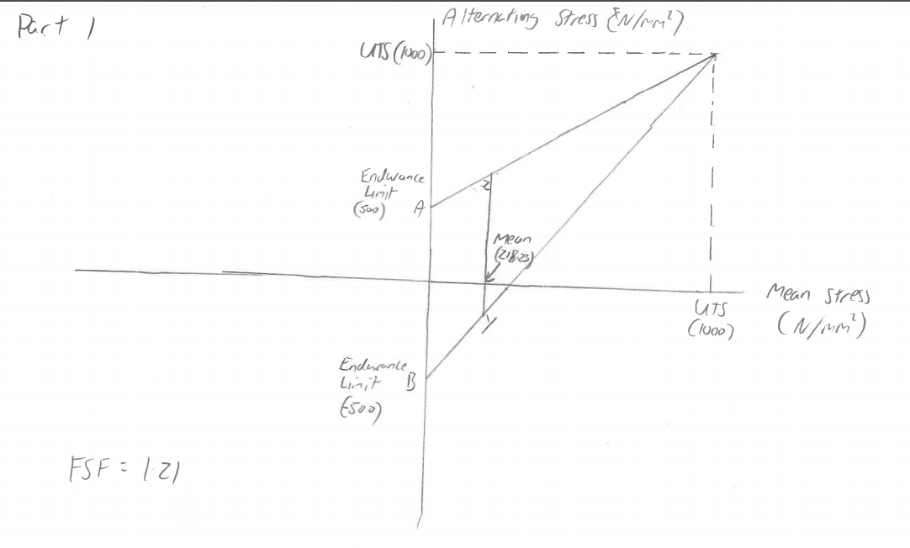
Figure 1 - Goodman Diagram for Part 1
Figure 1 shows the Goodman diagram used to find the fatigue safety factor.

Part 2
To calculate the nominal hoop stress the following equation is used.
Equation 15 - Nominal Hoop Stress for A and C
$$Nominal Hoop Stress=\frac{\left(\frac{Net Force}{2}\right)}{Cross Sectional Area}$$
This equation can be used for both point A and point C. The cross sectional area (CSA) used for point A is 72 mm^2, the CSA for point C is 184.5 mm^2.
The following equation is used for the nominal hoop stress at B
Equation 16 - Nominal Hoop Stress for B
$$Nominal Hoop Stress=Net Force*Cross Sectional Area$$
The CSA for point B is 118 mm^2.
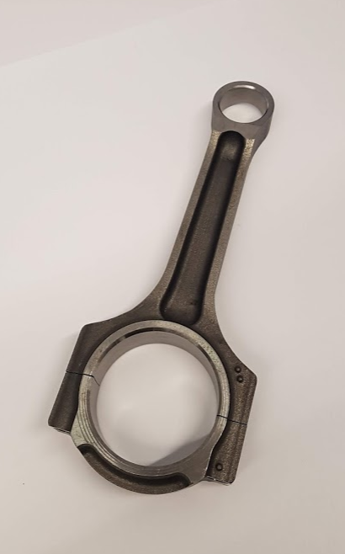
C
B
A
Figure 2 - Conrod Points
Figure 2 shows where measurements were taken for each point on the conrod.

Point A
Point A is taken at the little end of the conrod. At point A the net force is divided by 2, this is done as there is a hole and only one side is being calculated. So therefore, half of the force acts on the left side and half of the force acts on the right side. Most of the force acts on the side of the shank, not in the middle.
The mass used at point A is 0.35593 kg, this is calculated by adding the piston, 3 piston rings, 2 circlips and the gudgeon pin masses together.

Graph 4 - Nominal Hoop Stress (A)
When looking at the at graph x it can be seen that the stresses follow the same trends as seen in part 1. The stress experienced at point A are nearly half of the stress experienced on the pin. This could occur since only half of the little end is being looked at therefore the stresses will be halved. This is true for both the compressive and tensile stresses. This could possibly be due to point A being in such close proximity to the pin. If both sides at point A were considered the stress experienced at these points would be very similar to the stresses experienced at the pin.
Although there is a radius at point A, it is deemed too large to include a stress concentration. Although since there is both a radius and hole at point A there will be a stress concentration the value will ultimately not affect the safety factor enough to be included.
A fatigue safety factor was calculated for point A using the same method as part 1 and a value of 1.97 was the result. As with part 1 this part will not be at risk of breaking if it only experiences normal stresses.

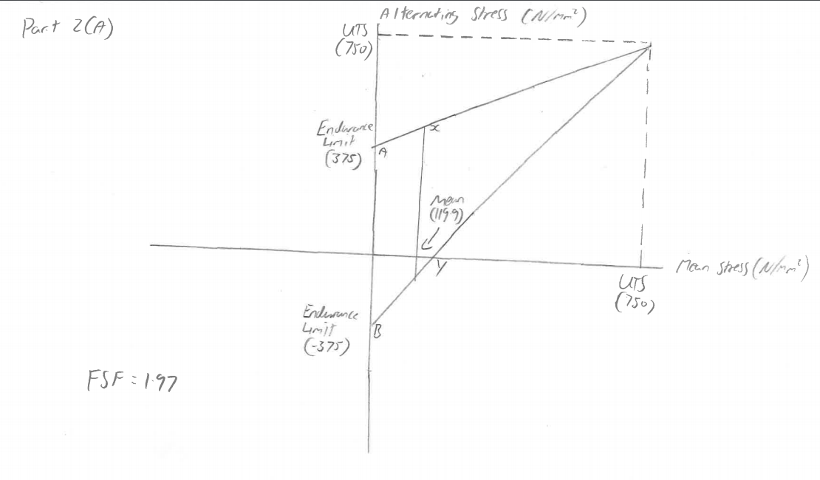
Figure 3 - Goodman Diagram Part 2 (A)
Figure 3 shows the Goodman diagram used to find the fatigue safety factor.

Point B
Point B is taken from the shank of the conrod. For point B the net force is left whole and not divided by 2, this is done because the shank is one continuous point with no hole in the middle. The mass used at point B is the mass at point A with 33% of the conrod mass added onto it. 33% of mass is not an accurate value to be added to the reciprocating mass, however it does produce a rough estimate and allows for simplification of the model.

Graph 5 - Nominal Hoop Stress (B)
As seen from graph 5 it can be seen that the stresses experienced at point B are greater than point A. This will be because the stresses are acting on the entire shank and not one half of it.
The safety factor found out at point B is 1.57. This implies that the shank is more likely to break than the little end. As with point A there is a radius at point B, it is however too large for stress concentrations to be considered a factored.
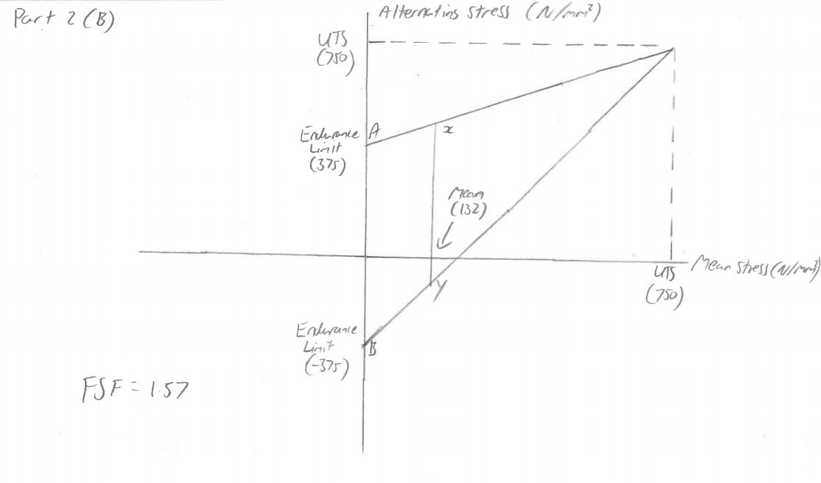
Figure 4 shows the Goodman diagram used to find the fatigue safety factor.
Figure 4 - Goodman Diagram Part 2 (B)

Point C
Point C is taken from beneath the crank pin. The mass used for point C is the mass at point A with the mass of the conrod added minus the mass of the conrod cap.

Graph 6 - Nominal Hoop Stress (C)

Looking at graph 6 it can be seen that the tensile stress experience at point C are the lowest of all three points. There is no compressive force acting on point C since point C is located below the crank pin. Therefore, the journal takes the compressive force.
The calculated safety factor at C is 2.51. This is calculated by using a stress concentration factor. Since there is a small radius at point C there is a stress concentration.

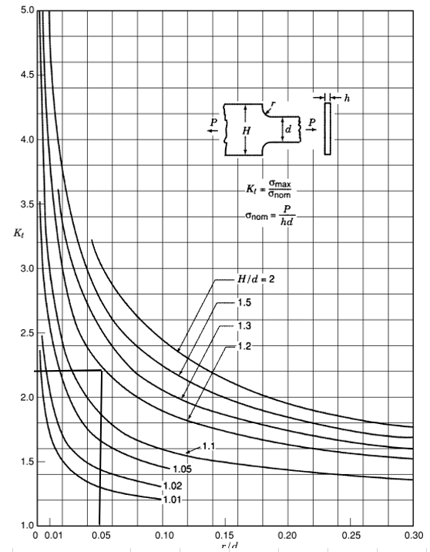
Figure 5 - Peterson Stress Concentration Diagram Part 2 (C)
A stress concentration is a point on a part where stress is concentrated, it normally occurs around small radiuses, notches or holes (Baldwin, 1954). Force lines compress around these areas which can cause the part to crack around this area. To calculate the stress concentration a Peterson stress concentration factor diagram for stepped tension bar diagram(Pilkey Walter, 2008) was used. As seen in figure 5. To calculate the stress concentration the radius divided by the diameter needs to be calculated. These values can be seen in table 4
Table 4 - Part 2 Stress Concentration
d (mm) | 9
H (mm) | 11.15
H/d | 1.24
r (mm) | 0.48
r/d | 0.053
Stress Concentration | 2.25

The r/d value can then be use on the Peterson diagram to determine the stress concentration. This value then has to be matched to one of the H/d lines on the graph. Since the value of H/d is 1.24 it was decided to use the H/d line of 1.2. When matching up the r/d value of 0.053 to the H/d line of 1.2 a stress concentration value of 2.25 was found.
Equation 17 - Allowable Range with Stress Concentrations
$$Allowable Range=2*\frac{Endurance Limit}{Stress Concentration}*\left(1-\left(\frac{Mean}{UTS}\right)\right)$$
The endurance limit is divided by the stress concentration as seen in equation 17 to find the actual allowable range.

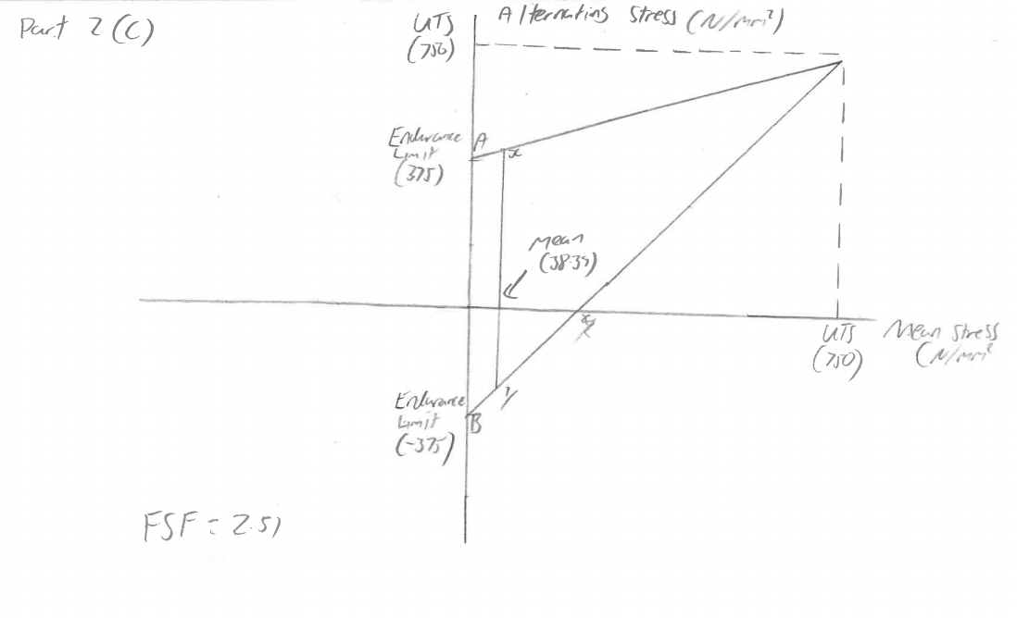
Figure 6 - Goodman Diagram Part 2 (C)

Figure 5 shows the Goodman diagram used to find the fatigue safety factor.

Part 3
Part 3 consists of investigating the properties of the standard conrod bolt and what forces as stresses act upon it.

Part A
To find the K Cap over K Bolt ratio the following formula is used.
Table 5 - Part A Measurements
L1 | L2 | Area Cap 1 | L3 | L4 | Area Cap 2 | Area Cap | Area Cap – Hole
20.79 | 4.14 | 86.0706 | 12.04 | 7.38 | 88.8552 | 174.9258 | 135.7258

Equation 18 – K Cap over K Bolt Ratio
$$K Cap over K Bolt Ratio=\frac{Youngs Modulus of the Cap*Area of the Cap}{Youngs Modulus of the Bolt*Area of the Bolt}$$

The Young’s Modulus of the cap is 170000 Pa, the area of the cap 135.72 mm^2 this value was gathered from measured values of the cap. These can be found in table 7, the Young’s modulus of the bolt is 210000 Pa and the area of the bolt is 39.2 mm^2. This value was taken from the Bosch automotive handbook.(Bosch, 2007). The Young’s Modulus values have been taken from lecture notes.(McDonald, 2019)

Part B
To find the stiffness of the bolt the following equation is used.
Equation 19 – Bolt Stiffness
$$Bolt Stiffness=\frac{Young^{'}s Modulus of the Bolt*Area of the Bolt}{Bolt Length to Second Engaged Thread}$$

To get the measurement for the bolt length to second engaged thread the depth of the cap hole was measured, the gap to the first thread was measured on the rod bolt hole and the length of one thread is known and this is multiplied by 2. These values were added together to get the total length to the second engaged thread. Photos of these measurements being taken can be seen in figure 7.
The bolt length to the second engaged thread is 25.75mm, the stiffness of the bolt ends up being 319689.3 N/mm.

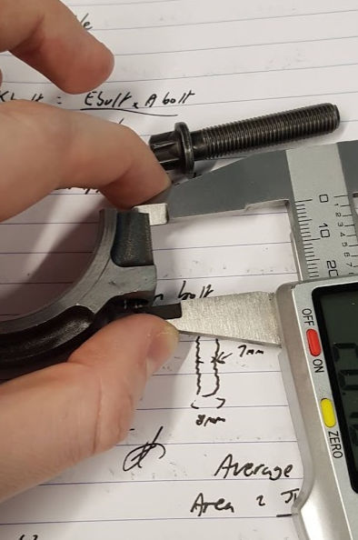
Figure 7 – Measuring to 2nd Engaged Thread
Figure 7 shows one of the measurements being taken to find the length of the bolt to the second engaged thread.

Part C
To find the alternating load on the bolt the following equation is used.
Equation 20 - Alternating Load
$Alternating Load=\left(\frac{1}{1+\left(\frac{KCap}{KBolt}\right)}\right)*\frac{Highest Inertia Force}{2}$

Equation 21 - Highest Inertia Force
$$Highest Inertia Force=\left(Reciprocating Mass*Crank Throw* ω^{2}*\left(1+\frac{Crank Throw}{Lenght}\right)\right)+(Rotational Mass*Crank Throw* ω^{2})$$
Where the reciprocating mass is 0.3559 kg and the rotational mass is 0.1783kg.
To calculate the the highest inertia force and thus the alternating load the rpm was increased to 6500. At this rpm the highest inertia is 12096.98N. This makes the highest alternating load at 6500 rpm 1590.5N. This value is the extra force on the bolt due to the inertia on the rod cap. The alternating load can be used to calculate the alternating stress with the following equation.
Equation 22 - Alternating Stress
$$Alternating Stress=\frac{Alternating Load}{Bolt Area}$$

Graph 7 - Alternating Load
By looking at graph 7 it can be seen that after 2500 rpm the alternating load increases at a linear rate. This is because ω increases at a linear rate after this point.

Part D
The Constants being used in this part can be found in table 6
Table 6 - Part D figures
Average Seating Face | Bolt Mu | Thread Mu
12.9 | 0.18 | 0.12

The following equation is used to find the clamping force acting on the bolt.
Equation 23 - Clamping Force
$$Clamping Force \left(N\right)=Bolt Area*\left(0.6*\left(0.9*UTS of the Bolt\right)\right)$$
Where the UTS of the bolt is 1100 MPa. The 60% of the 90% of the UTS is the axial force acting on the bolt when tightened into 90% yield. This is to ensure that there is no deformation occurring at the big end of the conrod. If the yield is greater than 90% the part will be at risk of going past its elastic limit, thus it won’t be able to return to its original shape.
This produces a clamping force of 23284.8N. From this value the circumferential friction force at the threads can be calculated.
Equation 24 - Circumferential Friction Force at Threads
$$Circumferential Friction Force at Threads \left(N\right)=Clamping Force*Thread Mu$$
The value for this is 2794.18N, this can be used to calculate the moment of circumferential force
$$Moment of Circumferential Force=\frac{Diameter}{2}*Circumferential Friction Force at Threads$$
This values comes out as 11260.53 N/mm. The bolt head friction then needs to be calculated.
Equation 25 - Bolt Head Friction
$$Bolt Head Friction=Clamping Force*Bolt Mu$$
This produces a value of 4191.26N, this can then be used to calculate the bolt head friction
Equation 26 - Torque Needed to Overcome Head Friction
$$Torque Needed to Overcome Head Friction=Bolt Head Friction*(\frac{Average Seating Face}{2})$$
This value comes out as 27033.65 N/mm
By adding the moment of circumferential force and the torque needed to overcome head friction the total torque with tightening can be calculated. This produces a value of 38.29 N/m at 90% yield.

Part E
The minimum stress acting on the bolt can be calculated using the following formula.
Equation 27 - Bolt Stress Minimum
$$Bolt Stress Minimum=\left(0.9*Bolt UTS\right)*0.9$$
Yield is 90% of the UTS and this value is tightening to 90% of yield hence why the 90% value of UTS is multiplied by 0.9. This produces a value of 891 N/mm^2.
Equation 28 - Bolt Stress Range
$$Bolt Stress Range=\frac{Alternating Load}{Bolt Area}$$
At 6500 rpm this produces a value of 40.57 N/mm^2. From this value the maximum bolt stress can be calculated.
Equation 29 - Maximum Bolt Stress
$$Maximum Bolt Stress=Bolt Stress Range+Minimum Bolt Stress$$
At 6500 rpm the maximum stress experienced by the bolt is 931.57 N/mm^2. This can be used to calculate the mean bolt stress.
Equation 30 - Mean Bolt Stress
$$Mean Bolt Stress=\frac{(Maximum Bolt Stress+Minimum Bolt Stress)}{2}$$
This produces a mean bolt stress of 911.29 N/mm^2

Part F
To look at the safety factor the stress concentration experience by the bolt first had to be calculated. To do this a Peterson stress concentration diagram for a semi-circular notch was looked at. The values in table 7 show the values used to work out the safety factor from figure 8.
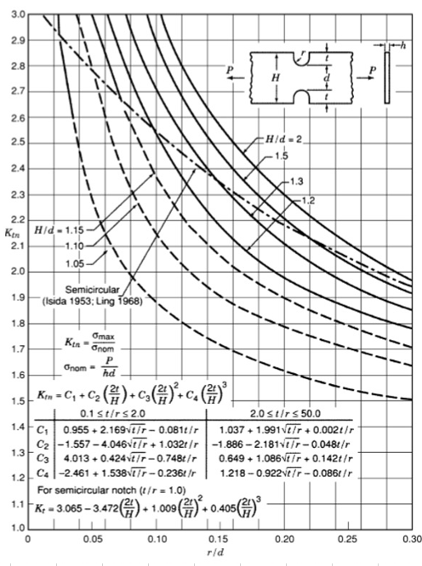
Figure 8 - Peterson Stress Concentration Diagram Part 3 (F)

Table 7 - Part 3f Stress Concentrations Dimensions
r (mm) | 0.146
d (mm) | 7.35
H (mm) | 8
H/d | 1.088435374
t (mm) | 0.277
t/r | 1.897260274

Since the r/d value did not match any of the H/d values on the graph, the calculation to work out the stress concentration had to be used. These equations can be found on figure 8. First C1, C2, C3 and C4 had to be calculated which involved using the t/r value. These values were then placed into the Ktn equation to find the stress concentration. The values gathered from doing these equations can be found in table 8.
Table 8 - Part 3 F Stress Concentrations
C1 | 3.788925756
C2 | -5.172031145
C3 | 3.177871458
C4 | -0.790295747
Stress Concentration | 3.442212367

With the new stress concentration acting on the bolt the allowable range can be calculated using equation 17. This produces an allowable range of 54.82 at 6500 rpm. The fatigue safety factor can be calculated by dividing the allowable range by the bolt stress range calculated in part 3 (e). This produces a safety factor of 1.35.

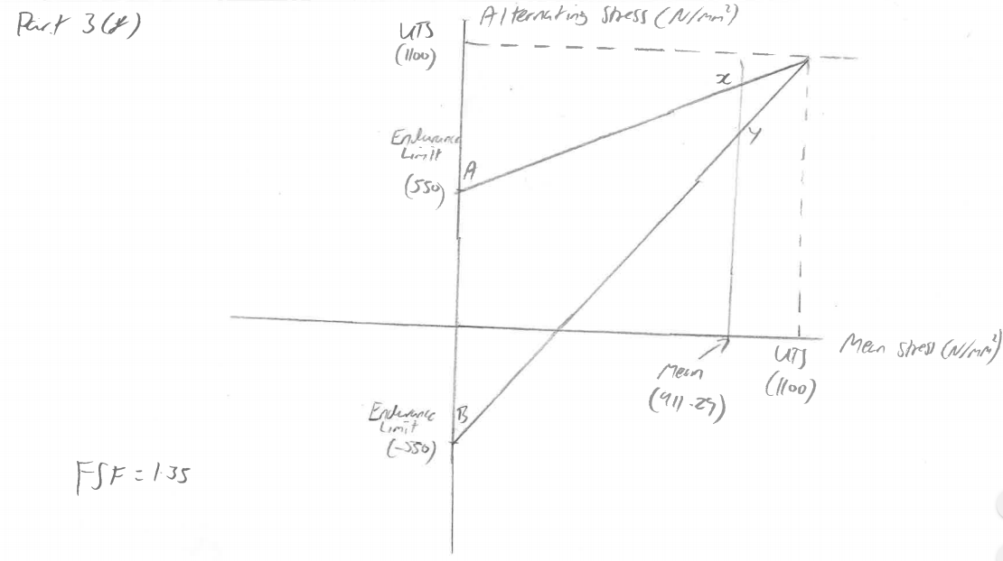
Figure 9 - Goodman Diagram Part 3 (F)
Figure 9 shows the Goodman diagram used to find the fatigue safety factor.

Part G

Modified RPM
For this part the rpm of the engine was increased to 9000 in 500 rpm increments. This was done to see the extra forces and stresses acting on the bolt if the rpm was increased. This would allow a new safety factor to be calculated to see if the bolt would remain safe at the new rpm.
At 9000 rpm the new highest inertia force is 23191.85 N. A 44% increase from the highest inertia force at 6000 rpm. This produced a new alternating load of 3049.24 N which is a 52% increase from the alternating load at 6500 rpm. The new mean stress is 929.89 N/mm^2, this is 2% increase from 6500 rpm. The new safety factor ends up with a value of 0.64. This means the part is at risk of breaking if the engine modified to rev higher. This safety factor has dropped by 212.6%. The highest the engine can rev with the conrod bolts still being safe would be 7000 rpm where the safety factor is 1.15.
Looking at these results if someone wanted to increase the rpm of this engine the conrod bolts would need to be redesigned to withstand the new forces acting on the bolt.

Modified Material
As the bolt is no longer able to survive a normal life span when the engine rpm is increased it needs to be modified so it is able to withstand the extra stresses acting on it. To do this first a new material was investigated. The new material chosen was ‘ARP Custom New Age 625 +’. This was chosen as bolts are made to fit the conrod currently using this material. This new material has a larger UTS with a value of 1861 MPa (ARP, 2020), this mean the new bolt should be able to withstand higher forces whilst still remaining safe for a normal life. A new Young’s Modulus couldn’t be found for the new material so therefore it was kept to the value of the original bolt.
As the new material has a higher UTS a new yield strength needs to be calculated, this is 90% of the UTS. This comes out as 1674.9 N. To achieve the same tightening torque as the original bolt the new bolt will only need to be tightened to 53.2% of the yield. This value was achieved using the goal seek function in excel. This means the new yield to get the same tightening torque is 891.05 N. From this a new maximum bolt stress can be calculated by adding the range calculated for the original bolt at 9000 rpm to the new yield of 891.05 N. This provides a maximum bolt stress of 968.83 N/mm^2.
Table 9 - Modified Material Results
New Endurance Limit | New Mean Bolt Stress (N/mm^2) | Allowable Range (N/mm^2) | Safety Factor
270.3203349 | 929.9401701 | 270.4829716 | 3.477237522

From table x the new endurance limit can be seen, the new endurance limit is under half of the original endurance limit of the bolt. The value for the endurance limit has had the stress concentration value, calculated in part 3 (f) taken into consideration as there will still be a stress concentration even with the new material.
The new mean bolt stress is nearly identical to the mean bolt stress of the old material at 9000 rpm, this is because they are being tightened to the same torque so therefore the stresses should be similar when compared with the old bolt. However, when comparing the allowable range, the new bolt has a range over 5 times greater than the original material. This shows that the new material will be able to withstand much greater forces. This can be seen when looking at the new safety factor which is around 5.5 times greater than the original bolt. With this new safety factor, the bolt should not be at risk of breaking under normal use even with the engine modified for the increased rpm.

Modified Material with Wasted Shank
As the safety factor was so large, reducing the size of the shank was considered as a way to save weight. The same overall length of the bolt will be kept the same as this means the design of the conrod and cap doesn’t have to be modified to fit the new bolt design. The following equation was used to find the minimum diameter of the shank.
Equation 31 - Minimum Bolt Diameter
$$Minimum Bolt Diameter= \sqrt{\frac{Original UTS}{New UTS*{\left(Average Bolt Diameter\right)}^{2}}}$$
This produces a value of 5.65mm, this is the minimum diameter the bolt can be without being at risk of breaking.
Table 10 - New Bolt Area 1 Dimensions
Area 1
Length (mm) | 5
Diameter (mm) | 7.35
Area (mm^2) | 42.42917228
K Bolt (N/mm) | 1782025.236

Table 11 - New Bolt Area 2 Dimensions
Area 2
Length (mm) | 24
Diameter (mm) | 5.66
Area (mm^2) | 25.07187287
K Bolt (N/mm) | 219378.8876

Table 12 - New Bolt Area 3 Dimensions
Area 3
Length (mm) | 8
Diameter (mm) | 7.35
Area (mm^2) | 42.42917228
K Bolt (N/mm) | 1113765.772

Tables 10, 11 and 12 show the dimension being used for the new design of the bolt. The diameter of area 1 and 3 had to remain at 7.35 mm as this will allow the bolt to be placed into the original conrod design. The diameter used for area 2 is 0.01 mm above the minimum diameter that can be used, this was done as it will allow the bolt to be as light as possible. To get the lengths for each area a bit of trial and error was done to find a bolt that would produce a good safety factor.
Table 13 - Modified Material with Wasted Shank Results
1/K (N/mm) | New Total Area (mm^2) | New K Cap/K Bolt
166632.0909 | 36.67301532 | 2.996024889

As the dimensions of the bolt have changed the area of the bolt and thus the stiffness of the bolt will have changed. The new values can be seen in table 13.
With these new values the same calculations that were done for the modified rpm in part G can be done for the new bolt. The inertia force remains the same as the original bolt as the bolt has no effect on the inertia force. The force acting on the bolt has been reduced by 45%, this is because the stiffness of the bolt has been reduced by 45%. The new alternating load on the bolt is 2901.86 N, this is 148N less than the original bolt, this is because the K Cap over K Bolt ratio is 0.199 greater than the original bolt which therefore causes there to be slightly less alternating load.
Since the area of the bolt has been reduced there is slightly more alternating stress and therefore the range of bolt stress has increased. The minimum bolt stress has increased from 891N/mm^2 to 1107.3 N/mm^2, this means that the maximum bolt stress has also increased from 968.79 N/mm^2 to 1156.42 N/mm^2. As both the minimum and maximum bolt stresses have increased, the mean bolt stress has increased.
The new allowable range at 9000 rpm is 216.18 N/mm^2, this is 166.76 N/mm^2 greater than the original bolt, however, it is 54.3 N/mm^2 less than the old bolt design with the new material. This is because some of the material has been removed to reduce the mass of the bolt, which will make it slightly weaker. This can be seen with the new safety factor of 2.73, although less than the old bolt design with the new material, it is still well within a safe range to not break outside of normal use.
Even if someone decided to uprate the turbocharger this new bolt design this bolt should be able to withstand a much greater power figure than the engine is currently producing since the safety factor is well above 1.
For further work this bolt could be optimised by trying to reduce the safety factor getting it closer to a value of 1. The new mass of the bolt and its impacts could be investigated, this could then be used to optimise the bolt. Finally impacts of adding an uprated turbocharger to increase the overall power of the engine and its impact on the bolt could be investigated.

Part H
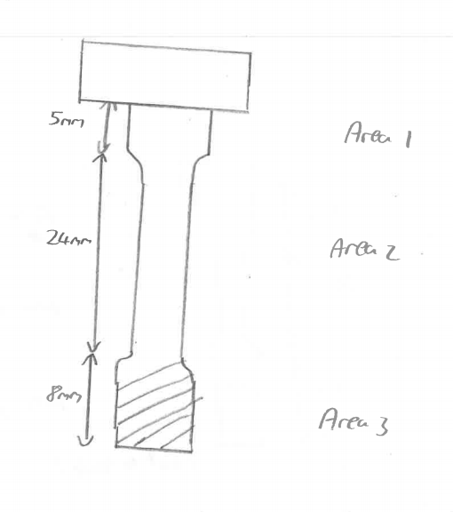
Figure 10 - New Bolt Design
Figure 10 shows a sketch of the new bolt design. If the bolt was to be made an accurate CAD model would need to be created as this could then be used to run Finite Element Analysis on to find the actual forces that will be acting on the bolt and conrod. This will also produce a visual representation of the forces. The UTS has been increased from the original bolt and the shank has been wasted, both have been done to improve the durability of the bolt.
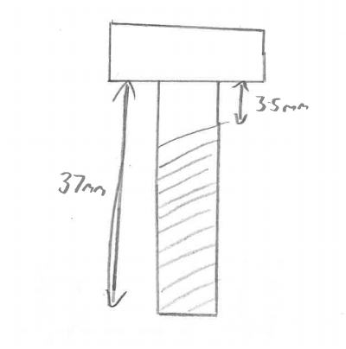
Figure 11 – Old Bolt Design
Figure 11 shows the design of the original bolt as a comparison to the redesigned bolt.

Part 4
This part will investigate the crankshaft with the forces and stresses acting on it. The fatigue safety factor of the crank will be calculated to see if is able to withstand the forces and stresses acting on it.
Table 14 - Crankshaft Figures
UTS Crankshaft | 750
R (m) | 0.0407
L (m) | 49.88
L1 (mm) | 12.75
L2 (mm) | 31.7
AB (mm) | 20.7
b (mm) | 45.985
D (mm) | 20.5
I (mm^4) | 33013.87693
Y (mm) | 10.35
D1 | 43
D2 | 48

Table 15 - Masses used for Crankshaft
Reciprocating Mass (kg) | Rotational Mass (kg)
0.445063333 | 0.317256667

A new upwards inertia needs to be calculated using the values from the crank. From this the net force at the crankpin can be calculated by subtracting the peak gas force from the upwards inertia force. As with part 1 the bending moment then needs to be calculated as this can be used to calculate the bending stress.
The shear stress can be calculated using the net force and inside diameter of the crank.

Graph 8 - Shear Stress Crankshaft
From graph 8 it can be seen that the tensile and compressive shear stresses follow the same trends seen in graph 2, however with the crank the tensile stress is much greater than the compressive stress.
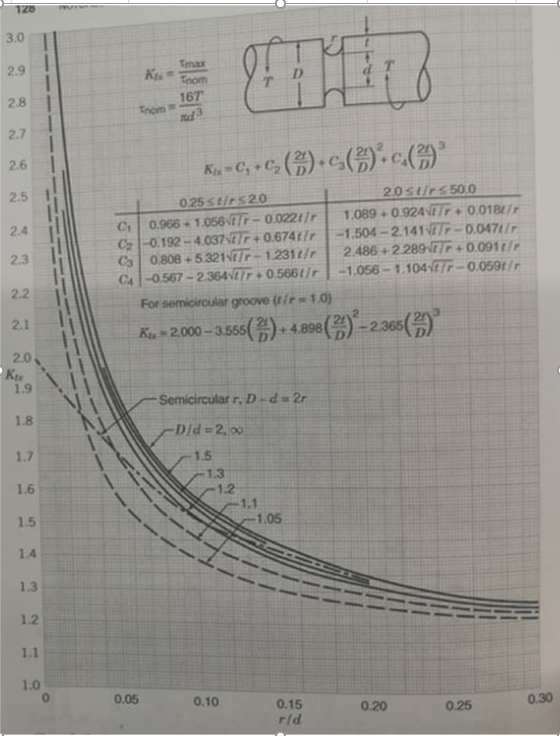
Figure 12 - Peterson Stress Concentration Diagram Part 4

For the crank a new stress concentration needs to be calculate using the dimensions in table 16.
Table 16 - Dimensions for Stress Concentration for the Crankshaft
r (mm) | 1.51
d (mm) | 44.2
t (mm) | 0.5
t/r | 0.331125828
H (mm) | 7.4
2t/d | 0.022624434

As the values did not allow a stress concentration to be obtained from the graph, it had to be calculated using the formula. The results from these calculations can be seen in table 17.
Table 17 - Stress Concentrations for Crankshaft
C1 | 1.566374948
C2 | -2.29185365
C3 | 3.462275538
C4 | -1.73991192
Kt | 1.516275124

Using the stress concentration, the endurance limit could be calculated. This ended up being 247.31. Using the calculated endurance limit the allowable range for the crankshaft can be calculated and used to find the fatigue safety factor of the crank.
The results can be seen in table 18.
Table 18 - Results for Crankshaft
Mean | Allowable Range | Safety Factor
36.87173 | 470.3158813 | 2.000583594

From these results it can be seen that the crank has a safety factor is great enough to withstand the normal forces that it will be experienced. As the safety factor is 2 some future work could be done to look at optimising the design.

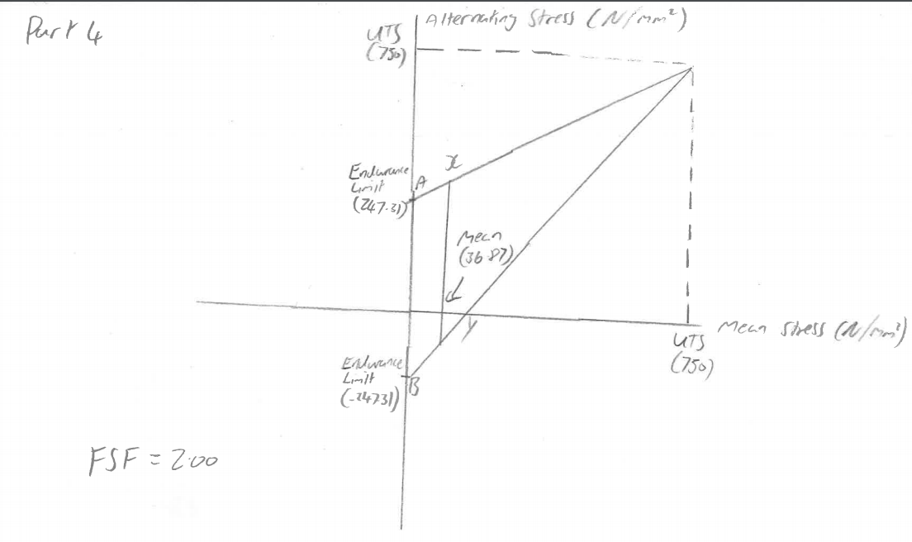
Figure 13 - Goodman Diagram Part 4

Figure 13 shows the Goodman diagram used to find the fatigue safety factor.

Conclusion
This assignment was to find out the fatigue safety factors of the gudgeon pin, three points on the conrod and the crankshaft. It would be expected that the safety factors are greater than 1 as these parts are used in the standard engine and would not be expected to break under normal conditions. This is what was found as all the parts did have a safety factor above.
Problems started to occur when the engine was modified. As the engine’s rpm was increased above standard values the safety factor of the bolts started to drop to unsafe levels. This is when the bolt had to be modified to not break under these new conditions. Changing the material to one with a greater UTS allowed the bolt to be more than strong enough to survive the modified engine under normal conditions.
Once the new material was chosen and found to work to acceptable levels a redesign of the bolt could be considered to make it lighter and therefore perform better. To do this some material was removed from the shank of the bolt. This was done with a gradual radius going from the larger diameter to the smaller diameter as this would reduce the stress concentration occurring at these points. By removing some material from the shank, the new bolt was still able to perform well within a safety factor acceptable to use with the modified engine.

References
ARP (2020) 2020 ARP Catalog. Available at: https://arpcatalog.com/20/ (Accessed: 7 February 2020).
Baldwin, W. M. (1954) Stress concentration design factors, Journal of the Mechanics and Physics of Solids. John Wiley & Sons. doi: 10.1016/0022-5096(54)90011-3.
Bosch, R. (2007) Automotive handbook / Bosch, Bentley Robert Inc, Cambridge, United States. Available at: http://encore.lib.warwick.ac.uk/iii/encore/record/C__Rb2158084__SBosch Automotive Handbook__P0,1__Orightresult__U__X3?lang=eng&suite=cobalt (Accessed: 8 February 2020).
CAE Simulation Solutions (2015) Infinite Life Fatigue Strength | CAE Simulation Solutions, CAE Simulation Solutions. Available at: http://www.cae-sim-sol.com/en/limit-stress-evaluation/infinite-life-fatigue-strength (Accessed: 7 February 2020).
Carvill, J. (1993) Mechanical Engineer’s Data Handbook, Mechanical Engineer’s Data Handbook. Elsevier. doi: 10.1016/c2009-0-24207-3.
McDonald, M. (2019) ‘Young’s Modulus Values’, in Advanced Engine Design. Swansea.
Pilkey Walter, P. D. (2008) ‘Petersons-Stress-Concentration-Factors.pdf’, (Lyman 1989), p. 560.
S. N. Bagchi, K. P. (1979) Industrial Steel Reference Book. Available at: https://books.google.co.uk/books?id=c9g632fk4mQC&pg=PA42&lpg=PA42&dq=gudgeon+pin+uts+1000&source=bl&ots=8Vr8fUUmXF&sig=ACfU3U1u3IO4ApEb9kFwB8C7vR2qa7IsaA&hl=en&sa=X&ved=2ahUKEwj_gduak8DnAhVAShUIHQXiAZUQ6AEwFHoECAoQAQ#v=onepage&q=gudgeon pin uts 1000&f=fal (Accessed: 7 February 2020).
Slaney, B. (2017) Ford 1.6 GTDI EcoBoost.

Appendix
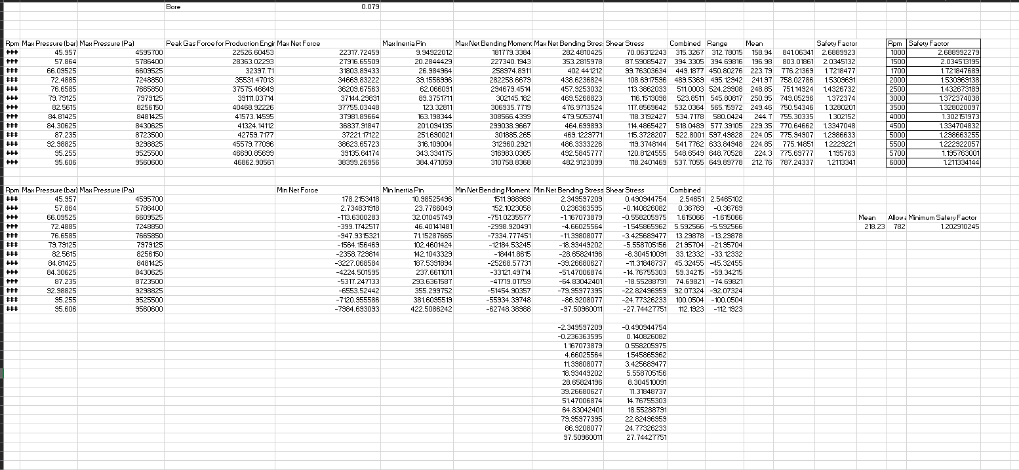
Figure 14 - Part 1 Excel

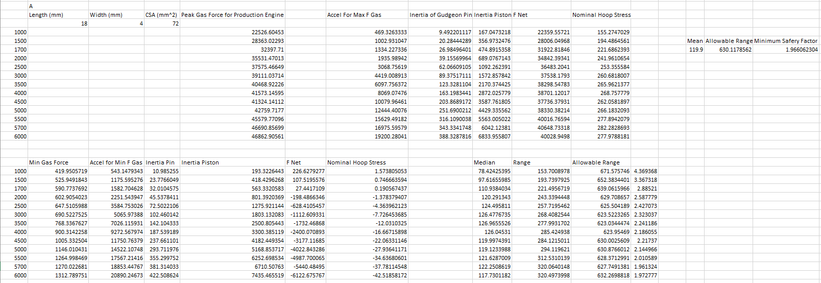
Figure 15 - Part 2 (A) Excel

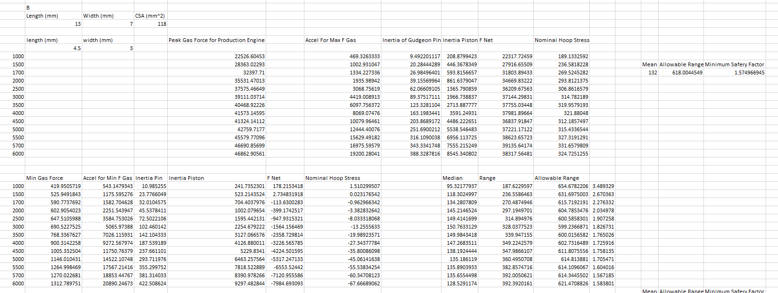
Figure 16 - Part 2 (B) Excel

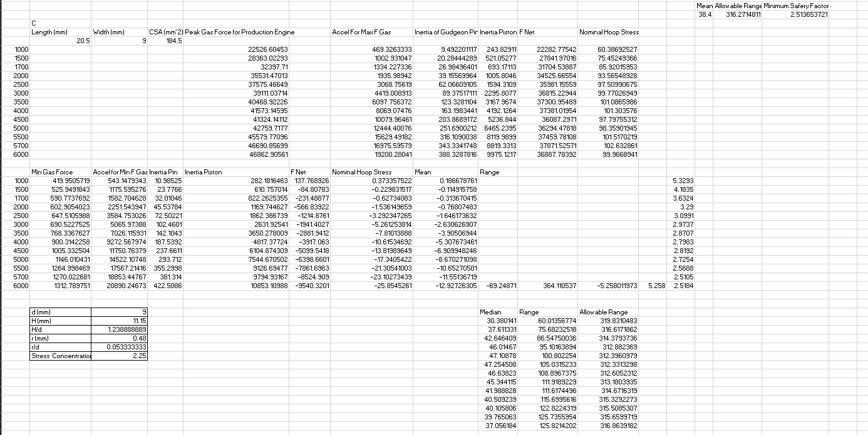
Figure 17 - Part 2 (C) Excel
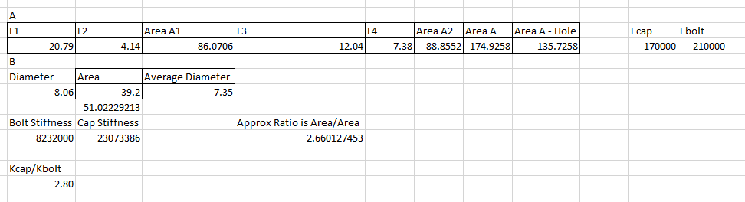
Figure 18 - Part 3 (a) Excel

Figure 19 - Part 3 (B) Excel

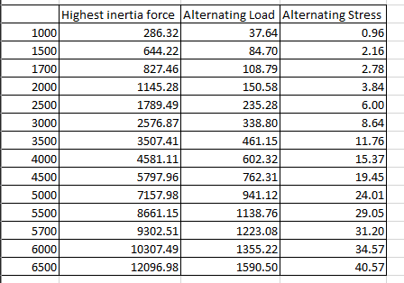
Figure 20 - Part 3 (C) Excel

Figure 21 - Part 3 (D) Excel

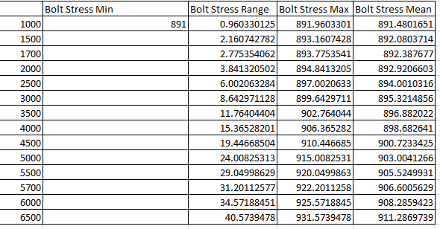
Figure 22 - Part 3 (E) Excel

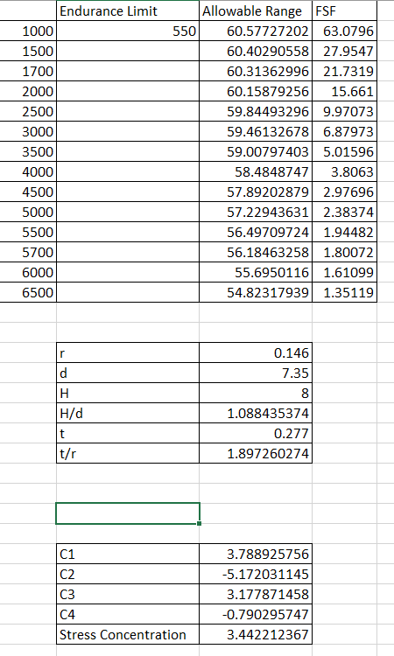
Figure 23 - Part 3 (F) Excel

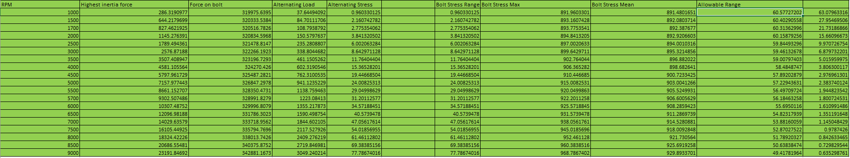
Figure 24 - Part 3 (G) Excel Modified RPM

Figure 25 - Part 3 (G) Excel Modified Material

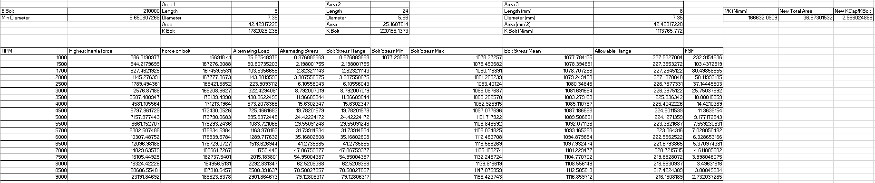
Figure 26 - Part 3 (G) Excel Modified Material and Wasted Shank
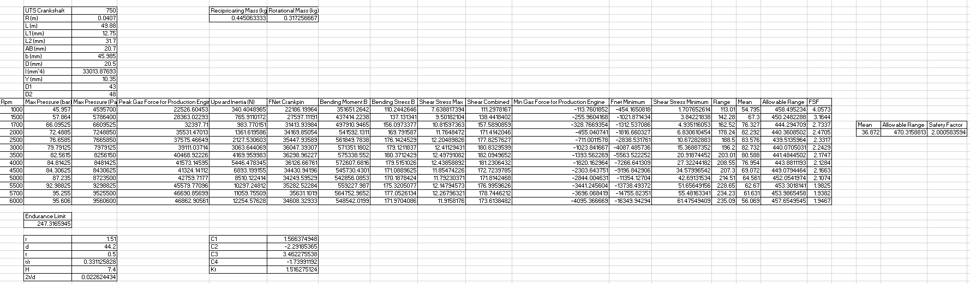
Figure 27 - Part 4 Excel

