Essay
(Case Study-Tesco)
TABLE OF CONTENTS
Introduction 3
Structure 2
Culture 3
Hofstede: National culture 4
People 6
Performance 7
Recommendation 7
Conclusion 8

LIST OF FIGURES
Figure 1 Organizational structure in Tesco 3
Figure 2: The Hofstede culture indicators of some of the countries 5

Introduction
The culture within an organization is defined as values, behaviours and the beliefs that contribute to the creation of the unique psychological and social environment. Such environment, if being positive, inclusive, and energetic, then there will be more engaged, satisfied and motivated staff within the firm. Hence, the report highlights the significance of culture, and different organizational structure to influence the people and their performance. The current essay is presented in the context of Tesco.
Tesco is a British grocery retailer and general merchandise having an existence in across the seven countries, including, Ireland, UK, India, Thailand, Malaysia, Czech Republic, Poland, Slovak Republic, and Hungary. The organization has made its position as third largest across the world in terms of gross revenue. The firm was founded in 1919 and then expanded rapidly with more than 6000 shops in different locations. The estimated revenue of the firm in 2019 is determined at £63,911 million. Tesco is continuously enhancing its business operations with the effective efforts and contribution of its more than 440,000 employees.

Structure
The management of employees in every organization is crucial, with an effective spread of roles and responsibilities. Thus, there is a need for developing an organizational structure so that a defined chain of command can be followed by an effective communication channel. The systematic hierarchical structure offers a ladder to the employees to get advanced in their career.
Functional organizational structure: Under the structure, those people who are required to perform similar tasks, are collaborated and grouped in accordance with their speciality. For example, all the human resource managers, and executives are placed in a Group of HR departments. Similarly, other functional departments are formed.
Types of organizational structure
Hierarchical structure: In this structure, different levels of authorities are defined in accordance with the chain of command. A vertical link is established between the several management layers which lie between the subordinates and the higher management within a firm.
Divisional Structure: This structure emphasizes the formation of teams based on the requirements of various projects so that the specific needs of customers and organizations can be efficiently fulfilled. For example, Tesco sells different products under the division of supermarket, hypermarket, convenience stores, and superstores.
Matrix Structure: The effective elements of functional and divisional structure when combined, then a matrix structure are formed. In a complex matrix structure, there is more autonomy provided to the team members, and they are expected to perform their work with more responsibility and authorities. This structure is established with an intention to promote creativity, innovation and a cooperative working environment to get more fruitful and productive results.
Flat organizational structure: This structure disrupts the traditional system of the top-down system with the decentralization of organizational functions. Every staff member under the structure is the boss of themselves, and thus, the bureaucratic element is eliminated along with the improvement of direct interactions.
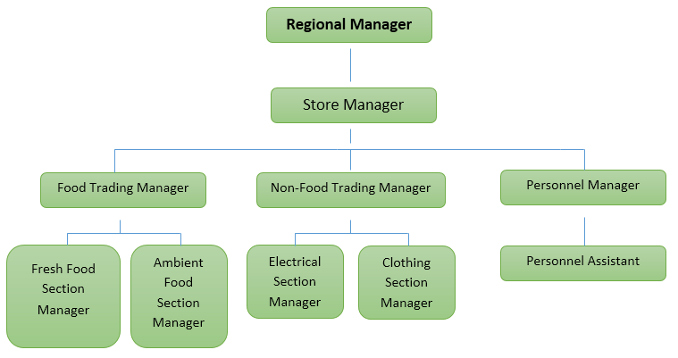
Figure 1Organizational structure in Tesco
Tesco is a leading multinational firm and therefore, it follows a functional organizational structure. There are different shops and stores across different countries, and therefore, the management has to manage a large number of staff (Tesco organizational structure, 2019). It would be impossible for the one person to keep eyes on the scattered employees of Tesco; thus, a hierarchical structure is followed within Tesco to deliver the best care to the customers along with products and services.

Culture
Organizational culture refers to a system where the behaviour of people is governed through shared values, assumptions, and beliefs. Such shared values and standards highly influence the people within the firm and their job performance. Management of an organization that ignores a strong corporate culture might not be successful in motivating and encouraging the staff that ultimately affect the productivity of the firm. The organizational culture can be categorized in formal and informal forms (Huczynski et al., 2013). A formal culture is established with the help of formal relationships, organizational policies, strict rules, disciplines, and norms for the performance of different jobs. At the other side, the informal culture within an organization is established with the social relationships among the staff. Such a relationship is created among team members with the meetings, interactions, and informal discussions with each other. The formal environment is intended to establish the common goal of the firm while informal culture is intended to satisfy the psychological and social needs of the employees. The formal culture focuses on work performance while informal culture helps to create interpersonal relations within the organizational structure (Hogan and Coote, 2014).
Within Tesco, there is a lack of inclusivity of the employees and creativity, as leaders follow the autocratic approach to manage them. The autocratic style ensures a lack of people involved and creates an environment where there is a control of higher management and leaders over the decisions and actions of the lower staff. Such issues need to be measured with the application of the Hofstede model and accordingly required steps needs to be taken to improve the organizational productivity, and performance.

Hofstede: National culture
The theory is determined to study how the workplace is influenced by the shared values in organizational culture. The model prescribes six dimensions of culture that helps to distinguish the culture in one country from that of the other based on independent preferences of the society.
Power Distance Index: The dimension defines the degree to which the less powerful individuals within a culture accept the unequal distributed power within the society in the UK. In the organizational context, the low power distance indicates that individuals demand justification for the unequal distributed power within the organization (Dimensions of National culture, 2019).
Individual Vs collectivism: The individualism depicts that people in a culture highly consider themselves and care for their families. At the other side, collectivism, represent the individuals in a society which prefers to consider the care of community members rather focus on themselves. In the organizational context, the dimension helps to determine whether the individuals are driven towards self-interest or prefer to work with a team for the common goal of Tesco.
Masculinity Vs Feminity: The masculinity culture shows the preference of success with assertiveness, achievement, and rewards within the society. In its opposite feminism represent the preference of individuals for cooperation, caring, modesty, and quality of life. In this regard, Tesco has a balanced preference of masculinity and feminist dimensions, as it considers the equality of gender within its organizational culture.
Uncertainty avoidance index: The dimension helps to determine the level to which society members feel ambiguity and comfortable with uncertainty. In context to Tesco, the index shows the issue of uncertainty and lack of clarity in the organizational policies and practices that affects the competence and professionalism of employees while performing their jobs (Minkov, 2018).
Long term Vs short term orientation: The dimension describes whether Tesco is a long term oriented or short term oriented in its operational activities. The low score represents that the organization is focusing only short term benefits, and thus it may impact its long term standing in the market.
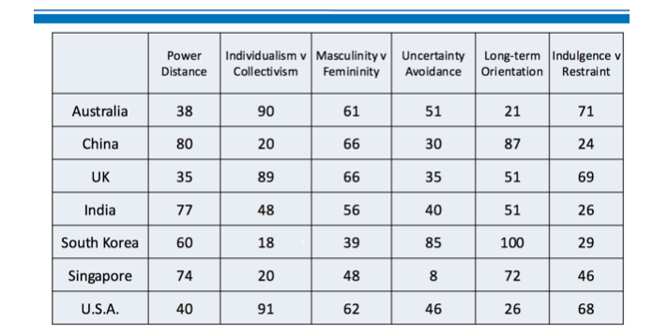
Figure 2: The Hofstede culture indicators of some of the countries
(Source: tutor2u.net/business)
Indulgence Vs restraint: Indulgence within the UK society drive human behaviour with enjoyful life and fun. At the other side, a restraint stands strict social norms which surpass the needs of gratification. In relation to Tesco, the indulgence helps to the development of a culture where employees enjoy performing their job while restraints show that they are not satisfied with the organizational culture and it leads to the creation of negative work environment.

People
The organization likes, Tesco can attain success and growth in the competitive market, with the support of its pillars, which are its employees. Thus, such personnel are needed to be motivated and engaged within the organization so that they can put their full potential for their job as well as organizational success. Lack of leadership support and concern for the employees within Tesco de-motivates the staff and represent a conflict based environment.
. Thus, in this respect, Maslow hierarchy theory is an effective motivational approach to facilitate the leaders in developing a fully motivated and engaged work environment. The theory is based on the psychological needs of the employees and provides five-tier models in a hierarchical level. The model state that human behaviour can be influenced for more energetic work when its psychological needs are fulfilled (Kaur, 2013). Such needs are associated with human survival and include, sleep, food, clothing, shelter, etc. The next level of motivation for the staff in Tesco is safety needs, which consists of protection elements such as stability, security, order, freedom, etc.
When the discussed needs are satisfied, then employees get motivated towards love needs which involves the need for an interpersonal relationship, feelings, love and belongingness. The next level of motivation comes with the fulfilment of esteem needs of the employees, which relates to the desire of reputation, respect, achievement, dignity, prestige, independence, and many more. The last hierarchical needs in accordance with the Maslow theory, are self-actualization needs. Such motivational level helps to realize the personal potential and personal growth of the individual within Tesco (Cherry, 2014).

Performance
The performance in Tesco is managed with the effective integration of organizational culture, structure and motivational aspects (Awadh and Alyahya, 2013). In the present, the management of Tesco has introduced performance appraisal mechanism within its culture to ensure that employees contribute their efforts in a definite manner as required to attain the organizational goals and objectives. The mechanism consists of an evaluation of the employees’ performance, and the outcome will help to decide the final reward of the employees.
The energetic organizational culture is of great significance for Tesco as it nurtures a working environment where people work with full motivation and show their loyalty towards organizational success. Moreover, specific, clear and defined responsibilities with the organizational structure facilitate to create a spirit of focused and goal orientation among the individuals within Tesco (Harwiki, 2013). It leads to reduced uncertainty, and thus clear command of the chain makes people more responsible for their job and its outcome. The people are important resources of a firm and their effective management ultimately opens up a new platform for Tesco to become more competitive and enthusiastic in the global retail environment.

Recommendation
The present culture, people, structure and performance of Tesco needs some improvement to ensure sustainable growth of all segments of the business. It is recommended to Tesco to make its culture featured with decentralized power. Such decentralization will ensure that every stores and shop of Tesco will be managed and monitored with more authorities and responsibilities. Leaders need to adopt a participative approach for its employees so that their inclusivity can bring more creative and productive decisions for the firm (Bortolotti et al., 2015). Further, it is recommended that the management needs to cultivate a sense of team spirit and collectivism among its staff. It will develop respect, acceptance, and a sense of goal-oriented among the employees. Thus, the overall performance and profitability of Tesco will be improved, and it can take maximum benefits from the productivity and increased performance outcome of its employees.

Conclusion
The evidence of the essay concludes that the overall performance of every firm is strongly influenced by its structure, culture, and its people. There are different types of structure, and every firm needs to adopt a specific structure to simplify its different operational activities. The report concludes the Hofstede culture model to identify the dimensions that can affect the workplace behaviour in the context of the national level. The Maslow theory is discussed in the report to demonstrate how an organization can make its people more motivated for their work in Tesco. In the end, the recommendations are provided to support the firm to improve its overall efficiency as well as competitive position.

References
Books & Journals
Awadh, A.M. and Alyahya, M.S., 2013. Impact of organizational culture on employee performance. International review of management and business research, 2(1), p.168.
Bortolotti, T., Boscari, S. and Danese, P., 2015. Successful lean implementation: Organizational culture and soft lean practices. International Journal of Production Economics, 160, pp.182-201.
Cherry, K., 2014. Hierarchy of needs. Retrieved Aug, 16, p.2014.
Harwiki, W., 2013. The influence of servant leadership on organization culture, organizational commitment, organizational citizenship behavior and employees’ performance (study of outstanding cooperatives in East Java Province, Indonesia). Journal of Economics and Behavioral Studies, 5(12), pp.876-885.
Hogan, S.J. and Coote, L.V., 2014. Organizational culture, innovation, and performance: A test of Schein's model. Journal of Business Research, 67(8), pp.1609-1621.
Huczynski, A., Buchanan, D.A. and Huczynski, A.A., 2013. Organizational behaviour (p. 82). London: Pearson.
Kaur, A., 2013. Maslow’s need hierarchy theory: Applications and criticisms. Global Journal of Management and Business Studies, 3(10), pp.1061-1064.
Minkov, M., 2018. A revision of Hofstede’s model of national culture: old evidence and new data from 56 countries. Cross Cultural & Strategic Management, 25(2), pp.231-256.

Online
Dimensions of National culture, 2019 [Online] [Assessed through] < https://www.hofstede-insights.com/models/national-culture/> [Assessed on 4th December, 2019]
Hofstede's Model, 2019 [Online] [Assessed through] < tutor2u.net/business/reference/hofstedes-national-cultures> [Assessed on 4th December, 2019]
Tesco organizational structure, 2019 [Online] [Assessed through] < https://prezi.com/-l58wxtvlexb/organisational-structure-of-tesco-and-ty-hafan/>, [Assessed on 4th December, 2019]

