BMSW5104 Managing Projects in the Organisation


Student name - Nikolay Rangelov (1907852)
Student Number - (1907852)
Module Name - BMSW5104 Managing Projects in the Organisation

Module Tutor – Dan Hart
University of Wales Trinity Saint David

Table of Contents
Introduction 3
Project management tools and technique 5
Organizing workflow and planning 9
Communication 9
Time management and scheduling 9
Project planning and the following steps that are essential to complete the process 10
identify the stakeholders 11
Roles and responsibilities 11
stage 3:conduct an opening shot gathering 11
Stage 4: Characterize project extension, financial plan, and course of events 12
Stage 5: Set and focus on objectives 13
Stage 6: Characterize expectations 14
Stage 7: Make a venture plan 14
Stage 8: Do a danger appraisal 14
Stage 9: Convey the task plan 15
SWOT analysis and self-assessment plan 15
Conclusion 18
References 19

Introduction
In this phase, guidance includes using the information, capabilities, tools and procedures to expand the exercises according to the preconditions of the enterprise. It was constantly practiced by accident, but in the 20th century it began to manifest itself as a special calling. This project is also based on the difficulties that the organisation ‘IDVERDE faced due to pandemic. The project plan consist of the following steps in sequence:
1. Launch
2. Organisation
3. Execution
4. Inspection and control
5. Completion
The project regarding BEECHE’S nature webinar for children was an idea that was initiated by Job Robb who believed that this project would bring a positive side during the global pandemic too. Bromley ecological training community at high Elms( BEECHE) is where individuals, of different age groups and varied foundations can seek after their interest in science, nature, craftsmanship, reasoning, writing, and music in a remarkable nature of forests, fields and lakes. Idverde oversees BEECHE for the benefit of Bromley Council as a feature of our long-running parks and green spaces the board contract with the Council.Jane Robb, idverde Bromley's Environmental Education Manager at BEECHE, elaborates, how the Education group adjusted their typical open air learning meetings to online meetings during the public lockdown because of Covid-19? As the country plunged into another lockdown on January fourth 2021 and schools were closed, individuals at BEECHE chose to take our projects on the web. The project was launched on the 15th of January and it was conducted till the end of March. The project was mainly designed to spread awareness regarding the science, nature and other topics that the students might be interested in. If this project didn’t exist it would reduce the chances for children to have their interest and how they could contribute to society with this knowledge (Keers, and van Fenema, 2018).
In any case, this being the second time in lockdown, users were presently ready to design such that empowered us to convey meetings online interestingly. The audience was fundamentally younger students matured from 7 and 12 years of age, who are at present incapable to be in school because of the lockdown. It was chosen to design the first meetings as a progression of online courses, with the expectation that it could give a continuing learning freedom to understudies, starting with two meetings: 'Rock around Bromley' and 'The Pond Habitat'. Rock around Bromley was motivated by a portion of the magnificent geography that can be found around Bromley, safeguarded and saved in different Sites of Special Scientific Interest (SSSI) and Regionally Important Geological Sites (RIGS). The principal arrangement zeroed in on a denehole (a man-made chalk opening from bygone eras) that can be discovered near High Elms Country Park, where BEECHE are based. Utilizing some intelligent exercises and an online course design, took understudies through the stone cycle, the development of chalk, how to distinguish chalk and the historical backdrop of deneholes (vom Brocke, and Lippe, 2015).
It was needed to consider the danger appraisal for the online classes, specifically, defending for the two members and staff conveying from home. This was what educated the online class design, so that staff could convey from home with negligible knowledge into their homes as just their head and shoulders would be obviously close by a PowerPoint introduction. The members' recordings and sound was killed by the host, and just the visit work was accessible. This obviously introduced difficulties for how to make the meetings drawing in and intuitive. Nonetheless, additionally gave pre-and post-meeting worksheets and exercises and included games that include connection through the visit (for example composing a word or number) during the online courses themselves.

Project management tools and technique
Idverde introduced this new project by using BEECHE’s concept of projects for children.The technique that valid for this particular project is waterfall technique.Waterfall technique is considered as a traditional management style since it expands on the upper referenced Classical methodology and takes it to an unheard of level. The title recommends, the Waterfall strategy depends on your venture the executives’ undertakings to be managed in an appropriately consecutive structure where the following errand is possibly performed constantly well when the past task has been finished (Nguyen, and Chileshe, 2015). Very much like a cascade, the assignments stream to the ideal course easily however just in the event that they are finished in a consecutive structure. The project management is carried out in a series of steps and also considering the legalities. The event that the business is chipping away at an intricate task with a ton of conditions the organisation can undoubtedly handle the management of such sort of venture utilizing Gantt charts of nTask.The tasks are appropriately checked while the procedure is under process and every one of the means are responsible and are really assessed to affirm that the interaction is consistent and with no issues or stresses. Gant diagrams are likewise used to unmistakably show a visual portrayal of the entirety of the stages that the errands go through and the entirety of the conditions engaged with the venture. The technique is applicable to this particular project as the cascade method is an astonishing strategy that is utilised for complex tasks that cannot be managed by the old style approach. This is a direct result of the way that staging is needed in the turn of events and assuming its truly need to convey an effective task, an appropriately inflexible work organizing is required (Aubry, and Lavoie-Tremblay, 2018).
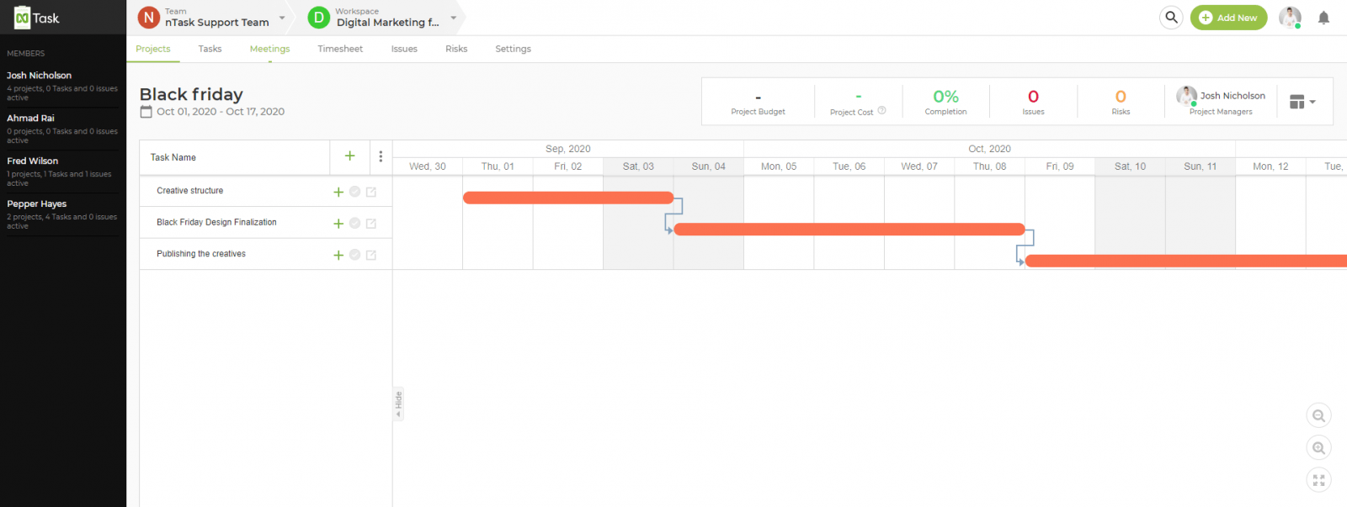
Waterfall is appropriate for this particular project for the following reasons:

- spending plan, necessities, and degree are fixed (eg. you're assembling an oddball project which doesn't require further turn of events)
- User can precisely gauge the work (the members are comfortable with innovation and you've accomplished a similar work previously)
- User can't stand to emphasize (eg. The business fabricating a pulse observing programming)
- project is intrinsically okay (employees are fabricating a clone of something that as of now works)
- the task has a difficulty date (eg. The Individual need to send a computer game by Christmas)

- clients can't or will not refresh programming (doesn't make a difference to web applications where updates are consistent)
The Advantages of using this technique are (van. 2015):
Extensive documentation - Since the members cannot go back to past development, they should always document it carefully by posting anything they can consider.
Information stays in the association - If the documentation is extensive, the data won't get corrupted if someone leaves. Moreover, user do not need to invest energy in training new people, as they can adapt to the task by studying the documentation (Duffield, and Whitty, 2016).
Colleagues can more readily design their time - Since everyone knows in advance what they will work on, they can be constantly donated for various purposes.
Straightforward - Course projects are divided into discrete and reasonably justified stages. In this way, the project board will be clear and cooperation will be reasonable even for those who are not involved (Eriksson, et al 2017).
The customer realises what's in store - Clients can know the cost and progress of work in advance so that they can plan their business practices and manage pay as planned.
Customer input not needed - After the need stage, the client's opinion does not matter (except for inconsistent feedback, support and social events). This means the individuals don't have to interact with them and wait for them to be free (Davies, and Brady, 2016).
Simpler to quantify - Since coursework projects are fundamental, it is much easier to gauge the progress of the projects by looking at a Gantt chart.
Better plan - Items have a higher union in light of the fact that during the plan stage the staff knows all that should be considered. There is nobody highlighting at-a-time problems that prompts convenience issues as it were.
However, the disadvantages include:
No returning - Every time the business completes one development, going back and making changes is tedious and expensive. Suppresses the organisation.
No space for blunder during the necessities stage - Everyone is enthusiastic about the requirements phase, and if the members get it wrong, all efforts are doomed.
Cutoff time creep - When one event is late, several different events are also late, including the end time of the event (Yap, et al 2017).
QA past the point where it is possible to be valuable - Testing is nearing completion, which means that technicians cannot improve the way they generate code given QA inputs.
Bug ridden programming - As testing comes to an end, most meetings tend to be overwhelmed with testing to get the assignment done on time and impress with dynamism. These brilliant wins result in poor quality and long lasting stretch problems.
Not what the customer entirely - More often than not, customers can't expressive what they need until they see what they needn't bother with. On the off chance that the customer acknowledges they need more than they at first suspected, the venture plan will require a significant upgrade (just as the financial plan) (Moran, 2016).
Unforeseen issues - Creators can't anticipate every one of the issues that will emerge from their plan, and once those issues surface, it's hard to fix them.
Certain tools that help irverde to exist in this competitive market and to showcase their efficiency, the tools have been mentioned below (Papke, et al 2017).

Organizing workflow and planning
The primary part and obligatory start of any endeavor is the orchestration phase, which at its most basic level is the center of the entire cycle. This movement shows who will carry out the task and how it should work, as expected, so that ideal quality can be ensured and achieved later. Usually large associations use complex plans like MS Project, which are for large meetings. However, for more modest gatherings, this is an alternate story. There are various solutions available that the business can use for itself that do not have all the luxurious features of these overarching action programs, anyway they really do it with their orchestration and guidance functions, adapting to predict future progress on assignments (Kerzner, 2015).

Communication
Since this is the main question for all intents and purposes, the set of methods and structures for appointment set by leaders, as in various areas of the market, correspondence within the congregation must be progressive and incredible. They use messaging along with the usual stuff, either way, individuals can use apps like Skype and Slack in the same way for instant conversations between employees, which creates a lot of collaborative effort, delivering confident better results (Radujković, and Sjekavica 2017).

Time management and scheduling
Money is the main factor in the development of a business or something for real. Also, remembering that in explicit effort individuals can inadvertently invest more resources and energy, the members must be careful with the various exercises that they spend money on. This is a consequence of the limited resources and time that comes with this case from the beginning, and also because they do not have to spend huge resources on meetings and equipment that may not be available when they schedule the work that needs to be done. ... So they have to safely prepare and clarify / confirm dates with the total number of partners before spending the entire fee for an empty room overflowing with resources but no work (Schwalbe, 2015).

Project planning and the following steps that are essential to complete the process
A project plan is essential before launching the idea into the market and like time, scope, and costs are talked about in the task arranging interaction, and alleviation plans are created after the ID of expected dangers. By contrasting the genuine advancement and the undertaking plan, the employees can likewise screen the exhibition of the group and find the important ways to improve it. Look at the 7 zones where task arranging is significant for effective undertakings (Verzuh, 2015).

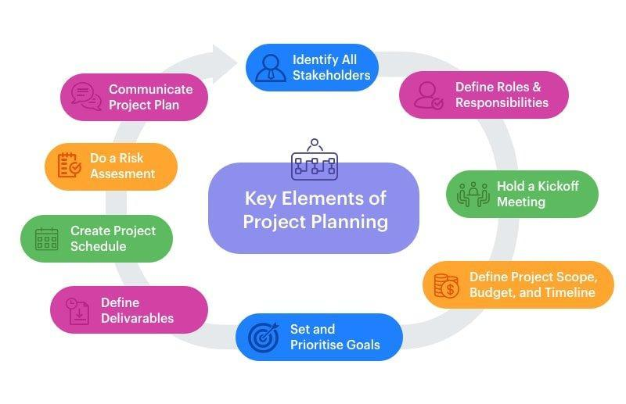

identify the stakeholders
Project partners incorporate with the client, the end-clients of the item, the organisation and its managers, and the group working straightforwardly on the task. Depending on the idea of the task, partners may likewise incorporate external associations or individual local area individuals that will be influenced by the undertaking. For example this particular project requires employees, customers and other human resources that are linked with this particular project (Meredith, et al 2017).

Roles and responsibilities
Typical positions include task support, project manager, and implementation partners. The various activities of authorized partners will differ depending on your efforts, but make sure the staff combine supplier and customer work. To make this evident to the workers or people who are part of the group it is recommended for them to develop an organisational chart according to skills that each employee can contribute with. It reports the construction of the undertaking association, the progression between colleagues (Gonçalves, et al 2017),
And the connections between workers. Venture hierarchical outlines are helpful devices for explaining who does what, getting purchase in, and setting assumptions for the gathering. The skills required by the children to contribute in this particular project is nature based skills for example, seed germination, and plantation. However, stakeholder-like workers who are managing groups should have leadership, observational, and analytical skills to respond to different situations (Marchewka, 2016).

stage 3:conduct an opening shot gathering
At this stage, the specific details of the activity are not defined, so they should remember to discuss the scope of the assignment, the monetary agreement, the schedule and the destinations in your assignment. Same with the birth declaration and compliance plan explanation. The first shot at a social event increases the speed of working relationships between employees to complete the full range of errands (Hornstein, 2015).

Stage 4: Characterize project extension, financial plan, and course of events
After the authority the opening shot, it's an ideal opportunity to characterize the task extension, financial plan, and timetable of the venture. Every one of these things is deserving of its own top to bottom clarification, so we'll simply characterize them momentarily here (Mendoza, et al 2017).
A.scope: Venture scope mentions what is going to be done (and not do)? Given the solicitations of the client and the vision examined by the group, what are the goals of this venture?
b. budget plan: Considering the degree and the assets needed to meet the undertaking goals, what is the normal monetary expense of the venture? According to our project the costs could vary by taking a quality decision to individuals searching for plant and nursery supplies, just as serving project workers who need a dependable wellspring of items. Our beginning up costs come to $41,500 which incorporates the expense of the nurseries ($38,000) and the expense of lease for the land ($1,000). The beginning up costs will be financed totally by Jim and Dan Forester (Guéguen, and Stefan, 2016).

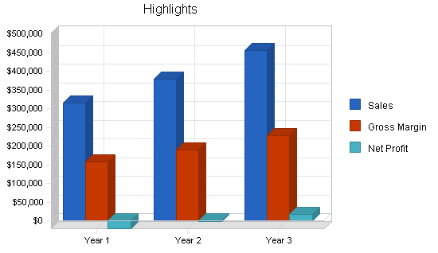

c. timeline : The task timetable orders the periods of the venture and the timeframe they can sensibly anticipate that they should be finished.

Stage 5: Set and focus on objectives
When the group comprehends the targets of the undertaking and they have recognised the stages to meeting those destinations, separate the 10,000 foot view destinations of your venture into singular objectives and errands. Focus on errands as indicated by significance and conditions. Likewise, they need a framework set up to guarantee remedial activities when objectives aren't met on schedule.they may have to change your timetable considering the objectives (Wierer Jr, and Tsao, 2015).

Stage 6: Characterize expectations
A deliverable, as characterized by the Undertaking the executives Establishment, is any novel and evident item, result, or ability to play out a help that is created to finish a cycle, stage, or venture.
Adventure assumptions are limited to the objectives of the job and are an important part of the mission plan. For example, if a client's goal is for end users to run their own organisation, assumptions may be part of a program that encourages clients to manage the organisation in the same way as scheduling materials for employees and end customers, based on the most ideal approach. Yes, it is being used lately. Programmed (Wierer Jr, and Tsao, , 2015).

Stage 7: Make a venture plan
Something beyond a period table, a venture plan is a report that subtleties the undertaking timetable and the hierarchical assets needed to finish each assignment. Its motivation is to impart basic data to the group, so it should be extensive and straightforward. To make an project plan, the business needs to additional separation the periods of the project into singular errands and exercises, decide conditions, succession the exercises and gauge the necessary assets and span of each assignment. The data they aggregate in this cycle may uncover essential changes in jobs, course of events, as well as financial plan. This is a significant advance recorded as a hard copy, a straightforward task plan and an advantageous piece of the cycle. It's greatly improved to make these changes before the venture has started, weeks or months after the fact (Joyce, and Paquin, 2016.).

Stage 8: Do a danger appraisal
A danger is a difficulty that might emerge throughout your undertaking. It's critical to distinguish project hazards and alleviate them at the task arranging stage instead of be looked asleep up some other time. Hold a gathering or request understanding from all colleagues about the dangers ought to be considered (Klasnja, et al 2015).
Areas of hazard include:
- Task Extension
- Assets (work force, monetary, and physical)
- Task delays
- What’s more, Disappointments of Innovation or Communication?
It is highly unlikely to control for every single possible danger, yet considering them early can save the project from disappointment.

Stage 9: Convey the task plan
Whenever the business have assembled the undertaking plan, try to convey it obviously to the group and any remaining partners. they may have made an undertaking correspondence plan when they set up the venture plan. If not, do it now! Building up strong correspondence channels and assumptions for project correspondence is pivotal. As a task chief, make certain to demonstrate the sort of correspondence they anticipate from all partners (Mintrom, and Luetjens, 2016).

SWOT analysis and self-assessment plan
SWOT analysis to maximize the value of what’s have, with maximum benefit to our organisation. In addition, user can reduce the likelihood of dissatisfaction by understanding what the business is lacking and avoiding the chances that in some way could lead to the business being poorly prepared.
Much better, the business can start to create a philosophy that will remember the opponents, and then wage an adequate fight in your market. Self-assessment An opportunity for delegates to self-examine and consider their characteristics and weaknesses, self-assessment is the basis for improvement as an expert, also gradually. By evaluating and guiding our own work, delegates can gain information to help them correct their shortcomings. The weakness of this particular business is the absence of brand value, also there is a restricted financial budget to advertise for the campaigns. However, the company also had some strengths such as low overhead, which gave them the space to manage their costs. They captured the right target market by focusing on children who were aged from 7 to 12 years. The project was precisely built for them and they received a positive response. The business also had a very valid research data that helped them to efficiently apply strategies related to the agricultural industry. The business might also face certain threats of failure of the business since it’s based on seasons. Moreover, other competitors might give a hard time to the business. The opportunities could include various alternatives for financial alternatives as per the budget of the organisation. The organisation could also focus on the concept of ‘rehash businesses, where the products or services could be recycled and encourage activities that are environmentally friendly (Cohen, and Goldhaber, D 2016).

strengths | weaknesses
- Valid experiential information on the grass care industry.  - A strong establishment with a profoundly attractive local area of imminent clients.  - Low overhead  - Captured the right target market. | - The absence of brand value.  - At first only one worker to help produce income.  - A restricted advertising financial plan to create brand mindfulness
opportunities | threats
- A market that is by and large impervious to financial plunges basically in light of the fact that most the imminent clients see grass care as a need and are reluctant to do it without anyone else's help.  - The capacity to discover capable representatives.  - Rehash business. | - Rivalry from the bigger, set up greens keepers.  - Future rivalry from a comparative, business person vivacious person.  - Occasional business isn't adequate to take the business through the away season.
The self-assessment plan can be carried out by following a series of steps as mentioned below:
- Choose a method for self- assessment method- as mentioned below idverde used SWOT analysis to identify the strengths, weaknesses, threats and opportunities for the business. This would help them to differentiate between their strengths and weaknesses.

- Develop a timeline for the assessment: the market search and data can be collected in a given period of time where the performance of the business can be observed and the success of the project can be measured. This would further help the business in analysing the strengths and weaknesses (Robertson, 2015).

- Set a goal: the business can also set their goals accordingly considering their strengths and weaknesses. This would help them to set their targets differently from their competitors (Saltmarsh, et al 2015),

- Receive feedback: after carrying out the evaluation proves it is important for the business to analyse the results and receive feedback from the audience so they can further clear out any mishaps. This would lead towards growth of the business (Nahum, et al 2018).
The following strategies that the researcher would implement in the business to fill in the gaps:

- To work on the weaknesses idverde can use various production techniques to work on their poor brand value. The company should simply work on their quality of production and carry out an effective market research. This would help them to keep up with the customer preferences and gain recognition in the market.
- Less number of workers: idverde should improve the size of their workforce by hiring more employees and this could further be encouraged by offering the individuals with various benefits to publish the job offers on different platforms and this would encourage more employees to be a part of the organisation.
- Idverde should come up with other strategies like diversification or by launching projects that can be accessed easily or encourage more shareholders to buy shares of the company and invest in the business. This would increase the income of the business and encourage them to develop effective advertising plans and use methods that would help them to reach out to more customers (Saltmarsh, et al 2015).
The self-assessment plan using SWOT analysis would help me to enhance my strengths and overcome my weaknesses as a leader of the organisation. training programs and delegation should be eccouraged at the workplace. As this would boost the self-esteem of the employees and help me to improve my leadership skills by maintaining a friendly environment by gaining suggestions from my subordinates while dealing with the plan (Robertson, 2015),

Conclusion
Considering idverde as the example here, different businesses like these could use certain tools and techniques that can be applicable on different projects and run campaigns that could benefit the society. Businesses have to always acknowledge the value of their position in the market and to do this they should go through a self- assessment plan that could help them to acknowledge. To plan the process of any association is crucial for the general achievement of the organisation. All degrees of preparation should do their part to join situational investigation, elective objectives and plans, objectives and plan assessment, objective and plan determination, execution, and screen. The executives plan 8and control their association to accomplish the ideal outcomes. Notwithstanding these means, chiefs should likewise consider the different effects like lawful issues, morals, and corporate social responsibility just as inner and outside factors when conceiving plans for their association. As demonstrated by the continuous achievement of the landscaping Company, these means and contemplations in the possession of the correct supervisors guarantee a promising future.Business people might have the option to improve their odds of achievement in business by embracing a genuine and definite self-evaluation. By assessing such close to home qualities as business abilities, experience, and information, monetary objectives, different preferences, readiness to exhaust exertion, and capacity to address difficulties, business visionaries might have the option to distinguish the business openings for which they are most appropriate. Sometimes, self-evaluation may even prompt inventive new business thoughts. Also, finishing a self-appraisal can assist business visionaries with perceiving zones where they will require help or preparing. By expanding self-information, it might likewise assist business people with pulling in financial backers and dazzle moneylenders.

References
Aubry, M. and Lavoie-Tremblay, M., 2018. Rethinking organizational design for managing multiple projects. International Journal of Project Management, 36(1), pp.12-26.
Cohen, J. and Goldhaber, D., 2016. Building a more complete understanding of teacher evaluation using classroom observations. Educational Researcher, 45(6), pp.378-387.
Davies, A. and Brady, T., 2016. Explicating the dynamics of project capabilities. International Journal of Project Management, 34(2), pp.314-327.
Duffield, S.M. and Whitty, S.J., 2016. Application of the systemic lessons learned knowledge model for organisational learning through projects. International journal of project management, 34(7), pp.1280-1293.
Eriksson, P.E., Larsson, J. and Pesämaa, O., 2017. Managing complex projects in the infrastructure sector—A structural equation model for flexibility-focused project management. International journal of project management, 35(8), pp.1512-1523.
Gonçalves, R.Q., von Wangenheim, C.A.G., Hauck, J.C. and Zanella, A., 2017. An instructional feedback technique for teaching project management tools aligned with PMBOK. IEEE Transactions on Education, 61(2), pp.143-150.
Guéguen, N. and Stefan, J., 2016. “Green altruism” short immersion in natural green environments and helping behavior. Environment and behavior, 48(2), pp.324-342.
Hornstein, H.A., 2015. The integration of project management and organizational change management is now a necessity. International Journal of Project Management, 33(2), pp.291-298.
Joyce, A. and Paquin, R.L., 2016. The triple layered business model canvas: A tool to design more sustainable business models. Journal of cleaner production, 135, pp.1474-1486.
Keers, B.B. and van Fenema, P.C., 2018. Managing risks in public-private partnership formation projects. International Journal of Project Management, 36(6), pp.861-875.
Kerzner, H., 2015. Project management 2.0: leveraging tools, distributed collaboration, and metrics for project success. John Wiley & Sons.
Klasnja, P., Hekler, E.B., Shiffman, S., Boruvka, A., Almirall, D., Tewari, A. and Murphy, S.A., 2015. Microrandomized trials: An experimental design for developing just-in-time adaptive interventions. Health Psychology, 34(S), p.1220.
Marchewka, J.T., 2016. Information technology project management: Providing measurable organizational value. John Wiley & Sons.
Mendoza, J.M.F., Sharmina, M., Gallego‐Schmid, A., Heyes, G. and Azapagic, A., 2017. Integrating backcasting and eco‐design for the circular economy: The BECE framework. Journal of Industrial Ecology, 21(3), pp.526-544.
Meredith, J.R., Shafer, S.M. and Mantel Jr, S.J., 2017. Project management: a strategic managerial approach. John Wiley & Sons.
Mintrom, M. and Luetjens, J., 2016. Design thinking in policymaking processes: Opportunities and challenges. Australian Journal of Public Administration, 75(3), pp.391-402.
Moran, A., 2016. MANAGING AGILE. SPRINGER INTERNATIONAL PU.
Nahum-Shani, I., Smith, S.N., Spring, B.J., Collins, L.M., Witkiewitz, K., Tewari, A. and Murphy, S.A., 2018. Just-in-time adaptive interventions (JITAIs) in mobile health: key components and design principles for ongoing health behavior support. Annals of Behavioral Medicine, 52(6), pp.446-462.
Nguyen, T.P. and Chileshe, N., 2015. Revisiting the construction project failure factors in Vietnam. Built Environment Project and Asset Management.
Papke-Shields, K.E. and Boyer-Wright, K.M., 2017. Strategic planning characteristics applied to project management. International Journal of Project Management, 35(2), pp.169-179.
Radujković, M. and Sjekavica, M., 2017. Project management success factors. Procedia engineering, 196, pp.607-615.
Robertson, J., 2015. Deep learning conversations and how coaching relationships can enable them. Australian Educational Leader, 37(3), pp.10-15.
Saltmarsh, S., Chapman, A., Campbell, M. and Drew, C., 2015. Putting “structure within the space”: Spatially un/responsive pedagogic practices in open-plan learning environments. Educational Review, 67(3), pp.315-327.
Schwalbe, K., 2015. Information technology project management. Cengage Learning.
van der Hoorn, B., 2015. Playing projects: Identifying flow in the ‘lived experience’. International Journal of Project Management, 33(5), pp.1008-1021.
Verzuh, E., 2015. The fast forward MBA in project management. John Wiley & Sons.
vom Brocke, J. and Lippe, S., 2015. Managing collaborative research projects: A synthesis of project management literature and directives for future research. International Journal of Project Management, 33(5), pp.1022-1039.
Wierer Jr, J.J. and Tsao, J.Y., 2015. Advantages of III‐nitride laser diodes in solid‐state lighting. physica status solidi (a), 212(5), pp.980-985.
Yap, J.B.H., Abdul-Rahman, H. and Chen, W., 2017. Collaborative model: Managing design changes with reusable project experiences through project learning and effective communication. International Journal of Project Management, 35(7), pp.1253-1271.

