Module: Digital Marketing (LCMB7010)

Digital Marketing Assessment on Adidas



Lecturer: Prof. Amitave Banik

Student Name: Ajith Kandula

Student ID: 2122120

Name of the University: University of Wales Trinity Saint David



Table of Contents

1. Background of Adidas…………………………………………………………….3
Part 1
- Introduction…………………………………………………………………………..4
- Overview of Adidas………………………………………………………………..5
- Market Place and Target Market for Adidas………………………………..5-6
- Revenue Streams for Adidas……………………………………………………6-7
- Cost Structure of Adidas…………………………………………………………7
- Supply Chain Management of Adidas…………………………………………7-8
- Digital Representation of Adidas……………………………………………….8
- The contribution of Digital Technologies to Marketing…………………..9-10
- Digital Marketing and Competitive Advantage of Adidas………………10-11
- Communications, Strategies, Digital Assets and E-commerce of Adidas…12
- 7Ps of Marketing Mix for Adidas…………………………………………….12-14
- Push and Pull Theory for Adidas……………………………………………14-15
- SOSTAC Plan for Adidas………………………………………………………15-17

Part 2
- Application of Machine Learning in Digital Marketing to maximize ROI…18-21
- Conclusion…………………………………………………………………………21
- Recommendations……………………………………………………………….21-22
- Lists of References……………………………………………………………..23-27

- Background of Adidas:
Adidas is one of the major manufacturers of sportswear in the world, and it offers a wide variety of goods and brands under its umbrella. Adidas, Reebok, and TaylorMade-Adidas Golf are the three primary brands that the corporation sells under. Moreover, Adidas is the parent company of Runtastic, an Austrian firm that specialises in the production of fitness technologies (Wright, 2019). Adidas is a multinational corporation that does business on a worldwide scale from its headquarters in Herzogenaurach, Germany. The company also has subsidiaries in over 160 countries. More than 60,000 people were employed by the firm around the globe in 2020, and it generated a total revenue of £23.8 billion that year (Muhamad Fauzi, 2021). The likes of football great Lionel Messi, basketball superstar James Harden, and the National Basketball Association are among the notable players and teams that Adidas has sponsored and promoted throughout the course of its history (NBA). In addition, the corporation has been associated with the Olympic games ever since its inception in 1928 and has been an official sponsor of the FIFA World Cup ever since 1970.

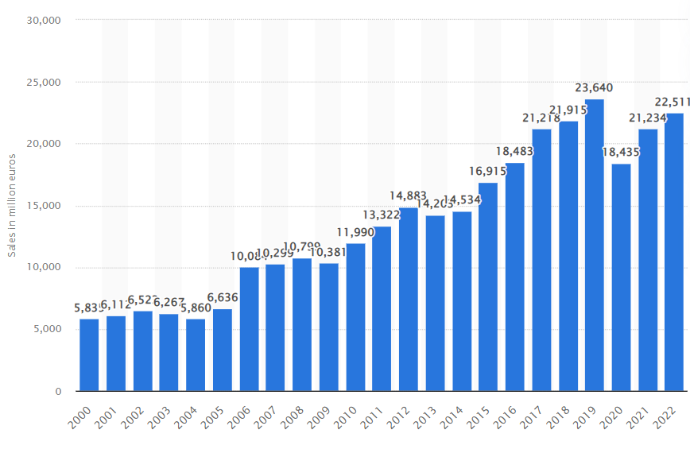
Figure 1: The Adidas Group’s net sales worldwide from 2000 to 2022
(Source: Statista, 2018)

Part 1

Introduction:

The use of digital technology is essential to establishing a competitive edge in any retailing or marketing setting. At the same time, marketing managers are faced with a number of issues around the strategic use of these technologies and the need to rethink their digital strategy. This is a must in order to remain competitive in the modern business environment. It is crucial for managers to have a more in-depth awareness of the perspectives held by consumers as well as their level of involvement with digital technology. Academic marketing provides thought leadership that may be of use to marketing strategists, allowing them to gain insight into how they can turn these issues into strategic opportunities that provide them a competitive edge. This has the potential to result in technology advances that produce value for customers, businesses, and society.Within this study, Adidas is a selected company. It is a German multinational company popular for its shoes. The company has used digital marketing to attract larger number of customers towards their brand (Basri, 2021). There digital marketing channels are Facebook, Instagram, LinkedIn, Twitter, YouTube, TikTok, and Pinterest. From the company’s inception, Adidas has placed a primary emphasis on developing cutting-edge technologies and producing high-quality goods specifically for athletes. In 1954, the German national soccer team won the World Cup while wearing Adidas cleats, which is considered by many to be the company’s first great achievement.


Figure 2: Adidas Headquarters
(Source: Pompliano, 2023)

- Overview of Adidas:
Adidas is a global firm based in Germany that specialises in the design and production of footwear, apparel, and accessories. Adolf Dassler, who had previously established a shoe firm together with his brother Rudolf in the 1920s, established the business in 1949. Adolf Dassler’s company was the first of its kind. Rudolf went on to establish Puma when the brothers decided to go their own ways in the wake of World War II. Adolf remained to operate the firm that would eventually become known as Adidas. The name “Adidas” is a combination of Adolf’s nickname “Adi” and the first three letters of his last name, “Das”. Adolf was given the nickname “Adi” when he was young (Basri, 2021).

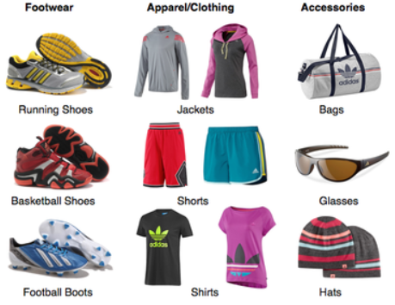
Figure 3: Product Portfolio of Adidas
(Source: Keishelleeadidas.weebly.com, 2023)

- Market Place and Target Market for Adidas:
Customers in the age range of 18 to 40 years old who have an interest in fashion,fitness, and sports constitute the majority of the company's target market. Adidas markets its products to both men and women, with a primary emphasis on young culture and fashion associated with streetwear. The firm creates items that are both practical and fashionable in order to appeal to customers that place equal importance on performance and appearance. Adidas has a wide variety of products, including footwear, clothes, and accessories, for a number of different sports and
activities, including football, basketball, jogging, and training (Kammerer, et al., 2020).
In addition, the brand sells lifestyle goods that are meant to be worn in a more relaxed setting. In terms of the markets in which they are sold, Adidas items are distributed all over the world via a variety of channels, including company-owned retail locations, e-commerce websites, and third-party merchants. The business already has a large footprint across the continents of Europe, North America, and Asia, and it is actively working to grow its operations in developing countries.
Although Adidas serves a wide spectrum of clients, its target demographic might be characterised as athletic and energetic people who appreciate style, quality, and performance. Younger people interested in sports and fitness, especially in the urban or streetwear fashion scene, make up the brand's sweet spot target demographic (Wildfeuer, 2018). In order to cater to this audience, the business often uses well-known sportsmen and influencers in its marketing initiatives. Adidas has also made an effort to connect with customers who care about the environment by incorporating eco-friendly materials and practises into its goods and marketing initiatives. Due to this, the business has been able to draw in more and more customers who are interested in ethical and ecological fashion.

Revenue Streams for Adidas:
Adidas is recognised for its athletic footwear and derives a substantial portion of its revenue from the footwear sales. The corporation provides a diverse selection of athletic shoes tailored to various sports such as running, basketball, soccer and tennis. Adidas offers a diverse range of sports and casual apparel, such as jerseys, shorts, t-shirts, and jackets, in addition to footwear. The establishment has formed alliances with various sports organisations and individuals, thereby contributing to the enhancement of revenue (Majcen, 2020). Adidas maintains a worldwide network of retail establishments, comprising both corporate-owned and franchised stores, to facilitate retail sales. The corporation has been increasing its retail footprint in significant regions such as China, where it has observed robust demand for its merchandise (Mikhail, 2019). Adidas engages in various licencing agreements and sponsorships with sports teams and athletes, thereby generating revenue through royalties and fees. The corporation serves as the designated sponsor for various prominent athletic competitions, such as the Olympic Games and the FIFA World Cup. Adidas has engaged in collaborative efforts with various brands and designers to produce exclusive merchandise and assortments. The cooperative efforts facilitate the creation of hype and stimulate purchases among consumers with a keen interest in fashion.

Cost Structure of Adidas:
The Cost of Goods Sold (COGS) for Adidas encompasses the expenses directly related to the production and manufacturing of their products. The category of marketing and advertising expenses encompasses the expenditures related to the promotion of the Adidas brand and its products through diverse channels. The category of research and development expenses pertains to the expenditures incurred by Adidas in the process of enhancing and innovating their products and technologies. General and administrative expenses refer to the operational costs that are necessary for the functioning of a company, encompassing various overhead expenses (Boteanu et al., 2020). The distribution and logistics expenses of Adidas encompass the expenditures related to the transportation of its merchandise to its clientele, which comprise shipping, warehousing, and transportation costs. The category of taxes and regulatory expenses encompasses the financial obligations that Adidas is required to remit to governmental and regulatory entities in the various jurisdictions where it conducts business.

Supply Chain Management of Adidas:
Adidas employs a stringent selection procedure to ascertain that its suppliers conform to the company's ethical and quality benchmarks. Adidas collaborates with diverse factories and production facilities across the globe to fabricate its merchandise. The organisation adheres to a lean manufacturing methodology with the aim of reducing waste and enhancing productivity (Kammerer, et al., 2020). Adidas employs a range of transportation modalities, such as air, sea, and land, to facilitate the conveyance of its merchandise from manufacturing plants to distribution hubs and retail outlets. The establishment of strategic partnerships with logistics providers has been undertaken by the company to guarantee the punctual delivery of its products. Adidas employs advanced inventory management systems to maintain optimal stock levels across its distribution centres and retail outlets. The organisation employs data analytics techniques to predict market demand and subsequently modify inventory levels in response. Adidas boasts a worldwide network of retail stores and e-commerce channels, facilitating its retail operations. The organisation leverages technological advancements and data analysis techniques to enhance its retail operations and enhance the overall customer experience. Adidas demonstrates a robust dedication to sustainability and collaborates closely with its suppliers to enhance environmental and social practises within its supply chain. The corporation has established ambitious sustainability objectives and routinely provides updates on its advancement.

Digital Representation of Adidas:
The Adidas website is not only attractively laid up and simple to use, but it also provides a comprehensive selection of items and details on the company's history, core beliefs, and many eco-friendly endeavours. In addition, the website has a blog part that discusses a variety of issues relating to sports, as well as fashion and culture. On social media sites such as Facebook, Twitter, Instagram, and YouTube, Adidas has millions of followers, which demonstrates the company's robust online presence (Salem and Sobaih, 2022). The company utilises social media to communicate with its consumers, disseminate information about newly launched products and promotions, and highlight its collaborations with athletes and other influential people. Moreover, Adidas offers clients the ability to explore items, make purchases, and monitor the status of their orders via the use of a mobile app (Hartwich et al., 2022).
Customers are also given the ability to personalise their purchases and build their own footwear using the site. Adidas promotes its goods and communicates with its target demographic via the use of digital marketing (Barbosa, 2022). This include strategies such as search engine optimisation (SEO), pay-per-click advertising (PPC), email marketing, and relationships with influential individuals. Customers are able to get a better idea of how Adidas items will appear on them before making a purchase thanks to a new virtual try-on tool that can be accessed via the company's website and mobile app. This function improves the overall quality of the online shopping experience and has the potential to cut down on exchanges and returns (Ames Valverde et al., 2021). Email marketing is a strategy that Adidas use to advertise its goods, provide its consumers with access to exclusive deals, and share entertaining material with them. Email is also used by the firm to solicit feedback from consumers and compile information about the preferences and actions of the customers.

The Contribution of Digital Technologies to Marketing:
According to Langan, et al., (2019), customers have the ability to shop for Adidas items online thanks to the company's comprehensive e-commerce infrastructure. For Adidas, this has been of the utmost importance, particularly during the COVID-19 epidemic, a time when the popularity of purchasing online has increased. They are also able to provide personalized experiences via the usage of their e-commerce platform, such as items that are tailored to the customer's specifications, personalized suggestions, and exclusive access to limited edition products. Augmented reality (AR) technology has been applied by Adidas in order to improve the overall client experience (Vitulano, 2022). For instance, they developed a game called ‘Tango’ that is driven by augmented reality that enables buyers to interact with Adidas items and learn about the benefits of such things. They also created virtual try-on experiences with the use of augmented reality technology so that shoppers could preview how things would appear on them before making a purchase.
The world of marketing has been dramatically revolutionised as a result of the rise of digital technology. The use of digital technology has completely altered the method in which firms do marketing. Digital technologies have made it easier for Adidas to attract and keep customers in highly competitive markets by providing a greater reach, cost-effective solutions, personalization, real-time analytics, improved customer engagement, and mobile marketing (Grewal et al., 2019). These technologies have also made it possible for businesses to expand their customer base. Businesses now have the ability to reach a larger audience, monitor consumer behaviour and preferences, and customise the marketing messages they send out thanks to digital marketing. Also Adidas now have the ability to expand their customer base outside their immediate geographic region because to the proliferation of digital technologies such as social media, email, and search engines. The firm is now able to more easily target prospective clients from a variety of geographic areas, demographic groups, and even time zones as a result of this (Jafari-Sadeghi et al., 2021). They may sell their goods and services in ways that are more efficient and cost-effective thanks to the proliferation of digital technology. For instance, advertising on social media platforms may be substantially more cost-effective than more conventional types of advertising for Adidas such as print advertisements or television commercials.
Adidas can tailor their marketing messages to the tastes, demographics, and behaviours of individual customers because to the proliferation of digital technology. This contributes to an improvement in conversion rates as well as improved consumer engagement. Digital technologies make it possible for companies to get data in real time on the actions and preferences of customers (Pergelova et al., 2018). Because of this, the firm is able to swiftly alter their marketing plans, improve their campaigns, and analyse the return on investment (ROI) of their marketing efforts. Businesses now have the ability to interact with their consumers in real time, provide customised suggestions, and react to customer queries thanks to the proliferation of digital technology. As per Zhang (2022), this results in a more positive experience for the consumer, which in turn strengthens their loyalty. The proliferation of smartphones and other mobile devices has made it possible for Adidas to interact with consumers regardless of where they are located. Because of this, new possibilities have presented themselves in the fields of location-based marketing, push alerts, and mobile applications.

Digital Marketing and Competitive Advantage of Adidas:
According to Ferina et al., (2019), traditional marketing tactics can only reach a fraction of the potential customers that can be reached through digital marketing. Businesses now have the ability to reach clients all over the globe thanks to the internet, which may result in higher levels of sales and income. Businesses are now able to tailor their marketing efforts to the specific needs of individual clients thanks to digital marketing. The use of digital marketing offers organisations with useful data and analytics that may assist them in better comprehending the actions and preferences of their customers. The exposure and credibility of Adidas may be improved via the formation of strategic partnerships with key opinion leaders and brand advocates. Adidas is able to tap into its audiences and attract new consumers by collaborating with influencers whose beliefs are congruent with those of the company's brand. Adidas is able to cultivate a feeling of community and establish a client base that is more devoted to the brand by connecting with consumers via social media and other digital means (Nuseir and Aljumah, 2020). Adidas is able to obtain insights into client behaviour and preferences, as well as the efficiency of its marketing initiatives, by evaluating the data gathered through its digital marketing activities.
Traditional marketing tactics may not compare well to the potential savings offered by digital marketing. For example, marketing through social media and email may be very cost-effective in terms of both reaching clients and keeping their interest. Both of these methods are reasonably affordable. Businesses are able to adapt to shifts in the market more quickly because to the flexibility afforded by digital marketing. Businesses are able to swiftly adapt their marketing plans and methods to meet the ever-shifting requirements and preferences of their client base when they use digital marketing (Mukambi, 2022). Adidas is able to maintain an edge over its rivals and keep one step ahead of the pack when it makes use of these data to continually improve the performance of its digital marketing strategy. Building a solid brand reputation and expanding Adidas's reach may be accomplished via the constant production of excellent content that strikes a chord with the company's intended audience. Customers of Adidas may benefit from more tailored experiences due to the company's ability to use data and technology.
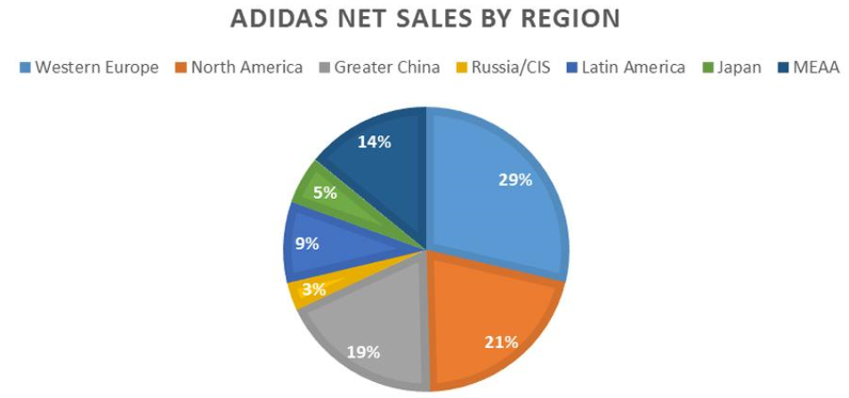
Figure 4: ADIDAS Net Sales by Region
(Source: Warner, 2018)
Adidas is able to customise its digital marketing efforts to send the most relevant material and offers to each individual consumer because it monitors the behaviours and preferences of its customers. This has the potential to boost consumer happiness at Adidas, as well as their loyalty and retention rates (Mehralian and Khazaee, 2022). Digital marketing provides Adidas with the opportunity to boost online sales by attracting more customers to its e-commerce website. By the use of targeted advertising and website optimisation geared towards search engines, Adidas is able to bring in a greater number of quality leads to its online shop. In addition, Adidas may utilise email marketing and retargeting advertisements to entice customers who have previously shown interest in their products but then left the site without completing their purchases.

Communications, Strategies, Digital Assets and E-commerce of Adidas:
Communications:
Adidas promotes its goods and interacts with its consumers using a variety of marketing channels, including both conventional and digital ones. The organisation has a robust presence on social media, with millions of followers across various platforms such as Instagram, Twitter, and Facebook. In addition, Adidas places a significant emphasis on influencer marketing by forming strategic alliances with notable individuals such as athletes, artists, and other celebrities for the purpose of promoting the brand's goods (Birch, 2019).
Strategy:
Adidas has a powerful brand strategy that is centred on innovation, sustainability, and diversity in its products. The firm has earned a reputation for producing innovative goods and maintaining a commitment to the use of environmentally friendly materials and production methods.

Digital Assets:
Adidas boasts a comprehensive online presence, featuring a website that provides a wide array of products and services available for purchase. The corporation has created several mobile applications, including the Adidas app, that offer users the opportunity to browse products, customize their own footwear, and access exclusive content (Pratama et al., 2022). Furthermore, Adidas has allocated resources towards nascent technologies such as augmented reality (AR) and virtual reality (VR) with the aim of enhancing the overall caliber of customer experience.

E-commerce:
Adidas has a strong online sales strategy, with a focus on streamlining the online purchasing process as its main goal. The company offers free shipping and returns and takes a number of payment methods, including Apple Pay and PayPal. Aside from that Adidas has made investments in emerging technologies like as chatbots and artificial intelligence in order to enhance the whole consumer experience and simplify the purchase procedure.

7Ps of Marketing Mix for Adidas:
Product:
Adidas provides a plethora of items, including but not limited to athletic footwear, like sports shoes, running shoes, basketball shoes, football shoes, athletic apparel like sports clothes, and accessories including hats, gloves, and socks, and more. In addition to that, they have items that are geared for ladies, men, and children.

Price:
In order to promote itself as a high-end brand, Adidas adopts a price strategy that places a premium on its products. They provide a variety of price ranges for their wares, each of which is determined by the kind of product, the level of quality, and the audience they are catering too (Ravangard, et al., 2020).

Place:
Adidas has a robust distribution network that includes their own branded locations, as well as online stores and retail partners located all over the globe. They have a presence in a number of different nations and have cleverly positioned their retail outlets all over the world to make it simple for consumers to reach them.

Promotion:
Adidas reaches out to its demographic using a variety of promotional channels including advertising, sponsorship, events, and social media in order to promote their products. In addition, they have formed promotional alliances with well-known people and teams in the sporting world.

People:
Adidas seeks to employ people who are informed about the things they sell and have a love for the sports in which they participate (Chana et al., 2021). They give their personnel with training to guarantee that they have the skills necessary to deliver superior service to their clients.

Process:
Adidas makes it a priority to maintain an ethical and environmentally responsible production procedure. They have taken steps to lessen their impact on the environment by lowering their carbon footprint and improving the ethical practises of their manufacturing plants.

Physical Evidence:
The interiors of Adidas shops are designed to exude a contemporary and hip vibe that effectively displays the brand's wares. They also make certain that their items are of high quality and that they live up to the requirements set out by their clients.
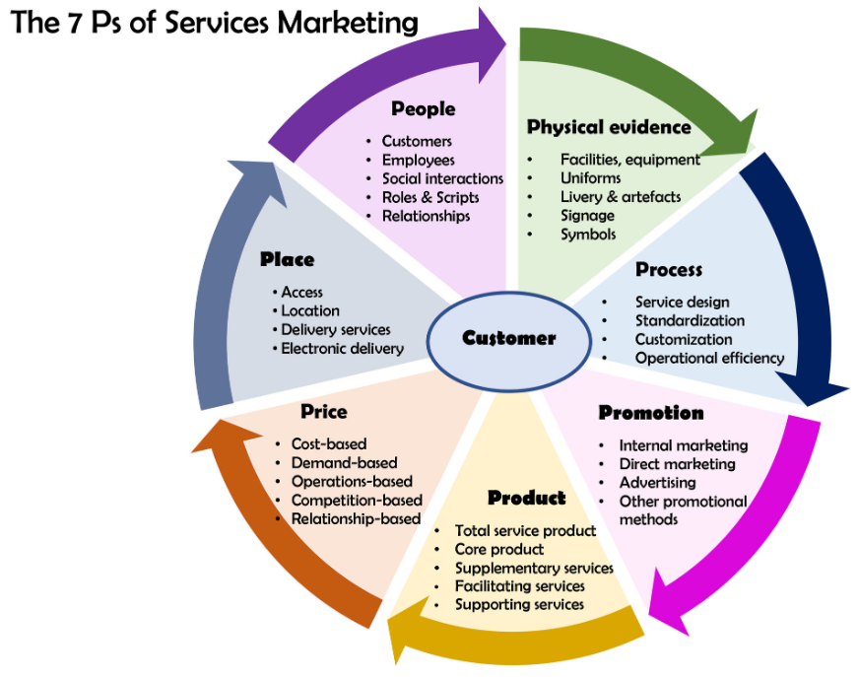
Figure 5: 7Ps of Marketing
(Source: Zahra, 2019)

Push and Pull Theory for Adidas:
The push and pull hypothesis is a marketing tactic that is used by businesses in order to advertise and sell their wares. The marketing technique that Adidas uses to sell its goods has elements of both the push and the pull theories. The corporation makes use of a variety of distribution channels in order to get its products into the hands of end users, and it generates demand for its goods by raising the level of awareness among end users.
The push theory include methods such as advertising, personal selling, and sales promotions. Adidas puts a significant amount of money on advertising in order to raise consumers knowledge of the brand and to market its goods. To further entice customers to acquire its goods, the corporation runs various sales promotions, including price reductions, the provision of free goods, and customer loyalty programmes (Clausen, et al., 2020). In addition, Adidas utilises personal selling in its retail shops and on its online platforms in order to market its items to individual customers.
On the other side, the pull theory is a business strategy in which corporations concentrate on increasing demand for their goods by raising awareness among consumers and responding to that demand. Moreover, Adidas makes use of this tactic by generating demand for its goods via a variety of channels, including social media, influencer marketing, and new debuts, amongst others. Instagram, Twitter, and Facebook are just some of the social media sites that Adidas use in order to raise awareness about its goods and communicate with the people it is trying to reach (Su, et al., 2018). Moreover, the corporation works along with influential people, athletes, and celebrities in order to support its goods and boost the appeal of such items. In addition, Adidas generates excitement about the debuts of its items by using teaser campaigns and developing limited edition collections. These strategies instill a feeling of immediacy in the minds of customers towards the purchase of the company's wares.
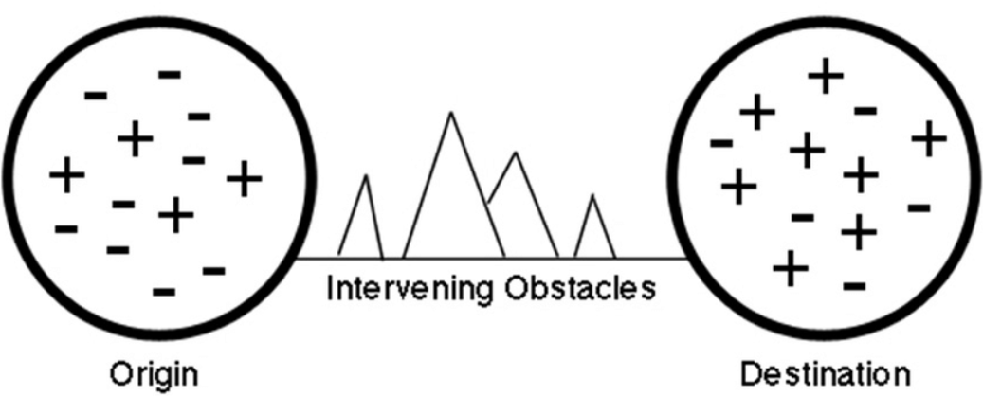
Figure 6: Push and Pull Theory
(Source: Mlambo and Mpanza, 2019)

SOSTAC Plan for Adidas:
In digital marketing, the SOSTAC model is a well-known framework that is used to construct an all-encompassing strategy with the purpose of accomplishing various marketing goals. Situation Analysis, Objectives, Strategies, Tactics, Actions, and Control are the components that make up SOSTAC. The SOSTAC plan offers a distinct and well-structured framework that may be used for the creation and execution of marketing programmes. It enables companies to concentrate on the essential components of their marketing plan and makes certain that all of the people participating in the process are on the same page. Also, the SOSTAC strategy would provide incentives for corporations such as Adidas to approach their marketing in a smart manner. It assists them in determining who their ideal customers are, determining what their goals are, and establishing a marketing plan that is in line with the objectives they have established for their company as a whole.
Situational Analysis:
An analysis of the circumstance reveals that Adidas is a worldwide leader in the sportswear industry. The corporation offers a varied range of products, including footwear, apparel, and accessories. The company holds a substantial market share within the industry and is engaged in direct rivalry with other major contenders, including Nike and Puma. In addition, Adidas upholds a significant online presence, encompassing an e-commerce platform and social media accounts.
Objectives:
Adidas has established a set of objectives that may encompass expanding its market share, diversifying its product portfolio, reinforcing customer allegiance, and enhancing its e-commerce revenue.
Strategy:
Adidas may adopt a strategy of expanding its product range to cater to the constantly changing demands of its customers. This objective will be achieved through the introduction of novel products. One potential strategy that the company may adopt to enhance brand image and increase consumer loyalty is to invest in marketing initiatives that highlight the firm's commitment to sustainable practices and innovative thinking.
Tactics:
Adidas employs various strategies such as collaborating with athletes and influencers to endorse its merchandise, leveraging social media to interact with its clientele, and offering tailored customer experiences via its online retail platform. Furthermore, Adidas has the potential to utilize social media platforms as a means of interacting with its clientele.
Action:
The proposed course of action for Adidas entails the implementation of the aforementioned strategies, the diligent tracking of critical performance metrics to assess the efficacy of the marketing approach, and the potential modification of the plan as necessary to achieve the desired objectives.
Control:
Monitoring the development of the marketing strategy, making modifications to the plan as necessary, and analysing the outcomes are all components of the control stage. In order to establish the efficacy of the marketing strategy, this may entail doing an analysis of the sales data, the feedback from customers, and the metrics from social media.
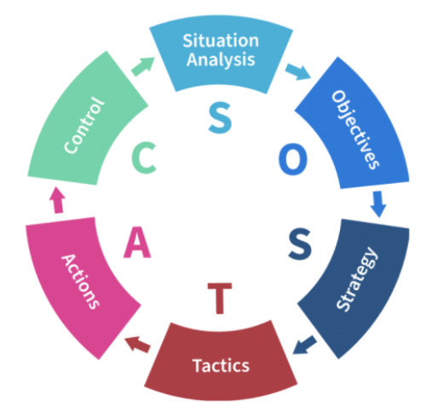
Figure 7: SOSTAC Method
(Source: Briray, 2020)

Part 2

Applications of Machine Learning in Digital Marketing to maximize ROI:
The area of digital marketing is expanding at a fast rate, and organisations are searching for new methods to increase their return on investment (ROI) via the use of cutting-edge strategies. The application of machine learning is one method that fits this category. Digital marketers now have the ability to gather, analyse, and act on massive volumes of data in real time thanks to machine learning. Marketers are able to map out customer journeys, develop tailored content, forecast consumer behaviour, and improve campaigns using the power of machine learning algorithms (Miklosik et al., 2019). It has been shown to be very successful in optimising ROI when machine learning is used in digital marketing. According to a study conducted by Deloitte, businesses who use machine learning into their marketing strategy experience a significant rise in both their revenue and their ROI.
The conventional method of marketing has been revolutionised by machine learning in this industry. Salminen et al., (2019) predict that by the year 2023, the most successful companies would incorporate machine learning into some areas of their sales process. Machine learning allows businesses to remain ahead of the competition by overcoming some of the most challenging challenges that marketing presents, such as personalisation, providing real-time customer help, and managing large amounts of data. To make sense of all the data they have access to, marketers utilise ML. Machine learning can analyse enormous volumes of data far more quickly and efficiently than humans can. This analysis is used to discover patterns and create predictions in a comparatively short amount of time. In addition, marketers can use these insights to optimise a significant portion of their workflow by, for example, conducting additional tests to enhance the user experience of their website, personalising and automating the consumer engagement process, and improving the user experience of their website.
The use of data sciences, which make it easier to make decisions and extract useful insights and information from massive datasets, has seen a significant uptick in the digital marketing environment over the course of the last decade. Nonetheless, in spite of these advancements, there is still a dearth of pertinent evidence on the steps that can be taken to enhance the management of data sciences in digital marketing. As per Mu and Zeng (2019), the area of digital marketing has been completely transformed by the use of machine learning, which enables businesses to analyse massive volumes of data and get insights that can be applied to the optimisation of marketing campaigns and the personalization of consumer experiences. Customer behaviour, tastes, and demographics may all be analysed with the use of machine learning algorithms, which can then be used to divide clients into distinct groups. Because of this, businesses are able to increase the efficacy of their marketing efforts by targeting certain groups of consumers with the communications they send to those customers.
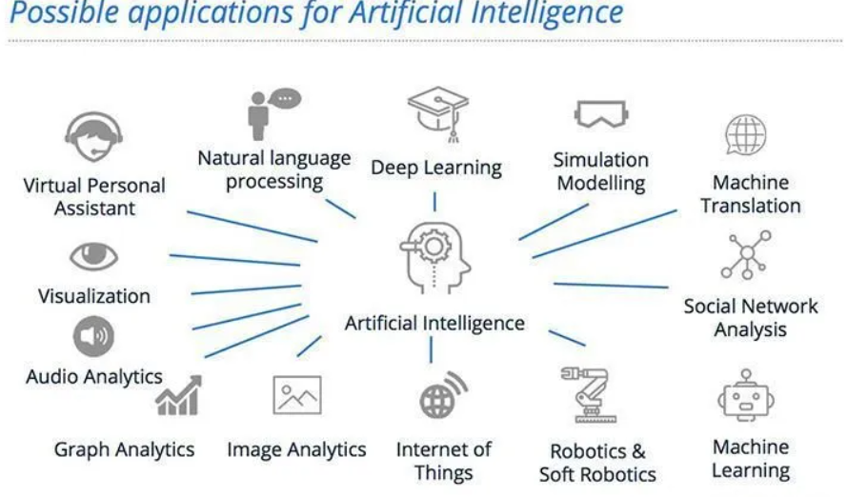
Figure 8: Possible Applications for Artificial Intelligence
(Source: Pittau, 2017)
Learning machines may be used to make predictions about future consumer behaviour, such as a customer's chance of making a purchase or leaving a service, for example. This information may be put to use to increase client retention and marketing initiatives in order to maximise profit (Saura, 2020). It is possible to utilise machine learning to customise a customer's experience by making product or content recommendations based on a customer's previous actions and the preferences they have expressed. By evaluating consumer data and making educated guesses about which advertisements would be most successful for certain customer categories, machine learning may be used to improve ad targeting and bring in more relevant leads. Analyzing the behaviour of customers on websites and social media platforms may be accomplished using machine learning, which can then be used to modify content in order to increase engagement and conversion rates. Discovering and preventing fraudulent activity in digital marketing, such as click fraud and bot traffic, may be accomplished via the application of machine learning (Ma and Sun, 2020). By delivering important insights and allowing tailored experiences for consumers, machine learning has the ability to dramatically increase the efficacy and efficiency of digital marketing initiatives.
Klaib et al., (2021) argued that algorithms that employ machine learning may be used to do real-time analysis of photos and videos, which enables organisations to recognise recurring tendencies and patterns that can be used to influence marketing choices. For instance, a fashion shop may employ picture analysis to determine which clothing designs and colour combinations are the most well-liked by the demographic they are trying to reach. Chatbots that are able to give real-time assistance to customers and answers to their inquiries may be developed with the help of machine learning algorithms (Ballestar, et al., 2018). The overall experience for the consumer may be enhanced as a result, and the available human resources can be reallocated to other activities. It is possible to employ machine learning algorithms to identify and prevent several types of fraud, including fraud using credit cards and bogus reviews. This may assist firms in preserving their reputations and avoiding damages to their financial stability.
CommonWealth decided to work with a firm that offers companies an AI-powered platform in order to improve the level of connection they have with their customers. The proprietary machine learning model developed by the business was able to estimate reader profiles in a significant deal of detail by analysing data from a customer relationship management system and seeing how consumers interact with the mobile app and website (Saura, 2020). CommonWealth may now dynamically serve targeted advertisements while simultaneously recognising reader profiles in real time. Copywriting and the development of marketing material has always been related with creativity and emotional sensitivity, both of which are plainly lacking in algorithms, which are known to be heartless. Within the realm of digital technology, the sentiment of consumers about marketing messages may be interpreted as data. The insights that may be gained from analysing that data can be put to use in developing the specific language that moves a particular customer to take action.
Algorithms based on machine learning may be used to conduct an analysis of client data and behaviour in order to provide suggestions for customised products. This has the potential to assist companies in increasing their sales and improving their level of satisfaction with their customers (Hair and Sarstedt, 2021). The data and actions of customers may be analysed using machine learning, which can then be utilised to create highly targeted advertisements. This has the potential to assist organisations in improving ad relevancy, enhancing engagement, and maximising return on investment. Companies like BMW and Disney utilise it to gauge how attentive their customers are while watching their movies by polling them with this question (Zhao, et al., 2019). Marketers may assess how people react to advertisements by using machine learning and emotion detection software, and then they can link how people feel with their intents to make a purchase. Businesses have the opportunity to increase their ROI and gain a competitive edge by integrating Machine Learning into their digital marketing efforts. However, it is essential to keep in mind that machine learning is not a one-size-fits-all solution. Before incorporating machine learning algorithms into their digital marketing strategies, businesses should carefully evaluate their requirements and objectives to ensure that the algorithms will best serve their needs.

Conclusion:
As a result of the inability of businesses to depend on one-size-fits-all, off the shelf solutions, customer interaction necessitates the adaptation of digital technologies to unique contexts, which often involves the creation of proprietary technology. These individuals must be able to deliver on the value promise of digital technologies in a manner that is congruent with the values of stakeholders and society. The use of machine learning in digital marketing provides companies with the chance to optimise their ROI by gathering insights into the behaviour of their customers and developing individualised experiences for those customers. Machine learning is becoming more important for organisations to use in order to remain ahead of the competition as the digital environment continues to grow.

- Recommendation:
Adidas places significant emphasis on research and development as a means of maintaining a competitive edge. Adidas has made a pledge to prioritize sustainability and minimize its ecological impact those are the sweet spots in business. The corporation has established a number of sustainability objectives, including the exclusive use of recycled polyester in all merchandise by 2024 and the attainment of carbon neutrality by 2050. Adidas boasts a formidable online presence and a resilient e-commerce infrastructure that facilitates seamless product browsing and purchase for its customers. Adidas has a robust digital marketing strategy that presents an appealing option for analysis and evaluation in your assignment due to its potential effectiveness and tactics. Conducting a competitive analysis of Adidas can offer valuable insights for this assignment by examining its strengths and weaknesses in relation to its competitors. As an individual, I possess a personal interest in the brand, its merchandise, or its promotional tactics, which potentially enhanced my engagement with the task at hand.

Lists of References:

Ames Valverde, M., Guerra Rosas, R.N., Liñan Flores, F.E., Moore de la Torre, C. and Reategui Ramirez, A.N. (2021). El refuerzo de la estrategia de marketing digital de Adidas en los jóvenes latinoamericanos ante los efectos de la Covid-19. Repositorio Institucional - Ulima.
Ballestar, M.T., Grau-Carles, P. and Sainz, J. (2018). Predicting customer quality in e-commerce social networks: a machine learning approach. Review of Managerial Science, 13(3), pp.589–603.
Barbosa, D.L.T. (2022). Adapting to the new sporting goods market era: Adidas differentiation in digital retail. run.unl.pt.
Basri, D.M.A.A.M.B.H. (2021). Effect of Brand Awareness and Brand Loyalty on the Purchase Decision of Adidas Brand Sport Shoes by Bandung City Adidas Lovers | Kontigensi : Jurnal Ilmiah Manajemen. jurnal.dim-unpas.web.id.
Birch, R. (2019). Adidas: A Strategic Audit. DigitalCommons@University of Nebraska - Lincoln.
Briray (2020). RevRoad + The SOSTAC Method. RevRoad.
Chana, P., Siripipatthanakul, S., Nurittamont, W. and Phayaphrom, B. (2021). Effect of the Service Marketing Mix (7Ps) on Patient Satisfaction for Clinic Services in Thailand. papers.ssrn.com.
Clausen, T.H., Demircioglu, M.A. and Alsos, G.A. (2020). Intensity of innovation in public sector organizations: The role of push and pull factors. Public Administration, 98(1), pp.159–176.
Ferina, N., Agung, A., Sri, G. and Professor, D. (2019). Opportunities and Challenges of Instagram Algorithm in Improving Competitive Advantage. International Journal of Innovative Science and Research Technology, 4(1).
Grewal, D., Hulland, J., Kopalle, P.K. and Karahanna, E. (2019). The future of technology and marketing: A multidisciplinary perspective. Journal of the Academy of Marketing Science, 48(1), pp.1–8.
Hair, J.F. and Sarstedt, M. (2021). Data, measurement, and causal inferences in machine learning: opportunities and challenges for marketing. Journal of Marketing Theory and Practice, 29(1), pp.1–13.
Hartwich, E., Ollig, P., Fridgen, G. and Rieger, A. (2022). Probably Something: A Multi-Layer Taxonomy of Non-Fungible Tokens. arXiv:2209.05456 [cs].
Jafari-Sadeghi, V., Garcia-Perez, A., Candelo, E. and Couturier, J. (2021). Exploring the impact of digital transformation on technology entrepreneurship and technological market expansion: The role of technology readiness, exploration and exploitation. Journal of Business Research, 124, pp.100–111.
Klaib, A.F., Alsrehin, N.O., Melhem, W.Y., Bashtawi, H.O. and Magableh, A.A. (2021). Eye tracking algorithms, techniques, tools, and applications with an emphasis on machine learning and Internet of Things technologies. Expert Systems with Applications, 166, p.114037.
Langan, R., Cowley, S. and Nguyen, C. (2019). The State of Digital Marketing in Academia: An Examination of Marketing Curriculum’s Response to Digital Disruption. Journal of Marketing Education, 41(1), pp.32–46.
Ma, L. and Sun, B. (2020). Machine learning and AI in marketing – Connecting computing power to human insights. International Journal of Research in Marketing, 37(3).
Mehralian, M.M. and Khazaee, P. (2022). Investigating the Interrelationships between Digital Marketing and Marketing Intelligence and Their Effect on Business Strategy. papers.ssrn.com.
Miklosik, A., Kuchta, M., Evans, N. and Zak, S. (2019). Towards the Adoption of Machine Learning-Based Analytical Tools in Digital Marketing. IEEE Access, 7, pp.85705–85718.
Mlambo, D.N. and Mpanza, S.E. (2019). Emerging Determinants of Youth Migration from an Afrocentric Perspective.
Mu, R. and Zeng, X. (2019). A Review of Deep Learning Research. KSII Transactions on Internet and Information Systems, 13(4).
Muhamad Fauzi, N. (2021). Technology Entrepreneurship (ENT600) : Adidas Group / Nursyamimi Muhamad Fauzi. ir.uitm.edu.my.
Mukambi, B. (2022). The Influence of Digital Marketing Strategies on Competitive Advantage Among Large Media Houses in Nairobi County Kenya. erepository.uonbi.ac.ke.
Nuseir, M. and Aljumah, A. (2020). Digital Marketing Adoption Influenced by Relative Advantage and Competitive Industry: A UAE Tourism Case Study. International Journal of Innovation, Creativity and Change. www.ijicc.net, 11(2), p.2020.
Pergelova, A., Manolova, T., Simeonova-Ganeva, R. and Yordanova, D. (2018). Democratizing Entrepreneurship? Digital Technologies and the Internationalization of Female-Led SMEs. Journal of Small Business Management, 57(1), pp.14–39.
Pittau, M. (2017). How Artificial Intelligence is changing Digital Marketing. Maurizio Pittau.
Pratama, A., Sutopo, W., Hisjam, M. and Istiqomah, S. (2022). Comparative Study of Global Business Strategy: Lessons Learned from Excellent Sports-wear Companies (Nike and Adidas).
Ravangard, R., Khodadad, A. and Bastani, P. (2020). How marketing mix (7Ps) affect the patients’ selection of a hospital: experience of a low-income country. Journal of the Egyptian Public Health Association, 95(1).
Salem, M.A. and Sobaih, A.E.E. (2022). ADIDAS: An Examined Approach for Enhancing Cognitive Load and Attitudes towards Synchronous Digital Learning Amid and Post COVID-19 Pandemic. International Journal of Environmental Research and Public Health, 19(24), p.16972.
Salminen, J., Yoganathan, V., Corporan, J., Jansen, B.J. and Jung, S.-G. (2019). Machine learning approach to auto-tagging online content for content marketing efficiency: A comparative analysis between methods and content type. Journal of Business Research, 101, pp.203–217.
Saura, J.R. (2020). Using Data Sciences in Digital Marketing: Framework, methods, and Performance Metrics. Journal of Innovation & Knowledge, 6(2).
Boteanu, A., Dutile, E., Kiezun, A. and Artzi, S. (2020). Subjective Search Intent Predictions using Customer Reviews. Proceedings of the 2020 Conference on Human Information Interaction and Retrieval.
Kammerer, A., Dilger, T. and Ploder, C. (2020). Emotional Branding—Identifying the Difference Between Nike and Adidas. Global, Regional and Local Perspectives on the Economies of Southeastern Europe, pp.287–297.
Keishelleeadidas.weebly.com (2023). Adidas Product Portfolio. [online] Keishel’s Blog on Adidas. Available at: http://keishelleeadidas.weebly.com/blog-posts/adidas-product-portfolio.
Majcen, A. (2020). Adidas AG: powerful brand making strides in key markets. run.unl.pt.
Mikhail, P. (2019). Improving Advertising Activity of the Organization -Case: Adidas. [online] Available at: https://www.theseus.fi/bitstream/handle/10024/345554/Parfenov%20Mikhail%2C%20Eduard%20Akaev%20thesis.pdf?sequence=2.
Pompliano, J. (2023). Adidas: A $1 Billion Bet On Digital. [online] huddleup.substack.com. Available at: https://huddleup.substack.com/p/adidas-a-1-billion-bet-on-digital [Accessed 24 Apr. 2023].
Statista (2018). The adidas Group’s net sales worldwide 2000-2018 | Statista. Statista.
Su, D.N., Johnson, L.W. and O’Mahony, B. (2018). Analysis of push and pull factors in food travel motivation. Current Issues in Tourism, 23(5), pp.1–15.
Vitulano, A.M. (2022). The evolution of digital marketing in sportswear brands. Tesi.luiss.it.
Warner, J. (2018). The battle for sporting goods supremacy: Nike vs Adidas. IG.
Wildfeuer, J. (2018). Branding and Customer Satisfaction: A Research about the Adidas Group. [online] Available at: https://www.theseus.fi/bitstream/handle/10024/146318/Bachelor%20Thesis%20Julia%20Wildfeuer.pdf?sequence.
Wright, M. (2019). Strategic Audit of Adidas. Honors Theses, University of Nebraska-Lincoln.
Zahra, Z. (2019). what are the 7ps of marketing mix and how should it be used?? www.linkedin.com.
Zhang, X. (2022). The Successful Strategy of Yeezy in Digital Marketing.
Zhao, Z., Anand, R. and Wang, M. (2019). Maximum Relevance and Minimum Redundancy Feature Selection Methods for a Marketing Machine Learning Platform. IEEE Xplore. doi:https://doi.org/10.1109/DSAA.2019.00059.

