Simon Evans 2025646

Assignment 2: Business review of another business utilising their published Financial Statements.
Lecturer: Howard Davies
ACPA7002: FINANICAL MANAGEMENT & PLANING
Contents Page
- Executive summary 2
- Introduction 3
- Use & limitations of financial ratios 4
  - Profitability Ratios 4
  - Liquidity Ratios 4
  - Activity Ratios 5
  - Leverage Ratios 5
  - Investor Ratios 5
- Ratio analysis 6
- Summary of findings 8
- Conclusions & recommendations 11
- Appendices 12
  - References 12
  - Ratio calculations 15
  - Statements 16

Executive summary
This document will assess McLaren as a suitable partner for a Joint Venture. An overview of the company will be outlined, followed by a short discussion of the uses & limitations of financial ratios.
Published financial statements from the McLaren Investor Annual reports are used to calculate Profitability, Activity, Leverage, Investor & Liquidity Ratios for a data range of 2016 to 2020, with year-to-date 2021 statements. Financial health of the Company is analysed by the ratio analysis, commenting on trends & anomalies, & identifying areas for further exploration.
Summary of findings applies wider reading for context of internal & external factors, & comparison to any identified industry standards. Conclusion & recommendations are reported and the identification of the suitability of McLaren as a Joint Venture Partner.

Introduction
McLaren is a British Car manufacturer built around technological innovation & successful Formula 1 team winning over 180 races & 20 championships. A privately traded company, & globally recognised brand, McLaren Group Limited’s (McLaren) key products are design & manufacture of sports & luxury cars, sensors, electronic & software components, & the electronic control systems (ECS) for the motorsport industry (Global Data PLC, 2021). In 2020 McLaren, operated through distinct business divisions of automotive, racing, applied technologies, & corporate services. The original company, McLaren Racing, predominantly designs, manufactures & races formula 1 cars. McLaren Automotive designs & manufactures high-end luxury performance vehicles. McLaren Applied drives the exploitation of McLaren intellectual property into external markets, including medical, automotive, & the transport sector.
Ashurst are McLarens official Legal representation since 2019, advising on deals that stabilised its capital structure, including, raising equity, the £170Million sale & leaseback of McLaren Campus, comprehensive refinancing of debt including a £550million equity investment, & a minority investment of £210million (up to 36% share) into McLaren Racing (Ashurst.com, 2022).
In 2021 the Applied Technology division was disinvested to Grey Bull capital (Global Data PLC, 2021), allowing McLaren to focus on the growth of the motorsport & Luxury car divisions, where McLaren Automotive is the groups key profit driver (www.mclaren.com, 2021). McLaren Applied operates with the current management team, supports existing customers, & McLaren’s innovation strategy.
‘The completion of the strategic review of Applied is the latest in a series of proactive steps to build a more focused and profitable Group.’ Paul Walsh- McLaren Group Executive Chairman (www.mclaren.com, 2021).
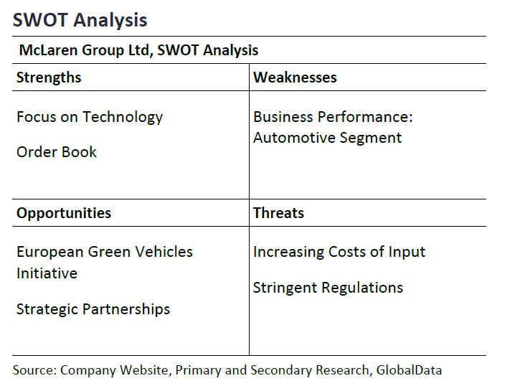
Swot analysis of McLaren Group Ltd. (Global Data PLC, 2021).

Use & limitations of financial ratios
Financial ratios are derived from the information contained within the Profit & loss statement, Balance Sheet & Cashflow statement, used to compare businesses, and the activity of a business over a period of time. They can be used by investors to decide whether a business is profitable, and worth the investment risk. They can be utilised to monitor a company’s financial health over an allotted period. Scalability & currency issues comparing companies are reduced as the numbers are compared against items on the balance sheet, profit & loss and cashflow statements, (Atrill and Mclaney, 2017).
Profitability Ratios:
Gross profit Margin (GPM), represents the percentage of revenue the company retains after removing COGS, assessing the financial health of the company. (Bloomenthal, 2020).
Operating profit Margin (OPM), the net income of a companies’ core business activities, omits non-operating income, & indirect factors that can mislead a company's performance. Operating profit is a good indicator of financial health, as it only includes essential operating expenses & asset related depreciation and amortisation.
Net Profit Margin (NPM) accounts for all costs that make up a sale. NPM is the profit before tax & interest, avoiding conflicting ways businesses are financed. Important indicator of financial health, whether the sales profits generated exceed the overheads & operating costs (Murphy, 2021). A limitation of NPM doesn’t show whether the company is managing its production costs.
Return on Assets (ROA) indicates your return on investment, indicating how efficiently your company utilises its assets, & what percentage of your investment is returned as profit (Gallo, 2017). A good benchmark ROA is industry dependent, limiting its ratio analysis use between industries (Hargrave, 2022). ROA is limited, more suited to asset-light business such as financial institutions. ROA compares returns to equity investors with assets by debt and equity investors. Therefore, more accurate variations of the ROA ratios can be utilised putting interest back into the formula (Hargrave, 2022). A high ROA may suggest the company is not investing into its Assets such as new systems & machinery.
Return on Equity (ROE) focuses on the net worth of the company, not on its assets, showing the percentage of profit against the invested equity (Gallo, 2017). Not every company can relate to assets, but every company has equity. Assumptions & estimations are built into the numbers, a product of the art of finance. Considerations of ROE is based on book value, not market value. ROA & ROE look at how companies use their resources but ROA includes company's debt, ROE removes liabilities (Hargrave, 2022)
Liquidity Ratios:
Current ratio measures the liquidity of a business, whether it has enough cash to pay of the short-term liabilities against its assets. A similar ratio, The Acid test removes inventory from the equation, due to the liquidity nature of most stock. Current ratio indicates the solvency of a company, and are useful in looking how a company is performing over time (Gallo, 2015). 2:1 could be considered a reasonable ratio, but would be industry dependent.

Activity Ratios:
Inventory Turnover averages the amount of times stock is cycled in a year, but does not account for seasonal variations & disruptions. Days payable outstanding (DPO) time taken in days on average to pay financial obligations (Hayes, 2019). A healthy DPO is industry dependent. Large corporations ‘have greater leverage to negotiate terms with suppliers and creditors, reducing DPO’s.
Day sales outstanding (DSO), the average number of days to receive payment for a sale. DSO can fluctuate seasonally, & the annual report may not provide the nuances of the year (Kenton, 2019). DSO & DPO can work together to provide the right balance of cash in and out of the business.
Leverage Ratios:
Debt to equity (D/E) leverage ratio looks at the proportion of external lending needed to finance a company’s operations (Wilkins, 2020.) Limitations of D/E is what companies’ constituents’ debt, is not always clear & D/E is Industry dependent. Interest coverage shows the ability to pay interest due against outstanding debt.
Investment Ratio:
Dividends can be paid to shareholders only if the company is profitable, indicating the businesses viability and performance, where regular payments to shareholders indicates financial strength. However, a company may opt not to pay dividends re-invest available funds for growth (Fontinelle, 2019.)
Statements are only a point in history & rely on the integrity of the individual(s) crafting them. Business conditions change, fluctuations of capital costs, KPI’s are not mapped, operating efficiencies & inflation can over report profit, & under value assets (Atrill and Mclaney, 2017). Ratios can help for decision making, but they don’t reveal the whole picture. Ratios can’t separate the company activities, are usually industry dependent, & multiple years are required to identify trends. It is important to use consistent methodologies for meaningful ratio analysis. Financial ratios indicate company financial strengths & areas to investigate.

Ratio analysis
2020 Profit & loss statement figures were adjusted to account for Preference shares.
GPM is relatively consistent for the 6-year data set, except for 2020 where it reduces to 18.64%, indicating a reduction in the efficiency of its manufacturing activities. Decreased supplier demand, overproduction, decreased unit price, decreased efficiency of reduced workforce & Covid legislation, increased production cost, supply chain issues, such as the semiconductors shortage, could all be relevant to the decrease in GPM. Poor management or poor products indicated by a fluctuating GPM, or could indicate an executable change to its business model, changes in product pricing, or company restructure (Bloomenthal, 2020).
OPM positive of 4.80% YTD in 2021 could be due to a reduction in debt, and a decrease in extraneous activities that won’t generate an immediate return on investment. The revenue from the sale of the production facility & leaseback is not included in the operating figure, and an example of a company with a large debt & positive operating profit, but reporting net losses. In debt heavy companies, the OPM may present the company's financial situation more favourable than NPM (Chen, 2019).
NPM for the data set indicates McLaren are not a profitable company, and during the pandemic, reported substantial losses. Operating costs, interest on debt obligations & overheads could be reduced to increase NPM. NPM reduces if operating costs increase faster than revenue growth. (Murphy, 2021). NPM can be boosted by one off transactions, such as a Joint venture, or sale & leaseback of Assets. Negative NPM indicates McLaren are not managing its production costs efficiently.
ROA in manufacturing industries can be useful to measure the efficiency of its process. For the data set, the ratios for ROA & ROE are negative, with 2020 showing a significant decrease in the efficiency of resources, & assets failing to produce growth.
A Current ratio of less than 1 suggests not having enough liquidity to pay your accrued short-term liabilities. However, too high ratio could indicate cash tied up in surplus inventory. Historic current ratio & quick ratios are cause for concern, with respective values less than 1.0 & 0.8, indicating issues with the liquidity of McLaren. 2021 YDT, is encouraging with McLaren in a more stable position to comfortably pay off their short-term liabilities, and currently indicates a slightly higher inventory retention than previous years.
Reduced Inventory Turns indicates a weakening of sales indicative of consumer demand failing due to pandemic, decrease in quality control of the product, market competitors, issues with supply of OEM parts, semiconductor shortage, etc. JIT manufacture is vulnerable to disruption during global supply chain issues (Accenture, 2020).
DSO of less than 45 days indicates McLaren are efficient at collecting their debts, however DSO increases in 2020 greater than 75days. High DSO can cause cashflow problems. DPO is fairly consistent with the exception of 2020, indicating issues with cash shortfall. A high consistent DPO strategy suggests the business may have been using the funds for freeing up cashflow, short term investments, or working capital (Hayes, 2019). In 2020 Risk of jeopardising supplier relations, early payment discounts, or a high DPO can suggest issues with paying creditors.
A decreasing D/E ratio suggests that the company is increasing being financed by its own generated equity, and a reduction in finance from its Creditors. Investors & finance institutes would prefer a lower gearing ratio. Typically, the larger the company, & capital heavy, the larger the gearing.
Manufacturing industries, such as automotive, are subject to fluctuations, and so interest coverage ratio of 300% is acceptable (Hayes, 2021). The Negative ratio in 2020 should be considered a red flag, and whilst interest data was not available at time of the report for YTD 2021.
For the investor ratios, McLaren directors do not propose a dividend for the final quarter of 2019 & 2020. When McLaren makes a net loss, dividends cannot be issued, & so Dividend yield & Dividend Cover ratios cannot be calculated. As a private company, a reliable source for Market share value could not be obtained. McLaren has not issued Dividends in the 6-year dataset due to reporting loss.

Ratio Analysis Appendix 1

Summary of findings
McLaren were financially unstable prior to the Pandemic (Benson, 2020), & indicative of their consistently negative NPM. In 2020, McLarens pre-tax losses increased to over £310 million, sales fell over 60% to nearly £390 million & reduced revenues of 48% against 2019 as a result of the pandemic. McLaren laid off 25% of staff and secured £150 million of emergency funding to manage its debt (Cattlin, 2021). There was a reduced global wholesale & decreased production volume in 2020, which negatively impacted on all ratios with decreased revenue, operational efficiency, increasing debt, & decreasing cashflow, whilst short-term liabilities and salaries straining cashflow (Accenture, 2020).
OEMs with inability to reduce fixed costs, have low liquidity to sustain long periods of lost revenue (Accenture, 2020.) In 2021, The McLaren Group secured a £550 million equity investment with £400 million of new capital, from preference shares and equity warrants, from Saudi Arabia's Public Investment Fund (PIF) & Ares Management. (Baldwin, 2021). McLaren opened a revolving credit facility of £110 million, raised equity & the sale of £170million, & 20-year lease back of McLaren Technology centre, released equity & eased cash flow, & retired the 5-year senior notes due in 2022 (McLaren 2020.) In the future, lease back may increase overheads & decrease profitability efficiency.
In Q2 2020, a simplified company restructure was proposed, with a new 5-year business plan focusing on profit over growth. In 2019 McLaren had Racing, Applied & Automotive combined on the balance sheet. 2021, McLaren is an automotive manufacturer with a large equity stake in an F1 Team, with Applied disinvested to Greybull Capital (Global data PLC, 2021.) McLaren racing minimum 25% minority stake sold, and retained controlling share, reducing risk of a volatile aspect of the McLaren group.
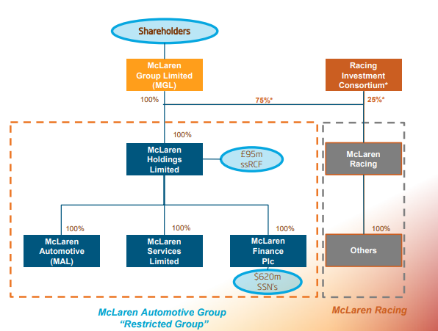
Group restructure (McLaren, 2021).
NPM fell in 2020 due to reduction in revenue, high administration costs, and increased production runs that saturated the market, devaluing the high-end car inventory 2021 NPM recovered to due to a reduction in operating costs, interest on debt obligations & overheads & due to one off transactions, such as a Joint venture, sale of Heritage cars, & sale & leaseback of the Manufacturing centre.
McLaren is not publicly traded; however private investors will want to see a future return on their investment. In the Auto industry, ROE 15-20% could be considered a good return, (Maverick, 2019), with an industry average of 15.86% for the 1st quarter of 2022 (Csimarket, 2022), however McLaren is still reporting negative equity. Automobile industry tend to have low-profit margins, due to intense competition, fluctuating demand, and increased operational costs of dealership networks and logistics. (Murphy 2022.) Dealership inventory reduction by Q4 2020 & CV-19 related closures, links to decreased inventory turns, Gross margins, and a reduction in overheads & dealership financial support (McLaren, 2020.) Post pandemic, McLaren limited production to automotive that produced a return & improving cash by reducing overhead costs in marketing, racing, & IT, and continuing overhead suppression in 2021, even with an increase in production.
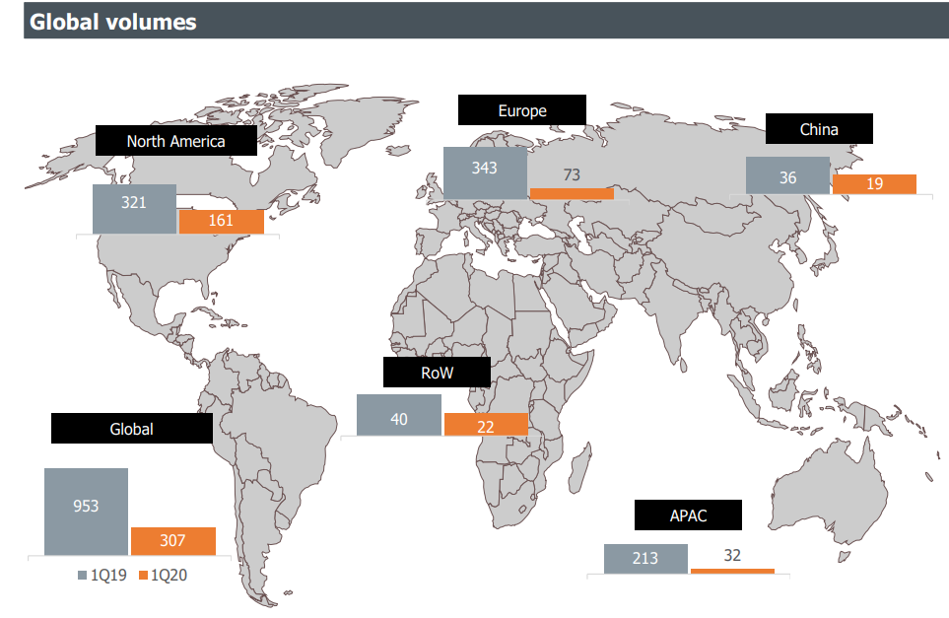
McLaren automotive global numbers volume 2020 & 2019 (McLaren, 2020).
McLaren liquidated their manufacturing HQ & Heritage car collection to finance debt over re-investing. A negative ROE suggests an unsustainable inefficiency in its processes. Reduced employment & overheads may explain consistent 2019 & 2020 Current ratio. This may affect production efficiency & quality reduction in 2021. Current ratio has improved in 2021 indicating sustainable liquidity, in part due to decreased inventory at dealers, decreased over heads, & decreased staff.
Automobile industry is capital intensive, if capital costs are low, the time value of money is reduced, favouring strategies that stimulate & accelerate growth, introducing new ideas, rather than increasing profit margins, such as creating efficient processes or terminating low, or unprofitable, growth projects, such as reducing extraneous research & development (Mankins, 2017).
For the automotive industry Covid affected production & consumer demands (Nayak et al., 2021). CV-19 Lock down of industries & day to day operations affected by Q4 2020 back to pre-pandemic operational capacity. Companies focused on growth prior to March 2022, realigned their business plans with company restructuring to capitalise on profit as a result of the economic down-turn. Automobile demand decreased, particularly in the initially hit Asia-Pacific region, (Köster & Igoe, 2020), disrupting supply chain production, and OEM supply.
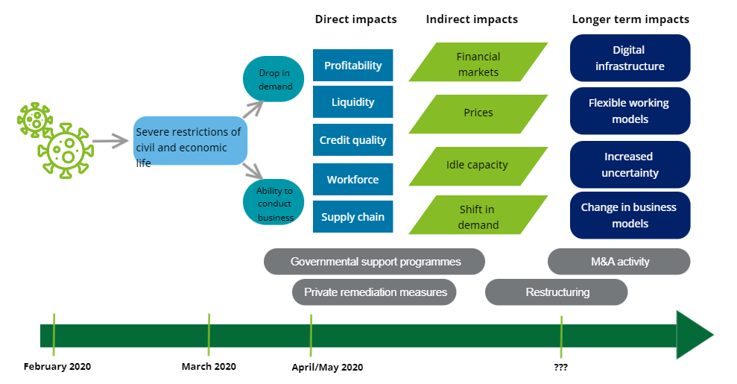
Potential Impacts of CV-19: Deloitte (Köster Igoe, 2020).
McLarens inventory turns descend through the dataset to 2021, suggesting increased working capital tied into inventory (Fernando, 2022). McLaren had become reliant on the profits of the Ultimate Series car, & with increased & uncapped production run in 2019, increased availability & decreased demand, with decreased quality adversely affected operations (Zhang, 2022), compounded by Cv-19 reduced workforce, operational capacity, supply chain disruptions & semiconductor shortage.
DSO increase in 2020 figures to greater than 75days, due to allowing trade creditors an extra 20-50 days payable. (McLaren Presentation, 2020). Limited cashflow had an increased effect on DPO indicative of CV-19 reduction of automotive sales due to supply chain issues, pandemic instability, and allowing increased days for debtor collection.
Critical financial ratios to evaluate the automotive industry include D/E, inventory turnover, and the ROE ratio, where the automotive industry consists of automobiles, commercial & OEMs (Maverick, 2019). For comparison, The D/E of General Motors is 143, BMW 124, Toyota 52, & Tata 145 (Maverick, 2019). By 2021, McLarens operations are less financed by creditors. However, a more comparative view of D/E with the Key competitors would give a better indication of McLarens operations.
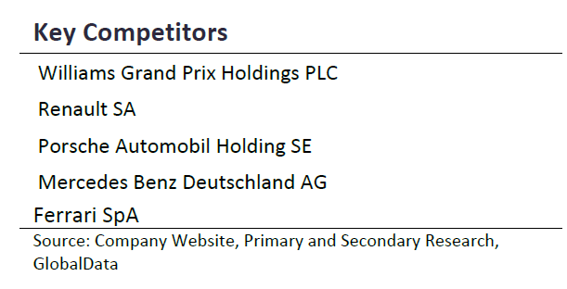
Key competitors of the McLaren group (Global Data PLC, 2021).
Conclusions:
Through company restructuring, & sale of assets, McLaren are in a focused & financially stronger position, reducing debt, increasing credit lines, strong supply-chain, & order book. McLaren have a strong investor network, quickly raising the required equity, & The Brand is a powerful intangible asset, linked to automotive innovation & leaders in high quality luxury vehicles. However, McLaren are not a profitable company & have not provided a return on equity for its shareholders.
The sale of the Manufacturing centre, Heritage Cars, disinvestment of McLaren Applied & JV of McLaren Racing, helped stabilise McLaren’s NPM back to pre-pandemic level. Further exploration of McLaren’s assets is needed to understand their capacity to survive further disruptions.
With minority share of McLaren Racing sold & McLaren Applied spun out, there may be a decrease in future innovation activities. In the short term this freed up capital, & reduced outgoings on non-profit return R&D, & extraneous activities that did not generate profit within the financial year. In the short term this alleviates pressure on McLarens cashflow, but long term, it may have an effect on the innovation side of McLaren, reducing their leadership in cutting edge technology. However, a focus on the profitable side of McLaren is needed, as a company that consistently reports losses is not sustainable.
Whilst McLarens is a recognisable brand, the inability to create a profit must be addressed & recent termination of projects that are not deemed short term profitable. To enter into a Joint Venture would require assurances of the company’s longevity & commitment to the project, & reviewing their 2021 Annual Report to understand if the company growth & business plan indicates the future profitability, & ultimately longevity of McLaren.

Recommendations:
Similar reports created for key competitors of McLaren to give clarity to McLarens current & future position, and to identify alternative collaborators
Report on quality control of 2021 McLaren production run to determine effects of staff & overhead reduction.
Further investigation into whether the company restructure has returned McLaren to a stable position, & whether they will report future profits, and their capacity to survive further disruptions, is recommended.
Further investigation into semiconductor shortage, & CV-19 effects on OEM supply chains for JIT manufacture.
McLaren are high risk. Short term projects could be considered, but long-term Joint Ventures should be carefully considered against the increased risk of McLaren’s past ability to turn a profit. At this point in time McLaren is too considered too High-Risk to recommend a Joint Venture.

Appendices
References
Accenture (2020). Impact on the Automotive Industry: Navigating the Human and Business Impact of COVID-19. [online] Available at: https://www.accenture.com/_acnmedia/PDF-121/Accenture-COVID-19-Impact-Automotive-Industry.pdf.
Ashurst.com. (2022). Transforming McLaren Group’s Strategy. [online] Available at: https://www.ashurst.com/en/about-us/partnerships/mclaren-group-partnership/transforming-mclaren-groups-strategy/ [Accessed 9 May 2022].
‌Atrill, P. and Mclaney, E.J. (2017). Accounting and Finance for Non-Specialists. 11th ed. Harlow, England ; New York: Pearson.
Baldwin, A. (2021). Saudi PIF buys into McLaren as part of 550 mln pound equity raise. Reuters. [online] 16 Jul. Available at: https://www.reuters.com/world/middle-east/saudis-pif-talks-buy-stake-mclaren-group-sky-news-2021-07-16/ [Accessed 20 May 2022].
Benson, A (2020) McLaren Racing to sell third of company- BBC Sport. [online] Available at: https://www.bbc.co.uk/sport/formula1/55292974 [Accessed 30 May 2022].
‌Bloomenthal, A. (2020). Why Gross Profit Margin Matters. [online] Investopedia. Available at: https://www.investopedia.com/terms/g/gross_profit_margin.asp.
‌Cattlin, R. (2021). City Index. A guide to McLaren Group: will McLaren IPO in 2021? [online] Available at: https://www.cityindex.co.uk/market-analysis/mclaren-ipo/.
‌Chen, J. (2019). Operating Profit. [online] Investopedia. Available at: https://www.investopedia.com/terms/o/operating_profit.asp.
‌Csimarket (2022). Auto & Truck Manufacturers Industry Management Effectiveness Information and Trends by quarter, ROE, Return On Assets, Return On Investment from 4 Q 2020 to 4 Q 2019 - CSIMarket. [online] Available at: https://csimarket.com/Industry/industry_ManagementEffectiveness.php?ind=404.
‌Köster, O. & Igoe, S. (2020). Deloitte. How COVID-19 infects financial reporting and results presentations. [online] Deloitte Switzerland. Available at: https://www2.deloitte.com/ch/en/pages/audit/articles/financial-reporting-survey-q1-2020.html.
Fernando, J. (2022) Investopedia. Debt-to-Equity (D/E) Ratio. [online] Available at: https://www.investopedia.com/terms/d/debtequityratio.asp#toc-limitations-of-the-debt-to-equity-de-ratio [Accessed 2 Jun. 2022].
Fernando, J. (2022). Inventory turnover definition. [online] Investopedia. Available at: https://www.investopedia.com/terms/i/inventoryturnover.asp.
Fontinelle, A. (2019). Why Do Some Companies Pay a Dividend, While Others Don’t? [online] Investopedia. Available at: https://www.investopedia.com/ask/answers/12/why-do-some-companies-pay-a-dividend.asp.
‌Gallo, A. (2015). A Refresher on Current Ratio. [online] Harvard Business Review. Available at: https://hbr.org/2015/09/a-refresher-on-current-ratio.
Gallo, A. (2017). A Refresher on Return on Assets and Return on Equity. [online] Harvard Business Review. Available at: https://hbr.org/2016/04/a-refresher-on-return-on-assets-and-return-on-equity.
Global data PLC (2021). McLaren Technology Group - Strategic SWOT Analysis Review. Report Code: GDAUT156672SA Hargrave, M. (2019). Analyzing a Company’s Liquidity Using the Operating Cash Flow Ratio. [online] Investopedia. Available at: https://www.investopedia.com/terms/o/ocfratio.asp.
‌Hargrave, M. (2022). How to Use Return on Assets When Analyzing a Company. [online] Investopedia. Available at: https://www.investopedia.com/terms/r/returnonassets.asp.
‌Hayes, A. (2019). How to Understand Days Payable Outstanding. [online] Investopedia. Available at: https://www.investopedia.com/terms/d/dpo.asp.
Hayes, A. (2021). Why the Interest Coverage Ratio Matters. [online] Investopedia. Available at: https://www.investopedia.com/terms/i/interestcoverageratio.asp.
Hahn, E. (2021). The role of profit margins in the adjustment to the COVID-19 shock. www.ecb.europa.eu. [online] Available at: https://www.ecb.europa.eu/pub/economic-bulletin/focus/2021/html/ecb.ebbox202102_05~cc3ed20c59.en.html.
‌Kenton, W. (2019). Understanding Days Sales Outstanding. [online] Investopedia. Available at: https://www.investopedia.com/terms/d/dso.asp.
Mankins, M. (2017). Stop Focusing on Profitability and Go for Growth. [online] ‌Harvard Business Review. (Available at: https://hbr. org/2017/05/stop-focusing-on-profitability-and-go-for-growth.
Maverick, J.B. (2019). Key Financial Ratios to Analyze the Auto Industry. [online] Investopedia. Available at: https://www.investopedia.com/articles/active-trading/082015/key-financial-ratios-analyze-automotive-industry.asp.
‌McLaren (2021). McLaren Group agrees sale of McLaren Applied. [online] Available at: https://www.mclaren.com/group/news/articles/mclaren-group-agrees-sale-mclaren-applied/ [Accessed 9 May 2022].
McLaren Investors. (2021). Results centre. [online] Available at: https://investors.mclaren.com/investors/result-centre/year/2021.
McLaren (2021) McLaren Investors. Interim Results 2021 Results centre. [online] Available at: https://investors.mclaren.com/sites/mclaren-ir/files/2021-11/interim-report-sep-2021.pdf
‌McLaren (2020) McLaren Investors. McLaren Q1 2020 Results. [online] Available at: https://investors.mclaren.com/sites/mclaren-ir/files/2020-05/mcLaren_q1_2020_results_presentation.pdf
‌McLaren (2020) McLaren Investors. Annual Report 2020 Results centre. [online] Available at: https://investors.mclaren.com/sites/mclaren-ir/files/report-document/mclaren-group-limited-2020-annual-report.pdf
‌McLaren (2019) McLaren Investors. Annual Report 2019 Results centre. [online] Available at: https://investors.mclaren.com/sites/mclaren-ir/files/2020-05/mclaren-group-limited-financial-statements-2019.pdf
McLaren (2021) Q3-2021-presentaion [online] Available at: https://investors.mclaren.com/sites/mclaren-ir/files/2021-11/q3-2021-results-presentation.pdf
Murphy, C. (2022). How to Calculate Net Profit Margin Using Apple’s Revenue and Profit. [online] Investopedia. Available at: https://www.investopedia.com/terms/n/net_margin.asp.
‌Nayak, J., Mishra, M., Naik, B., Swapnarekha, H., Cengiz, K. and Shanmuganathan, V. (2021). An Impact Study of COVID‐19 on Six Different Industries: Automobile, Energy and Power, Agriculture, Education, Travel and Tourism and Consumer Electronics. Expert Systems. [online] doi:10.1111/exsy.12677.
Wilkins, G. (2020). 6 Basic Financial Ratios And What They Reveal. [online] Investopedia. Available at: https://www.investopedia.com/financial-edge/0910/6-basic-financial-ratios-and-what-they-tell-you.aspx.
Zhang, S. (2022). The Strategy for McLaren to Change its Current Market Situation. [online] www.atlantis-press.com. doi:10.2991/aebmr.k.220405.142.

‌
‌

‌
‌

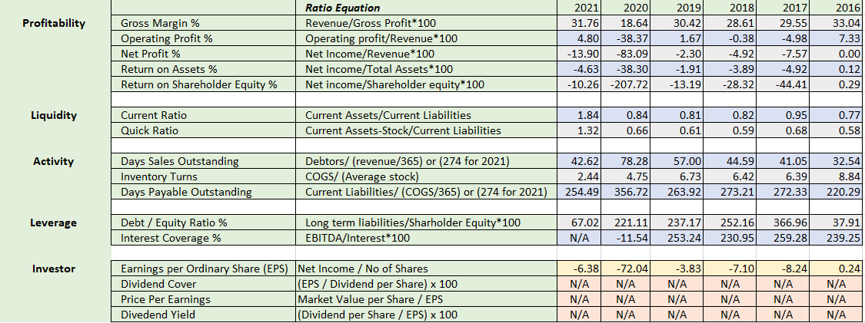
Ratio calculations
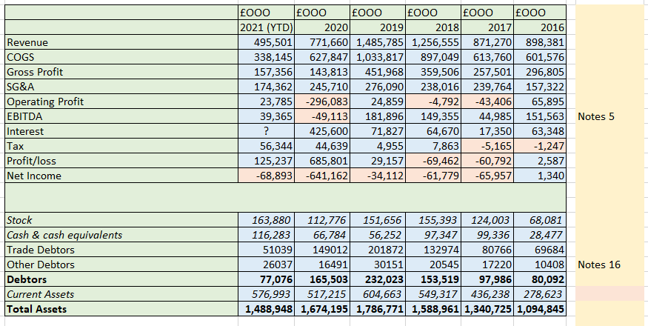

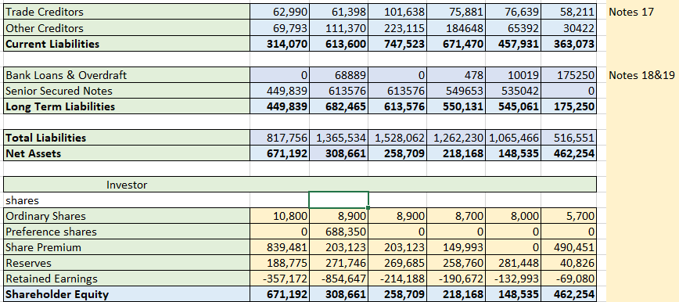
Statements
https://investors.mclaren.com/investors/result-centre/year/2021
2021 YTD
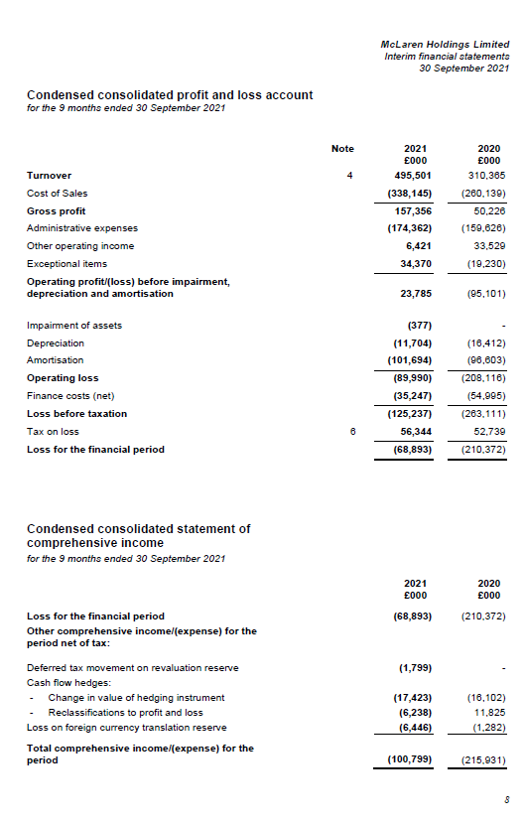
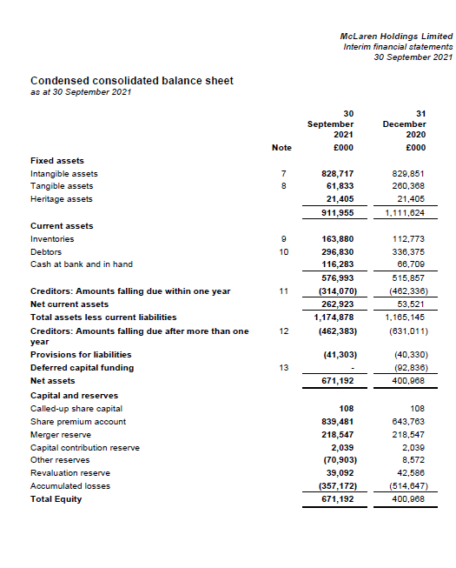
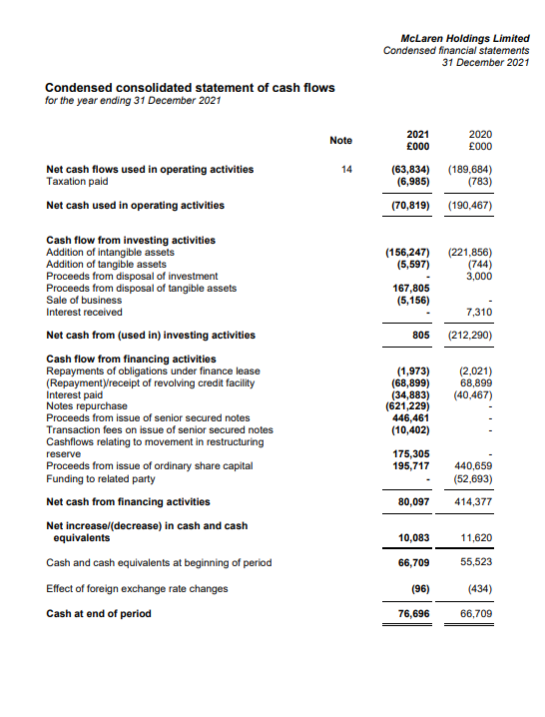
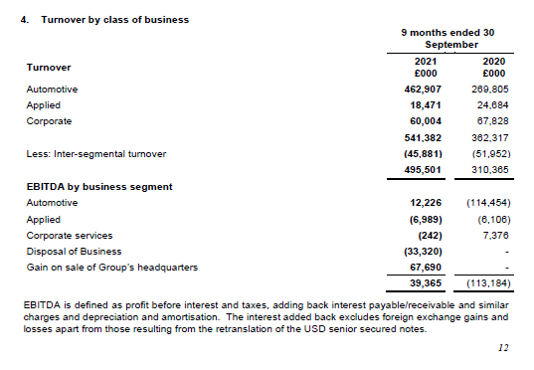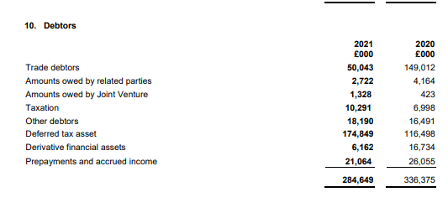
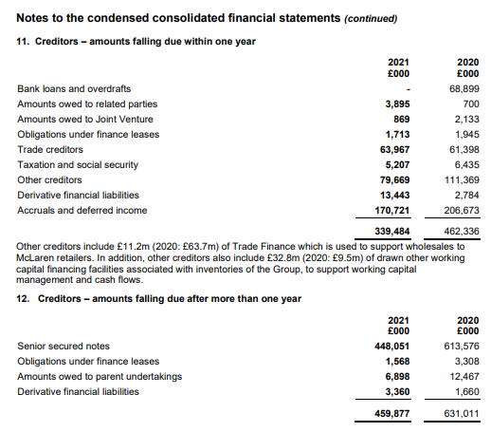
2020
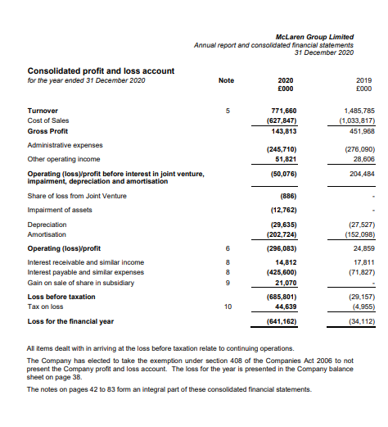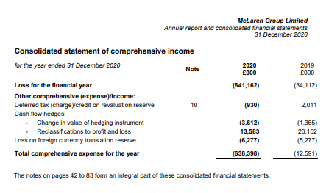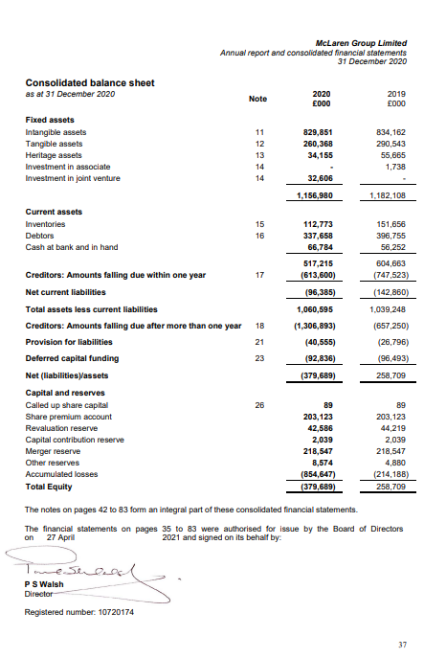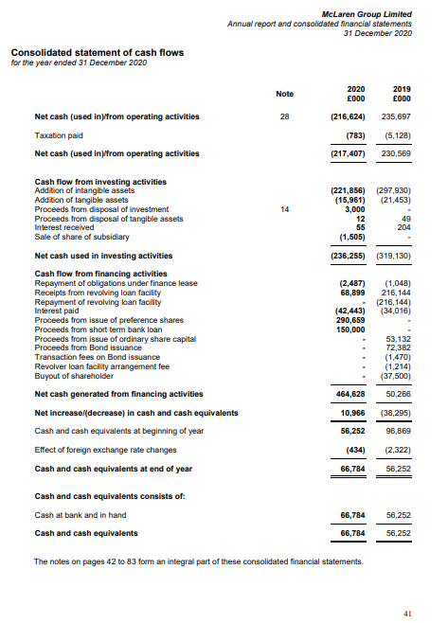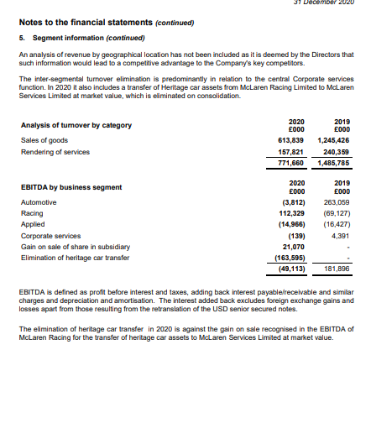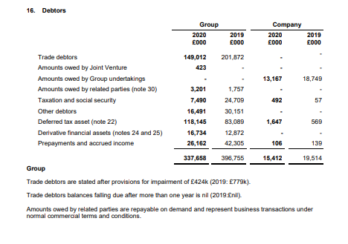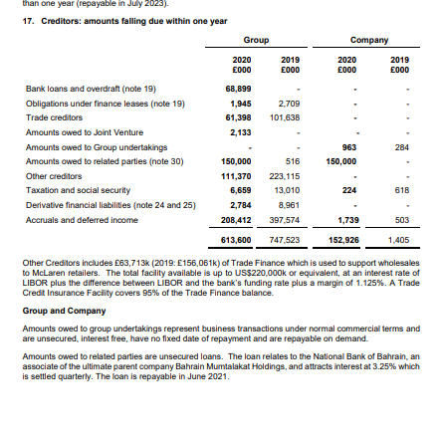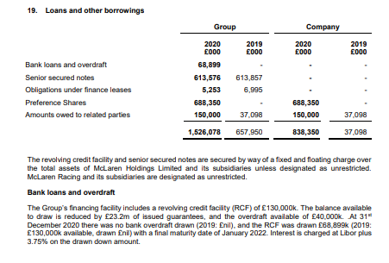

2019
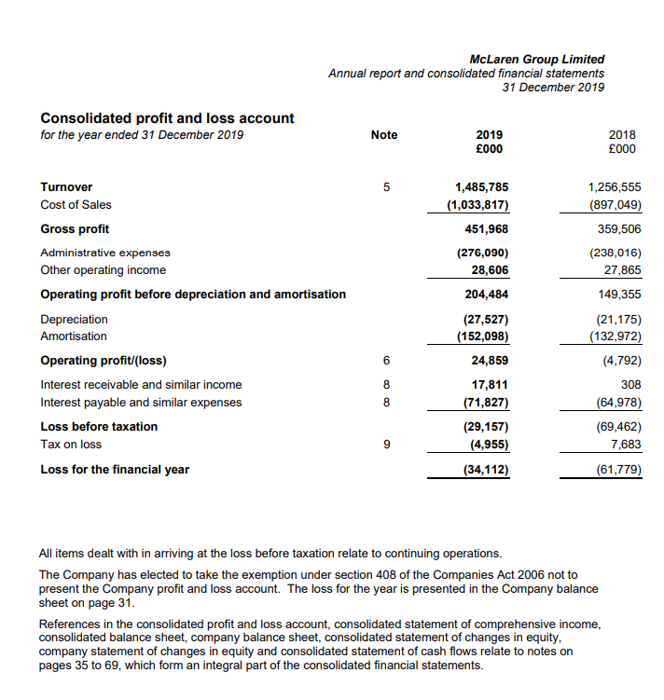
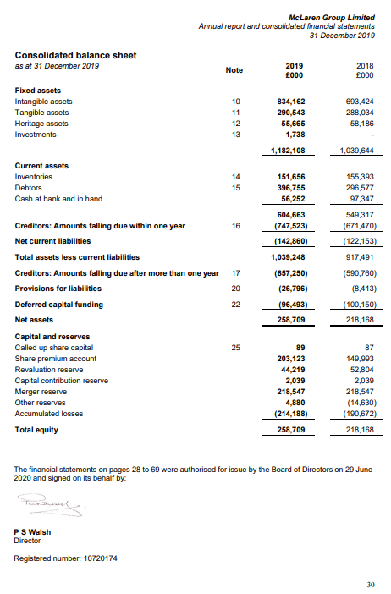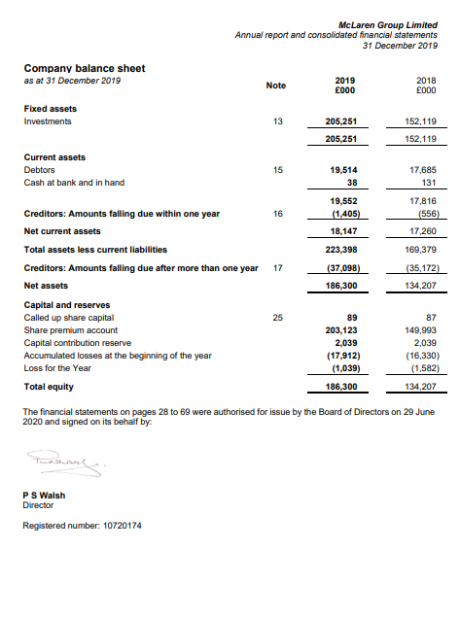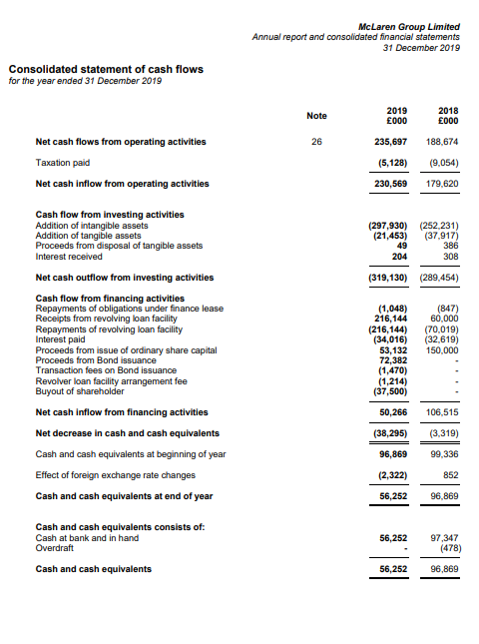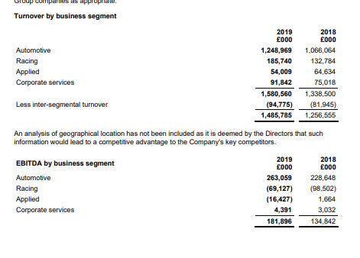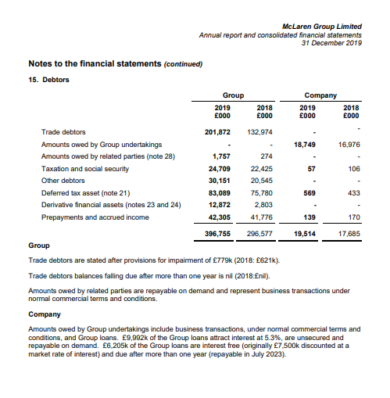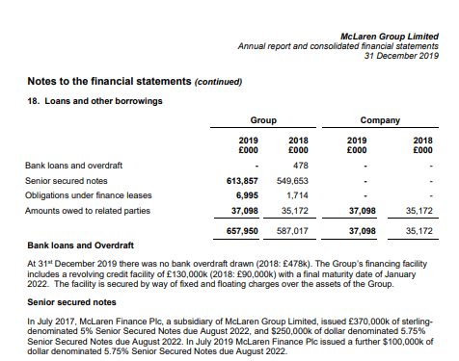

2018

