

MODULE: MANAGEMENT ACCOUNTING FOR MANAGERS
MODULE CODE: LCBB5010
ASSIGNMENT TITLE: COMPONENT 1: INDIVIDUAL REPORT

STUDENT ID:
WORD COUNT: 2024

Executive summary
Management accounting is significant for financial planning, monitoring and control of business operations. Tesla is a leading technology and automotive company that was founded in 2003. The revenue model and cost structure of Tesla is discussed in the report. Role of budgeting and financial & non-financial indicators of Tesla is evaluated in the report. Sustainable energy solutions and renewable energy services are managed by Tesla for sustainable operations.

Table of Contents
1. Introduction 4
2. Cost Analysis and Business Model 4
3. Budgeting and Financial Planning 6
4. Performance Measurement and Decision-Making 8
5. Sustainability and Ethical Considerations 10
6. Conclusion and Recommendations 11
References 12

1. Introduction
1.1 Background of the selected company
Tesla, Inc. is a multinational automotive and technology company and it was founded in 2003 that has headquarters in Austin, Texas. Tesla has more than 100k employees and it has focused on sustainable future development through solar energy and electric vehicles usage (Tesla, 2026). Tesla operates in automotive, clean energy and robotics or artificial intelligence (AI) industry and it provides electric vehicles (EVs), solar energy products, battery storage systems and energy solutions.
1.2 Importance of management accounting
Management accounting is important to support internal decisions of modern organisations. Management accounting is significant for cost control and reduction of businesses that is necessary for cost management (Maheshwari et al., 2024). Management accounting supports “planning, monitoring, controlling and decision-making” functions of businesses that support performance evaluation and budgeting to manage long term sustainability and profitability.

2. Cost Analysis and Business Model
2.1 Revenue model analysis
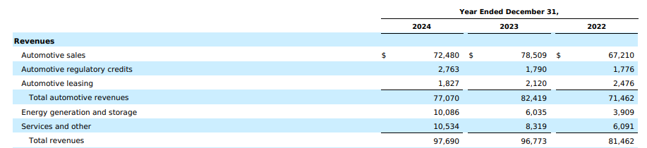
Figure 1: Revenue sources of Tesla
(Source: Tesla, 2026)
The revenue model of Tesla includes energy generation products, EVs and related services that support multiple sales streams and reduce business risk. For example, “automotive sales, automotive regulatory credits, automotive leasing, energy generation and storage and other services” make total revenue of $97,690m in 2024 (Tesla, 2026). Revenue sources of the company has been one of the biggest contributions from automotive sales as per the above figure that include different vehicles such as Model Y, Model 3, Model S and Model X. Direct-to-consumer sales model is implemented by the business and manages better profit margins and price control. In contrast, innovative products and services are important for evaluating customers' behaviour and improving revenue earnings (Allioui and Mourdi, 2023). Automotive regulatory credits are another key source of revenue that influences sustainable operations management by reducing carbon emissions. Hence, the revenue model of Tesla supports diversified sources to manage long-term growth opportunities and heavy investment for global expansion and innovation.
2.2 Key cost structures analysis
The key cost structure of Tesla includes fixed cost and variable costs that are an important part of management accounting. Fixed cost is a part of cost behaviour that includes expenses which do not change based on the output activity changes (Hansen et al., 2025). Tesla’s fixed cost includes manufacturing facility investment as the company produces products in large Gigafactories that need huge capital investment. Research and development (R&D) is another fixed cost of Tesla that includes heavy investment for technology innovation such AI and battery development. Administrative and corporate expenditure are another fixed cost of Tesla that include executive salary, management staff expenses and administrative personnel cost. In contrast, selling price determination is significant to cover production cost of businesses (Hardana et al., 2023). Variable costs changes depend upon production volume and it includes raw material cost of Tesla. For example, aluminium, nickel, lithium and steel are part of raw materials of Tesla however, direct labour and logistics are also part of variable cost. Hence, effective management is important to control both fixed and variable cost of Tesla for better profitability and operational efficiency.
2.3 Cost volume profit analysis model and limitations of the model
The cost of volume profit (CVP) analysis supports managers to understand changes in “revenue volume, expenses and price level” that affect profitability. As defined by Nworie et al. (2023), CVP analysis is a significant management tool to understand the relationship between “cost, revenue and volume” of businesses that affect profitability. CVP's primary objective is to support the pricing decision of Tesla.
Example for production of Model 3 of Tesla
Description | Amount
Selling price per vehicle  Variable cost per vehicle  Total fixed costs | $45,000  $30,000  $6,000,000,000
Contribution Margin  Formula = “Selling Price – Variable Cost”  Contribution Margin | $45,000 – $30,000  $15,000 per vehicle
Break-Even Point (Units)  Formula = “Fixed Costs / Contribution Margin”  Break-Even Units | $6,000,000,000/ $15,000  400,000 vehicles
Break-Even Revenue  Formula = “Break-Even Units × Selling Price”  Break-Even Revenue | 400,000 × $45,000  $18,000,000,000
Table 1: Example CVP analysis for Tesla
(Source: Self-Created)
Evaluation of CVP technique is significant for Tesla to understand targeted vehicles to cover total cost. The above table indicates approximately 400,000 vehicles need to be sold by Tesla to cover total “fixed cost and variable costs” and beyond the units the company can earn profit. CVP analysis is significant for financial management and business decision making by evaluating production decisions (Guo, 2022). Limitations of CVP analysis include assumptions for constant sales price that is not possible as market demand and competition influence Tesla to change model prices. However, CVP analysis simplifies cost analysis, which is another limitation of the technique. Thus, CVP analysis is significant for Tesla’s manager to use as a financial tool for pricing decision making.

3. Budgeting and Financial Planning
3.1 Role of budgeting
Budgeting is a key management accounting tool supporting organisational plan development and financial resources control. Budget is important to support internal planning of businesses and allocate resources effectively to achieve financial objectives and minimise operational cost (Zhou et al., 2025). The budget is playing a vital role for Tesla to ensure effective fund allocation, in production R&D, advertisement and expansion projects. In contrast, budgeting is important for financial planning that provides information about short-term priority of organisations (Yeo et al., 2024). Financial planning is a key function of budgeting that supports Tesla to invest huge amounts for new factories, AI system development and improving better technologies. In addition, performance monitoring and cost control is another significant role played by budgeting as it supports performance comparison with actual figures to identify variance. For example, the production cost of Tesla is higher than the budget figure that can influence managers to identify reasons and implement cost reduction strategies. Strategic resource allocation is another significant role played by budgeting for careful utilisation of financial resources to manage manufacturing operations internationally. Hence, budgeting is important for financial discipline management of Tesla and support that strategic business expansion and innovation.
3.2 Operating expenses changes analysis and decisions made by management
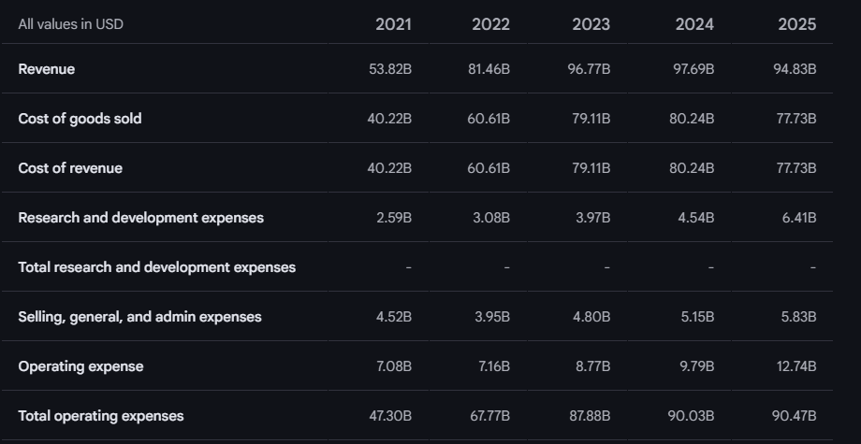
Figure 2: Operating expenses of Tesla for 2021-2025
(Source: Google Finance, 2026)
Operating expenses of Tesla consist of R&D, selling and administrative expenses and production regarding expenditure. Total operating expenses of Tesla was $12.74B in 2025 that was $9.79B in 2024, $8.77B in 2023 and $7.08B in 2021 (Google Finance, 2026). Increasing operating expenditure can be observed for Tesla in 2021-2025 due to rapid technology development and expansion. In addition, increased investment for R&D and global production facilities expansion also influence higher operating expenses of Tesla. In contrast, Tesla has focused on efficient production process management and renewable energy utilisation that supported battery materials recovery to produce 43,000 Model Y Rear-Wheel Drive vehicles (Tesla, 2023). The company management has focused on operating expenditure control through production efficiency and vertical integration strategy to produce batteries internally and reduce cost. Hence, the management decision indicates internal effectiveness to control operating expenditure and support strategic planning of Tesla.

4. Performance Measurement and Decision-Making
4.1 Financial or non-financial KPI’s of the company
Key performance indicators (KPIs) are important for evaluating organisational performance and measuring strategic objectives achieved by Tesla. Financial and non-financial KPIs of the company includes:
- Revenue growth is a financial KPI that analyses the increase in revenue of Tesla over years. For example, total 1,654,667 models have produced by Tesla in 2025 and 1,636,129 vehicles have sold in the year (Tesla, 2026). Consistent revenue evaluation supports Tesla in new vehicle launches and efficiency in market expansion tactics.
- Gross profit margin is another financial KPI that analyses revenue percentage retained after deducting production cost. Total gross profit of Tesla was $20,853m in 2022 that reduced to $17,450m in 2024 (Tesla, 2026). Tesla can evaluate production efficiency through a higher “gross profit margin” and it indicates strong pricing strategy and effective cost management; however, lower gross profit indicates production inefficiency.
- Vehicle delivery volume is a non-financial KPI that evaluates vehicle numbers delivered by Tesla on an annual basis. Production capacity of the company can be understood from the indicator and it also evaluates market demand for EVS.
- R&D intensity is a significant KPI that evaluates the proportion of revenue invested in research activity. A high investment value for R&D supports the innovation commitment of Tesla and it also manages technology leadership.
- Brand loyalty and customer satisfaction is a significant KPI that evaluates brand perception and customer feedback. Customers’ loyalty is influenced by high customer satisfaction from product or services consumption that influence buying behaviour (Juliawan, 2023). A high customer satisfaction leads to better repeat purchases of customers and improves the competitive advantage of Tesla.
Evaluation of financial and non-financial KPIs are important for Tesla to provide overview of financial and operational performance management and support profitability.
4.2 Strategic decisions the company
Strategic decisions of the company include gigafactory expansion in multiple countries based on production cost and demand forecast data evaluation. Tesla has 30 MM+ ft² factory space in three continents (Tesla, 2026). Tesla has decided to expand the large size of its gigafactory in Germany and China to reduce transportation costs and manage regional demand. However, battery technology development is another strategic decision taken by Tesla for influencing affordability of EVs. Tesla has taken strategic decisions for cost reduction and business expansion based on management and financial data evaluation.
4.3 Balanced scorecard implication with examples and limitations of the model
Balance scorecard (BSC) is a performance management framework that analyses four perspectives to understand organisational objectives and performance. “Learning and growth, internal process, customers and financial perspectives” of BSC (Al-Hosaini et al., 2023). BSC of Tesla as follows:
Financial perspective | Customer perspective
“Revenue growth, operating margin and profitability” are financial indicators of Tesla. | Brand reputation, customer satisfaction and vehicle quality evaluate market competitiveness and customer loyalty.
Internal process perspective | Learning and growth perspective
Manufacturing efficiency of Tesla is evaluated through supply chain management, automation and better battery production optimisation. | Innovation, technology advancement and employee development support long term strategy achievement of Tesla.
Table 2: BSC of Tesla
(Source: Self-Created)
BSC has some limitations due to its complexity in implementation that evaluates data from multiple perspectives and makes it time consuming. Subjective measurement is another limitation of BSC however, the above table indicates implementation of the framework is significant for performance evaluation.

5. Sustainability and Ethical Considerations
5.1 Integration of sustainability into financial decision-making
Sustainability is playing a vital role for managing financial decision making and business strategy development of Tesla that includes sustainable energy and transportation system management. Tesla has the mission of sustainable energy transition and positively influencing the basis on transportation system improvement (Tesla, 2024). Tesla integrates renewable energy solutions and EV technology for supporting environmental objectives and economic value creation.
5.2 Ethical considerations in cost management and pricing strategies
Ethical considerations of Tesla for pricing strategy include adjustment of vehicle price by adjusting market conditions; however, dynamic pricing supports profitability management. Product quality criticism is faced by Tesla for its consistent profitability focus and labour practices allegations create safety concerns (EBSCO, 2024). Cost management is also focused on by the business that occurs due to supply chain and labour practices management. The cost management decision of Tesla does not compromise product quality or safety standards and lower production cost can make reduction in vehicles reliability. Hence, ethical standards of Tesla for pricing Strategies and cost management can protect long term business sustainability and brand reputation.

6. Conclusion and Recommendations
6.1 Summary
It can be summarised as the direct to sales consumer sales model is followed by Tesla and “fixed cost and variable cost” are two main categories of cost structure of the business. Budgeting is playing a vital role for financial planning, performance monitoring, cost control and strategic resources allocation. Revenue growth and R&D intensity are some KPIs and sustainable operations of Tesla are observed for renewable energy solutions and sustainable energy system management.
6.2 Recommendations
- Cost forecasting model improvement can be recommended to Tesla for improvement in cost prediction accuracy that requires advanced analytics implementation in the “management accounting” system.
- Supply chain transparency improvement can also be suggested to the business for ensuring sustainable and ethical procurement practices that require raw material sourcing monitoring.

References
Al-Hosaini, F.F., Ali, B.J., Baadhem, A.M., Jawabreh, O., Atta, A.A.B. and Ali, A., (2023). The impact of the Balanced Scorecard (BSC) non-financial perspectives on the financial performance of private universities. Information Sciences Letters, 12(9), pp.2903-2913.
Allioui, H. and Mourdi, Y., (2023). Exploring the full potentials of IoT for better financial growth and stability: A comprehensive survey. Sensors, 23(19), p.8015.
EBSCO, (2024). Tesla Inc. Available at: https://www.ebsco.com/research-starters/business-and-management/tesla-inc (Accessed on: 05 March 2026).
Google Finance, (2026). Tesla Inc. Available at: https://www.google.com/finance/beta/quote/TSLA:NASDAQ?hl=en&tab=financials (Accessed on: 05 March 2026).
Guo, Y., (2022). [Retracted] Enterprise Management Decision and Financial Management Based on Dynamic Cost Volume Profit Model. Journal of Function Spaces, 2022(1), p.9016060.
Hansen, D.R., Mowen, M.M. and Heitger, D.L., (2025). Cost management. 5th Edition.Cengage Learning.
Hardana, A., Utami, T.W., Hasibuan, L. and Windari, W., (2023). Accounting information in improving corporate values and responsibility to stakeholders in cement manufacturing companies in Indonesia. The Journal of Management Science (JMAS), 6(2), pp.223-231.
Juliawan, T., (2023). Customer Satisfaction and Repeat Business are impacted by Product Quality and Services. KINERJA: Jurnal Manajemen Organisasi dan Industri, 2(1), pp.72-82.
Maheshwari, S.N., Maheshwari, S.K. and Maheshwari, S.K., (2024). Management Accounting and Financial Control. Sultan Chand & Sons.
Nworie, G.O., Okafor, T.G. and Igwebuike, C.C., (2023). Utilizing Cost-Volume-Profit Analysis for Informed Decision Making in Small Business Management. Central Asian Journal of Innovations on Tourism Management and Finance, 4(2), pp.102-115.
Tesla, (2023). Impact Report. Available at: https://www.tesla.com/ns_videos/2023-tesla-impact-report-highlights.pdf (Accessed on: 05 March 2026).
Tesla, (2024). Impact Report. Available at: https://www.tesla.com/ns_videos/2024-tesla-impact-report-highlights.pdf (Accessed on: 05 March 2026).
Tesla, (2026). About Us. Available at: https://www.tesla.com/en_in/about (Accessed on: 05 March 2026).
Tesla, (2026). ANNUAL REPORT PURSUANT TO SECTION 13 OR 15(d) OF THE SECURITIES EXCHANGE ACT OF 1934. Available at: https://ir.tesla.com/_flysystem/s3/sec/000162828025003063/tsla-20241231-gen.pdf (Accessed on: 05 March 2026).
Tesla, (2026). Manufacturing. Available at: https://www.tesla.com/manufacturing (Accessed on: 05 March 2026).
Tesla, (2026). Tesla Fourth Quarter 2025 Production, Deliveries & Deployments. Available at: https://ir.tesla.com/press-release/tesla-fourth-quarter-2025-production-deliveries-deployments (Accessed on: 05 March 2026).
Yeo, K.H.K., Lim, W.M. and Yii, K.J., (2024). Financial planning behaviour: a systematic literature review and new theory development. Journal of Financial Services Marketing, 29(3), pp.979-1001.
Zhou, F., Liu, Y., Traiwannakij, S. and Triatmanto, B., (2025). Strategic budgeting and budgeting evaluation effects on China’s manufacturing companies’ performance. Journal of Risk and Financial Management, 18(4), p.172.

